Elena Stanca 1918159
DEADLINE: 05/07/2024
Developing a Research Proposal
A critical evaluation of how managers motivate the employees to increase productivity at work in an organization

Contents
1.0 Introduction 2
Background of the Study 2
Rationale for the Study 3
1.1 Aim and Objectives 3
1.2 Research Question 4
2.0 Literature Review 4
2.1 Introduction 4
2.2 Defining the Productivity Management System and how it affects employee productivity. 5
2.3 Managers encourage employees with a positive work environment to enhance their productivity. 6
2.4 Different Managerial Approaches by the managers in enhancing team productivity. 7
2.5 The Human Relation Theory of the management in improving productivity a the workplace as a strategy. 8
2.6 The Conceptual Framework. 9
2.7 The Literature Gap. 10
2.8 Summary. 11
Methodology 11
Philosophy 12
Research Approach 13
Data Collection Method 13
Data Analysis 13
Sampling Technique 14
Ethical Behavior inside the Research Activity 14
Validity and Reliability 15
3.0 References 16
Appendix 19

1.0 Introduction
Management improves productivity as small to large enterprises face challenges with increasing productivity and society adjusting to new norms of living and working. The study will critically evaluate managers in motivating employees to increase their productivity in the context of Graze reflecting as a UK-based SME operating in the food and beverage industry. The study also added an aim objective of the manager's role in managing employee productivity while using various theories, research gaps and ethical considerations. In the next part of the methodology, the study will focus on primary research under quantitative analysis based on ethical behaviour and the survey questionnaire.

Background of the Study
In the present competitive as well as the fast-paced business environment various organizations continually often seek ways to properly enhance productivity to properly maintain a competitive edge (Andreas et al., 2021). This challenge is stated inside the food and beverage organization, wherein operational overall performance and employee motivation are crucial to fulfilment. Graze, a UK-based SME that specializes in healthy snacks, exemplifies demanding situations. With a dynamic marketplace and evolving customer possibilities, Graze wants to ensure that its employees stay stimulated and effective. Employee motivation is a key thing influencing productivity, impacting both the exquisite and amount of output. Understanding how managers at Graze inspire their employees can provide precious insights into effective manipulation practices inside SMEs inside the food and beverage zone.

Rationale for the Study
The rationale for this study is mainly rooted in the critical need for effective employee motivation strategies in different SMEs, particularly in the food as well as beverage industry (Ali et al., 2021). While huge companies regularly have large resources to invest in worker motivation and productivity projects, SMEs like Graze face unique challenges due to constrained belongings and unique organizational dynamics (Mariah et al., 2021). This has a look to fill a research gap using focusing especially on how managers in an SME context can efficiently encourage employees to enhance productivity. By exploring the research and strategies of managers at Graze, they check goals to provide actionable insights that may be finished to comparable agencies. Additionally, the meals and beverage enterprise give unique disturbing situations related to worker motivation, consisting of immoderate turnover prices and the need for non-forestall innovation (Basal Amah et al., 2022). Understanding a way to cope with those annoying situations can assist enhance employee pride, lessen turnover, and ultimately beautify organizational overall performance.

1.1 Aim and Objectives
The study aims to critically evaluate the role of managers in motivating employees to increase productivity at work
- To delineate different management approaches in improving team productivity in the context of Graze.
- To analyze how managers can create a positive work environment by enhancing employee productivity.
- To investigate different motivational techniques that managers can adopt to motivate employees and thus enhance productivity and performance.
- To recommend strategies that can help managers understand the various ways to enhance employee motivation and thus ensure better productivity.

1.2 Research Question
- What are the roles of management in serving useful advice for setting up a productive management system?
- What are the different ways management approaches in improving team productivity in the UK-based snack company Graze?
- What are the different motivational techniques used by the manager in the context of the food and beverage industry?
- What will be the best-suited strategies that will support employees in enhancing their productivity at the workplace?

2.0 Literature Review

2.1 Introduction
A literature review is a written account which is published by the researcher while understanding the existing debate relevant to the topic under the theoretical framework. The managers in the food and beverage industry introduce materials, rewards and incentives to enhance employee productivity.

2.2 Defining the Productivity Management System and how it affects employee productivity.
According to an author (Setiadi et al., 2023), productivity management is efficiently turning the inputs such as labor and capital used into the outputs such as goods and services, rewards, and development opportunities so that managers can improve staff productivity. The Productivity management system for the managers of the food and beverage company Graze focuses on teamwork, training programs, and setting long-term and shared goals while bridging the technical and skill gaps of the employees. On the other hand (Afrahi et al., 2022) stated that disengaged employees can negatively impact productivity reflecting its results in an entire organization and the economy. Poor project management approach from the management side enhanced when miscommunication increased with the employees in tracking their performance in the food and beverage sector. However, (Sugiarti, 2022), has discussed the proper training programs which can be proved as a building block for a more efficient workforce.
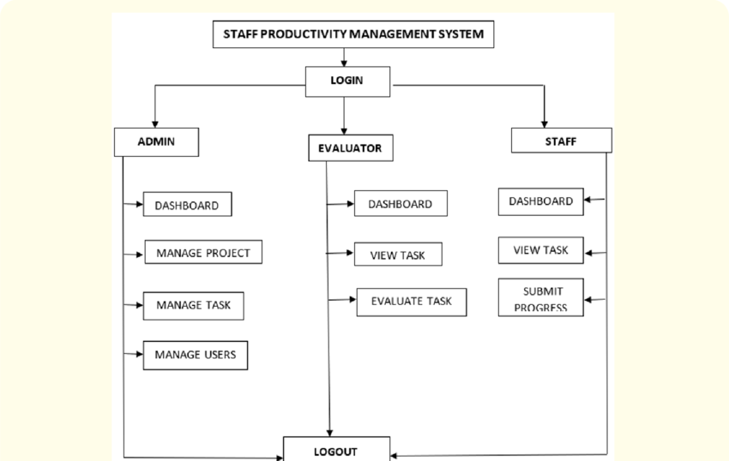
Figure: Staff Productivity Management System
Source: (Inyan et al., 2023)

2.3 Managers encourage employees with a positive work environment to enhance their productivity.
According to the author (Basalamah, 2021), the managers in the food and beverage sector work in favor of employee wellbeing. Motivating employees with their best effort in every task while cultivating a better workplace with positive workplace management. (Kamarudin et al., 2023), stated that some managers in the food and beverage industry try to micro-manage their teams failing to effectively communicate and reducing their productivity level. The author (Abbas et al., 2022), in this context, argued that it depends on the company who is liable to look after their management. The role of the company needs to be highlighted during recruitment as setting clear guidance and expectations for its employees.

2.4 Different Managerial Approaches by the managers in enhancing team productivity.
According to the authors (Belyaeva, Rudawska and Lopatkova, 2020), the managers in the food and beverage industry such as in Graze, majorly face the challenges of shifting customer preferences, complicated regulations imposed after Brexit and problems with safety and quality can also indirectly impact employee productivity. However, (Sharma, Srivastava and Fatima, 2023), the managers operating in small and medium companies like Graze, need to focus on imposing policies related to constant reporting and daily work schedules need to be defined correctly. The pervasive presence of e-commerce (sustainability, transparency and waste reduction) which is a major challenge for the F&B industry and needs a detailed understanding by the employees to strengthen their productivity. However, the authors (Adhvaryu, Kala and Nyshadham, 2022), reflects upon suggesting the management allocating tasks, who have expertise in the niche field such as menu planning should be handed over to employees who have a good knowledge of food and beverages. The inventory management employee knows the usage of data analytics to arrange the products. The employees need to enjoy their tasks so that it does not lead them to burnout.
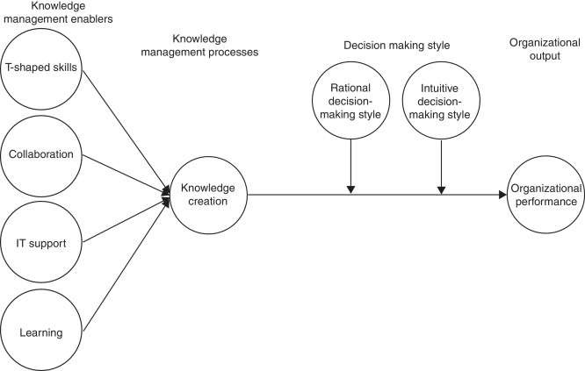
Figure: Different Managerial Approaches by the managers in enhancing team productivity.
Source: (Abubakar et al., 2019)

2.5 The Human Relation Theory of the management in improving productivity a the workplace as a strategy.
According to the author (Fasano and Rocca, 2024), the theory experiments to design and improve workplace productivity as the foundation of improving human relationships. The current changing work scenarios where the employees met with challenges in enhancing their productivity. The role of the managers highlighted here with the managers needs to pay attention to the employee's grievances and make them feel valued and productive. While indicating the role of the managers the theory is the amalgamation of giving more attention to every employee in the industry (F&B) or company (Braze) working as a part of a group or incentivise them by paying holidays or money to improve their working conditions.
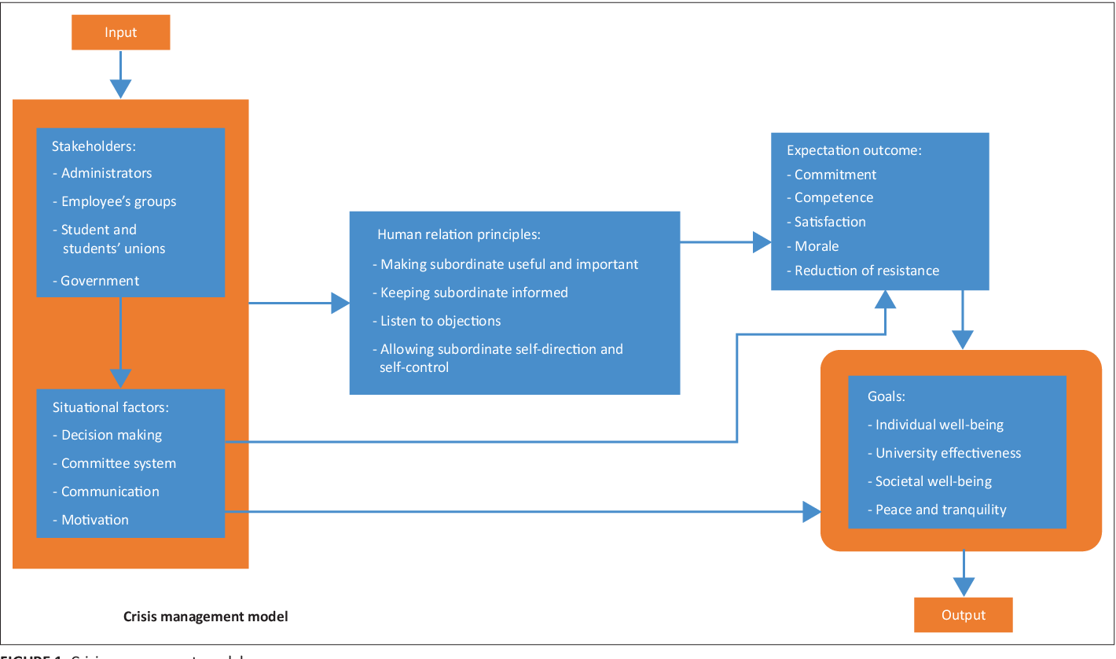
Figure: Human Relation Theory of Management
Source: (Omodan, Tsotetsi and Dube, 2020)

2.6 The Conceptual Framework.
The conceptual framework is the interconnected components and factors that are used in solving the challenges that exist in the real world while highlighting their causes and effects.

Managerial Approach
Employee Achievements
Creating Positive Work Environment
Encourage collaborations and teamwork.
Productivity Management
Supports in setting employees celar expectations from the company.
The role of Management in enhancing employee productivity
Table 1: The Conceptual Framework
Source: (Self-Made)

2.7 The Literature Gap.
This part of the study discussed and critically evaluated the role of managers motivating employees to increase productivity at work in an organization while highlighting the Food and Beverage industry in the UK. The chapter lacked an in-depth analysis of how to give priority to the technologies used by the management in the food and beverage industry in employee productivity management such as the usage of Slack, Microsoft Team Toggle and TimeBoy that enhance employees' communication and collaboration and the last two applications used in time tracking in task completion.

2.8 Summary.
The study has reflected on a different managerial approach to enhancing employee productivity by setting a positive work environment, emphasizing productivity management and the Human Relation theory reflects on prioritizing the employee's grievances and making them feel valued and productive. It also pinpoints different arguments regarding organizational roles, managerial challenges in the F&B industry and managers' inability to micromanage.

Methodology
This study employs a proper primary quantitative methodology by the process of utilizing survey questionnaires to collect data from the different employees at Graze. This method allows for the collection of measurable facts on employee perceptions, pleasure, and productiveness, permitting statistical assessment to discover tendencies and correlations (Sutopo et al., 2021). The quantitative technique is justified as it presents a based and intentional manner to assess the effectiveness of various motivational techniques, making sure that the findings are generalizable and can tell proof-based recommendations for boosting productivity at Graze.

Philosophy
The study adopts a very positive research philosophy, which mainly emphasizes objective measurement as well as observable phenomena. Positivism is justified for this research because it aligns with the motive of quantifying the impact of managerial motivational strategies on worker productivity (Nguyen et al., 2021). By specializing in empirical records and statistical evaluation, the examine can produce reliable and replicable consequences, unfastened from researcher bias. This philosophy supports the goal assessment of manipulation practices at Graze, contributing to sturdy expertise of effective worker motivation techniques.
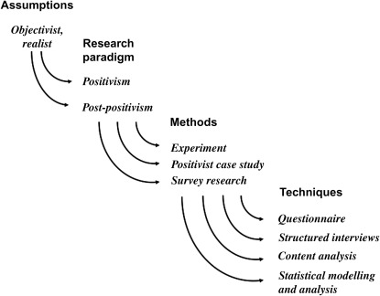
Figure: Positivism research philosophy
(Source: ScienceDirect, 2024)

Research Approach
A deductive research approach is very much utilized in this study, beginning with that of the established theories on motivation as well as productivity and the testing of these theories through empirical observation. This method is justified because it allows them to look to construct present-day knowledge, applying theoretical frameworks to the appropriate context of Graze (Paais et al., 2021). By formulating hypotheses primarily based on known motivational theories and then trying out the hypotheses through quantitative information series, the deductive technique guarantees a scientific and logical improvement from idea to exercise, improving the validity and reliability of the research findings.

Data Collection Method
The primary survey method is mainly chosen for data collection in this study to properly obtain some of the direct feedback from personnel at Graze regarding their stories and perceptions of managerial motivational strategies (Kalogiannidis et al., 2021). This approach is justified because it allows for the collection of standardized data from many respondents, facilitating the quantitative evaluation of tendencies and patterns. Surveys are green and cost-effective, allowing the researcher to accumulate information on employee motivation and productivity in a biased manner, making sure that the outcomes are dependable and representative.

Data Analysis
Descriptive data analysis is very much employed to properly analyze the survey responses from that of the different participants. This technique is justified because it offers a clean and concise summary of the information, highlighting key trends, averages, and patterns related to worker motivation and productivity (Rivaldo et al., 2021). By using descriptive analysis, the observer can effectively interpret the quantitative statistics, making it much less complex to discover the effect of diverse motivational techniques utilized by managers at Graze. This technique guarantees that the findings are supplied in a comprehensible layout, facilitating practical guidelines.

Sampling Technique
Simple random sampling is now properly selected for this study to ensure that every employee at Graze has a very much equal chance of being included in the actual sample. This approach is justified because it minimizes choice bias and enhances the representativeness of the sample, making the findings more generalizable to the complete personnel (Sugiart et al., 2021). Selecting a sample of 30 employees is potential and lets in sufficient records to behave with extensive statistical analysis. Using smooth random sampling, the examine ensures that the records collected present a wide variety of worker reviews and perspectives, contributing to the reliability and validity of the research results.

Ethical Behavior inside the Research Activity
Ethical considerations are very much paramount in this research to properly ensure integrity as well as respect for all participants involved. T. The take look at will adhere to moral guidelines by acquiring knowledgeable consent from all survey individuals, ensuring they're fully aware of the study's reason, techniques, and their proper to withdraw at any time without penalty. Confidentiality and anonymity of the respondents can be strictly maintained to defend their privacy and personal information.

Validity and Reliability
To ensure the validity as well as the reliability of the research, the study will mainly employ established survey contraptions and confirmed questions relevant to worker motivation and productivity (Hoffman et al., 2021). Validity is probably addressed with the aid of designing the survey to appropriately degree the constructs of interest, making sure that the questions are clear, relevant, and entire. Reliability will be ensured through accomplishing a pilot check of the survey with a small subset of employees to select out and rectify any inconsistencies or ambiguities.

3.0 References

- Abubakar, A.M., Elrehail, H., Alatailat, M.A. and Elçi, A., 2019. Knowledge management, decision-making style and organizational performance. Journal of Innovation & Knowledge, 4(2), pp.104-114.
- Adhvaryu, A., Kala, N. and Nyshadham, A., 2022. Management and shocks to worker productivity. Journal of Political Economy, 130(1), pp.1-47.
- Afrahi, B., Blenkinsopp, J., de Arroyabe, J.C.F. and Karim, M.S., 2022. Work disengagement: A review of the literature. Human Resource Management Review, 32(2), p.100822.
- Ali, B.J. and Anwar, G., 2021. An empirical study of employees' motivation and its influence on job satisfaction. Ali, BJ, & Anwar, G.(2021). An Empirical Study of Employees' Motivation and its Influence on Job Satisfaction. International Journal of Engineering, Business and Management, 5(2), pp.21-30.
- Andreas, D., 2022. Employee performance: The effect of motivation and job satisfaction. PRODUKTIF: Journal Keewatin dan Organizes, 1(1), pp.28-35.
- Basal amah, S.A., 2021. The role of work motivation and work environment in improving job satisfaction. Golden Ratio of Human Resource Management, 1(2), pp.94-103.
- Basalamah, S.A., 2021. The role of work motivation and work environment in improving job satisfaction. Golden Ratio of Human Resource Management, 1(2), pp.94-103.
- Belyaeva, Z., Rudawska, E.D. and Lopatkova, Y., 2020. Sustainable business model in food and beverage industry–a case of Western and Central and Eastern European countries. British Food Journal, 122(5), pp.1573-1592.
- Chanana, N. and Sangeeta, 2021. Employee engagement practices during COVID‐19 lockdown. Journal of public affairs, 21(4), p.e2508.
- Fasano, F. and La Rocca, T., 2024. Does the bank-firm human relationship still matter for SMEs? The game-changing role of digitalization. Small Business Economics, 62(1), pp.159-178.
- Ibis, E.Y., Wahyudi, W., Thoi, A., Ilham, R.N. and Sinta, I., 2022. The effect of career development and work environment on employee performance with work motivation as an intervening variable at the office of agriculture and livestock in Aceh. International Journal of Economic, Business, Accounting, Agriculture Management and Sharia Administration (IJEBAS), 2(2), pp.227-236.
- Kalogiannis’s, S., 2021. Impact of employee motivation on organizational performance. A scoping review paper for the public sector. The Strategic Journal of Business & Change Management, 8 (3), 984, 996(3).
- Kamarudin, N., Nizam, N.Z., Mat Sani, A. and Khodri Harahap, A.Z.M., 2023. The Impact of Micromanage Issue Among Manufacturing Industry: Employees Perception and Job Satisfaction. International Journal of Industrial Engineering & Production Research, 34(2), pp.1-14.
- Liang, M., Xin, Z., Yan, D.X. and Jianxiong, F., 2020. How to improve employee satisfaction and efficiency through different enterprise social media use. Journal of Enterprise Information Management, 34(3), pp.922-947.
- Mariah, N., Nyoman, N. and Martini, P., 2022. The Influence of Leadership Style, Work Incentives and Work Motivation on the Employees Performance of Regional Revenue Agency. Journal of Economics, Finance and Management Studies, 5(07), pp.1942-1954.
- Nguyen, P.T., Yandi, A. and Mahapatra, M.R., 2020. Factors that influence employee performance: motivation, leadership, environment, culture organization, work achievement, competence and compensation (A study of human resource management literature studies). Dinasti International Journal of Digital Business Management, 1(4), pp.645-662.
- Omodan, B.I., Tsotetsi, C.T. and Dube, B., 2020. Analysis of human relations theory of management: A quest to re-enact people’s management towards peace in the university system. SA Journal of Human Resource Management, 18, p.10.
- Pais, M. and Patibulum, J.R., 2020. Effect of motivation, leadership, and organizational culture on satisfaction and employee performance. The Journal of Asian Finance, Economics and Business, 7(8), pp.577-588.
- Positivist Paradigms (no date) Positivist Paradigms - an overview | ScienceDirect Topics. Available at: https://www.sciencedirect.com/topics/social-sciences/positivist-paradigms (Accessed: 14 June 2024).
- Rivaldo, Y., 2021. Leadership and motivation to performance through job satisfaction of hotel employees at Merlion Batam. The Winners, 22(1), pp.25-30
- Riyanto, S., Endri, E. and Ferlisha, N., 2021. Effect of work motivation and job satisfaction on employee performance: Mediating role of employee engagement. Problems and Perspectives in Management, 19(3), p.162.
- Salas‐Vallina, A., Alegre, J. and López‐Cabrales, Á., 2021. The challenge of increasing employees' well‐being and performance: How human resource management practices and engaging leadership work together toward reaching this goal. Human Resource Management, 60(3), pp.333-347.
- Setiadi, M.T., Sofi’i, I., Wahyudi, W. and Haryadi, D., 2023. Dynamic capability of servant leadership as a triggering factor for organizational commitment and employee performance. International Journal of Applied Finance and Business Studies, 11(2), pp.246-254.
- Sharma, R., Srivastva, S. and Fatima, S., 2023. E-Commerce and Digital Transformation: Trends, Challenges, and Implications. International Journal for Multidisciplinary Research (IJFMR), 5(5).
- Sugianti, E., 2022. The Influence of Training, Work Environment and Career Development on Work Motivation That Have an Impact on Employee Performance at PT. Surnames Elinda Primetime in West Jakarta. International Journal of Artificial Intelligence Research, 6(1), pp.1-11.
- Sugianti, E., 2022. The Influence of Training, Work Environment and Career Development on Work Hoffman, M. and Tadley’s, S., 2021. People management skills, employee attrition, and manager rewards: An empirical analysis. Journal of Political Economy, 129(1), pp.243-285.
- Sugiarti, E., 2022. The Influence of Training, Work Environment and Career Development on Work Motivation That Have an Impact on Employee Performance at PT. Suryamas Elsindo Primatama In West Jakarta. International Journal of Artificial Intelligence Research, 6(1), pp.1-11.
- Sutopo, Y.B., Sintija, K.A. and Maropeng, F.K., 2021. The influence of motivation, work discipline, and compensation on employee performance. Golden Ratio of Human Resource Management, 1(2), pp.72-83.
- Wartinah, S., Sudarso, P., Umami, R., Sabzali, M., Lestari, B., Rosalina, R. and Jermsittiparsert, K., 2020. Retracted: Teacher’s performance management: The role of principal’s leadership, work environment and motivation in Tegal City, Indonesia. Management Science Letters, 10(1), pp.235-246.

Appendix
Survey questionnaires
On a scale of 1 to 5, how motivated do you feel in your current role at Graze?

How often do your managers recognize and reward your efforts and achievements?

To what extent do you feel that your manager provides clear and achievable goals?

How effective are the communication channels between you and your manager?

Do you believe that your manager creates a positive work environment?

How often does your manager encourage your professional development through training and development opportunities?

How well do you understand the connection between your work and the overall goals of Graze?

Do you feel that your manager listens to and addresses your concerns and suggestions?

To what extent do you feel that your manager supports work-life balance?

How likely are you to recommend Graze as a great place to work to others?

