Commentary 3 – Photograph of Fountains Abbey from the South West
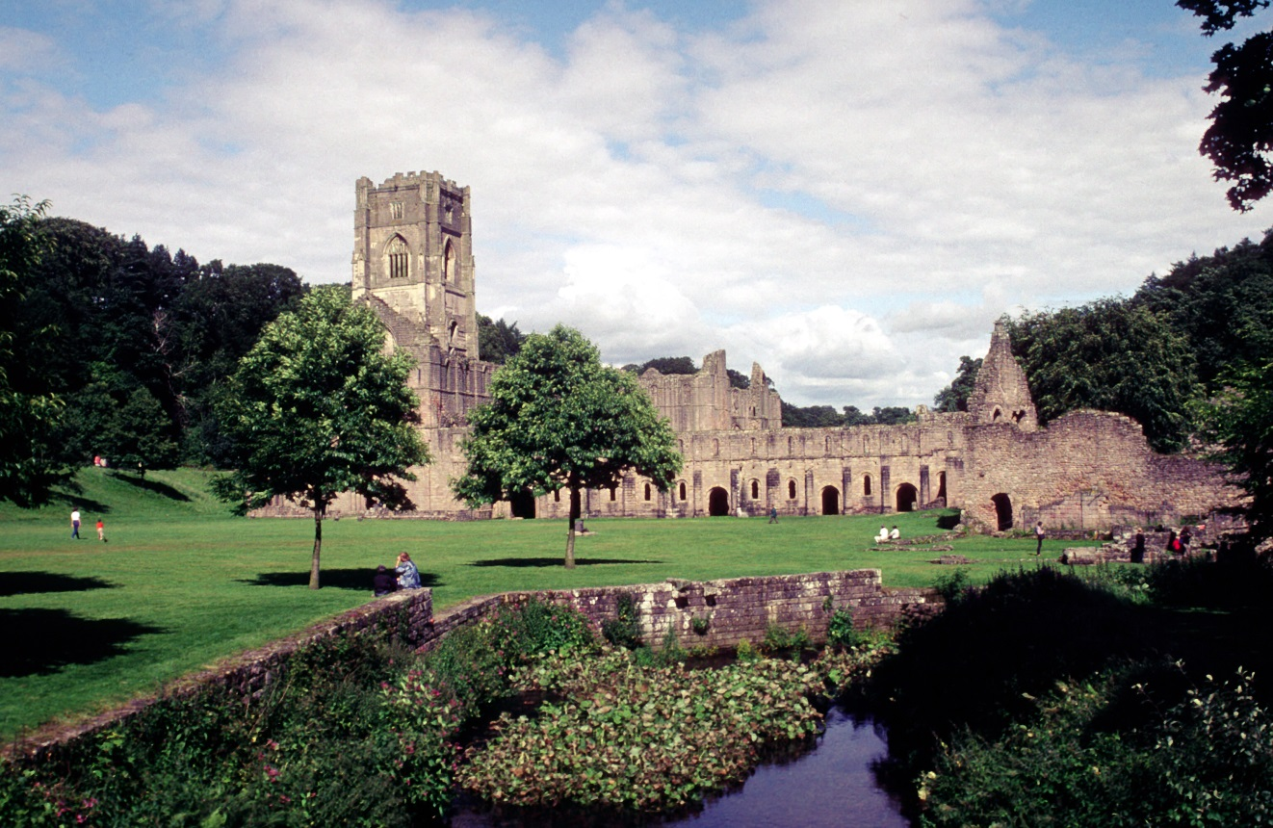
Image 1

This is a photograph of Fountains Abbey from its south western aspect. Visible in the photograph are the ruins of the abbey itself with the famous lantern tower on the left; the western range stretching across the centre; and the abbot’s house on the right. In the foreground is the River Skell and a portion of the monastery’s grounds.
There was no photographer credited with the picture, nor could I find out who actually took it
As the image was provided without provenance it is impossible to know when precisely it was taken. However, it can be inferred that it is a relatively recent photograph for a number of reasons. First: the picture is in colour and digital format, suggesting it was taken sometime after the mid-nineteen nineties when digital cameras became more publically available. Second: the ruin and its grounds appear to be similar to recent photographs used by the National Trust, who manage the site.
There are many potential reasons why the photographer may have decided to take this particular shot. On the most basic level, it was taken to capture the likeness of Fountains Abbey but this may have been for personal gratification, as part of a contract or for research purposes. It seems more likely that this is at least a semi-professional photograph as the angle and time of day are very well chosen - too well for it to have been randomly taken by a visitor.
The particular angle chosen is also interesting as it appears to be the most popular side of the monastery to photograph. A picture from a similar angle is used for the Abbey on the National Trust website and an aerial shot of the same side was chosen for the Digital Humanities Institute’s page on Fountains’ location. This trend is followed in printed sources too, as in Janet Burton and Julie Kerr’s book ‘The Cistercians in the Middle Ages’ they selected a photograph of Fountains Abbey from the west as one of their illustrative plates. The reason behind this popularity is probably because this direction captures the entire expanse of the monastery ruin with a backdrop of Yorkshire countryside.
This photograph was taken at Fountains Abbey, near Ripon in North Yorkshire.Given the angle of the photograph, it was most likely taken either from or near to a stone footbridge which crosses the river Skell; south west of the Abbey ruins and directly south of the Porter’s Lodge. The abbey itself was founded in Skelldale in the eleven thirties by a group of thirteen monks who had left Saint Mary’s York over a disagreement on how to properly lead a monastic life. Archbishop Thurstan, who had tried to intercede for the monks within their monastery, granted them land in Skelldale to establish a new abbey and the group travelled out to begin building.
The tale of the foundation of Fountains Abbey bears remarkable resemblance to the establishment of Citeaux – the original Cistercian monastery. In both cases a group of monks became dissatisfied with the way the Rule of Saint Benedict was being observed in their Benedictine monastery and thus decided to leave to found a new community. In the case of Citeaux, this original monastery was Molesme while for Fountains this was Saint Mary’s, York. Again in both instances, the monks retreat to a wilderness: for those leaving Molesme this was the ‘desert’ of Burgundy; later the area of Skelldale would be described as a ‘place of horror and vast solitude’. Elizabeth Freeman maintains that these parallels were not only intentional but also employed by Archbishop Thurstan to establish Fountains as the ‘Citeaux of the North’. This argument is very convincing, especially as the similarities between the Exordium Parvum and the Narratio de fundatione Fontanis monasterii are quite apparent upon reading them; not least in their description but also in their use of language. Both texts express how the new monasteries were founded in ‘places of horror and vast solitude’. This is a quote from the Old Testament book of Deuteronomy, chapter 32, verse 10 and appears in other Cistercian texts such as the vita prima. This descriptor not only grounds the choice of location in biblical precedent but, as R. H. C. Davis points out, reinforces the sentiment that hermits may well have chosen these sites. Burton and Kerr too noticed this creation of a link between the Cistercian and the desert fathers of monasticism. They extend the idea further by observing that this metaphor was used even in situations where the land had been well cultivated prior to monastic settlement. This association with the original monastic fathers and Saint Benedict would also likely have served the Cistercians well in legitimizing their order, especially as they began as a splinter group from the Benedictines.
The intended audience of this picture is predicated mostly upon why the photograph was taken in the first place. If it was for personal use then the audience would probably be friends and family of the photographer. However, if the photographer was contracted to take the picture for advertising the audience would then likely be potential visitors. Moreover, were the picture captured for research purposes then the audience would be those who read the final paper. As previously stated it seems likelier that this was a semi-professional photograph and thus probably intended for a wider viewing – either as promotional material or in published work.
Overall, a photographic record of an important site is always a useful resource. Most significantly, it allows for analysis and understanding of the location without having to visit in person - which can be difficult or expensive. However, the fact that this photograph has no provenance accompanying it lessens its usefulness as dating it is difficult and a photographer cannot be credited.

List of Illustrations
- Author Unknown, ‘Photograph of Fountains Abbey from the South West’, no date
Bibliography
Primary Sources
Exordium Parvum, English Translation by Order of the Cistercians of the Strict Observance, (O.C.S.O, nd). Available at: https://ocso.org/resources/foundational-text/exordium-parvum/ (accessed 10 March 2024)
Secondary Sources
Burton, J., and J. Kerr, The Cistercians in the Middle Ages (Woodbridge: The Boydell Press, 2011).
Davis, R. C. H., A History of Medieval Europe: From Constantine to Saint Louis, 2nd edn. (London: Longman, 1988)
Freeman, E., Narratives of a New Order : Cistercian Historical Writing in England, 1150-1220 (Turnhout: Brepols, 2002)

Wood, E. S., Collins Field Guide to Archaeology in Britain, 5th edn. (Glasgow: Collins, 1979)

Webliography
Burton, J., ‘Who were the Cistercians?’, [online]. Available: https://www.monasticwales.org/showarticle.php?func=showarticle&articleID=3 (accessed 10 March 2024)
Digitalkamera Museum, ‘History of the Digital Camera and Digital Imaging’, [online]. Available: https://www.digitalkameramuseum.de/en/history (accessed 10 March 2024)
Digital Humanities Institute, ‘The Abbot’s House’, [online]. Available: https://www.dhi.ac.uk/cistercians/fountains/buildings/abbots_house/ (accessed 10 March 2024)
Digital Humanities Institute, ‘The Crossing’, [online]. Available: https://www.dhi.ac.uk/cistercians/fountains/buildings/church/church11.php (accessed 10 March 2024)
Digital Humanities Institute, ‘Fountains Abbey: Location’, [online]. Available: https://www.dhi.ac.uk/cistercians/fountains/location/ (accessed 10 March 2024)
Digital Humanities Institute, ‘The Narratio de fundatione Fontanis monasterii’, [online]. Available: https://www.dhi.ac.uk/cistercians/fountains/history/sources/narratio.php (accessed 10 March 2024)
Digital Humanities Institute, ‘The New Community: Hardships at Skelldale’, [online]. Available: https://www.dhi.ac.uk/cistercians/fountains/history/origins/origins5.php (accessed March 10 2024)
Digital Humanities Institute, ‘Origins’, [online]. Available: https://www.dhi.ac.uk/cistercians/fountains/history/origins/index.php (accessed 10 March 2024)
Digital Humanities Institute, ‘The Western Range’, [online]. Available: https://www.dhi.ac.uk/cistercians/fountains/buildings/range/ (accessed 10 March 2024)
Google Maps, ‘Fountains Abbey’, [online]. Available: https://www.google.com/maps/place/Fountains+Abbey/@54.1090874,-1.5842311,229m/data=!3m1!1e3!4m6!3m5!1s0x487eab777f03be83:0x480de744382d3127!8m2!3d54.109512!4d-1.58186!16zL20vMGgxMGQ?entry=ttu (accessed 10 March 2024)
The National Trust, ‘Fountains Abbey and Studley Royal Water Garden’, [online]. Available: https://www.nationaltrust.org.uk/visit/yorkshire/fountains-abbey-and-studley-royal-water-garden (accessed 10th March 2024)

Image 1
Digital Humanities Institute, ‘The Crossing’, [online]. Available: https://www.dhi.ac.uk/cistercians/fountains/buildings/church/church11.php
Digital Humanities Institute, ‘The Western Range’, [online]. Available: https://www.dhi.ac.uk/cistercians/fountains/buildings/range/
Digital Humanities Institute, ‘The Abbot’s House’, [online]. Available: https://www.dhi.ac.uk/cistercians/fountains/buildings/abbots_house/
Digital Humanities Institute, ‘Fountains Abbey: Location’, [online]. Available: https://www.dhi.ac.uk/cistercians/fountains/location/
Digitalkamera Museum, ‘History of the Digital Camera and Digital Imaging’, [online]. Available: https://www.digitalkameramuseum.de/en/history
The National Trust, ‘Fountains Abbey and Studley Royal Water Garden’, [online]. Available: https://www.nationaltrust.org.uk/visit/yorkshire/fountains-abbey-and-studley-royal-water-garden
The National Trust, ‘Fountains Abbey and Studley Royal Water Garden’
Digital Humanities Institute, ‘Fountains Abbey: Location’
J. Burton, and J. Kerr, The Cistercians in the Middle Ages (Woodbridge: The Boydell Press, 2011). Plate 2, p. 126
The National Trust, ‘Fountains Abbey and Studley Royal Water Garden’
Google Maps, ‘Fountains Abbey’, [online]. Available: https://www.google.com/maps/place/Fountains+Abbey/@54.1090874,-1.5842311,229m/data=!3m1!1e3!4m6!3m5!1s0x487eab777f03be83:0x480de744382d3127!8m2!3d54.109512!4d-1.58186!16zL20vMGgxMGQ?entry=ttu
Digital Humanities Institute, ‘Origins’, [online]. Available: https://www.dhi.ac.uk/cistercians/fountains/history/origins/index.php
Digital Humanities Institute, ‘The New Community: Hardships at Skelldale’, [online]. Available: https://www.dhi.ac.uk/cistercians/fountains/history/origins/origins5.php
Digital Humanities Institute, ‘Origins’
Digital Humanities Institute, ‘Origins’
R. C. H. Davis, A History of Medieval Europe: From Constantine to Saint Louis, 2nd edn. (London: Longman, 1988), p. 257
Burton, and Kerr, The Cistercians in the Middle Ages p. 58
E. Freeman, Narratives of a New Order : Cistercian Historical Writing in England, 1150-1220 (Turnhout: Brepols, 2002) , p. 155
Exordium Parvum, English Translation by Order of the Cistercians of the Strict Observance, (O.C.S.O, nd). Available at: https://ocso.org/resources/foundational-text/exordium-parvum/
Digital Humanities Institute, ‘The Narratio de fundatione Fontanis monasterii’, [online]. Available: https://www.dhi.ac.uk/cistercians/fountains/history/sources/narratio.php
Burton, and Kerr, The Cistercians in the Middle Ages pp. 15-16
Burton, and Kerr, The Cistercians in the Middle Ages p. 16
Davis, A History of Medieval Europe p. 260
Burton, and Kerr, The Cistercians in the Middle Ages p. 58

