
Data Handling and Business Intelligence
Student name: Ivan Hristov Stoyanov (ID:2111872)
MODULE ID: LCBB5000

Hotel Reservation Average Price Analysis
Introduction
The objective of the analysis and visualization conducted is to determine the decline or increase in average price (room reservation price) over the year ranging from 2017 to 2021 while evaluating the use of Microsoft Excel for pre-processing, analyzing and visualizing data.
Data Description and Pre-processing
The Hotel Reservation dataset dimensions as shown on the table below was obtained using excel functions =ROWS('Hotel Reservation'!A1:S36276) and =COLUMNS('Hotel Reservation'!E1:S36276)
Rows | Columns
36276 | 15

There were no missing values on the data; I then filtered the Arival_year variable in the data and only include reservations from 2017 to 2021 as per the analysis requirements (Tamboli, 2021).
Analysis
In the analysis, I first added a new sheet called Analysis where I placed my results and observations. For starter, I determined the number of bookings that occurred in every year from 2017 to 2021 using the COUNTIF function in excel. The function implementation was =COUNTIF('Hotel Reservation'!$J$2:$J$36276,Analysis!D5) where 'Hotel Reservation'!$J$2:$J$36276 is the range of cells containing the arrival year values and Analysis!D5 is the criteria the function is checking and equating to the value in cell D5 in this case the cell D5 held the value 2017. The $ sign I used before the rows and column number is used to lock the value of the range meaning it will not change when counting the number of bookings of proceeding years.
YEAR | Number of Bookings
2017 | 6100
2018 | 28038
2019 | 177
2020 | 198
2021 | 192
TOTALS | 34705

As shown on the table above there was a significant increase in the number of bookings from 2017 to 2018 that was followed by a sharp decrease in the number of bookings from 2018 to 2019. 2020 and 2021 are fairly the same indicating the effects of the sharp decline on the number of bookings were still in play.
Next, I investigated the total revenues from 2017 to 2021 using an excel function SUMIF(). The function is implemented as =SUMIF('Hotel Reservation'!$J$2:$J$36276,Analysis!G5,'Hotel Reservation'!$Q$2:$Q$36276 where 'Hotel Reservation'!$J$2:$J$36276" is the range of cells in the Hotel Reservation dataset that containing the Arrival_year variable while "Analysis!G5" being the cell on the Analysis sheet where the year is specified to calculate the total revenue. Lastly, "'Hotel Reservation'!$Q$2:$Q$36276" is the range used to calculate the actual revenue totals.
The SUMIF() function basically checks from the Arrival_year variable the specified year as in this case 2017, then sums all the corresponding values from the Average_price variable hence resulting to the total revenue of that particular year.
As seen on the table below there was a great increase in revenue from the year 2017 to 2018 which could have resulted from increased demand as seen by the corresponding number of bookings during the same time or expansion of the hotel or even another positive factor that boosted the revenue at that time (Finau et al.,2015).
YEAR | Total Revenue per Year
2017 | 549304.1
2018 | 2984722
2019 | 18015.29
2020 | 20857.3
2021 | 19436.8
TOTALS | 3592335

Nevertheless, this does not continue, as there was a steep dropping of the total revenue by the year 2019, possibly due to natural disasters, an economic emergency where the hotel is located or due to the infamous pandemic that struck around that time covid 19 forcing hotels to close.
The hotel then experienced a minor increase during the year 2020 that was followed by a slight decrease in the subsequent year 2021 that can be credited to normal business practice during that time as the effects that struck at 2019 were still in effect.
Similarly, as shown on the line graph below shows the trend of the hotel’s total revenue from the year 2017 to 2021. Justifying the earlier analysis the line graph shows a sharp decline of the total revenue from 2018 to 2019 indicating a possible event that affected the hotels operation between those years. This was after a steep increase of revenue from the year 2017 to 2018. Finally, the preceding years after 2019 the line graph has a relatively stable trend showing hotels operations followed a new normal.

Finally, after determining the factors that would affects the increase or decrease of the average price over the years 2017 to 2021, I concluded to the investigating behavior of the total average price of a particular year using the AVERAGEIF excel function.
From the formula =AVERAGEIF('Hotel Reservation'!$J$2:$J$36276,A5,'Hotel Reservation'!$Q$2:$Q$36276) I used the arrival year variable as the range represented as 'Hotel Reservation'!$J$2:$J$36276. A5 represents the criteria that is the year 2017 representing the condition to be satisfied from the range values. To finish the average price variable is the average_range in the formula represented by 'Hotel Reservation'!$Q$2:$Q$36276 hence the cells that were averaged to obtain the total average of a specific year after the condition used in the criteria is satisfied, like to compute the total average price of the year 2017 reservations in this particular case. I later used a line graph to visualize my findings (Finau et al.,2015).
The table below shows the results after computing the total average of particular years from 2017 to 2021.
YEAR | T_Average price
2017 | 90.04985
2018 | 106.4527
2019 | 101.7813
2020 | 105.3399
2021 | 101.2333

From the results above, 2017 had the lowest total average that was 90.05 followed by a significant increase to 106.45 in 2018 which is the highest total average price recorded among the years. This was a result of the increased number of bookings in 2018 as observed earlier on the number of bookings per year analysis that was due to increased demand for hotel reservations or the hotel had promotional offers during that time. That caused the increased total average room reservation price as the hotel may have been pushed to increase prices to satisfy the high demand.
In the year 2019, the total average price reduced slightly to 101.78 that is still higher than the first year 2017. That could be because of increased competition or other economic factors leading the hotel to reduce prices to attract more customers, as seen earlier in 2019 recorded a sharp decrease in total number of reservations booking.
The following year 2020, the total average price increased to 105.34 that could have been because of the covid 19 pandemic attributed to travel restrictions that lifted in some regions or the hotel developed flexible options the customers resulting to some increase in demand. However, the increased demand was not sufficient to significantly influence the total average room reservation price.
In 2021, the total average price decreased to 101.23 that is very close to the total average price in 2019 that could be a result of prolonged covid 19 effects.
I used the pivot chart below to visualize the trend of the total average price from 2017 to 2021.

The graph shows a low point in 2017 with gradual increase to a peak in 2018, followed by a slight decrease in 2019. Then, there is a small increase in 2020 followed by a decrease to 2021.
The graph shows a steep upward trend in the total average room reservation price from 2017 to 2018, which could be attributed to increased demand and limited supply of hotel rooms. The slight decrease in 2019 and 2021 may reflect changes in demand due to external factors such as economic conditions. Additionally, the slight increase in 2020 may reflect the impact of the COVID-19 pandemic on the travel industry, as hotels may have had to adjust their pricing strategies to attract customers in a challenging environment.
Based on the analysis of the total average price I would recommend the hotel to conduct market analysis for identifying the factors that influence customer demand and adjust pricing strategies effectively. I would also recommend the hotel to improve on customer experience to increase total number of reservations hence increasing the total average price in the long run.
Furthermore, I would recommend the hotel to invest in advance data analytics to gain more insights on the average room reservation prices in order to make decisions that are more informed.
Finally, Microsoft Excel was used on the analysis as the main tool. Excel offers several built-in functions and formulas that make it easy to clean and preprocess data as in the case the AVERAGEIF function is used to calculate the total average price of room reservations over the years 2017 to 2021. Additionally, Excel provides several tools for data analysis, including pivot charts, and graphs tools that were used to extract insights from the Hotel Reservation datasets and identify patterns and trends.
Nonetheless, excel has some limitations such as the visualizations are somewhat limited as it is not possible to create more compound visualizations for the analysis such as heatmaps.
During the analysis using Microsoft Excel, I resolved that it could be a useful tool for pre-processing and analyzing data nonetheless more advanced data analytics tools such as R or Python can offer greater flexibility and allow analyses that are more complex. Therefore, I would recommend that the hotel invest in advanced data analytics tools and expertise to gain deeper insights (Simplilearn, 2021).
Student Score Analysis
Introduction
On this report, is the analysis of the Student_score dataset using SPSS statistic software with the aim of determining the relationship of both students who qualified and those who failed to qualify for reduced/free lunch and the student’s gender, pre-test and post-test scores. All this will be done while trying to answer the follow up questions provided.
Descriptive Statistics
As a standard procedure, I first checked for any missing values in the dataset; whereby I transposed the results in excel to the table shown below. There were no missing values in the data set, so I proceeded with the analysis (Roy, 2020).
 | Valid | Missing
School | 2133 | 0
School_setting | 2133 | 0
School_type | 2133 | 0
Classroom | 2133 | 0
Teaching_method | 2133 | 0
Student_No | 2133 | 0
Student_ID | 2133 | 0
Gender | 2133 | 0
Lunch | 2133 | 0
Pretest | 2133 | 0
Posttest | 2133 | 0

Gender
 |  | Frequency | Percent | Valid Percent | Cumulative Percent
Valid | Female | 1056 | 49.5 | 49.5 | 49.5
Valid | Male | 1077 | 50.5 | 50.5 | 100.0
Valid | Total | 2133 | 100.0 | 100.0
As shown in the Gender table above, the school takes 1056 female students (49.5% of the entire student populace) and 1077 masculine learners (50.5% of the overall student demographic). As of the dataset, the school consist of more male students equaled to the female students.
Next, I looked at the number of students that qualify and those who do not qualify for reduced/free lunch.
Lunch
 |  | Frequency | Percent | Valid Percent | Cumulative Percent
Valid | Does not qualify | 1215 | 57.0 | 57.0 | 57.0
Valid | Qualifies for reduced/free lunch | 918 | 43.0 | 43.0 | 100.0
Valid | Total | 2133 | 100.0 | 100.0

57% of the student population does not qualify for the reduced/free lunch whereas the remaining 43% who amount to 918 students qualified. This indicates that although most students do not qualify for the reduced/free lunch almost half the population qualify for reduced/free lunch that could mean they are at a disadvantaged social-economic position that could potentially affect their scores as per the analysis aim to find if there exist a relationship (Oh et al., 2014).
I then investigated the mean and median of students who qualified and those who did not qualify for the reduced/free lunch. As this could not be achieved directly because lunch is a string variable, I decided to calculate the mean and median of pre-test and post-test scores for students who qualify and those who don’t qualify for free lunch.
Report
Lunch |  | Pretest | Posttest
Does not qualify | Mean | 62.29 | 74.38
Does not qualify | N | 1215 | 1215
Does not qualify | Std. Deviation | 10.780 | 11.302
Does not qualify | Median | 62.00 | 74.00
Qualifies for reduced/free lunch | Mean | 45.25 | 57.48
Qualifies for reduced/free lunch | N | 918 | 918
Qualifies for reduced/free lunch | Std. Deviation | 10.400 | 11.085
Qualifies for reduced/free lunch | Median | 44.00 | 55.00
Total | Mean | 54.96 | 67.10
Total | N | 2133 | 2133
Total | Std. Deviation | 13.563 | 13.987
Total | Median | 56.00 | 68.00
The report above shows the mean of pre-test and post-test scores as per the lunch variable. It is clear that the students, who do not qualify for reduced/free lunch having a mean pre-test score of 62.29 and a mean for post-test score of 74.38, attain higher scores compared to the students who qualify reduced/free lunch as they have a mean for pre-test score of 45.25 and a mean post-test score of 57.48. The total mean for pre-test 54.96 and for post-test is 67.10. The median also follows the same pattern for both pre-test and post-test scores.
Finally, the results for both mean and median shows a substantial dissimilarity in pre-test and post-test scores between students that qualify and those who don’t qualify for reduced/free lunch, displaying how the students who did not qualify for reduced/free lunch are at an advantageous position matched to those who qualify for the reduced/free lunch. This possibly will indicate as earlier that students who qualify for reduced/free lunch originate from a humble social-economic background hence the school can use this result and empower those students more by providing additional support to improve their academic performance.
However, the report did not provide the mean and median differences of students’ pre-test and post-test score. In order to compute this I created a new variable in Spss called Differences which has the values of the difference between pre-test and post-test scores of every student, later I computed the mean and median difference from this variable.
Statistics
Difference
N | Valid | 2133
N | Missing | 0
Mean |  | 12.1463
Median |  | 12.0000
The difference table above shows the median difference is 12.0 and mean the difference is 12.1. Student scores improved by around 12 marks between the pre-test and post-test scores according to the results of the mean difference. Furthermore the difference mean shows that half of the students had a dissimilarity of 12 marks from the pre-test to post-test scores. Students generally improved their pre-test scores averagely by 12 points on the post-test. However, my analysis does not take into consideration individual changes of performance, as some students may have improved more while others may not have improved at all.
I then conducted clustering using the Student_score.csv dataset in spss, I opted to do a K-Means cluster analysis, but in spss in order to conduct the K-Means clustering, I started with the hierarchical cluster analysis in order to obtain the optimum number of clusters to use in the K-Means cluster analysis. I used the pre-test and post-test variables (Yıldırım, 2020).
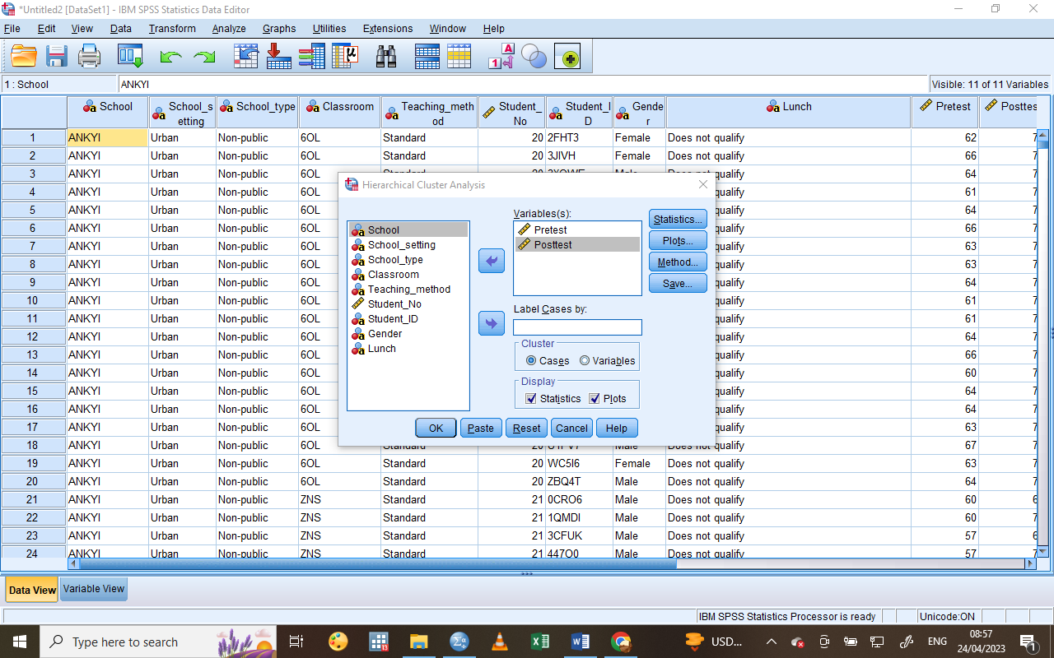
Under plots, I used dendrogram plot to help me in deciding the number of clusters the dataset has.
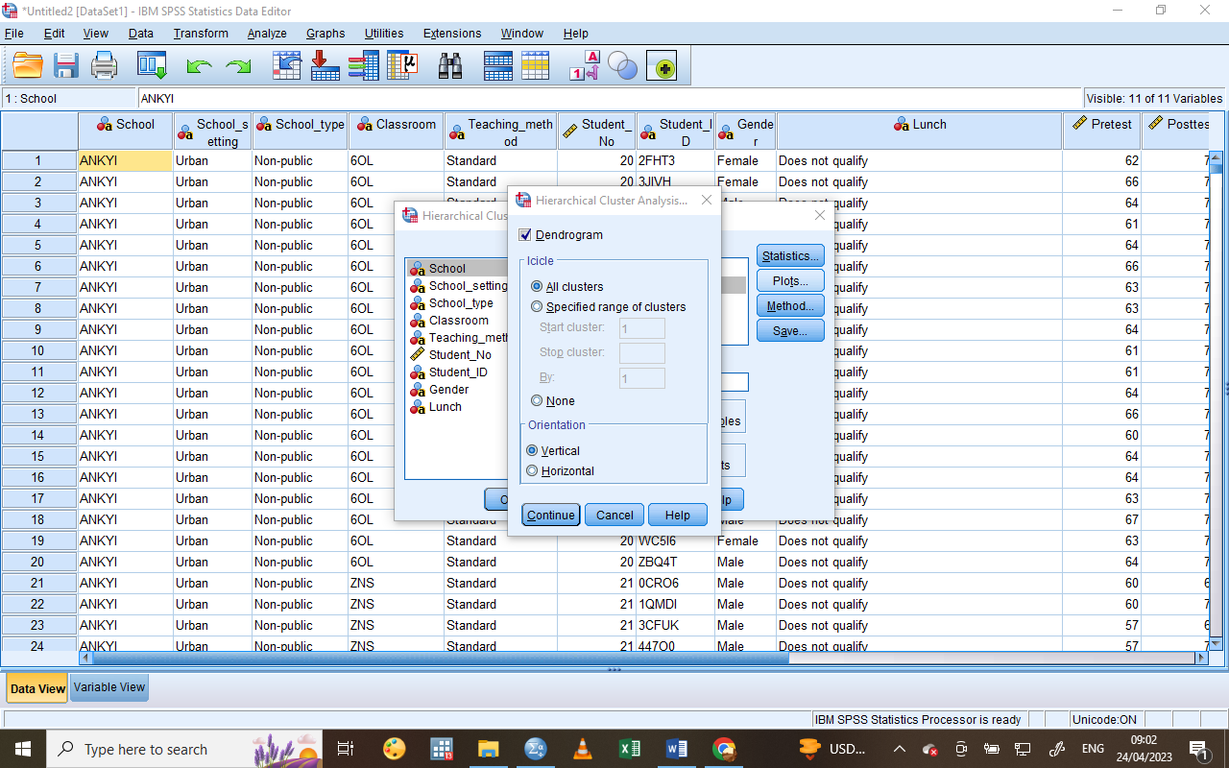
All the branches in the dendrogram denotes a connection and the closer a branch is to another the more homogeneous they are. So we move to the right the clusters are more heterogeneous so using the hypothetical line I added we can see that there are 3 main clusters. 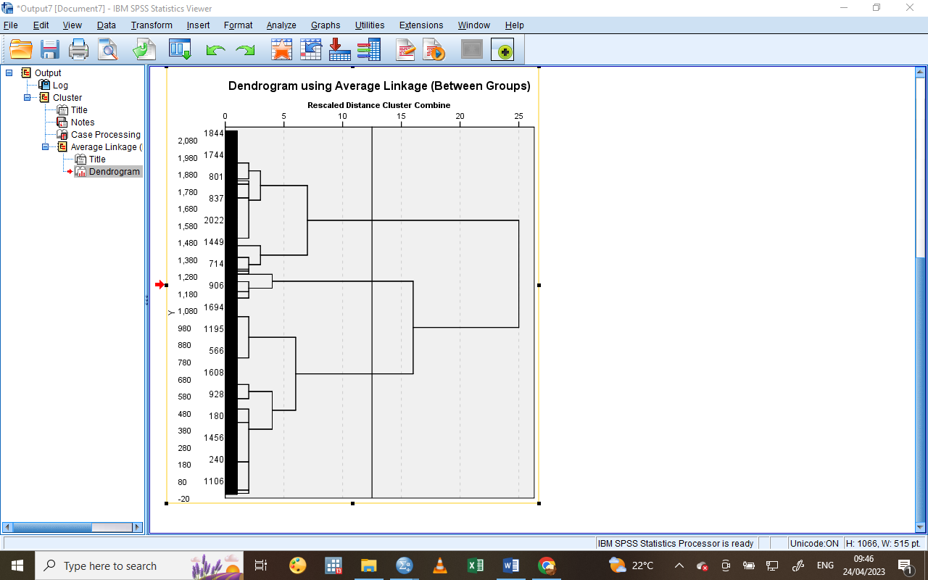
Next, on the analyze tab, I chose classify then K-Means cluster analysis using the same variables, I then specified maximum iteration to 99 and number of clusters to 3 as I had concluded earlier.
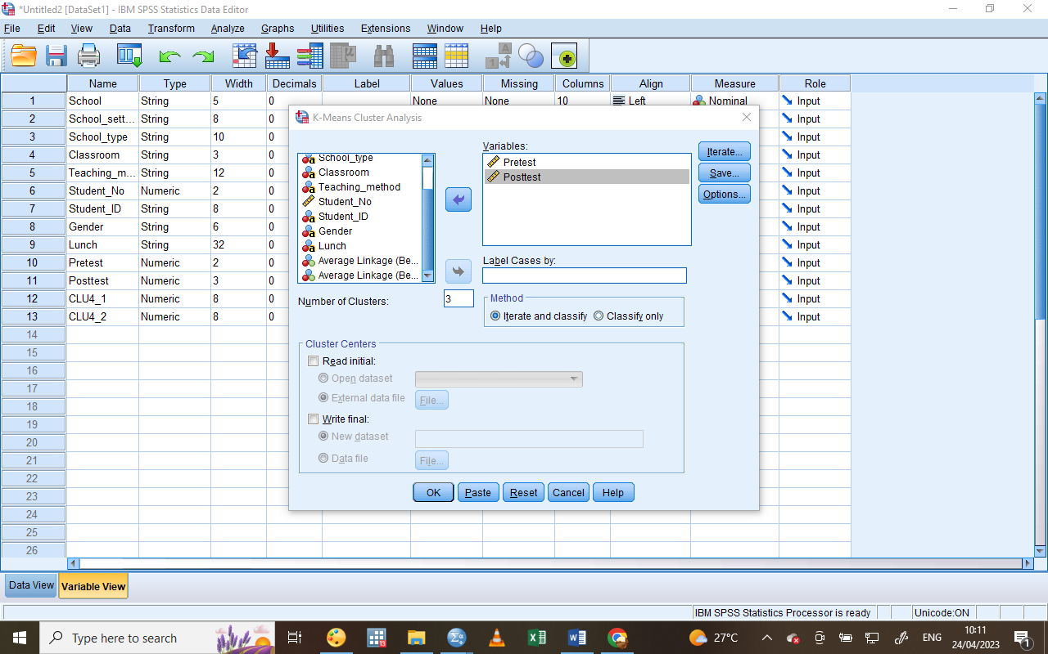
Under options, I also selected anova to help in identifying whether the variables I selected actually help to discriminate across different clusters.
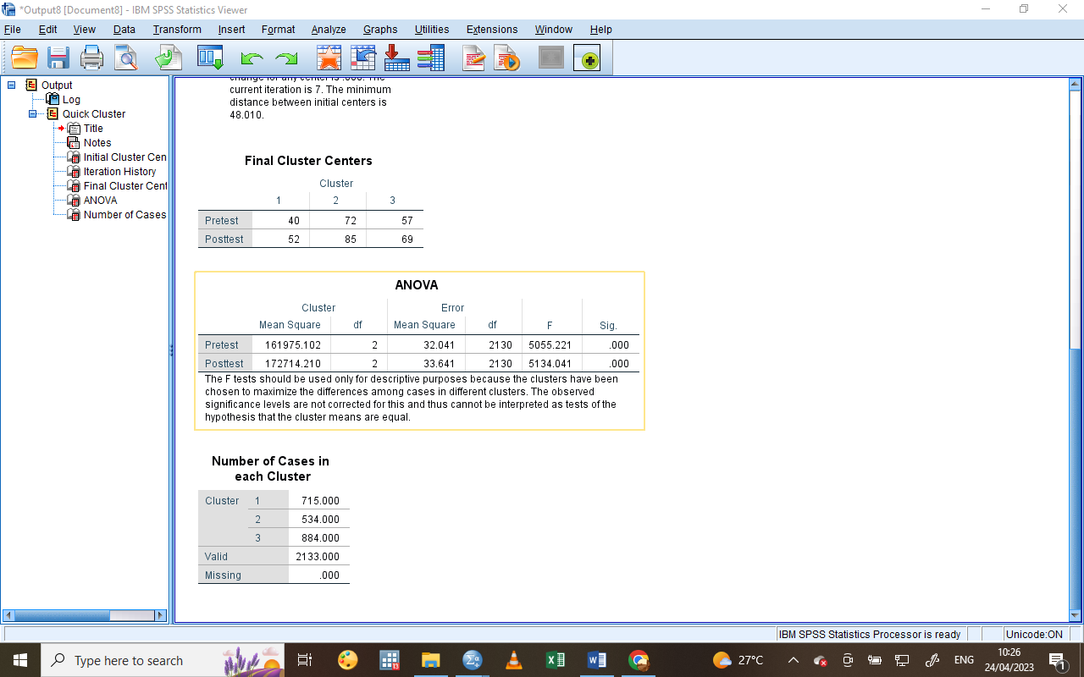

The significance level on the anova table above shows all the variables used are significant. The last table represents the size of each cluster in the dataset.
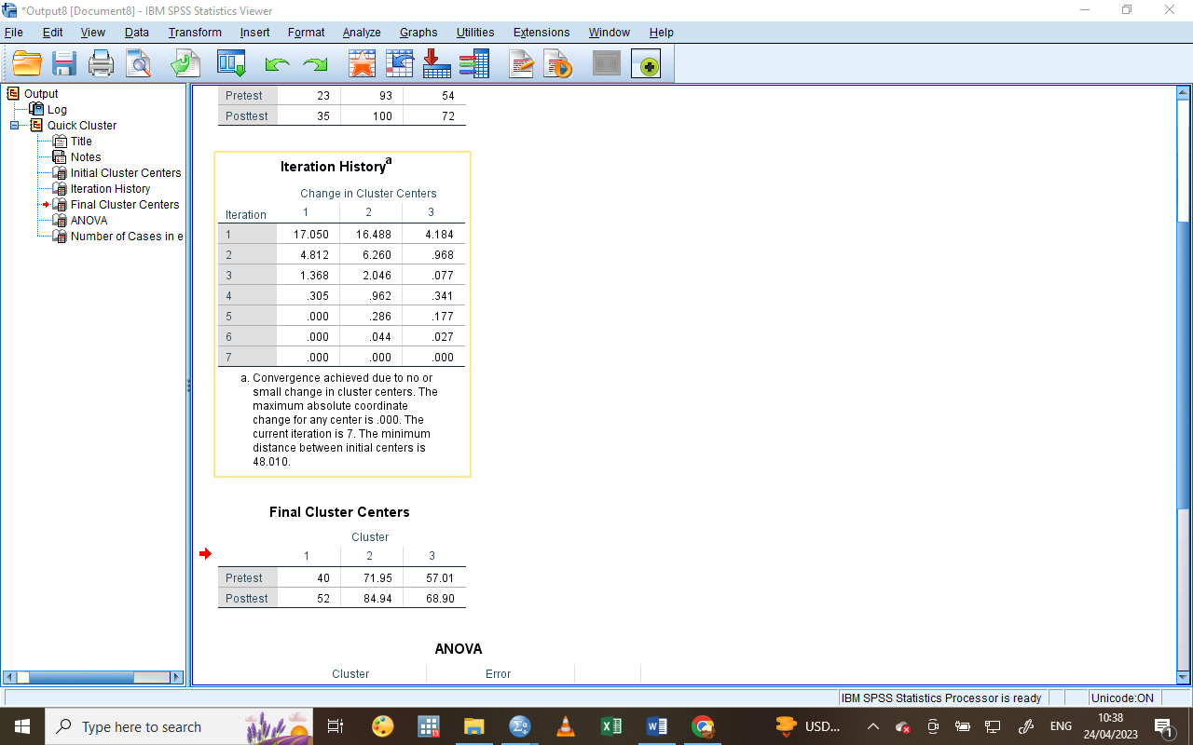
Since K-Means is an iteration model, the iteration history shows there were only 7 iterations. Final cluster center represents the average value of pre-test and post-test variables according to the 3 clusters.
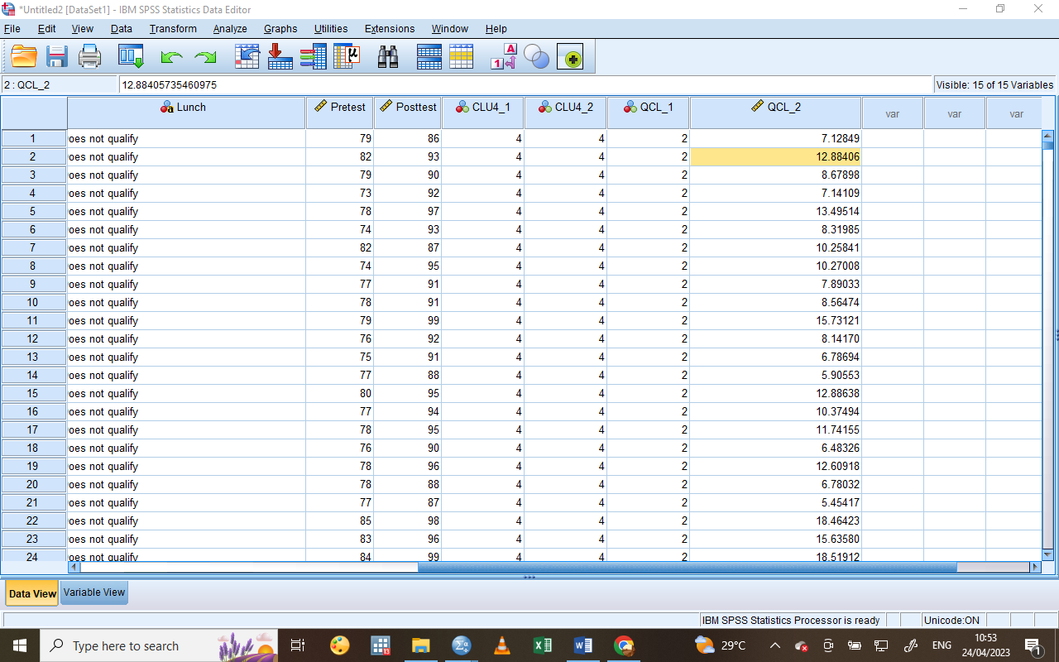The QCL_1 represents the cluster membership whereas the QCL_2 represents the distance to the cluster center, and the smaller the value the closer is the student close to the cluster center hence most represented by the cluster.
Data Mining Methods:
Clustering: Its, a data mining technique that encompasses grouping a series of similar data points together using different clustering methods such as portioning, hierarchical and density-based method. A business can use clustering to determine particular customers groups based on their purchase history and demographics.
Classification: It involves assigning categorical labels or tags to new data based on patterns observed in previous data using logistic regression, decision trees etc. it’s used in credit card companies to predict whether a new applicant is likely to be a good or bad risk based on their past credit history.
Association: Association identifies unique relationships between variables in a large database. It’s useful in making purchase suggestions for retailers.
Regression analysis: Regression is used in identifying a relationship between one or more predictor variables and a response variable. It’s used by sales team to predict sales estimates and impact of different marketing campaigns (Pedamkar, 2019).
Time series analysis: It involves analyzing and modelling data that differs over time. In business, financial institutions implement time series analysis to forecast future stock prices centered on past trends and patterns.
Text Mining Methods:
Sentiment analysis: This is used to analyze the emotional tone of textual content, such as social media posts. Hotel chains use sentiment analysis to monitor customer feedback and identify areas for improvement.
Information extraction: It’s a technique used to identify and extract valuable pieces of information from large amount of data. An e-commerce business can use it to automatically identify and categorize products mentioned in client reviews.
Text classification: the process of assigning categorical labels to text documents based on their content. In business, a news organizations use text classification to categorize news stories by topic, such as sports or politics (Tyagi, 2021).
Text summarization: This involves reducing length and complexity of textual data while retaining the meaning. In business, it’s used to verify whether a document satisfies user requirements.
Topic modeling: Identifies common themes and searches within a large collection of text documents. News organizations use topic modeling to identify trends in news coverage and focus its reporting accordingly.
Criteria | SPSS | Excel
Speed | Has parallel processing capabilities hence preferred by organizations to handle big data (Pedamkar, 2018). | When working with medium and small data its considered faster hence preferred by smaller organization to handle customer data
Accuracy | Its more accurate as it has minimum errors providing reliable statistical results | It lacks reliability in statistical analysis as it is prone to errors
Cost | Spss is more expensive compared to excel as it requires upgrades and high maintenance cost | Excel is significantly less expensive to purchase and very low maintenance cost.
Ease of using | Spss has user friendly interface but it still requires basic training before using it efficiently | It is easier to learn than spss also having a friendly user interface.

References
Finau, Glen, Prasad & Acklesh. (2015, May 5). Excel's Sumif and Sumifs function. QUT ePrints. https://eprints.qut.edu.au/93237/
Oh, Y., Osgood, D. W., & Smith, E. P. (2014). Measuring Afterschool Program Quality Using Setting-Level Observational Approaches. The Journal of Early Adolescence, 35(5-6), 681–713. https://doi.org/10.1177/0272431614561261
Pedamkar, P. (2018, October 5). SPSS vs EXCEL - 8 Most Important Differences You Should Know. EDUCBA. https://www.educba.com/spss-vs-excel/
Pedamkar, P. (2019, May 6). Data Mining Methods | Top 8 Types Of Data Mining Method With Examples. EDUCBA. https://www.educba.com/data-mining-methods/
Roy, B. (2020, February 22). All About Missing Data Handling. Medium. https://towardsdatascience.com/all-about-missing-data-handling-b94b8b5d2184
Simplilearn. (2021, January 15). What is the difference between Excel And Tableau || Simplilearn. Simplilearn.com. https://www.simplilearn.com/tutorials/excel-tutorial/excel-vs-tableau
Tamboli, N. (2021, October 29). Tackling Missing Value in Dataset. Analytics Vidhya. https://www.analyticsvidhya.com/blog/2021/10/handling-missing-value/
Tyagi, N. (2021, May 10). 7 Text Mining Techniques | Analytics Steps. Www.analyticssteps.com. https://www.analyticssteps.com/blogs/top-7-text-mining-techniques
Yıldırım, S. (2020, March 3). K-Means Clustering — Explained. Medium. https://towardsdatascience.com/k-means-clustering-explained-4528df86a120

