Reflective Report


March 2018
Module Name:
Project Name:
Name:
Student Number:

Academic Skills (M4X01434)
Down to Earth
Peter Basford
1707183

Table of Contents
Table of Contents 2
1 - Executive Summary 3
2 - Introduction 5
2.1 - Report Remit 5
2.2 - Background Information 6
2.3 - Models of Reflection 7
2.4 - Masterclass Sessions 10
3 - Reflection on the influence of the masterclasses 13
3.1 - Influence of the Masterclasses on the Project 13
3.2 - Influence of the Masterclasses on Personal Learning and Development 15
4 – Conclusion 17
References 18
Appendices 22

Table of Figures
Figure 1 - Gibbs' Multistage Model of Critical Reflection (Gibbs, 1988, p. 50) 5
Figure 2 - Kate of Gower Cottage Brownies with miscellaneous students. 7
Figure 3 - Mark Power in full flow. 8

1 - Executive Summary
This report contains a reflective look at my experiences over the first semester of my university experience. I worked in a group with other students to assist the Gower based social enterprise Down to Earth with their publicity by having an article about their latest building project in the local media.
I consider the reflective process as a whole, with reference to the work of Mezirow, Neuman, King and Kitchener. I discuss the models of reflection that I selected, those of the “What, So What, Now What” model created by Driscoll and the Gibbs multistage process of critical reflection. The masterclasses covered a range of topics, such as body language, successfully setting up a small business, psychology, entrepreneurship and the management of social enterprises. The Networking for Introverts session in particular was very interesting for me and prompted further personal exploration of the topics discussed.
I reflected that an area that I was inexperienced in was the management of a team in situations where autocratic leadership is not appropriate. Considering the performance of the team over the course of my project I can identify that there are situations where I, as team leader, should have stepped in and brought the more recalcitrant members of the group back into line. Reflecting on my own learning over the first semester I have gained an interest in the use of body language and psychology to my advantage in team situations. I considered my conscious use of body language to be a success following the semester.

Having identified areas of weakness I have since identified and implemented measures to improve on them.
- To improve my leadership skills I have joined the Army Reserves which provides ample opportunity to develop my leadership and planning skills.
- To improve on my ability to communicate with others I have gained an interest in media on the subject, such as TED talks and books.

2 - Introduction

2.1 - Report Remit
For the first semester of our academic year, we received talks from guest speakers on a range of topics. During said semester we undertook a project over the course of which we worked in groups to assist a range of organisations with achieving their goals. The purpose of this report is to reflect on the impact of the masterclasses upon my performance over the course of our first-semester project and upon my own personal learning and development. I will be analysing and applying two models of critical reflection, the Gibbs multi-stage model and the Driscoll “What” model to the first-semester project and to my own learning over the course of said semester. Having reflected upon the project and my own experiences I will assess my own need for further experience, training and education. I hope to analyse my own strengths, weaknesses and areas of potential improvement.

2.2 - Background Information
I worked as part of a group of students with the social enterprise Down to Earth. As a social enterprise, they operate on a not for profit basis (Social Enterprise UK, 2016) but are distinctly different from a charity. They focus on helping the vulnerable and disadvantaged and working with those not in employment, education or training to provide opportunities to learn valuable skills while assisting with the construction of sustainable buildings (Basford, et al., 2017). As they are relatively well off financially, having recently been funded to the amount of £583,000 by the People’s Postcode Lottery ‘Dreamfund’ (The Down to Earth Project, 2015), we were not tasked with raising funds as some of our peers were. Instead, we were tasked with promoting the Down to Earth Project through the medium of a newspaper article.

2.3 - Models of Reflection
“Reflection is not, by definition, critical. […] What is it, then, that makes reflection critical? Is critical reflection a deeper, more intense and probing form of reflection? […] The depth of a reflective effort does not, in and of itself, make it critical. For something to count as an example of critical learning, critical analysis or critical reflection, I believe that the persons concerned must engage in some sort of power analysis of the situation or context in which the learning is happening.” (Mezirow, 2000, p. 126)
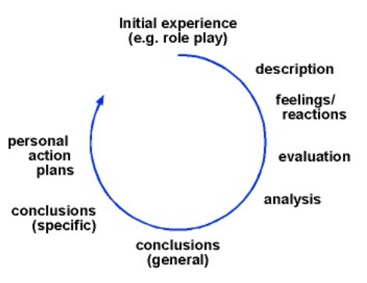
Neuman (1996) describes critical reflection as being tied to self-awareness and the ability to “recognize, acknowledge and process feelings and emotions as integral aspects of learning from experience” (Ibid., p. 460), this is in agreement with the earlier work of Gibbs (1988), whose multistage model lays out a clear and logical progression to follow in order to fully and rationally analyse previous experiences. Despite Mezirow (2000, p. 305) asserting that critical self-reflection can include intense emotions and what he describes as “grieving the loss of old meaning structures” I understand critical reflection as a fairly rational and emotionally detached process (King & Kitchener, 1994). It is my belief that it is when emotions are brought into reflective processes that people risk becoming invested in their past solutions to a problem and blind to possible alternatives that maybe do not fit their usual worldview.
Figure 1 - Gibbs' Multistage Model of Critical Reflection (Gibbs, 1988, p. 50)
I believe that it is one thing to reflect on an event or experience, but it may be quite another thing altogether to fully apply any conclusions that may be arrived at. As is seen with new year’s resolutions, just because people have reflected upon their life and decided that they should make a change does not mean said change will be successfully implemented. A large part of increasing the success of these changes may be from support from like-minded people, for a dramatic example of this one has only to look to Alcoholics Anonymous (Alcoholics Anonymous (Great Britain) Ltd, 2018) and other similar support groups. Perhaps this is where the more emotional side of critically reflective learning comes into play, while identifying things that can be learnt may be an emotionally detached process, it is in the changing of behaviour and establishing of new habits that emotional connections and support for others becomes important. As Mezirow (2000, p. 308) states, “Without the medium of healthy relationships, critical reflection would seem to be impotent and hollow, lacking the genuine discourse necessary for thoughtful and in-depth reflection.” From previous experience I know that attempting to explain what I have learnt to others and educating them is an important part of my own learning process, this is supported by the work of Gehrels (1984), whose experiences as a US school principle suggest that the act of helping others to learn from events and experiences is a vital part of absorbing the most useful information from those experiences.
Another element to be considered is the context of the learning experience, not only the prior life experiences of the person doing the reflection but also the wider culture from which they originated. In terms of personal context, a degree of self—awareness is required, as each person learns differently (Sharp, 1987), so should reflect on their experiences with their own learning style in mind to gain the most benefit from the reflective process. When it comes to the influence of culture upon a person’s willingness to reflect, this can be the culture one is surrounded by as a child, the way that a person’s parents have brought them up and the methods of teaching used in the education system. In my own experience, as a child, if I asked why something had happened I was perhaps given the facts necessary and encouraged to think my way through a problem out loud, with my parents then confirming or refuting my suppositions. While my parents have encouraged reflective and critical thought, the school system served me less well in this area, I am unable to think of a single teacher who would encourage any sort of critical approach to reflection and problem-solving.
The two models I have selected to apply to my own experiences are the Driscoll three-stage model (What, So What, Now What) and the aforementioned Gibbs multistage model. While I prefer the Gibbs model as I believe it offers a more in-depth process to more fully reflect on an experience it does have the drawback of being quite complex and slow to apply due to that same depth of reflection. I have also chosen Driscoll’s model as I feel it provides a good contrast to the complexity of the Gibbs model and the brevity of the process has merit in cases with less emotional investment involved (University of Nottingham, 2018).

2.4 - Masterclass Sessions
The first of the masterclass sessions that were put on for us was presented by Andy Rogers and was titled Networking for introverts. In my opinion, he was the best of all the guest speakers that we had the opportunity to listen to. He covered a range of topics from how to assess the body language of groups to reveal if they were open to the approach of new people, how to phrase requests and suggestions based upon what you know of the personality of the person you are talking to.
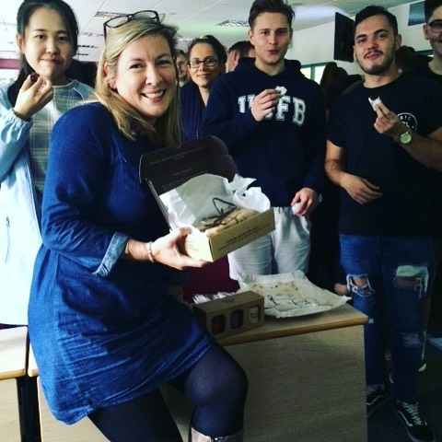
The following week we had a double bill of guest speakers in the form of Stifyn Parri, also known as Mister Producer and Kate of Gower Cottage Brownies. Kate used her time to talk to us about the challenges of starting a small business and lessons she had learned over the course of her journey from a small start-up to featuring on national television (Gower Cottage Brownies Ltd, 2018).
Figure 2 - Kate of Gower Cottage Brownies with miscellaneous students.
Mr Parri certainly had a lot to say for himself, however, a large portion of his talk was more about what a successful career he has had thus far, and the useful content of his talk was largely grouped in the latter half. I’m not sure I would go so far as to describe the talk as “both empowering and effective” (Parri, 2016) however he did have some useful observations on the nature of speaking to groups of different sizes, how to conduct oneself in an interview and how to present a pitch to someone.
On two occasions we had the immense good fortune to witness the infamous Ben Reynolds PhD (Culture & Urban Regeneration) BSc (Hons) M.M.R.S. giving his gripping talk on how he developed his range of social enterprises and details of his grand plans to regenerate Swansea (Urban Foundry, 2018). Unfortunately, despite receiving the talk twice, very little of the talk managed to percolate into my memory.
Benedict Room gave us a talk on the entrepreneurial spirit and how he has succeeded in pioneering a new sport in the Gower area (brdsports, 2008). While I went into the talk with low expectations as I have no interest in running my own business, he went on to explain the existence of intrapreneurs and their role within companies providing innovation and new developments. He discussed the details of the ACRO model for successful entrepreneurship (Business Wales, 2018), leading me to identify my strengths and weaknesses within the model. He also engaged his audience with activities for volunteers that acted as excellent examples of the pitfalls teams can fall into when there is no clear leadership and assumptions of the objective are made.
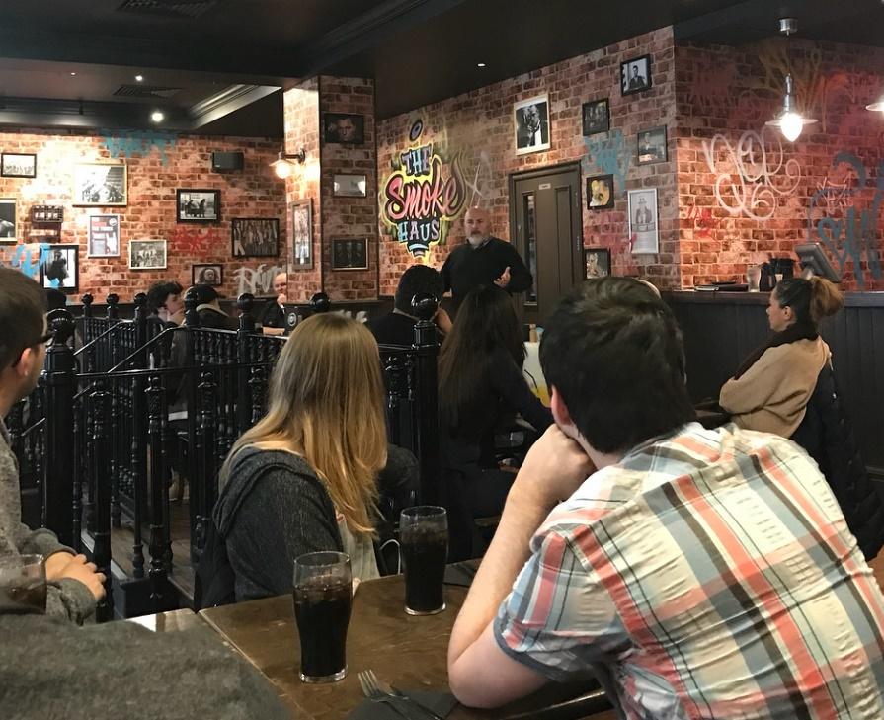
We received a talk from Jon Dawkins of Dirty Little Serifs and branding and design agency during which we were encouraged to imagine ways that we could re-brand an existing sport as a group. Another activity was to think of imaginative names for a new hairdresser’s, with the perhaps inevitable litany of coiffure-based puns (such as: Do or Dye, Dye Another Day, Trim and Let Dye, Cut to the Quick, etc.). I found him to be an engaging speaker, able to regale us with anecdotes from his wide range of past work experiences, including an exchange in the middle of the desert that sounded like something more appropriate to a spy novel than the life of a graphic designer (Dirty Little Serifs Limited, 2017). Though his masterclass was certainly entertaining I felt that not much of it was applicable to my own learning as I have little intention to pursue a career in marketing.
Figure 3 - Mark Power in full flow.
Mark Power of the Smoke Haus chain of barbeque restaurants treated us to both good food and an interesting talk about how he has set up and grown his business from a single location in Swansea, taking over a former Hooters location. He described how this was fortunate as the building already had the amenities installed that they required and as such they were able to launch despite a fairly anaemic starting capital. He explained to us how they take annual trips to locations in the US in order to gain inspiration for new methods and recipes they can bring to their embryonic chain of restaurants. He talked to us about the challenges that he has faced in expanding his business, logistical and otherwise, and how he was against the idea of allowing franchises to open, meaning that he and his business partners have a part in the running of their four restaurants.

3 - Reflection on the influence of the masterclasses

3.1 - Influence of the Masterclasses on the Project
Unfortunately, my group experienced several difficulties during our project which did not allow for many occasions when anything that I have learnt from the masterclasses could have been applied. One of the masterclasses that I did find useful was the talk by Jon Dawkins, as I found his information helpful when it came to the blog section of the project. To apply Driscoll’s model to the experience, the “What” element is that we published a blog, three times a week over the course of a month. The “So What” is that we learnt to pitch our writing to reach our target audience and I gained experience in managing a group of people over a longer-term project. “Now What” did I learn from the experience? I observed that though the preplanning worked well, I relied upon group members to post according to the timetable. As each person had two weeks between their posts I had expected them to have written their post beforehand and left them to it. I was continually surprised over the course of the blog to be receiving messages from some group members asking what they should write about, often less than a day before their post was scheduled. A conclusion I have drawn from this experience is that I should perhaps take a more active role in keeping people to a schedule in future, reminding them of approaching time limits in the preceding days and ensuring that they know what is required of them, while I took a more laissez faire style of leadership I now realise that I should have become more autocratic as the time pressure built (Mullins & Christy, 2013).
Another part of the project that I feel I could have improved upon was my initial briefing of the team once I had received instruction from our partner organisation. Due to the somewhat vague and nebulous nature of their requirements, I found myself confused and unsure of what they were intending we do. Should I find myself in a similar situation in future I shall ask more questions of the person handing down orders in order to ensure I have a clear idea of what is being requested. This was an area where one of our masterclasses had valuable advice for me, as Ben Room discussed the problems of vague instructions and the assumptions that people make around them, during his talk. Alongside this, I have since been taught the SMEAC (Situation, Mission, Execution, Any Questions, Check Understanding) method of briefing a team (Budihas, 2000), which I feel would have made our project objectives much clearer to my team than the rather disorganised and unsure briefing that I gave at the time. I understand now that while there is certainly room for improvement in my own leadership style, our instructions were flawed from the start. An important part of a hierarchical management system (as we experienced with our project, I was given instructions and then disseminated the information to my team) is for the leaders at the top to provide sufficient detail to their subordinates to understand the context of the project and the intent behind the instructions (Development, Concepts and Doctrine Centre, Ministry of Defence, 2010).

3.2 - Influence of the Masterclasses on Personal Learning and Development
During his talk, Ben Room discussed the ACRO model (Business Wales, 2018) with us and I thought it was a useful framework for the wider world of work, not limited to its application to entrepreneurship. I would say that my strengths are the A and O of the model, the qualities of Attitude and Organisation, as I consider myself a determined and motivated person with good planning, decision making and organisation skills. The areas that I am weaker at are the C and R of the model, Creativity and Relationships. While I believe myself to be quite adept at problem-solving and lateral thinking in the context of existing problems I am less capable of creating original ideas and identifying and creating opportunities.
Another element of the masterclasses that particularly interested me was the topic of body language and the way personality types can change the approach one should take to attempting to persuade people. The first of these topics were covered by both Stifyn Parri and Andy Rogers while the second topic was the sole purview of Andy Rogers. From their discussions on body language, I have come to realise the pointlessness of nervousness when it comes to dealing with unfamiliar situations (Cuddy, 2012). Though experiencing nerves seems to be inevitable I have done my best to not allow them to control me since I came to this realisation. This has led to my presenting the appearance of calmness which, along with my usually fairly phlegmatic demeanour, has itself led to people looking to me for advice in situations unfamiliar to everyone there. This, in turn, has given me further experience in team leadership, something I am keen to develop further.
On the topic of personality types, Andy Rogers had quite an interesting self-evaluation exercise (See Appendix B, Point 6 and Colours Self-Assessment) for determining our own personality type. I identified myself as a process and structure-oriented person, fortunately, the most common of the four personality types, I make considered decisions based on fact. Prior to his talk, I had never given much conscious thought to how I could take into account other people’s personalities when it came to persuading them of something. Now I know that I will have the easiest time persuading other people of a similar mind to me, if I were to be attempting to sell something to someone who makes fast decisions based upon their feelings I would need to couch my ideas carefully to achieve the maximum effect (Becket, 2013).

4 – Conclusion
Over the course of my first semester, I learnt a lot thanks to the masterclasses. While some of the masterclasses were of little use to me, others either gave me valuable and applicable information, caused me to look at subjects in a new way or presented ideas that had never occurred to me before. I reflected on where my skills could be improved and what I have learnt as a result of the masterclasses. Since the start of the first semester I have pursued opportunities to improve my leadership skills, key among these opportunities has been my joining of 108 Field Squadron of the Royal Monmouthshire Royal Engineers of the Army Reserve. This has allowed me to attend militia training weekends and weekday evening lessons, including lessons on leadership, command and planning, along with giving me the chance to apply these lessons to live situations.
Having gained an interest in improving my communication skills I have resolved to research the topic further through the range of excellent TED talks available on the subject along with searching for radio programs or podcasts that discuss the topic.

References
Alcoholics Anonymous (Great Britain) Ltd, 2018. Alcoholics Anonymous. [Online]
Available at: https://www.alcoholics-anonymous.org.uk
[Accessed 9 0 2018].
Basford, P., Crocker, L., Jeffreys, L., Leung, M., Muobike, P., & Rahman, S., 2017. Down to Earth Project Brief, Swansea: University of Wales Trinity Saint David.
Becket, X., 2013. How to Sell to Everyone: The 4 Personality Types. [Online]
Available at: https://www.webpagefx.com/blog/internet-sales/how-to-sell-to-everyone-the-4-personality-types/
[Accessed 10 3 2018].
brdsports, 2008. brd Sports - About Us. [Online]
Available at: http://www.brdsports.co.uk/about-us
[Accessed 10 3 2018].
Budihas, C. L., 2000. Basic Communications - The Combat Order. Marine Corps Gazette, 84(3), pp. 62-63.
Business Wales, 2018. Understanding Entrepreneurship - The ACRO Model. [Online]
Available at: https://businesswales.gov.wales/bigideas/understanding-entrepreneurship-acro-model
[Accessed 26 2 2018].
Cuddy, A., 2012. Your body language may shape who you are. [Online]
Available at: https://www.ted.com/talks/amy_cuddy_your_body_language_shapes_who_you_are
[Accessed 10 3 2018].
Development, Concepts and Doctrine Centre, Ministry of Defence, 2010. Army Doctrine Publication: Operations. [Online]
Available at: http://www.defencesynergia.co.uk/wp-content/uploads/2015/05/Army-Doctirne-Operations-Dec-2010.pdf
[Accessed 11 3 2018].
Dirty Little Serifs Limited, 2017. [Online]
Available at: http://www.dirtylittleserifs.com/
[Accessed 05 03 2018].
Gehrels, C., 1984. The School Principle as Adult Learner. Toronto: University of Toronto.
Gibbs, G., 1988. Learning by doing : a guide to teaching and learning methods. 1st ed. London: London FEU.
Gower Cottage Brownies Ltd, 2018. Gower Cottage Brownies. [Online]
Available at: http://www.gowercottagebrownies.co.uk
[Accessed 23 2 2018].
King, P. M. & Kitchener, K. S., 1994. Developing Reflective Judgment. 1st ed. San Francisco: John Wiley & Sons, Inc..
Mezirow, J., 2000. Learning as Transformation. 1st ed. San Francisco: John Wiley & Sons, Inc..
Mullins, L. J. & Christy, G., 2013. Management & Organisational Behaviour. 10th ed. Harlow: Pearson Education Limited.
Neuman, T. P., 1996. Critically Reflective Learning in a Leadership Development Context. Madison: University of Wisconsin.
Parri, S., 2016. Mr Producer. [Online]
Available at: https://mrproducer.co.uk/services_mentor/
[Accessed 23 2 2018].
Sharp, D., 1987. Personality Types: Jung's Model of Typology. 1st ed. Toronto: Inner City Books.
Social Enterprise UK, 2016. Social Enterprise FAQ. [Online]
Available at: https://www.socialenterprise.org.uk/Pages/FAQs/Category/FAQs
[Accessed 23 2 2018].
The Down to Earth Project, 2015. Down to Earth - Dreamfund. [Online]
Available at: http://www.downtoearthproject.org.uk/dreamfund/
[Accessed 23 2 2018].
University of Nottingham, 2018. Driscoll (By Borton). [Online]
Available at: https://www.nottingham.ac.uk/nmp/sonet/rlos/placs/critical_reflection/models/driscoll.html
[Accessed 12 3 2018].
Urban Foundry, 2018. Dr Ben Reynolds. [Online]
Available at: http://www.urbanfoundry.co.uk/?team=dr-ben-reynolds
[Accessed 26 2 2018].

Appendices
Appendix A: Life Design
Worksheets from our Life Design workshop.
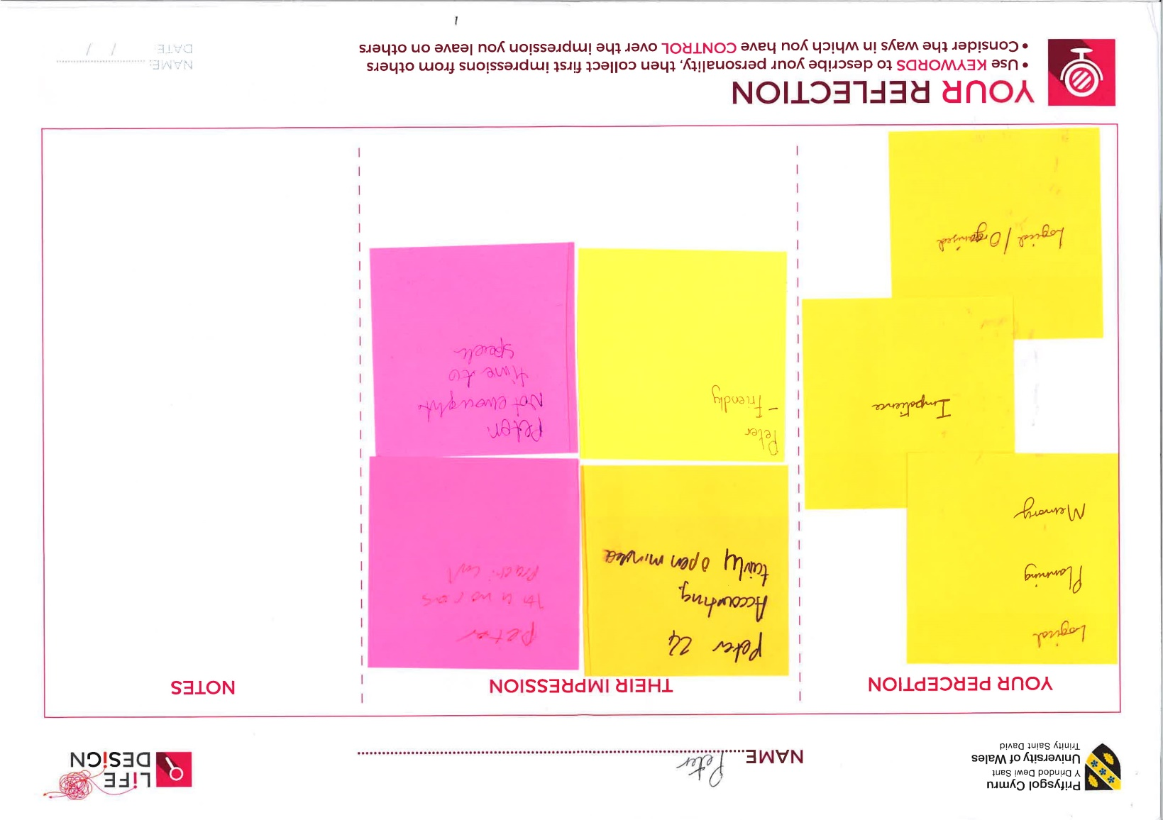

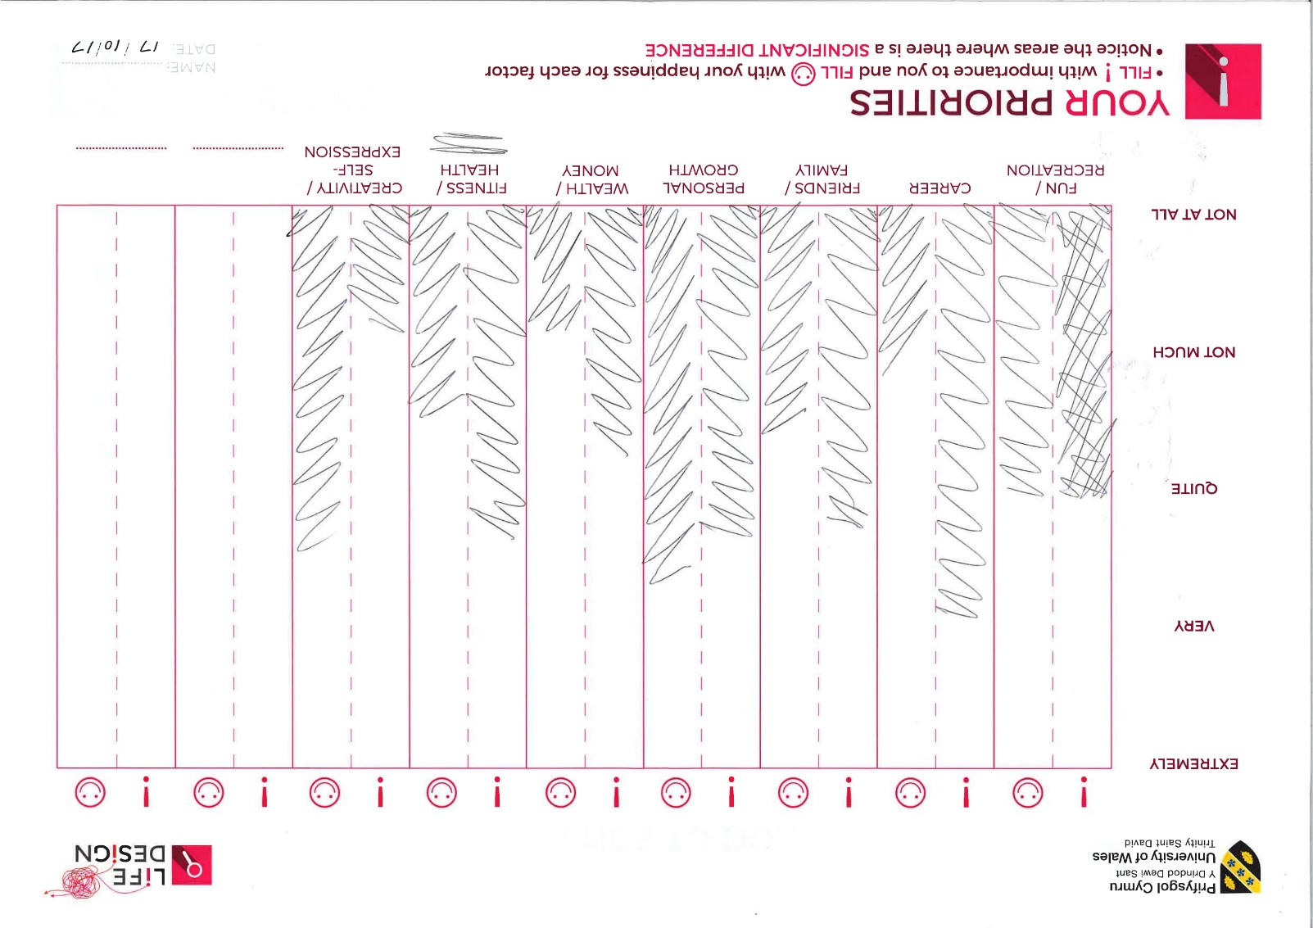
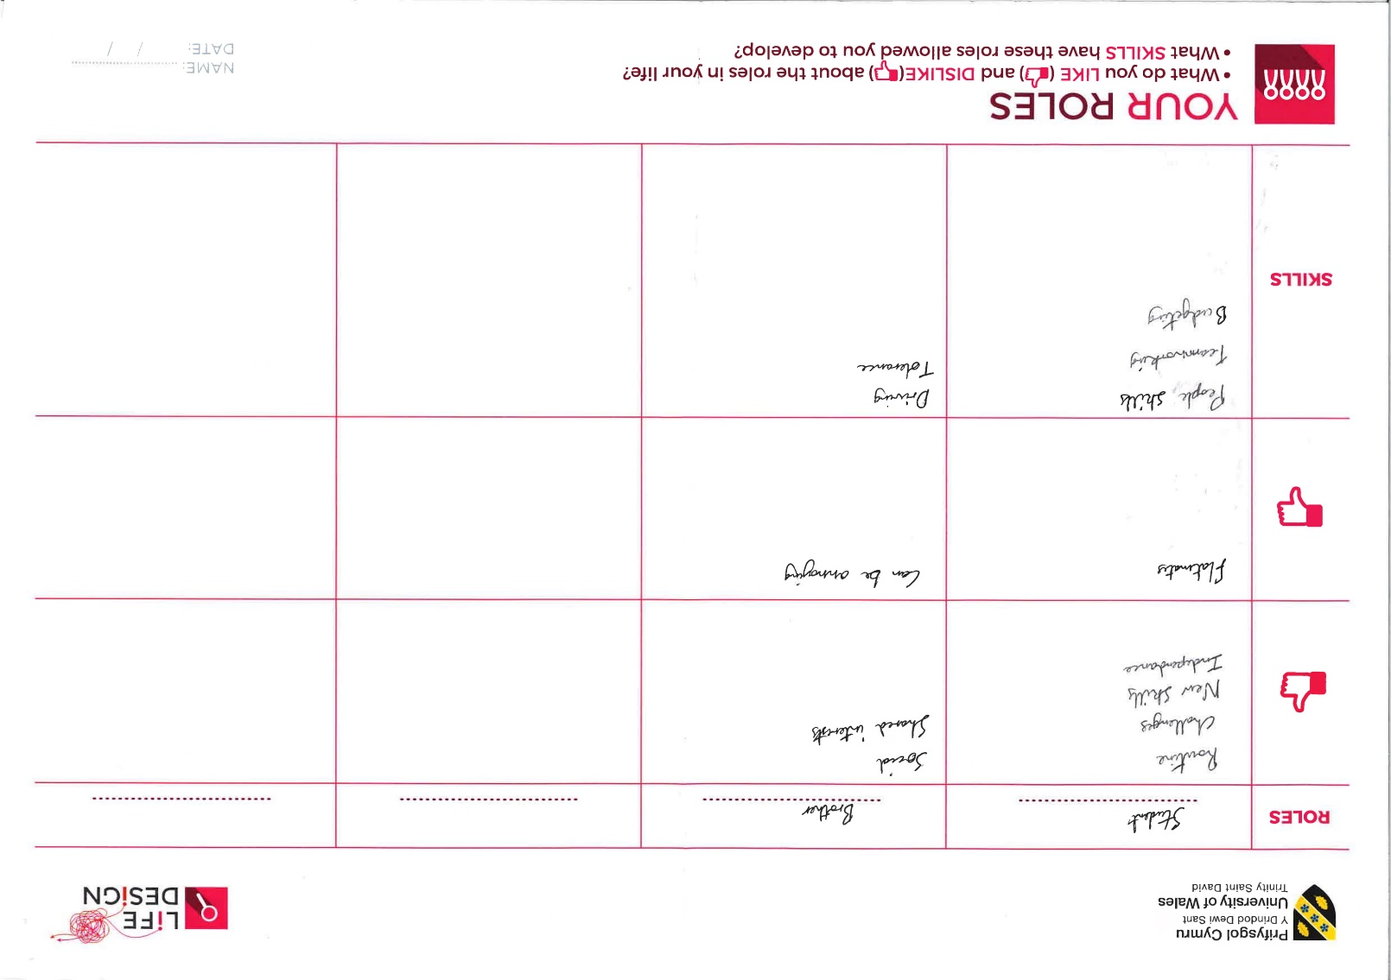
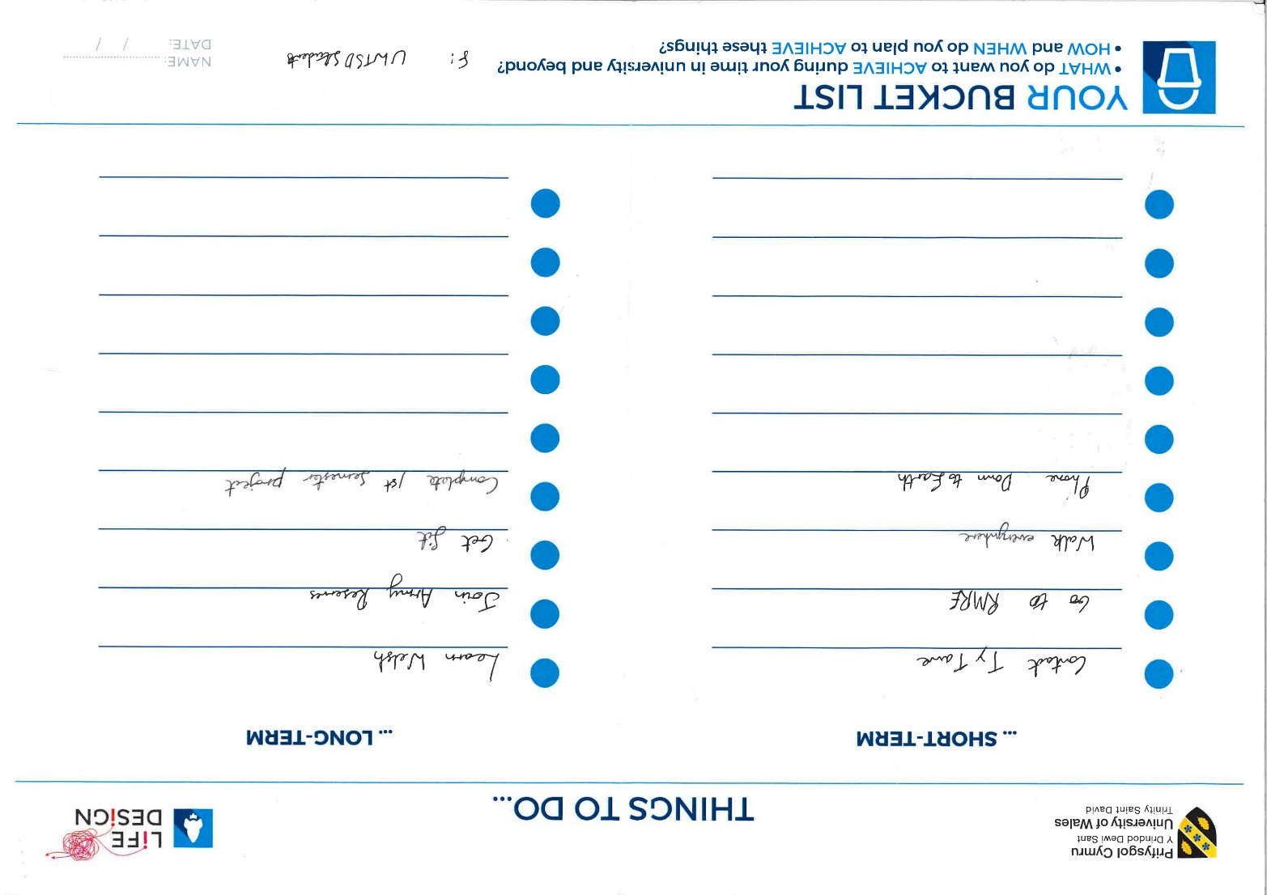

Appendix B:
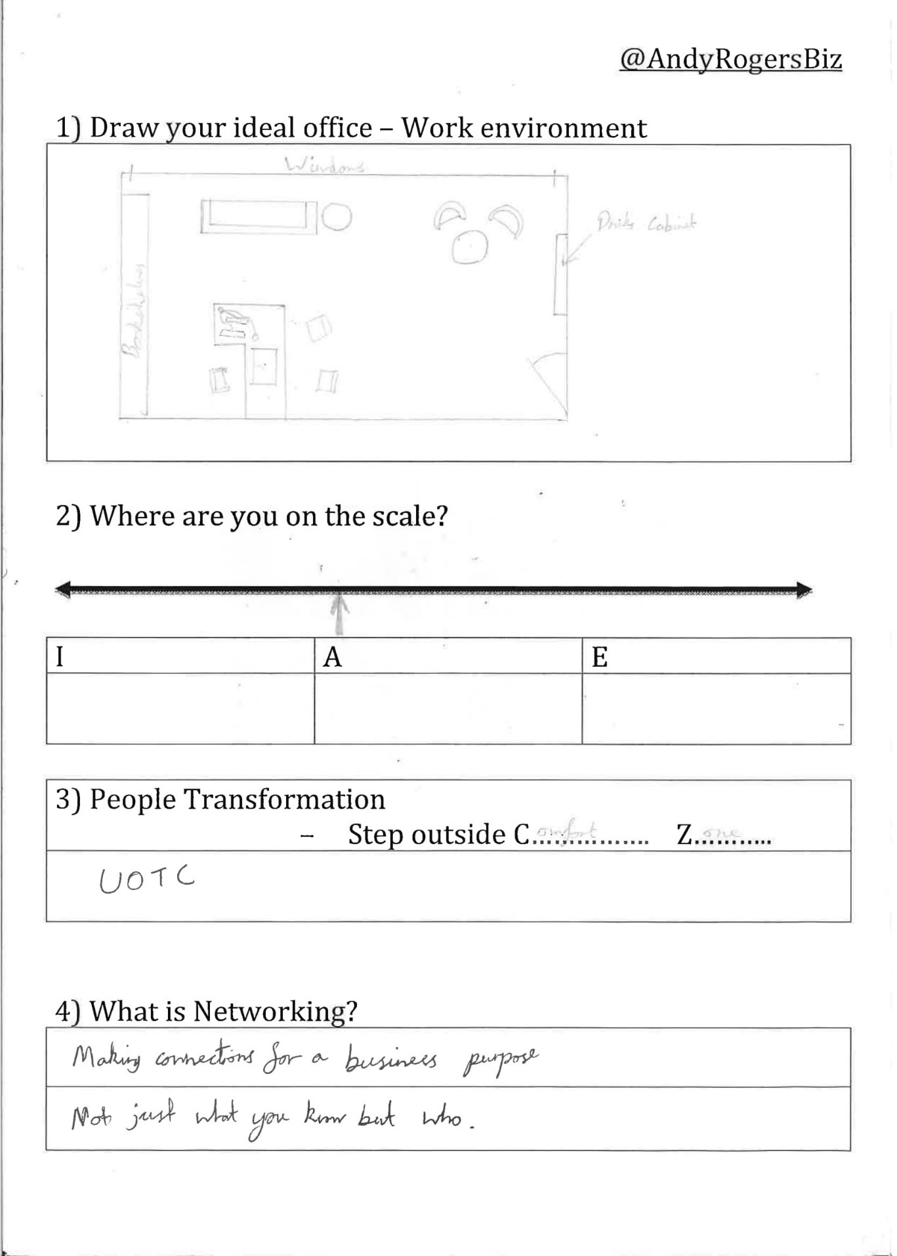
Worksheet from Networking for Introverts by Andy Rogers
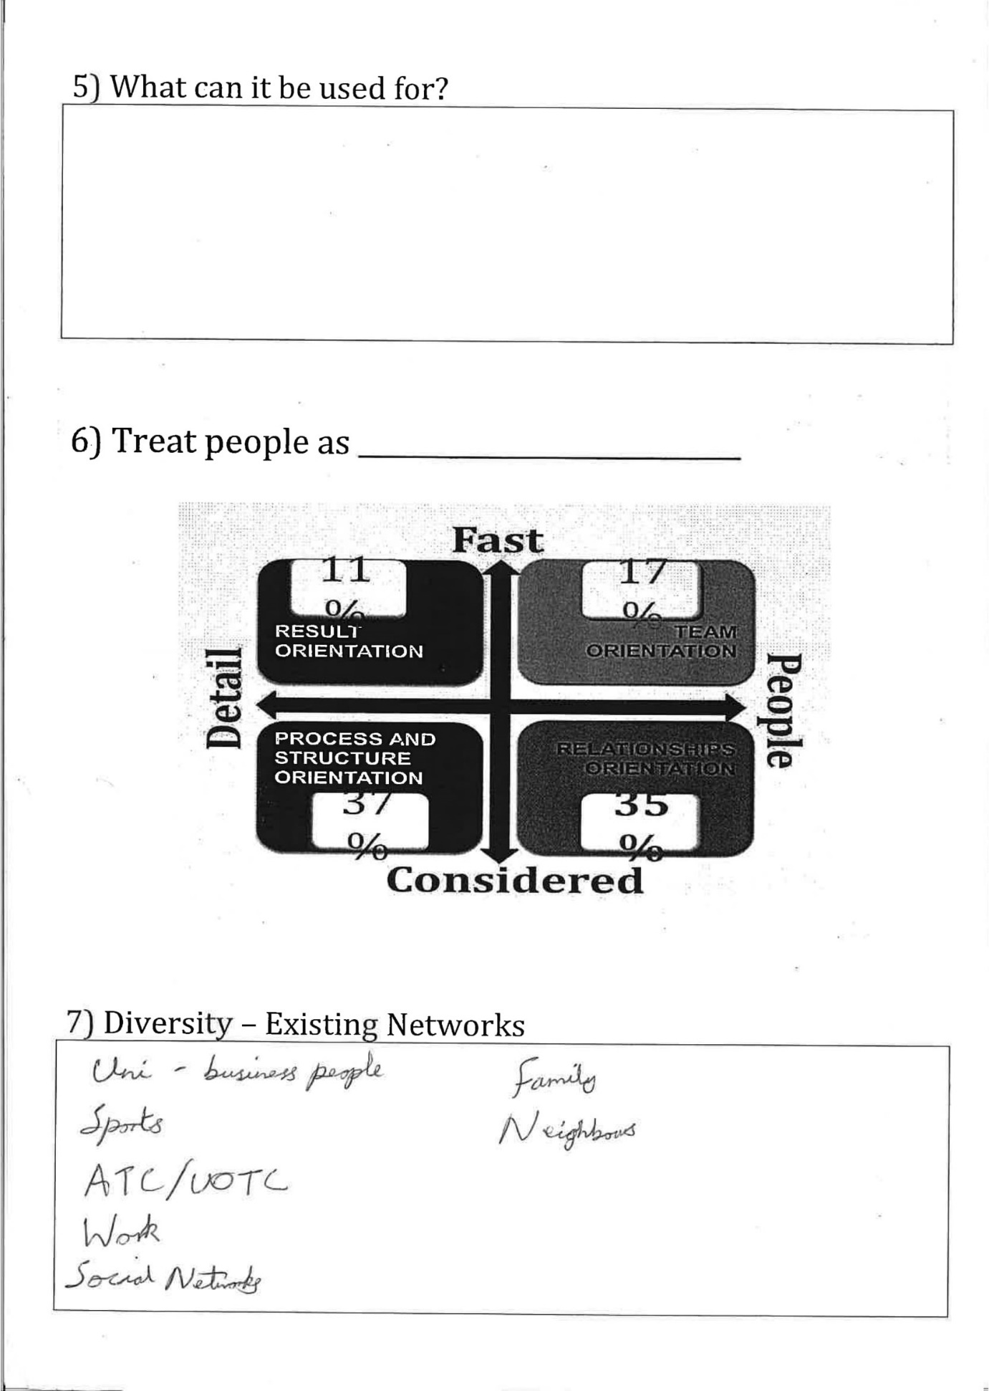
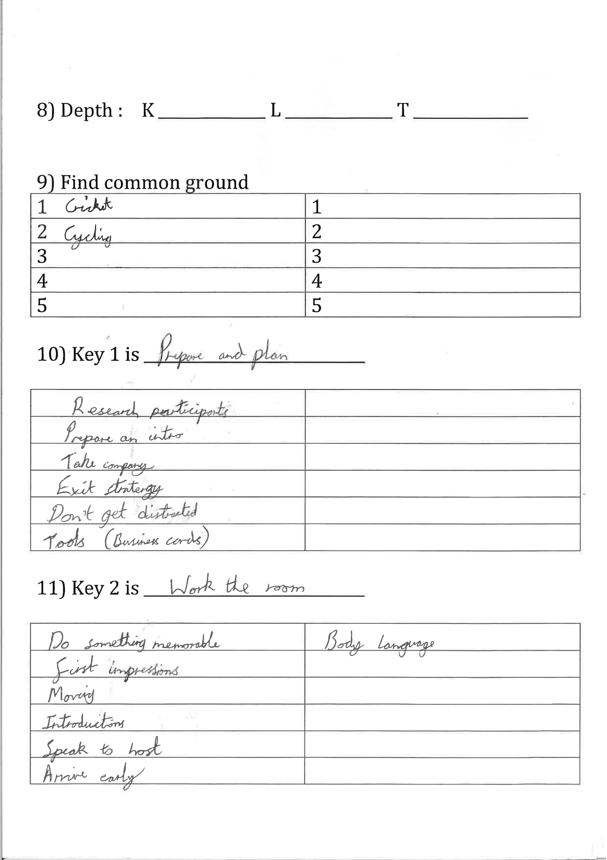
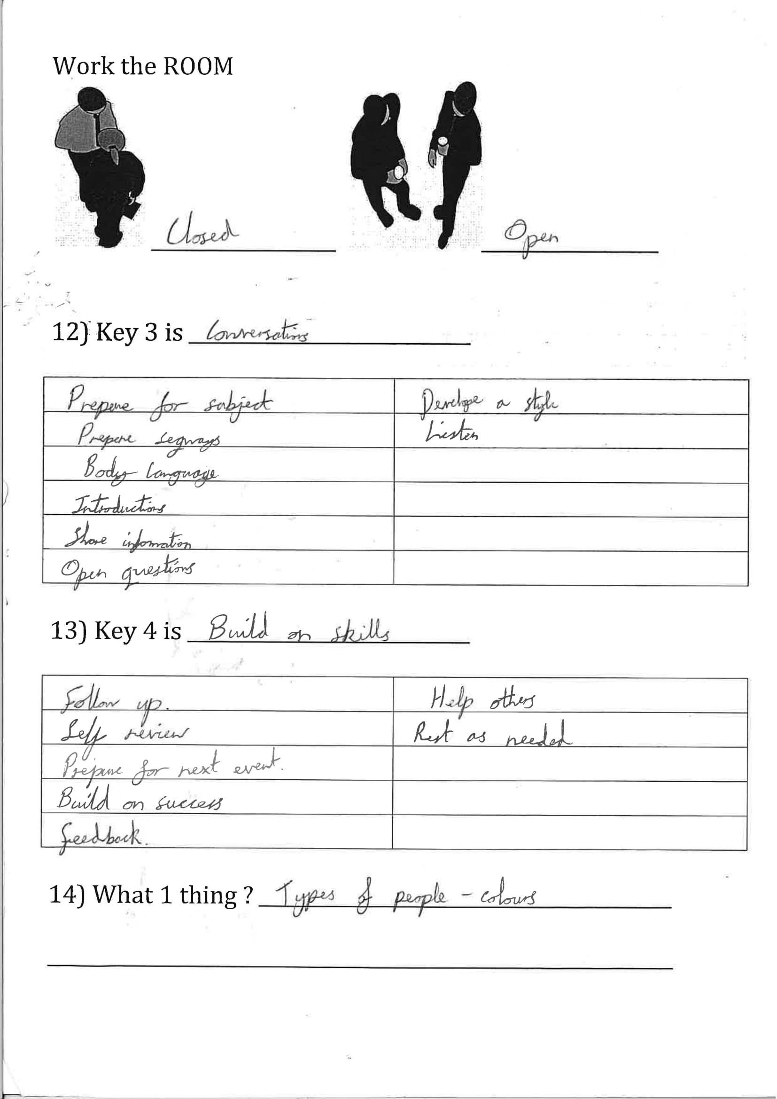
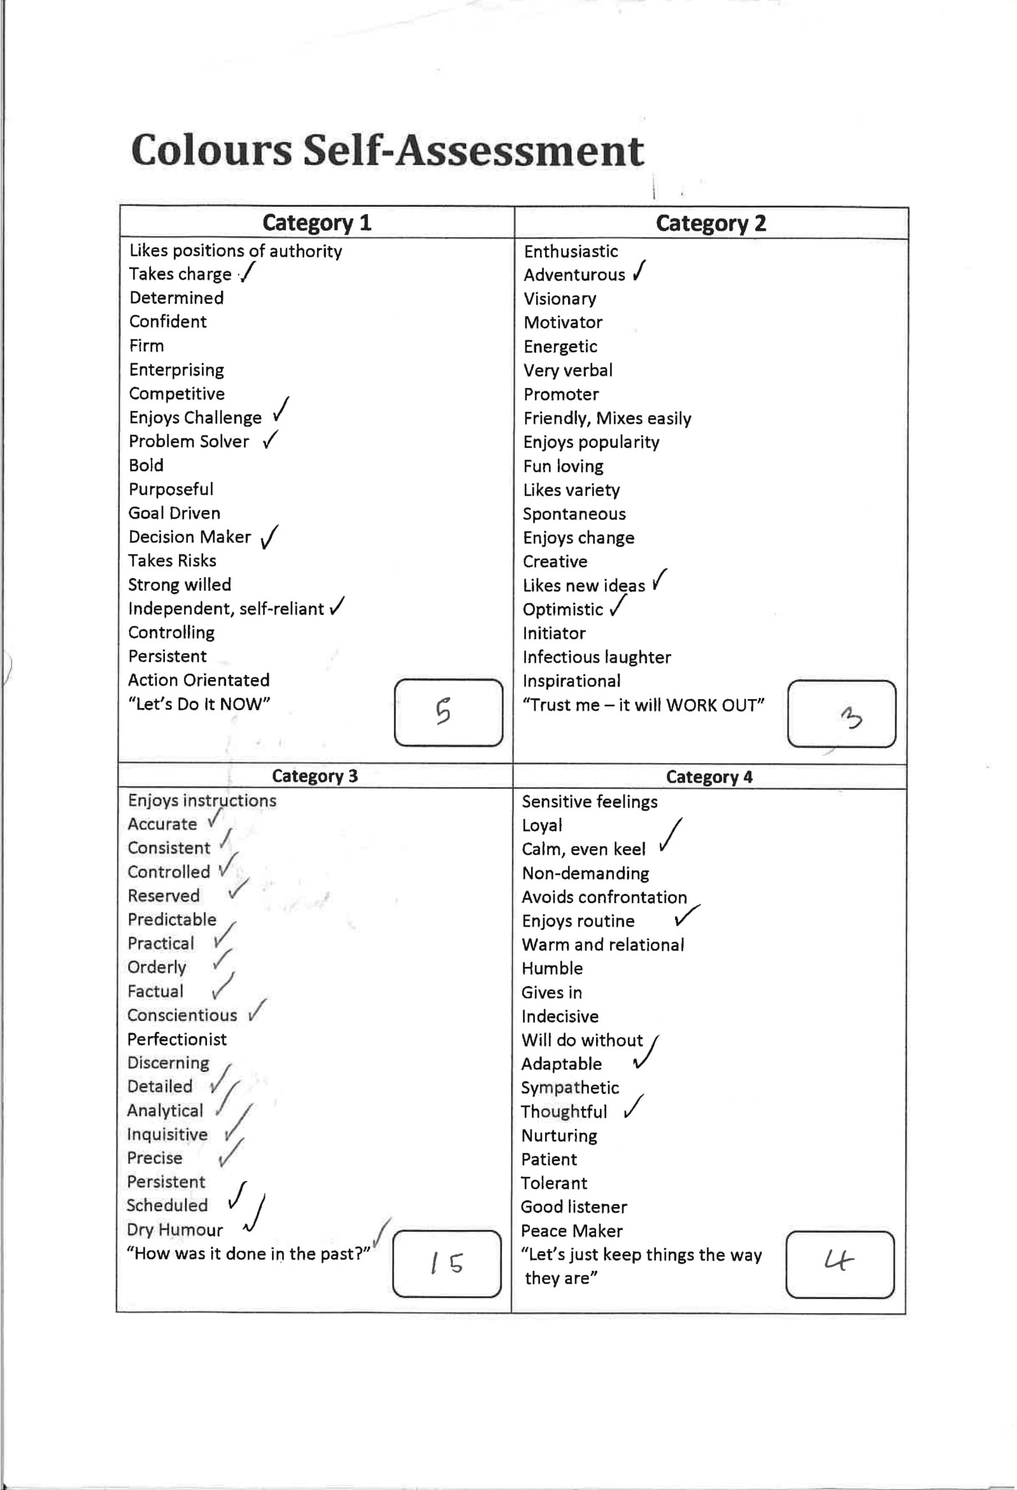
Appendix C:
Skills Audit and Action Plan


