  (Unknown, n.d.)  BUSiNESS PLAN  DR OLUWASEUN ADEGBITE  24TH October 2021 | Shazia C Ayub :2008734 Luminita M Cunescu : 2015625 Aalia A Raja : 2016494 Nicolae C Perca : 2016470 Alberto C Rodriguez : 2020319  BMSW4006

CONTENTS
FUSION-EXECUTIVE SUMMARY 2
BUSINESS/COMPANY OVERVIEW 2
MISSION AND VISION STATEMENT 3
PRODUCTS AND SERVICES 4
Fabric 4
Colour 5
MARKET AUDIT 6
1-SWOT 6
2-Pestel Analysis 7-9
ADDRESSING OUR WEAKNESSES 10
Competitors 11
TARGET MARKET 12
MARKETING PLAN 13
Logo 13
Incentives 14
Leaflet Distribution 15
Front 15
Back 16
Implementation Plan 17
MANAGEMENT TEAM 18-19
FINANCIAL PLAN 20
Profit/Loss 21
VAT Summary 22
CONCLUSION 23
REFERENCE 24

FUSION-EXECUTIVE SUMMARY

This report covers the idea of a unique business setup, which has been overlooked in the Fashion industry. With the coordination and cooperation of five partners of the business, this report has been prepared to spell out the idea and pave an action plan for the smooth materialisation of the business idea.
This report covers, methods adopted and the choice of materials for the finished goods. Reports consider the gaps in the industry and present a refined product plan. It details the roles of all partners of the business. It considers all the factors by deep analysis of SWOT and PESTEL tools. The report has a wide marketing plan and financial forecast of the business.

BUSINESS/COMPANY OVERVIEW

An Italian fashion designer Elsa Schiarelli (Famous Fashion Designers, n.d) once said, in difficult times fashion is always outrageous. (Vogue, 2017) This shows fashion takes form by taking the influence from the era. As the situation in the whole world changing very fast, this is making fashion appear and disappear from the scene at the same pace, as Karl Lagerfeld puts it, Fashion is about change (Vogue, 2017) If only thing permanent in the fashion industry is “change” then, unfortunately, we are paying a very heavy price in the form of landfill and waste resources for this change. On the other hand, fashion especially clothing has the ability for powerful expression. It expresses boldness, boredom, wilderness, modesty, beauty by taking the outer influence and bringing it into an individual’s personality. This is a matter of responsibility, as the world is in chaos, and fashion is very vulnerable in this case.

Fusion has potential customers based in England, Scotland, Northern Ireland and Wales from diverse backgrounds. The business has supplier based in Pakistan. Products are going to be stored in a garage owned by one partner, for free and from there are going to be posted to the customers after payment clearance. The business accepts debit and credit cards as well as PayPal and pays in instalment options.

MISSION AND VISION STATEMENT

Fusion is a web-based clothing business that brings colours of all spectrums and infuses them into the brand. Our mission is to bring fashion under one roof for fashion lovers of all backgrounds. We are conscious fashionable.

Fusion in on the course of seeking ways to set trends of making fashion more sustainable and planet-friendly as well as making fashion a meaningful choice and positive change.

One in four people in the UK are depressed and 6000 suicides are recorded in the country every year. (My therapy, 2017) Patient with depression sees a world less vibrant and colourless. A dull, drab and black and white environment can make depression worse. Such an influence comes from the dull weather and dull colours in clothes. (NICABM, n.d) Fusion aims to add colours to dullness and replace sadness with colours of life. All fashion brands in the country have their particular group of customers fusion seeks not only to infuse colours but infuse all the backgrounds too, by providing one platform for all.

When it comes to the production of the material Fusion adopts environment and climate-friendly methods. Fastest growing plants, which can thrive without needing pesticide is the priority of the business.

Each Briton throws away 3.1 kg textiles in one year and 1.7 kg per person goes to landfill. This behaviour ranks the UK fourth in textile waste. (Circular, 2020) Fusion also seeks for creating recycling points soon, to cope with the problem of landfills. Fusion is looking forward to introducing a repair service to make Fashion more sustainable and a guilt-free choice.

In the near future Fusion has a high potential for growing into a large-scale limited company and a presence in the high streets of the UK.

PRODUCTS AND SERVICES

Fusion has seen a gap in the market for this kind of product, which is affordable, fully degradable, anti-allergy, soft and durable. Creating clothes for those who like colour and fashion. So, they feel beautiful through their brighter outfits. Fashion at its best where east meets west.
Through our clothing line, we are protecting the environment too, saving people and the planet.
Fashion is a growing trend in the market and when things grow rapidly in these fields so is the wastage of textiles in landfills which lands to the release of toxic gas when they decompose.
According to a 2019 report,336 thousand of clothing ended up in a household residual waste in the United Kingdom.
We aim to use only sustainable and fully biodegradable fabrics.

Fabric
- HEMP: This plant takes about four months to get to the maturity. Out of it can be made strong and soft fabric. Hemp requires minimum care and can thrive without any toxic or pesticides. Fibre made of Hemp is fully biodegradable.

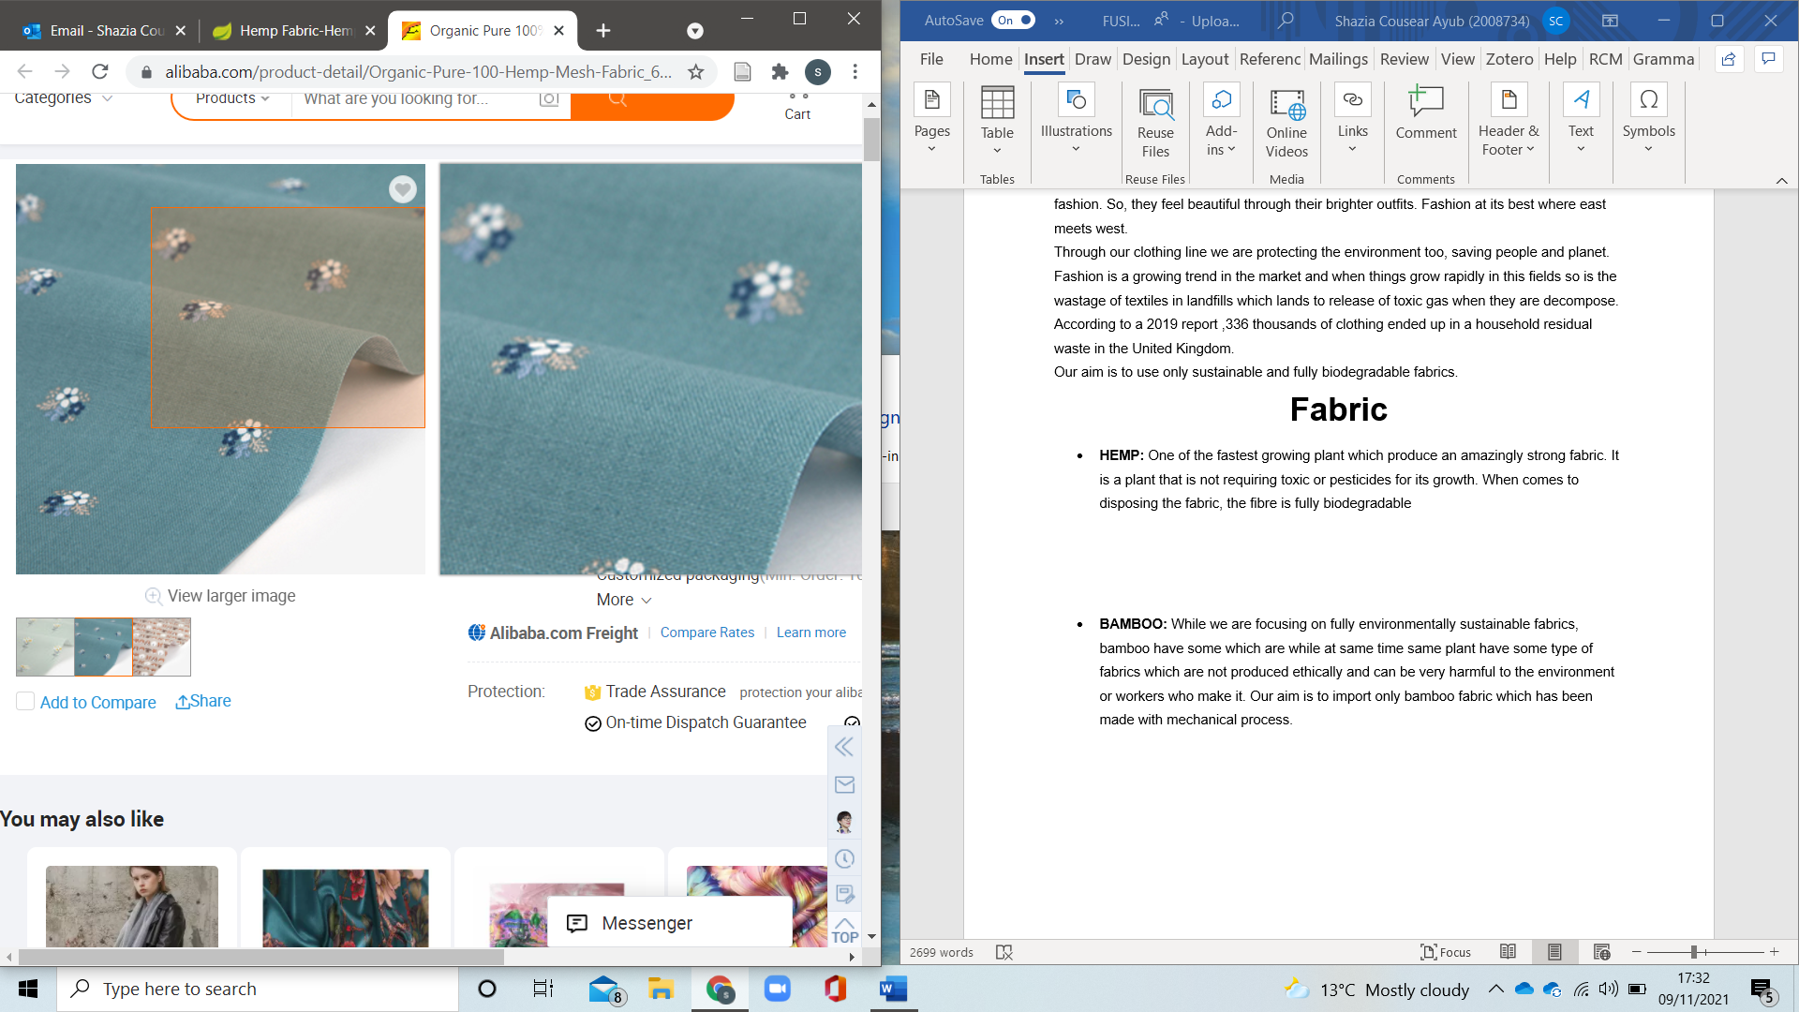
- BAMBOO: As planet friendly practices is our priority, Bamboo is another option for environmentally sustainable fabrics. Fusion only imports the kind of Bamboo fabric which aligns to its planet and worker friendly policies.

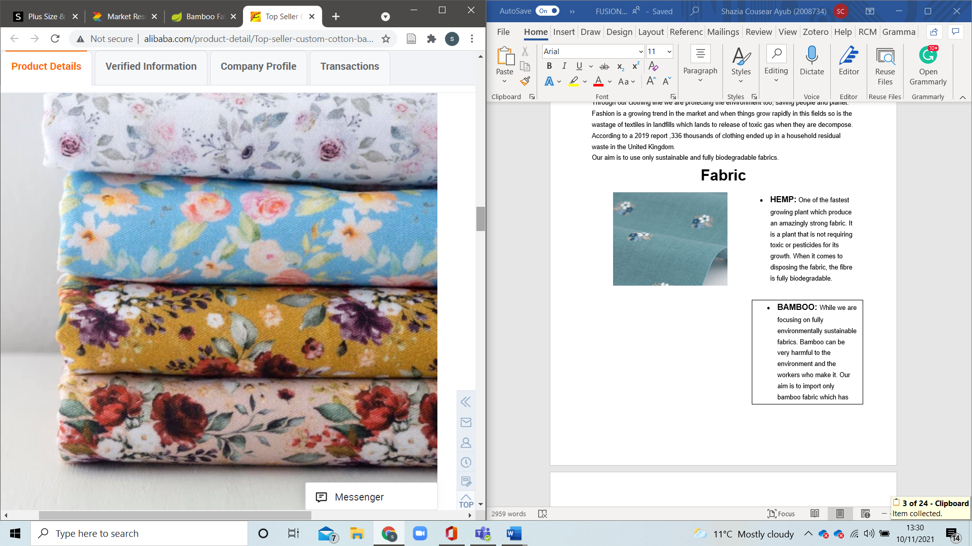

Colour
“The textiles industry of clothing is the second most polluting industry in the world. Synthetic dyes contribute to a big part of this pollution, with about 20 per cent of global water pollution being linked to the textile dyeing process. The main issue is the use of non-biodegradable petroleum-based colourants on the textiles” (Mogilireddy, 2018) that release toxins in the ecosystem. We aim to use an alternative of natural colours extracted from biodegradable plant sources.
In 2016 two synthetic biologists found a company COLORIFIX and researched the contamination in drinking water. They learned about the huge impact of the dyeing industry on water and human health. They are using an eco-friendly and cost-friendly dyeing process. With 68% less water used than conventional methods and 100% natural biologically produced.


Non-toxic use is encouraging us in getting our dye product through this company in our mission of creating colourful sustainable clothing that doesn’t compromise on quality.
(colorifix, 2021)
While some well-established brands like H&M are getting focused lately on sustainability and they are also collaborating with Colorifix, we at Fusion clothing aim in starting with making sure all our products are environmentally friendly.

MARKET AUDIT

1-SWOT

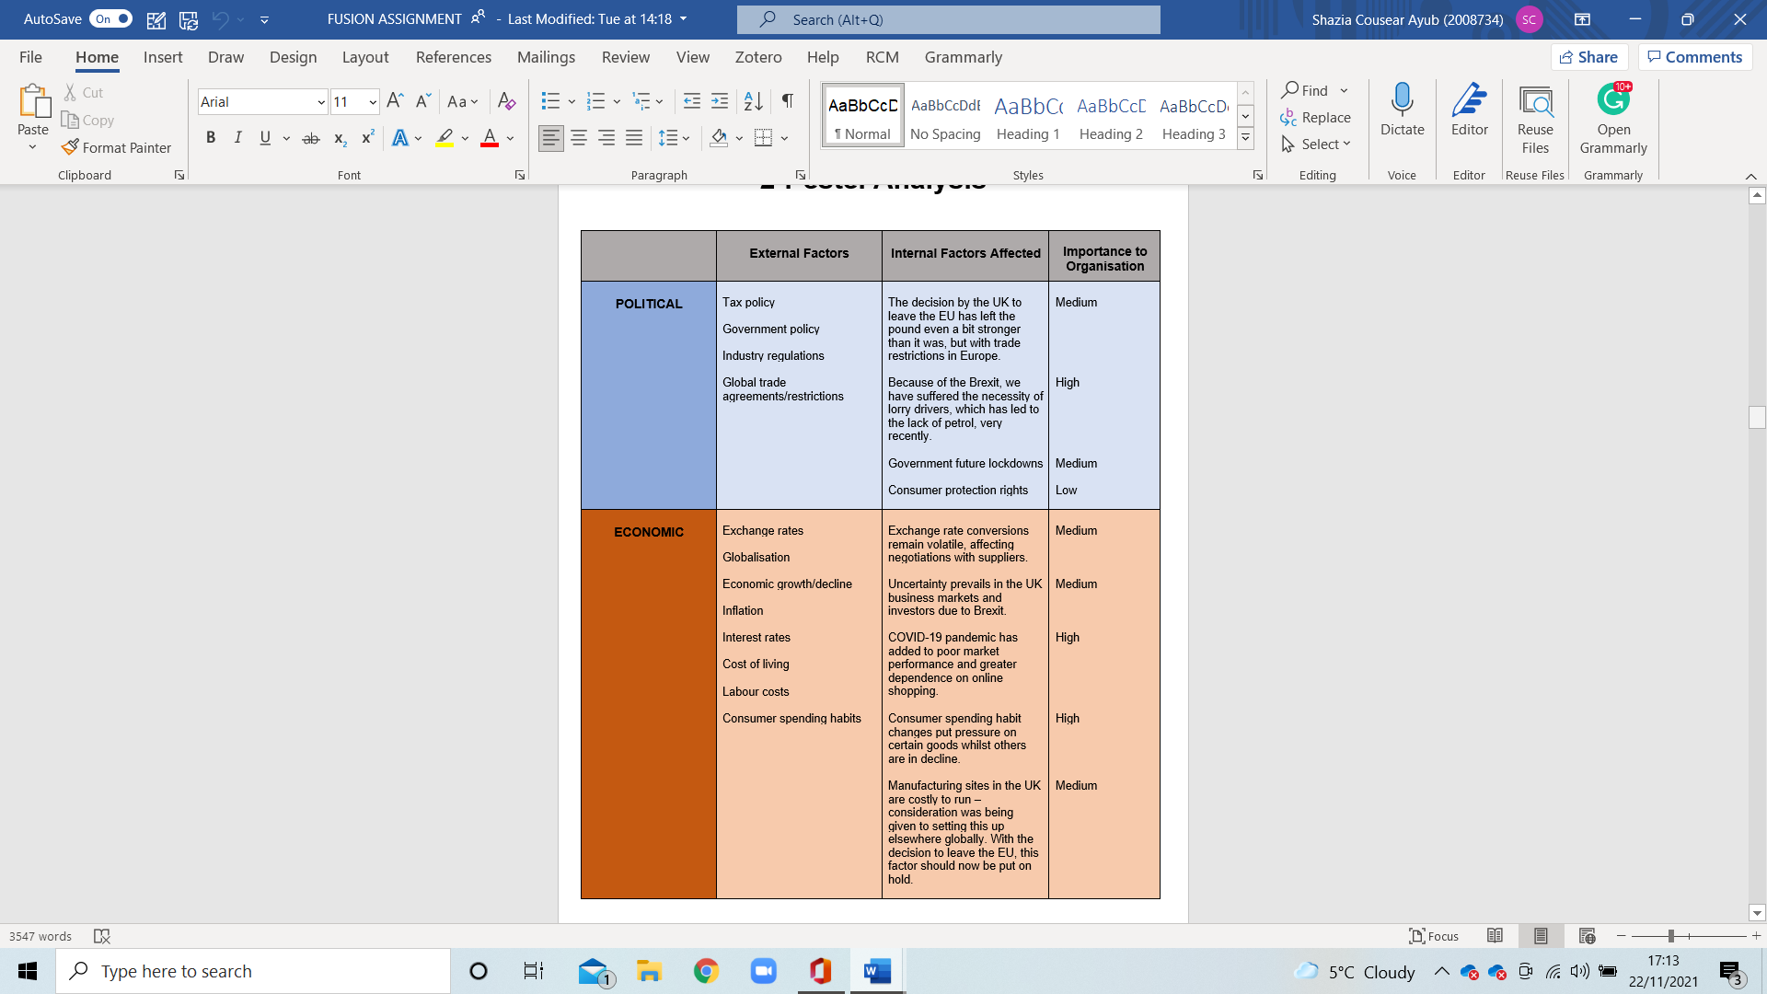
2-Pestel Analysis
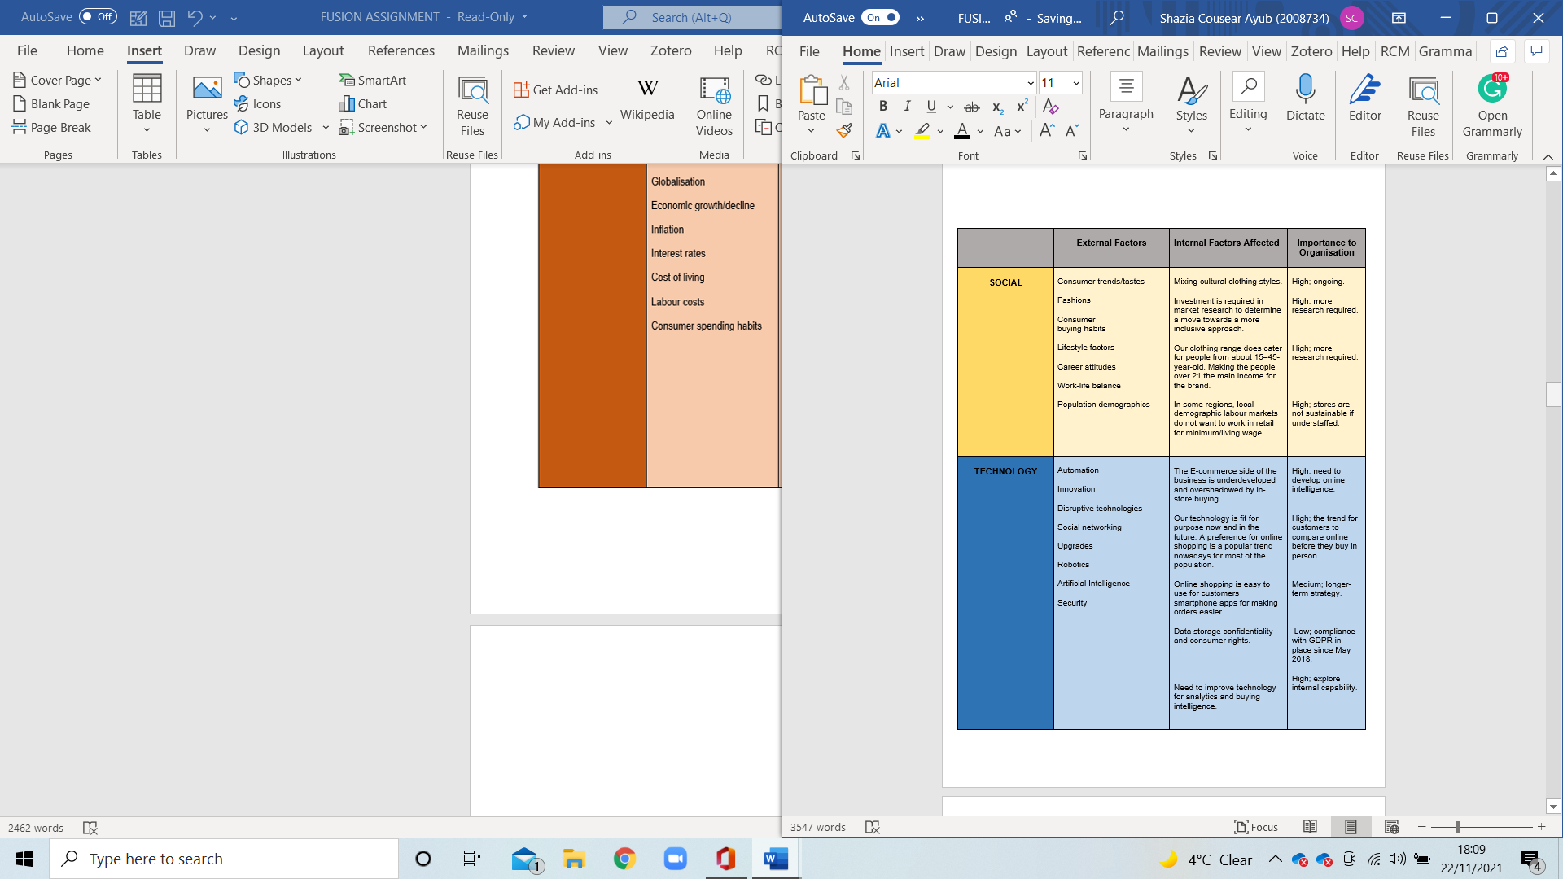

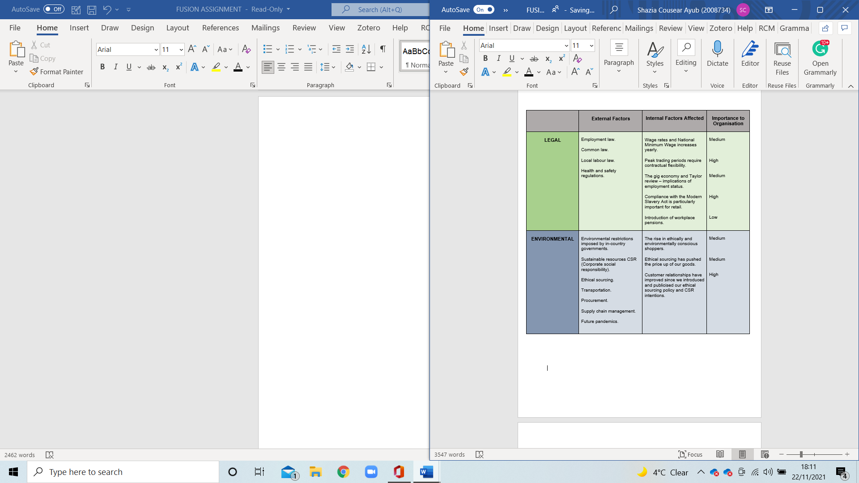
ADDRESSING OUR WEAKNESSES

As the delivery costs are high, Fusion has adopted a cost-effective way for this problem. We have contracted with the post office and on a small fee, we can send out unlimited parcels with no extra cost.
As our suppliers (manufacturers) are based in Pakistan, we also benefit from zero rate custom duty, as Pakistan is in UK’s Enhanced Framework 2027 scheme. (gov.UK, 2021)
To address the problem of no experience, our team is graduating in business at the UWTSD. By the time we step on the ladder of our business, we will have our graduation degree completed and equipped with essential skills.
Our innovative advertising style outweighs our small budget. Our discounts and promotions also help us to advertise our product effectively. A free T-Shirt with our logo is an example of it.
Where pandemic has disrupted the economy, it has also generated a gap in the market. We are working towards filling up some of the gaps.
There is a high difference in the currency of Pakistan and the UK which is working in our business’ favour.

Competitors
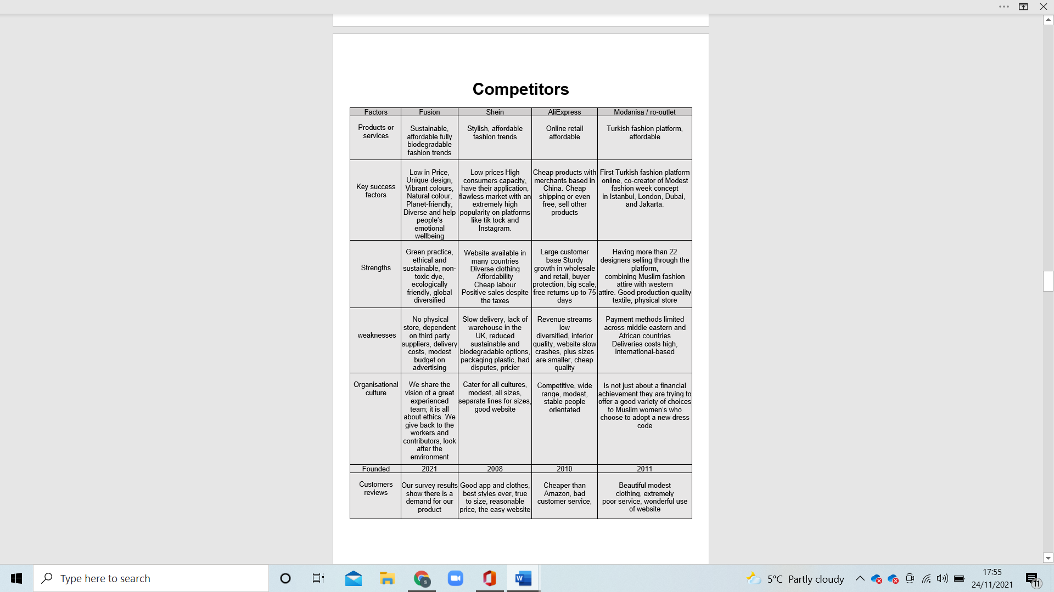

TARGET MARKET
“Target market segments are the (a) ability to reach buyers in the market, (b) competitive positioning are the (c) ability to reach buyers in the market, (d) compatibility of the market with the objectives and resources of the company, (e) profitability, and (f) expected market growth.” (Robert Mora Cortez, 2021)
Loyal and potential customers can complete a survey below to receive a 10% discount on their next order. https://forms.office.com/Pages/ShareFormPage.aspx?id=REPTm4EBUWcuNshUjEeIQGJExUY5KBMmSOYURtnjh1UQ0I4VzFNTkwyV0tFT0lBSjcySFRYR0FJOS4u&sharetoken=EznxKWSZnNtMUeXDa59t

MARKETING PLAN
The key stage to all businesses is the marketing strategies along with the development of the product. “Marketing strategies, tactics, and measurements should be aligned with the needs and behaviours of consumers at each of the decision journey stages. This pushes the customer decision journey beyond abstraction and into the world of practical application-the world of digital marketing analytics”. (Matthew D. Vollrath, 2021)
A way in which you can find the needs of customers is to use surveys and analyse the data to find the gap in the market and give customers what they want so they are more likely to buy your product and for you to thrive as a business.
This has to be constantly monitored and reassessed due to technology advancement and competition. Many stores either closed or scaled-down due to not being able to keep up with the cost of the premises. Online is cheaper, convenient, available anytime and at no cost of premises. Those who advanced online offering delivery, free in-store collection, click and collect or moved onto just online and closed their stores stayed as competitors. During the pandemic, everything went online which is why it's practical to start online and use a good marketing plan to promote the product. The main strategies are listed below.

Logo

Incentives
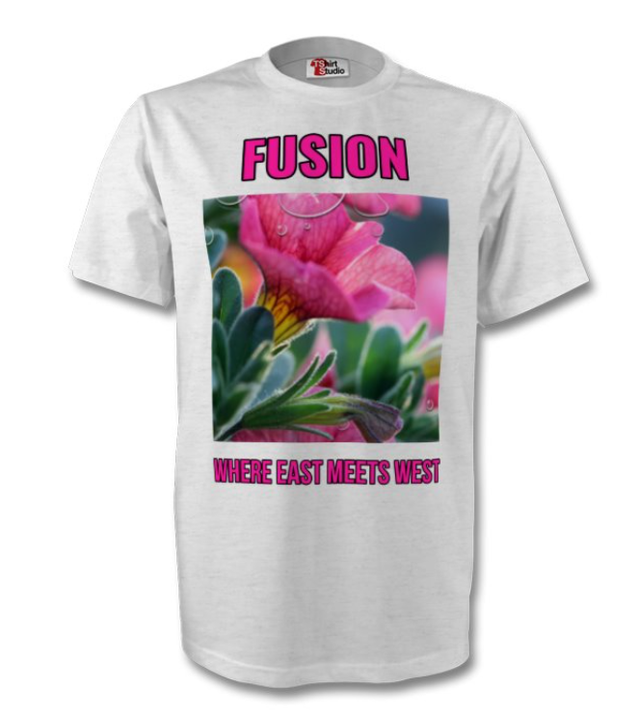
SPEND £100
GET
FREE T-SHIRT

Many companies only supply non-degradable products or use materials that are not anti-allergy, like polyester. Even the ones that have a line of clothing like this use cheap material producing low quality and have high prices. We aim to keep prices lower than the competition produces better quality, vibrant, fashionable clothes that will give us the edge in the market.

Leaflet Distribution

Front
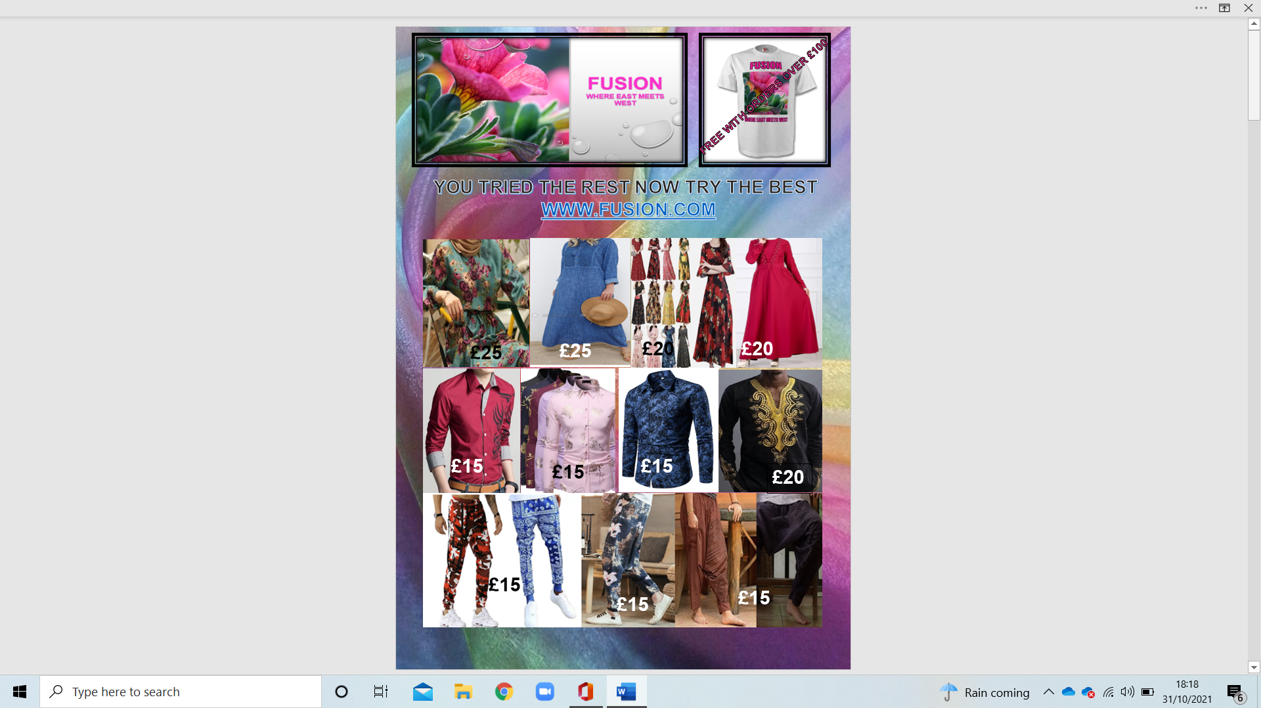
(Lightinthebox, n.d.), (ro.outlet, 2020), (Ebay, n.d.), (Mondanisa, 2021)

Back

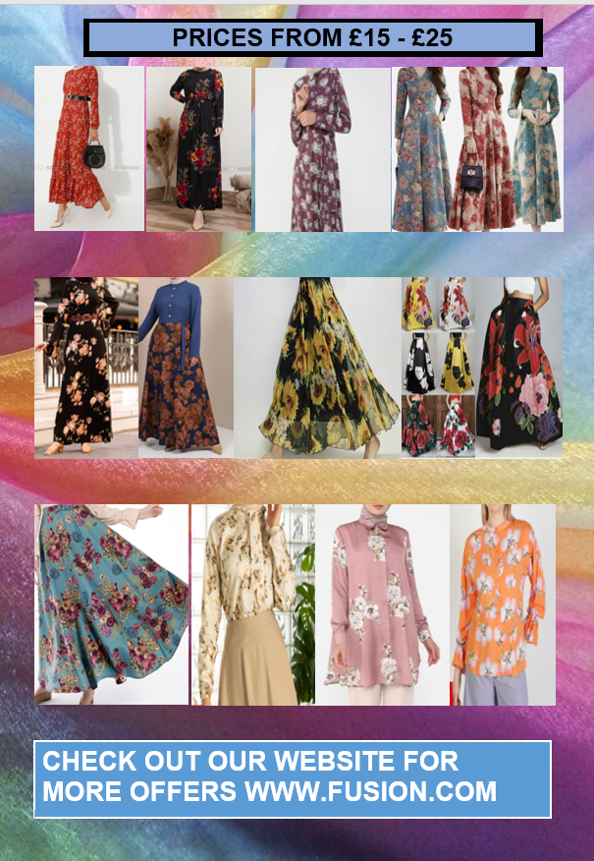
(Mondanisa, 2021) (Ebay, n.d.)

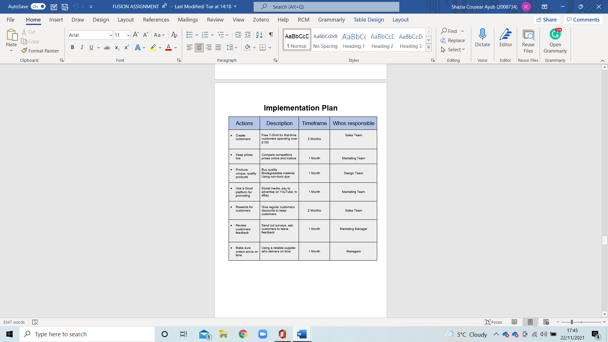
Implementation Plan

MANAGEMENT TEAM

- Luminita Marinela - Sales Manager
Luminita obligations comprehensively incorporate outreach group direction, deals process the board and business improvement. The superb objective of team leads is to accomplish deals targets. Project supervisors’ man of the hour and train their outreach groups towards making deals progress. Luminita additionally designs out deals’ methodologies, investigate past deals information, and estimate future deals execution.
At last, Luminita ceaselessly investigates openings for deals achievement. She works intimately with different groups, including the showcasing group, or potentially the client care group. Further, Luminita keeps up to date with the patterns in the business and sports business openings.

- Aalia Ali - Clothing Designer
Aalia is in the charge of designing and making our clothing. Her duties include overseeing the designs to make them reals, then marketing them for retail. Aalia, also, choosing the themes for designs and collections, participates in fashion shows with designs, picking fabrics colours, designs, and more for pieces, managing the production of pieces, creating prototypes or models, discussing designs with the other management team members, and finding new customer markets for designs.

- Shazia Cousear - Marketing Manager
Shazia unites various capacities, (for example, item advertising, advanced subject matter experts, content, and imaginative groups), adjusting every one of the groups whose work adds to a fruitful program or mission. Likewise address the advertising group to cross-practical groups including item the board, deals, or client care. Shazia might team up with these groups to guarantee new contributions are conveyed in a consistent manner or find new channels to arrive at clients.
She, also, assembles associations with individuals outside the organization. Solid associations with merchants, accomplices, and individuals from the media are significant for distinguishing freedoms to construct attention to the item and better draw in the organization's ideal interest group. An A-Level in Textiles with hands-on experience in the sewing industry designs owns clothes.

- Nicolae-Catalin – Accountant
Nicolae gets ready monetary records, benefit, and misfortune proclamations, and other monetary reports. His responsibilities and duties additionally incorporate examining patterns, costs, incomes, monetary responsibilities, and commitments brought about to foresee future incomes and costs. Reports association's accounts to the board and proposes ideas about asset use, charge methodologies, and presumptions hidden spending plan estimates.

- Alberto Castillo – Supervisor
Alberto uses measurements to show explicitly how you further developed activities, further developed proficiency, and cut expenses. Also, another of his responsibilities and skills are having very good verbal, and relational abilities, remarkable capacity to lead, extraordinary at propelling and tackling issues, solid arranging, and hierarchical abilities, conclusive with the capacity to give clear headings, an incredible cooperative person with the capacity to designate, solid compromise and arranging abilities. Basically, he supports his teammates.

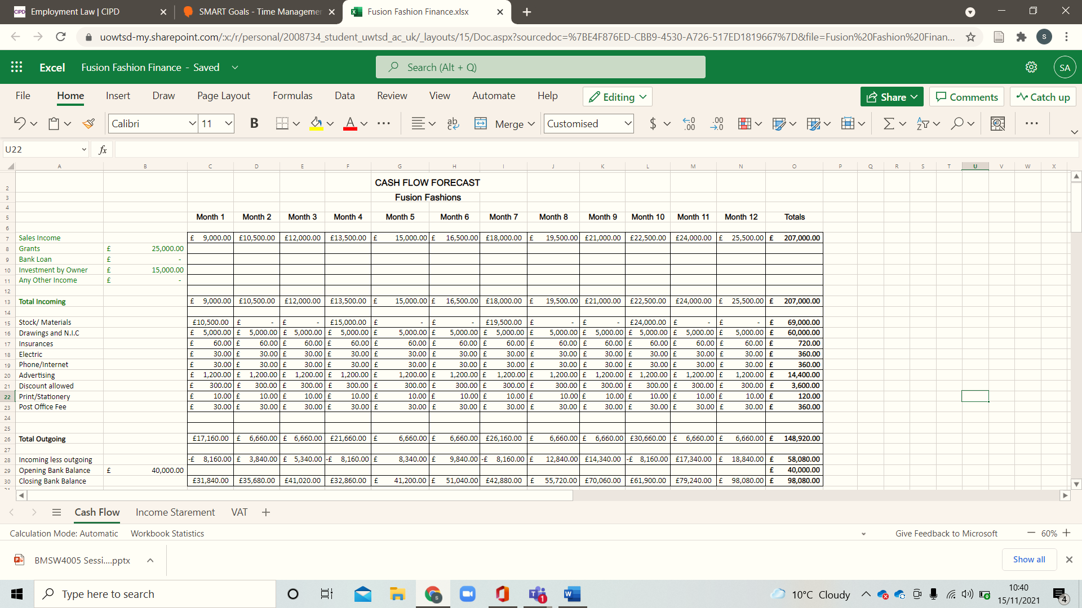
FINANCIAL PLAN

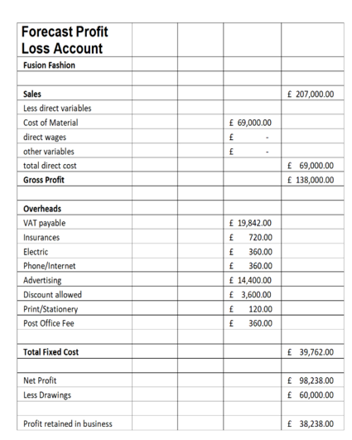
Profit/Loss

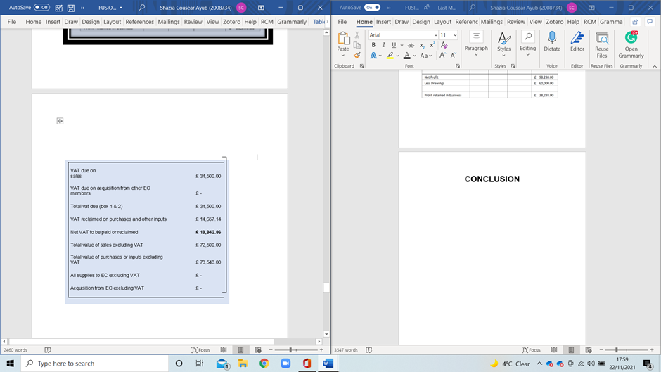
VAT Summary

CONCLUSION

Fusion’s plan shows that the business has a huge potential for growth and expansion. With its unique product, services and mission Fusion has a key place in the market. It’s mission and vision based on ethical and conscious practices adds value into the fashion industry. Internal and external factors affecting business would face and our potential competitors have been given detailed consideration. A well thought and specific advertising plan is presented. Finally, forecast financial reports are there to confirm that this business is going to be profitable and successful.

REFERENCE
Alibaba, 2021. Organic Pure 100% hemp mesh fabric jersey- buy organic. [Online]
Available at: https://www.alibaba.com/product-detail/Organic-Pure-100-Hemp-Mesh-Fabric_60739892747.html?spm=a2700.galleryofferlist.normal_offer.d_image.2f9326e8rBDNUb
Circular, 2020 UK named fourth largest textile waste producer in Europe Available at: https://www.circularonline.co.uk/news/uk-named-fourth-largest-textile-waste-producer-in-europe/
(Accessed: 04 November 2021)
colorifix, 2021. Our Impact - colorifix. [Online]
Available at: https://colorifix.com/why-colorifix/
[Accessed 09 11 2021].
Ebay, n.d. eBay. [Online]
Available at: https.//www.ebay.co.uk
[Accessed 31 October 2021].
Famous Fashion Designers, (n.d), Elsa Schiaparelli, Available at: https://www.famousfashiondesigners.org/elsa-schiaparelli
(Accessed: 04 November 2021)
Lightinthebox, n.d. Lightinthebox. [Online]
[Accessed 31https://www.lightinthebox.com/c/men-s-clothing_5585/2.html?prm=1.2.58.0#prodSortBar October 2021].
Matthew D. Vollrath, S. G. V., 2021. Avoiding digital marketing analytics myopia: revisiting the customer decision journey as a strategic marketing framework. Journal of Marketing Analytics (2021), Issue https://doi.org/10.1057/s41270-020-00098-0, p. 1.
Mogilireddy, V., 2018. Sustainable dyeing innovations: Greener ways to colour textiles. [Online]
Available at: https://www.prescouter.com/2018/11/sustainable-dyeing-innovations-greener-ways-color-textiles/
[Accessed 09 11 2021].
Mondanisa, 2021. Mondanisa. [Online]
Available at: https://www.modanisa.com/en/plus-size-dresses.htm
[Accessed 2021 October 2021].
My Therapy, 2017. Depression in the UK: The facts and figures you should know. Available at: https://www.mytherapyapp.com/blog/overcome-depression-uk-infographic-2017#:~:text=Depression%2C%20anxiety%20or%20phobias%20%E2%80%93%20each%20year%2C%201,this%20mental%20disorder%2C%20and%20that%20number%20is%20increasing.
(Accessed: 04 November 2021)
NICABM- National Institute for the Clinical Application of Behavioural Medicine, Depression: The Connection between Colour Perception and Mood, Available at: https://www.nicabm.com/depression-the-connection-between-color-perception-and-mood/
(Accessed: 04 November 2021)
ro. outlet, 2020. ro. outlet. [Online]
Available at: https://ro.outletshop2021.ru/category?name=bluza%20barbati%20camasa
[Accessed 31 October 2021].
Robert Mora Cortez, A. H. C. P. V. F., 2021. B2B market segmentation: A systematic review and research agenda. Journal of Business Research, 126(2), p. 422.
Unknown, n.d. live.staticflickr.com. [Online]
Available at: https://live.staticflickr.com/3385/3582897494_3f5eeea575.jpg
[Accessed 21 oct 2021].
Vogue, 2017. Elsa Schiaparelli’s Closet is up for grabs this Paris Fashion Week
Available at: https://www.vogue.com/article/designer-elsa-schiaparelli-vintage-clothing-for-sale
(Accessed: 04 November 2021)
UK Integrated Online Tariff, (2021) Geographical area 2027-GSP-Enhanced Framework
Available at: https://www.trade-tariff.service.gov.uk/geographical_areas/2027?country=PK
Accessed on (13 November 2021)

