Student Name: Charlotte Esi Jackson
Student ID Number: 22223874
Module Code: LCHS7009
Module: Population Health and Digital Health Promotion
Assignment Title: Poster
Lecturer: Dr Raheela Shaikh

References

Glanz, K., Rimer, B.K. and Viswanath, K. eds., 2015. Health behavior: Theory, research, and practice. John Wiley & Sons.
National Institute for Health and Care Excellence (2025) Obesity: Identification, Assessment and Management (NG246). London: NICE. https://www.nice.org.uk/guidance/ng246/resources/overweight-and-obesity-management-pdf-66143959958725 Accessed on 1 Jul 2026
Office for Health Improvement and Disparities (2024) Adult Obesity Profile. London: Department of Health and Social Care. Available at: https://fingertips.phe.org.uk/profile/obesity-physical-activity-nutrition (Accessed: 2 July 2026)
Kouvari, M., Karipidou, M., Tsiampalis, T., Mamalaki, E., Poulimeneas, D., Bathrellou, E., Panagiotakos, D. and Yannakoulia, M., 2022. Digital health interventions for weight management in children and adolescents: systematic review and meta-analysis. Journal of medical Internet research, 24(2), p.e30675.
Rosenstock, I.M., 1974. Historical origins of the health belief model. Health education monographs, 2(4), pp.328-335.
World Health Organization (1986) Ottawa Charter for Health Promotion. Geneva: World Health Organization. https://www.who.int/teams/health-promotion/enhanced-wellbeing/first-global-conference Accessed on 1 Jul 2026
World Health Organization (2021) Global Strategy on Digital Health 2020–2025. Geneva: World Health Organizationhttps://www.who.int/publications/i/item/9789240020924. Accessed on 1 Jul 2026
World Health Organization (2024) Obesity and Overweight. Geneva: World Health Organization. https://www.who.int/news-room/fact-sheets/detail/obesity-and-overweigh

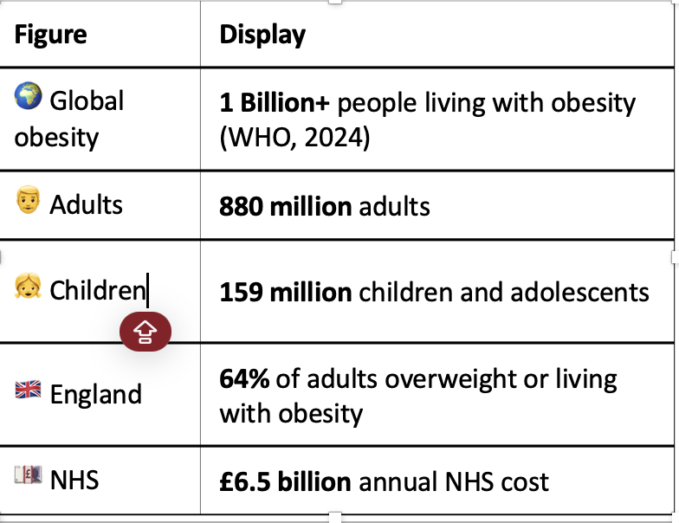
Chronic obesity increases the risk of type 2 diabetes, cardiovascular disease, hypertension, and several cancers (World Health Organisation, 2024). More than 1 billion people—880 million adults and 159 million children and adolescents—were obese in 2022 (World Health Organisation, 2024). 64.0% of English adults were overweight or obese in 2022/23, causing health inequalities, higher healthcare costs, and worse quality of life (Office for Health Improvement and Disparities, 2024). In 2024, obesity costs the NHS £6.5 billion and society £58 billion (Office for Health Improvement and Disparities). Mobile health (mHealth) apps provide personalised self-monitoring, goal-setting, and real-time feedback, making long-term weight management easier and more scalable (Kourvari et al., 2022; National Institute for Health and Care Excellence, 2025). Dietary counselling and physical activity programmes remain

