A Report to The Management Team of Trinity Social Care Home Birmingham on Effective Team Working for Effective Team Success
By
Tuty Jallow Sarr
2027118
Effective Team Working and Communication BMSW4002_BIRM
Vasilios Tavlaridis

Summary
This report will focus on section 1 the development of effective team working and outlining an appropriate model that best suites the facilities. Section 2 concentrates on the different roles and responsibilities of team members in achieving effective team working. Section 3 explores on the advantages of having effective team work in Health and Social Care setting (Assignment brief, 2021, p. 1 -2). Section 4 will focus on barriers to effective team working and section 5 provides recommendation and conclusion on how diversity can be a useful resource for the team.
Contents Page
 | Contents | page
 | Title | 1
 | Summary | 2
 | Contents Page | 2
 | Introduction | 3
1 | How to go about Developing Effective Teamwork | 3
 | 1.1 Description | 3
 | 1.2 Choosing Appropriate Model | 4
2 | Types of Roles for Cohesive and Effective Teamwork | 5
 | 2.1 Description of Roles | 5
 | 2.2 Types of Roles | 5
3 | Impact of Effective Team Working on Health and Social Care Setting | 7
 | 3.1 Description of Effective Teamwork | 7
 | 3,2 Positive Impact of Effective Teamwork | 7
4 | Barriers to Effective Team Working | 8
 | 4.1 Description | 8
 | 4.2 Barriers | 8
5 | Recommendations and Conclusion | 8
 | Reference list | 10
Introduction
Trinity Social Care Home Birmingham (TSCHB) is a residential facility providing personal care of up to eight people with dementia. It has a diverse workforce ‘in terms of gender, demography, age, background and experience’ (Care quality commission, 2020, p. 1). In 2019 an inspection found a lots of concerns about the quality of services (Care quality commission, 202, p. 1). Diversity is the combination of different individual with different attribute that needs to be mutually bonded for the achievement of their set goals. In a workplace diversity is a collection of sensible practices that needs a thorough understanding. (Cletus, et al., 2018, p. 37).
Given the forgoing, section 1 of this report will focus on how to develop an effective teamwork, outlining an appropriate model that best suites the facility’s situation; section 2 will concentrate on the different roles and responsibilities of team members in achieving effective teamwork, given the best possible technic from the literature review that best suits the facility. Section 3 will look at the impact an effective teamwork can have in a Health and Social Care setting; Section 4 will focus on barriers to effective team working and section 5 is recommendation and conclusion on how diversity can be a useful resource for the team.

Section 1: How to go About Developing Effective Teamwork for Trinity Care Home Birmingham (TSCHB)
1.1 Description - The term “Team is defined as “number of individuals working to achieve a particular goal to which they are mutually committed – example football team” (Morgan. 2017, p. 204). Diversity in a team as agreed by many scholars is to ensure every member of the team is seen as resourceful individual with the required qualification and characteristic essential to contribute to achieving the set goals. (Diversity in health and social care: learn how to promote, 2021, p. 2).

As the case study indicated, TSCHB has a diverse staff group. This notwithstanding, they are all mutuality bonded towards achieving the set goals. Therefore, first and foremost, we must look at the three essential elements of an effective team as highlighted by Coyle (2018, p.). These are as follows: context, composition, and process.

Context: are there adequate resources, enabling work climate of trust no conflict, performance reward system and effective leadership structure?

Composition: does team members have capability and qualification to do the work, is the allocation of roles okay, is the team diverse what is the right size, is there flexibility in task allocation?

Processes: is there a specific goal and common purpose the team? What is the social liaison like? It is assumed that all the above elements are in place at the facility. The major concern is the diverse nature of the employees which is affecting the effectiveness of the quality-of-service delivery.

Tarricone and Lica (2002 pp. 640- 644) states that the teamwork effectiveness will large rely on all team members creating an environment where they all equally contribute, participate and nature to promote an effective team. They went on further to say and agreed by Arrow et al., (2004, p. 4) that effect teamwork is a ‘vibrant social system’ and will change overtime and in so doing will go through a series of stages to become effective’. This depends on number of factors such as the leadership style, the Team combination, context, individual characteristics, and processes and models applied to achieve effective teamwork.

1.2 Choosing Appropriate Models - in the literature review, several developmental models for effective team working were available such as Wheelen 1999 model, Rubin, Plovnick, and Fry’s GRPI Model, Tuckman’s FSNP, who aligned relationship of team members and the like of Gersick 1988 model, Katzenbach and Smith, the TZ model, who are more on task base relationship. Most of them are similar on many aspects with slight differences and the model chosen will depend on the situation. I believe that Rubin, Plovnick, and Fry’s GRPI model together with culture code of Coyle (2018, pp. 8 - 11) for effective team building would be the best step in the right direction for TSCHB team. This model would be best because the TSCHB lost its path because of the diverse nature and needs to find its way back to purpose. (7 popular team effectiveness models and what they’re best suited for: understanding the various ways your team can reach the top, 2019, pp. 2 - 4).
The GRPI Model
- Goals – management should ensure that there is sense of direction by providing set goals, otherwise there will room for ‘dispute and disagreement’.
- Roles – they should ensure that each member have a clear understanding of what his/her duties and responsibilities are, where their authorities are, and what they should be accountable for to avoid conflict. If conflict arise which is inevitable address properly and move on
- Procedures – management should also ensure that policies, procedures, and processes are in place for successful operation. These are things like decision making methods, workflow procedures, conflict resolution strategies, and communicating best practices to name a few
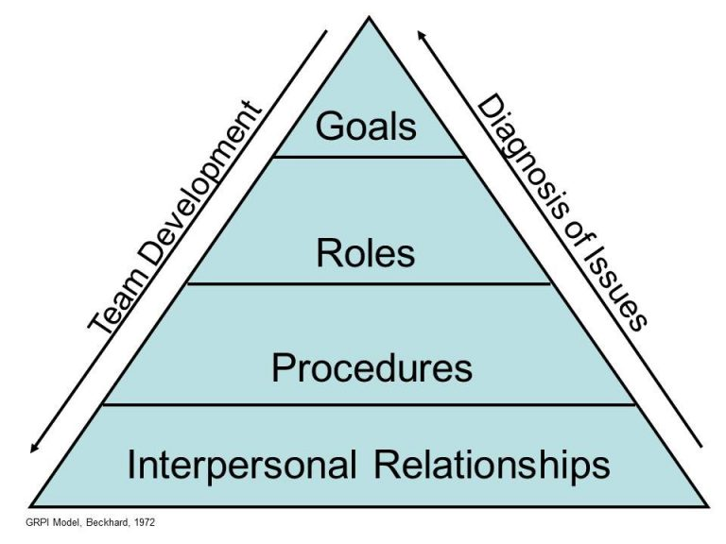
- Interpersonal Relationships – it is of upmost importance for members to build interpersonal relation to develop trust to ensure sense of belonging, good communication and adapting togetherness (7 popular team effectiveness models and what they’re best suited for: understanding the various ways your team can reach the top, 2019, pp. 2 - 4). See illustration 1 below

Fig 1 the GRPI Model from www.zenkit-blog.com
.
Management shouldn’t lose the sight that each team member is unique with characteristics, qualities, experience, and qualification that can drive teamwork success, which the next section will explore.

Section 2: Roles needed for Cohesive and Effective Teamwork
2.1 Description - Roles needed in a teamwork are those attributes required to perform the stifle responsibilities such as individual characteristics, experience and knowledge, and qualification as outlined by Belbin (2008).
2.1 Types of Roles - Mesmer-Magnus et al. (201, p.) attest on their study that the ‘roles-play in a teamwork is real representation of its adhesive and effectiveness’. ‘Effective team behaviour and successful team performance ‘is characterised by the roles-plaid. Most of these scholars agreed that there are certain roles needed to relate teamwork and performance. Most of them identified similar roles such as Tarricone and Lica (2002 pp. 640- 644). Belbin (2008, p. 28 - 29) Outlined 9 roles summed up to 3 as shown below.
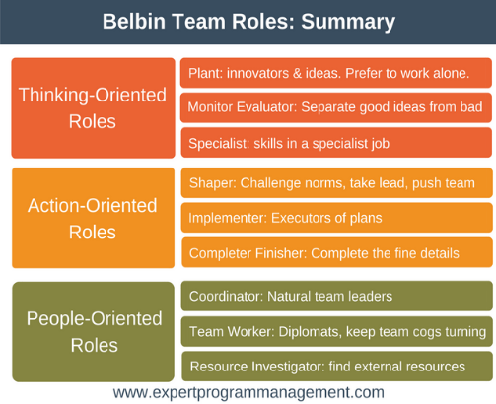
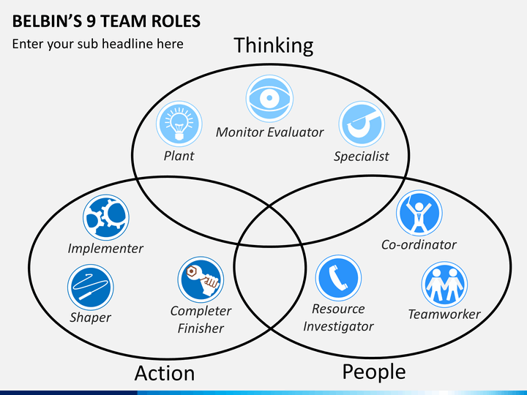

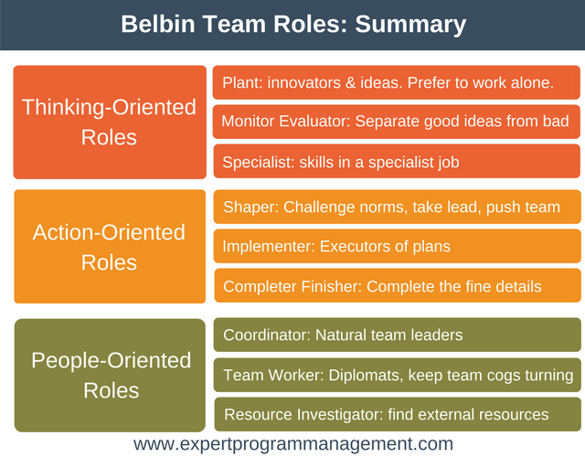

Fig 2 Belbin Team Roles (Belbin, 2008, pp. 27 - 28)

For the TSCHB team to collaborate effectively as a team and provide high standard quality services, the team should have a combination of these roles highlighted by Belbin (2008), as well as the five attributes identify by Pentlan (2008, p. 13) see fig 4
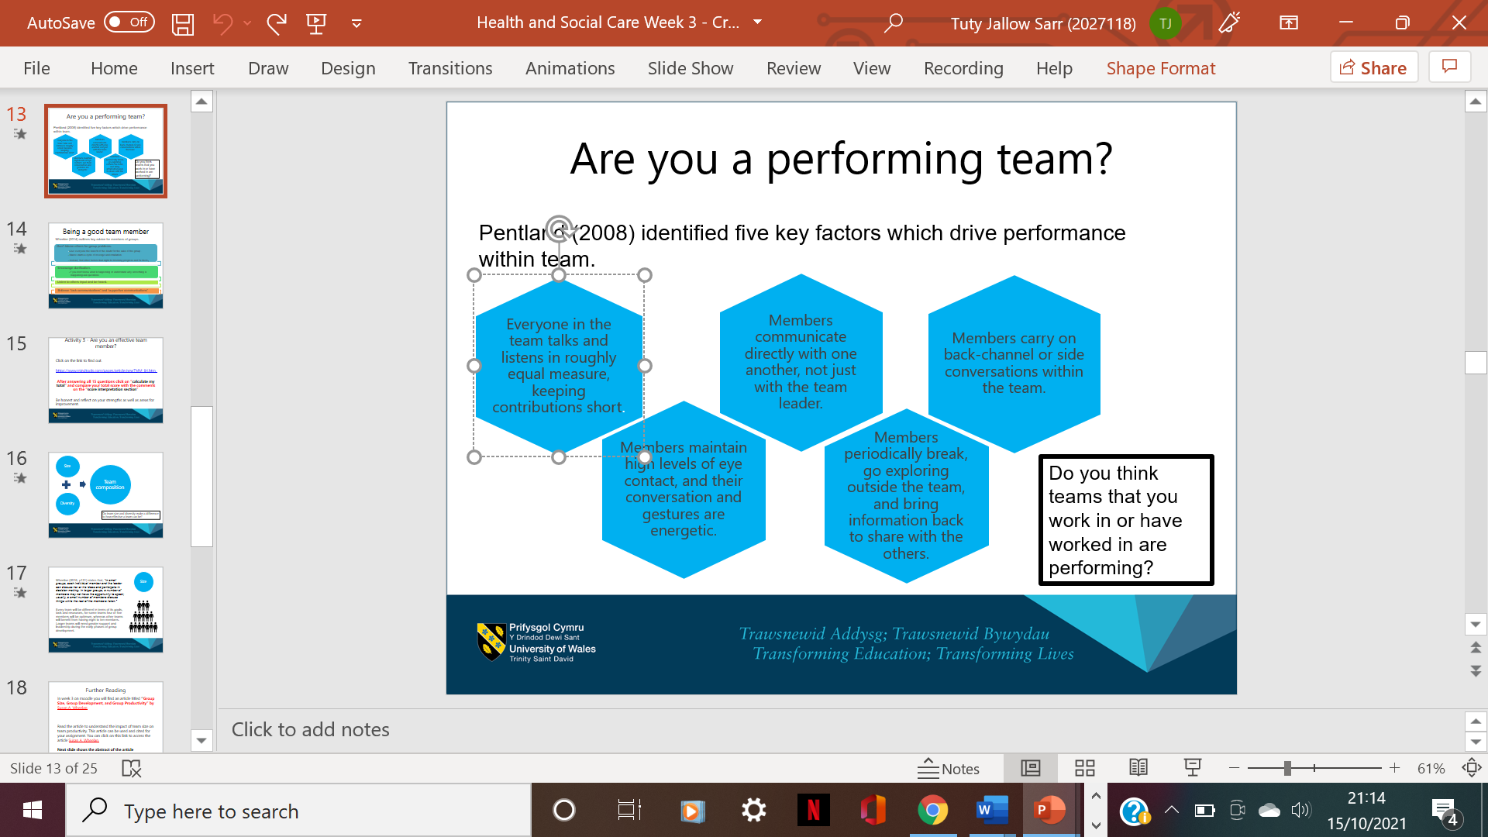

Fig 3 Pentlan five factors of effective team working (Pentlan, 2008, p. 13)
It’s all about committed and willingness to contribute and collaborate towards achieving set goals. In other to achieve this, the facility would have to develop a clear define goal with policies and strategies. These have to be communicated, shared, accessible and own by the entire staff. The staff would have to be provided with the conducive work environment in terms of material, policies and other facilities that will boost their commitment and love for their job. (Cook and Ummer, 2009, pp. 2 -12).

Section 3: The Impact of Effective Teamwork in the Health and Social Care Setting:
3.1 Description - Effective teamwork can have a vast impact on the Health and Social Care setting as outlined by Coyle (2018, pp. 8 - 11), is that individuals in a team will be more committed, have a sense of belonging and willingness to perform at their upmost if there is trust cohesion and empathy in their work environment. Individuals working in such at atmosphere constitute an effective and efficient team. (Stark, 2016, pp. 1-8).

3.2 Positive Impact of Effective Team - Given the diverse nature of the employees at the TSCHB in terms of (gender, age, demography, cultural background, and experience), the facility can tap into their various experiences to develop best practices in information sharing and task implementation. In other to achieve this, the facility would have to develop a clearly define goal with policies and strategies. These must be communicated, shared accessible and own by the entire staff. For instant Muslim women generally wants to be attended to by female, not male worker. Given the diversity of the TSCHB team such need can easily be satisfied. In this way the patient’s religious beliefs can be respected, thus, both customer and staff are satisfied and burst the quality of services and standard of work. Similarly, team members can serve as translators when communicating with patients who can’t speak English. Thus, achieving staff/customer satisfaction and less expenses for the facility. This will boost the quality of services and standard of services at the facility.

Section 4: Barriers to Effective Teamwork

4.1 Description - Barriers are those factors that will prevent the easy achievement of our set objectives or goals. This can be factors such as mostly characteristics of the team composition, the leadership style, lack of commitment, Lack of proper communication channels, and lack of set objectives policies strategies and procedures.

4.2 Barriers - The diverse nature of the employees at the facility and lack of clear policies and procedure is the root cause of effective team working. However, management of the facility are not tapping into various experiences and knowledge to develop best practices in information sharing and task implementation causing barriers to standard and quality services. Lack of clearly define goal with policies and strategies is causing team members to lose a sense of direction and purpose. They cannot identify themselves with the facility. For instant there is no commitment, shared vulnerability trust and willingness to undertake responsibility as required. The difference in background will pose serious communication problem. Also, there is the risk of sub-groupings the ‘US and Them’ (individuals from the same background sticking together) wanting to work together instead of as a team This can pose serious problem as outlined by Kaba et al. (2016, p. 12)

“…..Incidence of medical error, adverse clinical events and poor-quality health care is unacceptably high and there are data to suggest that poor coordination of care, or teamwork, contributes to adverse outcomes”.

These barriers if not addressed can lead to serious medical errors as outlined by Kaba et al., (2016, pp. 10 - 12). TSCHB management is strongly advice to implement the measures featured in this report in order to achieve a cohesive team as well as quality service delivery.

Section 5: Recommendation and Conclusion
From the foregoing, I personally believe that there is more to these theories and technicalities for teamwork to be effective. In practical terms and my personal experience working in different sectors in UK for over 20 years, it is not the five stages highlighted by Coyle (2018), nor the 9 roles of Belbin (2008). It should be together with the right combination of the team. Commitment in achieving set goals and target, the willingness and positive attitude towards assuming one’s responsibility, respecting individual’s differences coupled by a trusted and supportive management are also essential factors. This will positively boost an individual’s moral and self-esteem towards bonding mutually in achieving goals. Nonetheless, management should make it a reality by ensuring that all diverse sectors of the team are treated equally and are involved in decision making processes. There shouldn’t be any institutional biasness or racial, gender, or racial bureaucracy as these are major issues harming diverse teamwork success. Every team member must truly be accepted, trusted, and seen as a resourceful individual with qualities and characteristics that can mutually add value toward achieving the set goals. As experience has shown, diverse nature in teams poses critical issues that management don’t always address the way they should owing to lack of standard procedures. In reality, and as agreed by Kaba, et al., (2016) it depends on the individual formation of the team, the situation and the interaction between individual team members for the team to be effective.

Reference List

‘7 Popular team effectiveness models and what they're best suited for: understanding the various ways your team can reach the top’. (2019) Zenkit [blog]: Avialable at: https://zenkit.com/en/blog/7-popular-team-effectiveness-models-and-what-theyre-best-suited-for/. (Accessed: 7th October 2021/2021).

Arrow et al., (2004, p. 4) ‘Stages of team development and tam roles’, in Moodle week 2; uwtsd: London. Available at: https://moodle.uwtsd.ac.uk/course/view.php?id=5299 (Accessed: 27th September 2021)

Belbin, M. (2016) Team role circle, Available at: https://www.belbin.com/media/2302/belbin-team-role-circle.pdf. (Accessed: 9th October2021).

Care quality commission. (2020) Trinity view care home. [Report] 28 Febryary. Available at https://www.cqc.org.uk/location/1-5953323423/reports (Accessed 9/10/2021).
Celtus, H. E. et al. (2018). ‘Prospects and challenges of workplace diversity in modern day organisation: a critical Review’. Holistica journal of business and public admistration; vol 9, Issue 2, [pdf]. pp.35-52. DOI:10. 2478/hjbpa-2018-0011. Available at: https://sciendo.com/pdf/10.2478/hjbpa-2018-0011 (Accessed: 12th October 2021).
Cook, S, Cook, S, and Ummer, F (2009) ‘Characteristics of a high-performance team’, in Building a high-performance team: proven techniques for effective team working, IT Governance Ltd: Ely. Available at: file:///C:/Users/tutya/Downloads/BuildingCHARACTERISTICS_OF_A_HIGH-PERFORMANCE_TEAM)%20(2).pdf. (Accessed: 12th October 2021).
Coyle, D. (2018) ‘How to think about culture’. Daniel Coyle [Blog]: 6th February. Availble at: http://danielcoyle.com/2018/02/06/how-t o-think-about-culture/ (Accessed: 14th October 2021).
‘Diversity in health and social care: learn how to promote’, (2021). Training Express [Blog}: Available at: https://www.trainingexpress.org.uk/diversity-in-health-social-care/ ( Accessed: 7th October 2021).
Kaba, A. et al. (2016) ‘Are we at risk of groupthink in our approach to teamwork interventions in healthcare?’, Medical education, vol 50. Doi: 10.1111/medu.12943. Available at: https://pubmed.ncbi.nlm.nih.gov/26995480. (Accessed: 12th October 2021).
Mesmer-Magnus, J. e. (2017). The cognitive underpinnings of effective teamwork: a continuation. Career development internation ; vol/ 22 (5): Available
Morgan, P. (2017), The Business Student’s guide to study and employability,2nd edn. Los Angeles: SAGE.
Schumtz. J B, Meier. L L and T Manser. (2010 ) September. 12). 'How effective is teamwork really? The relationship between teamwork and performance in Healthcare teams: a systematic review and meta-analysis'. BMJ journal, vol 9, (9). Availble at: https://bmjopen.bmj.com/content/bmjopen/9/9/e028280.full.pdf (Accessed: 14th October 2021).
Stark, N (2016). ‘A project team analysis using Tuckman’s model of small group development’. Journal of Nursing Education • Vol. 55, No.12.pp. 1 – 13. Available a:t file:///C:/Users/tutya/Downloads/Natvig%20Stark%20(2016).pdf (Accessed: 10th October 2021).
Tarricone, P and Lica, J. (2002) ‘Successful teamwork: a case study’, in week 3 moodle, greating effective teams, uwtsd: London. Available at: https://moodle.uwtsd.ac.uk/course/view.php?id=5299 (Accessed: 9th October 2021).

Wheelan, S.A., (2016), Creating effective teams, 5th Ed, London, SAGE, in week 2 moodle, stages of team development, pp. 1 – 32. (Accessed 7/10/2021).

