Marketing plan is written for

Raffles Hotel

Student Name

____Alexandra-Gabriela Nita___

Student ID number
_____2215565_____

Marketing Essentials BMIH4005

Lecturer

_____Luciana Suardi____

Table of Contents
1 Introduction 3
2 Situational Analysis 3
2.1 SWOT Analysis 3
2.2 Segmentation and Targeting 4
2.3 Competitors 4
2.4 PESTLE Analysis 4
3 Objectives 5
4 Strategy 6
5 Tactics 6
5.1 Product 6
5.2 Place 7
5.3 Price 7
5.4 Promotion 7
6 Action 8
7 Control 8
8 Conclusion 9
9 References 10
10 Appendix 12

Introduction
With the current situation in the UK, where the pandemic's aftereffects and Brexit's lingering impact can still be found, the hospitality industry's marketing plans have to focus on novelty because customers now have different preferences. Hence, this marketing plan aims to devise strategies to position the targeted brand, Raffles Hotel, in the altered climate of the UK. Hence, out of the UK, England is the chosen geographical area the report will focus on. Raffles Hotel, established in 1887 and based in Singapore, is a colonial-style luxury hotel whose branches are present in England as well, which is why this country and its market are targeted (About Raffles, 2022).

Situational Analysis

SWOT Analysis
Strengths | Weaknesses
- Strong brand name  - Analysis-based marketing  - Innovative  - Diverse strategies  - A renowned name in the UK  - Availability of 3-star and 4-star hotels in the targeted geographical area, thus offering different price ranges. | - Not much of an international presence because of no hotel availability in significant countries like Japan.  - Despite the innovation, traditional methods are still followed.  - Consumer distrust in data protection.
Opportunities | Threats
- The number of cost-conscious people is growing after the pandemic (O’Connor et al., 2020).  - People who visit the UK after travelling was unbanned.  - Increased preferences for hygiene and cleanliness.  - Rise of social media and travel blogging. | - Inflation might cause price increases.  - Occupancy rates might lean towards reduction, especially after Brexit and the pandemic (Burnett and Johnson, 2020).  - Brexit caused fewer talented individuals to fill up staff.

Segmentation and Targeting
Since it is a 4-star luxury hotel, Raffles targets those customers who can afford premium pricing, which is worth it because of the comfort the hotel provides (Hargreaves, 2015). However, considering the current situation of the UK as its economy slowly gets back on its feet, Raffles' existing customer segments have also cut back on spending a lot of accommodations.

Competitors
The competitive outlook of Raffles in the UK can be seen in this positioning map below.
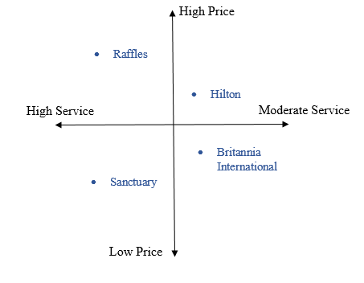

PESTLE Analysis

Factors | The Trends
Political | Severed relations with the EU following Brexit (Somai and Biedermann, 2016), opening borders for foreign partners, taking in Afghan refugees and extending a helping hand (Clark and Farrington, 2022).
Economic | GDP stands at 3.187 trillion (Trading Economics, 2022), the economy is slowly recovering after the pandemic, its hotel industry is worth 16.4 billion pounds in 2022 (IBIS World), thus being an excellent economic contributor; the appeal is still there as travelling rises to visit the popular streets of England, but inflation is also increasing.
Social | Rise in social media blogging in travel and hotel stays (Garrido-Moreno et al., 2018), people prefer comfort over luxury, the pandemic increased awareness of cleanliness and hygiene, quality is searched for more than elegance, and diversity in the staff and business is appreciated.
Technological | The UK's hotel industry is no stranger to technology; usage of CCTV cameras to strengthen guest security, a rise in contactless payments after the pandemic, free Wi-Fi service has now become a bonus point, use of Al bots to answer queries immediately (Rahimi, 2017).
Legal | Offerings of tax reductions to boost economic growth, different regulations pertaining to UK hotels like the Licensing Act of 1964, Working Time Regulations Act of 1998, etc. (Assetsure, 2022).
Environmental | As years pass, UK’s environmental conditions worsen. Pollution is spreading in both urban and rural areas. The worst environmental issue is air pollution, followed closely by poor waste management and industrial activity (Travaglio et al., 2021). Companies, including hotels, are expected to be more responsible.

Objectives
The objectives of this particular marketing plan for Raffles Hotel are as follows:
- Attract new customers travelling to England with price-conscious tactics.
- Put out advertisements signifying excellent, and clean, services.
- Gain a 10% boost in revenue by the end of 2022.
- Value comfort over luxury for once, despite being a luxury hotel in Victorian architecture.
- Gain better control of cost in order to make the pandemic's aftereffects fade.
- Fill labour shortages by at least 5% by the end of this year.
- Market limited room services with wider ones like offerings of Wi-Fi, breakfast and lunch, and other activities revolving around sports or wellness.

Strategy
In an industry where the threat of substitutes is more than possible due to similar services and better prices, hotels need to pay attention to their value proposition because it makes them unique in the eyes of the customers. In the case of Raffles, its value proposition generally resides in being one of the most well-known luxury hotels with great services, reasonable pricing, and full-fledged diversity (Hargreaves, 2015). However, this changes when the geographical area changes, which is why in the UK, its differentiation revolves around being a hotel that promises comfort and welcomes everyone, regardless of background, with open arms. In the current climate, the value proposition will remain the same because, after the pandemic, political upheavals, and Brexit, people have become more interested in the idea of everyone getting treated equally, especially in the means of gender. Since a huge portion of Raffles' customer segments is from the upper class, where such beliefs are more prominent, this differentiation strategy will do the trick.

Tactics

Product
Typically, Raffles' services are immaculate. Since it is a luxury hotel, its presence in its home and host countries are prominent due to its offerings of elegant rooms, hearty food, spacious dining rooms, spaces for business meetings, wellness and spa centres, and beautiful gardens to enjoy strolling among Mother Nature (About Raffles, 2022).
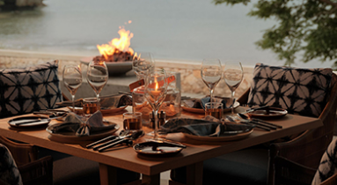
However, in the UK, its services are not well-known because it is not properly established there apart from a 4-star B&B. However, the brand will plan to offer treatment rooms, luxurious spas, pools, gyms, and excellent bars and restaurants, apart from the accommodations, in its upcoming London branch (Raffles Hotel, 2022).

Place
Since Raffles prefer following traditional methods despite the innovation, its distribution centres are mostly located in lobby outlets (Hargreaves, 2015). However, after the pandemic, Brexit, and the rise of technology, the marketing plan will focus on attracting London customers via online booking that can be done on its official website, which is easy to navigate. Furthermore, tourists can also book their rooms via phone calls to the lobby or reception, and contactless payment will be available, which is a good opportunity for Raffles to grasp, especially since its London instalment in undergoing development.

Price
Being a luxury hotel, Raffles strictly offers premium pricing in exchange for exquisite and high-quality services. Typically, like in Singapore, its home country, where its services are the most known, it charges over 800 USD per night stay. However, this has to change in the UK because the economy is still struggling, even when the pandemic is long gone. As a result, Raffles should combat the rising inflation and make its prices cost-effective to attract all kinds of customers because travellers are more likely to pick hotels that do not charge as much.

Promotion
Finally, in the means of promotion, Raffles uses all kinds, both digital and traditional, but with its inclination towards magazines and billboards, it leans more towards the latter. However, in the UK and considering the current world condition, this has to change. The rise in social media is Raffles’ opportunity to market its unique brand in the UK. Some examples of its online promotional tactics are given below.
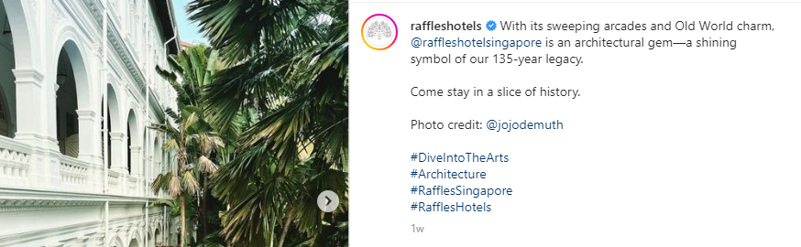
Figure 1 (Raffles - Instagram, 2022)
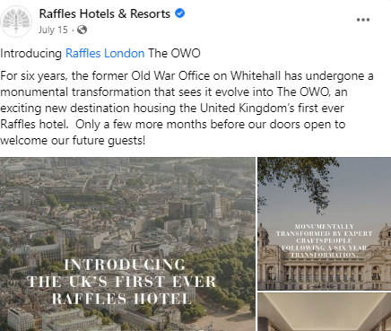
Figure 2 (Raffles - Facebook, 2022)
Hence, by using the same digital stances, along with the traditional ones, Raffles can start off on the right foot in the UK market, especially since it already has a large following on all social media platforms.

Action
In order to evaluate the action needed, the following Gantt chart can be observed.
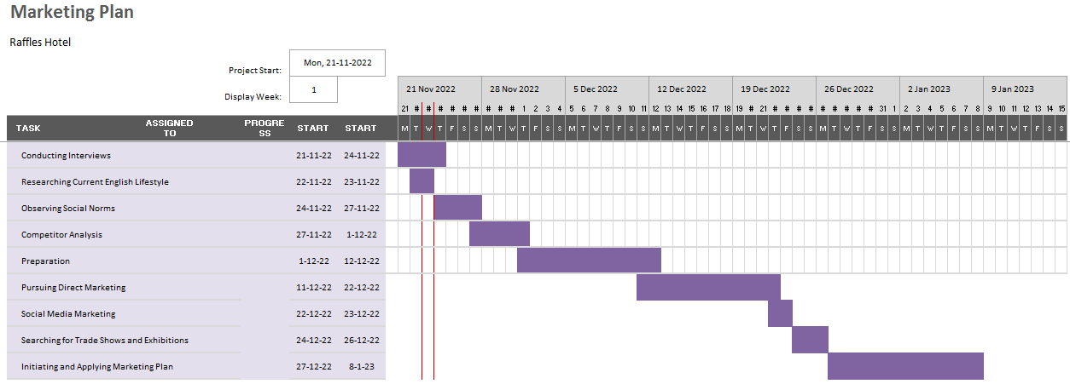
This Gantt chart was formulated as per the marketing research and activities required for Raffles’ new strategy in the United Kingdom, particularly England. These timed activities were made as per assumptions on how much time they would take in order to get accomplished. After the market research, which largely revolves around gathering primary data by interviewing potential customers, marketing activities will be pursued, which encompass the Communication Mix, specifically social media and direct marketing strategies.

Control
In terms of the brand’s Unique Selling Point (USP), which dictates a company’s specialness among competitors, Raffles’ promise to be as vigilant, friendly, and determined to provide comfort and a luxurious stay would be significant in its London branch (Payne et al., 2017). The main difference would reside in cost differentiations, cleanliness, and a celebration of the British royal values, as they hold these dear to themselves. Success would be measured via Key Performance Indicators (KPI), with some of them being grown in its official website for UK stays, list of bookings held in its lobby outlets, etc. Since its UK presence is not yet defined with property, every customer in this county would be considered new.

Conclusion
In conclusion, it can be stated that establishing its hotel, which would eventually grow into a group in London, UK, would not be much of a challenge for Raffles. Since the country values its rich history, class, and elegance, shifting to entirely new modes would not be necessary because the brand would already fit the criteria. However, it should reshape its cost structure because, as it was observed, the UK landscape is shaky, but it would gradually become better. Furthermore, Raffles already operates in Europe, but after its separation from the EU, the UK is bound to demand for some differentiation within its branch, and Raffles should do that by studying its social and cultural norms.

References
Burnett, M. and Johnston, T., 2020. Brexit anticipated economic shock on Ireland’s planning for hospitality and tourism: resilience, volatility and exposure. Tourism Review, 75(3), pp.595-606.
Clark, E. and Farrington, R., 2022. Migrants in vulnerable circumstances: not a quick fix. British Journal of General Practice, 72(714), pp.29-29.
Garrido-Moreno, A., García-Morales, V.J., Lockett, N. and King, S., 2018. The missing link: Creating value with social media use in hotels. International Journal of Hospitality Management, 75, pp.94-104.
Hargreaves, C.A., 2015. Analysis of hotel guest satisfaction ratings and reviews: An application in Singapore. American Journal of Marketing Research, 1(4), pp.208-214.
Hotels laws UK | hospitality legislation UK - assetsure (2022). Available at: https://www.assetsure.com/business/hotel-insurance/hotels-laws-uk/ (Accessed: November 23, 2022).
Industry market research, reports, and Statistics (2022) IBISWorld. Available at: https://www.ibisworld.com/united-kingdom/market-size/hotels/#:~:text=What%20is%20the%20market%20size,to%20increase%2045.5%25%20in%202022. (Accessed: November 23, 2022).
O’Connor, C.M., Anoushiravani, A.A., DiCaprio, M.R., Healy, W.L. and Iorio, R., 2020. Economic recovery after the COVID-19 pandemic: resuming elective orthopedic surgery and total joint arthroplasty. The Journal of arthroplasty, 35(7), pp.S32-S36.
Payne, A., Frow, P. and Eggert, A., 2017. The customer value proposition: evolution, development, and application in marketing. Journal of the Academy of Marketing Science, 45(4), pp.467-489.
Raffles Hotels & Resorts (@raffleshotels) - Instagram (2022). Available at: https://www.instagram.com/raffleshotels/ (Accessed: November 23, 2022).
Raffles Hotels & Resorts (2022) Facebook. Available at: https://www.facebook.com/RafflesHotels/ (Accessed: November 23, 2022).
Rahimi, R., 2017. Customer relationship management (people, process and technology) and organisational culture in hotels: Which traits matter? International Journal of Contemporary Hospitality Management.
Somai, M. and Biedermann, Z., 2016. Brexit: Reasons and challenges. Acta Oeconomica, 66(s1), pp.137-156.
The raffles story (2022) Raffles website – new window. Available at: https://www.raffles.com/about-raffles/ (Accessed: November 23, 2022).
Travaglio, M., Yu, Y., Popovic, R., Selley, L., Leal, N.S. and Martins, L.M., 2021. Links between air pollution and COVID-19 in England. Environmental pollution, 268, p.115859.
United Kingdom GDP2022 data - 2023 forecast - 1960-2021 historical - chart - news (2022) United Kingdom GDP - 2022 Data - 2023 Forecast - 1960-2021 Historical - Chart - News. Available at: https://tradingeconomics.com/united-kingdom/gdp (Accessed: November 23, 2022).

Appendix



