Module code:BMSW4002

Lecturer: Anita Nan

Effective team working & communication (Term 2)

Aissatu Djalo – 19008378 – Benefits of team work
Sheikh Nasima Ali – 1906866 – Stages of team development.
Bonita Brookes - 1905835 – Team roles
Nathaniel Smith – 1908672 - Management conflict (Team leader)
Ivaylo Dosev – 1909471 - Successful team development

These are the 5 approaches we will use to improve effective team working into your operations:

Benefits of team work.
Stages of team development.
Team roles.
Management conflict
Successful team development.
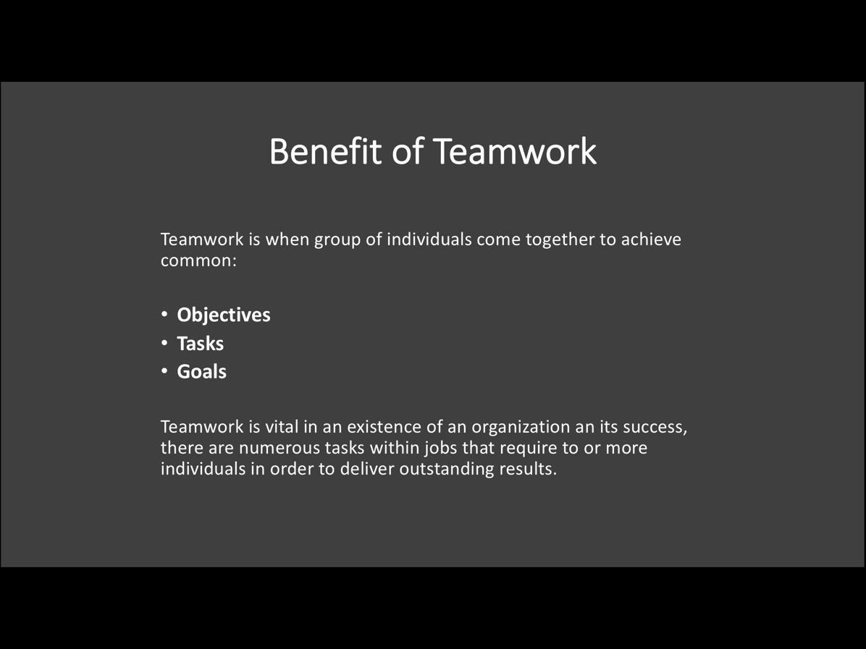

Notes

There is always an objective why people come together. People come together either to take a decision on an issue concerning their community, work condition, to determine solution over a common purpose. Likewise in places of work or organisation, teams are build to work together for a common objective. They engage into discussions or dialogues in order to come out with effective results to solve problems affecting the organisation.

They then carry out Tasks thereby through team working and brain storming and sharing of ideas and knowledge in order to succeed.

When solution is reached and presented successfully, then a Goal is achieved.

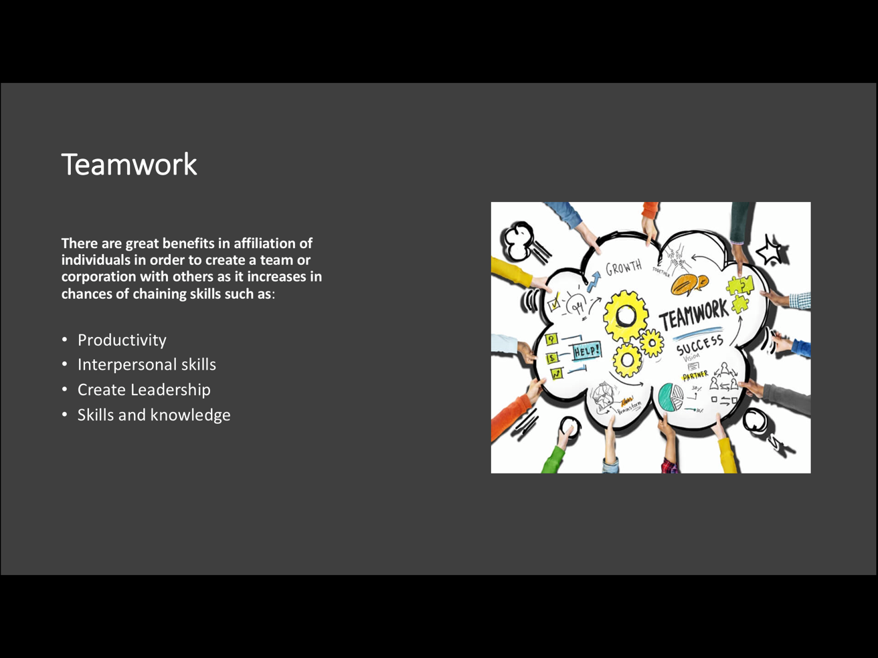

Notes

PRODUCTIVITY when an amount of work is divided into equal parts in according to their strengths and skills within the group, their workloads are delivered with efficiency and within time record. According to Hoffman (2016), “No matter how brilliant your mind or strategy, if you’re playing a solo game, you'll always lose out to a team”.
Create Leadership in the process of working as a team it varies on how a leader is recognised or chosen either by the group vote or individuals identifying themselves with a particular topic. Either way it can be beneficial for the group members to overall in enhancing their leaderships skills.
Interpersonal skills by creating solid corporation within the group it encourages on a very important aspect of teamwork which is communication. In order to achieve their mutual objective by encouraging and pushing each others.
Skills and Knowledge in the process of group working, sharing of information is vital. For the group to achieve the greatest result it is important to have everybody's contribution, skills and knowledge. According to Michael Jordan. (2018). “Talents wins games, but teamwork and intelligence wins Championship”.

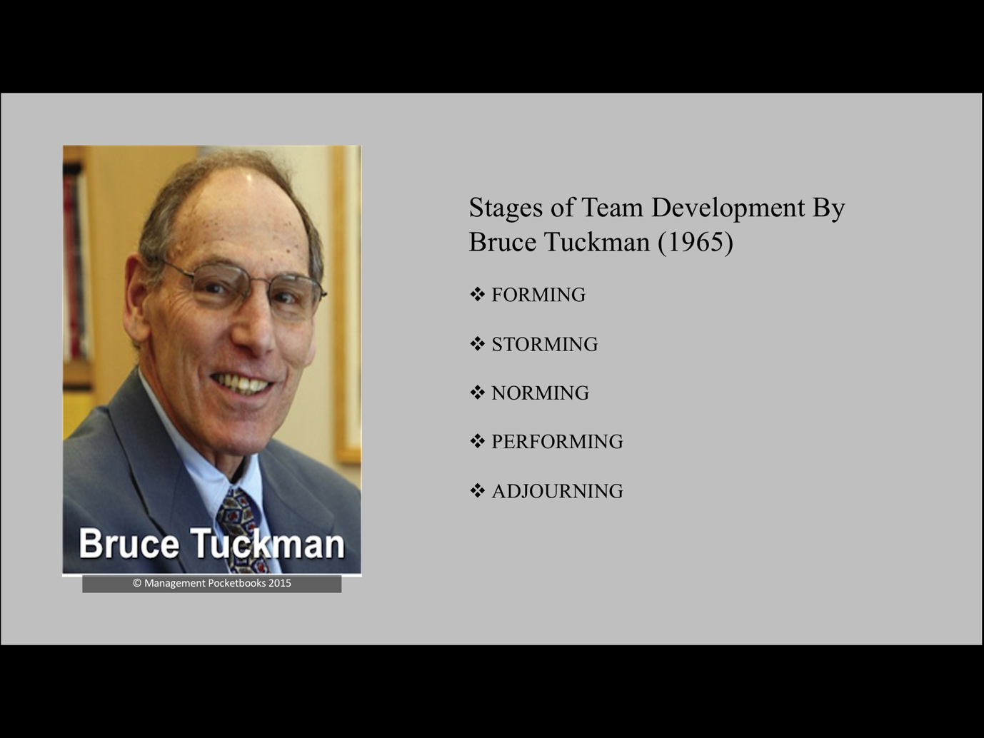

Notes

Bruce Tuckman developed team development model in 1965.
Recognised groups/teams not fully formed and functional at the start. Understood teams grew and developed through clearly defined stages.
There were 4 stages, 5th stage added in 1977.
Theory describes how team tackles, handles task from beginning of process to completion of task. Developing, team building every stage making it efficient and effective.

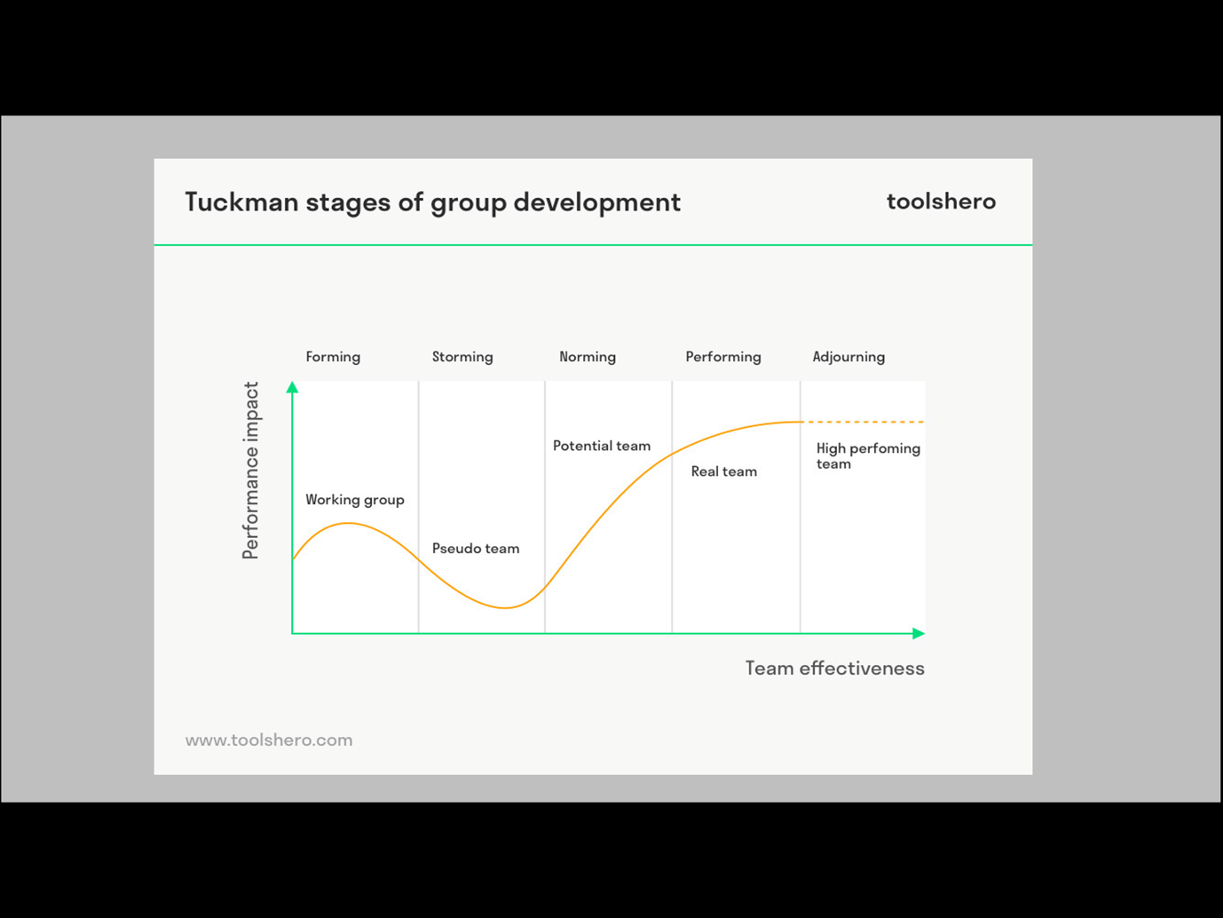

Notes

Forming – Orientation/Building Relationships
Variety of people assembled to work together to perform, achieve a task. Initially good atmosphere, behaviour, positive attitude towards one another. Individuals get acquainted, excitement to work together, get to know each other. Not much productivity, more focus on team and not actual work. Lots of uncertainties, searching for leader/authority figure. Trying to establish ground rules, goals, objectives for whole team and individuals.

Storming – Conflict
Most critical and difficult stage, addressing task. Different ideas/opinions. Conflicts start to arise; people get to know each others flaws, personalities clash, frustration towards one another. Disagreements and arguing happen regarding goals, responsibilities, timelines. Relationships between members either form or break. Some people not contributing, others take over or want to be always right. Power struggle forms as individuals start questioning team leader and authority. Important to overcome all obstacles, accept individual differences, work through conflicts otherwise failure to resolve matters will result in long term problems or break down of team and project.

Norming – Developing Cohesion
Start to settle and resolve issues, differences. Appreciating team members strengths, weaknesses and cooperating with team leader. Performance increases as commitment towards team and progress can be seen. Contributing and a high degree of trust will result in better communication. Sometimes storming can overlap norming as new tasks, problems occur but easier to resolve has been dealt with before.

Performing – Team Interaction
Team confidence and cooperation well established. More organised, motivated to reach targets. Clear and stable structure formed and functioning with little or no supervision. Individuals start to work more in synergy with each other, demonstrate support for each other. United to achieve goals and perform to high standards. Leaders play important part in establishing, maintaining productivity and team cohesiveness.

Adjourning – Closure
Goals/targets completed successful. Time for team members to move into different directions. Some people find it difficult to move on have grown close to team members, feel sense of loss, don’t want experience to end. Whilst others are glad to finish task and move on to bigger better things.

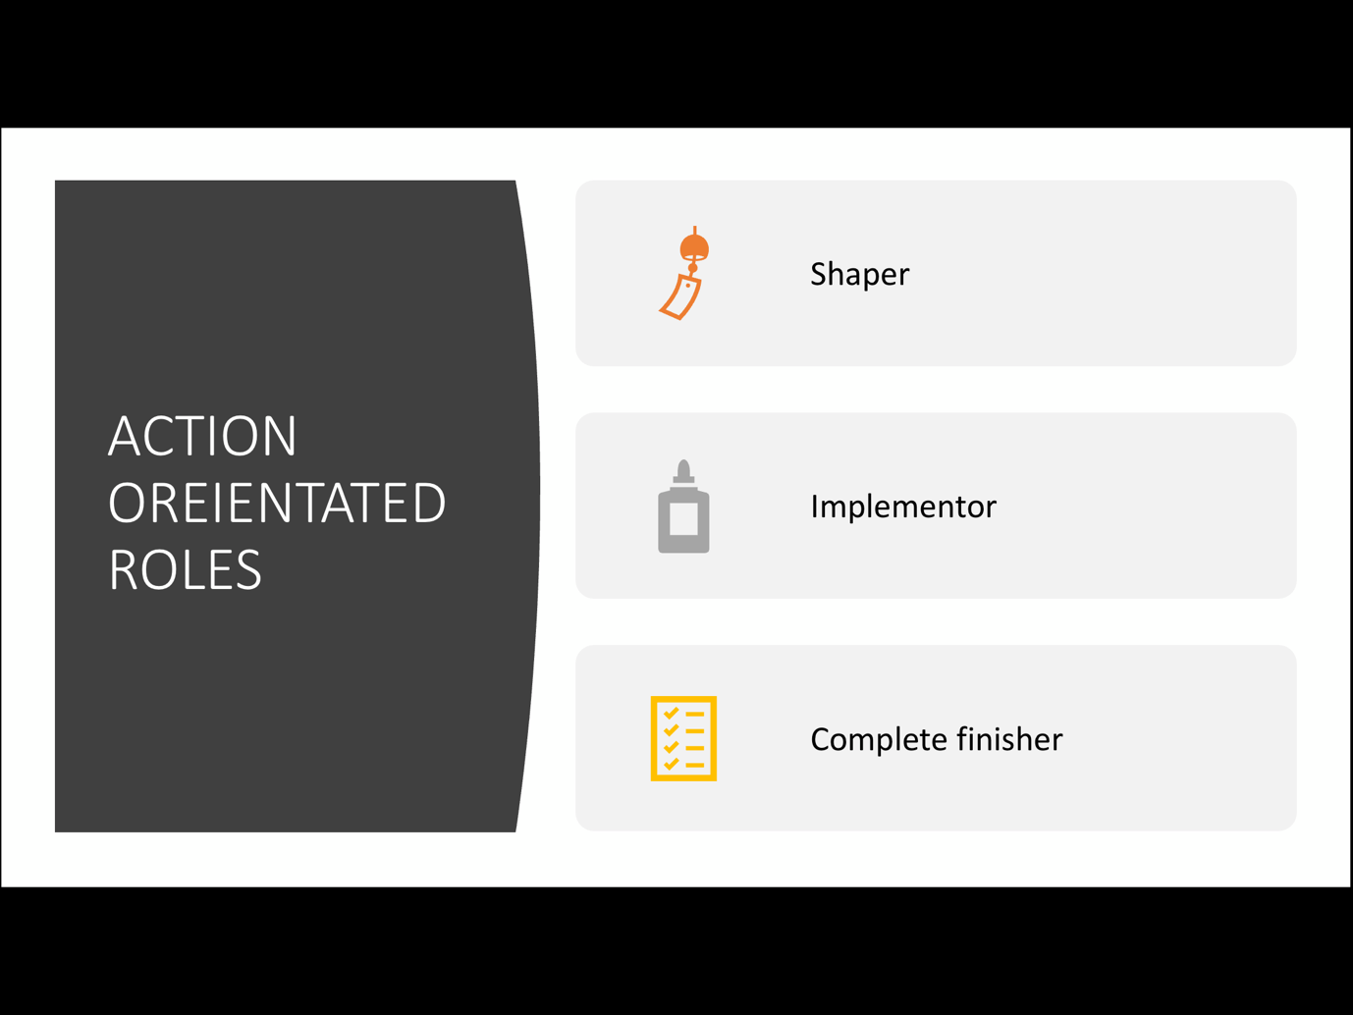
Notes
Team Roles - Dr Meredith Belbin and his team discovered that there are nine clusters of behaviour - these were called ' Belbin in 1981. Belbin believes that each of us possesses a pattern of behaviour that characterises one person's behaviour in relationship to another in facilitating the progress of a team. Shapers – challenge the team to better improvement. Implementer – turns the ideas into actions and get the things done. Completer Finisher - Ensures that the projects are completed thoroughly. Coordinator – takes the team leader role and acts as a president. Team worker – encourages cooperation, provides support and make the team work together. Resource investigator – explores the opportunities from outside and develop contacts.

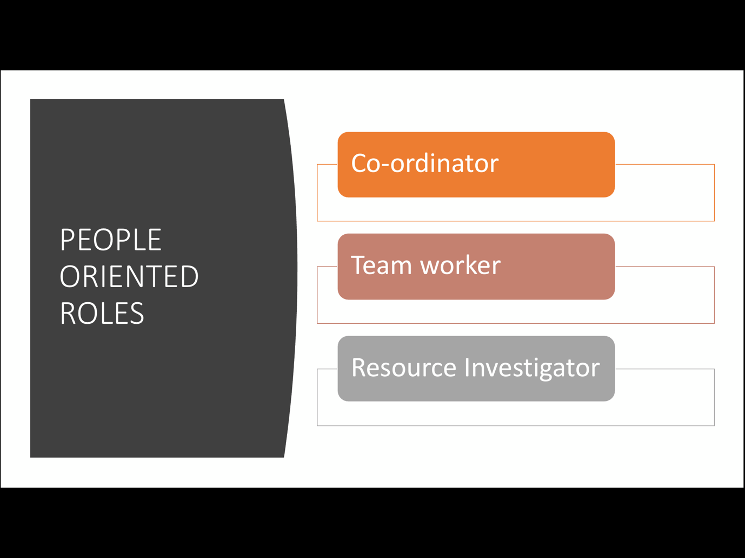

Notes
Each team needs access to each of the nine Belbin Team Role behaviours to become a high performing team. However, this doesn't mean that every team requires nine people! Most people will have two or three Belbin Team Roles that they are most comfortable with, and this can change over time. Each Belbin Team Role has its strengths and weaknesses, and each has equal importance. Plant – presents the new ideas and approaches.Monitor Evaluator – Analyses and evaluate the options given.Specialists – are the people who provide specialized skills.

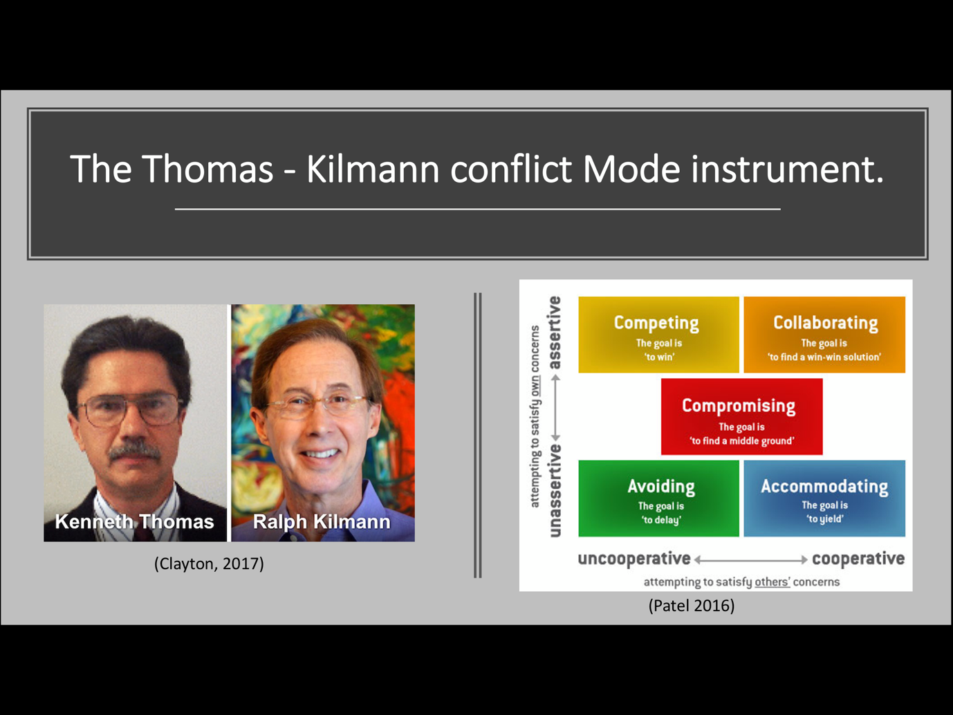
Notes

The Thomas - Kilmann conflict mode instrument Kenneth Thomas and Ralph Kilmann Implemented their model as a form of research during the 1970s. The idea was based off of Robert Blake and Jane Mouton managing conflict styles model in the 1960s.
Is conflict negative?
According to Gallo Conflict on its own could be detrimental to growth in the work place, however when managed appropriately could benefit the working environment.
When working in a team it is vital that opinions that support the teams endeavours are expressed even if it goes against the grain.

(Gallo 2008)

- Competing – The idea is to win.
- Accommodate – The idea is to yield.
- Avoiding – The goal is to delay.
- Collaborating – The idea is to work together.
- Compromise – The goal is to find middle ground.

(Thomas and Kilmann, 2012)
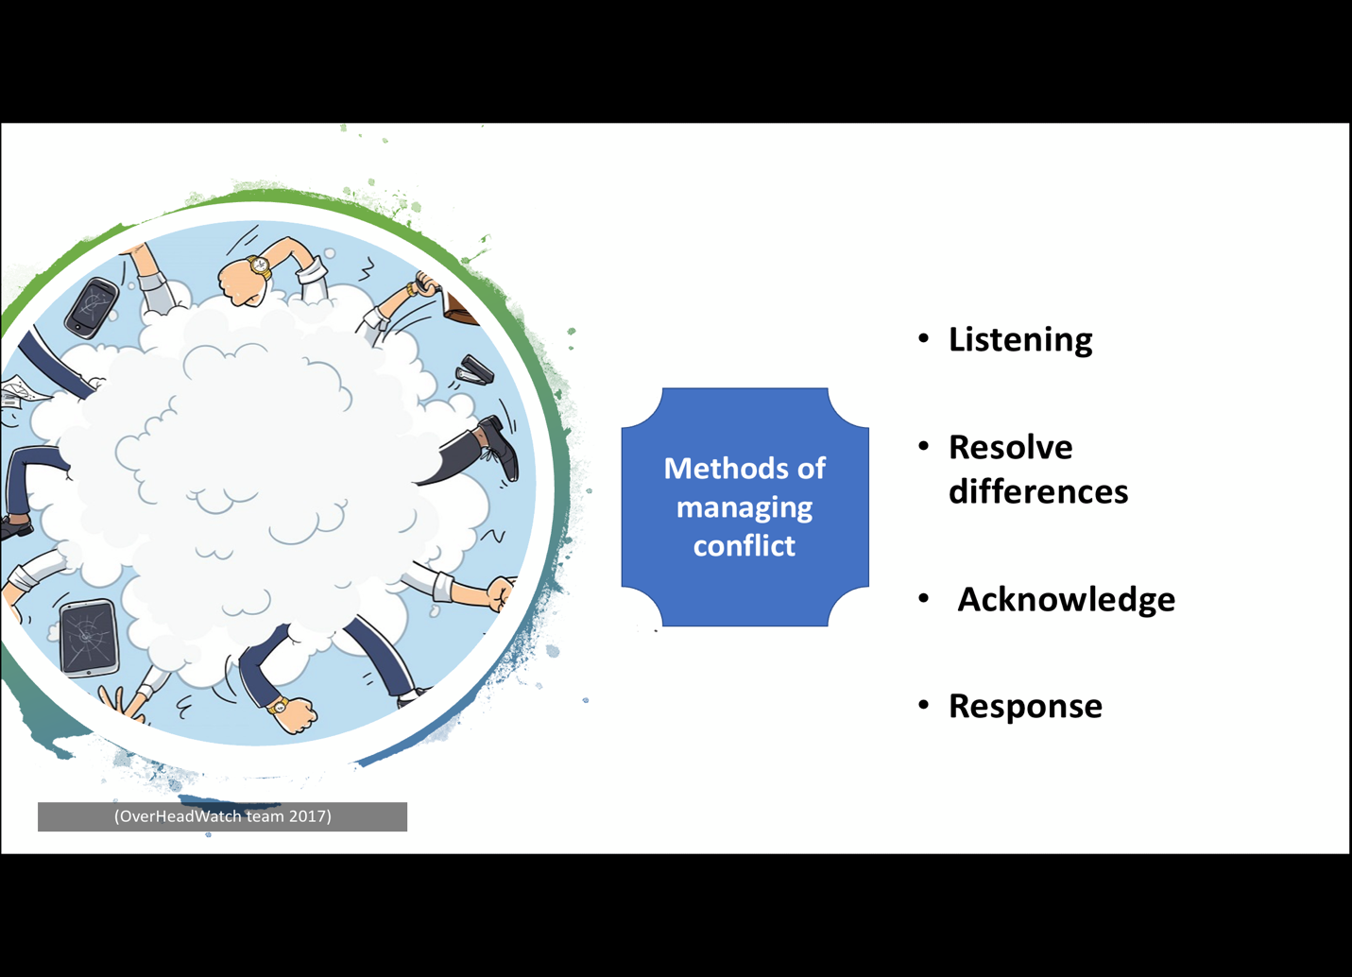

Notes

- Listening - The skill of listening is very vital in order to understand ones point of view. It is important to understand that you do not listen just to respond, but listen to get a real sense of what someone is trying to convey.
- Acknowledge – Having the ability to disagree with someone and simultaneously allowing the person to know you hear and understand their point of view could reduces the risk of an argument.
- Response - Now that you have actively listened and acknowledge your team mates point of view it gives you the ability to critically think and give a more constructive response. You have to be open to the fact that your idea may not be accepted, also be ready to compromise.
- Resolve differences – At this point of the disagreement both parties have to be willing to come to a mutual ground that the majority of the team agrees to. Following these four methods could be the difference of having just conflict or having two different ideas explored and coming to a common ground.

(Thomas and Kilmann, 2012)

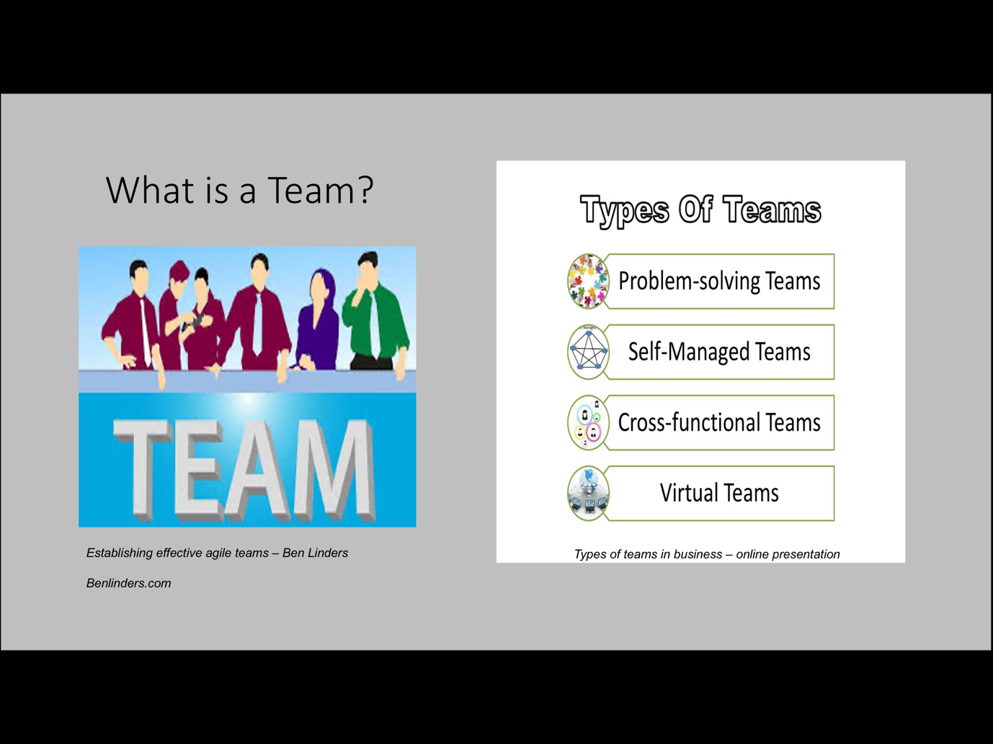
Notes

1. Team is a collected group of people who work together on related obligations toward a common purpose. People on a team collaborate on sets of associated responsibilities which can be required to achieve a goal. Each member is responsible for contributing to the crew, however the organization as an entire is chargeable for the group’s fulfillment. (Collins and Miller , 1994.)
2. Problem solving team is a group of individuals assembled to work on a mission that entails resolving one or extra problems which have already arisen or to deal successfully with issues as they rise up.
Self-managed teams are self-prepared, semiautonomous small groups of personnel whose contributors determine, plan, and control their day-to-day activities and duties below reduced or no supervision. Also known as self directed group or self-controlled natural work team.
Cross Functional Team is group of people with one-of-a-kind functional specialties or multidisciplinary abilities, chargeable for sporting out all stages of a program or task from start to finish.
Virtual Teams are when the people work basically with electronic communications. These people can be in same building or on different continents.

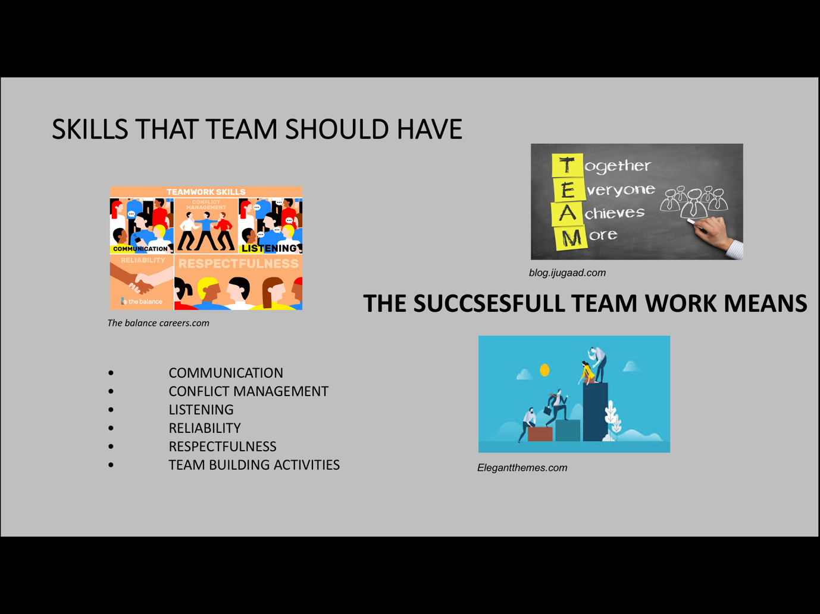
Notes

Communication talents are wanted to speak as it should be with a wide type of human beings at the same time as keeping accurate eye touch, exhibit a varied vocabulary and tailor your language in your target market, concentrate correctly, present your thoughts as it should be, write without a doubt and concisely, and work properly in a group.
Conflict management - conflict may be described as extraordinary objectives and attitudes between two or greater parties. Conflict management is the procedure of identifying and addressing differences that, if left unresolved, ought to have an effect on objectives.
Listening that is the ability to receive and interpret exactly messages in the communication.
Reliability - reliable in performing process-associated duties, finishing assigned projects, assembly closing dates and appointments.
Respectfulness - building a subculture of appreciate inside the place of work may be a powerful source of blessings for the enterprise, for managers, and for personnel. It is a two-way street of ensuring employees respect the enterprise, and allowing employees to sense their work is valued and recognized.
Team - building sports are often erroneously labelled as strange, however they don’t have to be. The secret is to pay attention at the activities almost absolutely everyone loves. For example, focus on universally fun and friendly games and activities. Potlucks are sure to please nearly everyone, and most people love scavenger hunts or board games too. The secret is to adapt to your team, and let the good times roll.

References:

Gallo, A., 2018. Why We Should Be Disagreeing More At Work. [online] Harvard Business Review. Available at: <https://hbr.org/2018/01/why-we-should-be-disagreeing-more-at-work> [Accessed 11 Apr. 2020].

Tuckman’s team and Group development model
https://www.thecoachingtoolscompany.com/get-your-team-performing-beautifully-with-this-powerful-group-development-model/
Elsey, E (Feb 07 2014)
Patel, H., 2016. Kilmann conflict mode instrument. [online] Available at: <http://honeybpatel.blogspot.com/2016/03/my-thomas-kilmann-conflict-mode.html?m=1> [Accessed 22 Apr. 2020].

Michael Jordan. (June 2018). Talents wins games, a team wins trophy. Online https//wwwforbes.com. Accessed 05th May 2020.

Thomas, K.W. and Kilmann, R.H., 2012. Thomas-Kilmann Conflict Mode Instrument. [online] Available at: <10.1037/t02326-000> [Accessed 24 Apr. 2020].

Who is Bruce Tuckman
https://www.pocketbook.co.uk/blog/2015/04/07/bruce-tuckman-group-development/
Clayton, M (April 07 2015 )
Clayton, M., 2017. Kenneth Thomas & Ralph Kilmann: Conflict Modes - Management Pocketbooks. [online] Management Pocketbooks. Available at: <https://www.pocketbook.co.uk/blog/2017/09/12/kenneth-thomas-ralph-kilmann-conflict-modes/> [Accessed 22 Apr. 2020].
Collins Miller , 1994 Team Building Exercises and Activities/ Making Team Building an Everyday Priority Available at: https://www.mindtools.com/pages/article/newTMM_52.htmAccessed Accessed: (01.04.2020)

Tuckman stages of group development
https://www.toolshero.com/management/tuckman-stages-of-group-development/
Mulder, P (2013)
Hoffman Reid (May 2016), The best quote. Online. https//www.telephraph.co.uk accessed 05th May 2020.
OverHeadWatch Team, 2017. What are the methods for managing conflict ? [online] Available at: <https://overheadwatch.com/what-are-the-methods-for-managing-conflict/> [Accessed 11 Apr. 2020].
Picture 1 – Establishing Effective Agile Teams Available at: https://www.benlinders.com/2019/establishing-effective-agile-teams/ Accessed : (01.04.2020)
Picture 2 – Types of teams in business Available at: https://en.ppt-online.org/35306Accessed : (01.04.2020)
Picture 3 – Teamwork skills(The balance careesrs.com) Available at: https://www.thebalancecareers.com/list-of-teamwork-skills-2063773 Accessed: (01.04.2020)
Picture 4 - Team Building Activities Your Team Will Actually Enjoy Available at: https://www.elegantthemes.com/blog/business/team-building-activities Accessed: (02.04.2020)
Picture 5 – 10 effective team building strategies Available at: https://blog.ijugaad.com/10-effective-team-building-strategies/ Accessed: (02.04.2020)

Picture 6 – 10 effective team building strategies Available at: https://blog.ijugaad.com/10-effective-team-building-strategies/ Accessed : (02.04.2020)
Businessdictionary definitions Available at : http://www.businessdictionary.com/ Accessed: (02.04.2020)
Communication Skills, Listening skillsAvailable at: https://www.skillsyouneed.com/ Accessed: (02.04.2020)
Conflict management Available at: https://www.apm.org.uk/body-of-knowledge/people/interpersonal-skills/conflict-management/ Accessed: (02.04.2020)
Reliability Availableat:https://www.csu.edu/humanresources/empdev/documents/DependabilityReliability.pdf Accessed: (02.04.2020)
Respect in the workplace, 2007 Available at: https://roubler.com/respect-in-the-workplace/ Accessed: (02.04.2020)

The Nine Belbin Team Roles
Available at : www.belbin.com/about/belbin-team-roles/Accessed:05.05.2020

The Team Roles
Available at: www.leadershipsolutions.co.nz/about-belbin/the-team-roles/
Accessed:05.05.2020

The Business Skills Handbook,2009
Available at:https://books.google.bg/books?id=pkLODgAAQBAJ&pg=PA112&dq=Implementer+%E2%80%93+turns+the+ideas+into+actions+and+get+the+things+done.&hl=bg&sa=X&ved=0ahUKEwjEv-6YqJ3pAhUEYsAKHQelArMQ6AEIJjAA#v=onepage&q=Implementer%20%E2%80%93
Accessed:05.05.2020

