Yuanyuan Xiong（ Kimberly）
My research is about「Translation path of cultural genes of Jiangnan Gardens in contemporary wearable jewellery」.

CHECLISTS:
- Have you identified a sub-question, theme, keyword, or concept to develop through practice?
Sub-questions：
Q1- What are the design concepts or philosophical ideas behind the landscape design of Jiangnan gardens?
Q2- How do people perceive these ideas or thoughts?
Q3- How do these perceptions get translated into jewelry?
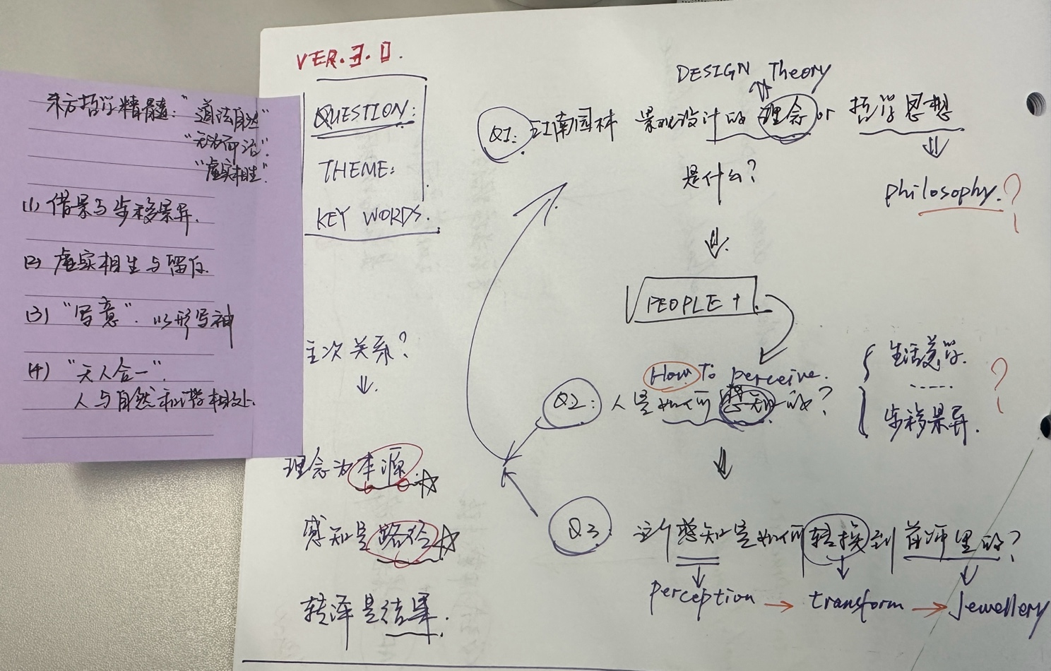

- Does your practice test variables, how many?
Variable type | What is being varied | Why it matters
Independent (3) | 1. Borrowed-scenery framing  2. Intentional emptiness/“leave-blank”  3. Capturing-the-spirit through form | They are the three Jiangnan-garden design principles whose perceptual and affective impact the study wants to isolate.
Dependent (multi-dimensional) | • Participants’ cognitive understanding (clarity scores)• Emotional resonance (self-reported affect)• Translational creativity (quality of jewellery sketches/prototypes) | These outcome measures show how strongly each principle is decoded and re-encoded in a new medium.

- Can you link a variable to other research, practices, influences, experiences, or something you've read?
Independent variable | Related research and practice
Borrowed Scenery | - The concept was first systematized in the "Applying Scenery" section of "Yuan Ye" (by Chi Cheng, 1635), and later developed into the "Shakkei" theory in Japanese gardens.
Contemporary landscape scholars regard it as a "depth of field - narrative - regionalism" triple strategy; for example, the comparative analysis on "borrowing scenery and lending scenery" in Landscape Research.
From a practical perspective, Jones (2018) adapted the techniques from "Yuan Yi" to the art of walking, exploring how body movement "carries the scenery" and enters urban exploration.
My experiment is similar to the research on gaze control - context fusion: The viewing window and jewelry can serve as "wearable frames for scenery", testing how the external landscape is reorganized by the body.

- Have you documented how these influences, experiences, or readings have shaped your thinking and evolved your practice?
Document format | Content | Stage
Research Diary | Key Reflection: Which presuppositions were rejected? Which assumptions were formed? | Throughout the entire process of planning
Influence Map | Concept - Practical Case - Personal Experience | Update immediately after each round of data collection is completed.
Iteration Dossier | The motivations, design changes, and expected-versus-actual differences of each experimental version (V1.0 → Vx.x) | Weekly filing
Design changes ——
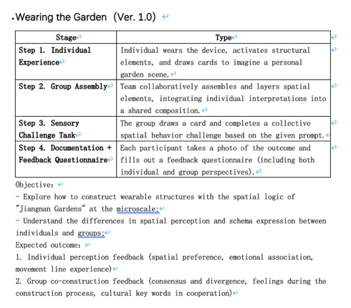VER.1.0 (fail → Not strongly related to the research)
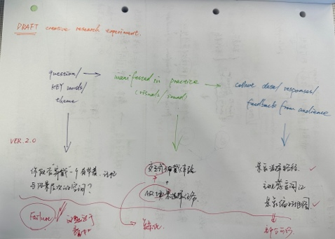VER.2.0 (fail → The practice is overly complicated )
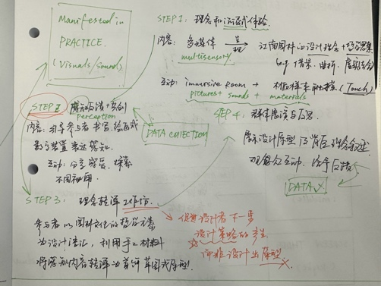VER.3.0 (in process)
- Have you experimented with design, for example, by creating visuals, sounds, or concept art?
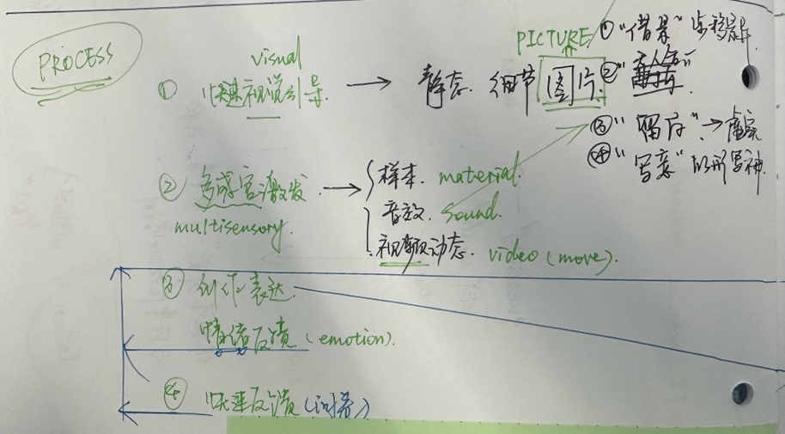 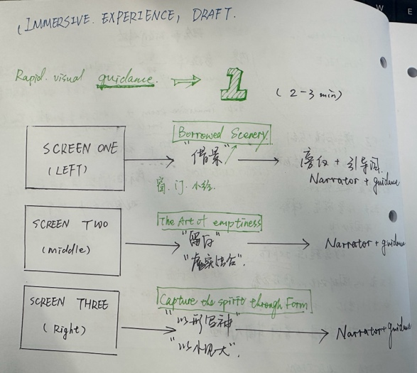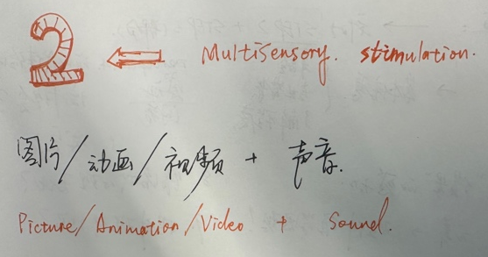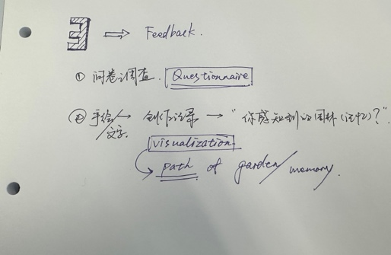 [ A plan of 3 steps in place ]
Visual-GIF
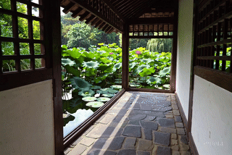 (The next step will be to add sound effects and narration.)

- Have you identified what information you are gathering from the audience, how you will gather it, and what you hope to discover？
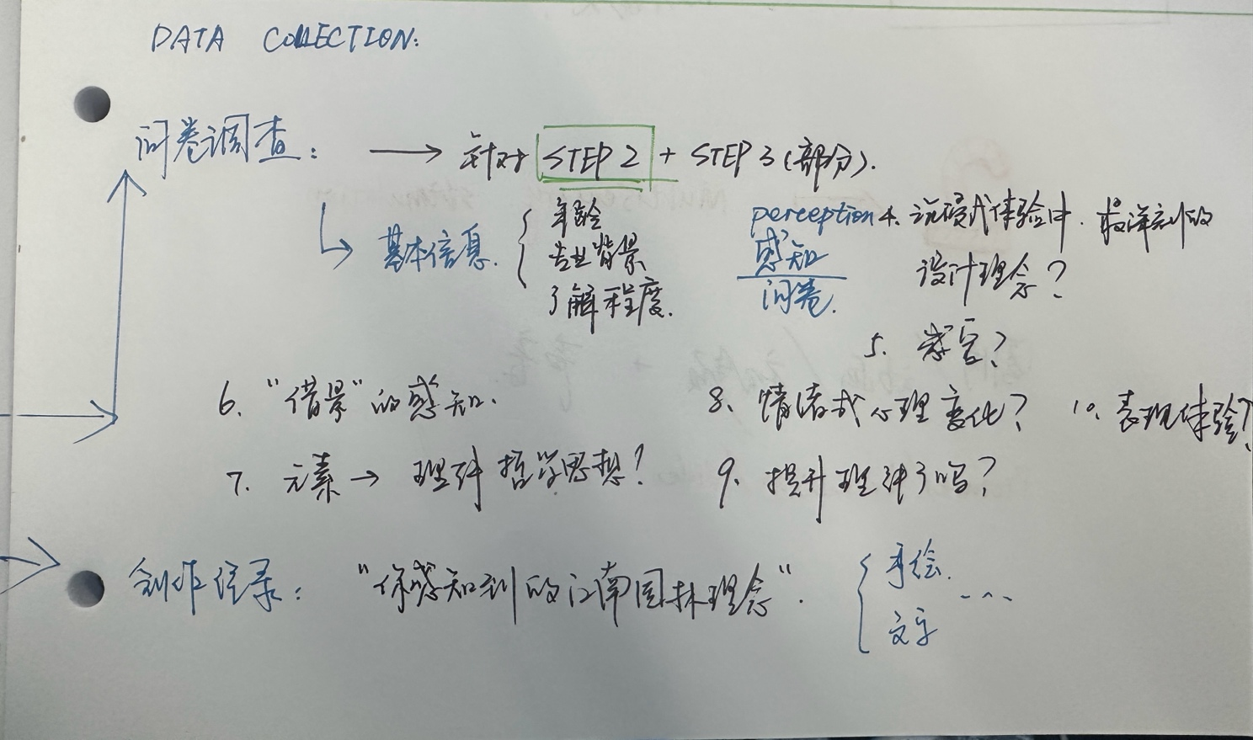
Dimension | Tools and Methods | The insights expected to be found
Clarity | Questionnaire | Which design principle is the easiest to be accurately "read out"? The differences in understanding among people from different backgrounds
Affect | Questionnaire | Does design blank space significantly reduce arousal and enhance pleasure?
Creative Output | Quick Imagery Path Sketch | The difference in stay time between meandering walk and linear movement; the correlation between interaction-intensive areas and the position of the frame.

