A marketing plan is written for

___________________________Ritz Carlton in London____________________________

Student Name

___________________Printesa Eftimie_______________________________

Student ID number
_____2206215______________

Marketing Essentials BMIH4005

Lecturer Luciana Suradi

Introduction
The main purpose of the marketing plan is to effectively strategies the operations towards the customer so that they can gain information about the hotel that they need. A marketing plan is prepared for Ritz Carlton in London to make sure that they effectively market their services to the customers to increase their reach in the market. A situational analysis will be conducted in this report through the 5Cs. Certain smart objectives will also be drawn to analyse the potential of the marketing plan.

Situation Analysis
5 'C's
Company
SWOT analysis of Ritz Carlton in London
Strengths | Weaknesses
- Large base of employees with over 33000  - Having a Global presence with over 70 hotels worldwide.  - Reward programs for customers.  - High brand quality (Jobber and Ellis-Chadwick, 2019). | - The service is quite expensive.  - The price is influenced by the economy.
Opportunities | Threats
- Making the services cashless through digital implementation.  - Expand into new countries. | - Heavy competition within the market.  - The increasing cost of operations.
Table 1: SWOT Analysis
(Source: Created by the learner)
Customers
The segmentation and targeting can offer knowledge about the customer base of Ritz Carlton in London. The main basis of segmentation for the company is the people who can afford a luxurious hotel in order to fulfil their rich lifestyle. The services are quite expensive and with the influence of the premium pricing strategy, it is evident that Ritz Carlton in London tries to attract customers belonging to well-to-do families (Bowie et al., 2016).
Competitors
Porter's five forces theory can successfully analyse the competition that Ritz Carlton in London faces within the market.

Rivalry (High) | There is heavy competition within the market where companies like Unilever, Kraft foods and Group DANONE are trying to attract customers towards the premium customer base. The company has been facing this competition for the last 150 years and has gained a strong position within the market (Smith and Zook, 2019).
New entrants (Low) | The threat of new entrants within the market is quite low because the companies that already have a share of the market have a customer base that is loyal to their service.
Buyers (High) | The changing economy has been a determining factor for the increase in the purchasing power of buyers. Ritz Carlton in London needs to decide on the services that they offer to the customers on the basis of the demands.
Suppliers (Medium) | The hotels are quite dependent upon their suppliers to provide access to the raw materials that they need to successfully offer the services to the premium customer base. The change in the demand of the suppliers will impact the operating cost of the company (Smith and Zook, 2019).
Substitutes (Low) | Ritz Carlton in London is a luxury hotel offering premium service to customers who have a rich lifestyle. It is not always easy for other organisations in this industry to successfully offer the same quality of service at a lower price.

Table 2: Porter’s five forces
(Source: Created by the learner)
Collaborators
Ritz Carlton in London has been effective in maintaining relationships with other business organisations through their B2B service. Marriott Rewards is an organisation that has partnered with Ritz Carlton in London to meet the demands of the customers within the market (Kotler et al., 2020).
Climate
The Pestle analysis can help in understanding the external environment of Ritz Carlton in London.
Political factors | America has achieved a certain political stability that offers support to the business organisations that contribute to the overall GDP of the nation. However, due to the recent pandemic, the business had suffered a huge loss as the tourism business we are not able to run much. This impacted the productivity and profit running ability of Ritz Carlton in London operating within the USA (Clow, 2013).
Economic factors | The current economy of the nation is $26.155 trillion (Clow, 2013). This shows that the economy is in support of the operation that Ritz Carlton in London is having through the luxury hotels. However, the rising inflation has impacted it to a certain extent.
Social factors | The change in demand of the customers is an important social factor that the company has to consider while operating within America.
Technological factors | Big data is an influential technology that has been implemented in several organisations like Ritz Carlton in London allowing them to enhance their operating ability and monitor the performance of the employees.
Legal factors | The employment law along with the health and safety law are certain legal factors that the company needs to consider while operating within the nation to provide flexibility and assurance to their employees.
Environmental factors | The company has to consider the recycling policies while operating in America and increase the sustainable impact on the environment successfully.
Table 3: PESTLE Analysis
(Source: Created by the learner)

Objectives
There are broadly three objectives that Ritz Carlton wants to achieve in their business process.
- To achieve customer satisfaction
- To attract the customers in the post pandemic period.
- To hire employees to successfully mitigate the labour shortages due to the Brexit issue.
SMART target
Specific | The objective of Ritz Carlton in London is very specific where they want to achieve customer satisfaction through the services that they are offering. The company is also hoping to hire new customers and employees within the organisations to increase its scale of operations.
Measurable | The success of achieving the objective is quite measurable because calculating the number of customers that are getting satisfied after the services through a feedback system can be achieved (Ryan and Jones, 2012). The increase in the customers can be measured through the increase for the sales within the company.
Accessible | The objective is accessible because the premium service that they offer cannot be offered by a large number of organisations.
Relevance | The target that has been set is quite relevant to the demand within the market.
Time-bound | The time that has been set to achieve the objective is the duration of the service for each customer. Around 8 weeks has been taken by the company to successfully meet the objectives that they have.
Table 4: SMART Table
(Source: Created by the learner)

Strategy
Discuss and explain your organisation's value proposition
The main value proposition that the company offers to the customers is genuine care and comfort to make sure that the experience that the customers are having through the premium services can be everlasting and contribute to the repurchase of the service (Ryan and Jones, 2012).
How the organisation differentiates
The organisation differentiates their service through the premium pricing strategy that is being opted within the market and also focusing on the employee behaviour patterns to make sure that the customers are satisfied through the service.
How will you communicate the value proposition?
The value proposition can be effectively communicated using the digital advertisement that the company has implemented in their process recently.
How will it be delivered?
The delivery of the information will be done through the social media channels like YouTube, Facebook and Instagram (Kartajaya et al., 2016).
The link value proposition to our customer segments
The social media platform has been used as a way to analyse the lifestyle of the customers and to direct that information directly to the customers who are in need of it.
How will this affect the targeting and positioning of the organisation?
The results won't be coming as fast as before as the range of customers is quite high but the possibility of new customers being gained by the company is more (Bacon, 2004).
Bowman's strategy clock
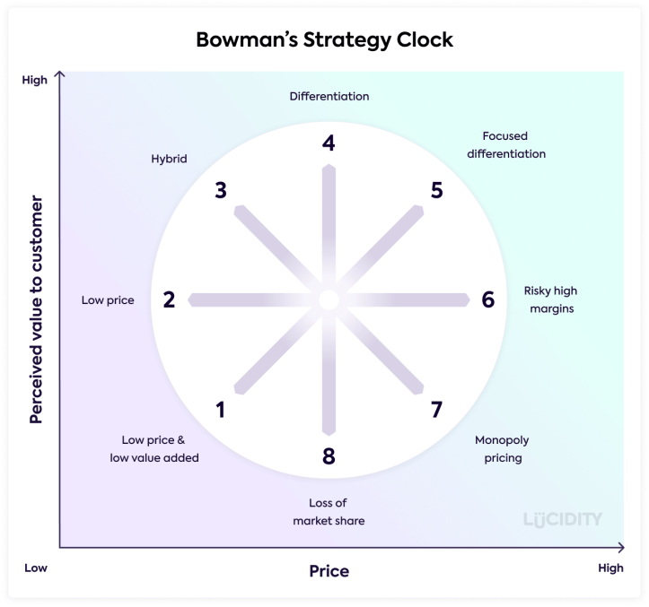
Figure 1: Bowman’s Strategy Clock
(Source: Housden, 2012)
According to Bowman's strategy clock, the company is using the differentiation strategy.

Tactics
Marketing mix
Product - The service that Ritz Carlton in London is offering is based on a premium service to the customers within the chain of luxury hotels that they have.
Place (Distribution) – The company has its presence globally through 70 different luxury hotels which makes it easier for customers to locate the place.
Price – The company uses the premium pricing strategy that is targeted towards a specific set customer base that has a rich lifestyle and can afford the services effectively.
Promotion – The promotion of the company is based on the digital marketing offered to the customers through different social media channels (TODUA, 2021).

Action (WBS and Gantt Chart)
Tasks | Start Date | Duration (days)
Set the target market | 1 December 2022 | 4
Creating the marketing team | 5 December 2022 | 7
Offering the service | 12 December 2022 | 5
Gaining feedback | 17 December 2022 | 6
Table 5: WBS
(Source: Created by the learner)
Control
There are certain services and benefits that are given to the employees like free food, health insurance, job training and soft skill training. The success of the company is measured through the increase or decrease in the sales of the service offered by Ritz Carlton in London (Elg and Ghauri, 2021).

Conclusion
The above report was based on the marketing plan of the company and the way they operate within the market. The situational analysis was done followed by the strategy that the company uses and the action that can be taken in the marketing plan was highlighted.

References
Jobber, D. and Ellis-Chadwick, F., 2019. EBOOK: Principles and Practice of Marketing, 9e. McGraw Hill.
Bowie, D., Buttle, F., Brookes, M. and Mariussen, A., 2016. Hospitality marketing. Routledge.
Smith, P.R. and Zook, Z., 2019. Marketing communications: Integrating online and offline, customer engagement and digital technologies. Kogan Page Publishers.
Kotler, P., Armstrong, G., Harris, L.C. and He, H., 2020. Principles of Marketing (8th European ed.).
Clow, K.E., 2013. Integrated advertising, promotion and marketing communications, 4/e. Pearson Education India.
TODUA, N., 2021. of Thesis: Social Media Marketing. Evaluation, 4, p.5.
Elg, U. and Ghauri, P.N., 2021. A global marketing logic: local stakeholders’ influence in diverse emerging markets. International Marketing Review.
Housden, M., 2012. CIM Coursebook Marketing Information and Research. Routledge.
Kartajaya, H., Kotler, P. and Setiawan, I., 2016. Marketing 4.0: moving from Traditional to Digital. John Wiley & Sons.
Ryan, D. and Jones, C., 2012. Understanding digital marketing–Marketing strategies for engaging the digital generation. 2. pianos. Lontoo: Kogan Page.

Appendices


