
COMMUNITY ENGAGEMENT LCBB4011
COURSEWORK – PORTFOLIO
Romanian Orthodox Church in Canterbury

Student Name & ID: Gabriel Chirosca 2244324
Lecturer Name: Dr Molly Jack Charles Oham
Assessment 1: Coursework - Portfolio
Submission / deadline: 01/09/2024
Word Count: 3000 words

Table of Contents
Introduction 3
Element 1: Community Outreach 3
Element 2: Stakeholder Mapping Exercise 6
Element 3: Community Engagement Plan 9
Element 4: Practical Discussion 14
Conclusion 17
References 18

Introduction
The Romanian Orthodox Church and its strategic role for the development and welfare of the Romanian Orthodox Church in Canterbury, Kent in the United Kingdom.
St. Peter Church conducts regular services at Canterbury Cathedral led by Fr. Grigore Pașcu, who has been involved in the management of the mission since its start in 2014 (Dunstan Mildred Peter, 2024). This mission is canonically under the Romanian Orthodox Archdiocese of the West and Southwest Europe with its seat in Paris. The Metropolis is self-governing and it is a part of Romanian Orthodox Church. Alongside this, it is directed by the Metropolitan Synod that gathers bishops from different European countries. It oversees parishes, deaneries, and monasteries in Western and Southern Europe. Hence, the purpose of this report is to examine the community, its outreach, stakeholders associated with the community, and developing a community engagement plan with the help of which Romanian Orthodox Church can enhance people wellbeing. These needs demands for an intervention strategy that combines social, economic and cultural components as well as ethical and environmentally-sound principles.

Element 1: Community Outreach
For the Romanian Orthodox Church, the St Peter’s Church in Canterbury boasts of routine services under the conduct of Father Grigore Pașcu. This mission is functioning according to the canonical regulation of the Romanian Orthodox Metropolis of Western and Southern Europe which is in hierarchy with the Patriarchate of Romania. The Archdiocese of Western Europe of the Patriarchate of Moscow located in Paris with the attributions over France, Switzerland, the Kingdom of Netherlands, Belgium, the United Kingdom, Ireland, Iceland and the representation of the Romanian Patriarchate to the EU institutions seated in Brussels. The metropolis comprising of this diocese is Rome, it also consists of another diocese, the Diocese of Spain and Portugal based in Madrid. Father Grigore Pașcu started his mission in Canterbury in 2014 when he was called to become the priest of this community. The parishes of the metropolis are grouped into Deaneries and there are monasteries and there are several associations in the metropolis.

Ethical considerations
Romanian Orthodox Church prioritises the engagement of young people to support their presence in the UK Youth Parliament. Their moral aspects represent their influence over decisions and actions in community development activities. Campaigns of the Romanian Orthodox Church empower the voices of community people to have rights. An affirmative approach to building solidarity with other communities in the UK supported the strong presence of the Romanian Orthodox Church in Canterbury Kent. Equality in terms of household structure, qualifications, health, benefits, and claimants helped to empower the policies of equity (Gov, 2023). By respecting equality, the Romanian Orthodox Church also enlarges its scope to monitor the performance of young members.
Social factors: In Canterbury, the population grew by 4.1%, rising from approximately 151,100 in 2011 to 157,400 in 2021. This increase is smaller compared to the national growth rate for England, which saw a 6.6% rise, with the population expanding by nearly 3.5 million to reach 56,489,800 (Office for National Statistics, 2022). Education is a core sector that fosters activities such as the University of Kent which supports the economy of the area. Personal health is relatively average compared to the national average, backed up by many health facilities. Canterbury’s employment profile is healthy from the perspective of the spread of the economy because contains other sectors such as education, tourism, and retail. Generally, the unemployment in Kent is lower than the national unemployment, although its local fluctuations may be different. The housing market in Canterbury is somewhat cut throat and depends on the area, and how close it is to the capital.
Economic factors: Canterbury exceeds the national median in seven indicators: Employment density, unemployment rate, gross weekly workplace pay of full-time adults, the adults with relevant qualifications of RQF 4 and above, with RQF 2 and above, average business survival rate of 3 years and the proportions of employees in the knowledge economy. However, it falls below the national median in five areas: figures such as median gross weekly resident earnings, the employment rate, 5-year percentage change in employees, number of businesses and GVA per head. Canterbury is again very high in RQF2 and above attaining a population index of 90. With 5 out of 100, the subject is not impressive, but the employment rate figure is even worse 6.8 out of 100 (Kent, 2024). Education, tourism and retail are among the key players providing the city its income, the University of Kent among other institutions. The city contributes to the increase in business activities due to its historical attractions, including Canterbury Cathedral. Generally, the proportion of employment is rather stable, and the unemployment rate is lower than in the rest of the country. In Kent, it is possible to find a favorable economic impact of the area’s proximity to London to support areas of business such as supply chain, manufacturing, and farming. This has boosted economic activities of the county since the transport networks of such a nature adds on the diversification of the economy thus making it more resistant.
Cultural factors: Kent and Canterbury with great pride has a responsible history and it has influenced the culture in the region. Canterbury home to a UNESCO listed Canterbury Cathedral is a lively city that boasts; the Canterbury Tales and the Marlowe Theatre. The city also has a Canterbury Festival to enjoy arts and dramatics performance. Kent, as being referred to as the ‘Garden of England’, has a great range of historical landmarks and beautiful views (Flackleyash hotel, 2024). Throughout the county there are castles, gardens and museums to name but a view revealing the rich history of the place and healthy cultural activities. Both areas have really rich history that interplays with the modern cultural events, making the two cultural realms distinctive.

Element 2: Stakeholder Mapping Exercise
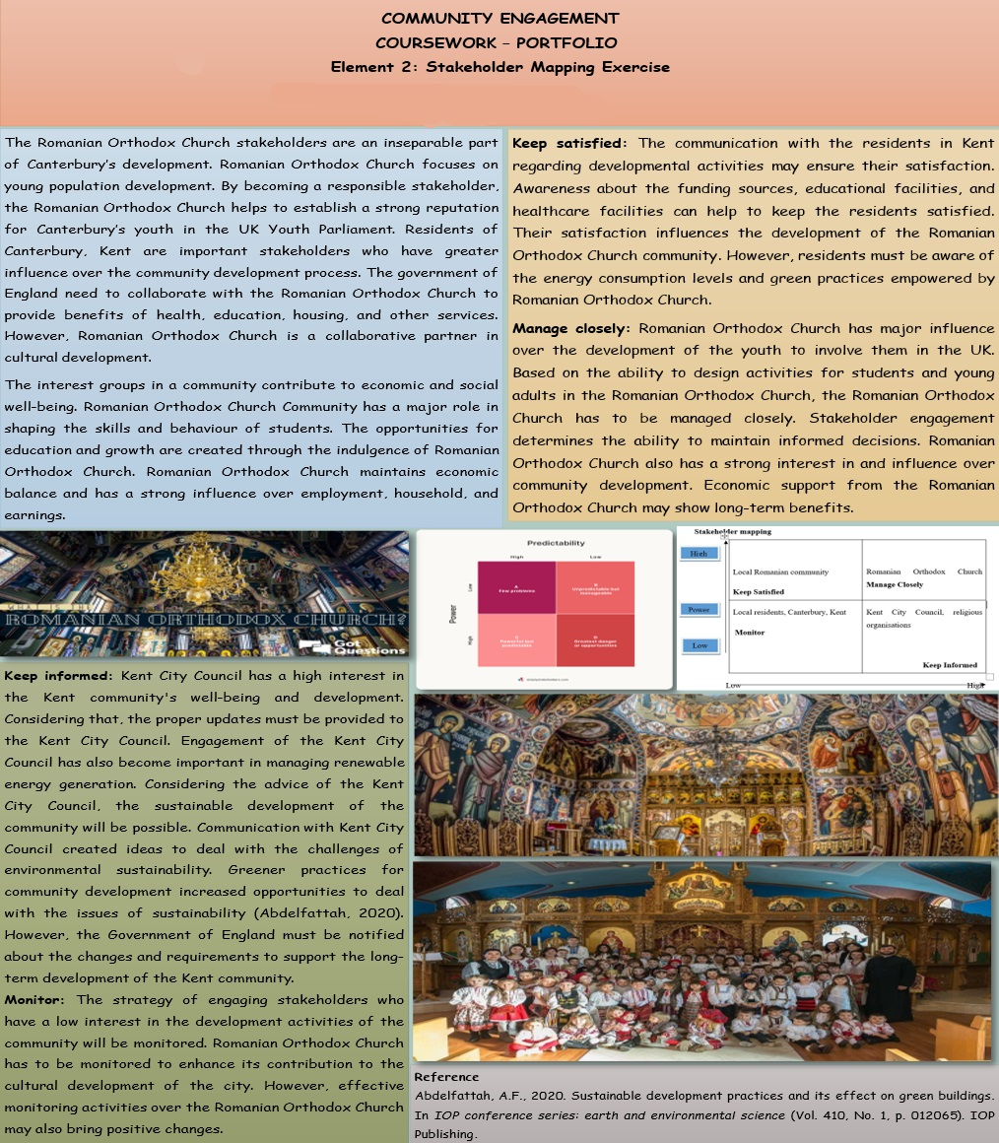
The Romanian Orthodox Church stakeholders are an inseparable part of Canterbury’s development. Romanian Orthodox Church focuses on young population development. By becoming a responsible stakeholder, the Romanian Orthodox Church helps to establish a strong reputation for Canterbury’s youth in the UK Youth Parliament. Residents of Canterbury, Kent are important stakeholders who have greater influence over the community development process. The government of England need to collaborate with the Romanian Orthodox Church to provide benefits of health, education, housing, and other services. However, Romanian Orthodox Church is a collaborative partner in cultural development.
The interest groups in a community contribute to economic and social well-being. Romanian Orthodox Church Community has a major role in shaping the skills and behaviour of students. The opportunities for education and growth are created through the indulgence of Romanian Orthodox Church. Romanian Orthodox Church maintains economic balance and has a strong influence over employment, household, and earnings.
Stakeholder mapping
High  Local Romanian community  Keep Satisfied  Power | Romanian Orthodox Church Manage Closely
Local residents, Canterbury, Kent  Monitor  Low | Kent City Council, religious organisations  Keep Informed
Low High
Interest
Figure 1: Stakeholder Power Grid
Source: (Developed by the author)
Keep satisfied: The communication with the residents in Kent regarding developmental activities may ensure their satisfaction. Awareness about the funding sources, educational facilities, and healthcare facilities can help to keep the residents satisfied. Their satisfaction influences the development of the Romanian Orthodox Church community. However, residents must be aware of the energy consumption levels and green practices empowered by Romanian Orthodox Church.
Manage closely: Romanian Orthodox Church has major influence over the development of the youth to involve them in the UK. Based on the ability to design activities for students and young adults in the Romanian Orthodox Church, the Romanian Orthodox Church has to be managed closely. Stakeholder engagement determines the ability to maintain informed decisions. Romanian Orthodox Church also has a strong interest in and influence over community development. Economic support from the Romanian Orthodox Church may show long-term benefits.
Keep informed: Kent City Council has a high interest in the Kent community's well-being and development. Considering that, the proper updates must be provided to the Kent City Council. Engagement of the Kent City Council has also become important in managing renewable energy generation. Considering the advice of the Kent City Council, the sustainable development of the community will be possible. Communication with Kent City Council created ideas to deal with the challenges of environmental sustainability. Greener practices for community development increased opportunities to deal with the issues of sustainability (Abdelfattah, 2020).
Monitor: The strategy of engaging stakeholders who have a low interest in the development activities of the community will be monitored. Romanian Orthodox Church has to be monitored to enhance its contribution to the cultural development of the city. However, effective monitoring activities over the Romanian Orthodox Church may also bring positive changes.

Element 3: Community Engagement Plan
Goals and objectives
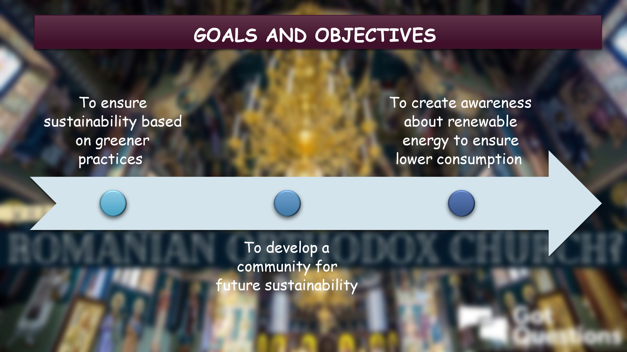
- To ensure sustainability based on greener practices
- To develop a community for future sustainability
- To create awareness about renewable energy to ensure lower consumption
The issue of sustainability and environmental degradation can create difficulties in dealing with community development activities. The stakeholder involvement within a community engagement plan can help resolve the problem associated with green practice implementation in the Kent community. The shift towards renewable energy also developed the need to accept greener practices for low energy consumption. The community engagement plan will be based on the sustainability management practices of the Canterbury, Kent’s community.

Principles and standards
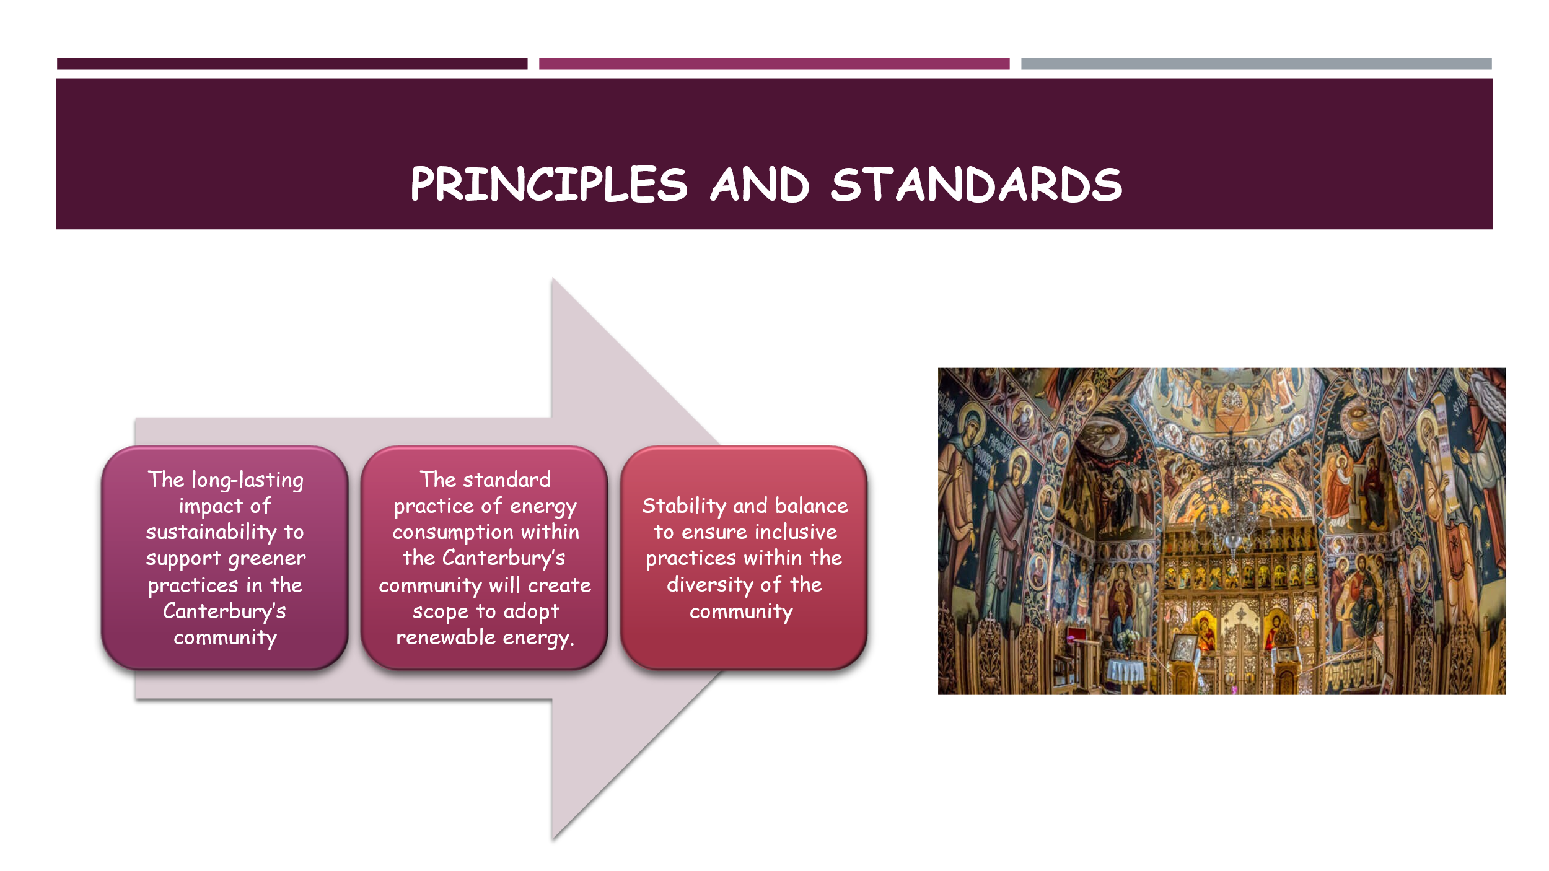
- The long-lasting impact of sustainability to support greener practices in the Canterbury’s community
- The standard practice of energy consumption within the Canterbury’s community will create scope to adopt renewable energy.
- Stability and balance to ensure inclusive practices within the diversity of the community
Informed decision-making process to deal with the challenges of sustainability and energy consumption. The principle of diversity and inclusion will be inextricably linked to the goal of sustainable community development (Winston, 2022). Standard consideration of climate actions brings changes for the future and ensures sustainability.

Adaptable strategies
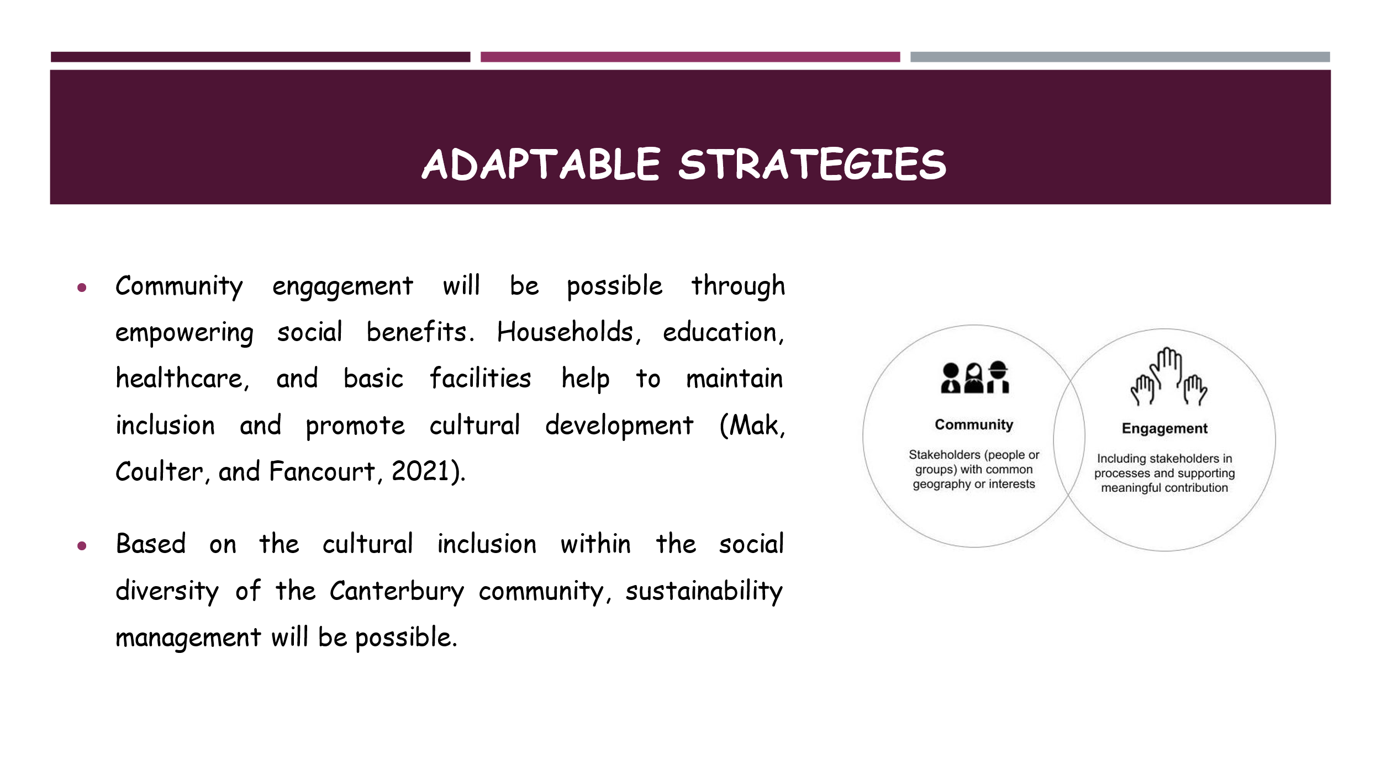
- Community engagement will be possible through empowering social benefits. Households, education, healthcare, and basic facilities help to maintain inclusion and promote cultural development (Mak, Coulter, and Fancourt, 2021).
- Based on the cultural inclusion within the social diversity of the Canterbury community, sustainability management will be possible.
A goal to support climate actions within the upcoming years can help the Canterbury community to empower the practices of net zero emission. The businesses around the Romanian Orthodox Church need to decarbonise their operations and focus on sustainable materials while establishing a sustainable supply chain. Low-carbon technologies can also help to promote climate action (Sovacool, 2021). Romanian Orthodox Church may focus on the principle of organic sustainability and the long-lasting impact of green practices.

Adaptable strategies (cont.)
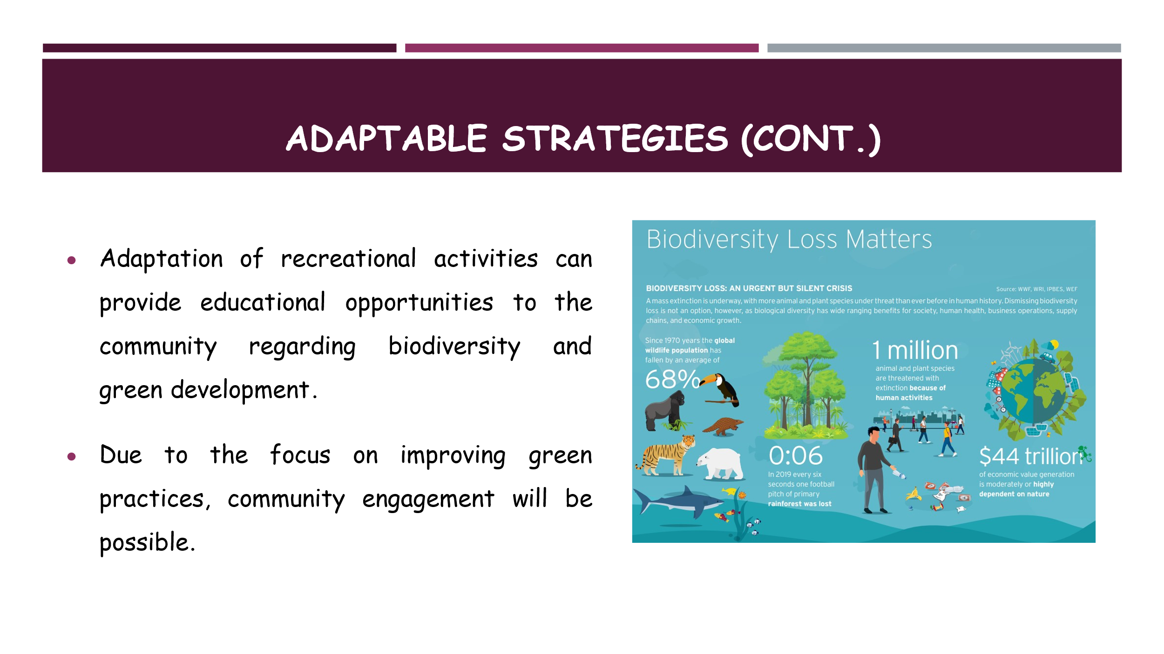
- Adaptation of recreational activities can provide educational opportunities to the community regarding biodiversity and green development.
- Due to the focus on improving green practices, community engagement will be possible.
Low energy consumption practices of Romanian Orthodox Church may help to adapt to the clean energy usage processes to avoid challenges in retaining sustainability. Workplaces and homes in Canterbury, Kent can adapt to renewable energy generation practices to support sustainable community development. Clean energy usage has a positive impact on community engagement processes (Hanke and Lowitzsch, 2020).

Potential collaborations
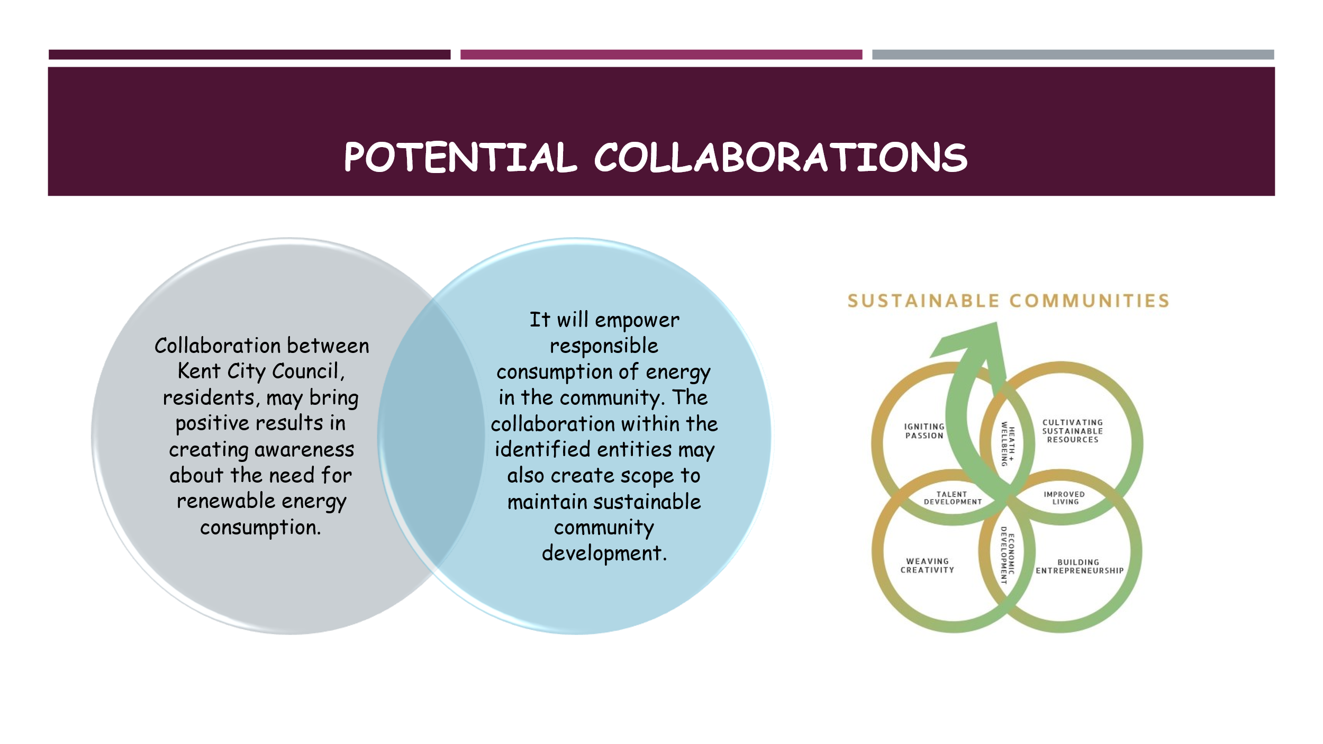
- Collaboration between Kent City Council, residents, may bring positive results in creating awareness about the need for renewable energy consumption.
- It will empower responsible consumption of energy in the community. The collaboration within the identified entities may also create scope to maintain sustainable community development.
Kent City Council, and local government have to engage in net zero objectives. The balance between consumption and release can influence environmental sustainability management practices positively. Informed decisions of the stakeholders can create opportunities to support sustainability. The climate action of the Canterbury, Kent will be supported by the Kent City Council. The actions to avoid possible issues of climate change in Canterbury, Kent and England will help the community to be active in adapting to the changes and managing climate change. Economic development with greener practices will be possible by collaborating with the Kent City Council, and the Government of England. With the strategy of maintaining collaboration within the different entities, the household, education, and health facilities can be provided based on the principle of diversity and inclusion.

Element 4: Practical Discussion
Active engagement with stakeholders can create a scope of maintaining direct communication. The strategy of direct communication enhances possibilities to develop awareness to make decisions among stakeholders (Greenwood, 2023). It provides opportunities to connect with the stakeholders to share concerns regarding challenges associated with sustainability management, energy consumption, and community development for the future. Increased opportunities to identify the strategies to deal with the challenges can be created with the active engagement of stakeholders in the community engagement plan. The purpose of meeting the goals of sustainability can be fulfilled with the effective engagement of different stakeholders. The benefits of direct communication within the members of Romanian Orthodox Church and its stakeholders may bring changes to empower community-based activities that may create long-lasting impact over the entire Canterbury, Kent.
Social and environmental changes have created possibilities to support changes to adapt to the strategies of sustainability management. Stakeholders of the community engagement plan will help to maintain collaboration with the Romanian Orthodox Church and its different stakeholders. Holistic development of the community will be possible with active engagement of stakeholders. It may also create possibilities to maintain local community involvement in the community engagement plan. By considering the benefits of having stakeholders' advice, the community will learn the importance of managing collaboration while focusing on sustainable development goals.
Equal distribution of economy, rights, healthcare facilities, housing facilities, and sustenance within the community of Canterbury, Kent will help the community to obtain benefits of financial and other facilities. It will not only help to empower the overall development of the community but will also extend possibilities of collaboration management within Kent City Council, community people, and the Government of England. By benefiting the community in terms of equal opportunities, accessible facilities, and safety, the Kent City Council may generate possibilities for the long-term growth of the Romanian Orthodox Church in the UK.
Renewable energy generation under the supervision of Kent City Council will also generate scope for improving renewable practices. Clean energy will not only benefit the community but also will benefit the environment. Kent City Council will be committed to renewable energy development and sustainability management for the Kent community. Renewables determine the future of energy consumption, which reflects the need to create a balance between renewable energy consumption and sustainable development (Al-Shetwi, 2022).
Active engagement of the Kent City Council will support the economic development of the Kent community. Contribution to the prosperity of sectors in England will generate a scope of upskilling the people of the Kent community to learn the green economy development processes. Capitalisation of diverse sectoral growth in Kent will help to improve the resilience of the community to fight against economic uncertainties. Responsible investment of the Kent City Council will align with the practices of sustainable community development. Collaborative work practices may help to achieve the goals of sustainable community development.
Collaboration with the Kent City Council can bring changes based on sustainability and environmental well-being. The Romanian Orthodox Church can work in close association with the Kent City Council which may generate possibilities to implement plans of climate action. The focus on net zero goals of the Romanian Orthodox Church and the Kent City Council will be actualised with the support of the government. Support towards sustainability may enhance the scope of maintaining biodiversity for the long term (Rotherham, 2022).
As a member of the community, it can be assessed that the Kent City Council rejuvenates the enthusiasm within Canterbury’s youth. The involvement of the youth in the community engagement plan will contribute their opinions and ideas to the informed decision-making process. The possibility of retaining collaboration between the community members and the Kent City Council increases after the involvement of Canterbury’s youth within the UK Youth Parliament group. The benefits are the development of citizenship behaviour, responsible consumption habits, and consciousness regarding future sustainability. It may also involve the youth of the Kent City Council within the environmental sustainability management goals.
Personal experience as a community member increases awareness about social, economic, and cultural factors. The Kent City Council and the Government of England focus on local community development with a focus on long-term impact development on community well-being. Based on the strategy to implement the standards of diversity and inclusion, the stakeholders have generated opportunities to learn the cultural habits of the Romanian Orthodox Church and become aware of the changes in the socio-economic structure of the community. By considering the value of maintaining sustainability, collaboration with important stakeholders may bring positive changes. It may enhance possibilities to support sustainability and long-term development of the community.
As a community member, it can also be evaluated that the ethnic and cultural diversity in the Romanian Orthodox Church can generate possibilities to deal with the challenges associated with sustainable community development. The Kent’s initiative helped in securing the bio-economy that created benefits to empower employment within the Canterbury’s community. Earning to boost the net-zero goals of the Canterbury’s community may bring changes in citizenship behaviour. By building a green society, the stakeholders are aiming to deal with the challenges of managing responsible consumption, low energy usage, climate change, and informed decisions. The green construction, with the support of stakeholders, also helped the local people to be actively engaged in the community engagement plan for future development. Community sustainability with effective socio-cultural inclusion may bring positive changes in the case of building a strong unity (Conti, 2021). Active communication with different stakeholders provided ideas to deal with the prevalent issues and support sustainable community development activities.
Recommendations
- The focus on long-lasting impact development to form a sustainable community can help the Romanian Orthodox Church to work collaboratively. The strategies of maintaining sustainable development with the collaboration between the community and stakeholders may bring long-lasting impacts on sustainable community development.
- The standards of inclusive practices need to be aligned with community development practices. It may generate possibilities of creating stability within the community to establish solidarity to withstand the challenges of climate change and environmental degradation. Inclusive practices increase the scope of maintaining sustainability within the community (Esquierdo-Leal and Houmanfar, 2021).
- Community development with equitable practices can empower the economy of the Romanian Orthodox Church. The funding sources and the local government must focus on equal distribution of the economy. It may enhance possibilities to deal with the challenges related to investment and economic development of the Romanian Orthodox Church.
- However, the community must rely on the standards of responsible consumption to avoid difficulties in consuming energy. Renewable energy consumption and cleaner energy production may also enhance the possibilities of dealing with the issues of sustainability and energy usage in the Romanian Orthodox Church.

Conclusion
Thus, it can be concluded that the Romanian Orthodox Church activities as well as their community engagement have played a huge role in the process of sustainable development of Kent community. Therefore, through engagement of stakeholders like the Kent City Council, Romanian Orthodox Church, the government has a model that would work to support the Canterbury’s economy together with the welfare of Canterbury, Kent’s citizen’s while respecting the environment. Thus, the focus on equality, professionalism, and appreciation of cultural difference has maintained Canterbury, Kent as an example of community sustainability and development. Thus, it can be stated that the focus on renewable energy sources and sustainable development will help the community to progress, ensuring Canterbury, Kent to become an example of the reminiscence of the historical past and the implementation of innovative technologies. Thus, Romanian Orthodox Church now has sufficient resources to meet the future challenges and opportunities due to effective stakeholder engagement and strategic planning.

References
Abdelfattah, A.F., 2020. Sustainable development practices and its effect on green buildings. In IOP conference series: earth and environmental science (Vol. 410, No. 1, p. 012065). IOP Publishing.
Al-Shetwi, A.Q., 2022. Sustainable development of renewable energy integrated power sector: Trends, environmental impacts, and recent challenges. Science of The Total Environment, 822, p.153645.
Conti, L., 2021. Caring and Power-Sharing: How Dialogue Influences Community Sustainability. Journal of Dialogue Studies, 9.
Esquierdo-Leal, J.L. and Houmanfar, R.A., 2021. Creating inclusive and equitable cultural practices by linking leadership to systemic change. Behavior analysis in practice, 14(2), pp.499-512.
Flackleyash hotel. 2024. Kent - The Garden of England. [online] Available at: <https://www.flackleyashhotel.co.uk/blog/kent-the-garden-of-england.html#:~:text=Although%20other%20regions%20have%20tried,%2C%20Devon%2C%20Derbyshire%20and%20Gloucestershire.> [Accessed 12 August 2024].
Gov. 2023. How your area has changed in 10 years: Census 2021. [online] Available at: <https://www.ons.gov.uk/visualisations/censusareachanges/E06000014/> [Accessed 6 August 2024].
Greenwood, M.R., 2023. Community as a stakeholder: focusing on corporate social and environmental reporting. In Australasian Perspectives on Corporate Citizenship (pp. 31-46). Routledge.
Hanke, F. and Lowitzsch, J., 2020. Empowering vulnerable consumers to join renewable energy communities—towards an inclusive design of the clean energy package. Energies, 13(7), p.1615.
Kent, 2024. Statistical Bulletin May 2024. [online] Available at: <https://www.kent.gov.uk/__data/assets/pdf_file/0006/8187/Kent-economic-indicators-report.pdf>. [Accessed 12 August 2024].
Mak, H.W., Coulter, R. and Fancourt, D., 2021. Associations between community cultural engagement and life satisfaction, mental distress and mental health functioning using data from the UK Household Longitudinal Study (UKHLS): does area deprivation moderate associations?. BMJ open, 11(9), p.e045512.
Office for National Statistics, 2022. How the population changed in Canterbury: Census 2021. [online] Available at: <https://www.ons.gov.uk/visualisations/censuspopulationchange/E07000106/>. [Accessed 12 August 2024].
Rotherham, I.D., 2022. Challenges for the restoration of cultural values in UK woodlands. Forest Ecology and Management, 503, p.119756.
Sovacool, B.K., 2021. Who are the victims of low-carbon transitions? Towards a political ecology of climate change mitigation. Energy Research & Social Science, 73, p.101916.
Winston, N., 2022. Sustainable community development: Integrating social and environmental sustainability for sustainable housing and communities. Sustainable Development, 30(1), pp.191-202.

