

APPENDIX GA36d

LEVEL 7 ASSESSMENT SPECIFICATION

Student name: | ARYA MARTIN | Student ID number: | 2220294
Programme: | MSc/PgDip/PgCert Cybersecurity and Digital Forensics
Module: | Digital Forensics Analysis
Module code: | ACCA7031 | Contribution to Overall Module Assessment (%): | 100%
Lecturer: | Dr. Nitheesh Kaliyamurthy | Internal Verifier: | Munyaradzi Murira
Assignment Title: | Research, Analyse and Investigate Digital Cybersecurity incidents and perform digital forensic assessment | Word count (or equivalent): | 5000
Submission deadline: | 2nd January 2024 | Return date of provisional marks & written feedback: | TBA

Table of content
Digital Forensics Research Report
1.1 Current State of the Field
1.2 Emerging Trends in Digital Forensics
1.3 Key Challenges Faced in Digital Forensics
1.4 National and International Job Market
2 Tools Analysis Report
2.1 Evaluation of Open Source Tools with Commerci.
References
3.Task3
INDIVIDUAL REPORT (AFTER EXCHANGING THE HARD...
31.Cyberbullying Investigation and Digital Forensics
3.2Overview of the case:
3.3 Analysed data from the hard drive from group B
3.4My Contribution:
3.5In conclution
Before the transition of the hard drive to Team C,
3.6INTRODUCTION
3.7 My Contribution:
Task 4
4.INDIVIDUAL REPORT
4.1 Resources:
4.2My Contribution:
4.3In conclution
4.4References
5.Annexures
1. Chain of Custody
2. Minutes of Meeting
3. Video Presentation
4, Data Collection Report.pdf
5. Team Reports
6. Google Sheet

Digital Forensics Research Report

Current State of the Field
Digital forensics is a field within cybersecurity that focuses on investigating cybercrimes and recovering electronically stored data. In the early 2000s, digital forensics was an independent field because computer-based crimes were emerging, and the evidence collected in investigations was limited to computers (Raghavan, 2012). Consequently, digital forensics was initially known as computer forensics. In recent years, the prevalence of cybercriminal activities in society has led to a significant growth in digital forensics. With the evolution of ARPANET into the internet and the widespread use of personal smart devices, computer forensics has expanded into digital forensics, encompassing not only computers but also other electronic devices (Ibarra-Esquer et al. 2017). Digital forensics involves the identification, processing, analysis, and documentation of crime investigations related to electronically stored data. (Kumari and Mohapatra 2016) mention major branches of digital forensics, which include computer forensics, mobile device forensics, network forensics, forensic data analysis, and database forensics. Today, digital forensics has become crucial for organizations and government agencies in addressing cybercrimes and legal issues involving digital devices. Furthermore, digital forensics is increasingly utilized in legal proceedings related to data theft, network breaches, online theft or identity fraud, white-collar crimes, and more.
Digital forensics encompasses multiple frameworks including the cyber kill chain, unified kill chain, diamond model, and others, which were not published before the 1990s or late 2000s (Yadav and Rao, 2015). These frameworks and models play a crucial role in digital forensics, as they enable investigators to conduct in-depth analyses of cyber-attacks and extract vital information about the attack, such as the attacker's motives and capabilities. Presently, these frameworks are widely utilized by numerous digital forensic teams to conduct effective cyber investigations.
Cybersecurity and digital forensics are distinct yet interconnected terms (Sharma et al. 2019). Cybersecurity involves the practice of safeguarding and defending computers, servers, electronic devices, and physical areas. Conversely, digital forensics is focused on investigating cybercrimes and recovering data to gather evidence. The cybersecurity team works on enhancing network security by implementing information security policies to detect and prevent network anomalies from infiltrating the network and compromising the systems. On the other hand, the digital forensics team works to identify the source of the hack or network anomaly, comprehend the attack vectors, and discern the attacker's aims and motives behind the attack (Neshenko et al. 2021). These two fields are highly interdependent, collaborating to uphold digital security across various sectors and industries.

Emerging Trends in Digital Forensics
As cybercrimes continue to advance and circumvent robust security measures, it becomes essential to upgrade digital forensics methods to investigate such crimes with the help of artificial intelligence (AI). Digital forensics is also harnessing AI and machine learning capabilities to investigate cybercrimes using cloud-based AI tools. (Dunsin et al. 2023). Real-time data collection and processing using AI aids investigators in effectively probing advanced cybercrimes involving fileless malware or rootkits. Additionally, cloud technology has revolutionized the management of critical services and digital infrastructure for organizations. With the adoption of reliable cloud applications, digital forensics has also begun utilizing cloud-based forensic tools, enabling investigators to distribute evidence data across multiple servers and protect the data using complex encryption systems and cloud security policies. According to a survey conducted by Statista, the number of mobile device users is projected to reach 7.5 billion in 2025 (Taylor, 2023). With the increased usage of mobile devices, containing vast amounts of mobile data and extracting relevant information has become challenging. Consequently, forensic tools have been developed to overcome these challenges and effectively conduct mobile forensics.

Key Challenges Faced in Digital Forensics
Experts and professionals in cyber forensics are entrusted with extracting data from a wide range of electronic devices and sources. However, as these devices and sources are developed independently by multiple vendors, it has become a challenge for investigators to safely and effectively extract data from multi-vendor devices. Moreover, if the data in the electronic device is encrypted using advanced encryption algorithms, investigators will be unable to decrypt the data without the actual decryption keys (Solutions, 2023).
Another significant challenge in digital forensics is that investigators often lack access to the information content of the data and only have access to the metadata (Anderson et al. 2021). Additionally, investigators do not have complete control over the storage systems from which data is extracted, and such restrictions can hinder forensic investigators from accurately recovering data, potentially leaving important data for analysis. While enhanced security measures and policies like end-to-end encryption and data handling protect digital data from malware and cyber-attacks, they also present significant complexity for investigators in analyzing digital data (Solutions, 2023).
Digital forensics services heavily depend on multiple external suppliers for funding. However, the reduction in funding in the market has led to a decrease in the number of external suppliers. Consequently, cyber forensics is facing challenges due to insufficient internal capacity and a limited budget for utilizing external expertise to solve complex cybercrimes. Under the General Data Protection Regulation (GDPR) and Personal Data Protection Act (PDPA) acts, it has been stipulated that, to increase data protection, data could be stored under multiple jurisdictions. If the data is not stored in a single location but in multiple geographical locations, investigators could face legal issues when accessing the data (Started, 2023).

National and International Job Market
Businesses and organizations are currently grappling with a surge in cyber-attacks and data breaches, leading to significant financial and reputational losses. In response, there has been a rapid increase in the demand for digital forensic investigators to investigate and mitigate these cyber-attacks. (MarketsandMarkets 2023) estimated the global growth of the digital forensic market as displayed in the below image:
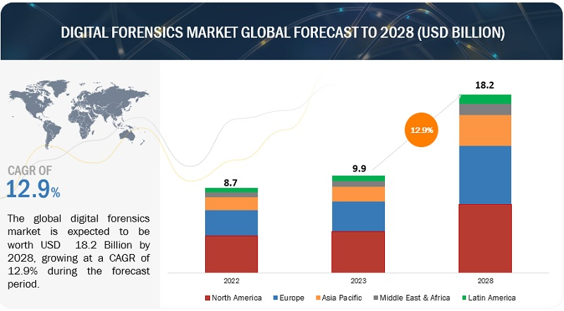
With the gradual increase from the 2022 to 2028, there will be a significant increase in each continent which will be worth 18.2 Billion USD. Similarly (Digital Forensics Market – Global Industry Analysis. 2023) also stated that the global digital forensics market was worth USD 9.19 billion in 2022 and is predicted to grow to USD 26.47 billion by 2029, at a CAGR of 16.3%. Along with these, as per a news article published by the University of Central Florida, various positions are available for motivated investigators, including information security analysts, forensic computer analysts, chief information security officers, and more. Each of these roles requires a distinct skill set and offers compensation commensurate with the level of expertise.
Furthermore, a popular job portal, Indeed, has listed numerous job openings in the field of digital forensics. For instance, there is a full-time digital forensic job titled "Digital Forensic Technician Apprenticeship," which requires applicants to utilize digital forensic systems and tools. Additionally, the position of "Digital Forensic Specialist" is being offered with a salary of approximately €50,000. This role entails conducting digital forensic examinations and researching innovative methods for data extraction and collection.
A survey conducted by Crunchbase in 2021 revealed that there were approximately 1,800 companies operating in the United Kingdom, with over 60 percent being micro-businesses employing fewer than 10 employees. The statistics below illustrate the job openings in the United States for the year 2021.

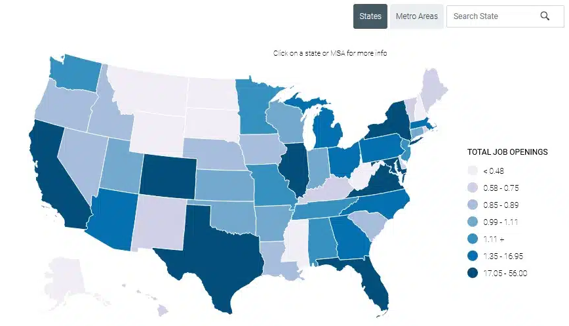

Tools Analysis Report
Digital forensics tools are becoming vital for conducting cyber investigations. There are multiple digital forensics tools available in the market which are used by many organizations or government agencies to collect and analyze digital evidence. Below is the evaluation of digital forensic tools –
Tool | Features | Capabilities | Example
Yara | - Multi-platform support for Windows, Linux, and MacOS  - Utilizes Python scripting language for automation  - Supports multiple file types such as zip, tar, and more | Yara is a versatile tool for identifying and categorizing malware. It allows investigators to collect multiple samples of malware and create custom rules for advanced malware analysis. | For example, Yara can be used to identify specific patterns or behaviors within malware samples, aiding in the detection and classification of various types of malware (Volarević, Tomić and Milohanić, 2022).
Network Miner | - Supports Windows and Linux  - Enables audio extraction from VOIP communication  - Offers advanced OS fingerprinting capabilities | Network Miner is a powerful network forensics tool capable of extracting artifacts such as passwords, emails, and other information from PCAP files (Sikos 2020). | For instance, it can identify and extract VoIP conversations from network traffic, providing valuable evidence for forensic investigations.
Velociraptor | - Utilizes Velociraptor query language  - Supports server automation  - Deployable on cloud platforms | Velociraptor is a robust digital forensics and cyber response tool that excels in hunting artifacts across multiple endpoints (Security 2023). It is capable of reconstructing activities performed by attackers during an attack, providing valuable insights into the tactics and techniques employed by malicious actors. | For example, Velociraptor can be used to track and analyze the movement of an attacker within a compromised network, aiding in incident response and threat hunting efforts.
Volatility | - Cross-platform and modular too  - Supports fast and efficient algorithms for analyzing RAM dumps  - Compatible with both 32-bit and 64-bit computing architectures | Volatility is a leading memory forensics tool renowned for its ability to extract information from volatile storage components, such as RAM. | For instance, it can be utilized to analyze memory dumps from compromised systems, enabling the extraction of critical forensic artifacts, including process and network connections, providing valuable insights into the activities of an attacker (Almutairi et al., 2020).
KAPE | - Supports virtual and raw hard drives (VHD & RAW)  - Fast, customizable, and scalable artifact parser tool  - Compatible with the Windows operating system | KAPE is a high-speed artifact parser tool designed for extracting Windows artifacts from live systems or storage devices. | For example, it can rapidly collect and parse a wide range of forensic artifacts, including event logs, registry hives, and file system metadata, facilitating efficient and comprehensive forensic analysis.
Redline | - Exclusive support for Windows systems  Capable of collecting registry data, running processes, memory snapshots, and more | Redline is a sophisticated forensic tool tailored for analyzing infected endpoints using memory dumps and file structures. | For instance, it can be used to reconstruct the timeline of events leading to a security breach, providing crucial insights into the tactics and techniques employed by attackers (Rey 2023).
Autopsy | - Support for robust file systems including NTFS, FAT, exFAT, HFS, EXT2/3/4, and more  - Extends support to Android devices  - Multi-user collaboration capabilities | Autopsy is a comprehensive digital forensics tool renowned for its ability to investigate infected computers and analyze malicious activities conducted by attackers. | For example, it can be utilized to perform in-depth analysis of file systems, recover deleted files, and examine artifacts from Android devices, aiding in the reconstruction of digital evidence in forensic investigations.
Splunk | - Real-time monitoring and alerting capabilities  - Utilizes metrics data to enhance artifact searching  - Capable of tracking, scanning, and analyzing system-generated data in real time | Splunk is a powerful program designed for tracking, scanning, and analyzing system-generated data in real time. | For instance, it can be used to monitor and analyze large log files, PCAP files for network analysis, and other data sources, enabling the detection and investigation of security incidents and anomalies in enterprise environments (Satybaldina et al. 2023).

Evaluation of Open Source Tools with Commercial Tools
In the field of digital forensics, there is a wide array of open-source tools available, alongside several commercial options that offer more advanced features. One of the primary advantages of open-source tools is that they do not require a license key for activation, whereas commercial tools necessitate the purchase of a license key by the user. Some prominent commercial tools include Encase, OS Forensics, Magnet, WinHex, and others. Evaluation of these commercial tools with open source tools can be seen in the below table:.
Tools | Type | Key Features | Evaluation
FTK | Open Source | - User-friendly with graphical interface  - File system analysis, registry, and email analysis  - Integration capability with other forensic tools  - Ability to navigate between multiple case files (Ghazinour et al. 2017)  - Seamless data sharing for improved forensic investigation | Highly regarded for its user-friendly interface and integration capabilities, making it a valuable tool for forensic investigators.
Sleuth Kit | Open Source | - Command line tools for disk analysis  - Cross-platform support for file systems like FAT, NTFS, exFAT, and more  - Modular components for customization based on specific investigation requirements (Hibshi et al. 2011) | Widely praised for its cross-platform support and modular components, enabling customization for diverse forensic needs.
Pro Discover | Open Source | - Analysis of disk images by generating bit-by-bit copies  - Graphical user interface for increased productivity  - Support for file carving to recover deleted data for evidence collection | Recognized for its efficient disk image analysis and user-friendly interface, making it suitable for investigators with varying levels of expertise.
CAINE | Open Source | - Live environment for immediate forensic work without installation  - Specifically designed for incident response teams  - Bypasses the need for installation, enabling immediate forensic work | Highly valued for its live environment feature, allowing immediate forensic work without the need for installation, particularly beneficial for incident response teams.
Encase | Commercial | - Extensive capabilities for examining digital media  - User-friendly interface for simplifying complex investigation cases  - Focus on providing security to the evidence collected by the forensic team(Lovanshi and Bansal 2019) | Highly regarded for its extensive capabilities in examining digital media and its focus on evidence security, making it a trusted tool for complex investigations .
OS Forensics | Commercial | - Examination and analysis of file attributes, metadata, and deleted data recovery  - Extraction and analysis of network artifacts such as syslog, network traffic, and registry entries  - Analysis of live RAM to examine running processes for finding file-less malwares | Recognized for its wide range of analysis capabilities, including file attribute and metadata analysis, network artifact examination, and live RAM analysis, making it a comprehensive tool for forensic investigations.
Magnet | Commercial | - Analysis and reporting of digital evidence across multiple platforms  - Recovery of various artifacts such as internet history and social media messages (Ghazinour et al. 2017) | Highly praised for its specialized focus on digital evidence analysis and extensive artifact recovery across diverse platforms, making it a valuable tool for comprehensive investigations.
WinHex | Commercial | - Inspection of disk structures and images  - Analysis of recovered deleted files, even from unallocated disk space  - Hex editing for direct manipulation of binary hex data | Recognized for its advanced disk and hex editing capabilities, particularly valuable for in-depth inspection and analysis of disk structures and recovered deleted files.

References
- Ibarra-Esquer, J., González-Navarro, F., Flores-Rios, B., Burtseva, L. and Astorga-Vargas, M. 2017. Tracking the Evolution of the Internet of Things Concept Across Different Application Domains. Sensors 17(6), p. 1379. Available at: http://dx.doi.org/10.3390/s17061379.
- Kumari, N. and Mohapatra, A.K. 2016. An insight into digital forensics branches and tools. 2016 International Conference on Computational Techniques in Information and Communication Technologies (ICCTICT) . Available at: http://dx.doi.org/10.1109/icctict.2016.7514586.
- Sharma, B.K., Joseph, M.A., Jacob, B. and Miranda, B. 2019. Emerging trends in Digital Forensic and Cyber security- An Overview. 2019 Sixth HCT Information Technology Trends (ITT) . Available at: http://dx.doi.org/10.1109/itt48889.2019.9075101.
- Neshenko, N., Bou-Harb, E. and Furht, B. 2021. A behavioral-based forensic investigation approach for analyzing attacks on water plants using GANs. Forensic Science International: Digital Investigation 37, p. 301198. Available at: http://dx.doi.org/10.1016/j.fsidi.2021.301198.
- Dunsin, D., Ghanem, M.C., Ouazzane, K. and Vassilev, V. 2023. A Comprehensive Analysis of the Role of Artificial Intelligence and Machine Learning in Modern Digital Forensics and Incident Response. Available at: https://doi.org/10.2139/ssrn.4554035.
- Anderson, P., Sampson, D. and Gilroy, S. 2021. Digital investigations: relevance and confidence in disclosure. ERA Forum 22(4), pp. 587–599. Available at: http://dx.doi.org/10.1007/s12027-021-00687-1.
- Digital Forensics Market – Global Industry Analysis. 2023. Available at: https://www.maximizemarketresearch.com/market-report/global-digital-forensics-market/3163/#:~:text=Global%20Digital%20Forensics%20Market%20size,at%20a%20CAGR%20of%2016.3%25.
- MarketsandMarkets 2023. Digital Forensics Market Share, Forecast, Trends | Growth Analysis [2030]. Available at: https://www.marketsandmarkets.com/Market-Reports/digital-forensics-market-230663168.html [Accessed: 21 December 2023].
- Sikos, L.F. 2020. Packet analysis for network forensics: A comprehensive survey. Forensic Science International: Digital Investigation 32, p. 200892. Available at: http://dx.doi.org/10.1016/j.fsidi.2019.200892.
- Security, H.N. 2023. Velociraptor: Open-source digital forensics and incident response - Help Net Security. Available at: https://www.helpnetsecurity.com/2023/08/30/velociraptor-open-source-digital-forensics-incident-response/.
- Rey, C. 2023. Redline Tryhackme Walkthrough - Cyber Rey - Medium. Available at: https://cyberrey.medium.com/redline-tryhackme-walkthrough-80d9a19647c6.
- Satybaldina, D.Zh., Bisenbaeva, N.K., Seitkulov, Ye.N. and Seksenbaeva, A.K. 2023. Detecting and classifying network attacks with Splunk Machine Learning Toolkit. BULLETIN of the L N Gumilyov Eurasian National University MATHEMATICS COMPUTER SCIENCE MECHANICS Series 142(1), pp. 21–34. Available at: http://dx.doi.org/10.32523/2616-7182/bulmathenu.2023/1.2.
- Ghazinour, K., Vakharia, D.M., Kannaji, K.C. and Satyakumar, R. 2017. A study on digital forensic tools. 2017 IEEE International Conference on Power, Control, Signals and Instrumentation Engineering (ICPCSI) . Available at: http://dx.doi.org/10.1109/icpcsi.2017.8392304.
- Lovanshi, M. and Bansal, P. 2019. Comparative Study of Digital Forensic Tools. Data, Engineering and Applications , pp. 195–204. Available at: http://dx.doi.org/10.1007/978-981-13-6351-1_15.
- Hibshi, H., Vidas, T. and Cranor, L. 2011. Usability of Forensics Tools: A User Study. 2011 Sixth International Conference on IT Security Incident Management and IT Forensics . Available at: http://dx.doi.org/10.1109/imf.2011.19.
- Almutairi, A., Satari, B.S., Rivas, C., Stanciu, C.F., Yamani, M., Zohoorsaadat, Z. and Mokhov, S.A. (2020). Evaluation of Autopsy and Volatility for Cybercrime Investigation. International Journal of Digital Crime and Forensics, 12(1), pp.58–89. doi:https://doi.org/10.4018/ijdcf.2020010104.
- Chadd, K. (2020). The History Of Cybercrime And Cybersecurity, 1940-2020. [online] Cybercrime Magazine. Available at: https://cybersecurityventures.com/the-history-of-cybercrime-and-cybersecurity-1940-2020/.
- Ghosh, A., Majumder, K. and De, D. (2020). Android Forensics Using Sleuth Kit Autopsy. Advances in intelligent systems and computing, pp.297–308. doi:https://doi.org/10.1007/978-981-15-8061-1_24.
- Javed, A.R., Ahmed, W., Alazab, M., Jalil, Z., Kifayat, K. and Gadekallu, T.R. (2022). A Comprehensive Survey on Computer Forensics: State-of-the-Art, Tools, Techniques, Challenges, and Future Directions. IEEE Access, 10, pp.11065–11089. doi:https://doi.org/10.1109/access.2022.3142508.
- Raghavan, S. (2012). Digital forensic research: current state of the art. CSI Transactions on ICT, 1(1), pp.91–114. doi:https://doi.org/10.1007/s40012-012-0008-7.
- Solutions, A.D.F. (2023). The State of Digital Forensics. [online] www.adfsolutions.com. Available at: https://www.adfsolutions.com/news/the-state-of-digital-forensics.
- Started, G. (2023). Meeting the Future of Digital Forensics and Evidence Management Sustainability is at a Turning Point. [online] Available at: https://www.ibm.com/downloads/cas/RWL5O1PY#:~:text=Increased%20use%20of%20digital%20technology [Accessed 20 Dec. 2023].
- Volarević, I., Tomić, M. and Milohanić, L. (2022). Network forensics. [online] IEEE Xplore. doi:https://doi.org/10.23919/MIPRO55190.2022.9803427.
- Yadav, T. and Rao, A.M. (2015). Technical Aspects of Cyber Kill Chain. Communications in Computer and Information Science, 536, pp.438–452. doi:https://doi.org/10.1007/978-3-319-22915-7_40.
- Taylor, P. (2023). Forecast number of mobile users worldwide 2020-2025. [online] Statista. Available at: https://www.statista.com/statistics/218984/number-of-global-mobile-users-since-2010/#:~:text=In%202021%2C%20the%20number%20of.

3.TASK
INDIVIDUAL REPORT (AFTER EXCHANGING THE HARD DRIVE)
Cyberbullying Investigation and Digital Forensics
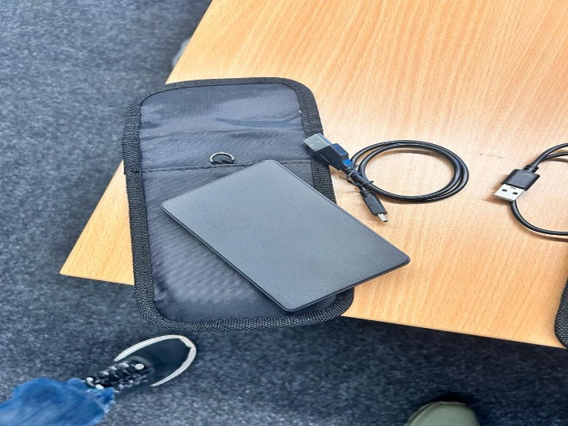

3.1Introduction
Cyberbullying has emerged as a serious public health concern, especially for young people. The purpose of this paper is to investigate one particular instance of cyberbullying. The project was assigned to us (Group C) by Group B.
Team Members:
Pranjal Sinha ( 2220277)
Arya Martin ( 2220294)
Bala Jaya Chandra Pichikala ( 2219819)
Sneha Sindhe (2304464)
Sakthi Sangeetha Kandaswamy ( 2236179)
Mehulgiri Ashvingiri Goswami (2214858)

3.2Overview of the case
The case of cyberbullying during our investigation into the Social Media Investigation. This case study is based on information gathered from three primary sources: a police report, social media chats, and call logs.In the initial stage of the investigation, I have focused on establishing the context and identifying key individuals involved. Working with The police report I noticed that Emmy James as the victim and Justine Elias as the suspect. Social media interactions revealed seven instances across Instagram, Facebook, and WhatsApp, involving users Seer Musta, Lee Saint, Fred William, Justine Elias, and Zhen. Additionally, concerns were raised about cyberbullying based on Alfred Adam's persistent calls to a specific number.
3.3 Analyzed data from the hard drive from group B
3.3.1Chats :30 screenshots of social media chats in .JPG and .PNG formats.
3.3.2Call Logs : 2 screenshots of call logs in .PNG format.
Readme.txt
3.3.3Document.rar ;Later revealed e_PoliceReport-CS-01 and e_PoliceReport-CS-02
3.3.4Files with .File extension :e_IMG_0010, e_IMG_0013
encrypt_file002.cpp
IMG_0010.jpeg, IMG20231123140.jpg
3.3.5Hard Drive:
The Maxone 500GB hard drive, initially appearing empty with an ExFAT32 file system, became a focal point of the investigation. The discovery of hidden files and folders, including e_PoliceReport-CS-01 and e_PoliceReport-CS-02, opened new avenues for exploration. The use of the PowerISO tool and File System Events service facilitated a detailed analysis of these files, uncovering crucial information.
3.4My Contribution
In our collaborative effort to investigate the simulated financial crime scenario, each team member was assigned specific tasks, contributing to a comprehensive digital forensic analysis. My assigned responsibility involved utilizing the FTK (Forensic Toolkit) tools to scrutinize the contents of the victim's hard drive. Through this process, I successfully uncovered valuable evidence in the form of chat and call logs, which proved instrumental in reconstructing the sequence of events during the cyber-attack. FTK's robust capabilities allowed for a thorough examination of the hard drive, revealing crucial information that contributed to the overall understanding of the attacker's activities. This collaborative approach, with each member focusing on their designated tasks, facilitated a more efficient and nuanced investigation, highlighting the significance of specialized tools and expertise in digital forensics.
3.5 In conclusion
Our group adeptly managed a simulated Cyberbullying scenario, seamlessly integrating digital forensic techniques into our investigation. Through collaborative efforts and the strategic application of forensic tools, we successfully uncovered pertinent evidence, showcasing our proficiency in handling cyber-related incidents. The meticulous analysis conducted on the hard drive, coupled with the insights presented in our comprehensive report and engaging presentation, serves as a tangible demonstration of our collective expertise in the dynamic field of digital forensics
Task 3 Group Report Link (Click here) Group C - Task 3 - ACCA7031 - Digital Forensics Analysis.docx
PPT Link (Click here) Group C - Task 3 - Video Presentation.mp4

Before the transition of the hard drive to Team C,
Digital Forensic Investigation by Collecting and Analysing Data

3.6 Introduction
In this project, we tackled a financial crime scenario in a virtual environment set up in Oracle VirtualBox. The arrangement included Kali Linux as the attacker's platform and Windows 10 Home as the victim's OS
The team staged a phishing attack, using the victim's wireless connection to send an email with a reverse shell payload. This allowed the attacker to remotely monitor and modify the victim's activities, such as making unauthorised purchases on Amazon. To carry out this action, tools like Setoolkit and msfvenom were used to create malware. The team examined several types of evidence, such as phishing emails, Screen Capture sessions, and screenshots from Remote Desktop Protocol (RDP) sessions. Each piece of evidence was painstakingly tagged with precise timestamps. Steganography and encryption were also used to conceal evidence, and the hard drive was partitioned so that the Windows client and Kali Linux ran independently. The major goal of the work was to find, analyse, and present digital evidence in the context of a sophisticated cybercrime scenario
3.7My Contribution

I played a pivotal role in the early stages of our digital forensic investigation. My primary focus was on meticulously examining the victim's Amazon account, where I actively engaged in the simulation by creating an account and placing orders. This hands-on approach provided insights into the attacker's actions, shedding light on potential financial repercussions and aiding in the reconstruction of the cyber incident's timeline. Simultaneously, I delved into the Windows 10 system, specifically addressing the challenge of file hiding. Uncovering concealed files within the operating system was a crucial step in understanding the attacker's techniques and identifying potential areas of compromise. Additionally, I collaborated with the team in crafting a phishing email through the Kali platform, a pivotal element in the simulated attack scenario. My multifaceted involvement in these tasks laid the groundwork for our comprehensive investigation, offering valuable perspectives on the intricacies of the cyber incident

4.Task
INDIVIDUAL REPORT
MobileForensic Tools: Cellebrite UFED, Oxygen Forensic Detective, Magnet AXIOM, and other tools covered during courses.
4.1Resources
One cell phone for each squad
Digital Forensic Tools: Cellebrite UFED, Oxygen Forensic Detective, Magnet AXIOM, and other tools covered during courses.
Phone Details:
Model: Note 14 (16G)
Brand: Ulefone
Colour: Lavender Purple
IMEI-1: 355617730545789
IMEI-2: 355617730545771
S/N:3102SH1010027469

MediaTek Helio A22
3GB RAM+16GB ROM
6.52-inch HD+ Display
8MP Main Camera
5MP Front Camera
Face Unlock
4500mAh Battery
Powered by Android™ 12

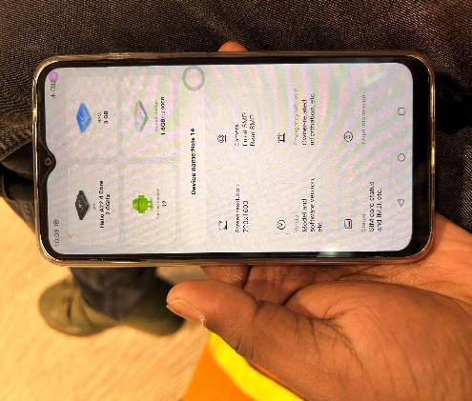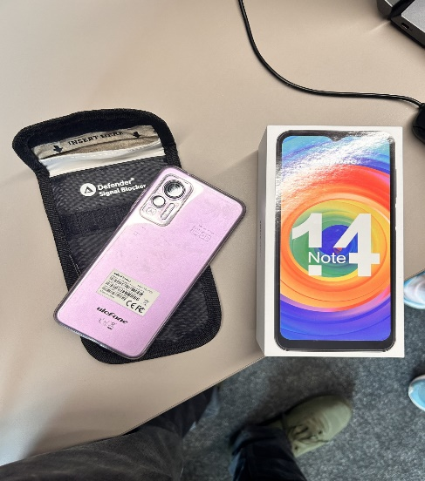
4.2My Contribution
Engaging in mobile forensics, my responsibilities were centered around implementing a comprehensive password-cracking methodology and analyzing various digital artifacts using the Cellebrite Universal Forensic Extraction Device (UFED). Employing advanced password-cracking techniques, I aimed to circumvent the security measures of the mobile device under investigation. This involved a meticulous analysis of potential passwords, considering factors such as the submission date and known patterns. The goal was to unlock the device and gain access to its contents, ensuring a thorough examination of the data within.
In addition to password cracking, the use of the Cellebrite UFED played a crucial role in extracting and analyzing digital evidence. The tool proved instrumental in decoding and presenting information such as pictures, call logs, and other details stored on the mobile device. By leveraging the capabilities of Cellebrite, I could piece together a comprehensive understanding of the user's activities, interactions, and communications, contributing significantly to the overall mobile forensic investigation.
The combination of a systematic password-cracking methodology and the powerful capabilities of Cellebrite allowed for a thorough exploration of the mobile device's contents. This approach not only ensured the extraction of valuable digital evidence but also facilitated the reconstruction of a comprehensive timeline of events, shedding light on potential motives and activities relevant to the investigation. Overall, my role in employing these forensic techniques showcases the importance of leveraging specialized tools and methodologies for in-depth analysis within the realm of mobile forensics.

4.2.1Craking technique I have done
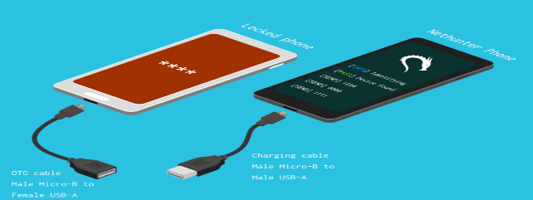
Step by step process
The mechanism called brute force attack using nethunder
We meet two cables like otg and usb
Otg cable connecte with the phone which we need to crack
Other one connects with logged on phone here install android net hunder to perform brute force attack
By using this mechanism net hunder will automatically try the combinations
4.3In conclusion
The examination into the suspect's actions turned up 23 audio recordings made between July and September 2023, with a particular focus on specific dates in August and September, implying key events or talks on those days. The analysis of call logs revealed numerous possibly questionable conversations, with the longest chat being with an Indian number. The suspect's contact list shows professional links to the United Kingdom, which are validated by a UK work contact number. An review of 218 media files revealed a wide-ranging travel pattern that included stops in India, the United Kingdom, Dubai, and Poland. The suspect's visit in Dubai appears to be confined to transit, since their travel ends in Swansea, UK, indicating their residency.

4.4References

1] Leuthkit.org. Autopsy. [Online]. Available at: https://www.sleuthkit.org/autopsy . Accessed on 12 December 2023.
2] AWS. 2022. Cellebrite Launches Cloud-Based Digital Intelligence Solution, Doubles Cloud Footprint Each Year through AWS Partner Transformation Program. [Online]. Available at: <https://aws.amazon.com/partners/success/cellebrite/>. Accessed on 12 December 2023

4.5Annexures
ALl of these files can be found in the OneDrive Folder.

Chain of Custody
  - Team C - Task 3 - Receiver.docx
  - Team C - Task 3 - Sender.docx
  - Team C - Task 4.docx

Minutes of Meeting
  - Meeting Notes - 1.docx
  - Team Discussions/Meeting Notes.docs

Video Presentation
  - Group C - Task 3 - Video Presentation.mp4

Data Collection Report.pdf

Team Reports
  - Group C - Task 3 - ACCA7031 - Digital Forensics Analysis.docx
  - Group C - Task 4 - ACCA7031 - Mobile Digital Forensics Analysis.docx

Google Sheet
  - Google Sheet - Task 3 & 4.xlsx

