Strategic Management for SMEs
MODULE CODE: BMSW6104
LECTURER: BENTE FATEMA
STUDENT: COSTEL ANDONE (2027240)

REBELLION DEVELOPMENTS LIMITED

Contents
1. Introduction 4
2. Overview of REBELLION DEVELOPMENTS LIMITED 4
3. Evaluation of Current Strategic Direction 5
3.1 Current Strategic Direction 6
3.2 The Vision, Mission, and Objectives of Rebellion Developments Limited 6
3.3 VMOST Analysis 8
4. SWOT Analysis for REBELLION DEVELOPMENTS LIMITED 9
4.1 Internal Environment (Strengths and Weaknesses): 9
4.1.1 Strengths 9
4.4.2 Weaknesses 9
4.2 External Environment (Opportunities and Threats): 10
4.2.1 Opportunities 10
4.2.2 Threats 10
5. Stakeholder Analysis for REBELLION DEVELOPMENTS LIMITED 11
5.1 Stakeholder for REBELLION DEVELOPMENTS LIMITED 11
5.1.1 Employees 11
5.1.2 Customers 11
5.1.3 Platforms 12
5.1.4 Publishers 12
5.1.5 Suppliers 12
5.1.6 Local Community 12
5.1.7 Industry Groups 12
5.2 Shareholders: 12
5.3 Employees: 13
5.4 Customers: 13
5.5 Suppliers 14
5.6 Regulatory Bodies: 14
6. Strategic growth options for Rebellion Developments limited. 14
7. Selection of strategies and Recommendations for Rebellion developments limited 18
7.1 Focus on live service games. 18
7.2 Motivation 18
7.3 Growth into mobile gaming 18
7.4 Rationale 18
7.5 New genre and IP investment 18
8. Barriers or challenges might have faced and how to overcome rebellion developments limited 19
9. Conclusion 20
10. REFERENCES 21
11. Appendix 23

1. Introduction
Wang et al. (2007) assert that Small and Medium Enterprises (SMEs) have a significant impact on the economic advancement of nations on a worldwide scale.
This report undertakes a comprehensive analysis of the current strategic direction of REBELLION DEVELOPMENTS LIMITED. It includes an evaluation of the external environment using tool such as SWOT analysis. Additionally, a stakeholder analysis is conducted to identify and assess the interests and influence of various stakeholders. Furthermore, the report explores strategic growth options specifically tailored for small and medium-sized enterprises (SMEs) operating within the video game industry. Finally, based on the findings, key strategic recommendations are provided. The primary objective is to provide a viable and enduring business approach that strategically situates the organisation for sustained prosperity within a dynamic and fiercely competitive milieu.
The purpose of this research is to conduct an analysis and make substantial contributions to the field of strategic management, specifically focusing on small and medium-sized firms (SMEs) that operate in dynamic industries.
This report considers the obstacles encountered by small and medium-sized enterprises (SMEs), including constraints in resources and fluctuations in the market. The aim is to guarantee that the suggested strategy is in line with the objectives and limitations of the organisation. In the subsequent sections, a comprehensive assessment of the present condition of REBELLION DEVELOPMENTS LIMITED will be conducted, along by the formulation of a strategic course of action that duly considers the dynamic nature of the video game business.

2. Overview of REBELLION DEVELOPMENTS LIMITED
REBELLION DEVELOPMENTS LIMITED is an independent video game development firm established in 1992, with its headquarters located in the United Kingdom. Since its establishment, the firm has experienced substantial growth and has garnered recognition for its well acclaimed titles, including the Sniper Elite series, Alien vs. Predator, and Strange Brigade. The success of the corporation can be attributed to its capacity to develop high-quality games that have garnered a substantial and dedicated following (https://rebellion.com/about-us/).

Regrettably, the company experienced a lack of substantial profitability, particularly in the preceding fiscal year (2022), as evidenced by the included documents accompanying this report (Table 1).
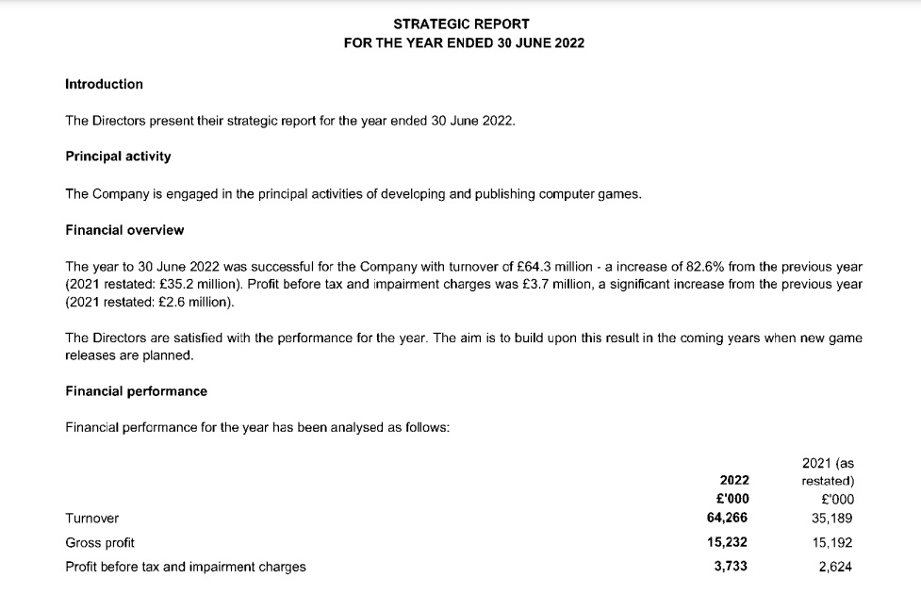
Table 1. Strategic Report rebellion developments limited 30 June 2022.
Source: https://find-and-update.company-information.service.gov.uk/company/02770940/filing-history

Nonetheless, the video game industry is characterised by intense competition, driven by dynamic shifts in technology, market conditions, and customer preferences. This study undertakes a critical evaluation of the company's existing strategic direction with the objective of offering recommendations for the purpose of achieving long-term sustainability.

3. Evaluation of Current Strategic Direction
Before offering a new method, REBELLION DEVELOPMENTS LIMITED must assess its strategic trajectory. The mission, vision, objectives, and methods of the organisation are examined.
Strategic alliance prospects were divided into three categories by Barney et al. (2018). These alliances may help firms improve their operations. Alliances can also create a competitive environment that boosts business performance. They can help a company enter or exit new markets or sectors.

3.1 Current Strategic Direction

Rebellion Developments focuses on developing high quality AAA games for consoles and PC across genres like first-person shooters, real-time strategy and vehicle simulation (Rebellion, 2023). Rebellion owns multiple game IP like Sniper Elite, Strange Brigade, Evil Genius etc Their games often leverage historical settings and warfare themes (FIG. 1).


Figure 1. Some games owned by Rebellion Developments Limited
Source: https://deal.town/gamers-gate/new-gamersgate-deals-the-quarry-no-mans-sky-sifu-and-more-FKCEFT597

3.2 The Vision, Mission, and Objectives of Rebellion Developments Limited

Vision: Rebellion Company's vision and mission is to produce high quality products that will delight players, readers, viewers and fans and to be a leading creator of immersive and innovative gaming experiences that inspire and entertain gamers around the world.
The vision focuses on inspiring gaming experiences, while the mission describes REBELLION DEVELOPMENTS LIMITED's approach to harnessing talent and technology. Goals include growing new IP, users and talent while expanding into new platforms and maintaining profitability. The goals aim to position Rebellion as a leading developer of creative games.

Mission: Rebellion Developments uses cutting-edge technology and creative talent to develop high-quality, original games across multiple genres and platforms. Their games aim to transport and engage players in richly imagined worlds full of action, adventure and fun.

Objectives:
- To release at least one new major IP game title per year.
- To grow the global player community to over 10 million engaged users by 2025.
- To hire the industry's top creative talent and provide an inspiring work culture that encourages innovation.
- Its advanced technology, such as the Asura game engine, to enable innovative gameplay.
- To expand beyond core games into mobile, casual, and educational gaming segments.
- Creating interactive communities of deep fans on media platforms.
- To maintain operational excellence to produce games efficiently, on time and on budget.
- To pursue strategic partnerships and licensing agreements to expand the reach of own brands.
- Generate over $500 million in annual revenue with 20% profit margins by 2027.
- To be recognized as one of the most creative and innovative game developers in the industry.

3.3 VMOST Analysis

According to Bleistein et all. 2006, The VMOST Analysis, alternatively referred to as the MOST Evaluation is a strategic planning framework as well as an assessment technique utilized in organizational contexts. This form of analysis guarantees that stakeholders within an organization acquire dependable insights regarding the intended modifications within their organization (FIG. 2).
Upon conducting a meticulous examination, this study will propose multiple alternatives for effecting change while maintaining focus on the strategic and long-term vision of the company.
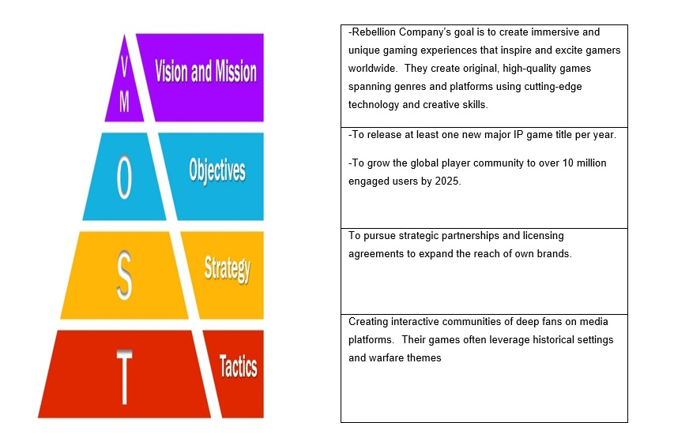
Figure 2. VMOST analysis tool.
Source: https://businessanalystmentor.com/most-analysis/#:~:text=MOST%20analysis%20is%20a%20useful,position%20the%20business%20to%20succeed

4. SWOT Analysis for REBELLION DEVELOPMENTS LIMITED
According to Gurl (2017), it is crucial for a corporation to establish the objective for performing a SWOT analysis.
The significance of establishing organisational objectives resides in upholding the company's commitment to doing SWOT analysis and modelling various industry components.
Furthermore, it is crucial for the corporation to engage in comprehensive research pertaining to its industry, company, and market circumstances with the aim of identifying and documenting instances of business strengths, weaknesses, potential opportunities, and dangers.
Finally, it is imperative for the business to choose its priorities based on the findings of the SWOT analysis. Subsequently, a strategic plan should be established to effectively execute the research outputs derived from the SWOT study.

4.1 Internal Environment (Strengths and Weaknesses):

4.1.1 Strengths

Rebellion, a prominent entity in the gaming industry, has cultivated a robust assortment of
prosperous game franchises, including Sniper Elite and Strange Brigade, so solidifying its
notable market position.
The company has gained recognition for its adept and imaginative development teams,
whose contributions have been instrumental in the production of superior and
groundbreaking games.
The presence of a well-established fan following for REBELLION contributes to the
cultivation of brand loyalty and may serve as a catalyst for successful product launches.

4.4.2 Weaknesses

Resource Dependency: REBELLION, being a small and medium-sized enterprise (SME),
may encounter limitations in resources, which might restrict its capacity to effectively
compete against larger industry participants in areas such as marketing and research
budgets.
Limited diversification might offer a potential risk for the firm as it heavily depends on a small
number of important franchises. This reliance may leave the company susceptible to
marketplace fluctuations and trends, hence increasing its vulnerability to changes in
consumer preferences.
Market Visibility: In contrast to well-established industry leaders, REBELLION may
encounter challenges in terms of market exposure and awareness, which might potentially
hinder its capacity to recruit new clients.

4.2 External Environment (Opportunities and Threats):

4.2.1 Opportunities

The continuous advancement of novel technologies, like virtual reality and augmented realities, presents REBELLION with prospects to delve into inventive gaming encounters.
Global Expansion: The escalating global need for video games provides REBELLION with prospects to broaden its market penetration and appeal to a broader range of consumers.
Collaborations and partnerships can serve as valuable opportunities for expansion and enrichment of a company's products, particularly when engaging with other entertainment groups or technology firms.

4.2.2 Threats

According to Altıok (2011), The video game business is characterised by a high level of competitiveness, as prominent industry participants consistently introduce novel products. The company REBELLION is currently confronted with the risk of seeing a decline in its market share due to the presence of larger and more well-equipped competitors.
The industry is distinguished by the swift pace of technological innovations. Failure to adapt to these dynamic changes could potentially result in REBELLION's games being outdated or less attractive to consumers.
Regulatory problems can arise from alterations in regulatory frameworks, particularly in relation to content and distribution, which may provide difficulties for the company's operational activities and game development procedures.
Pickton et al. (1998) the SWOT analysis serves as a focal point for managers to convene and deliberate on pertinent issues that impact the firm. Consequently, SWOT analysis functions as a tool for formulating plans and facilitating management development.

5. Stakeholder Analysis for REBELLION DEVELOPMENTS LIMITED
According to Brugha et al. (2000), the increasing prevalence of stakeholder analysis can be
attributed to a heightened acknowledgment of how the attributes of stakeholders,
encompassing individuals, groups, and organisations, impact the decision-making.
procedures.
The utilisation of the term "stakeholder" serves to restrict the scope of consideration from the
entire community to individuals within the community who possess a vested interest in the
ongoing events (Lee, 2007). A stakeholder refers to an individual who possesses a vested
interest and concern in a certain entity, usually within the context of a business.

5.1 Stakeholder for REBELLION DEVELOPMENTS LIMITED

5.1.1 Employees

The developers, designers, artists, programmers, testers, managers and other staff who work for Rebellion. They have an interest in fair compensation, good working conditions, job security, creative freedom, career growth opportunities etc.

5.1.2 Customers

The gamers who purchase and play Rebellion's games. They are interested in high quality, innovative and entertaining game experiences at reasonable prices. Shareholders: The founders, investors and owners who have provided capital to Rebellion and own equity stakes. They are interested in sustainable growth, profitability and return on their investment.

5.1.3 Platforms

The console makers (Sony, Microsoft, Nintendo) and digital storefronts (Steam, Epic Games Store) that enable Rebellion to publish and distribute their games to gamers. They want high quality games on their platforms.

5.1.4 Publishers

Companies like 505 Games that co-publish and market Rebellion's games in exchange for a share of revenues. Their interest lies in profitable franchises.

5.1.5 Suppliers

Providers of game engines, middleware, peripherals and other technology and services used by Rebellion in game development. They want Rebellion's continued business.

5.1.6 Local Community

As a business located and operating in Oxfordshire, UK, Rebellion has civic duties like providing jobs, supporting local causes etc.

5.1.7 Industry Groups

Associations like UK Interactive Entertainment that support the policy interests of the UK and global video game industry.
Managing the needs and priorities of these diverse stakeholders is an important aspect of Rebellion's business strategy and operations. Key stakeholders like employees, customers, shareholders, and publishers have significant influence on the company's success.

5.2 Shareholders:

-Expectations: The primary objective of shareholders is to attain financial gains from their
investments. Shareholders anticipate that the company will consistently generate profits and
uphold or enhance the value associated with their shares.

-Power and Influence. Shareholders possess considerable influence within a corporation by virtue of their voting rights and capacity to engage in divestment or further investment activities. The influence of expectations on strategic decisions can be substantial.

5.3 Employees:

-Expectations: Employees have a strong inclination towards job security, equitable
remuneration, prospects for professional advancement, and a conducive work atmosphere.
Additionally, individuals may also strive to align themselves with the values and goals of the
organisation.
-Power and Influence. Although the power of individual employees may be constrained,
their aggregate impact on a company's performance can be significant, since it
encompasses enhanced productivity, creativity, and general workforce morale.

5.4 Customers:

-Expectations: Customers have certain expectations when it comes to the products and
services they receive. In the context of the gaming industry, these expectations typically
revolve around three key aspects: the quality and innovativeness of the games, the
promptness and effectiveness of customer care, and the fairness of pricing. In addition, there
is a possibility that they place importance on ethical conduct within their commercial
operations and actively participate in community initiatives.

-Power and Influence: The level of customer satisfaction has a direct impact on the money
generated. The emergence of social media has provided customers with a medium through
which they may articulate their viewpoints, thereby exerting an influence on the reputation
and prosperity of companies.

5.5 Suppliers

-Expectations: Suppliers anticipate receiving punctual remittances, equitable contractual
agreements, and a secure, enduring partnership. In addition, individuals may also express a
desire for transparency and adherence to ethical corporate practises.
-Power and Influence: Suppliers possess the power to exert influence by regulating the
accessibility of vital inputs, contingent upon the distinctiveness of the resources they offer.
A tenuous supplier relationship has the potential to cause disruptions in operational
processes.

5.6 Regulatory Bodies:

-Expectations: Regulatory entities anticipate adherence to legal statutes and regulations
pertaining to the gambling sector, encompassing criteria for content quality and safeguarding
of data.
-Power and Influence: Regulatory bodies has substantial authority, as failure to adhere to
regulations can lead to financial penalties, legal complications, or even the cessation of
activities. Policies play a significant role in shaping the environment of the industry.

6. Strategic growth options for Rebellion Developments limited.
The Ansoff Matrix, established by Igor Ansoff, a distinguished American planning specialist, is an operational planning instrument that establishes a correlation between a company's advertising approach and its overarching strategic orientation.
The document includes a 2x2 chart or matrix that outlines four possible growth techniques. One aspect of the matrix pertains to the evaluation of both current and new products, while the other aspect focuses on the assessment of both existing and new markets (Fig. 3).
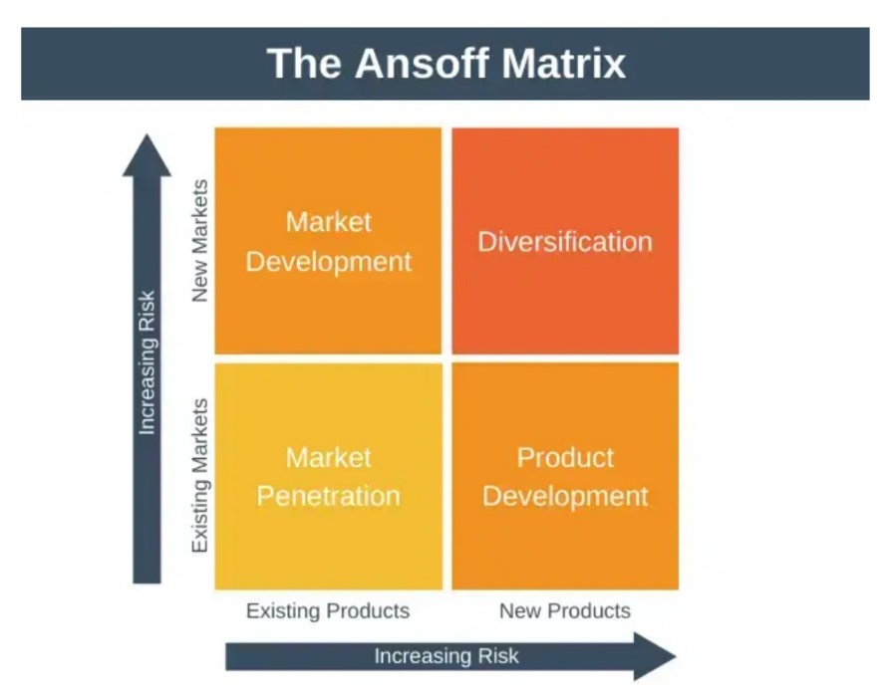
Figure 3: The Ansoff Matrix
Source : https://expertprogrammanagement.com/2022/01/the-ansoff-matrix/

6.1 Market penetration
According to Ansoff (1957), market penetration is a strategy approach utilised by corporations to increase their sales within the current product market, while also reducing the effects on rivals in the market.
Market penetration is often considered the most straightforward and first strategy for achieving growth in most firms.
The objective of this strategy is to facilitate expansion by introducing current items into previously untapped markets. This strategy encompasses many markets in a comprehensive manner, encompassing potential expansion into new consumer categories or international markets.

Rebellion Developments Limited Company can employ many strategies to foster market development. These strategies encompass:

- Expanding into uncharted markets, such as introducing the product in a previously untapped nation.
- -The implementation of novel product dimensions or alternative packaging options.
- -One potential example of diversifying distribution channels involves the establishment of an online store by a face-to-face retail outlet.
- -The development of products that cater to distinct market segments involves many strategies, such as adapting the packaging of a same product to effectively target diverse genders or age groups.

Market development is often a compelling option in certain circumstances, such as when there exist substantial and unexplored markets or when novel distribution channels emerge, facilitating the provision of goods and services to new markets.
6.2 Market development
Tsatsoula (2018), says this strategy expands the business into new markets. To maximise marketing effectiveness, extra market segmentation is used to identify opportunities and build tactics to reach new customers.
There exist various strategies that organisations can employ to cultivate a market, such as:

- Expanding into novel markets, such as introducing one's product in a hitherto untapped nation.
- The act of developing novel product dimensions or innovative packaging.
- One example of the emergence of new distribution channels is the establishment of an online store by a previously exclusively brick-and-mortar retailer.
- The development of products tailored to certain market segments involves the customization of a single product to cater to distinct demographics, such as gender or age groups, through variations in packaging and presentation.

6.3 Product development
According to Loredana (2016), this strategic approach aims to foster expansion by developing novel items for established markets.
Rebellion Developments Limited Company has various avenues through which it can pursue product development, encompassing the following:

- -Investments in study and development (R&D) refer to the allocation of financial resources towards activities aimed at enhancing knowledge, innovation, and technological advancements within an organisation or industry. Selecting this option may seem apparent if the company lacks competitiveness due to the superior quality of products offered by its competitors.
- -Acquiring the intellectual property rights of products from another company.
- -Introducing novel product enhancements to diminish the appeal of prior iterations.

6.4 Diversification
Expand into adjacent markets like movies/TV shows based on Rebellion's game IP.
Leverage the Sniper Elite brand into new tactical shooting game genres and simulations. Acquire non-gaming software companies to diversify revenues away from hit-driven gaming business.
The Ansoff Matrix provides a structured way for Rebellion to identify opportunities for growth across markets and products. A mix of market penetration, market development and product development strategies are recommended to drive sustained growth (Fig. 4).

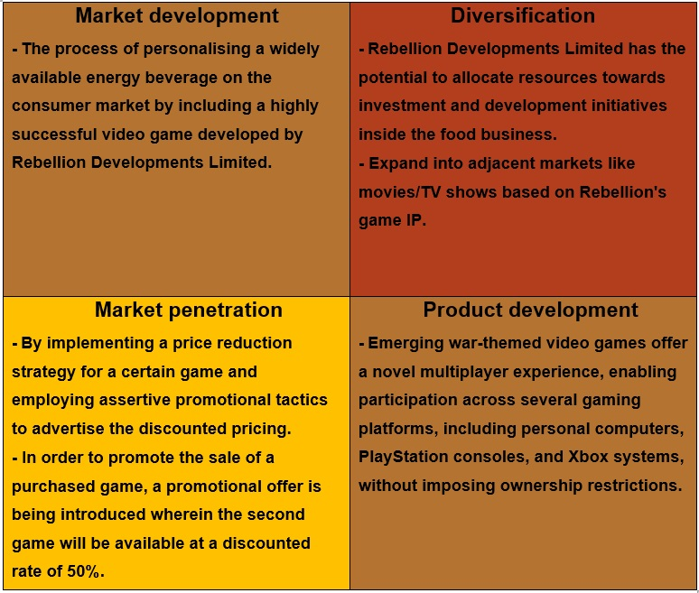

Figure 4. The Ansoff Matrix
Source: https://online.visual-paradigm.com/diagrams/templates/ansoff-matrix/

7. Selection of strategies and Recommendations for Rebellion developments limited
Lynch (2018) posits that the successful execution of entrepreneurial strategy hinges upon three primary factors: personal considerations, allocation of implementation resources, and the formulation of a comprehensive business plan.

7.1 Focus on live service games.
Rebellion should prioritise games as a service with microtransactions and content updates. This delivers reliable ongoing revenue unlike one-time game purchases. Rebellion may fund additional maps, modes, and expansions for Sniper Elite with battle passes and in-game purchases.

7.2 Motivation
Fortnite, Apex Legends, Genshin Impact, and others have succeeded long-term with the Games as a Service concept. It funds development and profits through player interaction and commercialization.

7.3 Growth into mobile gaming
Rebellion should port Sniper Elite and Strange Brigade to mobile. Mobile versions can expand casual gaming audiences. Mobile games are free-to-play and make money from in-game purchases.

7.4 Rationale
Mobile games generate over half of worldwide gaming revenue and are increasing rapidly. The top mobile games can make billions. Porting IP is safer than designing a mobile IP.

7.5 New genre and IP investment
Rebellion should develop new properties in underrepresented genres like horror, RPG, and strategy while continuing the established franchise. Rebellion's innovations and IP catalogue grow. Logically, relying entirely on current teams is problematic when player enthusiasm wanes. New IP in new genres boosts revenue and minimises reliance on old shows.

In short, this strategy diversifies Rebellion's platforms, business models and IP portfolio. The combination of live service plays, mobile expansions and new IP investments sets several pillars for sustained long-term growth.

8. Barriers or challenges might have faced and how to overcome rebellion developments limited
There were, are, and will be numerous barriers and challenges in the way of implementation, says Abu et all. (2019).
- Rebellion, an independent studio, has lesser game development and marketing expenditures than large publishers. They can solve this by generating a few high-quality titles rather than a vast portfolio, sharing costs through co-development, and partnering with publishers.

- Innovation vs. Profit Focus: Innovative games and profitable/safe sequels typically conflict. Rebellion can mix large franchise titles with new IP. Self-publishing gives them more creative control.

- Significant demand and significant turnover characterise game talent acquisition and retention. Rebellion should give stock, profit shares, bonuses, and creative projects to attract talent. Workplace collaboration boosts retention.

- Tech investments are needed to keep up with new gaming engines, platforms, and distribution methods. Rebellion needs appropriate tech funds and competent in-house technical teams for fundamental tech like their Asura engine.

- Players' tastes change when new genres and platforms arise. Rebellion must foresee trends and try new games alongside franchises. Data analytics and creative risk-taking are needed.

- Rebellion competes with large companies like EA and Activision for gamers' time and money. High-quality immersive games and Rebellion's reputation in tactical shooters can help beat the competition.

- Rebellion may overcome problems by focusing on fundamental competencies, cautious financial management, rewarding and empowering staff, staying ahead in tech, and making high-production games.

9. Conclusion
In summary, rather than depending largely on sequels of already established titles, Rebellion Developments has to place a greater emphasis on the creation of fresh game intellectual property. Investing in marketing and publishing capabilities will allow new intellectual property to be self-published. Growing Rebellion's intellectual property portfolio can be sped up by the acquisition of nimble, creative studios. Reaching new markets may be facilitated by expanding into adjacent media and forming collaborations with manufacturers of gaming consoles, publishers, and industry leaders in mobile gaming. To be successful in driving innovation in game design and technology, Rebellion must first and foremost be able to attract, encourage, and keep talented employees. The end goal for Rebellion is to make the transition from a good quick follower to an innovative leader in immersive action gaming. This will be accomplished by becoming a leader in the field.

10. REFERENCES

Abu, F., Gholami, H., Saman, M.Z.M., Zakuan, N. and Streimikiene, D., 2019. The implementation of lean manufacturing in the furniture industry: A review and analysis on the motives, barriers, challenges, and the applications. Journal of cleaner production, 234, pp.660-680.
Aithal, P.S., 2015. How an effective leadership and governance supports to achieve institutional vision, mission and objectives. International Journal of Multidisciplinary Research and Development, 2(5), pp.154-161.
Altıok, P., 2011. Applicable vision, mission and the effects of strategic management on crisis resolve. Procedia-Social and Behavioral Sciences, 24, pp.61-71.
Ansoff H. I. (1957). Strategies for Diversification. Harvard Business Review. 35, pp.113-24
Barney, J, & Hesterly, W 2018, Strategic Management and Competitive Advantage: Concepts and Cases, Global Edition, Pearson Education, Limited, Harlow. Available from: ProQuest Ebook Central. [13 November 2023].
Bleistein, S.J., Cox, K. and Verner, J., 2006. Validating strategic alignment of organizational IT requirements using goal modeling and problem diagrams. Journal of Systems and Software, 79(3), pp.362-378.
Brugha, R. and Varvasovszky, Z., 2000. Stakeholder analysis: a review. Health policy and planning, 15(3), pp.239-246.
Freeman, R.E., 2010. Strategic management: A stakeholder approach. Cambridge university press.
Gurl, E., 2017. SWOT analysis: A theoretical review.
Hussain, S., Khattak, J., Rizwan, A. and Latif, M.A., 2013. ANSOFF matrix, environment, and growth-an interactive triangle. Management and Administrative Sciences Review, 2(2), pp.196-206.
Lee, K., 2007. Who Are the Stakeholders? Journal of Technology Studies, 33(1), pp.2-8.
Loredana, E.M., 2016. The use of Ansoff matrix in the field of business. In MATEC Web of Conferences (Vol. 44, p. 01006).
Lynch, R 2018, Strategic Management, Pearson Education, Limited, Harlow, United Kingdom. Available from: ProQuest Ebook Central. [13 November 2023].
Metcalfe, C.E., 1998. The stakeholder corporation. Business Ethics: A European Review, 7(1), pp.30-36.
Namugenyi, C., Nimmagadda, S.L. and Reiners, T., 2019. Design of a SWOT analysis model and its evaluation in diverse digital business ecosystem contexts. Procedia Computer Science, 159, pp.1145-1154.
Pickton, D.W. and Wright, S., 1998. What's swot in strategic analysis?. Strategic change, 7(2), pp.101-109.
Pickton, D.W. and Wright, S., 1998. What's swot in strategic analysis?. Strategic change, 7(2), pp.101-109.
Tsatsoula, E., 2018. Application of Ansoff's Matrix-Methodology: Marketing Growth Strategies For Products.
Wang, C., Walker, E.A., & Redmond, J. (2007). Explaining the lack of Strategic Planning in SMEs: The importance of owner motivation. International Journal of Organizational Behaviour, 12(1), 1-16.
Whittington, R, Regnér, P, Angwin, D, Johnson, G, Scholes, K, Whittington, R, Regnér, P, Angwin, D, Johnson, G, & Scholes, K 2019, Exploring Strategy, Text and Cases, Pearson Higher Education & Professional Group, Harlow, United Kingdom. Available from: ProQuest Ebook Central. [13 November 2023].

Websites consulted:
https://deal.town/gamers-gate/new-gamersgate-deals-the-quarry-no-mans-sky-sifu-and-more-FKCEFT597
https://find-and-update.company-information.service.gov.uk/company/02770940
https://rebellion.com/

11. Appendix



