

Title: Has the introduction of the Twenty Mile-Per Hour speed limit in Wales had an impact on the Public’s Confidence in Policing?

Learner Name: Michael Gutierrez

Learner’s University Registration Number: 2134525

BSc (Hons) Professional Police Practice

Declaration

Declaration - This work has not previously been accepted in substance for any degree and is not being concurrently submitted in candidature for any degree. Signed: M.Gutierrez Date: 06/04/2025

Statement 1 - This dissertation is being submitted in partial fulfilment of the requirements for the degree of BSc. Signed: M.Gutierrez Date: 06/04/2025

Statement 2 - This dissertation is the result of my own independent work/investigation, except where otherwise stated. Other sources are acknowledged by footnotes giving explicit references. A bibliography is appended. Signed: M.Gutierrez Date: 06/04/2025

Statement 3 - I hereby give consent for my dissertation, if accepted, to be available for photocopying and for interlibrary loan, and for the title and summary to be made available to outside organisations. Signed: M.Gutierrez Date: 06/04/2025

Statement 4 - I hereby give consent for my dissertation, if accepted, to be available on the university’s IT system to those who have consent to use the system. Signed: M.Gutierrez Date: 06/04/2025

Abstract

This research paper has been prepared with the view to exploring as to whether the introduction of a twenty mile per hour speed limit in Wales has had an impact on the public’s confidence in the Police. Whilst other research papers in public confidence look to explore the confidence of the Police to do their job, this will focus more on the relationship between the pubic and the Police since the introduction of the new speed limit. Throughout this paper there will be an introduction, literature review, methodology, an analysis of results conclusion and a bibliography.

Contents Page

Chapter 1 – Introduction – Page 6
Chapter 2 – Literature Review – Page 8
2.1 Introduction – Page 8
2.2 What is the speed limit change? – Page 8
2.3 Why was the speed limit introduced? – Page 9
2.4 What was the cost? – Page 10
2.5 What do the public think? – Page 10
2.6 The relationship between the public and the Police since its introduction – Page 14
2.7 Why the public’s confidence in the Police is important. – Page 14
2.8 Factors impacting the public’s confidence toward the Police negatively. – Page 15
2.9 Summary – Page 16
Chapter 3 Methodology – Page 17
3.1introduction – Page 17
3.2 Aims and Objectives of Project – Page 18
3.3 Research Strategy – Page 18
3.4 Primary Research – Page 18
3.5 Ethics – Page 19
3.6 Confidentially and Anonymity – Page 19
3.7 Risk Assessment – Page 20
Chapter 4 Analysis of Results – Page 21
Conclusion and Recommendations – Page 28
Bibliography – Page 30

Introduction

Over the past twenty years, academics investigating Police confidence as well as law makers have increasingly focused on identifying the factors that influence public trust in the Police. The public’s trust in the Police is especially important within the UK due to the fundamental basis of Policing deriving from the “peeling principles” specifically the term of “policing by consent”. New policies can have an effect on how the public perceive the Police, with the new speed limit introduction being so hotly disputed within the media, it is important to see it has impacted this important relationship. Scholars have explored various factors influencing public confidence in the police over time. Some researchers have highlighted the importance of police effectiveness in combating crime and disorder, reducing victimization, and alleviating the fear of crime.

Theresa May, the then Home Secretary, removed public confidence as the sole measure of police performance in England and Wales. Maintaining public trust and confidence is crucial for effective policing policies and practices (Home Office, 2010). These elements can (a) Promote active involvement of the public in determining priorities and management of services, (b) ensure public institutions are more accountable and responsive at the local level, and (c) achieve public cooperation with law enforcement and adherence to legal regulations (Sindall, Sturgis and Jennings, 2012; Jackson and Bradford, 2010).

The aim of this research will be to identify if a change imposed by the government and implemented by local authorities has had a significant impact on the confidence the public have in the Police. There is yet to be research into this topic given that the speed limit change has only been in place since late 2023 with it not being prosecuted straight away. The public’s confidence has been of high priority of late especially around instances of misconduct which have been increasingly prevalent in recent years.

The research will be conducted by means of a quantitative survey that will be published for members of the public to answer anonymously. The anonymity of surveys has shown that they are more likely to be answered honestly although there is a limitation for the answers to be further examined.

The review of relevant literature will bare the main focus of this paper where the new twenty mile-per hour speed limit will be interrogated to help highlight facts around it. There will also be a brief review of the confidence the public have in the Police as well as developing on the points mentioned around the importance of confidence in the Police. The methods of research will be further explained within a methodology showing how the chosen methods have been determined. A review of the survey will help outline the findings and also highlight further avenues of research.

Chapter 2 Literature Review

2.1 Introduction
This chapter will provide an overview of the twenty mile per hour speed limit within Wales. This project of research will be exploring three objectives to assist with identifying any impact the speed limit introduction has had and looking to identifying room for further assessment and research. The following objectives are prevalent within this project of research. Due to the distinct lack of academic research due to the speed limits infancy on this topic and as such, academic sources will be scarce.
- To identify the impact on the twenty mile per hour speed limit in Wales.
- An exploration of societies views on the introduction of the speed limit
- This paper will explore if the speed limit’s introduction has had a negative impact on the relationship between the public and the Police.

2.2 What is the speed limit change?
A speed limit of twenty-mile-per hour has been introduced throughout Wales in what are defined as being restricted roads¹. The twenty-mile-per hour speed limit was introduced in Wales on 17th September 2023 following a trial phase in eight areas of Wales with implementation dates spanning 16th June 2021 through 18th May 2022. These eight areas were referred to as being phase one of the twenty-mile-per hour programme (tfw.wales, 2023).

¹ Restricted roads are defined as being those with streetlights at least every 200 yards. Road Traffic Regulation Act 1984.

2.3 Why was the speed limit introduced?
The introduction of this speed limit into law is the first of its kind in the UK with its implementation starting with a task force that was constructed by the then deputy minister for Economy and Transport in Wales Lee Walters. This task force was formed following comments that were made by the then First Minister for Wales Mark Drakeford in the Senedd where he stated;
“We know that 20mile-per hour zones reduce speed of traffic, reduce accidents – particularly accidents to children – and we want to see that become the default position right across Wales.” (Welsh 20mile-per hour Task Force Group, 2020).

Introducing a lower speed limit for traffic is expected to reduce the likelihood, and severity of collisions on our roads and is said it will lead to fewer pedestrians and cyclists being seriously or fatally injured. The implementation is also said to help support the Welsh Government’s vision for walking, wheeling and cycling being the publics first choice when it come to their day-to-day activities as well as being a major behaviour change which is expected to bolster communities and their well-being in Wales. Another factor that is expected to have a benefit is to also to reduce the strain and impact on the NHS (Welsh Government, 2021). The Welsh Government (2021) have set their goals out clearly within the task forces publication with these goals not only focusing on a reduction in serious collisions but as stated, to also encourage a change in behaviours toward a mode of transport that the public make of their own choice.

Another potential benefit identified is that the reduced speed limit will assist with the reduction in pollution as there is a sense that drivers will avoid the built-up areas, and the road identified as being restricted roads. This has also been trialled in countries across the European continent with Milan being one of the cities to make such speed restriction changes (etsc.eu, 2015).

2.4 What was the cost?
The same as any major policy or law change has not come without cost. The Welsh Government has confirmed that the cost to implement it was in the region of £32 million. However, Davis and Jones (2022) have published their findings that the reduction in speed could provide savings in the first year in terms of casualties to the NHS of £92 million pounds (GOV Wales, 2024)
The government have highlighted that the saving expected to the NHS is based on a reduction of casualties related to road traffic collisions only. They expect to see in the long term, a reduction in general health related costs by people electing to walk more frequently. This is due to the health benefits of being more active in their choice of transport methods which will also in tern reduce the cost to the Tax Payer as well as the workload on the NHS (tfw.wales, 2023).

2.5 What do the public think?
A publication from the BBC News has shown that the public (96% of those signing the 20mile-per hour petition said they were from Wales) engaged in the largest petition ever seen with over 244,000 asking that the new speed limit be rescinded and removed calling it “disastrous”. This petition was published and signed by these within two days of the implementation coming into effect (BBC News, 2023).

During a debate in the Senedd following this petition, Mr. Drakeford was asked if he would scrap the change simply saying “no”. This question was put to him from the leader of the opposition Andrew RT Davies who Mr. Drakeford accused of spreading misinformation regarding the speed limit change saying that he and his political party (the conservatives) had been referring to it as a “blanket limit” for all 30 mile-per hour roads. Mr. Drakeford has stated that the term “blanket” was misleading and causing the high level of opposition they faced from the public. (BBC News, 2023)

The question can be asked, were the public adequately informed of the reasons for changing the limit and was there disinformation disseminated by those who either opposed the law change, or those who simply oppose the political party responsible for the law change. There are a number of publications to suggest that disinformation played a big part in peoples understanding of what the speed limit change was.

In September 2020 research was conducted by Beaufort research on behalf of the Welsh Government to establish the public attitude toward the change. In this report they found that 80% of those surveyed (1,002 people across Wales) would be supportive of a twenty-mile-per hour limit where they live. The same question was asked in November 2022 producing the finding that only 63% of those surveyed (1,000 people across Wales) would support a twenty-mile-per hour speed limit where they live (Government and Research, n.d.). This shows that public confidence and attitude toward the speed limit has reduced by no less than 17% in its infancy. These two surveys can be explored in more detail, however, these findings of research initiated by the Government itself shows a trend to be in line with the petition submitted by the Welsh public that has been disregarded by the former first minister (Government and Research, n.d.)

In the case of a study conducted by Queens University of Belfast where twenty-mile-per hour speed limits were introduced in Belfast and Edinburgh, they concluded the report with mixed results between the two cities. These results were varied based on the approach taken, social understanding with the fundamental finding being that data collected in Belfast was inconclusive to accurately report (Jepson et al., 2022). A publication from Hunter et al (2023) concluded that there is little no effect on the rates of collision or serious injury when a twenty mile-per hour speed is introduced in place of a thirty mile-per hour limit. This report has been published on the back of the research conducted in the former. Professor Hunter has been keen to highlight that this report, specifically its headline is a misrepresentation of their findings. The later report has provided findings from both cities, one could argue that is merely a different perspective of the findings.

It would appear that in the findings from the research conducted that the public’s attitude toward the speed limit is declining. This is bolstered by the petition that was signed by record breaking number of people whose voices appear to not have been heard to date (BBC NEWS, 2023). This policy change is the first of its kind, although other similar projects have been trialled and researched in other areas of the UK, there is still much research required on the topic to establish the publics true perspective. Whether the public agree with the speed limit change or not, there is consistent data to support that a reduction in speed has had a direct positive impact on the number of serious collisions on the road in areas where a speed limit has been reduced. This research however does not identify if the public know the reasons for reducing the speed. While the public appear to be informed that the speed limit has been reduced, it does not appear they have been adequately informed as to the rational behind changing it, with them possible thinking this change is simply an avenue for revenue.

A recent survey conducted by SurveyGoo on behalf of brake.org for road safety week in September of 2023 shows people’s opinions about speed. One key statistic to take from this survey shows that 64% of respondents, say they speed when they believe the posted speed limit is too low. This figure increases to 77.6% of Welsh respondents. These figures could be an early reflection of how drivers feel about the default speed limit being reduced from thirty mile-per hour to twenty mile-per hour on these roads. Yet when the question focusing on thinking about where the respondents live, 47.7% of Welsh respondents, in the same survey have stated that Traffic moves too fast, even on roads that have a twenty mile-per hour speed limit (Survey Goo cited in, Brake, 2023).
During this same survey the question was asked of the participants, which of the following reasons would encourage you not to speed?
45.6% “if someone I knew was hurt in a crash caused by a speeding driver/rider” and 39.7% If the penalty for getting caught speeding was harsher,
37.0% saying If I thought I would get caught.
30.0% If there were more speed cameras on the roads
24.7% replied “if there were more police cars on the road”
Albeit there were other options, the results show that there is a clear societal influence on people’s perception to speed. The highest response showing people are more likely to reduce their speed if they know someone who has been injured however, a strong argument can be made that enforcement of the speed limit from a policing and/or legal perspective would also have a strong impact on people being encouraged not to speed.

A study was conducted by William et al, (2022) to canvas people living in Edinburgh who had seen a twenty mile-per hour speed limit introduced across the city to encompass 80% of the city increasing from the earlier implementation of 50% of the city. The surveys conducted concluded that in the three implementation regions that received the intervention examined in this study, public support and opposition to Edinburgh's twenty mile-per hour speed limit appear to have shifted in favour of the policy, but safety perceptions remained unchanged. Cycling is frequently viewed as a luxury for the wealthy or as a less expensive mode of transportation for those living in poverty, whereas driving is considered a necessity in most societies, with the built environment currently built around car use (William et all, 2022). What has also been highlighted in this piece if further evidence that the political will to enact a policy can be significantly impacted by public reactions to proposed policies.

2.6 The relationship between the public and the Police since its introduction
This project of work will look to explore if the public’s perception toward the Police since the inception of the new speed limit has declined. Due to the significantly short period of time having elapsed since the introduction, there is very little research conducted. The only way this can be answered is further academic research being required. A series of questions will be asked for the purpose of this paper, to assist with answering this question.

2.7 Why the public’s confidence in the Police is important.
The relationship between the public and the Police is said to be important as it has been encompassed by the term “public confidence”. It has been identified that having high levels of public confidence has a direct link with the public’s perception of the Police in terms of their legitimacy and the consent the public give for them to be Policed.
With the whole foundation of Policing in the UK being based on the “peeling principles” of the Police conducting their duties under the term of “policing by consent” the confidence of the public is vital (Home Office, 2012). It has been said that this model of policing is exclusive and derives from the public co-operating with the Police and not being based on fear of the Police. This co-operation is key to securing the approval of the Police to do their job.

2.8 Factors impacting the public’s confidence toward the Police negatively.
Relationships between the public and the Police have been troubled for years and are often found to deteriorate during times of Police misconduct. These declines have been particularly prevalent lately in instances such as when David Carrick, who plead guilty to 49 offences which were committed over is career in the Metropolitan Police (BBC News, 2023). This trend can be expected with the recently banned former Police Officer John Stinger who has been convicted of sexual offences against a girl under the age of 13 (BBC News, 2023)

The below graph shows sudden and drastic decline in the public’s perception when asked if they think the Police are doing a good or excellent job. This can be related back to the figures displayed by The College of Policing where they show the number of officers that have been added to the Governments Barr list in the year 2019 – 2020 and 2022 – 2023 (College of Policing, 2019).
Nb. these two years have been looked at in isolation from the years 2020 – 2022 due to a change in the way the data was collected see fig.1.
Fig.1
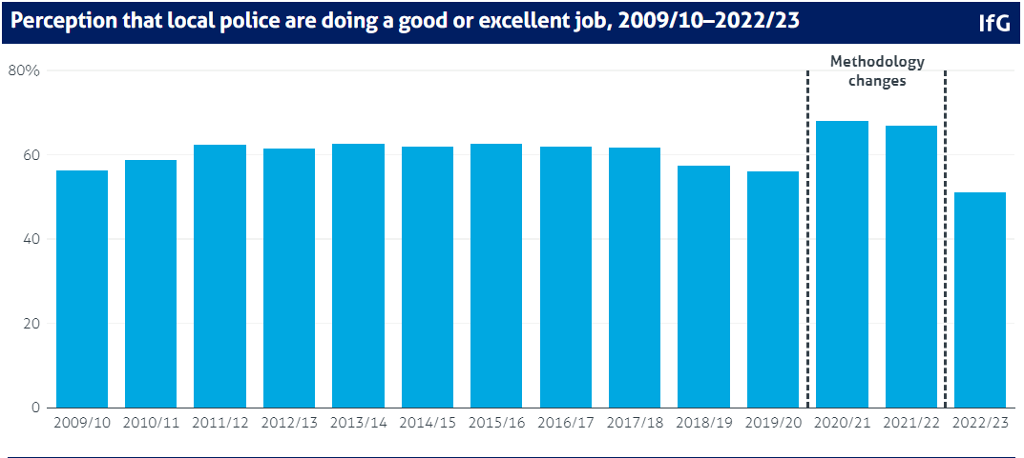
(Richards and Davies, 2023)

2.9 Summary
Whilst the research project has likely created more questions than it has answered, questions need to be identified in order to adequately assess the true effectiveness of change. The twenty mile-per hour speed limit introduction is certainly not a favourable decision in the eyes of the public and there is no direct linkage to a decline in the relationship between the Police and the Public as a result of it. That said, there is yet to be much in terms of statistical data available for people that have been involved in road traffic collisions from “Stats 19” returns to local government. The number of prosecutions or speed awareness courses that are provided to drivers breaking the speed limit given that the speed limit enforcement has only begun for the financial year April 2024 into 2025. Once figures for the number of fines or alternatives being issued are released only then can the public’s attitude toward the Police in relation to this topic be measured more accurately.
On top of these issues in the raw data available, the Welsh Government has upon a change in leadership from Mark Drakeford to Vaugh Gethin, which also saw a change in the transport secretary Ken Skates has agreed that if people want change, the government will devolve the decision to local councils to change the speed limit should they deem it appropriate on certain roads. Whilst this may be welcomed by the public on a majority basis, the Leader of Swansea council has requested that the Welsh Government should help to foot the costs for revert the speed limits (BBC News, 2024).

Chapter 3 Methodology

3.1introduction
Research has been defined in the Cambridge Dictionary (2021) as being ‘A detailed study of a subject, especially in order to discover (new) information or reach a (new) understanding’ with a research methodology focusing on the means adopted to obtain the information desired to assist with the research being conducted. This can be done to either expand on existing statistics or information available or, as in this case, gather new information to begin to build an understanding of the topic being researched.

It has been said that the methodology of a research project should be the foundation for any research paper thus giving credibility to the paper and findings (Carter, 2018). A methodology has been developed through the years with Beske (2003) homing in that a methodology is generic in its term as there are a multitude of methods that are available to be adopted. Hewson (2006) states that primary search is the generation of new data, and it is used to address a specific research topic using direct methods. Direct methods can include interviewing participants, and indirect methods can include observations of participants in a controlled setting or manner.

This research paper is looking into the effects that a change to the speed limit on restricted roads in Wales is having on the public’s confidence in Policing since its introduction. There is currently a distinct lack of academic research in relation to this topic and as such there is limited research available to draw on to see what the impact there has been. This chapter will provide an understanding of the methods that have been adopted to research this topic along with an explanation for how the decision was made to use them.
3.2 Aims and Objectives of Project
The aims and objectives of this study will be to identify how the publics’ perception towards the Police has been impacted since the introduction of the twenty miles per how speed limit in Wales on restricted roads.
Objectives:
- To identify the impact on the twenty mile per hour speed limit in Wales.
- An exploration of societies views on the introduction of the speed limit
- This paper will explore if the speed limit’s introduction has had a negative impact on the relationship between the public and the Police.
3.3 Research Strategy
This study will use primary research strategy as it will be based on my own research because the 20 mile-per hour speed was introduced on the 17^{th of} September 2023 with there being no research conducted since its introduction. Therefore, quantitative data and primary research will be used throughout the dissertation.

3.4 Primary Research
Using primary research allows the researcher to conduct research literature that is based on a specific topic. A questionnaire is the most popular method that is used to conduct primary research with Dawson (2009) outlining, that conducting primary research involves your own observations or experiences by information you gather others whilst researching. A questionnaire can be beneficial because of the retrieval of information on the chosen subject, and this will allow the researcher to gather all data throughout the research process. It is important to note that questionnaires can be answered anonymously which can increase responses. Being anonymous can increase responses and encourage respondents to be truthful which means the research more reliable. It has been argued that the reply rates for questionnaires can be low because participants can forget to respond and fail to return the questionnaire completed.

3.5 Ethics
Ethics will be important when doing primary research with Maclaughin and Muncie (2013) defines ethics as “ways of thinking what is right, good, moral and the process of reasoning and justification”. In relation to ethics The University of Trinity St David (2025) is committed to the maintenance of high ethical standards when research is undertaken, the university recognises that research undertaken is to be considered appropriate and to conform to accepted ethical principles and the conduct of governance.

3.6 Confidentially and Anonymity
Confidentially and anonymity is vital when conducting research and this includes secondary research. Therefore, whilst researching an effort will be made to ensure that there is no personal information from any existing data that is found will be revealed. Ruane (2016) defines confidentially within this context as, protecting privacy of research by not disclosing the persons identify or associating their information to them. Anonymity can be outlined when the researcher or the audience that reads the findings can answer honestly and connect to a response. Although the research that is being conducted in this project is not sensitive it is still an important element throughout the research because participants will feel they can be open and honest about their responses.
There is research indicating that making online surveys anonymous may boost response rates. For instance, according to a study that was published in BMC Medical Research Methodology, anonymity may encourage more people to divulge private information (Smith et al., 2011). Whilst there is no private information being collected within this project, what Smith et al. (2011) suggests is that people responding will feel more comfortable in answering questions, especially as in this survey where they are asked if they have exceeded the speed limit.

3.7 Risk Assessment
Universities have highlighted that the university must carry out risk assessment to generate a safe system of work for all activities carried out by university personnel. This is extended to the students who are studying within their institution. These risk assessments will help to assess the impact the research will have on the environment in which it is conducted.

Chapter 4 Analysis of Results

This project of research has been undertaking to help identify how the public’s confidence toward the Police has been affected since the introductions of a twenty mile-per hour speed limit on restricted roads in Wales. To help answer this question a survey was prepared and posted into the public domain allowing anonymous replies. The public’s perception as identified within the literature review is one of the most important and relevant factors in terms of Policing within the United Kingdom given the way in which it was proposed by Mr Robert Peel. The Police within the UK, police with the consent of the majority of the public. If the public’s confidence is affected, then so are the foundations on which UK Policing is built. With this topic being researched within this paper on a primary basis, this will provide a foundation for further and more expansive research to be conducted. The returns provided have all been done so anonymously with the targeted audience being the public from a public domain.

The questionnaire has been completed by a total of 49 people total. Whilst this is a very small portion of the Welsh population, participation with the questionnaire is optional, and has not been marketed are targeted using social media algorithmic approach due to the cost.

The main question being investigated within this research which has been asked and answered is “Since the speed limit implementation, has your experience with the Police changed?”. Of the 49 respondents an overwhelming 95.9% have answered “No”.
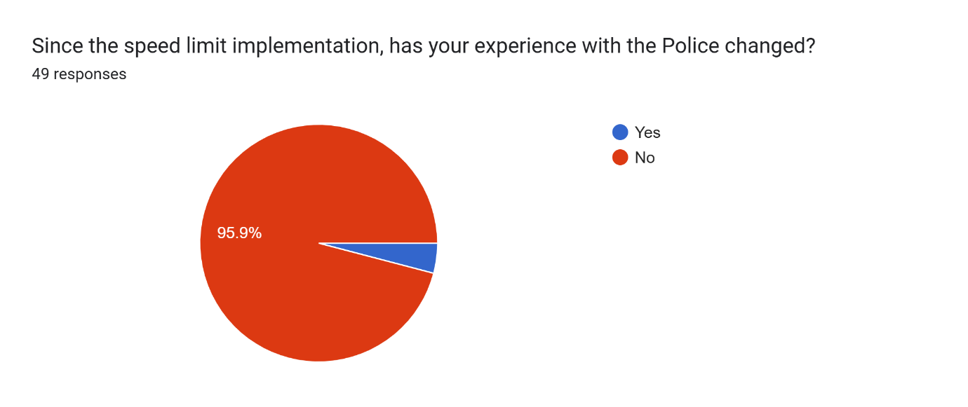
The two respondents who have answered identifying that their experience with the Police having changed, both have identified that their experience has become “More Positive”. This has been answered by one person who has stated in the previous question that they have not experienced a change in their experience with the Police.
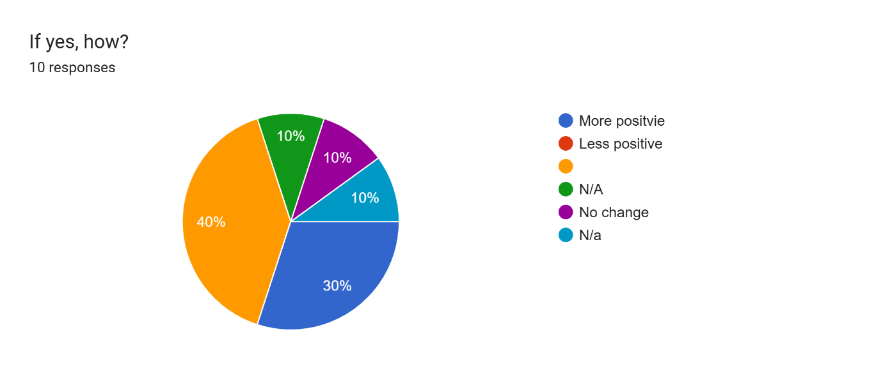

Whilst these respondents support that there has been no change especially a negative impact, the speed limit appears to have had very limited impact on the public confidence toward the Police since implementation. The results have shown that a total 4 people at the start of the survey stated they have previously had a “somewhat negative” experience with the Police and 1 person saying their experience has been “negative”.

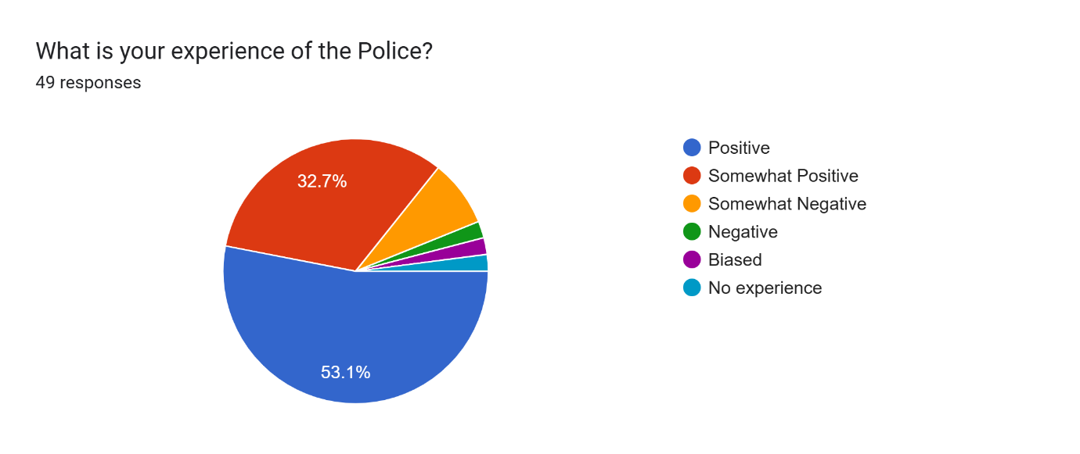

Another question posed was enquiring if the respondents had been prosecuted for speeding within a twenty mile-per hour section. There was then a follow up question to establish how the driver had been dealt with.

Five people have answered saying that they had been prosecuted for exceeding the speed limit. Of these five, four have highlighted they had received the offer to attend a speed awareness course and one having received a letter.
The person saying that had received a letter about their speed identified they had been travelling between 21 – 25 miles-per hour. The rest having received the offer of a speed awareness course have three of these four were travelling at 26 – 30 miles-per hour. With no one responding to with a higher speed indicated, there is evidence to support that drivers are reducing their speed in these areas.
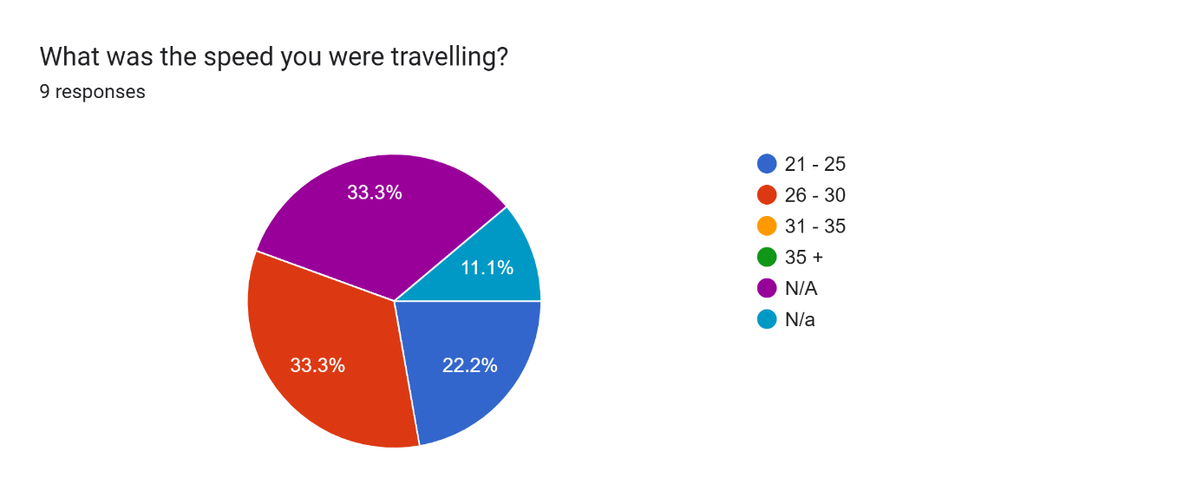

With the public’s confidence being the fore front of this research and there already being very little impact on the confidence within the context of this paper when discussing the changes the respondents have experienced. A question has been asked about how the respondents perceive the Police’ application of the law asking, “Do you think the Police are applying the law correct and proportionately?”.
Seventeen have answered saying they do not think they are. While again, the majority are showing signs of positivity toward the Police, the answers, without elaboration show a confliction when discussing their experiences with the Police. However, with only one of those highlighting they had been prosecuted for speeding having received a letter answering this question negatively.
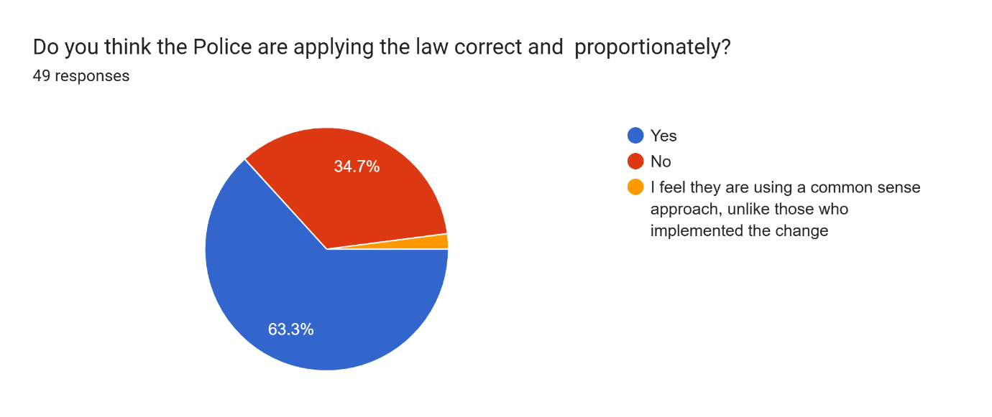
Overall, the findings from this research show that the public’s confidence has not been negatively impacted since the introduction of the Twenty mile-per hour speed limit. There is a general sense in the data that the speed limit is not being implemented correctly or proportionately, the survey has not allowed for the respondents to elaborate further. However, the results when looking at this who have received the offer to attend a speed awareness course have stated answered they do deem the Polices approach to be correct and proportionate. A larger pool of participants will help to build on this answer as they would do for the overall objective of this research paper.

Whilst there is no direct research into the topic this paper has explored, the questions that have been asked will also help to address other aspects of the speed limits introduction. As highlighted within the literature review, the speed limit introduction had objectives set out by the Welsh Government which included making roads safer, encouraging a change in mode of transport and reduce the strain on the NHS. Whilst the strain on the NHS cannot be directly answered when looking into the speed reduction from a policing context, the questions asked are from the public’s perception. With their perception they were asked “What do you think the result is in terms of road safety since the introduction?”. Almost half the participants have said they do not feel there has been a change.
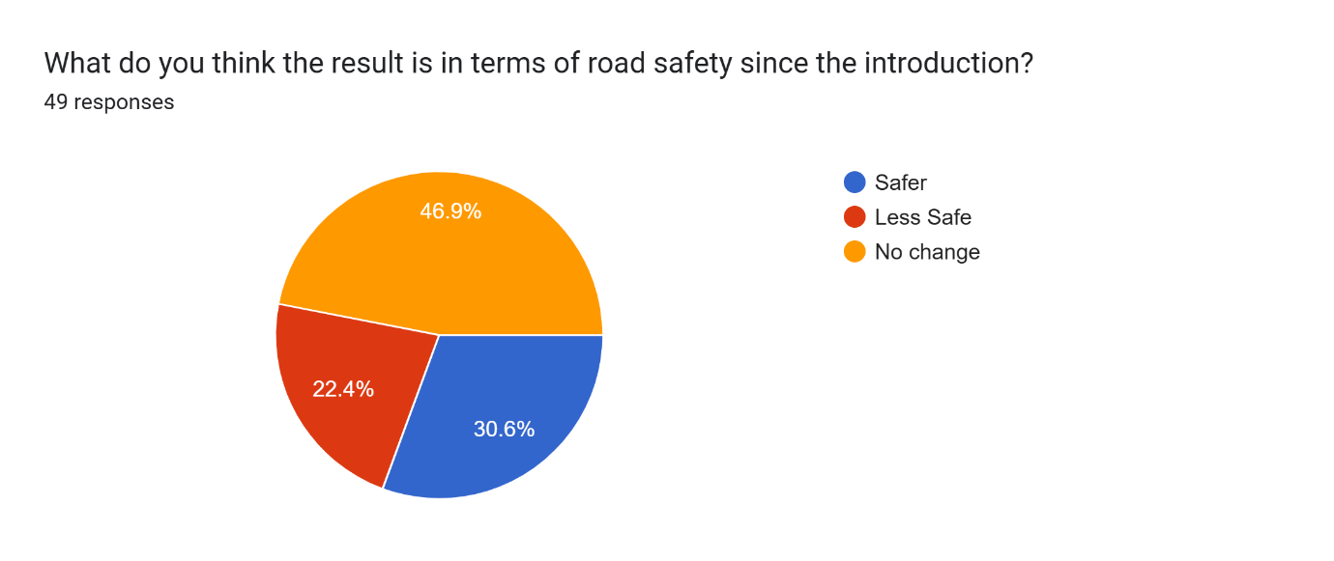
The public’s attitude toward travelling has been impacted with 44.9% of respondents saying their attitude toward travelling has changed. Whilst this research is not directly investigating this area and cannot provide any elaboration on whether other modes of transport have been elected, it does allow an insight into the public’s attitudes.
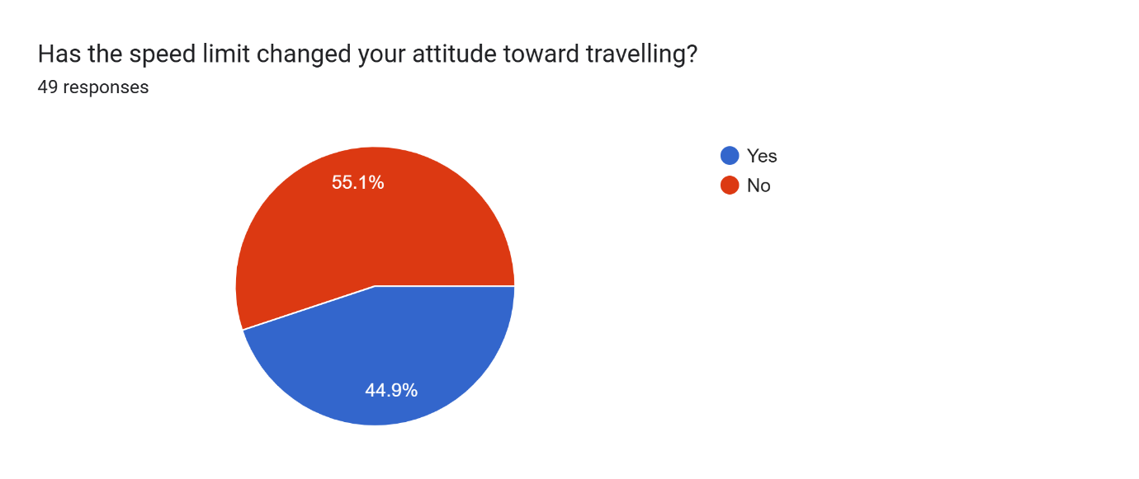

Within the research conducted there is a clear sign of there being a lack of understanding from the public about what the speed limit change is and what roads it has affected. From the survey answers this has been backed up when looking at the questions answered around who was responsible for implanting the change, and especially when asking if it was a “blanket speed limit introduction”. It would appear that the term being used so extensively has saturated the public.
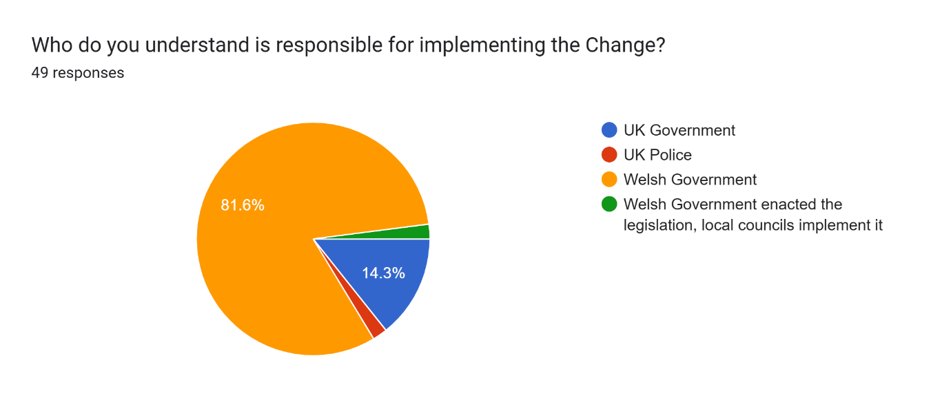
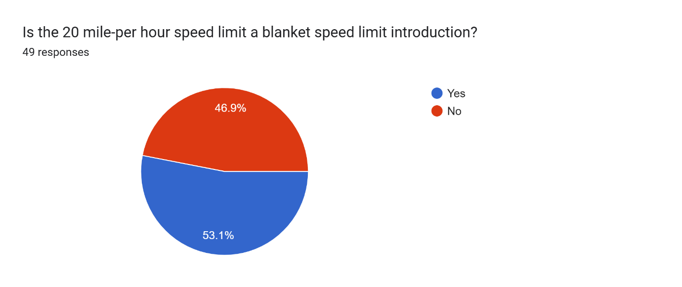

There are a number of questions that can be asked to further enhance what has been discovered from the survey posted, including specifically around the respondent’s attitude toward how they travel. There is also room for data to be collected from Welsh policy forces regarding road traffic collisions in the areas where the speed limit has changed. This will assist in answering whether the change has made the roads safer. Whilst these questions may not assist directly with the purpose of this research, they will give credibility to the survey when comparing true factual data against the opinions and feelings of the public.

Conclusion and Recommendations

It is clear from researching the topic that there is a distinct lack of academic research available to help draw a true conclusion. The research conducted as part of this paper shows that confidence in the Police has increased since the introduction of the speed limit however, these findings are from a very small number of people in the wider focus. Even though drivers have been caught speeding they have attended speed awareness courses which result in no points being imposed, they have recorded that their confidence in the Police has increased.

The questions that were posed to the participants have been focused on the fundamentals around the topic, albeit there is some surplus information which can be used when researching the impact the twenty mile-per hour speed limit has had socially, medically as well as politically and in the context of Policing where there is the clear need for further research to truly understand the impact of the public’s confidence.

As the financial year 2024 – 2025 comes to an end there will be going forward in the near future more statistical data available from credible governmental sources. This data will help provide an understanding of the publics willingness to obey the speed restriction based on those caught speeding, as the information will be comparable with the of the same roads prior to the change. Stats 19 booklets which will again be comparable with the same roads to see if there has been decline in pedestrian casualties. Questions can then be asked again with a larger group, if possible, to help answer the question further once this data is available.

The topic of the public’s confidence towards the Police will continue to be prevalent and is impacted by many factors. As discussed, these factors of late have regularly brought a negative connotation toward the Police due to all too often officers being dismissed for misconduct or in other cases dismissed over illegal actions. Other factors that can affect the effectiveness of Police to do their job based on the public’s perception is that of legislation. With this legislation change having such a strong public opinion and the Police being the “face” of legislation they may bare the brunt of the policy change. Are we going to see that the publics attitude toward the Police going to be maintained because they see the legislation change as a revenue for avenue from the government.

Bibliography

20mile-per hour Wales: Some roads to revert to 30mile-per hour after backlash. (2024). BBC News. [online] 19 Apr. Available at: https://www.bbc.co.uk/news/uk-wales-68859568.

20mile-per hour: Welsh Conservative Andrew RT Davies blasts speed limit. (2023). BBC News. [online] 1 Oct. Available at: https://www.bbc.co.uk/news/uk-wales-politics-66977841.

College of Policing (2023). Police dismissals (Home Office forces) 2022 to 2023 College of Policing. [online] www.college.police.uk. Available at: https://www.college.police.uk/ethics/barred-list/police-dismissals-2022-2023.

College of Policing. (2019). Barred list | College of Policing. [online] Available at: https://www.college.police.uk/ethics/barred-list#police-dismissal-numbers-4 [Accessed 18 Feb. 2025].

etsc.eu. (2015). 30 km/h limits gaining rapid acceptance across Europe | ETSC. [online] Available at: https://etsc.eu/30-kmh-limits-gaining-rapid-acceptance-across-europe/

Fairclough, S. (2024). John Stringer: Police ban for ex-officer who sexually abused girl. BBC News. [online] 11 Oct. Available at: https://www.bbc.co.uk/news/articles/cp8lpmr7gpro.

Fairclough, S. (2024). John Stringer: Police ban for ex-officer who sexually abused girl. BBC News. [online] 11 Oct. Available at: https://www.bbc.co.uk/news/articles/cp8lpmr7gpro.
GOV Wales. (2024). Introducing 20mile-per hour speed limits: frequently asked questions | GOV.WALES. [online] Available at: https://www.gov.wales/introducing-20mile-per hour-speed-limits-frequently-asked-questions#130580.

Government, W. and Research, B. (2022). Wales Omnibus Prepared for: Welsh Government -Public Attitudes to 20mile-per hour. [online] Available at: https://www.gov.wales/sites/default/files/publications/2022-11/20mile-per hour-public-attitudes-survey-further-research.pdf.

Government, W. and Research, B. (n.d.). Traffic Orders & 20mile-per hour Public Attitudes Survey November 2020 Wales Omnibus Study. [online] Available at: https://www.gov.wales/sites/default/files/publications/2021-07/traffic-orders-and-20mile-per hour-public-attitudes-survey.pdf.

Home Office (2012). Definition of Policing by Consent. [online] gov.uk. Available at: https://www.gov.uk/government/publications/policing-by-consent/definition-of-policing-by-consent.

Hunter, R.F., Cleland, C.L., Busby, J., Nightingale, G., Kee, F., Williams, A.J., Kelly, P., Kelly, M.P., Milton, K., Kokka, K. and Jepson, R. (2023). Investigating the impact of a 20 miles per hour speed limit intervention on road traffic collisions, casualties, speed and volume in Belfast, UK: 3 year follow-up outcomes of a natural experiment. J Epidemiol Community Health, [online] 77(1), pp.17–25. https://jech.bmj.com/content/77/1/17.abstract

Jackson, J. and Bradford, B. (2010). What is Trust and Confidence in the Police? Policing: A Journal of Policy and Practice, [online] 4(3), pp.241–248. https://academic.oup.com/policing/article-abstract/4/3/241/1467577?login=false

Jepson, R., Baker, G., Cleland, C., Cope, A., Craig, N., Foster, C., Hunter, R., Kee, F., Kelly, M.P., Kelly, P., Milton, K., Nightingale, G., Turner, K., Williams, A.J. and Woodcock, J. (2022). Developing and implementing 20-mile-per hour speed limits in Edinburgh and Belfast : mixed-methods study. research-repository.st-andrews.ac.uk

Kelly, J., Ellison, C. and Burns, J. (2023). David Carrick: The serial rapist and abuser in a police uniform. BBC News. [online] 16 Jan. Available at: https://www.bbc.co.uk/news/uk-64283783.

Murray, M. (2024). Welsh roads see 20mile-per hour limit enforced with points and fines. BBC News. [online] 16 Mar. Available at: https://www.bbc.co.uk/news/articles/c4n789jv49jo.

Home Office (2010). Police reform: Home Secretary’s written ministerial statement. [online] GOV.UK. Available at: https://www.gov.uk/government/speeches/police-reform-home-secretarys-written-ministerial-statement

Richards, G. and Davies, N. (2023). Performance Tracker 2023: Police. [online] Institute for Government. Available at: https://www.instituteforgovernment.org.uk/publication/performance-tracker-2023/police.

Richards, G. and Davies, N. (2023). Performance Tracker 2023: Police. [online] Institute for Government. Available at: https://www.instituteforgovernment.org.uk/publication/performance-tracker-2023/police.
‌
Sindall, K., Sturgis, P. and Jennings, W. (2012). Public Confidence in the Police: A Time-Series Analysis. British Journal of Criminology, 52(4), pp.744–764. https://academic.oup.com/bjc/article-abstract/52/4/744/440007?login=false

Survey Goo cited, Brake. (2023). Let’s talk about SPEED: a Road Safety Week survey report. [online] Available at: https://www.brake.org.uk/get-involved/take-action/mybrake/knowledge-centre/reports/lets-talk-about-speed-a-road-safety-week-survey-report.

tfw.wales. (2023). Default 20mile-per hour speed limit on restricted roads | Transport for Wales. [online] Available at: https://tfw.wales/default-20mile-per hour-speed-limit-on-restricted-roads.

Transport Research Institute. Technical Paper 101 The value of prevention -casualty reductions in switching from a 30mile-per hour to 20mile-per hour speed limit default in Wales Report Title. (2022). Available at: https://blogs.napier.ac.uk/tri/wp-content/uploads/sites/56/2022/11/TRI-Technical-Paper-101.The-value-of-Prevention.AD_.pdf.

Wales’ 20mile-per hour speed limit: Petition against breaks records. (2023). BBC News. [online] 19 Sep. Available at: https://www.bbc.co.uk/news/uk-wales-66853445.

Weitzer, R. and Tuch, S.A. (2005). Determinants of Public Satisfaction with the Police. Police Quarterly, 8(3), pp.279–297. doi:https: https://journals.sagepub.com/doi/abs/10.1177/1098611104271106

Welsh 20mile-per hour Task Force Group. (2020). Available at: https://www.gov.wales/sites/default/files/publications/2020-07/20mile-per hour-task-force-group-report.pdf.

Welsh Government (2021). Introducing default 20mile-per hour speed limits. [online] GOV.WALES. Available at: https://www.gov.wales/introducing-default-20mile-per hour-speed-limits.

Williams, A.J., Manner, J., Nightingale, G., Turner, K., Kelly, P., Baker, G., Cleland, C., Hunter, R. and Jepson, R. (2022). Public attitudes to, and perceived impacts of 20mile-per hour (32 km/h) speed limits in Edinburgh: An exploratory study using the Speed Limits Perceptions Survey (SLiPS). Transportation Research Part F: Traffic Psychology and Behaviour, 84, pp.99–113. doi:https://doi.org/10.1016/j.trf.2021.11.022 available at: https://www.sciencedirect.com/science/article/pii/S1369847821002722

