Student Name: Tonya Hoyte Boland
Student Number: 2315864
Programme of Study: Illustration
Module: ADAD5004 Research in Practice
Word Count: 2750
Tutor Name: Delyth Lloyd- Evans
Three Keywords: Communication, Expression and Connection

Illustrating Emotion: A Semiotic Approach to Supporting Neurodivergent Children’s Emotional Expression and Connection
This proposal aims to examine the concepts of the words communication, expression and connection within an illustrative framework not only through their theoretical lens but also by using semiotics to convey emotion and work to foster interpersonal understanding particularly for neurodivergent individuals. As an individual with both autism and ADHD I have personally experienced the often significant challenges in interpreting and processing nuanced emotional cues. This has sometimes led to issues in communicating with others. My related practice will be to create a “My Feelings” style of wall planner that will help children identify, communicate and express their emotions using blob shaped stickers or magnets. Each blob will have a unique colour and facial expression that represents a different emotion.
Communication, expression and connection are part of the foundations of human interaction. However, for those whose neurodivergence affects and impacts on their ability to interpret and understand emotional cues they can often remain elusive. Navigating social constructs can be difficult for these individuals and can cause confusion, isolation and anxiety. As Baron-Cohen (2000) observes, persons with autism often experience “impairments in the development of intuitive psychology” leading to difficulties in understanding the emotions of others. This world is dominated by language and implicit social constructs, which means that alternative and visual modes of communication are vital for those that need them. Through this proposal I want to respond to these needs and challenges by using semiotics to explore how illustration can be used as a powerful vehicle for emotional expression and connection. The wall planner that I am going to develop will be available as a visual communication tool to identify and share their emotions.
Communication can be understood as “the process of transmitting information from one individual to another” (Hall, S. 1980). This can be through written, non-verbal or visual means. Communication involves a delicate mesh of signals, interpretations and cues. However, it is not solely about transferring information when relating to emotional literacy and neurodivergence. For illustrators it becomes the bedrock upon which to express ideas that we understand and feel. Hall explains communication as involving encoding and decoding meaning where the encoder transmits a message and the receiver decodes it according to their personal parameters such as personal context and emotions. This exchange of information is fluid in interpretation, not set. Illustrators must consider several factors, including how facial expressions, colours, shapes and symbols are interpreted or “decoded” by diverse audiences. The planner needs to embrace these elements by using character design as a vehicle for emotional cognisance. when verbal dialogue falls short (Leeuwen and Kress 2006).
Charles Sanders Peirce expanded this by identifying three types of signs: icons (which resemble the thing they represent), indexes (which are causally linked to their referents), and symbols (which rely on learned associations). The blob characters operate primarily as archetypal signs with their individual forms, colours, lines and shapes denoting different emotions. To use semiotics effectively when illustrating my planner, I will have to think about my target audience, which are primarily neurodivergent children aged 3 to 10. The illustrations not only have to be eye-catching; they also must be meaningful and lend emotional support to their communication when verbal dialogue falls short (Leeuwen and van Kress 2006).

When exploring the communicative potential of visual semiotics, Leeuwen and van Kress proposed that images possess their own "grammar." Composition, colour, gaze and framing all convey meaning in visual design, as do syntax and structure in verbal language. I will take cues from this theory when designing my emotion planner by organising characters in a way that supports choice and emotional recognition. Each blob will be designed to be as equally valid and equally available as each other, reinforcing the idea that all emotions are acceptable, a concept deeply important in supporting emotional development, especially for neurodivergent children.

Visual communication also supports empathy, a concept championed by philosopher Martha Nussbaum (1995) who argues that art allows us to imaginatively access experiences increasing our “receptiveness to the inner state of others” (McRobie, H. 2014). For children who struggle to identify or articulate their feelings, empathetic characters become tools of emotional projection. Illustrators such as Tove Jansson, creator of the Moomins, and Marc Boutavant, illustrator of Edmond the Squirrel, offer compelling examples of how simplified, expressive character design fosters emotional connection. Their use of soft shapes, minimal lines and subtle expressions makes their characters deeply relatable without needing complex detail, an approach that closely aligns with my own.

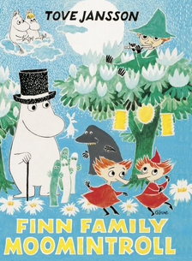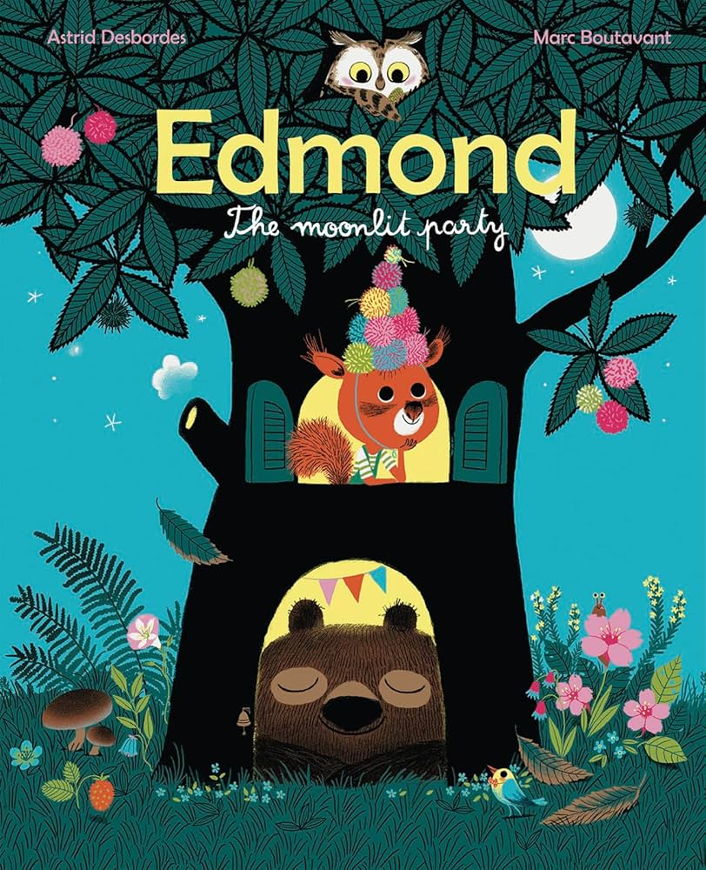
Fig 1. Finn Family Moomintroll (1986) Fig 2. Edmond the Squirrel (2015)

Contemporary examples, such as the Google Arts & Culture’s experiment Blob Opera, evidence further how abstract, character-like forms can evoke emotional responses through minimal visual cues. This suggests that communication in illustration doesn’t require realism but can create enough ambiguity to invite interpretation but distinct enough to signal emotional meaning.
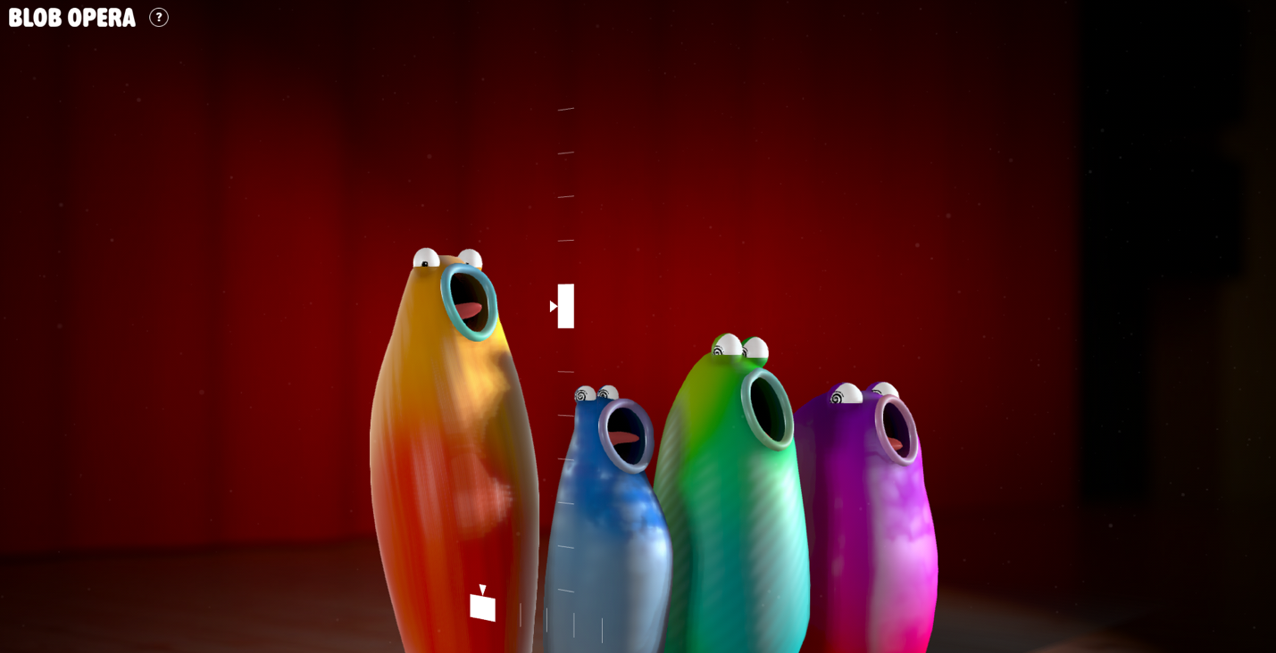Fig 3. Blob Opera (n.d.)
Expression refers to the outward manifestation of internal states such as thoughts, emotions and sensations through multiple mediums including facial expressions, physical gestures, music, speech and art. It allows an individual to communicate feelings that without it would remain ineffable or private. Expression is vital when the standard communicative tools cannot be utilised, such as when a person is unable to vocalise their feelings. Expression can make communication accessible and effective when other methods fail, especially for neurodivergent children. Expression interprets and transforms emotional experiences into something perceivable. My emotion planner will need to use the concept of expression as communicative and empathetic tool to aid verbal emotional articulation. “We do not learn from experience, we learn from reflecting on experience” (Dewey, J., 1934). In Art as Experience, Dewey argued that genuine artistic expression stems from an individual’s experience. This involves processing it internally, then reconstructing it outwardly into a form that others can engage with. For Dewey, expression and experience are inseparable; it is the crystallisation of lived emotion into a communicable form. My aim in the design of my planner is to learn from this research to create opportunities for children to engage with expressions of emotions they recognise in themselves, giving visual form to otherwise intangible and internal states.
Expression also plays a crucial role in the development of personal and social identity. According to psychologist D.W. Winnicott (1971), the ability to express oneself authentically is central to the development of a "true self" which linked to their feelings of aliveness and connection to reality. As research denotes, for children, particularly neurodivergent children, visual and emotional expression through art becomes a vital channel for self-understanding and interaction with others.
Connection grows from mutual understanding and successful communication. It is important to have a sense of feeling seen and understood. Humans need to be emotionally aligned with one another. In visual communication, connection is both the goal and the result for effective expressions and interpretation (Kress & Van Leeuwen, 2006).Semiotics is concerned with how meanings are made and how reality is represented (and indeed constructed) through signs, sign ­systems, and processes of signification (Chandler, D. (2022). It helps us to understand how visual forms are meant and conveyed. Ferdinand de Saussare (1916) conceptualised the sign as composed of the signifier (the form) and the signified (the concept).
If we take a linguistic example, the word 'Open' (when it is invested with meaning by someone who encounters it on a shop doorway) is a sign consisting of:
- a signifier: the word open;
- a signified concept: that the shop is open for business.

- (Chandler, D. (2022)

When examining emotional semiotics, facial expressions, colours and shapes function as signs that convey affective meaning.

In anger the eyebrows come down and together, the eyes glare, and there is a narrowing of the lip corners. During conscious suppression or unconscious repression of anger, the expression may be less obvious, though the person may show signs of their anger in a split-second micro-expression. For most, anger is vocalized as one of two ways: if not controlled, anger can even generate a roar or yell; when controlled it may have sharp edge to it. Typical sensations include feeling hot, (hence the term “seeing red”), sweating, muscle tension, and clenching one’s jaw and/or fists. Most people find themselves leaning forward with their head/chin jutting forward and puffing their chest/body to appear larger.
- (Ekman, P. (2017)

Illustration, as a form of visual communication uniquely leverages semiotics. It can reduce complex emotions into digestible and recognisable signs, which can be especially helpful for children or individuals with cognitive processing differences (Hodge & Kress, 1988). Thus, illustrations can be used as emotional scaffolding which children can use to help them externalize, process and communicate their feelings.

Persons with autism often report difficulties in recognising and interpreting the facial expressions, tone of voice and body language of others. These are the cardinal conveyors of emotional meaning in neurotypical communication (Baron-Cohen, 1995). This is known as alexithymia.

The trait of alexithymia, which means “no words for emotions” in Greek, was named in the 1970s by a group of psychoanalytic psychiatrists to describe a cluster of cognitive-emotional processing deficits (Nemiah & Sifneos, 1970; Sifneos, 1973). In these early clinical descriptions with psychiatric patients, four core features were identified as comprising a multidimensional alexithymia construct: difficulty identifying one's own feelings (DIF); difficulty describing one's own feelings (DDF); an externally orientated thinking style (EOT) characterized by a tendency to not focus attention on one's internal feelings and thoughts; and constricted imaginal processes, usually defined as a reduced frequency of daydreaming and fantasizing activity (Taylor et al., 1985).
- Preece, D. A. & Gross, J. J. (2023)

Research indicates that many neurodivergent individuals prefer visual aids to verbal instructions or explanations. This can be particularly true when navigating emotions (Ashburner et al., 2010). Additionally for children with ADHD, variability in attention spans and impulsivity can cause issues with emotional regulation, making structured visual tools especially beneficial (Kofler et al., 2019). According to Brinton & Fujiki (2017), visual tools such as emotion wheels, pictograms and emoji-based charts have become increasingly popular tools in therapeutic and educational settings. They aim to aid the externalisation of internal states by providing a visual and conceptual vocabulary for the individuals that use them.

However, when researching these charts, many lack a sense of relatability (See Fig. 1). Neurodivergent children may not connect or identify with generic smiley faces or characters with more clinical structured designs. This is where illustration plays a critical role in the project. Abstract characters that are imaginative and expressive can emotionally resonate with individuals as figures that are able to bridge the gap between feelings and the ability to communicate them effectively.
My blob characters will be designed with these factors in mind: each has an exaggerated but relatable expression such as drooping mouths for sadness, sharp, angular eyes for anger, spirals or soft arcs for confusion or joy. These visual expressions are intended to mirror, validate, and support the emotional lives of the children using the planner.

The application of colour theory will further strengthen the expressive power of these blobs. Johann Wolfgang von Goethe (1810) argued in his Theory of Colours that colours evoke specific emotional responses. For instance, in describing the emotive properties of the colour blue he stated:

“This color has a peculiar and almost indescribable effect on the eye. As a hue it is powerful - but it is on the negative side, and in its highest purity is, as it were, a stimulating negation. Its appearance, then, is a kind of contradiction between excitement and repose... Blue gives us an impression of cold, and thus, again, reminds us of shade. We have before spoken of its affinity with black.”
-Gothe (1810)

Gothe also associated red with seriousness and dignity, and yellow with joy. In a more psychological framework, Faber Birren (1961) later linked colours to moods in Color Psychology and Color Therapy, arguing that colours have direct impacts on emotional states. By assigning specific colours to each blob character — such as a cool blue for sadness, a vibrant yellow for happiness, or a stormy grey for anxiety — the planner uses an intuitive visual language that even pre-literate or verbally delayed children can grasp.

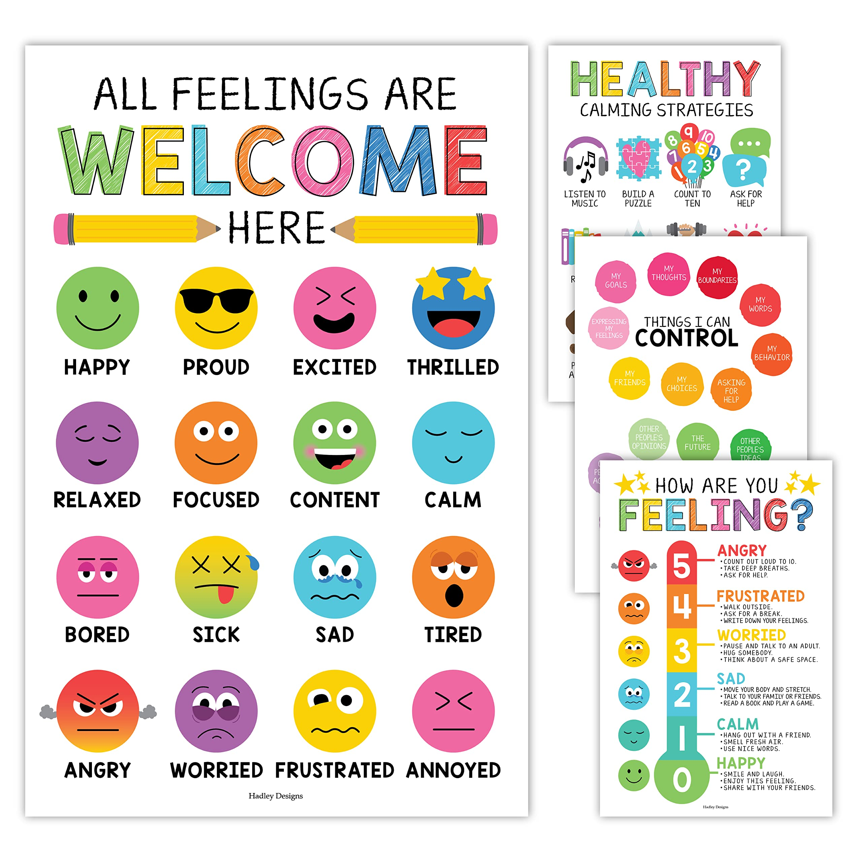
Fig 4. Emotion Chart, Hadley Designs (2025)

The proposed planner is to be a visual and tactile tool specifically designed to help children identify, track and communicate their emotional states. The planner will consist of an illustrated wall chart that can be displayed on walls at home or in classrooms.

Children’s media; including animation and picture books, play a crucial role in developing emotional literacy. Vibrant visuals, expressive characters and simplified narratives in these formats, help children understand and express or articulate complex emotions.
For neurodivergent children, who may experience adversities when trying to identify and communicate their feelings, emotionally resonant media can be notably impactful.
Examining emotional expression created by illustrators in children’s animation and picture books will inform the development of my emotion planner.
Animations such as Inside Out (Docter & Del Carmen, 2015) both highlight and embody this educational potential. The film personifies emotions like Joy, Anger, Sadness, Fear, and Disgust into brightly coloured characters each with distinct personalities. This approach makes abstract feelings accessible and relatable. The movie has been widely praised by educators and psychologists for its role in teaching emotional self-awareness and regulation (Brackett et al., 2016, Ekman, P. 2016).
In preparation for my practical work, I will be looking at various illustrators work who have focused on emotion-based projects, in order to draw inspiration for how to create characters with unique expressions, colours, shapes and gestures than can on sight embody specific feelings.
“...we believe that visual design, like all semiotic modes, fulfils three major functions. To use Halliday’s terms, every semiotic fulfils both an ‘ideational’ function, a function of representing ‘the world around and inside us’ and an ‘interpersonal’ function, a function of enacting social interactions as
social relations.”
- Kress and van Leeuwen (2006)

The semiotic relationship between colour, shape, and emotion is foundational to emotional expression in children’s media. Kress and van Leeuwen’s (2006) theory of visual grammar underlines how colour and compositional choices convey meaning. For instance, as discussed by multiple theorists, red is often associated with anger or energy, while blue may signify sadness or calm. My blob-like characters will be amorphous and simplified, which will allow for maximum emotional projection by young viewers. Their ambiguous form aims to enable children to attribute meaning without being confined or constrained by realism. The use of blobs with unique faces and colours as part of an emotion planner will tap into this same visual language. As Molly Bang (2000) demonstrates in Picture This, even simple changes in colour, shape or position can cause a dramatic shift in emotional perception. This makes blobs ideal candidates for conveying the nuances of mood and feeling in an inclusive, non-verbal, non-threatening way.

In conclusion, the intersection of children’s visual media and emotional development offers rich insights for tools aimed at supporting neurodivergent children. Animation and picturebooks that personify emotions using colour and character design not only entertain but educate. The development of an emotion planner using blob characters builds on these strategies, creating a system that externalizes emotion in a digestible, visual format.
Through this proposal and the supporting research, I have sought to demonstrate the vital roles of communication, expression, and connection within visual illustration, particularly as tools for supporting neurodivergent individuals. Drawing on semiotic theory and emotional literacy research, it is clear that visual modes of communication provide essential alternatives to verbal dialogue, especially for those who experience difficulty interpreting or expressing feelings. By developing an illustrated emotion planner featuring colourful, expressive blob characters, I aim to create an accessible and empathetic tool that empowers children to recognise, articulate, and share their emotions.
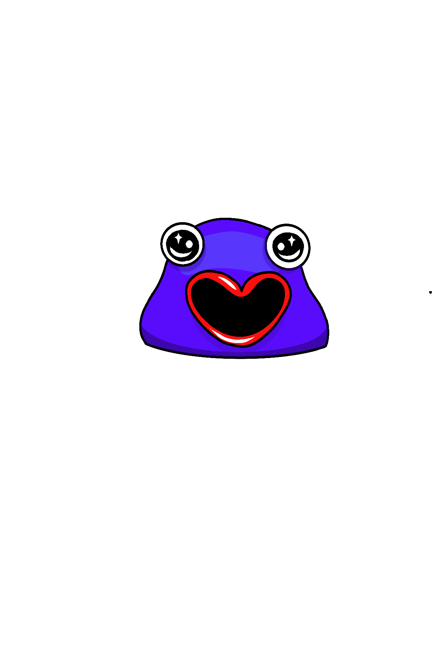
Informed by theorists such as Hall, Kress and van Leeuwen, Peirce, and Dewey, and inspired by successful examples in children’s media such as Inside Out and The Moomins, my work will embrace colour theory, shape, and expression to foster emotional understanding and create interpersonal connection. This project will not only support others but will also challenge and deepen my own practice as an illustrator—pushing me to think more critically about the emotional impact of my designs, to refine my visual storytelling skills with the goal to create work that is both inclusive and meaningful. Ultimately, this project highlights how illustration, through thoughtful and empathetic design, can bridge emotional gaps, create shared meaning, and strengthen the fundamental human need to connect.
Fig 5. Emotiblob idea

Bibliography

Ashburner, J., Ziviani, J., & Rodger, S. (2010). Surviving in the mainstream: Capacity of children with autism spectrum disorders to perform academically and regulate their emotions and behavior at school. Research in Autism Spectrum Disorders, 4(1), 18–27. https://doi.org/10.1016/j.rasd.2009.07.002

Baron-Cohen, S. (1995). Mindblindness: An essay on autism and theory of mind. MIT Press.
Baron-Cohen, S. (2000). Theory of mind and autism: A fifteen-year review. In Understanding other minds: Perspectives from developmental cognitive neuroscience (pp. 3–20). Oxford University Press.
Baron-Cohen, S., Golan, O. and Ashwin, E. (2009) ‘Can emotion recognition be taught to children with autism spectrum conditions?’, Philosophical transactions of the Royal Society of London. Series B. Biological sciences, 364(1535), pp. 3567–3574. Available at: https://doi.org/10.1098/rstb.2009.0191.

Birren, F., 1961. Color Psychology and Color Therapy: A Factual Study of the Influence of Color on Human Life. New York: McGraw-Hill.

Chandler, D. (2022) Semiotics: the basics. Fourth edition. London: Routledge. Available at: https://doi.org/10.4324/9781003155744.
Google Arts & Culture. (n.d.). Blob Opera. [online] Available at: https://artsandculture.google.com/experiment/blob-opera/AAHWrq360NcGbw?hl=en&cp=e30..
Goethe, J.W., 1810. Theory of Colours. London: John Murray (English translation, 1840).

Docter, P., & Del Carmen, R. (Directors). (2015). Inside Out [Film]. Pixar Animation Studios.
Desbordes, A. (2015). Edmond, the Moonlit Party.

Ekman, P. (2017). Homepage - Paul Ekman Group. [online] Paul Ekman Group. Available at: https://www.paulekman.com/.
‌
Kofler, M.J. et al. (2017) ‘Heterogeneity in ADHD: Neurocognitive predictors of peer, family, and academic functioning’, Child neuropsychology, 23(6), pp. 733–759. Available at: https://doi.org/10.1080/09297049.2016.1205010.
Kress, G., & van Leeuwen, T. (2006). Reading Images: The Grammar of Visual Design (2nd ed.). Routledge.
Jansson T., (1986). Finn family Moomintroll. Middlesex: Puffin Books.
Jansson, T., 2001. The Book about Moomin, Mymble and Little My. London: Sort Of Books. (Original work published 1952)
Peirce, Charles Sanders (1931-58): Collected Writings (8 Vols.). (Ed. Charles Hartshorne, Paul Weiss & Arthur W Burks). Cambridge, MA: Harvard University Press
Preece, D. A., & Gross, J. J. (2023). Conceptualizing alexithymia. Personality and Individual Differences, 215, 112375-. https://doi.org/10.1016/j.paid.2023.112375

Mcdonnell, C., Vasquez, J., Sugar, R. and Nickelodeon (Television Network (2020). The art of Invader Zim. New York: Abrams.
McRobie, H. (2014). Martha Nussbaum, empathy, and the moral imagination. [online] openDemocracy. Available at: https://www.opendemocracy.net/en/5050/martha-nussbaum-empathy-and-moral-imagination/.
‌Nikolajeva, M. (2012). Reading Picturebooks: How Picturebooks Work. Routledge.
Nussbaum, M.C., 1995. Poetic Justice: The Literary Imagination and Public Life. Boston: Beacon Press.

References
Ashburner, J., Ziviani, J., & Rodger, S. (2010). Surviving in the mainstream: Capacity of children with autism spectrum disorders to perform academically and regulate their emotions and behavior at school. Research in Autism Spectrum Disorders, 4(1), 18–27. https://doi.org/10.1016/j.rasd.2009.07.002

Baron-Cohen, S. (1995). Mindblindness: An essay on autism and theory of mind. MIT Press.
Baron-Cohen, S. (2000). Theory of mind and autism: A fifteen-year review. In Understanding other minds: Perspectives from developmental cognitive neuroscience (pp. 3–20). Oxford University Press.
Chandler, D. (2022) Semiotics: the basics. Fourth edition. London: Routledge. Available at: https://doi.org/10.4324/9781003155744.
Ekman, P. (n.d.). What is Anger? | Feeling Anger. [online] Paul Ekman Group. Available at: https://www.paulekman.com/universal-emotions/what-is-anger/.
Hadleydesigns.com. (2023). Behavior Chart. [online] Available at: https://hadleydesigns.com/collections/behavior-chart [Accessed 24 Apr. 2025].

Goethe, J.W., 1810. Theory of Colours. London: John Murray (English translation, 1840).

Kofler, M.J. et al. (2017) ‘Heterogeneity in ADHD: Neurocognitive predictors of peer, family, and academic functioning’, Child neuropsychology, 23(6), pp. 733–759. Available at: https://doi.org/10.1080/09297049.2016.1205010.
Kress, G., & van Leeuwen, T. (2006). Reading Images: The Grammar of Visual Design (2nd ed.). Routledge.
McRobie, H. (2014). Martha Nussbaum, empathy, and the moral imagination. [online] openDemocracy. Available at: https://www.opendemocracy.net/en/5050/martha-nussbaum-empathy-and-moral-imagination/.

Peirce, Charles Sanders (1931-58): Collected Writings (8 Vols.). (Ed. Charles Hartshorne, Paul Weiss & Arthur W Burks). Cambridge, MA: Harvard University Press
Preece, D. A., & Gross, J. J. (2023). Conceptualizing alexithymia. Personality and Individual Differences, 215, 112375-. https://doi.org/10.1016/j.paid.2023.112375
Nussbaum, M.C., 1995. Poetic Justice: The Literary Imagination and Public Life. Boston: Beacon Press.

