Strata Florida

A brief report of the site and its local area, both within modern and historic context

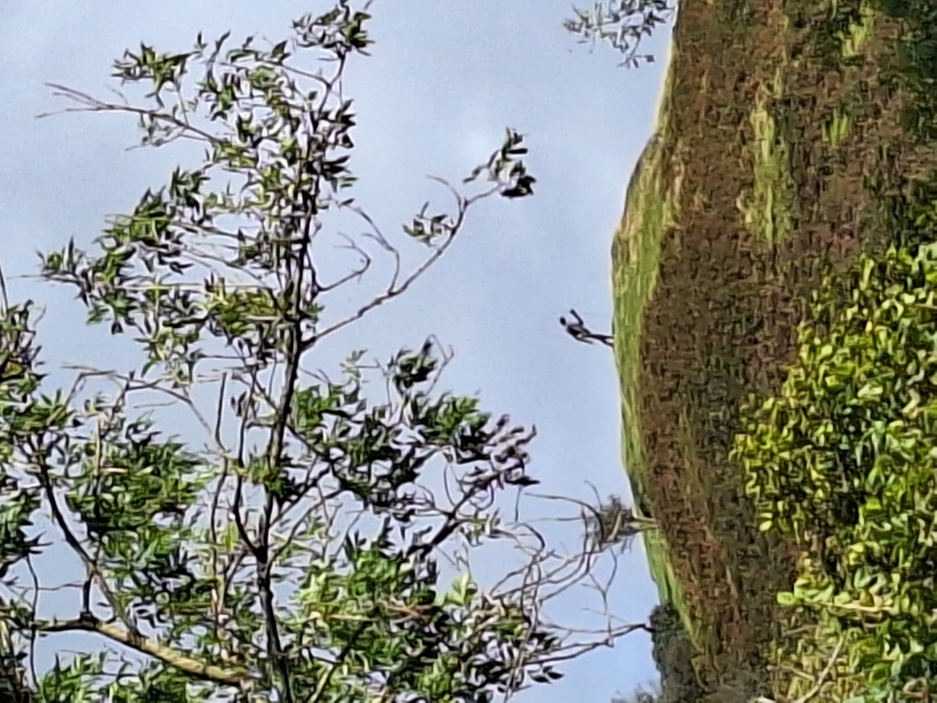
Statue of the Pilgrim, atop the mountain beside Strata Florida, Lexin Jessopp (2025)
Overview
This document aims to outline the basic knowledge I would deem is essential in order to gain an understanding of the Strata Florida abbey and its surrounding features. Alongside this, the document will note areas of particular importance, whether this may be historically, geographically, or simply details about these areas that help the reader to gain a thorough understanding of the site – this may be an understanding of why certain buildings are positioned as they are, or the uses of some areas to one another.
Biodiversity
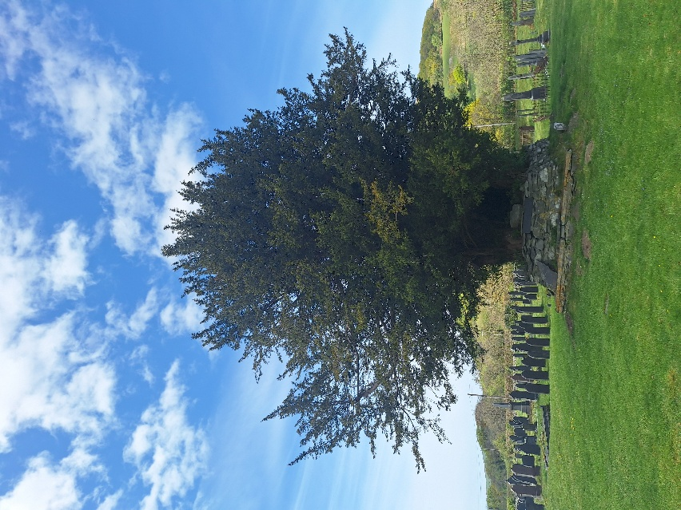
Standing atop the hill beside the Abbey, on which stands the statue of the Pilgrim, offers the best view of the valley in order to asses the biodiversity of the land. Not only is there a wide range of different flora and fauna, but many different kinds of biomes can be observed, For instance, the grasslands surrounding the abbey appear very plain from this angle, but the added height of the elevated position allows for a better view of the clear difference in forestry areas. That is, that there is both a cultivated ancient woods, and a designated hardwood forest grown for the purpose of felling as industrial supplies. Some of these areas are reserved for private felling, however the Teifi Tree company has offered their trees for sale in a number of different Christmas markets, such as Morriston and Carmarthen (Kaz, 2024). This outsourcing shows some connections with broader Welsh communities, however it is limited by the short term in which an average family may be searching for a natural Christmas tree to have in their home. Though for an average person it may be difficult to determine the exact age of some of the trees, it is clear to see that many, such as the trees within the graveyard of St Marys Church, have been there for decades, if not centuries.
The site within its surrounding area
The site of Strata Florida resides on the outskirts of the small Welsh village of Pontrhydfendigaid, a town within the county of Ceredigion. Its popularity is very small, as of the 2022 census the number of residents stood at a mere 707, 5 less than the previous census of 2011 (CensusData, 2022). Unless a visitor was to intentionally seek out the site, it is incredibly easy to miss, and there is arguably insufficient signage or local guidance to draw in more guests to the abbey. During time spent at the site as part of an excavation module, it was possible to see coaches which brought groups of elderly visitors, possibly from a nursing home or group, however it was not possible to determine their exact origin from a glance.
From standing at a higher vantage point, it is also possible to see the number of Iron Ager hillforts which surround the valley, in varying sizes and scales. These are at a greater distance from the site but nonetheless emphasize the significance of the area to a great number of civilisations.
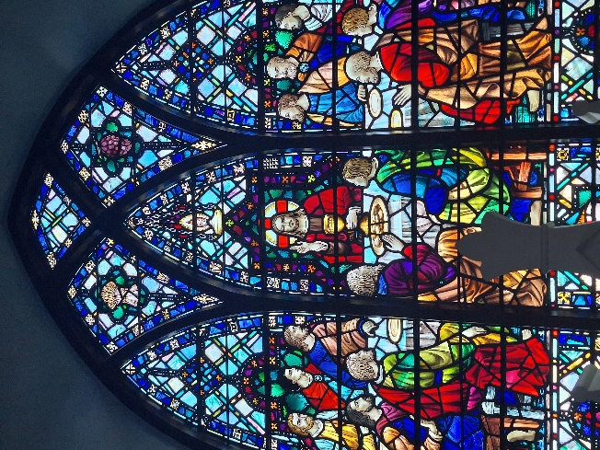
Directly beside the Abbey itself is the more modern Chapel of St Mary, a functional chapel which still observes notable occasions such as Easter and Christmas services. It has its own rich history which may not be seen at first. Upon closer inspection, small features such as an inverted brick with a date etched onto it suggest that the chapel has undergone its own repairs and renovations – a flipped date suggests that it was the first construction date, however that the site has since seen further work and therefore this date is no longer a relevant account of the age of the site. Tombstones and commemorative plaques around the graveyard suggest that the chapel has been in use since the 18th century, with bodies buried from the local people, and those from further afield.
Strata Florida Abbey
Whilst the rolling fields and local village paint a serene image, by far the greatest point of interest in the valley is the Strata Florida Abbey. It cannot be denied that the Abbey itself is merely a shadow of its former glory, decayed and broken, and therefore does not portray a full image to the observer of the grandeur that greeted a 12th century visitor to the site. Engravings within the gates of the castles show various carved symbols, which may allude to the Welsh past of the site, but also offer visitors areas of fascination to observe. In its current state, many of the walls have collapsed, and what remains has been treated or coated with some form of concrete layer to prevent further erosion. Some debate can be seen about whether or not the site should be restored to its former glory, however the concrete protections suggest that the Strata Florida Trust may seek to portray a dilapidated image of the site, in order to highlight its disastrous history, rather than gloss over this with an expensive renovation that ultimately may damage some of the existing features.
Excavations undertaken by UWTSD Lampeter across various summers have revealed that the site has a rich neolithic history. Foundations of walls have been discovered within the stable yard, and are currently still being excavated in order to gain a better understanding of the extent to which these two sites overlap, however it is certainly to be noted that this area has continually been deemed important within Welsh history - even pre-dating when the concept of Wales may have been formed, and it would have instead been merely some lands.
Comparison to other Abbeys in Wales
Strata Florida was not exempt from the dissolution of the Monasteries between 1536 and 1540, enacted by the Tudor King Henry VIII, and therefore suffered the same fate as almost all monasteries, abbeys and religious buildings in Britain during his period. They were stripped of all items of value, furniture and natural building materials included – these were sold off to gain further profits for the crown – before being left in ruin, with the religious sects unable to even reside within the empty halls (Historic UK, 2023).
Brief History, Heritage and Preservation of Site
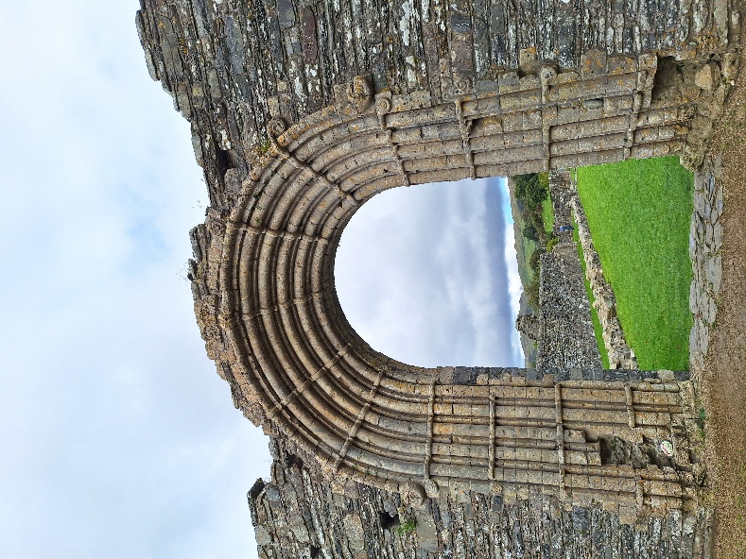
Owned by Cadw, an organisation which protects and aims to preserve Welsh Heritage sites, and operated by the Strata Florida Trust, the site has evolved drastically across the centuries since its original foundation date of the 1st of June, 1164 (Monastic Wales, 2025). Strata Florida predominantly acted as a Cistercian Abbey, ran by the monks which resided within its walls. Archaeological evidence within the building suggest there may have been older structures on the site which predate the abbey. The baptismal font within the abbey is evident of this – unlike in many standard Cistercian buildings, it does not reside at the entrance door of the abbey, but instead is within the back, slightly de-centred. This may allude to a previous, older Welsh structure being on the site, and may have been kept to denote some form of appreciation or respect for these older practices.
Image of the gate of the Abbey, Lexin Jessopp, 2025
Conclusion
From an archaeological perspective, the site is rich in historical sites yearning to be observed and explored, ones which have offered up an even more colourful insight to the daily life of monastic Wales in the 12th and 13th centuries. Without such an important site, with noted figures such as Gerald of Wales (also known as Giraldus Cambrensis) writing as a contemporary figure, there may have been very little information preserved to the modern day about what was an integral part of Welsh life in this time.
Bibliography
All images taken by Lexin Jessopp, at the site and the local area (2025)
Dissolution of the monasteries. (2023, November 16). Historic UK. https://www.historic-uk.com/HistoryUK/HistoryofEngland/Dissolution-of-the-Monasteries/
Kaz. (2024, November 25). Teifi Trees. West Wales Family Life. https://www.westwalesfamilylife.co.uk/pick-your-own-real-christmas-tree/teifi-trees/
Monastic Wales (2025). Strata Florida Site details: Strata Florida
Pontrhydfendigaid Census, 2022, CensusData.uk

