Agile Test Edward Prasad (1809704) 13/12/18

Q1.
a)
I will use user stories to format the requirements. User stories allow a given requirement to be stated as a short sentence that is easy to understand from all parties.
As an employee I want to be able to search the product list so that I can find the product a customer has requested.
As a customer I want to be able to search the products so that I can find the product I want and place an order.
As a customer I want to be able to see the discounts that are available on a given item so that I can best formulate my decision.
As a warehouse manager I want to be able to see the stock levels of the products so that I know when back orders will be created.
As a manager I want to be able to see how many items of each product has been sold so that I can formulate reports.

b)
Object decomposition allows the system to be compartmentalised into different groups. This then allows for interactions and behaviours to be detailed showing how the different parts of the system interact with each other, however, it does not allow for chronology or data structures to be defined.
An advantage of object decomposition is that it is easy to understand and to see the interactions of the system and is quicker to produce than an algorithmic approach that will define each possible step of the system.

Q2.
a)
The below image shows a new repository being created using the online tool Bitbucket which is a browser based distributed development tool that utilises git.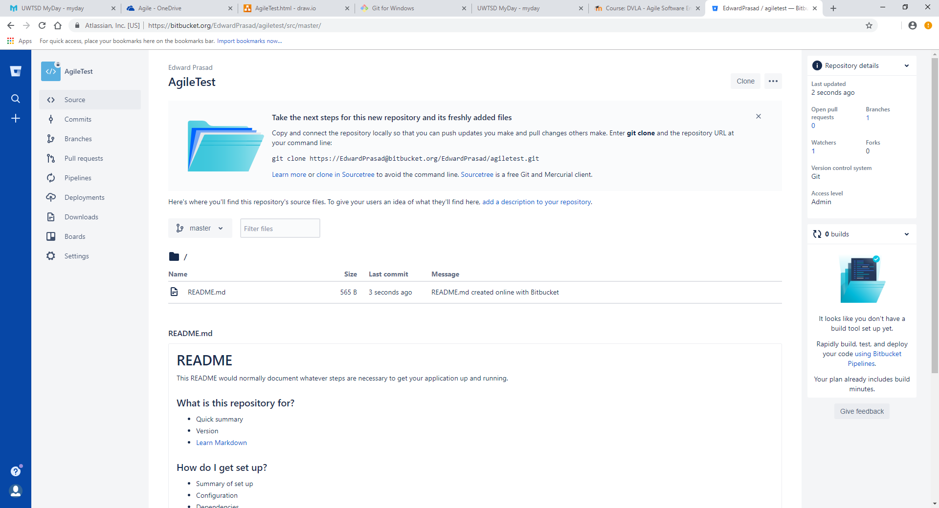
b)
Git is a tool for distributed development. Git has one global, or master, repository that users can be given permission to access. Once permission is given, any user is able to clone the repository using the command git clone. This creates a full copy of the repository on the user’s local machine including any and all commits that have been performed. Cloning a repository allows developers to access the same code at the same time, but still work independently.
When a developer has updated code, with a new feature for example, they will add the work to their local repository using the command git add. This is important as it stages the local repository ready for a commit before being added to the master repository.
Git commit is a command that records all changes made to files in the repository. This recorded changes are stored in the repository so when it is uploaded to the master repository every other developer can see the changes that have been made. This command also includes a message for so it is easy to see which commits did what.
Git push allows the developer to send their updated code to the master repository so that other developers can view their code.
The git pull command updates a local repository with the files of the master.
A pull request can be made by a developer which requests that other developers, potentially a team leader, pulls their code and reviews it before it is merged to the master repository.
Merging repositories means that the changes in one repository are added in full to another, this is usually performed after a pull request as to ensure the code is accurate before updating.

c)
The software could be created using a scrum approach. In this method the requirements would be broken down into user stories and then added to a product backlog. The product backlog is a list of all the requirements that are needed for the project.
Once the product backlog has been defined the team will design the system for the implementation to follow. This stage allows the development team to have a guide as to what to create in addition to the requirements.
After the design, the development team will take certain user stories, which have been prioritised by the scrum master, and implement them. The implementation takes place during sprints, a short period of time such as two weeks. At the end of each sprint the whole team partakes in a retrospective where they discuss what went well, what didn’t go well and what they will achieve during the next sprint.
Once a feature of the system, as defined by the user stories, is implemented it undergoes testing. This testing works to ensure the code created is accurate according to the requirements as well as the client’s perception.
Finally, after the code has been tested it will be deployed to the client.
This cycle is then repeated in an iterative process until the full project is complete.

Q3.
a)
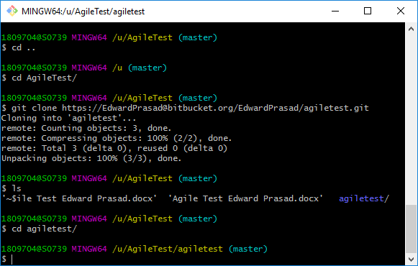
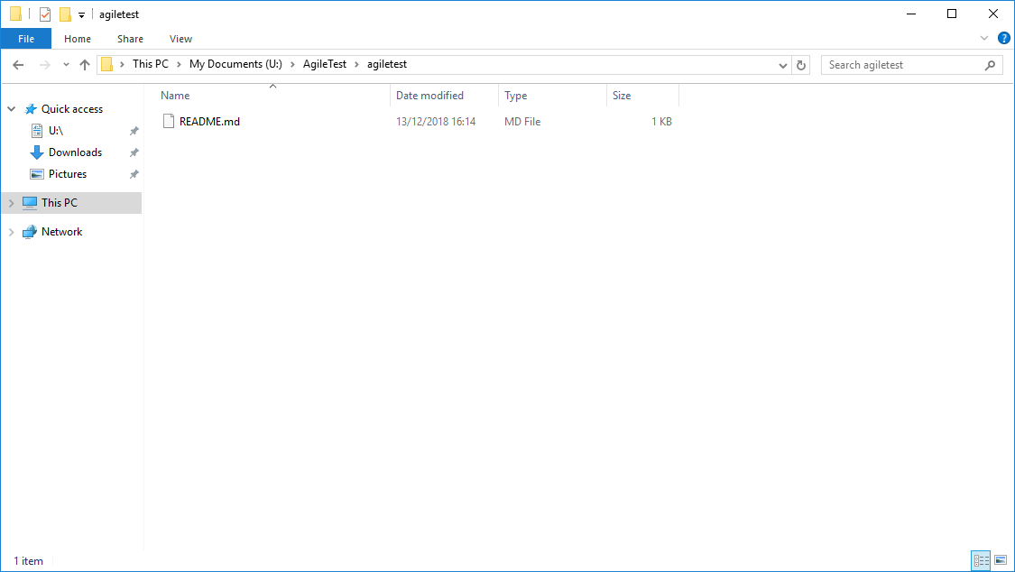
The above images show the master repository, created in Bitbucket, being cloned locally and navigated into.
By cloning the repository like this I am able to make changes to the folder, by adding files etc., and commit them to the main repository updating it.
With a local repository I can create a branch, for example ‘branch1’ as in the image below. This means I am able to utilise the same files from the master but work in a different workspace so that my changes don’t immediately update the master repository on a commit, it would first have to be merged.
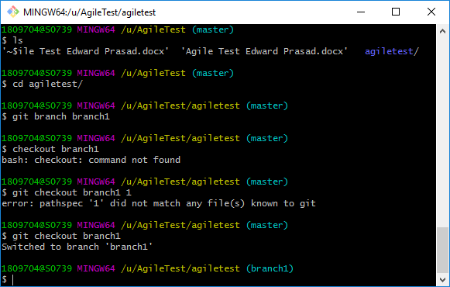
b) 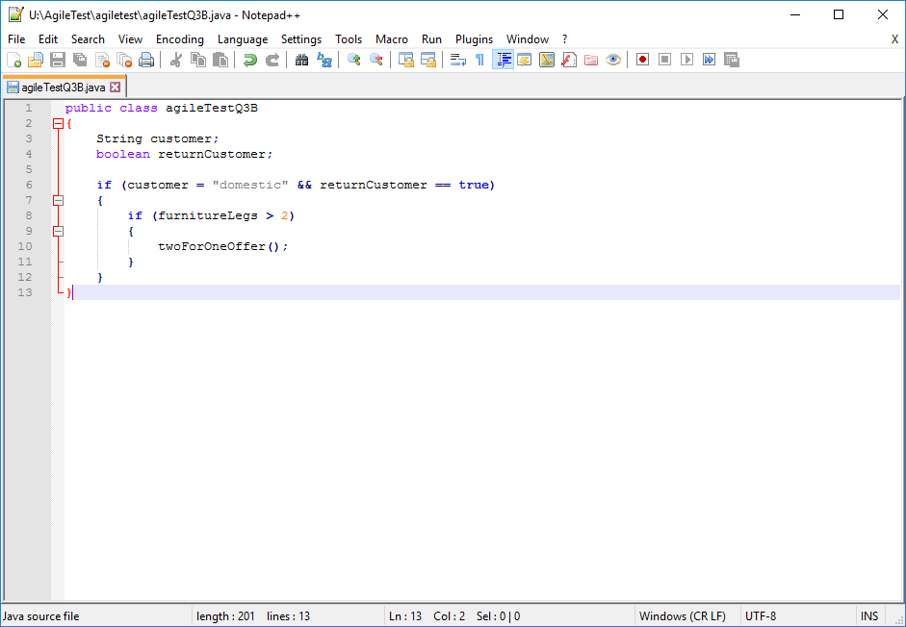
File (agileTestQ3B) added to local repository and committed to Bitbucket.
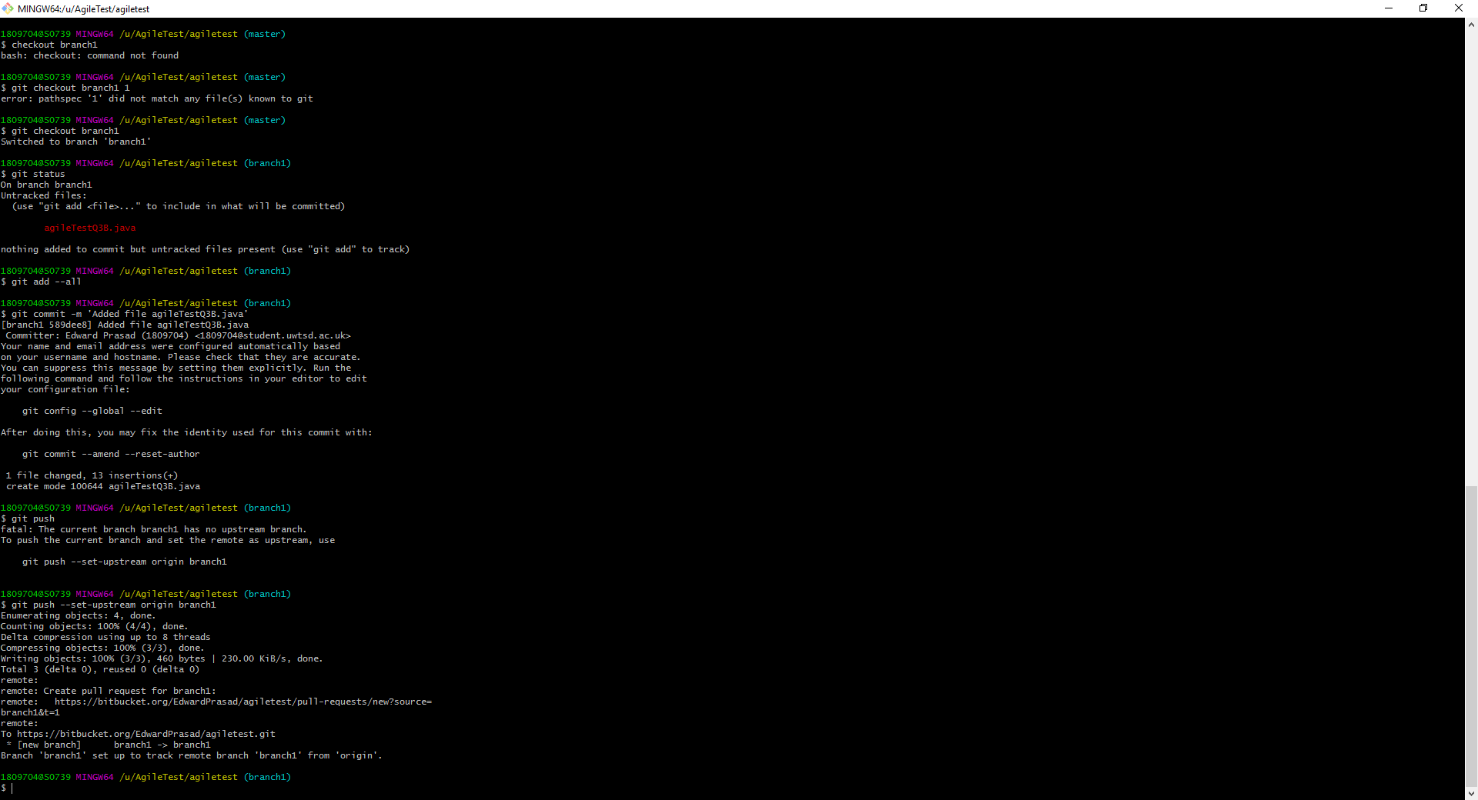
c)

The above images show the file agileTestQ3B.java being added to the local repository U\AgileTest\agiletest\ in the branch ‘branch1’ with the command git add –all (add all new files). Then committed to the repository with the message “Added file agileTestQ3B.java”. Then the file is pushed to the master repository on Bitbucket.

The below image shows the file mentioned above added to the repository on Bitbucket under the branch ‘branch1’.
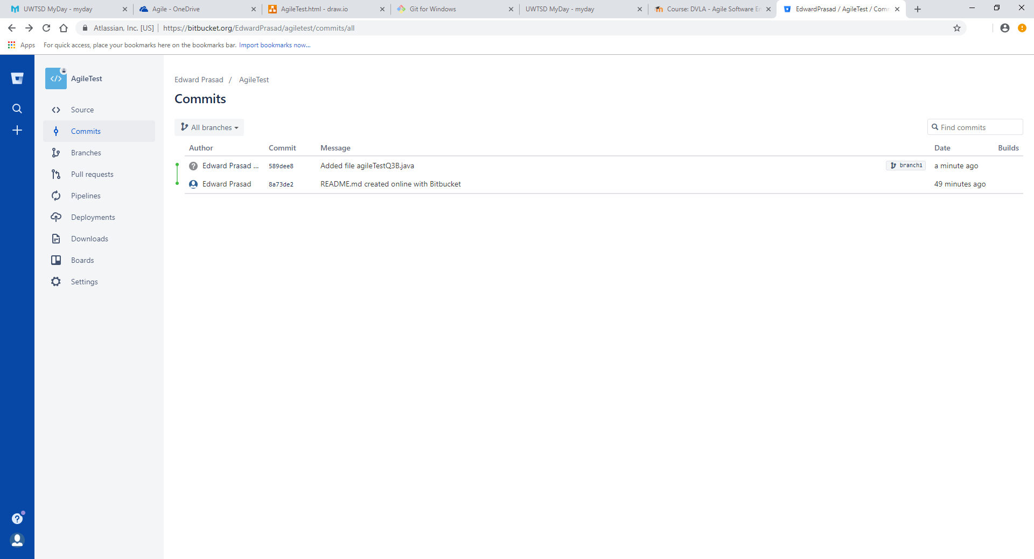

Q4.
a)
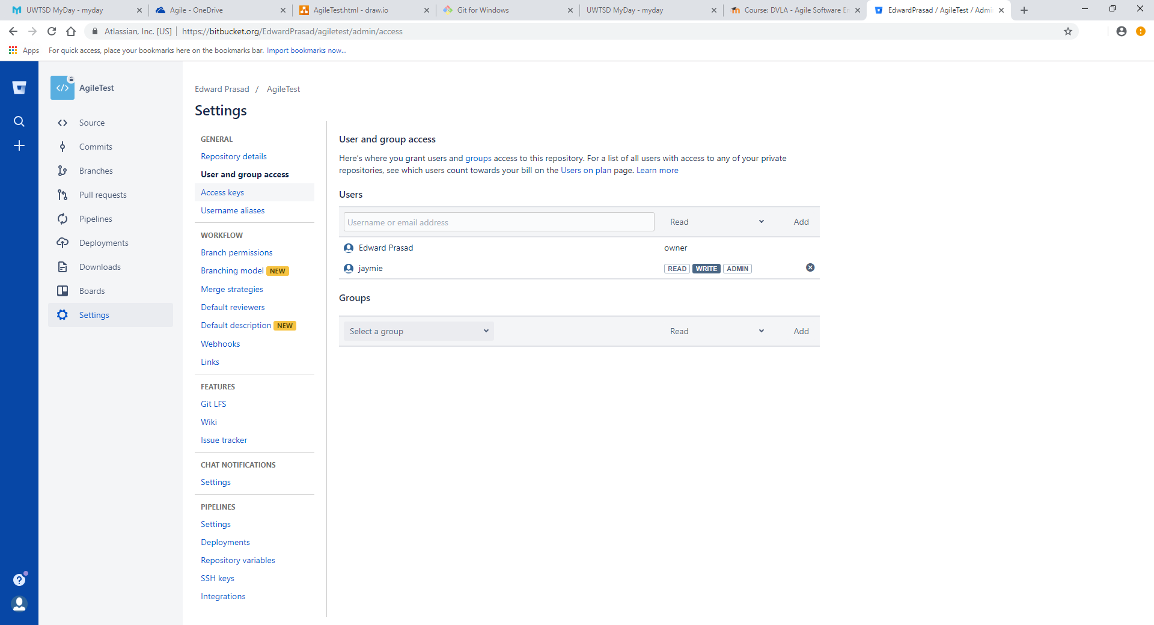
Repository shared to jaymie.phillips@uwtsd.ac.uk.
b)
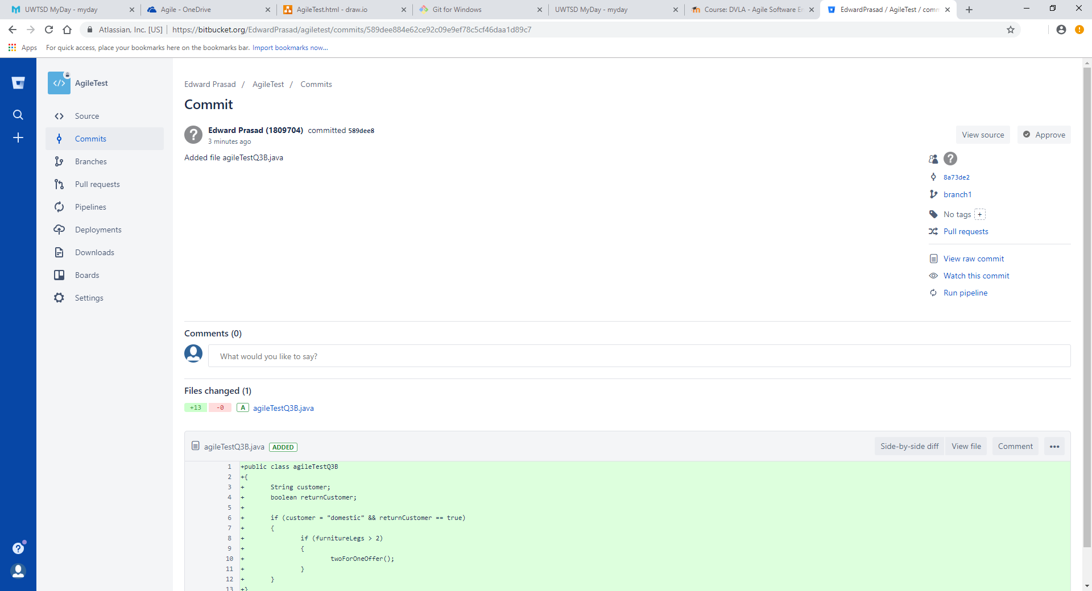
c)
Unit tests can be performed on pieces of code containing multiple features. This works by creating individual tests for each feature, or method, and then running each all of the tests together as part of a test suite.
These unit tests can be performed in java using the testing tool Junit. Each test is written in Junit and when ran the software displays how many tests passed or failed, and why if failed.

