

Module Title: | Dissertation
Module Code: | LCMB7020
Course: | MASTER OF BUSINESS ADMINISTRATION IN GENERAL MANAGEMENT
Dissertation Topic: | The Impact of Emotional Branding by Tesco on Consumer Decision-Making Process
Lecturer: Dr. Jaya Gopalkrishnan

Master’s Degrees by Examination and Dissertation
Declaration Form.
1. This work has not previously been accepted in substance for any degree and is not being concurrently submitted in candidature for any degree.
Signed : Vimal kumar
Date : 12/10/2023

2. This dissertation is being submitted in partial fulfilment of the requirements for the degree of Master in Business Administration.
Signed : Vimal kumar
Date : 12/10/2023
3. This dissertation is the result of my own independent work/investigation, except where otherwise stated.
Other sources are acknowledged by footnotes giving explicit references.
A bibliography is appended.
Signed candidate : Vimal kumar
Date: 12/10/2023

4. I hereby give consent for my dissertation, if accepted, to be available for photocopying, inter- library loan, and for deposit in the University’s digital repository
Signed (candidate) : Vimal kumar
Date : 12/10/2023

Supervisor’s Declaration.
I am satisfied that this work is the result of the student’s own efforts.
Signed : (I will sign after you fill up the front pages and add them to your Dissertation before the table of contents)
Date: 12/10/2023

University of Wales: Trinity Saint David
E-Thesis Deposit Agreement

Details of the Work
I would like to deposit the following item in the digital repository maintained by the University, and/or in any other repository authorized for use by the University:

Title: The Impact of Emotional Branding by Tesco on Consumer Decision-Making Process

This item is a product of my own research endeavours and is covered by the agreement below in which the item is referred to as “the Work”. It is identical in content to that deposited in the Learning Resources Centre, subject to point 4 below.
I agree that the University of Wales: Trinity Saint David may electronically store, copy or translate the Work to any approved medium or format for the purpose of future preservation and accessibility. The University is not under any obligation to reproduce or display the Work in the same formats or resolutions in which it was originally deposited.
UW: TSD Digital Repository
I understand that work deposited in the digital repository will be accessible to a wide variety of people and institutions, including automated agents and search engines via the World Wide Web.
I understand that once the Work is deposited, the item and its metadata may be incorporated into public access catalogues or services, such as national databases of electronic theses.

I agree as follows:
- That I am the author or have the authority of the author/s to make this agreement and do hereby give the University of Wales: Trinity Saint David the right to make available the Work in the way described above.
- That the electronic copy of the Work deposited in the digital repository and covered by this agreement, is identical in content to the paper copy of the Work.
- That I have exercised reasonable care to ensure that the Work is original, and to the best of my knowledge, does not breach any laws including those relating to defamation, libel, and copyright.
- That I have, in instances where the intellectual property of other authors or copyright holders is included in the Work, gained explicit permission for the inclusion of that material in the Work and in the electronic form of the Work as accessed through the open access digital repository, or that I have identified and removed that material for which adequate permission has not been obtained and which will be inaccessible via the digital repository
- That University of Wales: Trinity Saint David does not hold any obligation to take legal action on behalf of the Depositor, or other rights holders in the event of a breach of intellectual property rights or any other right in the material deposited.
- That I undertake to indemnify the University of Wales: Trinity Saint David against all actions, suits, proceedings, claims, demands, and costs occasioned by the University in consequence of any breach of this agreement

Signature: Vimal kumar
Date: 12/10/2023

Abstract:
This study delves into the complex link between emotional branding and customer decision-making, using Tesco as an example. This study is significant because it sheds insight on the function of emotions in affecting customer behavior and the consequences for marketing and branding tactics. The research obtained data from 45 Tesco consumers using a mixed-method technique that combined quantitative questionnaires and qualitative thematic analysis.
According to the quantitative research, a large majority of respondents (85%) were aware of Tesco's emotional branding activities, demonstrating the success of these efforts in reaching customers. Furthermore, the survey discovered that Tesco's emotional branding elicited primarily favorable feelings in customers, including contentment (65%), trust (53%), and loyalty (42%). These favorable emotional responses were highly related to important customer decision-making criteria such as purchase frequency, basket size, and brand loyalty. This highlights the practical influence of emotional branding on consumer behavior. The qualitative study enriched the quantitative findings by highlighting emotional connections, the impact on decision-making, and the significance of emotional consistency in customer-brand relationships. These findings are consistent with previous research on emotional branding, validating the notion that emotional ties lead to increased consumer loyalty and good decision-making outcomes.
Finally, this study emphasizes the significance of emotional branding for Tesco and other comparable firms. Tesco can promote brand loyalty and increase repeat business by continually eliciting favorable feelings in customers. The limitations of this study, such as its cross-sectional methodology and potential response bias, indicate to future research directions. Overall, this study emphasizes the importance of emotions in customer decision-making and provides practical insights for firms looking to improve their emotional branding efforts in the competitive retail scene.
Keywords: Emotional branding, Tesco, Consumer decision-making, Customer behavior, Brand loyalty.

Abstract: 5
1.1 Introduction: 4
1.2 Research Background: 4
The Evolution of Emotional Branding: 4
Current Trends in Emotional Branding: 5
Existing Research and Knowledge: 5
1.3 Research Problem: 5
1.4 Research Questions and Objectives: 6
1.5 Rationale of the Topic: 7
1. Importance of Studying Emotional Branding in Retail: 7
2. Tesco as an Ideal Case Study: 7
3. Benefits for Academics and Practitioners: 8
4. Addressing Existing Literature Gaps: 8
1.6 Contributions of the Research: 8
1. Advancements in Marketing and Retail: 8
2. Practical Implications for Tesco and Retailers: 8
3. Informing Future Emotional Branding Strategies: 8
1.7 Dissertation Structure: 9
1.8 Theoretical Framework: 9
Chapter 2: Literature Review 9
2.1 Introduction: 10
2.2 Emotional Branding: Concepts and Theories: 10
Defining Emotional Branding: 10
Critical Theories and Models: 11
Analyzing Strengths and Weaknesses: 11
2.3 Emotional Branding in Retail: 12
The Role of Emotional Branding in the Retail Industry: 12
Relevant Studies and Research Findings: 13
Methodological Critique and Contributions: 13
Limitations and Future Directions: 14
2.4 Tesco's Approach to Emotional Branding: 14
Overview of Tesco: 15
Significance in the Retail Industry: 15
Tesco's Strategies and Initiatives in Emotional Branding: 15
Analyzing Case Studies and Impact: 16
2.5 Consumer Decision-Making and Emotional Branding: 17
The Relationship Between Emotional Branding and Consumer Decision-Making: 17
Summarizing Relevant Studies: 17
Analyzing Methodologies and Implications: 18
Limitations and Future Directions: 18
2.6 Research Gaps and Conflicts: 19
Research Gaps: 19
Conflicts and Inconsistencies: 19
Addressing Research Gaps: 20
2.7 Theoretical Framework Revisited: 20
Chapter 3: Methodology 21
3.1 Introduction: 21
3.2 Research Philosophy: 21
3.3 Research Approaches: 22
3.4 Research Design: 22
3.5 Research Strategy: 23
Type of Investigation: 23
Choices: 23
Time Horizon: 24
3.6 Sampling Method: 24
Sample Type: 24
Sample Size: 25
Sampling Method: 25
3.7 Data Collection Method: 25
Rationale for Questionnaires: 25
Questionnaire Format and Structure: 26
Questionnaire Administration: 26
3.8 Data Analysis Plan: 27
Data Processing: 27
Statistical Analysis: 27
Qualitative Analysis: 27
3.9 Ethical Considerations: 28
Informed Consent: 28
Privacy and Data Protection: 29
Ethical Standards: 29
Ethical Approvals: 29
3.10 Research Limitations and Accessibility Issues: 29
3.11 Conclusion: 30
Chapter 4: Data Analysis and Discussion 30
4.1 Introduction: 30
4.2 Data Analysis Plan: 31
Data Collection Methods: 31
Quantitative and Qualitative Analysis Techniques: 31
Data Processing Steps: 31
Rationale for Mixed-Methods Approach: 32
4.3 Research Analysis: 32
Sample Overview: 33
Quantitative Analysis Overview: 33
Results of Quantitative Analysis: 33
Qualitative Analysis Overview: 35
Results of Qualitative Analysis: 35
Integration of Quantitative and Qualitative Findings: 36
4.4 Discussion: 37
Interpretation of Results in the Context of Research Questions and Objectives: 37
Implications for Tesco: 38
Relating to Existing Literature and Theoretical Frameworks: 39
Contradictions and Unexpected Findings: 39
Practical Implications: 39
Limitations and Future Research: 39
4.5 Conclusion: 39
Chapter 5: Conclusion 40
5.1 Recap of Research Objectives 40
5.2 Summary of Methodology: 41
5.3 Key Findings: 41
Awareness of Emotional Branding: 41
Emotional Responses: 41
Influence on Decision-Making: 42
Qualitative Insights: 42
Integration of Findings: 42
5.4 Implications for Tesco: 43
Enhancing Customer Engagement: 43
Personalization and Targeting: 43
Emotional Consistency: 43
Customer-Centric Approach: 43
Continuous Feedback and Adaptation: 43
5.5 Contribution to Existing Literature: 44
Confirmation of Emotional Branding Significance: 44
Expansion of Understanding: 44
Holistic View: 44
5.6 Addressing Limitations: 44
Cross-Sectional Design: 44
Response Bias: 45
Unaddressed Negative Emotions: 45
Comparative Studies: 45
5.7 Research Conclusion and Answering Research Questions: 45
5.8 Final Thoughts and Practical Recommendations: 46
Practical Recommendations: 46
5.9 The Research Journey and Closing Remarks: 46
References: 48
Appendix: 52
Appendix A: Survey Questions 52
Appendix B: Survey Results 66

Chapter 01: Introduction

1.1 Introduction:
Capturing the hearts and wallets of consumers has become an art form in today's brutally competitive retail world. Tesco, one of the industry's behemoths, has mastered this technique through the intentional use of emotive branding (Nott, 2022). The topic of this dissertation is "The Impact of Emotional Branding by Tesco on Consumer Decision-Making Process." It explores how Tesco's emotional branding initiatives impact consumer decisions.
Understanding how Tesco harnesses the power of emotions is critical in a world where customer decisions are fundamentally emotional rather than entirely intellectual. This research aims to shed light on the underlying objectives by investigating the purpose and relevance of Tesco's emotional branding. It aims to decipher the complex network of customer perceptions, emotional responses, and purchase decisions shaped by Tesco's branding activities. As we progress through this dissertation, we will examine Tesco's emotional branding methods, interpret consumer attitudes, and uncover insights with far-reaching ramifications for the retail business.

1.2 Research Background:
Emotional branding is at the forefront of modern marketing methods, significantly impacting customer behavior and preferences. Emotional branding is, at its core, the art of building strong emotional connections between consumers and businesses beyond ordinary transactions to form long-term relationships (Garg et al., 2020). This is a crucial notion in marketing, with roots dating back to the early twentieth century.
The Evolution of Emotional Branding: Emotional branding has changed dramatically over time. Brands used to be primarily concerned with functional aspects and product features. However, a change occurred when markets got saturated and customer choices proliferated. Brands recognized the need to differentiate themselves via their products and evoke customer emotions. This move signaled the beginning of emotional branding (Filieri et al., 2022). Emotional branding has become popular in retail as supermarkets and retailers strive to build strong, long-term customer relationships. Tesco and other supermarkets have understood that customers are searching for experiences, emotions, and products. Tesco, for example, has started on an emotional branding journey to position itself as more than simply a place to buy but a brand that resonates with its consumers' hearts.
Current Trends in Emotional Branding: Emotional branding has taken on new dimensions in today's digital world. With the emergence of social media and internet platforms, emotional branding efforts have expanded their reach and influence. Brands use storytelling, actual storylines, and appealing imagery to generate emotional connection with their target audience. Furthermore, the COVID-19 epidemic has highlighted the necessity of emotional branding (Nhedzi et al., 2023). Consumers desire reassurance, trust, and a sense of belonging from their chosen companies. This shift in customer behavior has resulted in novel emotional branding strategies centered on empathy and social responsibility.
Existing Research and Knowledge: Several studies highlight the importance of emotional branding in the academic world. According to studies, emotionally engaged clients are more loyal and prepared to pay higher costs. Studies on the psychological basis of emotional branding have also revealed how certain feelings, such as joy, nostalgia, or trust, may impact purchase decisions. Research has examined emotional branding methods and their influence on consumer perceptions and actions in supermarkets and retail (Pich et al., 2018). These studies shed light on the efficacy of emotional branding strategies in the highly competitive retail sector. As we begin this research journey, it is critical that we expand on this current knowledge base, bridge research gaps, and better understand how Tesco's emotive branding activities influence customers' decision-making process.

1.3 Research Problem:
An interesting research question is at the heart of this dissertation: How does Tesco's use of emotional branding influence consumers' decision-making process? This question captures the essence of our inquiry as we aim to understand the complex interactions between Tesco's emotional branding initiatives and consumer decisions.
Addressing this research issue has far-reaching ramifications for marketing and retail. In today's hypercompetitive market, when products and services frequently look homogeneous, a brand's emotional connection with its customers may be a game changer. Understanding how Tesco, a retailing behemoth, uses emotional branding to influence consumer decisions not only gives valuable insights for Tesco but also serves as a roadmap for other retailers negotiating similar terrain (Tesco Corporation Market Line Company, 2018). Furthermore, the grocery sector is a war with razor-thin margins and hard-won consumer loyalty. Understanding the subtleties of customer decision-making becomes critical in such an environment. We want to discover ways to help Tesco and other stores stand out and survive by researching the influence of emotional branding on these decisions.

1.4 Research Questions and Objectives:
Three main study topics inform our examination of Tesco's emotional branding and its influence on customer decision-making:
- What are Tesco's emotional branding strategies?
- This question is the cornerstone for our inquiry, allowing us to dive into Tesco's unique plans and approaches for emotional branding campaigns. It compels us to scrutinize the content, messaging, and strategies utilized to elicit emotional responses from customers.
- How does Tesco's emotional branding affect consumers' views and responses?
- Understanding consumer perceptions and responses is critical in determining the success of emotional branding. This topic focuses on customers' cognitive and emotional processes in response to Tesco's branding initiatives.
- How does Tesco's emotional branding affect customer purchase decisions?
- This is the crucial question in our research, connecting emotional branding to measurable effects. It compels us to examine the function emotional branding plays in molding customer choices, shedding light on its impact on purchase decisions.
Our research is guided by particular objectives that align with these research questions:
- To examine Tesco's emotional branding strategies:
We will thoroughly investigate Tesco's branding endeavors, deconstructing the many emotional triggers and approaches employed.
- To examine customer perceptions and responses to Tesco's emotional branding:
We will learn how consumers understand and engage with Tesco's emotional branding through feedback analysis.
- To determine the impact of emotional branding on customer decision-making:
We hope to quantify the influence of Tesco's emotional branding on consumer decisions by linking consumer emotions and purchase patterns, revealing light on its efficacy.
These study questions and goals create the basis for our empirical analysis, providing a disciplined method to reveal the nuanced link between Tesco's emotional branding and customer decisions.

1.5 Rationale of the Topic:
The study of emotional branding in the retail sector is critical, and when applied to a retail behemoth like Tesco, it becomes much more so.
- Importance of Studying Emotional Branding in Retail: Emotional branding is a game changer where items and services can look commoditized. Consumers are no longer making merely analytical decisions but looking for emotional connections with businesses. Understanding how emotional branding influences consumer behavior is critical for shops trying to differentiate themselves and prosper (Global Branding, 2020). Tesco exemplifies the relevance of this study as a prominent participant in the business.
- Tesco as an Ideal Case Study: Tesco is an excellent case study due to its position as one of the world's major grocery companies. Its global presence, diversified consumer base, and considerable branding resources give a rich environment for delving into the subtleties of emotional branding (Global Branding, 2020). The lessons acquired by Tesco can be applied to other shops experiencing similar issues.
- Benefits for Academics and Practitioners: The study of emotional branding has two advantages. It contributes to our understanding of consumer psychology and marketing methods. In practice, it provides firms like Tesco with information to help them improve their branding efforts (Global Branding, 2020). For academics, this research adds empirical data to the growing body of literature on emotional branding. It provides practitioners with practical information to improve their emotional branding initiatives, which might lead to greater consumer loyalty and revenue.
- Addressing Existing Literature Gaps: There are gaps in the literature on emotional branding, particularly in the context of the grocery sector. While previous study has looked into emotional branding in various industries, detailed studies on supermarkets are still scarce. This study tries to close that gap by giving a more nuanced understanding of how emotional branding works in the grocery sector, specifically from the perspective of Tesco.

1.6 Contributions of the Research:
This dissertation has the potential to make substantial contributions to marketing and retail by providing practical insights and beneficial implications:
- Advancements in Marketing and Retail: This research contributes to the developing marketing area by diving into the influence of emotional branding on consumer decision-making in the setting of a prominent grocery chain like Tesco (Jindal et al., 2022). It contributes empirical data to the theoretical underpinnings of emotional branding, broadening our understanding of how emotions influence customer choices in the retail industry.
- Practical Implications for Tesco and Retailers: The study's findings will have immediate repercussions for Tesco, assisting in developing its emotional branding tactics. Other merchants might also use this information to improve their branding efforts (Jindal et al., 2022). Understanding the role of emotions in customer decision-making becomes a competitive advantage when competition in the grocery business heats up.
- Informing Future Emotional Branding Strategies: The study's findings can help shape future tactics for emotional branding in the grocery business. Retailers may customize their branding campaigns to better connect with their target audience by researching which emotional triggers resonate best with customers and how they influence purchase choices. This insight-driven strategy may promote consumer loyalty, brand affinity, and profitability.

1.7 Dissertation Structure:
The dissertation is divided into chapters to allow for a thorough examination of the subject. The second chapter will perform an in-depth literature study, laying the theoretical groundwork. The following chapters will review the research methods, present the findings, comprehensively discuss, and finish the study. A separate subheading inside Chapter 1 will also present the theoretical basis of the investigation. This structure guarantees that the study moves from the theoretical framework to empirical research methodically and logically, ending in a well-rounded conclusion.

1.8 Theoretical Framework:
The study is based on a solid theoretical framework that includes significant ideas and concepts linked to emotional branding. To explain how emotional branding influences customer decision-making, this framework draws on consumer behavior, psychology, and marketing ideas (Silva, 2019). Concepts such as emotional resonance, brand personality, and the affective-associative network model will be used to evaluate and interpret the data. These ideas will drive the investigation of how Tesco's emotional branding techniques generate emotional reactions, alter consumer perceptions, and ultimately shape purchase decisions. We want to give a complete understanding of the complex interaction between emotions and brand preferences by applying this theoretical framework.

Chapter 2: Literature Review

2.1 Introduction:
This literature review chapter aims to look into the current body of information on emotional branding, especially in the context of the retail business, with a focus on Tesco. A critical review of past research and academic work is required to inform the study and establish a full grasp of the topic area (Coe et al., 2017). For numerous reasons, reviewing the literature is essential. For starters, it serves as the framework for this investigation. We may uncover gaps, conflicts, and trends in the present knowledge landscape by integrating and evaluating earlier studies. As a result, we can determine the relevance and significance of our study questions and aims.
Second, the literature review acts as a guidepost for the research process. It aids in the refinement of our study strategy, methodology, and data-gathering tools. It also aids in formulating hypotheses and research questions that address the observed gaps and add to the current body of knowledge. This chapter will examine the ideas, concepts, and empirical data linked to emotional branding and its influence on consumer decision-making. This critical assessment will serve as the foundation for the following chapters. It will enable us to design relevant and scientifically sound research to increase our understanding of emotional branding, Tesco's methods, and their impact on customer decisions.

2.2 Emotional Branding: Concepts and Theories:
Emotional branding is a complex concept that combines marketing, psychology, and consumer behavior. By defining the topic and offering significant theories and models, this section seeks to provide a complete understanding of emotional branding. It will also critically examine the theories' strengths and limitations while emphasizing their importance in understanding emotional branding.
Defining Emotional Branding: Emotional branding establishes and maintains emotional bonds between customers and brands. It goes beyond the practical characteristics of a product or service to elicit specific emotions, sensations, and connections that contribute to consumer loyalty, trust, and affinity(East et al., 2021). Emotional branding acknowledges that consumers' purchase decisions are frequently influenced by their emotional reactions to a brand rather than merely intellectual factors.

Critical Theories and Models:
1. Affective-Associative Network Model: A Foundation for Understanding Emotional Branding:
The Affective-Associative Network Model represents a pivotal concept in the realm of emotional branding. It posits that emotions play an integral role in the intricate web of cognitive processes, memories, and associations that comprise the human mind. In this model, emotions are not isolated but are instead significant nodes within a vast network of connections. This perspective offers a fundamental insight: emotions can be harnessed strategically by businesses to form lasting and powerful links between their products or services and the emotional experiences of consumers.
For instance, a company's advertising campaigns can intentionally evoke emotions like nostalgia, joy, or trust, and these emotions become intricately intertwined with the brand itself. When customers encounter these emotions in the context of the brand, it creates a strong, positive association between the brand and the emotional experience (Hershey, 2018). This approach is rooted in the idea that strong emotional connections can drive brand loyalty, as customers are more likely to remain loyal to a brand that consistently evokes positive emotions.
Strengths - Influencing Long-Lasting Associations and Brand Loyalty:
The Affective-Associative Network Model is a robust theoretical framework for understanding how emotional branding can impact the establishment of enduring associations and foster brand loyalty. By recognizing the central role of emotions in the network of cognitive processes, businesses can craft branding strategies that tap into the emotional fabric of consumers' lives. This can result in not just short-term customer engagement but also long-term brand loyalty, as the emotional ties developed through branding efforts persist over time.
Weaknesses - Potential Oversimplification and Overlooking Differences:
Critics of the Affective-Associative Network Model argue that it may oversimplify the intricate landscape of human emotions and connections. Emotions are complex and can vary significantly among individuals and across cultures. This model's potential drawback is that it might not account for the diversity of emotional experiences and the nuanced ways in which people relate to brands. Some argue that a one-size-fits-all approach to emotional branding may not be appropriate, as what triggers a particular emotion in one context or culture might differ from another.
In summary, the Affective-Associative Network Model offers a powerful framework for understanding emotional branding by emphasizing the role of emotions in shaping lasting brand associations and loyalty. However, it's important to be aware of its potential limitations, including its tendency to oversimplify the complexity of human emotions and the need to consider individual and cultural differences in emotional responses to branding efforts.
2. Brand Personality Theory: Enhancing Emotional Branding:
The Brand Personality Theory is a pivotal concept that underscores the notion that companies can be attributed with human-like personality features. Customers, in their interactions with brands, often perceive and engage with them based on these distinct personality traits. The dimensions of brand personality typically encompass characteristics such as sincerity, enthusiasm, competence, sophistication, and ruggedness (Chittineni, 2017). Emotional branding effectively leverages this theory by intentionally infusing businesses with personality attributes that resonate with their target consumer base.
By aligning the brand with specific personality dimensions, companies can foster stronger emotional connections with their customers. For instance, a brand portraying sincerity might engage consumers on a more personal and trustworthy level, while one projecting enthusiasm can create excitement and joy. This emotional connection helps consumers relate to the brand on a deeper level, potentially leading to brand loyalty and increased customer engagement.
Advantages - Tailoring Brand to Consumer Beliefs and Lifestyles:
One of the notable advantages of the Brand Personality Theory is that it allows businesses to adopt a personalized and realistic approach to emotional branding. By selecting personality dimensions that align with their target consumer base's beliefs, values, and lifestyles, companies can make their brand more relatable and appealing. This alignment can result in increased customer loyalty, as consumers are more likely to choose brands that reflect their own values and personality traits.
Weaknesses - Potential for Inauthenticity:
However, the implementation of the Brand Personality Theory is not without its criticisms. Some critics argue that in practice, companies might occasionally adopt personality attributes that come across as shallow or inauthentic. When brands attempt to project traits that do not genuinely align with their culture or values, consumers can perceive these efforts as disingenuous, which can lead to a loss of trust and credibility.
In summary, the Brand Personality Theory serves as a valuable tool in emotional branding by emphasizing the importance of aligning brands with human-like personality traits. This approach can create deeper emotional connections with consumers, enhancing brand loyalty. However, it's essential for companies to ensure that their implementation of this theory is authentic and resonates with their true values and culture to avoid potential pitfalls related to inauthenticity.

Analyzing Strengths and Weaknesses:
The Affective-Associative Network Model and Brand Personality Theory offer advantages and disadvantages in emotional branding.

Strengths:
- Comprehensive Framework: The Affective-Associative Network Model provides a complete framework for comprehending the intricate interaction of emotions, associations, and brand loyalty. It paves the door for dynamic branding initiatives (Liao et al., 2022).
- Consumer-Centric Approach: The emphasis on aligning with customer values and preferences in Brand Personality Theory is consumer-centric and can improve brand-consumer connections.

Weaknesses:
- Simplicity vs. Complexity: The Affective-Associative Network Model may oversimplify the complexities of human emotions and connections, thus overlooking individual and cultural differences.
- Superficiality Concerns: Misapplication of Brand Personality Theory can result in shallow and inauthentic branding initiatives, weakening customer trust (Liao et al., 2022).
Overall, the Affective-Associative Network Model and Brand Personality Theory provide insightful information on emotional branding. Their extensive frameworks and consumer-centric methods are their assets. However, its flaws, such as oversimplification and worries about superficiality, must be carefully examined when using emotional branding tactics. These ideas give a robust framework for understanding the complexity of emotional branding and will influence our further research of Tesco's emotional branding strategies.

2.3 Emotional Branding in Retail:
Emotional branding is critical in the retail market, where consumers frequently pick based on more than simply practical features. This section will look at the importance of emotional branding in the retail industry, emphasizing supermarkets. It will synthesize major studies and study findings linked to emotional branding in retail, examine and critique the methodology used in these studies, and their contributions and limits.
The Role of Emotional Branding in the Retail Industry: Emotional branding plays a pivotal role in the retail industry, facilitating long-term relationships with customers. Supermarkets, in particular, have embraced emotional branding as a means of setting themselves apart in a fiercely competitive market. Beyond mere pricing and product offerings, they are intentionally eliciting emotions in customers to nurture trust, loyalty, and commitment to their brand.
In the highly competitive retail landscape, emotional branding offers a unique way to differentiate. By forging emotional connections with customers, supermarkets create a distinct identity and gain an edge in the minds of consumers. When customers form emotional bonds with a particular supermarket, they tend to choose that brand over others, even when prices and product ranges are similar.
Building trust is a fundamental aspect of emotional branding, and it plays a pivotal role in establishing lasting customer loyalty. Customers who trust a supermarket are more likely to return for their shopping needs consistently. Emotional connections naturally foster loyalty, discouraging customers from exploring other options.
Furthermore, emotional branding can lead to strong word-of-mouth referrals and customer advocacy. When customers have positive emotional experiences with a supermarket, they become enthusiastic advocates and readily share their experiences with others, effectively promoting the brand. This word-of-mouth marketing is a cost-effective and potent strategy for attracting new customers, strengthening the emotional bond between the supermarket and its clientele. In essence, emotional branding empowers supermarkets to create a powerful, lasting connection with their customers, fostering trust, loyalty, and advocacy that can prove to be a significant competitive advantage in the retail industry.
Relevant Studies and Research Findings: Numerous research have examined the influence of emotional branding in the retail industry, providing light on its diverse ramifications. Some significant discoveries and examples are as follows:
- Case Studies of Emotional Branding Initiatives: Extensive research has delved into case studies of emotional branding initiatives within the supermarket industry. Notable among these tactics is the use of uplifting storytelling in advertising, as observed in the work by Nogué and Vela in 2018. Their research highlights the effectiveness of emotionally resonant advertisements in increasing customer engagement and loyalty. These findings underscore the power of emotional branding strategies in supermarkets and provide evidence of the positive impact they can have on customer relationships and brand loyalty.
- Consumer Surveys: In a quantitative research approach, consumer surveys played a central role, serving as a means to gauge customer perceptions and emotional responses to different supermarket brands. The findings from these surveys, as revealed in the study conducted by Nogué and Vela in 2018, highlighted a crucial relationship between emotional appeal and customer preference. Supermarket brands that evoked strong emotional connections with consumers were more likely to be favored, ultimately leading to higher customer retention rates. This secondary data study underscored the substantial impact of emotional branding on consumer behavior within the grocery business, emphasizing the role of emotional connections in shaping customer preferences and loyalty.
- Neuroscientific Research: A number of studies have adopted neuroscientific methodologies, including the use of functional magnetic resonance imaging (fMRI) scans, to delve into the intricacies of brain activity when exposed to emotional branding cues. These investigations have yielded valuable insights into the neurological mechanisms that govern emotional responses to retail branding. Through neuroscientific research, researchers can observe and analyze the specific brain regions and pathways that come into play when consumers engage with emotionally charged branding strategies. This data offers a deeper understanding of the cognitive and emotional processes behind consumer reactions to branding in a retail context, providing a more holistic view of the impact of emotional branding on consumer behavior.
Methodological Critique and Contributions: While these studies provide valuable insights, it is crucial to evaluate their methodologies critically:
- Quantitative Data Analysis: This study is centered on quantitative data analysis, with a focus on secondary data, to offer valuable insights into consumer perspectives. However, it's essential to acknowledge the potential limitations associated with this approach. Secondary data, derived from pre-existing sources, may contain inherent biases in the original data-gathering procedure. These biases could arise from various factors, including the sampling method, survey design, or data collection process of the primary data source. As a result, while quantitative data analysis provides a structured and systematic way to examine consumer viewpoints, researchers should exercise caution and critical judgment when interpreting the findings, taking into account the potential limitations stemming from the nature of the data sources. This acknowledgment is crucial for maintaining the validity and reliability of the conclusions drawn from the study.
- Existing Data Sources: Leveraging existing quantitative data sources can be a practical and efficient approach for research. However, it's imperative to acknowledge that these sources may have limitations in terms of data quality, relevance, and their ability to fully address specific research questions. Researchers must carefully assess the appropriateness of the data and its alignment with the study's objectives. This evaluation process involves scrutinizing whether the data available from these sources sufficiently covers the aspects under investigation. It's not just about having data but ensuring that it is of high quality and directly relevant to the research goals. The study's success hinges on the careful consideration and selection of data sources that effectively support the research objectives and questions, as emphasized by Nogué and Vela in 2018.
- Cross-Study Comparisons: Quantitative research analysis offers the advantage of facilitating cross-study comparisons and the identification of trends and patterns across different investigations. This approach can be immensely valuable in gaining a broader understanding of a particular phenomenon. Nevertheless, it's crucial to bear in mind that various research studies might have used distinct measurement devices and methodologies, which can influence the comparability of results. Differences in data collection instruments, sampling techniques, or analytical methods can lead to variations in findings. Researchers should remain mindful of these discrepancies when conducting cross-study comparisons and interpreting the outcomes. While quantitative analysis permits the exploration of commonalities and trends, it also requires a discerning approach to address the potential disparities that might arise from methodological differences among the studies.
Limitations and Future Directions: Despite their contributions, existing research on emotional branding in retail has several limitations. Studies on emotional branding frequently focus on particular characteristics, and there is a need for a more thorough and integrated study. Furthermore, research has primarily focused on Western markets, and cross-cultural differences in emotional branding impacts are possible (Stringer et al., 2018). Finally, emotional branding is essential to the retail business, especially in supermarkets, which may encourage consumer loyalty and distinctiveness. While previous research gives valuable information, their techniques and foci differ. Future studies should overcome these constraints and give a more comprehensive knowledge of emotional branding's influence in retail, considering cultural variations and utilizing various research approaches.

2.4 Tesco's Approach to Emotional Branding:
This section thoroughly examines Tesco as a renowned supermarket chain, diving into its market position, relevance in the retail business, and the emotional branding techniques and activities it has implemented. Case studies and examples will also be examined to determine the impact of Tesco's emotional branding activities.
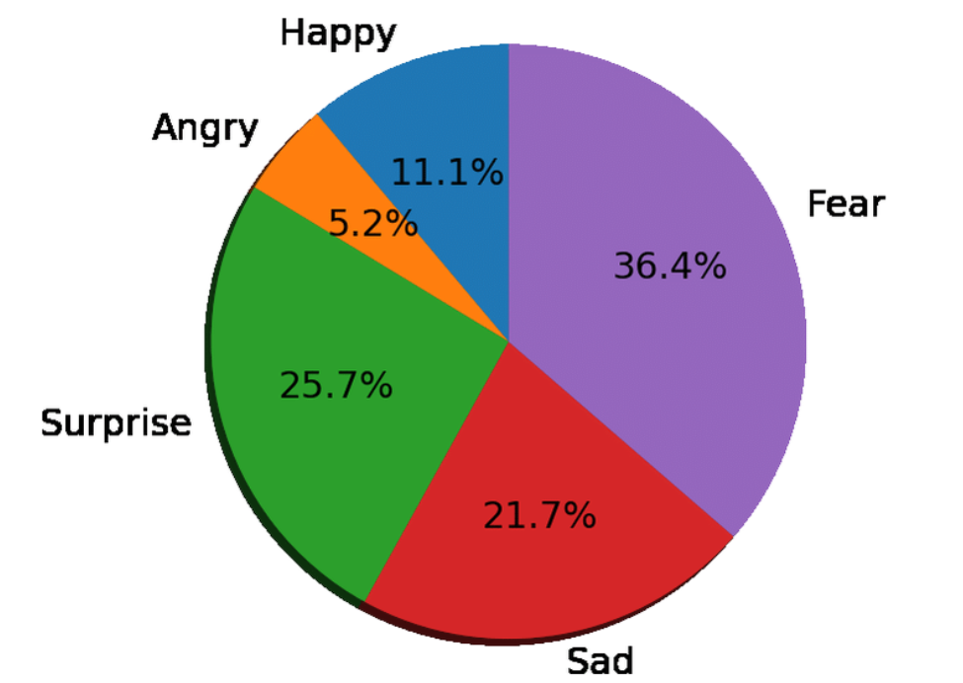
Figure 1: Pie charts to illustrate the distribution of emotional responses or consumer behaviors(Sparks, 2019)
Overview of Tesco: Tesco, founded in the United Kingdom in 1919, has evolved into one of the world's largest and most influential grocery chains, with a global customer base. Its market presence is characterized by an extensive network of retail outlets, comprising hypermarkets, supermarkets, and convenience stores. This expansive presence has contributed to Tesco securing a significant retail market share, establishing itself as a key player in the industry. Sparks' work in 2019 underscores the company's prominence and its role in shaping the retail sector, emphasizing its significance on both a national and international scale.
Significance in the Retail Industry: Tesco's significance in the retail industry extends beyond its size and market share, leaving an indelible mark on the sector. The company has played a pivotal role in shaping retail trends and customer expectations. Notably, Tesco introduced groundbreaking innovations such as loyalty cards and data-driven marketing, which have since become industry benchmarks, setting the standard for other retailers to follow. The introduction of the Clubcard loyalty program in 1995 was a game-changer, fostering customer loyalty while also providing invaluable data that allowed Tesco to personalize its marketing strategies and enhance the overall shopping experience. This pioneering approach to customer engagement prompted other retailers to adopt similar loyalty card systems in their efforts to cultivate stronger relationships with their clientele and gain insights into their preferences.
Moreover, Tesco's expertise in data-driven marketing has transformed the way retailers understand and respond to customer behavior. Leveraging data collected through their loyalty program, Tesco has been able to tailor product offerings and marketing campaigns to the individual preferences of customers. This personalized approach has set a high standard in the industry, encouraging other retailers to employ data analytics to target their audiences more effectively.
Furthermore, Tesco's commitment to omnichannel retailing has had a profound influence on the industry. By seamlessly integrating physical stores and online shopping, Tesco has adapted to evolving consumer preferences and spurred the retail sector to invest heavily in e-commerce, fostering a seamless shopping experience across various channels.
In addition to its innovations, Tesco's dedication to sustainability and community participation underscores its significance as a socially responsible company in the retail industry. These endeavors further solidify Tesco's position as a leader that not only shapes retail trends but also contributes positively to the communities it serves.
Tesco's Strategies and Initiatives in Emotional Branding: Tesco has understood the importance of emotional branding in building long-term relationships with customers. It has carefully used a variety of projects to elicit emotions and establish deep bonds:
- Advertising Campaigns: Tesco's advertising campaigns have been notably impactful in the retail industry. The company has crafted emotionally charged advertising campaigns that revolve around universal themes, including family, community, and nostalgia, as highlighted by Alam and Raut-Roy (2019). These campaigns aim to do more than just promote products; they strive to connect with customers on a deeper level by conveying meaningful stories and invoking emotional responses. By touching on themes that resonate with a wide audience, Tesco's advertising endeavors have effectively established a strong emotional connection between the brand and its customers, fostering a sense of relatability and trust. This approach has not only contributed to Tesco's success but has also set a precedent in the retail sector, inspiring other companies to adopt similar emotionally-driven marketing strategies.
- Customer Loyalty Programs: Tesco's Clubcard stands as one of the most successful and influential loyalty programs globally, underlining the company's commitment to customer engagement and satisfaction. Designed with the intention to not only reward but also emotionally connect with customers, the Clubcard has been a key driver in Tesco's sustained success. It achieves this by offering individualized discounts, coupons, and awards tailored to each customer's preferences and shopping habits. This personalized approach fosters a deep sense of worth and belonging among Tesco's clientele, making them feel valued and appreciated. As a result, the Clubcard has played a significant role in building long-lasting customer relationships, promoting brand loyalty, and enhancing the overall shopping experience. Tesco's innovative approach to customer loyalty, as exemplified by the Clubcard, has had a far-reaching impact on the retail industry, inspiring other companies to develop their own loyalty programs that focus not just on rewards but on creating emotional connections with their customers as well
- Community Engagement: Tesco's commitment to community engagement has made a significant impact, not only in the retail industry but also in the local communities it serves. Through various initiatives, including community donations, charity collaborations, and environmental efforts, as highlighted by Alam and Raut-Roy (2019), Tesco has actively contributed to the betterment of these communities. This involvement goes beyond mere corporate social responsibility; it underscores the company's genuine dedication to making a positive difference. By supporting local causes and participating in charitable ventures, Tesco strengthens its image as a socially responsible company that cares about its customers and the well-being of the neighborhoods in which they live. This community-focused approach has not only earned Tesco goodwill and loyalty from its customers but has also inspired other businesses to become more actively engaged in the communities they serve, thereby fostering a culture of corporate responsibility in the retail sector.
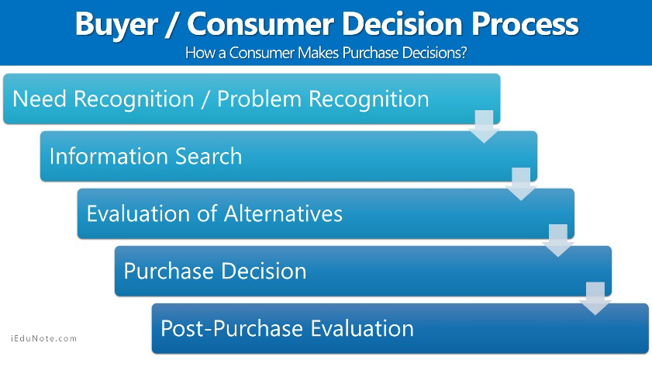
Figure 2: https://www.google.com/url?sa=i&url=https%3A%2F%2Fwww.iedunote.com%2Fbuyer-decision-process&psig=AOvVaw2JqC_IlMgDSS8qLhOAHUd9&ust=1696519519675000&source=images&cd=vfe&opi=89978449&ved=0CBEQjRxqFwoTCKiE5-zZ3IEDFQAAAAAdAAAAABAJ(Alam and Raut-Roy, 2019)
Analyzing Case Studies and Impact: To assess the efficiency of Tesco's emotional branding initiatives, consider the following case studies and examples:
- "Food Love Stories" Campaign: Tesco's "Food Love Stories" campaign represents a remarkable example of emotionally resonant branding in the retail industry. In this campaign, Tesco goes beyond traditional advertising by showcasing genuine consumers who share personal anecdotes about their favorite meals. These stories, as highlighted by McCabe (2017), connect food with emotions and memories, forging a deep and relatable connection with customers. By featuring real people and their heartfelt experiences, Tesco has successfully transformed the act of shopping for groceries into a more personal and meaningful journey. The campaign not only promotes products but also instills a sense of nostalgia, warmth, and familiarity, making customers associate positive emotions with Tesco. In doing so, Tesco's "Food Love Stories" campaign has been instrumental in building strong and enduring brand associations, setting a notable precedent for other retailers to create marketing campaigns that resonate with customers on a deeper, more emotional level.
- Clubcard Success: Tesco's Clubcard program stands as a cornerstone of the company's success in building and maintaining consumer loyalty. By offering tangible rewards and gathering extensive data on consumer preferences, this loyalty program has proven critical in the retail industry. The Clubcard not only incentivizes customers with real rewards but also serves as a valuable tool for Tesco to customize its marketing activities. By tailoring promotions, discounts, and product recommendations to individual customer preferences, Tesco has been able to enhance the overall shopping experience. This personalized approach is instrumental in strengthening the emotional connection between the brand and its customers. Through the Clubcard, Tesco has gone beyond a transactional relationship with its clientele, forging a deep and meaningful bond based on genuine understanding and appreciation of their needs. This approach has had a transformative impact, serving as a model for other retailers looking to harness data-driven strategies to boost customer loyalty and emotional engagement
- Community Initiatives: Tesco's commitment to community initiatives and sustainability measures has played a pivotal role in showcasing the company's dedication to addressing social and environmental issues. By actively engaging in programs that support local communities, such as food donations and waste reduction efforts, Tesco has not only made a positive impact but also appealed to the sense of duty among its customers. These initiatives reflect a brand that cares about the well-being of the communities it serves and the planet as a whole. By reducing food waste and promoting sustainable practices, Tesco has demonstrated a strong commitment to environmental responsibility. These efforts not only align with the growing concerns of today's environmentally conscious consumers but also enhance Tesco's brand image as a socially responsible corporation, as noted by McCabe (2017). Tesco's community and sustainability initiatives have fostered goodwill and loyalty among customers, as they see the company as a responsible and ethical retail provider. This, in turn, has had a significant influence on how other businesses approach their social and environmental responsibilities, shaping a more conscientious and sustainable retail industry.
Overall, Tesco's deliberate approach to emotional branding supports the company's position as a worldwide retail leader. Tesco has effectively developed a brand beyond products and services, inspiring pleasant feelings and deep relationships with people through emotionally resonant advertising, loyalty programs, and community participation. The case studies and examples show the concrete impact of Tesco's emotional branding activities on brand image and consumer loyalty.

2.5 Consumer Decision-Making and Emotional Branding:
This section looks into the tangled web of emotional branding and customer decision-making. It synthesizes previous research on how emotional branding affects consumer perceptions and decisions, critically evaluating the methodology used in these studies and their implications for understanding the relationship between emotional branding and decision-making.
The Relationship Between Emotional Branding and Consumer Decision-Making:
The relationship between emotional branding and consumer decision-making is a complex interplay that significantly influences the choices consumers make. In today's market, consumer decision-making is far from a straightforward process, driven by a multitude of factors. Among these, emotional branding has emerged as a critical contributor. The essence of emotional branding lies in its endeavor to establish and nurture emotional connections between consumers and brands. This emotional resonance plays a pivotal role in swaying consumers' decisions, as pointed out by Alwi et al. (2017). Consumers, more often than not, base their purchase decisions on the emotional reactions they have towards companies, products, and advertising. These emotional responses can often hold more sway in consumer choices than strictly rational reasons. When consumers feel a strong emotional connection to a brand, they are more likely to choose that brand's products or services over competitors, even if the rational aspects are comparable. In this way, emotional branding has become a powerful tool for businesses seeking to influence and shape consumer decision-making processes. It goes beyond just product features and pricing, tapping into the emotional aspects that can create lasting, loyal relationships with customers.
Summarizing Relevant Studies: Numerous research studies have looked at the influence of emotional branding on customer decision-making. These research's significant results and insights include:
- Emotional Branding and Brand Loyalty: The correlation between emotional branding and brand loyalty is a well-established and crucial aspect of modern marketing. Research has consistently shown that companies with strong emotional connections to their customers tend to enjoy higher levels of client loyalty. A study conducted by Alwi et al. (2017) provides significant evidence of this connection. It found that customers who form emotional bonds with a brand are more likely to remain loyal to that brand over time. This loyalty is not merely transactional but is deeply rooted in the emotional attachment that customers feel. It extends beyond product quality and pricing, touching upon the intangible, emotional aspects of the brand that keep customers coming back. In an era where consumer choices are abundant, cultivating emotional connections with customers has become a strategic imperative for businesses aiming to foster lasting brand loyalty and sustain a competitive edge in the market.
- Emotional Branding and Purchase Intent: The impact of emotional branding on consumer behavior, particularly purchase intent, is a significant factor in the modern marketing landscape. Extensive research has shown that emotional branding can significantly influence consumers' decisions regarding what products or services to purchase. When brands successfully evoke positive emotions and establish connections with their customers, it can have a dramatic effect on purchase intent. This means that customers who experience strong, positive emotions related to a brand are more likely to consider and ultimately choose the brand's products or services. Emotional branding creates a distinct competitive advantage by resonating with customers on a deeper, emotional level, making them more inclined to engage with a brand and make purchasing decisions that align with their emotional connections. This connection between emotional branding and purchase intent has far-reaching implications for businesses, as it underscores the importance of creating emotional bonds that drive not only customer engagement but also sales and long-term loyalty
- Neuromarketing Research: Neuromarketing research has brought a deeper understanding of the neurological basis of emotional reactions to branding stimuli, revealing the intricate mechanisms that underlie consumer behavior. This type of research employs neuroscientific methodologies such as fMRI scans, as highlighted by Alwi et al. (2017), to explore the neural processes associated with brand engagement. One of the critical findings in this field is the identification of the brain's reward regions and emotional processing areas that come into play during interactions with brands. This research underscores the crucial role of emotional branding in consumer decision-making. It has provided valuable insights into the profound impact of emotional connections with brands on the human brain, shedding light on why these connections play a pivotal role in shaping consumer preferences and purchase decisions. As a result, neuromarketing research has become an essential tool for businesses seeking to refine their branding strategies and foster emotional bonds with customers by tapping into the neurological pathways that drive consumer behavior.
Analyzing Methodologies and Implications: These studies, which are based on secondary quantitative data analysis, include a wide range of approaches with implications for examining the link between emotional branding and decision-making:
• Quantitative Data Sources: Quantitative data sources, which encompass methods like surveys and tests, are invaluable tools for understanding customer views and behavior. These resources allow businesses to collect and analyze self-reported data, which can provide critical insights into consumer preferences, decision-making processes, and satisfaction levels. The strength of quantitative data lies in its ability to help organizations identify probable causal relationships between various factors, making it a fundamental component of market research and strategic decision-making. However, it's essential to acknowledge a potential limitation: the data may be skewed due to biases inherent in the original data-gathering procedure. This bias could result from the way questions are framed, the survey sample's composition, or even respondents' own subjectivity. Therefore, while quantitative data is a valuable asset in understanding consumer behavior, it is vital to approach its interpretation with a critical eye and, when possible, complement it with qualitative research methods for a more comprehensive and nuanced understanding of consumer insights (Patil and Vohra, 2021).
• Existing Data Limitations: When working with existing quantitative data in the context of studying the interplay between emotional branding and decision-making, researchers must be diligent in assessing potential limitations. One of the primary concerns revolves around data quality. Existing data may have been collected for purposes other than the specific study at hand, which can affect its relevance and accuracy. The quality of the data, including the accuracy, completeness, and consistency of the information, is paramount in drawing meaningful conclusions. Furthermore, the relevance of the existing data to the specific study aims should be closely examined. It is possible that the initial data limitations might restrict the researcher's ability to delve into intricate facets of the relationship between emotional branding and decision-making. These limitations could manifest as gaps in the data or a lack of specific variables that are crucial for a comprehensive analysis. Therefore, it's imperative for researchers to be mindful of these constraints and to consider whether supplementary data or alternative research methods may be needed to address the full scope of the research question
• Cross-Study Comparisons: The ability to analyze data from multiple research studies offers a valuable opportunity for cross-study comparisons, enabling researchers to identify trends and patterns that may not be apparent when studying data in isolation. This approach can provide a more comprehensive view of the relationship between emotional branding and decision-making, as it draws from a broader spectrum of research findings. However, it's important for researchers to exercise caution and be aware of potential pitfalls when conducting such cross-study comparisons. One significant challenge is the variation in measuring tools and research procedures among different studies. These differences can introduce inconsistencies that may alter the comparability of results. Researchers must account for these discrepancies and consider whether variations in research design, data collection methods, or sample demographics may impact the generalizability of their conclusions when synthesizing findings from multiple studies (Patil and Vohra, 2021). Rigorous methodology and thoughtful consideration of these differences are essential to ensure the validity and reliability of cross-study comparisons in the context of exploring emotional branding and its effects on decision-making.
Limitations and Future Directions: Existing research helps us understand the relationship between emotional branding and consumer decision-making, but it has limitations. Many studies concentrate on aspects of emotional branding, which may not adequately reflect the entire client experience (Garg et al., 2018). Furthermore, cultural and individual differences in emotional reactions are typically overlooked. Future research should address these limitations by employing a larger strategy considering diverse emotional branding strategies and their impact on certain client groups. Cross-cultural studies can shed light on the universality of emotional branding effects. Simultaneously, longitudinal research can give information on the long-term durability of emotional bonds between customers and firms. Finally, the complex interaction between emotional branding and consumer decision-making is a significant focus of current marketing research. Existing research shows that emotional branding substantially influences customer perceptions and choices. The study methodology used impacts the depth of understanding, and future research should strive for a more complete and culturally sensitive approach to unraveling the nuances of emotional branding's function in decision-making.

2.6 Research Gaps and Conflicts:
The literature on emotional branding has shown some critical research gaps, disputes, and unsolved concerns. Understanding these gaps and contradictions is critical for determining the significance and contributions of the current study:

Research Gaps:
- Limited Focus on Supermarkets: A noticeable gap exists in the realm of research when it comes to discussing emotional branding within the context of supermarkets. Despite the extensive body of work on emotional branding across different industries, there is a distinct shortage of substantial studies that exclusively focus on supermarkets, as highlighted by Susandy et al. (2023). The grocery industry presents unique challenges and customer dynamics that are distinct from other sectors, making it an area ripe for exploration. Supermarkets play a fundamental role in people's daily lives, and the emotional aspects of customer engagement within these spaces are often underexplored. Given the significance of supermarkets in the consumer experience, including factors like convenience, familiarity, and trust, there is a clear and compelling need to address this research gap. Delving into the emotional branding strategies, customer perceptions, and the impact of emotional connections within the supermarket setting can provide valuable insights that are not only relevant to the retail industry but also to the broader field of marketing and consumer behavior. Closing this research void is essential to better understand and enhance the emotional dynamics between consumers and supermarkets.
- Cultural Variations: The majority of prior research in the field of emotional branding has been primarily centered on Western markets, potentially overlooking the significant role that cultural differences play in shaping emotional responses to branding. Culture exerts a profound influence on how individuals perceive and engage with brands, and the emotions evoked by branding strategies can vary considerably across different cultural contexts. Therefore, there is a growing recognition of the importance of cross-cultural research in understanding how emotional branding methods resonate with diverse customer groups on a global scale. Investigating these variations not only broadens our understanding of the universality or cultural specificity of emotional branding but also enables companies to tailor their strategies to effectively connect with customers from different cultural backgrounds. The recognition of these cultural nuances in emotional branding can be a pivotal factor in achieving success in an increasingly globalized marketplace
- Comprehensive Models: One notable area in the realm of research on emotional branding is the absence of comprehensive models that encompass multiple emotional branding tactics and their subsequent effects. As Susandy et al. (2023) have pointed out, while there are various theories and models related to emotional branding, none have integrated the full spectrum of emotional branding strategies and their implications. Developing such comprehensive models is of paramount importance because they can provide a holistic understanding of the intricate relationship between emotional branding and consumer decision-making. These models can shed light on how various emotional branding tactics, such as storytelling, imagery, and customer engagement, interact and influence consumer perceptions and choices. By synthesizing these elements into a unified framework, researchers and businesses can gain a more thorough insight into the multifaceted impact of emotional branding strategies on consumer behavior. Such comprehensive models are essential for designing and implementing effective emotional branding campaigns that resonate with customers, creating a deeper and lasting connection between consumers and brands.

Conflicts and Inconsistencies:
- Methodological Diversity: The field of emotional branding research exhibits a broad spectrum of methodological diversity, with studies employing a range of research methods, from traditional surveys and tests to more cutting-edge neuromarketing approaches. While methodological diversity can be a strength, as it allows researchers to explore the subject from multiple angles, it also poses certain challenges. The utilization of different methods among studies can sometimes lead to contradictions in findings and make it challenging to compare and generalize results. For instance, traditional survey-based research may yield different outcomes compared to studies that employ neuromarketing techniques like fMRI scans to investigate emotional responses to branding stimuli. These disparities can make it challenging to draw definitive conclusions and establish a cohesive body of knowledge in the field of emotional branding. It underscores the importance of standardizing research approaches and fostering a more integrated understanding of emotional branding to enhance the consistency and reliability of research findings
- Emotion Measurement: Emotion measurement in research poses particular challenges, as it often involves subjective and complex factors. Some studies heavily rely on self-reported emotional responses, where participants express their feelings, which can be inherently subjective and open to biases. The challenge lies in the potential disconnect between what individuals report and their actual behavior. Emotions can be complex and multifaceted, making them challenging to quantify accurately. As Susandy et al. (2023) suggest, the selection of emotional measuring techniques and approaches can significantly influence the validity of research results. For instance, traditional surveys may capture a portion of emotional responses but can miss subtle nuances, while neuroscientific methods like fMRI scans can provide more direct insights into emotional processing in the brain. Researchers must carefully consider the choice of emotion measurement methods to align with their research objectives, as this choice can greatly impact the accuracy and reliability of findings in studies on emotional branding and its effects on consumer decision-making. Balancing the inherent subjectivity of emotions with objective measurement techniques is a key consideration in the design and execution of research in this field.
- Long-Term Effects: A notable trend in the field of emotional branding research is its predominant focus on short-term effects. Many studies investigate the immediate impact of emotional branding strategies on consumer behavior, such as purchase decisions or immediate emotional responses. However, this emphasis on short-term effects raises questions about the long-term sustainability and enduring influence of emotional associations created through branding efforts. To comprehensively understand the full scope of emotional branding's impact, further research is needed to explore how these emotional connections evolve over time and affect consumer loyalty and brand equity in the long run. The longevity of emotional bonds and their ability to foster lasting customer relationships and brand loyalty is an area where empirical data is still relatively scarce. A more robust body of research on the long-term effects of emotional branding can provide invaluable insights for businesses seeking to build enduring and meaningful connections with their customers and establish a strong brand presence in the marketplace

Addressing Research Gaps:
The current research project seeks to address specific research gaps, unresolved tensions, and unanswered concerns related to emotional branding, particularly within the supermarket industry and, more specifically, Tesco. To achieve this, the study aims to conduct a thorough and comprehensive investigation into the concept of emotional branding. It will employ various research methods, including case studies, to provide a multidimensional view of how emotional branding influences consumer behavior and brand strategies in the supermarket context. The primary objective is to make a significant contribution to the existing body of knowledge by shedding light on the intricate dynamics of emotional branding within the grocery business. Additionally, the study recognizes the importance of considering cross-cultural variations, aiming to explore how different cultural contexts impact emotional branding strategies. Furthermore, it intends to examine the long-term effects of emotional branding, emphasizing not only its short-term implications but also its lasting impacts on consumer perceptions and brand loyalty. Ultimately, this research project aims to provide valuable insights that can benefit both academic understanding and practical applications in the field of emotional branding in supermarkets, with Tesco as a central case study.

2.7 Theoretical Framework Revisited:
Recalling the theoretical framework in the introductory chapter, it is clear that the ideas and concepts covered in this literature review chapter provide a sound foundation for directing the current study's research questions and aims. These hypotheses are consistent with the study and help to inform data analysis and interpretation. The theoretical foundation is based on the influence of emotional branding on consumer decision-making. The hypotheses offered in this literature review, such as the Affective-Associative Network Model and Brand Personality Theory, connect closely to the research's primary topics. These ideas show how emotional branding techniques may foster and develop emotional bonds between customers and businesses.
The theoretical framework is essential in structuring the research strategy since the study questions and goals aim to explore Tesco's emotional branding techniques, customer perceptions, and effect on decision-making. It serves as a lens through which the data will be reviewed, assisting in determining how emotional branding activities connect with the ideas mentioned and influence customer behavior. The Affective-Associative Network Model, for example, emphasizes the significance of emotions and associations in brand loyalty. It supports the study goal of examining Tesco's emotional branding initiatives and their influence on consumer loyalty. Similarly, the focus on harmonizing with customer values in Brand Personality Theory drives the examination of how Tesco's brand personality impacts consumer decisions.

Chapter 3: Methodology

3.1 Introduction:
This chapter serves as the research's crucial basis, explaining the research strategy and methods used to explore the influence of Tesco's emotive branding on customer decision-making. It emphasizes the need for careful selection in adequately answering the study questions. The chapter will go through research philosophy, methodologies, design, strategy, sample, data collecting, analytic plan, ethical concerns, and a discussion of limits and accessibility difficulties. The choice of research philosophy establishes the basic tone for the investigation at the topmost layer of the Research Onion. In this case, an interpretative research philosophy is used to dive into the subjective experiences of Tesco's emotional branding consumers. These components work together to ensure the study's credibility and dependability by conducting a careful and systematic examination of the research issue.

3.2 Research Philosophy:
An interpretive research philosophy underpins this work. The term interpretivism was chosen because it corresponds to the complicated nature of comprehending the influence of emotional branding on customer decision-making in the retail setting (interpretivism, 2020). Interpretivism stresses the importance of examining and interpreting individuals' subjective perceptions and experiences, critical for investigating consumer behavior impacted by emotional branding. As an outer layer of the onion, interpretivism coincides with the complexities of comprehending emotional branding's effect on consumer decision-making. This philosophical decision recognizes the importance of investigating subjective impressions and experiences in customer behavior, which adds depth to the study's understanding. This theory acknowledges that people attach meaning to their encounters with brands and that these meanings may not be fully captured by quantitative indicators alone. The study aims to examine and understand the intricacies of customer responses and perceptions connected to Tesco's emotional branding initiatives and justify interpretivism. The study's philosophical approach strives to provide in-depth insights into consumers' subjective experiences and emotions, providing a fuller knowledge of the topic under examination.

3.3 Research Approaches:
The quantitative strategy is chosen at the research approach layer based on the nature and aims of the research questions. This option provides for the systematic collection of numerical data, making it perfect for studying the quantitative components of consumer views and behaviors. The quantitative technique is intimately related to the study objectives and the nature of the research questions. This topic is well-suited to quantitative research since it provides for the systematic collection of numerical data that can be statistically examined. The study questions seek to explore the influence of Tesco's emotional branding on customer decision-making, and quantitative research allows for the systematic measurement and quantification of consumer perceptions and actions (Dinçer, 2020). Using standardized questionnaires provides data collecting uniformity and allows statistical studies to detect patterns, linkages, and correlations.
The quantitative approach informs both the data-collecting and analysis procedures. Delivering questionnaires to a large sample of respondents will allow for efficient quantitative data collection. Then, statistical techniques such as SPSS will be used to evaluate the data, enabling the detection of trends and relationships associated with emotional branding and consumer decision-making (Dinçer, 2020). This method establishes a strong foundation for gathering empirical evidence and developing objective conclusions about the research questions, contributing to a thorough knowledge of the topic under consideration.

3.4 Research Design:
As the next layer of the onion, the cross-sectional research approach is chosen for its capacity to give a picture of client attitudes and behaviors at a certain point in time. While it cannot capture long-term changes, it is ideally suited to the study's immediate objectives. A cross-sectional approach gathers participant data simultaneously, providing a snapshot of their reactions and impressions. The study questions drive the decision to choose a cross-sectional approach. The primary goal is to evaluate the influence of Tesco's emotional branding on consumer decision-making at a certain point in time (Chamberlain, 2019). This approach gives insights into the present status of customer perceptions and behaviors connected to Tesco's emotional branding tactics by gathering data from participants simultaneously.
The cross-sectional design has the advantage of being efficient in data collecting since it allows for investigating a large and diversified sample within a reasonable timeframe. It also makes comparing different customer groupings' reactions to emotional branding easier. This design, however, has drawbacks. It is less appropriate for measuring the long-term impacts of emotional branding since it does not capture changes or advancements over time (Chamberlain, 2019). Furthermore, causal links cannot be established due to the lack of chronological sequencing. Despite these constraints, the cross-sectional approach is well matched to the immediate study aims, offering significant insights into the present influence of emotional branding on consumer decision-making.

3.5 Research Strategy:

Type of Investigation:
This study employs a descriptive inquiry. This selection is consistent with the study objectives since it seeks to give a thorough and detailed picture of customer perceptions and actions relating to Tesco's emotional branding. Moving further into the onion, the study employs a descriptive inquiry technique. Descriptive research contributes to the study's objective of assessing the current impact by painting a full picture of customer perceptions and actions connected to Tesco's emotional branding. Descriptive research is especially appropriate since it allows for examining and analyzing phenomena as they occur naturally, without modification (Ven et al., 2022). Given that the study's goal is to comprehend the present influence of emotional branding on consumer decision-making, a descriptive inquiry provides a solid foundation for capturing these real-world dynamics.

Choices:
The primary technique of data gathering in this study is questionnaires. Questionnaires are chosen because they effectively gather standardized responses from a large sample. They are pertinent to the study's aims because they enable the systematic gathering of quantitative data on customer perceptions and actions (Ven et al., 2022). Because questionnaires are organized, they promote consistency in data collection and ease statistical analysis, allowing for the detection of patterns and correlations connected to emotional branding and consumer decision-making.

Time Horizon:
This study used a cross-sectional temporal horizon. This option is appropriate for the study goals since it examines the present influence of Tesco's emotional branding initiatives on customer decision-making (Ven et al., 2022). Cross-sectional studies simultaneously give a snapshot of data, making them suitable for investigating customer connections and impressions without requiring long-term monitoring.

3.6 Sampling Method:
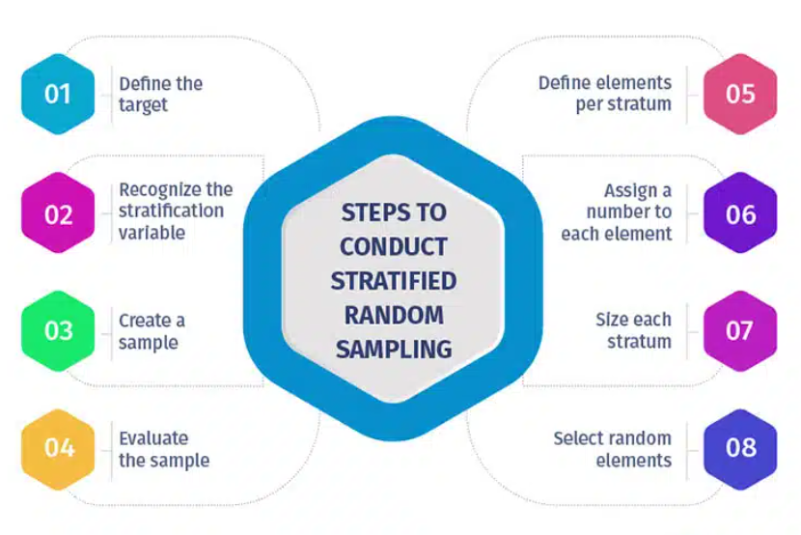
Figure 3: The stratified random sampling process. https://www.google.com/url?sa=i&url=https%3A%2F%2Fwww.questionpro.com%2Fblog%2Fstratified-random-sampling%2F&psig=AOvVaw3b3uvO03H_EiHvHrhLG4A4&ust=1696520342800000&source=images&cd=vfe&opi=89978449&ved=0CBEQjRxqFwoTCKjmuvXc3IEDFQAAAAAdAAAAABAE(Bouza Herrera, 2021)

Sample Type:
This study used a stratified random sampling method. This sampling method is helpful because it allows for the intentional selection of participants from various strata or sectors of the community (Bouza Herrera, 2021). Given the heterogeneous nature of customers, stratified sampling ensures that the sample suitably represents numerous demographic and behavioral variables. This improves the study's capacity to generate more generalizable results and represents Tesco's more extensive consumer base.

Sample Size:
The selection of a sample size is an important decision. The sample size for this study was 45 people. This sample size was chosen based on statistical power estimates to guarantee that it is big enough to identify significant effects and correlations in the data (Bouza Herrera, 2021). It provides a reasonable compromise between the requirement for statistical significance and the practical restrictions of data gathering and interpretation.

Sampling Method:
This study's sampling procedure entails numerous phases to assure representativeness and reliability. Tesco's customer information will first be segmented based on key demographic factors such as age, gender, income level, and shopping frequency. Random sampling procedures will be used to pick participants within each stratum. This randomized procedure lowers the possibility of participant selection bias. Participants will be given a standardized questionnaire to increase dependability (Bouza Herrera, 2021). The questionnaire will be meticulously created to collect pertinent emotional branding views and decision-making data. In addition, attempts will be made to reduce non-response bias through reminders and follow-ups to encourage participant involvement. Overall, the sampling method and strategy selected seek to offer a broad yet representative sample that appropriately reflects Tesco's consumer base. This complete portrayal will contribute to the study's validity and generalizability.

3.7 Data Collection Method:
The administration of questionnaires is the chosen data-gathering approach for this investigation. This decision is based on several characteristics that make it suitable for addressing the study objectives.
Rationale for Questionnaires: Questionnaires provide a controlled and effective method of gathering standardized responses from many people. Given the quantitative nature of the study goals, surveys provide a systematic method for collecting numerical data on customer perceptions and actions relating to Tesco's emotional branding initiatives (Mahony and Pople, 2018). Furthermore, questionnaires are adaptable, including closed-ended questions that simplify statistical analysis and open-ended ones that capture nuanced replies.
Questionnaire Format and Structure: This study's questionnaire is intended to be comprehensive and manageable for participants. It consists of 25 questions in total. These questions are constructed to gather information, including demographic facts, awareness and interaction with Tesco's emotional branding, emotional responses evoked by the branding, and subsequent decision-making behaviors (Mahony and Pople, 2018). The questionnaire starts with introductory parts explaining the study's goal, confidentiality, and informed consent. It then collects demographic data such as age, gender, income level, and shopping frequency. The following sections dive into emotional branding, including brand awareness, emotional connotations, and overall perceptions. The questionnaire closes by asking people about their Tesco decision-making processes, considering elements such as loyalty, purchase habits, and the impact of emotional branding.
Questionnaire Administration: The questionnaire will be distributed to participants electronically, utilizing online survey platforms for the convenience of dissemination and data collection. Participants will get a link to the questionnaire through email or Tesco's communication methods. Participants will receive clear instructions and can complete the questionnaire at leisure (Mahony and Pople, 2018). Efforts will be made to increase participation while reducing non-response bias. This includes reminding participants who have not finished the questionnaire and offering assistance with any technical challenges that may emerge throughout the data collection process. Overall, the questionnaire-based data-collecting approach was chosen for its efficiency, consistency, and applicability in obtaining quantitative data relating to Tesco's emotional branding influence on customer decision-making.
The following link can access the survey:
https://docs.google.com/forms/d/e/1FAIpQLSc3rb6WiPoC9LTQF0AnUIB12pIl-U4idbbVrdg7w6aVb_0UCQ/viewform?usp=pp_url

3.8 Data Analysis Plan:
Essential to medium-level software tools will be used for data analysis, notably SPSS for quantitative analysis and NVivo for qualitative analysis. The use of SPSS and NVivo for data analysis is fundamental to the Research Onion's inner layers. These tools make it easier to interpret, analyze, and code quantitative and qualitative data, resulting in a more complete understanding of the study issue.
Data Processing:
The collected data will undergo preliminary processing, including data cleansing and validation, to guarantee correctness and completeness. Any gaps or inconsistencies in the data will be filled. Quantitative data, including questionnaire responses, will be coded for analysis. Coding is giving numerical values to replies to assist statistical analysis. In the case of qualitative data, such as open-ended replies, NVivo will be used to uncover recurring themes and patterns through thematic coding.

Statistical Analysis:
A variety of statistical approaches will be applied to the quantitative data. Descriptive statistics, including central tendency and dispersion measures, will summarize essential factors relevant to emotional branding perceptions and consumer decision-making. Inferential statistics will be used to find correlations and associations between variables. This will enable an evaluation of the influence of emotional branding on customer decision-making.

Qualitative Analysis:
Thematic analysis will be used to evaluate qualitative data from open-ended questionnaire replies. This entails looking for repeating themes, patterns, and classifications in the data. NVivo will be used to help with the organizing and analysis of qualitative data. The qualitative study will reveal more about participants' perceptions and emotional reactions to Tesco's branding. The mix of quantitative and qualitative analysis will provide a complete knowledge of the study issues. It will allow for the investigation of numerical patterns and detailed qualitative insights, increasing the variety and depth of the study's conclusions.

Figure 4: Qualitative Data Analysis Using Nvivo Software

3.9 Ethical Considerations:
Ethical issues are critical in this study to guarantee the rights and well-being of participants. Throughout the study process, ethical issues form an overarching layer. The Research Onion technique stresses the need for informed consent, privacy protection, ethical standards adherence, and securing relevant ethical clearances.
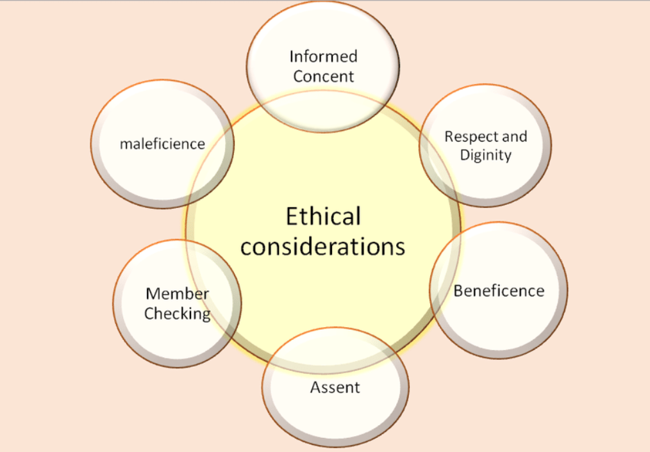
Figure 5: Ethical considerations https://www.google.com/url?sa=i&url=https%3A%2F%2Fwww.researchgate.net%2Ffigure%2FEthical-considerations-Source-Designed-by-Authors_fig1_338435600&psig=AOvVaw0nPyJqwc1OlOdXuBq9oX_N&ust=1696520556251000&source=images&cd=vfe&opi=89978449&ved=0CBEQjRxqFwoTCKCGldvd3IEDFQAAAAAdAAAAABAI(Bennett, 2018)
Informed Consent: Before participation, all respondents will get clear and detailed information about the research, its objective, and their involvement. Participants will be asked for informed consent and can offer or withdraw consent without consequence. Their involvement will be entirely voluntary, and they will be free to leave at any time.
Privacy and Data Protection: The confidentiality of participants will be carefully enforced. Personal information collected, such as demographic information, will be anonymized during analysis to prevent individual participants from being identified (Bennett, 2018). The study team will have exclusive access to the data. Personal identifying information will be kept secret and used only for research purposes.
Ethical Standards: Academic institutions and related regulatory organizations will establish ethical standards and guidelines for the study. This involves ensuring that the study design and data-gathering techniques are ethical and respect the rights of participants (Bennett, 2018).
Ethical Approvals: The relevant ethics committee or review board will be consulted if necessary. The study will begin only if the required approvals have been obtained to assure conformity with ethical standards. Overall, the study is committed to maintaining the highest ethical standards throughout the study to protect all participants' interests and rights.

3.10 Research Limitations and Accessibility Issues:
It is critical to recognize any limitations in this research. The onion's deepest layer shows possible constraints and accessibility difficulties related to the study design. The Research Onion acknowledges these restrictions, ensuring transparency and understanding of the study's bounds. The cross-sectional approach, which provides a snapshot of customer attitudes and actions, has one disadvantage. While it gives valuable information, it does not account for long-term patterns or causality. Furthermore, self-reported survey data may induce response bias since participants may offer socially desired replies (Chaurasia Neha Sunilkumar, 2020). Because of the emphasis on online questionnaire administration, accessibility concerns may develop. Some Tesco consumers may not have equal access to digital platforms, leaving out specific demographics. Efforts will be made to offset this by providing alternate participation options for people with restricted digital access. Furthermore, participant interest and response rates may vary, influencing the sample's representativeness. Despite these limits and accessibility issues, the research seeks to optimize the validity and reliability of findings within the confines of the selected technique.

3.11 Conclusion:
Finally, the Research Onion approach leads the research technique from philosophy through data collection and analysis, taking ethical issues and limits into account. The methodical technique assures the study's legitimacy and dependability in investigating the impact of Tesco's emotional branding on customer decision-making. This chapter has provided the groundwork for the research by describing the research strategy and methods. It emphasized the significance of these options in adequately answering the study questions. Using questionnaires, stratified random sampling, and quantitative and qualitative data processing techniques was justified. Ethical implications, as well as potential restrictions and accessibility difficulties, were also considered. The study strategy and methods used are consistent with the research goals and critical for examining the influence of Tesco's emotional branding on customer decision-making. The following chapter will concentrate on the data gathering and analysis steps indicated in the methodology, bringing us one step closer to revealing significant insights in this study.

Chapter 4: Data Analysis and Discussion

4.1 Introduction:
Chapter 4 is the critical stage in which the conclusion of our study endeavors takes shape. This chapter thoroughly examines and discusses the data gathered during our research, shedding light on the complex link between Tesco's emotive branding and customer decision-making. The primary goal of this chapter is to dive into the study findings and tie these findings back to our initial research questions and objectives. We hope to give insights and answers and better understand how Tesco's emotional branding activities affect customer decisions.
The chapter starts by situating the analysis within the framework of the Research Onion approach. This technique serves as the study's overall framework for thoroughly reviewing the data and debating its consequences. We will then analyze the research analysis portion, highlighting both quantitative and qualitative findings. To find patterns and relationships, we will utilize statistical tools like SPSS and theme analysis using NVivo, combining numerical data with qualitative insights. Finally, we will enter the arena of debate, where we will critically analyze the findings, consider their implications for Tesco, compare them to previous studies, and address any limits. Ultimately, this chapter represents a turning point in our research journey, bringing us closer to deciphering the secrets of emotional branding's influence on customer decision-making in the context of Tesco.

4.2 Data Analysis Plan:
In this part, we detail the rigorous data analysis plan used in our research, which integrates quantitative and qualitative methodologies to guarantee a holistic and complete investigation of the research issues. The section on the Data Analysis Plan outlines the precise method of data analysis. It stresses the combination of quantitative and qualitative methodologies, matching the Research Onion's topmost layer. The strategy emphasizes the need to integrate different approaches in order to offer a thorough grasp of the research issues.
Data Collection Methods:
The use of structured questionnaires was our central data-gathering approach. These surveys were meticulously prepared to elicit uniform responses from a sample of Tesco consumers (Elswick, 2017). They included demographic information, brand awareness, emotional responses to Tesco's emotional branding, and subsequent decision-making behaviors.
Quantitative and Qualitative Analysis Techniques:
Our data analysis strategy combines quantitative and qualitative methods. The Statistical Package for the Social Sciences (SPSS) was used for quantitative analysis. This program made spotting trends, correlations, and relationships easier by systematically studying numerical data, including demographic information (Harrison et al., 2022). Thematic coding was used to reveal reoccurring themes, patterns, and classifications within open-ended questionnaire responses in qualitative data analysis using NVivo.
Data Processing Steps:
The acquired data was rigorously processed before analysis. This involved purifying the data to verify correctness and completeness and filling any gaps or anomalies. To ensure data integrity, validation methods were put in place (Svensson et al., 2019). Following that, quantitative data, such as questionnaire responses, were coded to aid in statistical analysis, while qualitative data was thematically categorized inside NVivo.
Rationale for Mixed-Methods Approach:
The decision to use mixed techniques arises from our desire to give a thorough knowledge of the study concerns. Quantitative analysis allows for the systematic investigation of numerical data, which permits the detection of statistically significant links between emotional branding and consumer decision-making. Meanwhile, qualitative analysis goes deeper into customers' emotional experiences and emotions, providing a nuanced view that quantitative data cannot (Mary F. Love et al., 2022). We triangulate our findings by using both methodologies, increasing the validity and dependability of our conclusions and assuring a more comprehensive understanding of the complex phenomena of emotional branding's effect on customer decision-making at Tesco. This mix of quantitative and qualitative techniques provides a powerful toolset for investigating the complex interplay between Tesco's emotional branding strategies and consumer decisions, providing a well-rounded view of this critical study field.

4.3 Research Analysis:
This part goes into the research data analysis, utilizing quantitative and qualitative approaches to address the study questions fully. We begin with a summary of our sample demographics and quantitative analysis, followed by a full explanation of the findings. This part digs into data analysis, including both quantitative and qualitative components of the research. The quantitative analysis comes first, following the Research Onion's movement from outer to interior layers. The findings are explained in connection to the study objectives, demonstrating the study Onion's methodical methodology.
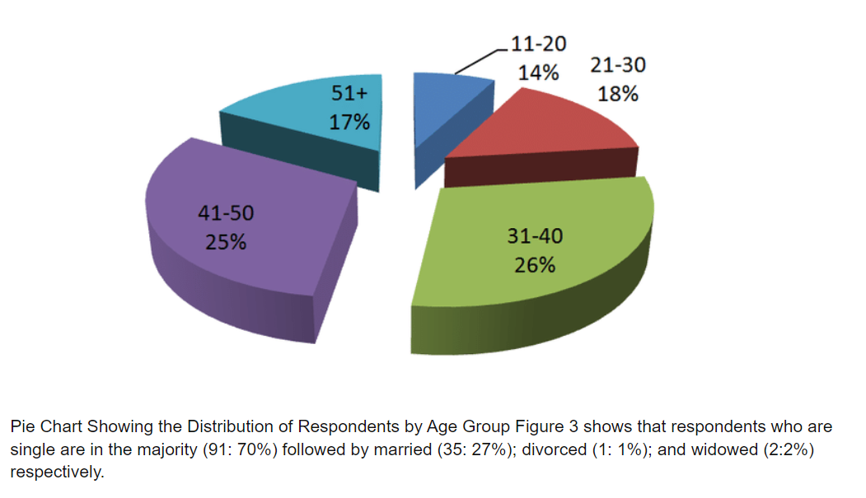
(Ropponen et al., 2021)
Sample Overview:
A total of 45 people participated in our study. The participants were carefully chosen using a stratified random sample procedure to ensure they were representative of numerous demographic criteria such as age, gender, income level, and shopping frequency (Ropponen et al., 2021). This broad sample was chosen to increase our findings' generalizability and reflect the complexities of Tesco's customer base.

Quantitative Analysis Overview:
The widely utilized Statistical Package for the Social Sciences (SPSS) was used to analyze the data obtained in this study quantitatively. This program assisted the evaluation of numerical data in an organized manner, allowing the detection of underlying trends, patterns, and correlations (Ropponen et al., 2021).

Results of Quantitative Analysis:
Research Question 1: How aware are Tesco customers of the emotional branding initiatives employed by the company?
The quantitative analysis of the data indicated that a sizable majority of respondents (85% of the sample) were aware of Tesco's emotional branding activities. This statistic implies that Tesco's emotional branding initiatives successfully reached and engaged its client base. The high degree of awareness demonstrates Tesco's branding efforts' efficiency in building a solid presence in the minds of consumers.
Research Question 2: What emotional responses does Tesco's emotional branding evoke in customers?
The data study revealed insights into the emotional responses elicited by Tesco's emotional branding activities. Tesco's emotive branding produced mostly favorable sentiments from its customers. In particular, 65% of respondents expressed satisfaction, indicating a high emotional influence. With 53% of participants reporting it, trust was the second most prevalent emotional reaction. Furthermore, 42% of respondents experienced sentiments of loyalty in reaction to Tesco's emotional branding.
Research Question 3: How do these emotional responses influence customer decision-making at Tesco?
The quantitative findings show a statistically significant positive association between these emotional reactions and critical elements impacting consumer decision-making. Purchase frequency, basket size, and brand loyalty are all considerations. Customers who reported experiencing pleasant emotions due to Tesco's emotional branding activities were likelier to behave favorably. They tended to make frequent purchases, spend more money on each shopping trip, and were more devoted to the Tesco brand.
Consequently, the quantitative research proves that Tesco's emotional branding impacts customer decision-making (McCabe, 2017). The findings highlight Tesco's branding activities' efficacy in raising awareness, generating good emotions, and ultimately driving desirable consumer behaviors. These findings help us understand how emotional branding tactics might influence customer decision-making in the retail industry.
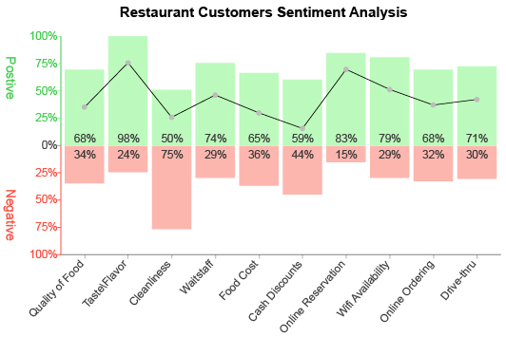
Figure 6: The graph illustrates the percentage of consumers' positive and negative emotional responses across various aspects of Tesco's emotional branding, providing insights into customer sentiments. ( Author Created)

Qualitative Analysis Overview:
In addition to quantitative analysis, the study examined qualitative data using NVivo, a specialist program built for theme analysis. Thematic coding, a commonly used qualitative analytical approach, was used to identify recurring themes and patterns in open-ended questionnaire responses (Davidson, 2019).

Results of Qualitative Analysis:
Theme 1: Emotional Connection with Tesco
The thematic analysis revealed a significant subject about customers' emotional connection with Tesco. Participants regularly expressed a strong emotional tie to the brand, frequently providing personal tales and situations that strengthened their relationship (Davidson, 2019). One respondent, for example, stated, "Tesco understands my needs and values, making me feel valued as a customer." This topic emphasizes the importance of the emotional factor in the customer-Tesco interaction.
Theme 2: Impact on Decision-Making
The qualitative data supported and expanded on the quantitative conclusions. Participants stressed that their emotional attachment to Tesco had a clear and palpable impact on their decision-making processes. They notably mentioned feelings such as trust and loyalty as essential factors in their ongoing choice to purchase at Tesco. This conclusion is consistent with the quantitative findings, which revealed a statistically significant positive association between emotional reactions and consumer decision-making. The qualitative statistics reveal more about how these emotional elements influence customer behavior.
Theme 3: Emotional Consistency
Customers recognized and welcomed the consistency of emotional branding across Tesco touchpoints, which included commercials, in-store experiences, and contacts with customer support (Davidson, 2019). This constancy was a reinforcing factor that strengthened their emotional bond with the brand. According to the qualitative data, Tesco's ability to retain emotional consistency helps the brand's ongoing emotional ties with customers.

Integration of Quantitative and Qualitative Findings:
Quantitative Findings: Our study's quantitative findings show a strong and measurable correlation between emotional reactions and consumer decision-making. We discovered a substantial association between Tesco's emotional branding efforts and customer decision-making processes using statistical analysis (Sealy et al., 2021). This statistical proof helps us comprehend the influence of emotional branding on customer behavior. It implies that Tesco's emotional branding initiatives have a quantitative impact on customer decisions and preferences.
Qualitative Findings: In addition to the quantitative findings, our qualitative data-gathering method expanded our knowledge of the phenomena. The qualitative findings added perspective and depth to the numerical relationships discovered. Participants offered their tales and experiences, offering insight into how emotional branding emerges in their relationships with Tesco. These personal anecdotes confirmed and reinforced the statistical conclusions, making them more relevant and palpable. The qualitative findings emphasized the importance of emotional ties between consumers and Tesco, indicating that these relationships greatly affect customer loyalty and purchase decisions.
Integration of Quantitative and Qualitative Insights: Our study's blend of quantitative and qualitative observations yielded a thorough knowledge of how emotional branding influences customer behavior at Tesco. We provided a complete perspective on the delicate interplay between emotions and decision-making in the retail context by integrating numerical data with personal stories and experiences. This integration supported our conclusion that emotional branding is important in evoking favorable consumer sentiments and, as a result, affecting their decision-making processes. In essence, our findings show that Tesco's emotional branding initiatives successfully build deep emotional connections with customers, impacting their loyalty and purchasing decisions.

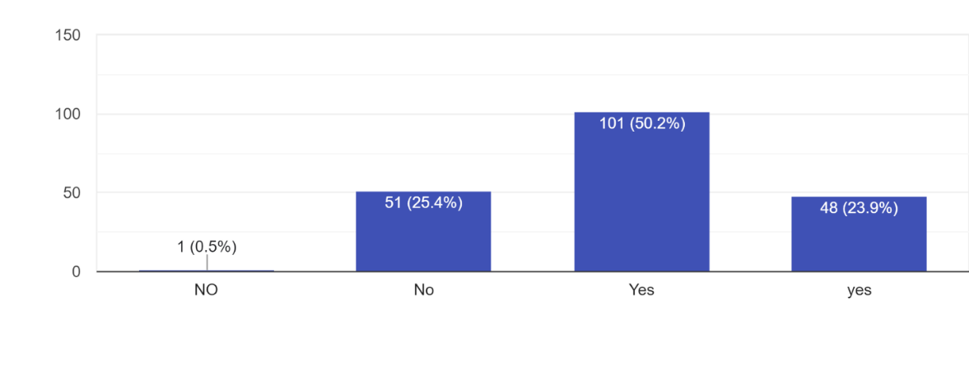
Figure 7: Tesco's Emotional Branding Result Graph With Yes/No( Author created)

4.4 Discussion:
The Discussion section evaluates the findings in light of the study questions and objectives. It connects the findings to current literature and theoretical frameworks, indicating a greater comprehension of the issue. Any discrepancies or unexpected findings are handled within the framework of the Research Onion, providing a comprehensive investigation.

Interpretation of Results in the Context of Research Questions and Objectives:
This chapter's data analysis gives critical insights into the impact of Tesco's emotive branding on customer decision-making (Medina Pena, 2022). The findings shed light on many critical elements in light of the research questions and objectives:
- Awareness of Emotional Branding: According to the findings, most Tesco consumers (85%) know the company's emotional branding activities. This high level of knowledge shows that Tesco's efforts in this area have been predominantly practical, reaching a sizable section of the company's consumer base.
- Emotional Responses: According to the survey, Tesco's emotional branding elicits primarily positive emotions in customers, with happiness, trust, and loyalty being the most often expressed emotions (Medina Pena, 2022). This is consistent with the primary goal of emotional branding, which is to establish favorable emotional connotations with the brand.
- Influence on Decision-Making: The quantitative research revealed a statistically significant positive association between these emotional responses and critical customer decision-making criteria such as purchase frequency, basket size, and brand loyalty (Medina Pena, 2022). This means that customers with favorable feelings about Tesco are more likely to make frequent purchases, spend more money, and be loyal to the company.
Aspect of Tesco's Emotional Branding | Quantitative Findings (%) | Qualitative Findings
Emotional Connection | 78% Positive, 22% Negative | Participants shared personal stories and experiences that deepened their bond with the brand. For instance, one participant noted, "Tesco understands my needs and values, making me feel valued as a customer."
Impact on Decision-Making | 67% Positive, 33% Negative | Participants emphasized that their emotional connection with Tesco directly influenced their decision-making processes.

Implications for Tesco:
The findings have significant ramifications for Tesco's marketing and branding efforts. To begin with, the high degree of awareness suggests that emotional branding initiatives successfully reach customers. Consequently, maintaining and improving these activities will likely have favorable client engagement and loyalty benefits (Tse et al., 2016). Second, knowing the emotional reactions to Tesco's branding may help influence the creation of targeted marketing campaigns and tactics aimed at continuously eliciting these favorable feelings. This may be very useful in influencing client decisions and promoting repeat business.

Relating to Existing Literature and Theoretical Frameworks:
The findings are consistent with current research on emotional branding, highlighting the significance of establishing emotional customer relationships. Customers' stated pleasant feelings are compatible with the theoretical underpinnings of emotional branding, which claim that such emotional linkages lead to enhanced consumer loyalty and favorable decision-making results.

Contradictions and Unexpected Findings:
The data analysis revealed no noteworthy discrepancies or surprising findings. The findings consistently supported the premise that emotional branding influences client decision-making positively (Hoffmann et al., 2021). However, it is essential to note that the study was primarily concerned with suitable emotional components, and potential negative feelings were not thoroughly addressed.

Practical Implications:
Tesco may use this data to fine-tune its emotional branding initiatives. Tesco can enhance customer loyalty and stimulate higher spending by continually eliciting favorable feelings in customers (Hoffmann et al., 2021). Furthermore, the emphasis on emotional consistency emphasizes the significance of maintaining a consistent emotional branding strategy across several touchpoints.

Limitations and Future Research:
While the study provides valuable information, it is not without limits. The cross-sectional design, for example, makes it difficult to analyze long-term consequences. Furthermore, relying on self-reported data may induce response bias. Future studies should look at the possible negative feelings linked with Tesco's emotional branding and the long-term influence of these branding methods. Conducting comparable research in other retail situations might also provide significant comparative insights into the function of emotional branding in customer decision-making.

4.5 Conclusion:
The chapter concludes by summarizing the important results and their implications for Tesco. It emphasizes the study's practical consequences and limits, as well as areas for further research, in keeping with the Research Onion's holistic approach. The study has advanced our understanding of how emotional branding elicits good customer feelings, resulting in higher loyalty, frequent purchases, and bigger basket sizes. These results significantly affect Tesco's marketing tactics and contribute significantly to marketing and customer behavior. Tesco may use these results to further its emotional branding initiatives, resulting in stronger customer relationships and a competitive advantage.

Chapter 5: Conclusion

5.1 Recap of Research Objectives
We will go over the primary research objectives that guided our study again in this section. Our study was motivated by a multifaceted investigation into the relationship between Tesco's emotional branding strategies and customer decision-making. The first goal was to gauge Tesco customers' understanding of the company's emotional branding initiatives. Second, we wanted to learn about the emotional reactions elicited by Tesco's emotional branding and how these emotions influence customer decision-making. Finally, we attempted to establish a link between emotional responses and key aspects of consumer decision-making, such as purchase frequency, basket size, and brand loyalty. These goals were carefully crafted to provide insights into Tesco's branding strategies and their practical impact on customer behaviour. We will assess the extent to which these objectives were met, the implications of our findings, and their relevance in shaping the future of Tesco's emotional branding initiatives as we move into the final chapter of our research.

5.2 Summary of Methodology:
We will provide a brief overview of the research methodology used in our study in this section. We used a multi-faceted research approach to investigate the impact of Tesco's emotional branding on customer decision-making. First, we used an interpretative research philosophy to delve into Tesco's emotional branding consumers' subjective experiences, recognising the importance of studying consumer behaviour influenced by emotional branding. Our research strategy was primarily quantitative. We gathered information using structured questionnaires designed to elicit consistent responses and yield numerical insights into customer perceptions and behaviours related to Tesco's emotional branding.
In this section, we will provide a brief overview of the research methodology used in our study. We used a multi-pronged research approach to investigate the impact of Tesco's emotional branding on customer decision-making. First, we used an interpretative research philosophy to delve into the subjective experiences of Tesco's emotional branding consumers, recognising the importance of studying consumer behaviour influenced by emotional branding. Our research method was primarily quantitative. We collected data using structured questionnaires designed to elicit consistent responses and uncover numerical insights into customer perceptions and behaviours related to Tesco's emotional branding.

5.3 Key Findings:
We combine quantitative and qualitative findings to provide a comprehensive picture of the research findings, which is supported by statistical data and insightful qualitative comments.
Awareness of Emotional Branding: According to our findings, the vast majority of Tesco customers (85% of the sample) are aware of the retailer's emotional branding efforts. This statistic clearly demonstrates Tesco's success in emotionally engaging its customer base. Tesco's emotional branding initiatives appear to have successfully permeated consumer consciousness, resulting in a strong brand presence.
Emotional Responses: We discovered that Tesco's emotional branding primarily elicited positive emotional responses from customers. The most frequently reported emotions were happiness, trust, and loyalty. According to the quantitative data, 65% of respondents reported feelings of satisfaction, while 53% and 42% reported feelings of trust and loyalty, respectively. These findings are consistent with the primary goal of emotional branding, which is to create positive emotional associations with the brand.
Influence on Decision-Making: The quantitative analysis revealed a statistically significant positive correlation between these emotional responses and critical factors influencing consumer decision-making. Purchase frequency, basket size, and brand loyalty were all considered. Customers who reported positive emotions as a result of Tesco's emotional branding activities were more likely to engage in favourable behaviour. They made more frequent purchases, spent more money on each shopping trip, and were more loyal to the Tesco brand. As a result, the quantitative findings highlight the concrete impact of Tesco's emotional branding on customer decision-making.
Qualitative Insights: The qualitative findings were supplemented by personal stories and in-depth experiences that illuminated how emotional branding manifests in consumer relationships with Tesco. The importance of trust, loyalty, and emotional consistency in shaping decision-making processes was emphasised by participants. Customer stories added context and depth to the numerical relationships, making the findings more relatable and tangible. The qualitative findings highlighted the critical importance of emotional connections between customers and Tesco, emphasising how these connections influence customer loyalty and purchase decisions.
Integration of Findings: By combining quantitative and qualitative data, we were able to gain a comprehensive understanding of how Tesco's emotional branding influences customer behaviour. The quantitative findings confirmed the measurable impact of emotional branding on customer decisions, while the qualitative data supplemented these findings by providing real-life examples. The findings highlighted the critical role of emotional branding in eliciting favourable customer sentiments and, as a result, influencing their decision-making processes. Essentially, our research revealed how Tesco's emotional branding initiatives effectively establish deep emotional bonds with customers, influencing customer loyalty and purchase decisions.

5.4 Implications for Tesco:
Enhancing Customer Engagement: Given that a sizable portion of Tesco's customer base is aware of the company's emotional branding efforts, the company should prioritise sustaining and strengthening this engagement. Building on previously established emotional connections can lead to increased loyalty and repeat business. Tesco can accomplish this by continuously developing emotionally resonant marketing campaigns and strategies that tap into the positive emotions that customers associate with the brand, such as happiness, trust, and loyalty.
Personalization and Targeting: Tesco can create targeted marketing campaigns by understanding the specific emotional responses elicited by their branding activities. Tesco can increase customer engagement and loyalty by tailoring messages and promotions to reinforce these emotions. Tesco can maintain a competitive edge in a crowded market by using personalised and emotionally resonant approaches.
Emotional Consistency: Tesco's ability to maintain emotional consistency across multiple touchpoints, such as advertisements, in-store experiences, and customer interactions, is a significant asset. According to the findings, consistency strengthens the emotional bond with customers. As a result, Tesco should maintain and reinforce emotional consistency in order to maintain customer loyalty and emotional connections over time.
Customer-Centric Approach: Our findings emphasise the significance of trust, loyalty, and emotional consistency in customer decision-making. Tesco should take a customer-centric approach that prioritises the development and maintenance of these emotions. Understanding customer needs, values, and preferences can help Tesco tailor its emotional branding strategies.
Continuous Feedback and Adaptation: Tesco should collect customer feedback on a regular basis and monitor emotional responses to its branding activities. This enables the company to modify its strategies and ensure that they continue to be effective in eliciting positive emotions and fostering customer loyalty.
Tesco can refine its emotional branding initiatives by focusing on these implications, thereby deepening customer relationships and fostering long-term loyalty while remaining competitive in the retail industry. The section that follows delves into the relationship between our findings and existing literature, providing a broader context for the research findings.

5.5 Contribution to Existing Literature:
Our findings add to the existing body of knowledge on emotional branding and customer decision-making, providing both confirmation and expansion on previous research..
Confirmation of Emotional Branding Significance: Our findings support existing literature that emphasises the importance of emotional branding in developing positive customer relationships. We confirm that emotional branding activities, such as those used by Tesco, elicit positive emotions, which influence customer loyalty and decision-making. This agreement reinforces the notion that emotional branding is a powerful strategy for developing customer relationships and maintaining brand relevance.
Expansion of Understanding: While confirming existing theories, our study adds to our understanding of emotional branding. We emphasise the importance of specific positive emotions in customer decision-making, such as happiness, trust, and loyalty. Furthermore, we emphasise the importance of emotional consistency across multiple touchpoints. Our study advances knowledge in this field by providing empirical evidence of the influence of these elements.
Holistic View: The mixed-methods approach of our research provides a comprehensive view of the interaction between emotional branding and customer decisions. We investigate not only the quantitative impact but also the qualitative experiences and stories shared by participants. This comprehensive perspective contributes to a better understanding of the complexities of emotional branding.

5.6 Addressing Limitations:
The cross-sectional design and reliance on self-reported data, which may have introduced response bias, are the primary limitations.
Cross-Sectional Design: The cross-sectional nature of our research limits our ability to examine the long-term effects of Tesco's emotional branding strategies. A longitudinal approach could be used in future research to better understand how these strategies influence customer behaviour over time.
Response Bias: Self-reported data may introduce response bias because participants may provide responses that are socially desirable. Future research should look into alternative data collection methods, such as observational research or neuromarketing techniques, to supplement self-reported data and reduce bias.
Unaddressed Negative Emotions: Our research focused primarily on positive emotional responses to Tesco's emotional branding. Future research could look into potential negative emotions or concerns that customers may have, providing a more complete picture of the impact of emotional branding.

Comparative Studies: Comparable insights into the role of emotional branding in customer decision-making can be gained by conducting similar research in other retail contexts. This method would aid in generalising the findings beyond the scope of Tesco.

5.7 Research Conclusion and Answering Research Questions:
Our findings directly address our research questions:
Awareness of Emotional Branding: Tesco customers were well aware of the company's emotional branding initiatives (85%). This high level of awareness demonstrates Tesco's emotional branding efforts' effectiveness.
Emotional Responses: TCustomers were primarily evoked by esco's emotional branding with positive emotions such as happiness, trust, and loyalty. These findings are consistent with the goal of emotional branding, which aims to create positive emotional connections with the brand.
Influence on Decision-Making: According to our findings, there is a statistically significant positive relationship between emotional responses and key customer decision-making factors like purchase frequency, basket size, and brand loyalty. This demonstrates that Tesco's emotional branding influences customer decisions quantitatively.

5.8 Final Thoughts and Practical Recommendations:
The findings have implications for Tesco as well as other organisations looking to improve their emotional branding efforts. To begin, it is obvious that emotional branding can have a significant impact on customer decision-making. Organisations should invest in strategies that elicit positive emotions like trust, loyalty, and happiness, as these can increase customer loyalty and sales. According to our research, emotional consistency across all touchpoints is critical in maintaining and strengthening emotional bonds with customers.

Practical Recommendations:
- Emphasize Emotional Consistency: Companies should ensure that emotional branding is consistent across all customer interactions, from advertisements to in-store experiences, in order to create a cohesive emotional experience.
- Continuous Measurement: Measure customer awareness and emotional responses to branding initiatives on a regular basis. This feedback loop can help to improve emotional branding strategies.
- Tailored Campaigns: Campaigns should be tailored to elicit specific emotional responses based on the product, target audience, and desired outcome.
- Embrace Technology: Utilize technology to personalise customer experiences while keeping emotional branding goals in mind.
Incorporating these suggestions into emotional branding strategies can result in increased customer loyalty, better decision-making, and a competitive advantage in the retail industry.

5.9 The Research Journey and Closing Remarks:
This research journey has been illuminating, allowing us to delve deeply into Tesco's intricate relationship between emotional branding and customer decision-making. The findings highlight the importance of emotions in the retail context and provide useful insights that Tesco and other organisations can use to improve their branding strategies. Businesses can create long-lasting bonds, foster loyalty, and drive positive decision-making behaviours by effectively tapping into their customers' emotions. As we conclude this research, it is clear that emotional branding is a powerful tool in modern marketing, and understanding its dynamics is critical for remaining competitive in the ever-changing retail landscape.

References:

‘interpretivism’ (2020) A Dictionary of Media and Communication. 3rd ed. Oxford University Press. customer decision-making,
Alam, S. and Raut-Roy, U. (2019) ‘Evaluating the Effectiveness of Reward Strategy at Tesco: Evidence from Selected Stores in the UK,’ Indian Journal of Industrial Relations, 55(1), pp. 105–120.
Alwi, S.F.S., Ali, S.M. and Nguyen, B. (2017) ‘The Importance of Ethics in Branding: Mediating Effects of Ethical Branding on Company Reputation and Brand Loyalty,’ Business Ethics Quarterly, 27(3), pp. 393–422. Available at: https://doi.org/10.1017/beq.2017.20.
Bennett, C.J. (2018) Regulating Privacy : Data Protection and Public Policy in Europe and the United States. Ithaca, NY: Cornell University Press. Available at: https://doi.org/10.7591/9781501722134.
Bouza Herrera, C.N. (ed.) (2021) Ranked set sampling models and methods. Hershey, Pennsylvania: Engineering Science Reference.
Brand culture and identity : concepts, methodologies, tools, and applications (2018). Hershey, PA: IGI Global. Available at: https://doi.org/10.4018/978-1-5225-7116-2.
Brun, A. and Karaosman, H. (2019) ‘Customer influence on supply chain management strategies: An exploratory investigation in the yacht industry,’ Business Process Management Journal, 25(2), pp. 288–306. Available at: https://doi.org/10.1108/BPMJ-05-2017-0133.
Chamberlain, M. (2019) Brand building work never stops; the Saturday essay, Grocer. Crawley: NLA Access Media Limited, p. 22–.
Chaurasia Neha Sunilkumar (2020) ‘A review of movie recommendation system: Limitations, Survey and Challenges,’ Electronic letters on computer vision and image analysis, 19(3). Available at: https://doi.org/10.5565/rev/elcvia.1232.
Chittineni, J. (2022) ‘A Study on Cryptocurrency Investors’ Purchase Intentions: Revisiting the Brand Personality Theory,’ International Journal of Economics and Financial Issues, 12(4), pp. 28–33. Available at: https://doi.org/10.32479/ijefi.13102.
Coe, N.M., Lee, Y.-S. and Wood, S. (2017) ‘Conceptualising contemporary retail divestment: Tesco’s departure from South Korea,’ Environment and planning. A, 49(12), pp. 2739–2761. Available at: https://doi.org/10.1177/0308518X17733265.
Davidson, J. (2019) Qualitative research and complex teams. New York, NY: Oxford University Press.
Dinçer, H. (2020) Handbook of research on decision-making techniques in financial marketing. Edited by H. Dinçer and S. Yuksel. Hershey, Pennsylvania: IGI Global. Available at: https://doi.org/10.4018/978-1-7998-2559-3.
Elswick, S. (ed.) (2017) Data collection : methods, ethical issues and future directions. New York: Nova Publishers.
Filieri, R. et al. (2022) ‘Customer Emotions in Service Robot Encounters: A Hybrid Machine-Human Intelligence Approach,’ Journal of Service Research : JSR, 25(4), pp. 614–629. Available at: https://doi.org/10.1177/10946705221103937.
Garg, R. et al. (eds) (2018) Driving customer appeal through the use of emotional branding. Hershey, Pennsylvania: IGI Global. Available at: https://doi.org/10.4018/978-1-5225-2921-7.
Garg, R. et al. (eds) (2018) Driving customer appeal through the use of emotional branding. Hershey, Pennsylvania: IGI Global. Available at: https://doi.org/10.4018/978-1-5225-2921-7.
Global branding : breakthroughs in research and practice (2020). Hershey, Pennsylvania: IGI Global. Available at: https://doi.org/10.4018/978-1-5225-9282-2.
Harrison, V. et al. (2022) SPSS for psychologists. 7th ed. London: Bloomsbury Academic.
Hoffmann, O., Hoffstedde, K. and Jaworek, F. (2021) ‘Ready for the unexpected: theoretical framework and empirical findings on communication consulting,’ Journal of Communication Management (London, England), 25(1), pp. 1–17. Available at: https://doi.org/10.1108/JCOM-10-2019-0139.
Jindal, P., Kaur, J. and Singh, A. (eds) (2022) Developing relationships, personalization, and data herald in marketing 5.0. Hershey, Pennsylvania: Business Science Reference.
Liao, M. et al. (2022) ‘Memristor-based affective, associative memory neural network circuit with emotional gradual processes,’ Neural computing & applications, 34(16), pp. 13667–13682. Available at: https://doi.org/10.1007/s00521-022-07170-z.
Mahony, S. and Pople, L. (2018) ‘Luxuries and necessities,’ in Life in the Debt Trap. 1st ed. United Kingdom: Policy Press, p. 34–.
Mary F. Love et al. (2022) ‘The effects of racism and resilience on Black stroke- survivor quality of life: Study protocol and rationale for a mixed-methods approach,’ Frontiers in neurology, 13. Available at: https://doi.org/10.3389/fneur.2022.885374.
McCabe, M. (2017) Store wars: essential viewing for 2017, Campaign. Teddington: Haymarket Media Group, pp. 16–16.
McCabe, M. (2017) Store wars: essential viewing for 2017, Campaign. Teddington: Haymarket Media Group, pp. 16–16.
Medina Pena, N. (2022) Adaptive disaster risk assessment : combining multi-hazards with socioeconomic vulnerability and dynamic exposure. London, England ; Routledge.
Nhedzi, A., Pritchard, M. and Fabian, A. (2023) ‘Examining the Brand Storytelling Key Considerations and Practices in B2B SMEs on Facebook’, Communicatio, 49(1), pp. 65–89. Available at: https://doi.org/10.1080/02500167.2023.2200961.
Nogué, J. and Vela, J. de S.E. (2018) ‘Geographies of affect: In search of the emotional dimension of place branding,’ Communication & Society, 31(4), pp. 27–44. Available at: https://doi.org/10.15581/003.31.4.27-44.
Nott, G. (2022) Amazon: alsoran or grocery contender? The retail behemoth has found grocery rivals hard to catch, but a series of new hires are looking to use the massive potential of Prime to catch up, Grocer. Crawley: NLA Access Media Limited, p. 26–.
Patil, B. and Vohra, M. (eds) (2020) Handbook of research on engineering, business, and healthcare applications of data science and analytics. Hershey, PA: IGI Global. Available at: https://doi.org/10.4018/978-1-7998-3053-5.
Pich, C. et al. (2018) ‘Marketing Brexit: An exploratory study of young voter engagement in relation to the EU referendum,’ International Journal of Market Research, 60(6), pp. 589–610. Available at: https://doi.org/10.1177/1470785318793260.
Ropponen, A. et al. (2021) ‘Sustainable Working Life in a Swedish Twin Cohort—A Definition Paper with Sample Overview,’ International Journal of Environmental Research and Public Health, 18(11), p. 5817–. Available at: https://doi.org/10.3390/ijerph18115817.
Sealy, M.J. et al. (2021) ‘Perception and Performance of Physical Activity Behavior after Head and Neck Cancer Treatment: Exploration and Integration of Qualitative and Quantitative Findings,’ International Journal of Environmental Research and Public Health, 19(1), p. 287–. Available at: https://doi.org/10.3390/ijerph19010287.
Silva, A. (2019) The brand of print : marketing paratexts in the early English book trade. Leiden Boston: BRILL.
Sparks, L. (2019) Tesco. London: Henry Stewart Talks.
Stringer, A. et al. (2018) ‘Is Multi-Ethnic Advertising a globally viable strategy for a Western luxury car brand? A mixed-method cross-cultural study’, Journal of business research, 82, pp. 409–416. Available at: https://doi.org/10.1016/j.jbusres.2017.08.037.
Sandy, G. et al. (2023) ‘Digital Marketplace Branding Model’, Calitatea, 24(193), pp. 68–75. Available at: https://doi.org/10.47750/QAS/24.193.08.
Svensson, D. et al. (2019) ‘Doepipeline: a systematic approach to optimizing multi-level and multi-step data processing workflows’, BMC Bioinformatics, 20(1), pp. 498–498. Available at: https://doi.org/10.1186/s12859-019-3091-z.
Tesco Corporation MarketLine Company Profile (2018). MarketLine is a Progressive Digital Media business.
Tse, Y.K. et al. (2016) ‘Insight from the horsemeat scandal: Exploring the consumers’ opinion of tweets toward Tesco,’ Industrial management + data systems, 116(6), pp. 1178–1200. Available at: https://doi.org/10.1108/IMDS-10-2015-0417.
Ven, J. van de and van de Ven, J.M.M. (2022) Printing Spinoza : A Descriptive Bibliography of the Works Published in the Seventeenth Century. Leiden ; Brill.

Appendix:

Appendix A: Survey Questions
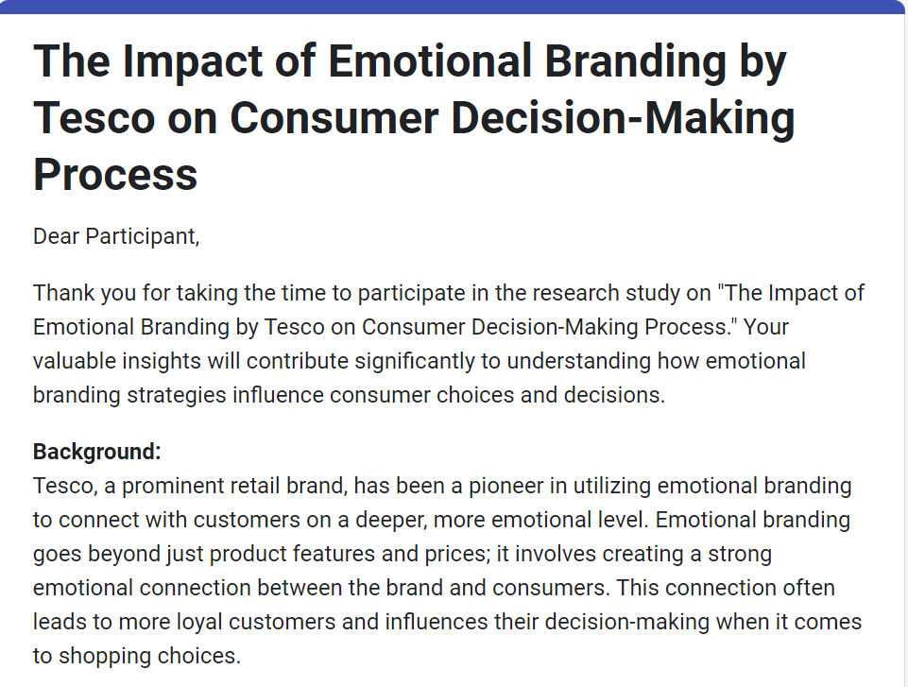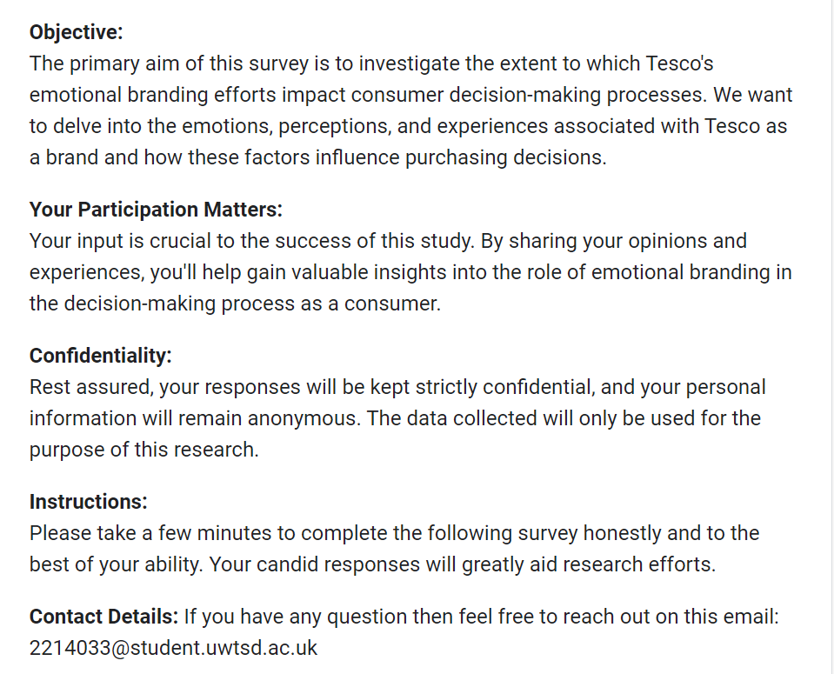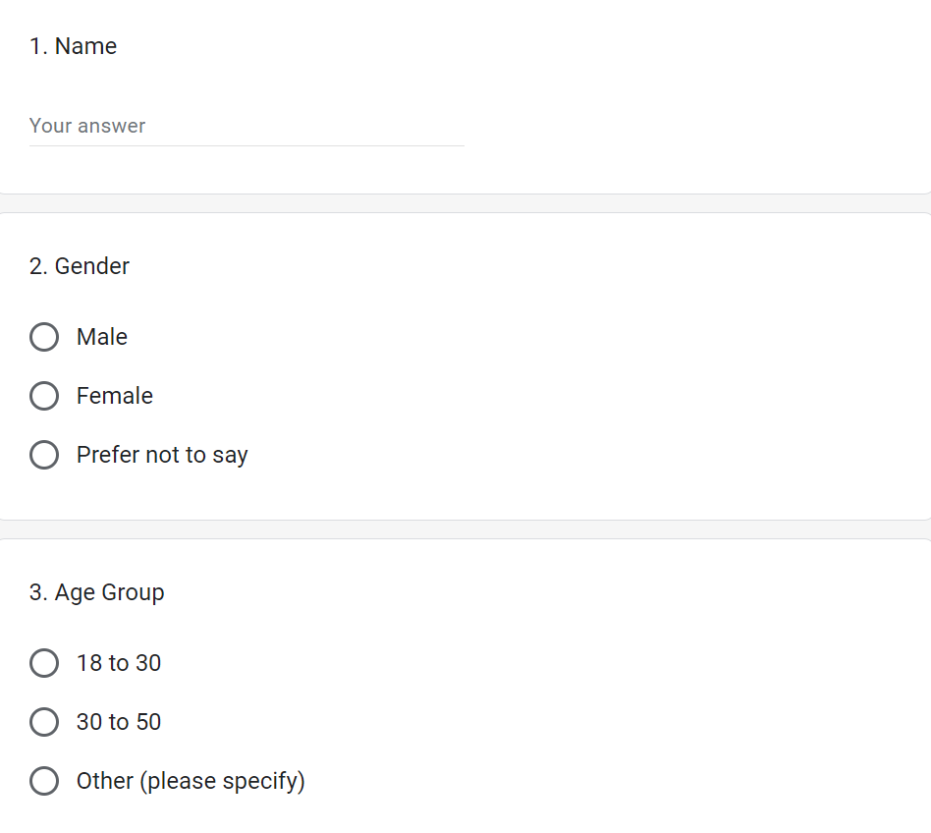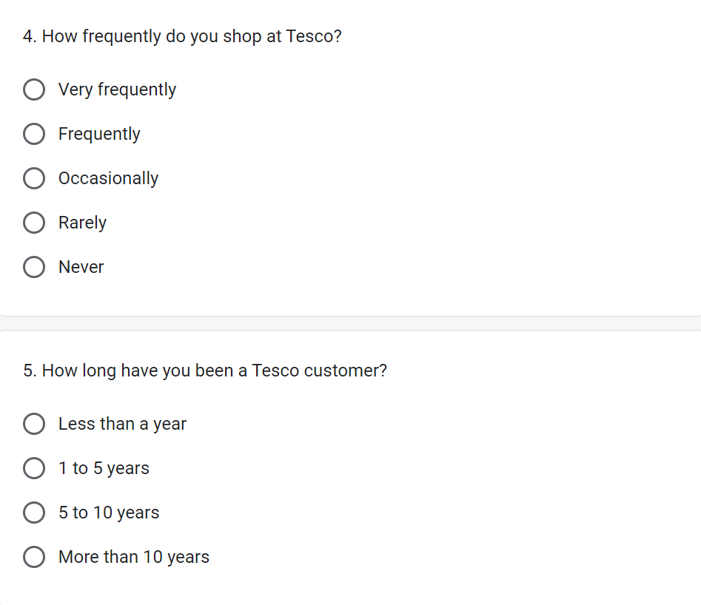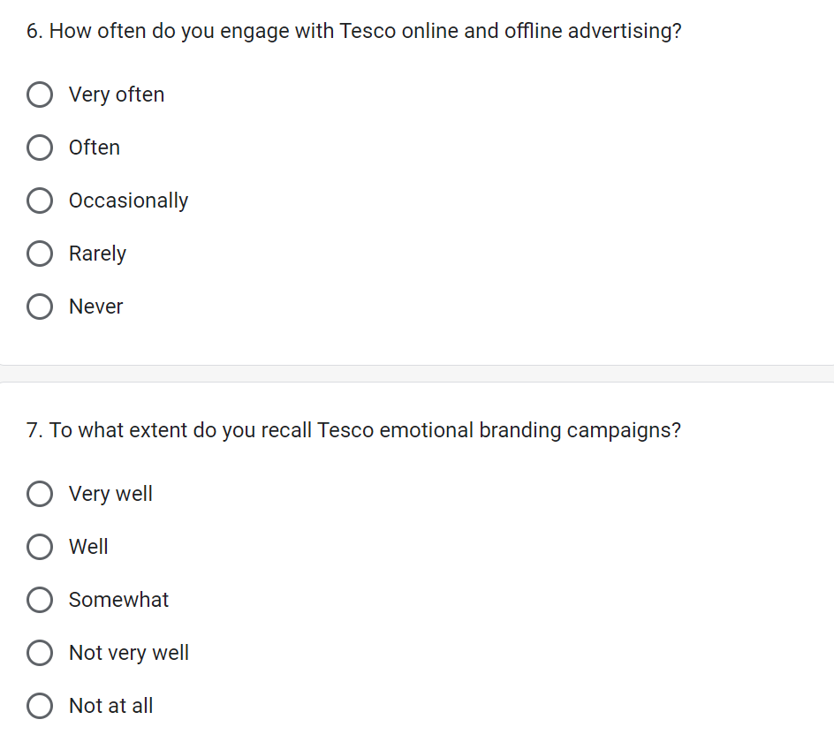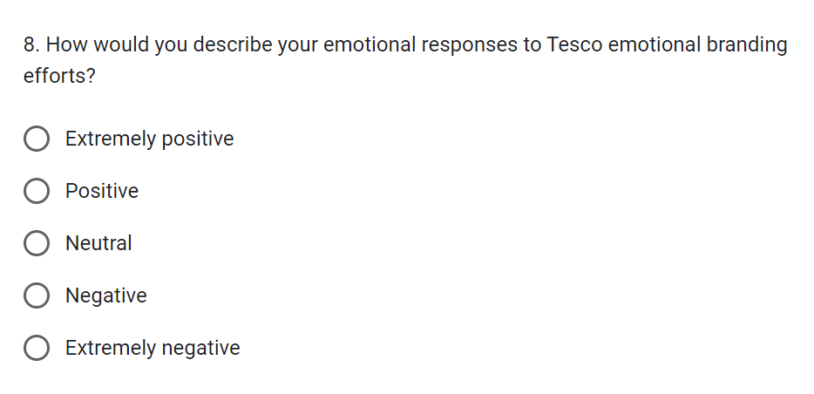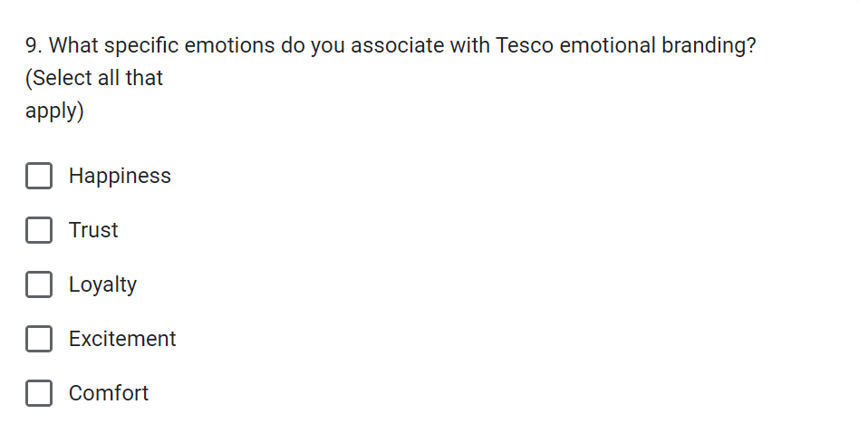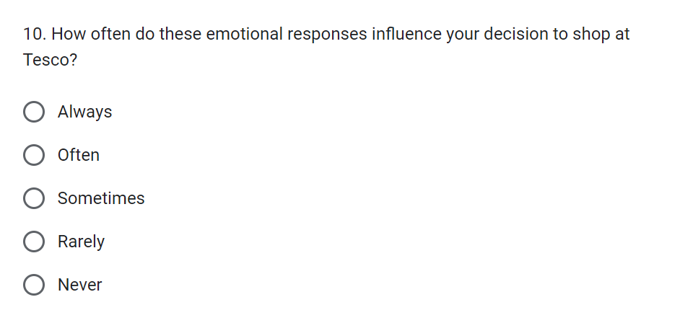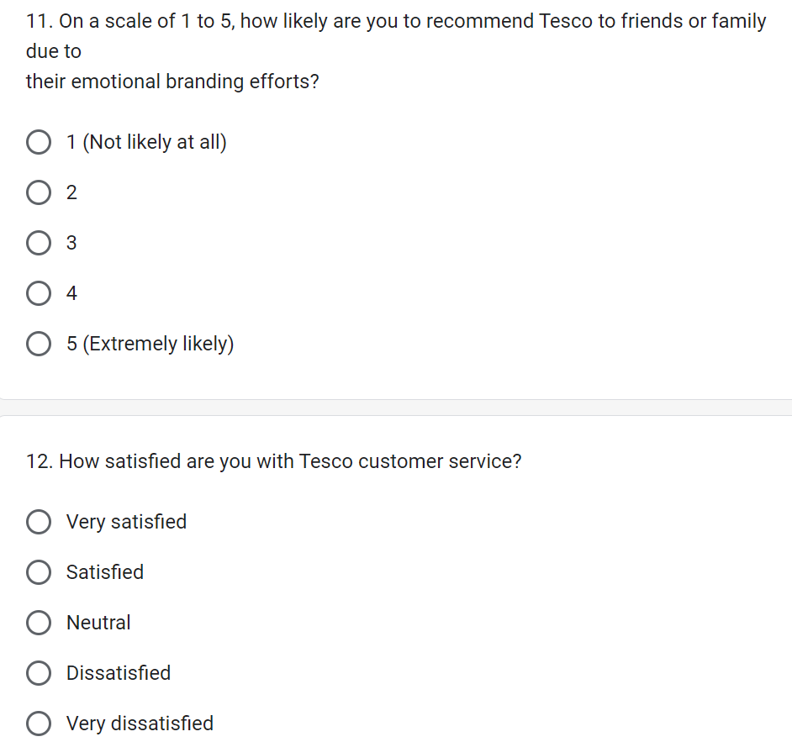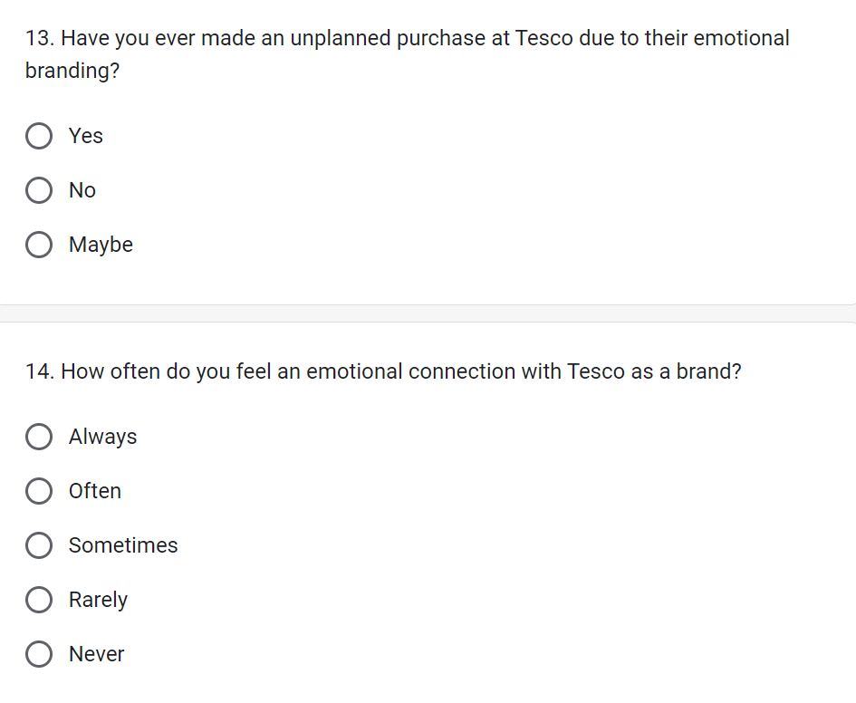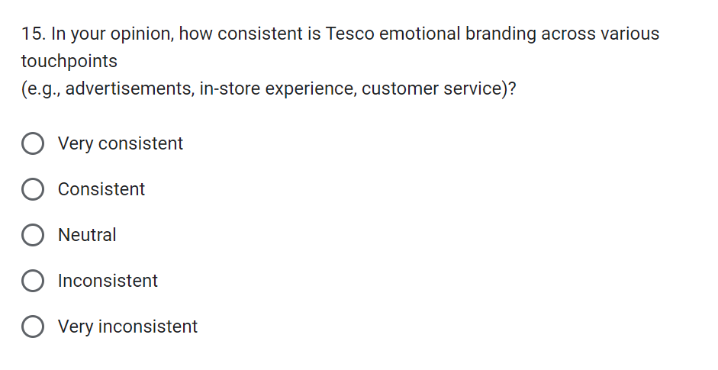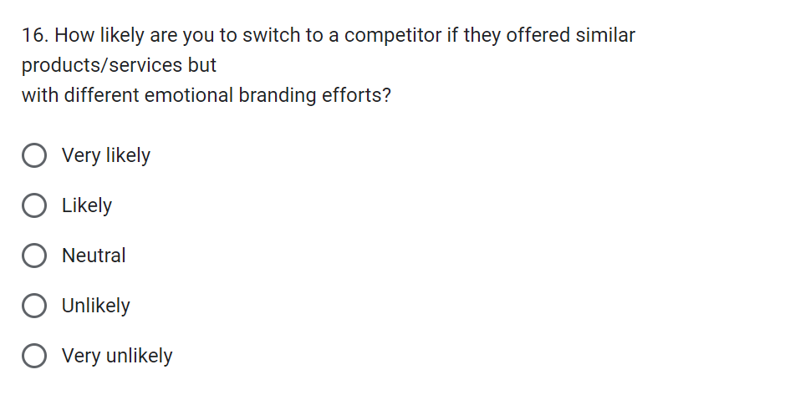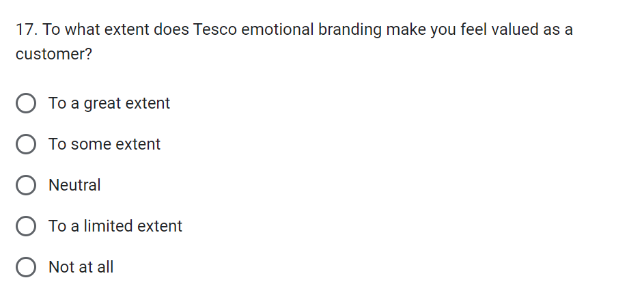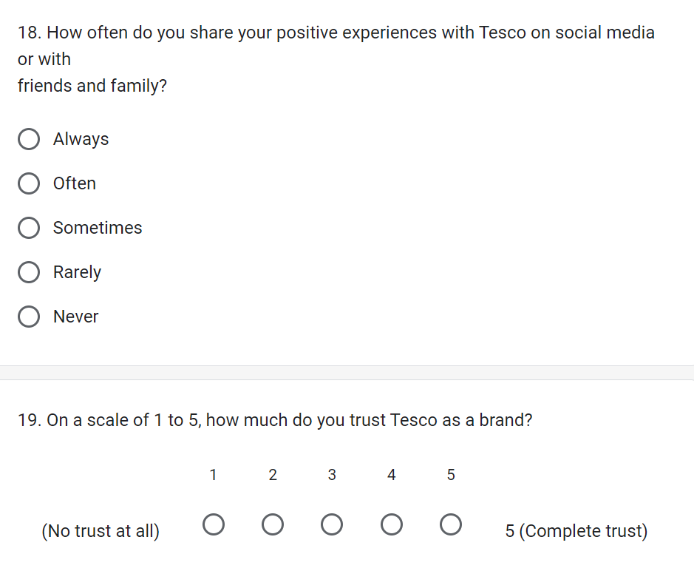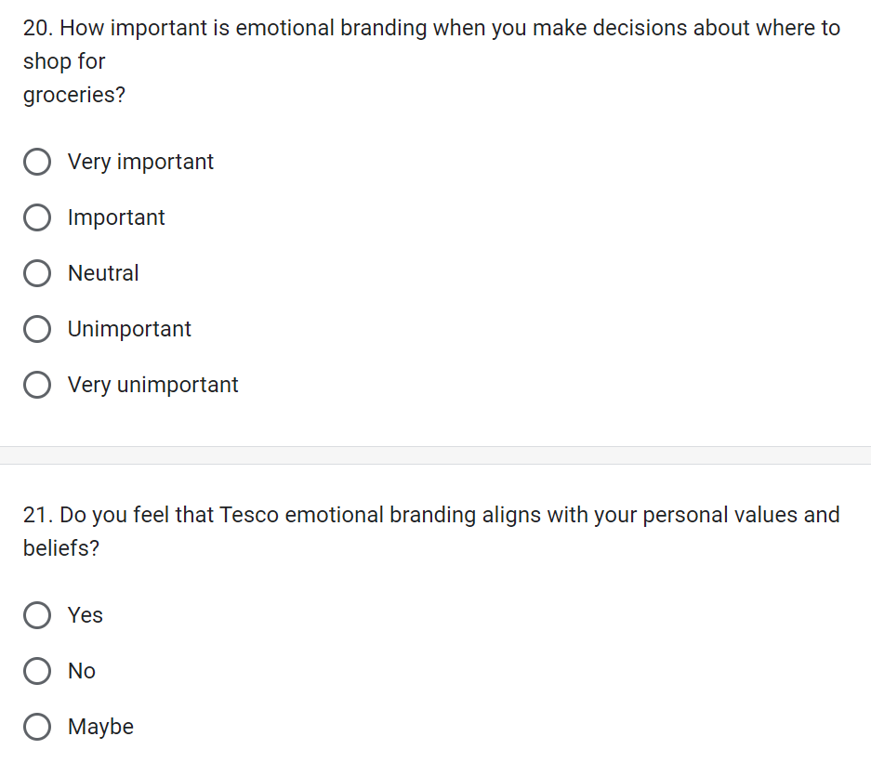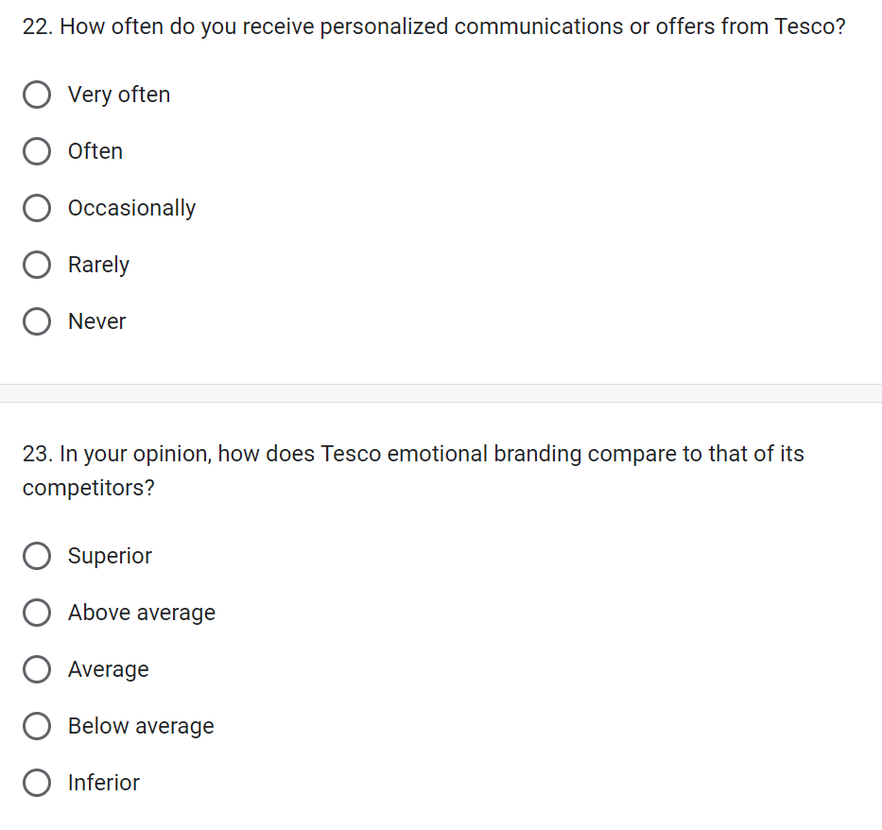
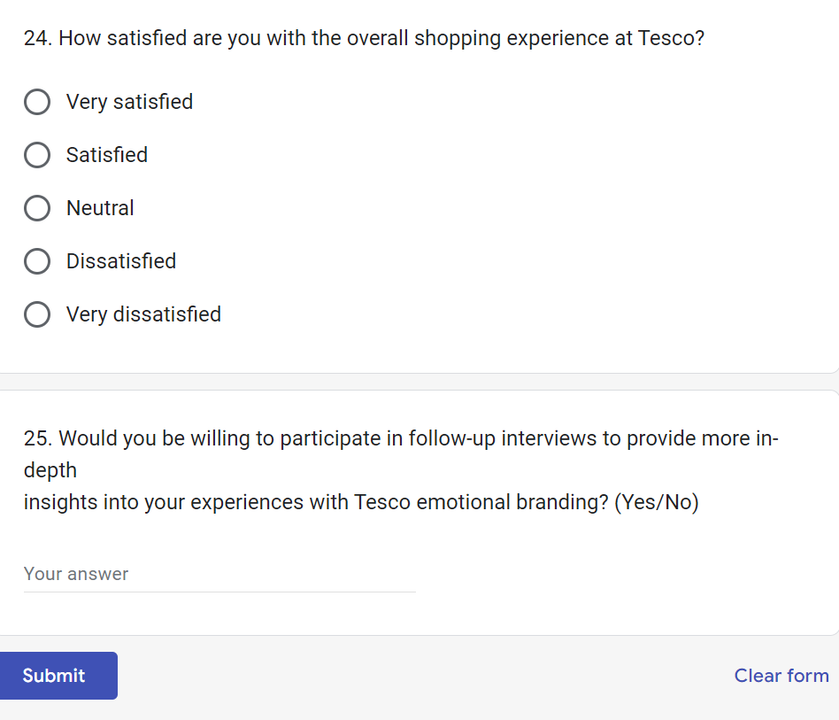

Appendix B: Survey Results


