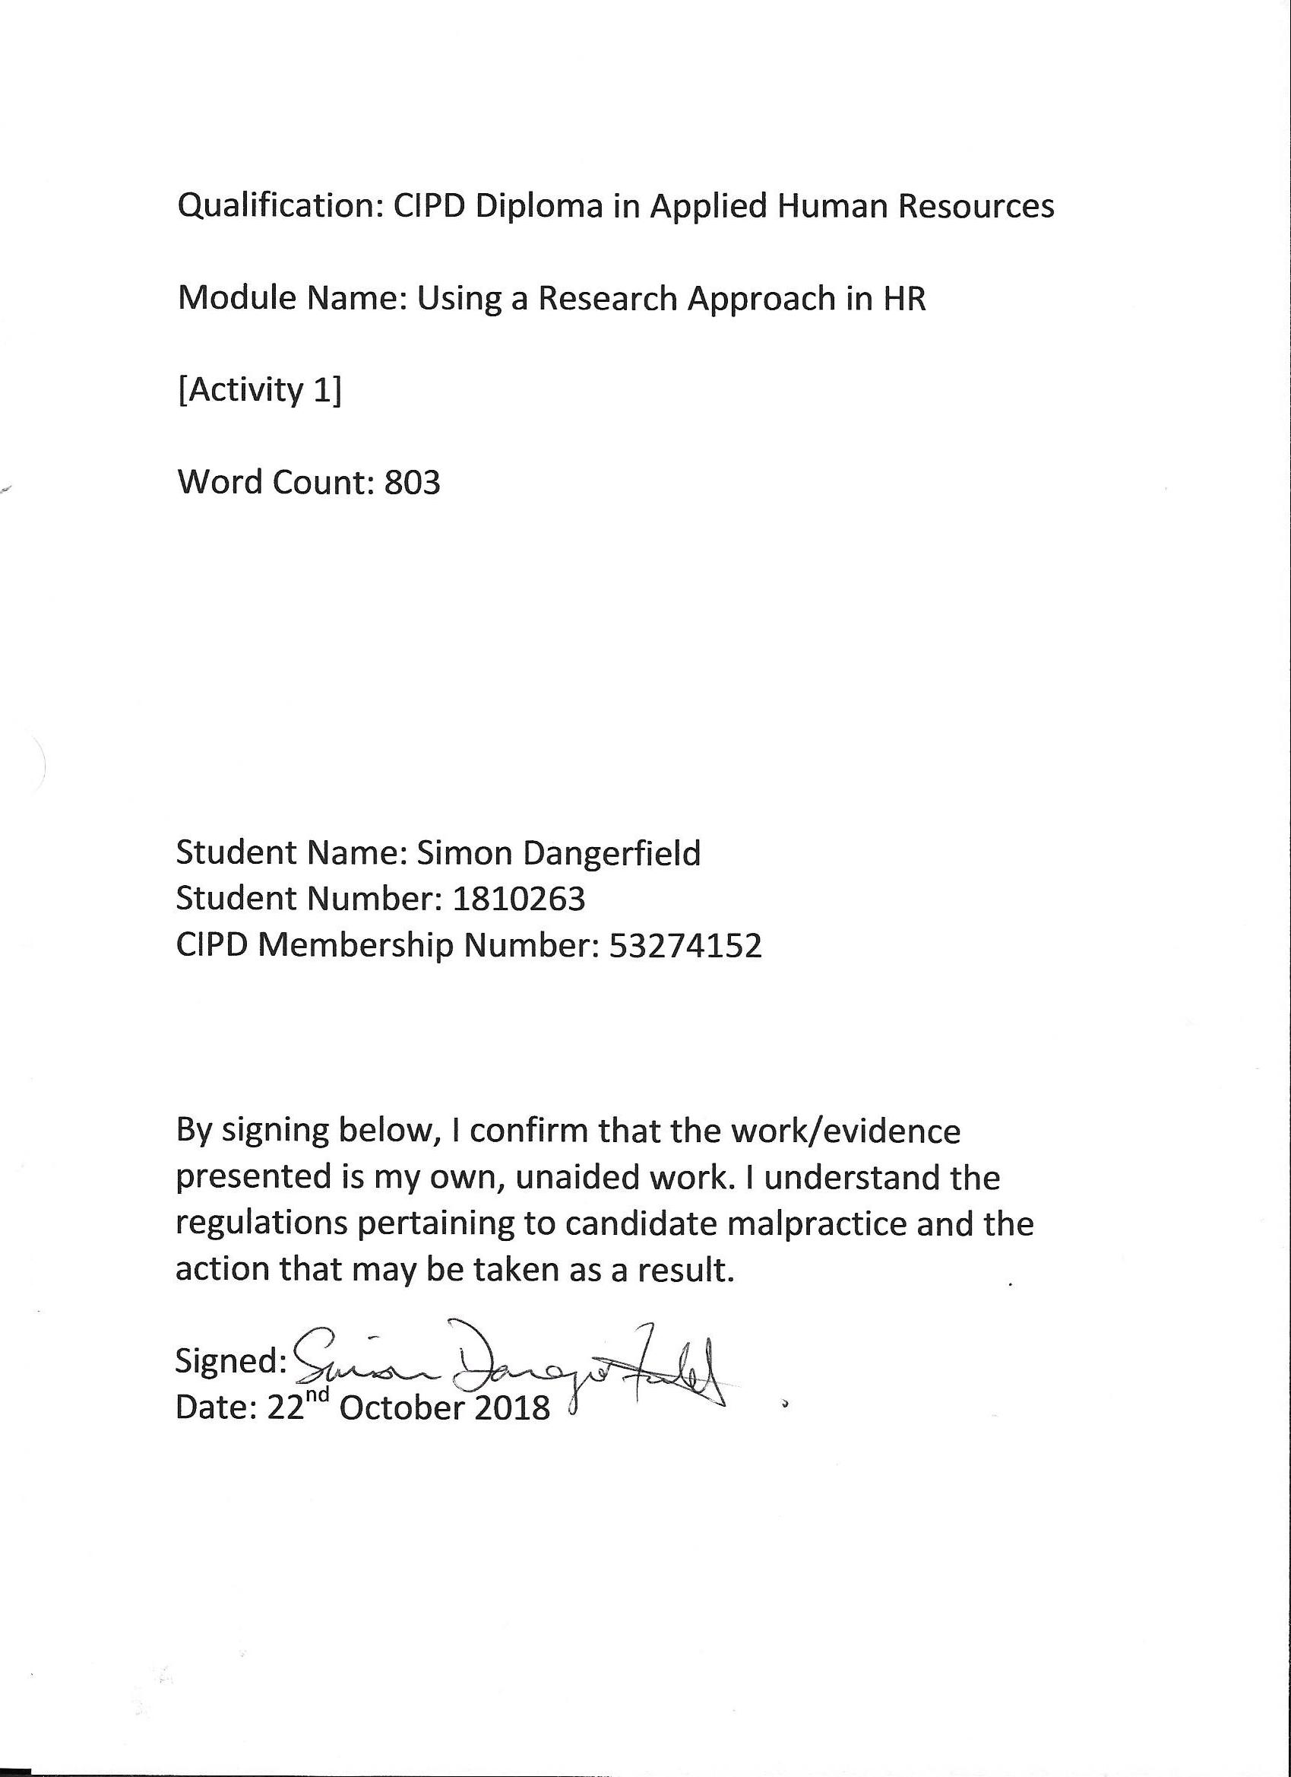
- Explain the nature of research and the stages of the research process.

Research is the systematic collection and analysis of data or evidence required to increase knowledge, inform thinking, improve the decision making process and take effective action (Anderson, 2013; Taylor and Woodhams, 2016). Bryman and Bell (2015) argue that research must be reliable i.e. similar results would be obtained if repeated; replicable i.e. another researcher would be able to conduct the same research; and valid i.e. the conclusions are consistent with the data collected.
Anderson (2013) compares research to project management and breaks down the process into various stages. The first stage is identifying a suitable topic to research. It should be manageable, interesting and the results should add value for the reader. Time, resources, skills and access are necessary, as is an understanding of issues affecting the organisation and the opinions of stakeholders (Perkins and Woodhams, 2016; Horn, 2012; Anderson, 2013). The next stage is to evaluate literature and find out what has previously been identified to address gaps in knowledge and help focus the aim and objectives of the project (Perkins and Woodhams, 2016; Gilbert and Pope, 2010). Research requires good quality evidence from trustworthy sources to improve decision making and increase credibility (Barends, 2017; Jacobs, 2017).
The next stage is to collect good quality quantitative or qualitative data from primary or secondary sources (Taylor and Woodhams, 2016). Primary data is ‘new’ data collected for the research project, whereas secondary data already exists from previous research (Horn, 2012). Quantitative research looks for the hard facts and can be presented in statistical or graphical forms. Questionnaires are good tools to use as data can be collected and analysed relatively quickly. Qualitative research provides a deeper insight and understanding into opinions, attitudes and behaviours. Interviews and focus groups are ideal but more time consuming when recording and analysing the results (Barnham, 2015; Horn, 2012). Finally, writing-up the research project, drawing conclusions, recommendations and presenting the findings are arguably the most important stages in order for the research to be viewed as credible and not to have the conclusions and recommendations dismissed (Perkins and Woodhams, 2016).

- Compare and contrast different approaches to research.

Anderson (2013) explains that the four appropriate research designs are cross-sectional, case study, action and comparative. The most appropriate design will be determined by the project’s objectives and the situation being investigated.
Cross-Sectional design collects data through questionnaires or structured interviews at a single point in time allowing the researcher to establish patterns and make comparisons. It is cheap to organise and administer and produces large amounts of data. However, it requires an adequate sample size and often sacrifices quality for quantity. Poorly designed questionnaires produce poor quality data and ambiguous results (Anderson, 2013; Perkins and Woodhams, 2016).
Case Study design involves a detailed investigation into one specific issue over a period of time using interviews and observations. It generates large amounts of qualitative data which can be difficult and time consuming to analyse. It is a focused study making it difficult to generalise and cross check information. Learning cannot be transferred to other areas or used in a different context (Anderson, 2013; Perkins and Woodhams, 2016).
Action research aims to solve problems and promote change through a cycle of planning, taking action and observing the effects of that action. However, while it may describe the effects of actions, it does not explain why the action has occurred or what has motivated it. It is also time consuming, adding little value or understanding outside the research setting (Anderson, 2013; Perkins and Woodhams, 2016).
Finally, comparative designs allow researchers to compare different groups or situations. A standardised survey gathers data from different settings allowing the researcher to compare and contrast findings. Comparative research can be difficult to organise and administer and comparisons must be made accurately or the validity of the research will be affected (Anderson, 2013; Perkins and Woodhams, 2016).

- Give examples of how research can be used in researching HR.

Research justifies why HR practices are beneficial and it evaluates the successfulness of HR policies and practices, whilst also contributing to the development of HR at strategic, policy and operational levels. Anderson (2013)
For example, a cross-sectional research project by an HR professional into employee engagement will provide a snap shot of the level of corporate loyalty at that time, however for the organisation to know if it is succeeding in this area, further research will be needed to compare and contrast findings over different points in time. Equally, if the organisation operated in several countries, a comparative approach would allow the researcher to compare employee engagement across all sites. However, if a researcher studied the culture of an organisation, a case study approach would be most appropriate, allowing the researcher to observe employees more in depth over a long period of time. This research would produce detailed and complex data but may not necessarily help understand similar issues in a different organisation (Anderson, 2013; Perkins and Woodhams, 2016).

References

Anderson, V. (2013) ‘Research methods in human resource management’ in Taylor, S. and Woodhams, C. (eds). (2016) Studying human resource management. 2nd ed. London: Chartered Institute of Personnel and Development.

Barends, E. (2017) Evidence-based practice: an introduction [video]. Available at: https://youtu.be/ikJ687g2tPo
(Accessed: 10 October 2018)

Barnham, C. (2015) ‘Quantitative and Qualitative Research’. International Journal of Market Research, Vol. 57, Issue 6, p837-854. Available at: https://web-b-ebscohost-com.ezproxy.uwtsd.ac.uk/ehost/pdfviewer/pdfviewer?vid=1&sid=c0c8849b-2623-4ab2-a33d-868adf23b295%40pdc-v-sessmgr01
(Accessed: 18th October 2018)

Bryman, A. and Bell, E. (2015) Business Research Methods. 4th ed. Oxford: Oxford University Press.

Gilbert, G.E. and Pope, C. (2010) ‘A Brief Introduction to Evaluating the Literature’. Journal of the National Medical Association, January 2010, Vol.102(1), pp.65-67. Available at: https://search-proquest-com.ezproxy.uwtsd.ac.uk/docview/214032714?accountid=130472&rfr_id=info%3Axri%2Fsid%3Aprimo
(Accessed: 18th October 2018)

Horn, R. (2012) Researching and writing dissertations: a complete guide for business and management students. 2nd ed. London: Chartered Institute of Personnel and Development.

Jacobs, K. (2017) ‘The Case for Evidence-Based HR’ HR Magazine, May 2017, p3-11. Available at: http://msgfocus.com/files/amf_mark_allen_group/workspace_9/Evidence-Based_HR_Supplement_May17.pdf
(Accessed: 10th October 2018)

Perkins, G. and Woodhams, C. (2016) ‘Using Information in Human Resources’ in Taylor, S. and Woodhams, C. (eds). (2016) Studying human resource management. 2nd ed. London: Chartered Institute of Personnel and Development.

Saunders, M., & Lewis, P. (2012). Doing research in business and management : An essential guide to planning your project. Harlow: Financial Times Prentice Hall.

Taylor, S. and Woodhams, C. (eds). (2016) Studying human resource management. 2nd ed. London: Chartered Institute of Personnel and Development.

By: Venkatesh, V., Brown, S. and Bala, H. (2013) ‘Bridging the Qualitative-Quantitative Divide: Guidelines for Conducting Mixed Methods Research in Information Systems’. MIS Quarterly, Vol. 37 Issue 1, pp. 21-54. Available at https://web-a-ebscohost-com.ezproxy.uwtsd.ac.uk/ehost/viewarticle/render?data=dGJyMPPp44rp2%2fdV0%2bnjisfk5Ie46bJPt6mvS7ek63nn5Kx95uXxjL6nrkevr61Krqe2OLKwskq4p684v8OkjPDX7Ivf2fKB7eTnfLutt0u2prBNrqikhN%2fk5VXj5KR84LPgjOac8nnls79mpNfsVbartEuyq7NIpNztiuvX8lXk6%2bqE8tv2jAAA&vid=0&sid=5ee668ab-e4fc-41f7-8bbb-19583909d46f@sdc-v-sessmgr06
(Accessed: 18th October 2018)

