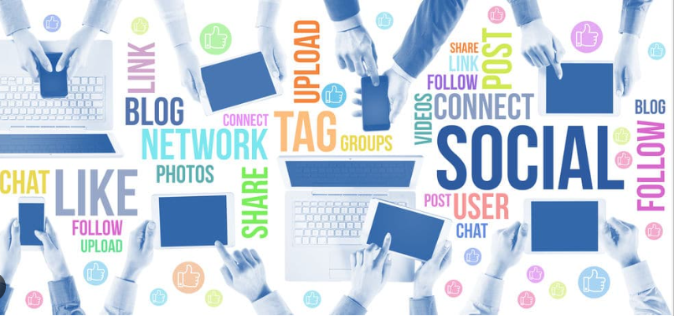

Social and digital media

Andrew Omoregie | I.D2317934 | 20.03.2024

  - Digital Skills
  - Lecturer’s Name: Amitave Banik
  - Module code: LCLM4002
  - Submission deadline: 28.04.2024

Contents

Introduction 2
The Advantages of social media on customers 3
Instagram advantage 3
Disadvantages of social media 4
Instagram disadvantages 4
Conclusion 4
Reference : 5

Introduction
This report aims to discuss how social and digital media have changed the way businesses reach their customers. The implications of these changes extend to the way organizations communicate with customers and assist them in making purchasing decisions. There are various changes to the marketing methods that have been effective in the past, which have led to the creation of new metrics to gauge the effectiveness of various marketing methods and track how customers are reached. However, success in these new mediums of communication can sometimes lead to unintended consequences. Overall, the changes in social and digital media have had a significant impact on the way customers are reached, making it more effective and efficient. This is especially important for newer web-based businesses that provide no physical goods and rely on customer agreement to purchase a service. Certain company-specific examples will not be provided in this discussion to preserve confidentiality. The success of each marketing method depends on the extent to which the information provided about the product/service has reached the customer. Traditional marketing methods mainly relied on advertisement through radio, TV, billboards, or directly conveying product information to a customer in a store. The information then was only loosely targeted towards potential customers, and obtaining feedback on whether the information had reached the intended individuals was difficult. The institution of market research was the first step in attempting to gauge customer reach and how feedback was obtained through consumers about a product's marketability. This information would, in turn, lead to better products and improved marketing methods. The aim was always to capture the customer's outlook on a product while not directly engaging the customer in communication.

The Advantages of social media on customers
Social media platforms have transformed how businesses engage with their customers, offering numerous advantages that can positively impact customer relationships and brand success. One significant advantage of social media for customers is the enhanced communication and interaction it enables. Companies can now directly connect with their customers in real-time, fostering a sense of community and allowing for personalised interactions. This level of engagement can lead to increased customer loyalty and satisfaction as clients feel heard and valued (Anon, 2023). The 6th Annual Social Media Marketing Industry Report by Mike Stelzner, published by Social Media Examiner, highlights the importance of social media for businesses, with 92% of marketers stating it's crucial. The report also highlights the importance of original written content, blogging, Google+, podcasting, and LinkedIn. It also covers major social networks and activities, including blogging, Twitter, Facebook, LinkedIn, YouTube, Pinterest, Instagram, Vine, Forums, podcasting, Snapchat, and mobile. The report also addresses questions about ROI, outsourcing, content types, and other marketing tactics (Odden, 2014).

Instagram advantage
With over 2 billion monthly users, Instagram is a popular medium for businesses of all sizes and industries. Considering that 63% of American users access the site every day and 97% do so once a month, businesses can succeed by implementing a focused Instagram strategy. By being active on social media and publishing frequently, businesses can engage with their target audience and raise brand awareness. Businesses can monetize Instagram in many ways, such as through shoppable posts, brand ambassador relationships, and direct sales. Instagram also gives brands the chance to show off their individuality through live events and Instagram Stories, which provide users an intimate glimpse at the business and its staff. Live events, like Facebook Live Q&As, can help fans develop a connection, trust, and sense of trustworthiness (Kuligowski, 2023).

Disadvantages of social media
Using social media to advertise one's company, goods, or services may raise concerns about data security, privacy, and trust. It is imperative that corporations are cognizant of these concerns and implement suitable procedures to mitigate their liability with regard to the acquisition, utilisation, and preservation of personal data. Social media marketers rely heavily on trust, especially regarding the special aspects of transaction security and privacy. According to a survey by Ratnasingham, one of the main reasons consumers have not made larger purchases online is because they are afraid of credit card fraud. Furthermore, privacy issues have caused a significant PR disaster for some major social media marketers, severely damaging their company image (Arsath, 2018). Social media is time-consuming and needs to be monitored constantly. Engaging with customers at times of comments, messages, new products and complaints.

Instagram disadvantages
One disadvantage of Instagram for customers is the potential negative impact on mental health due to the constant exposure to idealized and curated images that can lead to feelings of inadequacy, lower self-esteem, and body image issues (Fardouly, Diedrichs, Vartanian, & Halliwell, 2015). This phenomenon, known as social comparison, can contribute to increased anxiety and depression among users, particularly young people who are more susceptible to these influences.

Conclusion
Social and digital media platforms, such as Instagram, offer businesses an effective means to reach a wider customer base. Instagram's visual nature and high user engagement make it a valuable tool for businesses to showcase products and services, connect with consumers, and enhance brand visibility. Businesses can create compelling content that resonates with diverse audiences globally by leveraging Instagram's features like stories, posts, and live videos. Moreover, Instagram's advertising capabilities enable targeted marketing to reach specific demographics efficiently. However, despite its advantages, Instagram also presents challenges. The platform's algorithm changes and increasing competition can make it difficult for businesses to stand out and reach their target audience organically. Additionally, managing customer interactions and feedback on social media requires constant monitoring and engagement to maintain a positive brand image.
In conclusion, while social and digital media, including Instagram, offer businesses extensive opportunities to expand their reach and engage with customers, it is essential to navigate both the advantages and disadvantages effectively to maximise the platform's potential for reaching a wider customer base.

Reference :
Why Social Media Marketing is Important for Business In 2023 | Post. [online] Available at: https://www.givethedogabone.com/blog/why-social-media-marketing-is-important-for-business-in-2023 [Accessed 19 Apr. 2024].
Odden, L. (2014). 2014 Social Media Marketing Industry Report. [online] B2B Marketing Blog - TopRank®. Available at: https://www.toprankblog.com/2014/05/2014-social-media-marketing-industry-report/ [Acesseed 22.04.2024]
Kuligowski, K. (2023). 10 reasons to use Instagram for your business. [online] business.com. Available at: https://www.business.com/articles/10-reasons-to-use-instagram-for-business/ [Acssesed 22.04.2024]
Arsath, M. (2018). SYED HAMEEDHA ARTS & SCIENCE COLLEGE, Kilakarai National Level Seminar on ‘Digitalization in Business’ Social Media Marketing: Advantages and Disadvantages. [online] Available at: https://www.shanlax.com/wp-content/uploads/SIJ_MGT_Oct2018_V6_N1_032.pdf. [Accessed 22.04.2024]
Fardouly, J., Willburger, B.K. and Vartanian, L.R. (2017). Instagram Use and Young Women’s Body Image Concerns and self-objectification: Testing Mediational Pathways. New Media & Society, 20(4), pp.1380–1395. https://doi.org/10.1177/1461444817694499 [Accessed 23.04.2024]
‌

