Emma Keating – Frist resubmission 17/12/25
Q1. Examine two key external factors likely to impact on BPE’s acquisition of Emrosu. (AC 1.1)
Shiva will need to consider many factors if she is changing from a small family run business to possibly increasing up to one hundred corporate stores owned by Emrosu. For Shiva to analyse, evaluate and consider the risks, benefits and impacts she could use one of a few methods to gather information to have an insight of all key important factors. One of the methods that I would recommend to Shiva would be to use the Pestle framework method. The Pestle Framework method will be useful to Shiva as it has been used previously prior to starting up new businesses or making changes to existing businesses taking into consideration all external factors by Business Managers, Project Managers, Entrepreneurs, Consultants and Educators. The Pestle model can be used to assess the risks to the external changes by analysing the possible impact in particular key areas. Pestle covers the Political, Economic, Social, Technological, Legal & Environmental factors.
I have included an example of a Pestle model below:
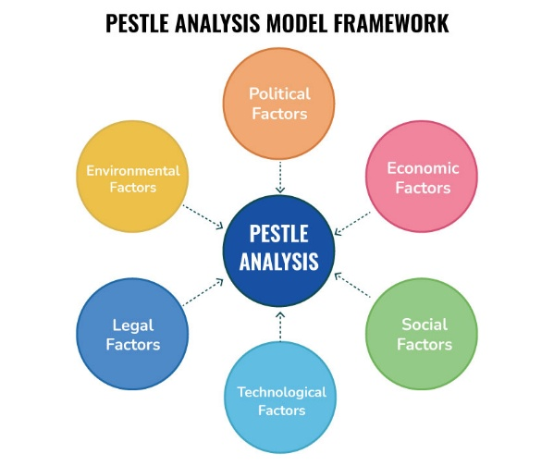
(Speaking Nerd, 2021)

Focusing on the possible acquisition of BPE by Emrosu and using the Pestle method Shiva can analyse key external factors such as the Social and Legal implications making an informed decision managing the risks and capitalizing on opportunities. The social factors that Shiva may analyse could be the buyer trends as Emrosu is a national chain of internet pharmacies allowing customers to request their medicines online. Is this something that is in demand in the current trend with the option of home delivery possibly an increase in sales benefiting the business or do customers prefer the personal service that Shiva has offered for over thirty years? Another factor that could be analysed might be Legal consideration of how compliant online pharmacies are with data protection regulations as all confidential details on patients will need to be held online and authority to order and deliver prescription drugs and any legalities that may come with this including the possible risks or threats. Training can be given by Emrosu to reduce the risks and ensure all new employees are complying with the regulations.

Q2. Discuss two business goals that BPE might set once the acquisition has been completed, explaining the reasons why it is important that they plan to achieve these. (AC 1.2)
Once the acquisition from BPE has been completed, Shiva would benefit from setting short- and long-term goals for the business and her employees. By setting clear goals the future of the business expectations will be transparent to all those employed both in the transition period and those new to the business. The employees will then be kept engaged and be aware of what is expected of them with the business changes. I would suggest to Shiva that all employees have updated training and Personal Development Plans put in place to ensure consistency and reassurance during the process. I would expect new technology systems would need to be put in place especially as Emrosu is an internet pharmacy which the previous employees of BPE may not be familiar with as a local pharmacy currently offering a face-to-face service. Training will need to be given not just on the systems but on the legalities of data protection online and any software systems that may help them communicate between branches.
One method that Shiva could use when planning her goals would be the SMART metric method which broken down will cover specific, measurable, achievable, relevant & time-bound goals. Businesses have used this method for many reasons whilst planning and project managing. For Shiva using this method she could focus on a specific goal by setting a business target of increasing the pharmacy sales by 10% for example and then a timebound goal setting a deadline that is achievable for example within 6 months.
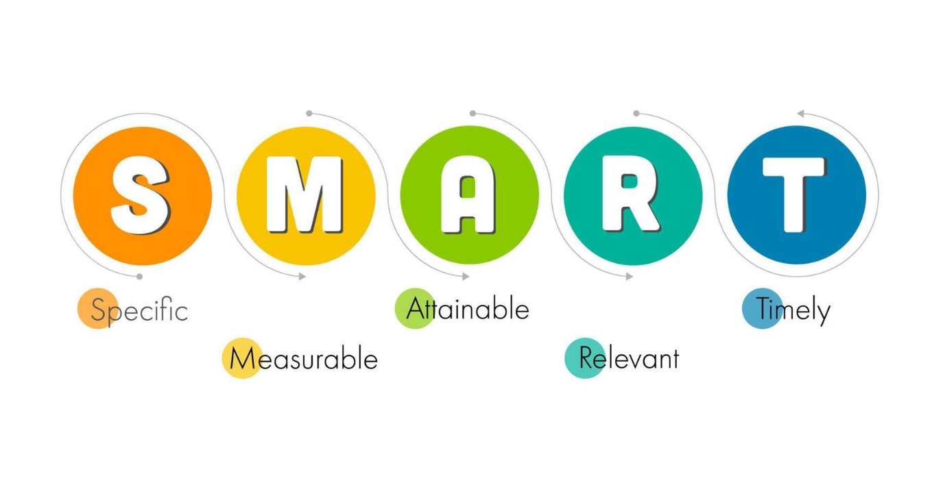
(Krittapol Ingpanjalap, 2025)

Q3. Discuss:
- The products and services that BPE and Emrosu deliver
Shiva is currently running an independent pharmacy business BPE providing a prescription service, selling health and beauty products and offering pharmacy services which I would imagine has a small stock holding restricting the variety of products compared to larger businesses like Emrosu. A national chain business like Emrosu has a separate warehouse that allows them to contain more stock and therefore more variety of products to sell at wholesale prices. Larger businesses ordering more bulk buying products like Emrosu can be more competitive in their pricing and offers for their customers by being associated with brands. Shiva also offers a personal service including health advice, blood pressure checks, consultations and vaccinations from her five pharmacy stores. Emrosu will not be able to offer the personal service that BPE is currently offering due to the small people team that they work on being mainly an internet-based business working from a head office with a Board of Directors, Sales & Marketing, Purchasing and Financing Team.
- Their main customers. (AC 1.3)

Shiva currently relays on local customers using BPE as her five stores are all within a 20-mile radius of each other whereas Emrosu offers both an internet and store service within their 95 branches. By offering the internet option, Emrosu is covering a wider geographic customer base being able to collect orders in store or select a home delivery which may be more convenient. Emrosu is also covering many age ranges as they are offering more updated options with the internet ordering which the younger generation may prefer but also the branch option which the older generation may be more used to. By offering the online option and having a large stock holding in a warehouse, Emrosu will be able to offer their service at a quicker delivery time to a wider customer base such as care homes that may be requiring large repeat orders to be delivered for convenience.

Q4. Review the range of technology that could be available to the people professionals working at BPE and Emrosu and how these could be utilised to improve working practices and collaboration after the acquisition. (AC 1.4)
BPE is highly likely to be using a very small software system between the five branches whereas a larger scale organisation like Emrosu that offers internet ordering, will be using a more advanced updated system between their ninety-five stores.
BPEs people professionals would benefit from having updated technology systems in place to manage their Human Resource information, especially as they will be merging into a larger business with Head Office Departments requiring easy access to information. The people management systems they could use may be like those that I currently use in my employment with a scale of 900 employees such as Fourth payroll and Reach recruitment. The systems can be used from as early as the point of application of vacancies to employee records for the entire employment period. Having a system in place that can hold employee records can be easier to people manage for rotas, annual leave, absences, training and disciplinaries. Some employees may work between branches and have a multi-role with more than one manager needing to see personnel information. If the information is held online, it can be accessible to more than one manager.
BPE could improve their communication and collaboration between branches by using video conferencing systems such as Microsoft Teams. Microsoft Teams will allow the people professionals to have online message chats, video calls, share files and share screens to make presentations or work on projects together. This may even make some positions more flexible allowing for working remotely and more adaptable hours.
Training platform systems can be used between the branches online to ensure that all employees can be kept up to date with any changes to policies and procedures. Each employee would have a record held for all those training sessions attended whether in person or online plus managers can allocate training for them directly. This will help to keep a track record of each employee’s training record but also avoid unnecessary duplicate training attendance.
My above suggestions are all positive reasons for updated technology systems, but they will all come with a risk of breach to security of personal records. It is recommended that all systems are kept as secure as possible and all users will have full training of them plus secure log ins to the systems to protect the information. There should also be regular backups processed so that there is not a risk of losing the personnel data.
Q5. Define what is meant by ‘Organisational culture’ and why it will be important to foster an appropriate and effective workplace culture in BPE after the acquisition. (AC 2.1)
Organisational culture is a mixture of shared values, beliefs, traditions, customs, attitudes and behaviours within a workplace or business. Put simply it is the atmosphere and the way things are done in the workplace. The organisational culture can affect several things from the way employees communicate to the way decisions are made in the business and the quality of the production. There will be a vary of culture between different organisations as they will not all have the same beliefs, values and ways that they work.

The below Edgar Schein model of organisational culture explains from a psychologist point of view the layers of culture consisting of artifacts, values and basic underlying beliefs. The aspect of the model is that culture is deeply embedded within an organisation and by understanding them it can encourage managers to shape the business culture and focus on achieving goals that are set.
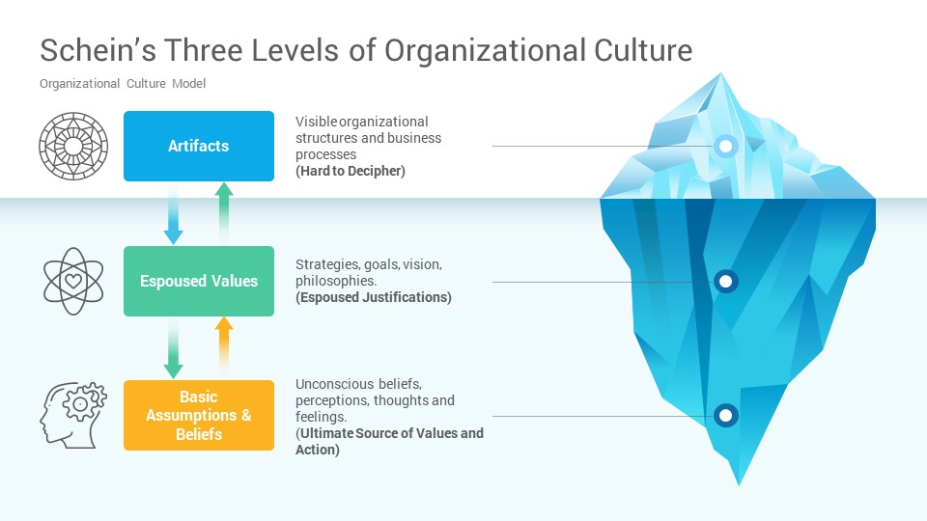
(Palm, 2022)
It is very important within a business to encourage a positive organisational culture so that all employees can be aligned in what is expected of them within the workplace showing unity sending a clear message. The organisation can share the business core values as part of a workplace induction or advertise them as part of the recruitment process to be transparent in their company expectations.
Having a positive culture in the workplace can lead to increased employee engagement keeping staff motivated, enjoying their work more which can encourage job satisfaction and increased productivity. If employees are happy, feeling that they can share and express any ideas they may have working towards targets and goals together this sometimes helps morale. Employee’s need to feel valued and listened to, it helps for managers to have regular one to one conversation with employees as sometimes the company culture may need to be reiterated if there are any issues.
A good strong organisational culture will be needed for both the transitional period and after the acquisition for BPE as some employees may be part of the process with changes affecting them. Some employees may need more support than others with the changes for example if some are not as confident as others in the changes to the technology. This needs to be considered by both BPE and Emrosu to promote effective workplace cultures.
Q6. Explain how organisations function as whole systems and how the work actions of the people professionals at BPE, after the acquisition, could impact the organisation. (2.2)
Taking into consideration the different structures between BPE and Emrosu as part of the transition will be helpful. Currently Shiva mainly manages the five branches at BPE with a flat structure herself however, Emrosu has a standard hierarchical structure for their internet business and ninety-five branches run by a Board of Directors. Emrosu has a Head Office with several Departments interacting between each other, this is something that Shiva is not used to, but she will need to consider this new way of working sometimes needing approval from the Board of Directors for any decisions rather than make them herself as she usually runs the branches day to day. Working with the Head Office and functional Departments at Emrosu will ensure consistency between branches in how they are managed avoiding any inconsistency. This will also be the case for the employees that transfer to Emrosu. Emrosu will benefit from supporting the BPE employees in a smooth transition with team building, training and clear communication to ensure they are kept motivated. There will also be a lower risk of any disputes between employees if any issues are reduced by offering one to one support so that the employees feel listened to.
There will be positive and negative affects from the changes within the business but by Shiva using a model such as the McKinsey 7’s Framework as shown below, she will be able to enable the employees to transition easily into the Emrosu structure. By delving deep into the strategy, structure, systems, style, staff, skills and shared values of Emrosu it will give a clear visual direction of the changes ahead.
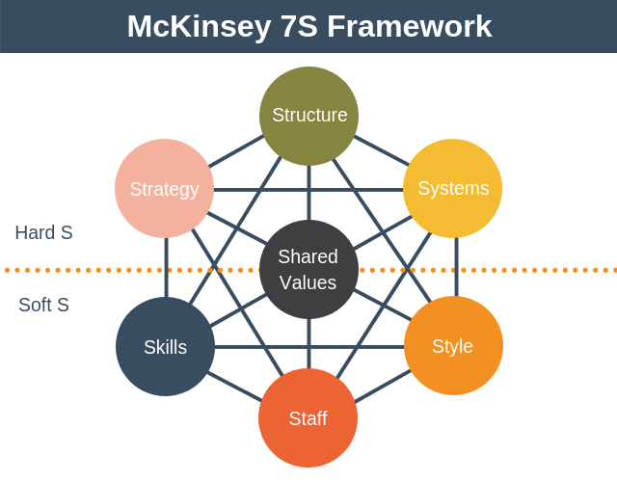
(Rajak, 2018)

Q7. Explain the main reasons why it is important that any changes made following the acquisition are planned and effectively managed. (AC 3.1)
It is essential for the transition change to be smooth within BPE and Emrosu, that all changes are planned well so that they are managed to avoid any devasting consequences from the very beginning. The customers, employees and the sales of the business could be affected and create a negative impact that could be difficult to recover afterwards.
Models such as the Kotter’s 8 step change model could be used so that a structured approached vision is clear for the change journey and everyone is aware of the steps. The employees can be involved in the journey of change, including them and allowing them to see hopefully the positive effect of an increase in sales for example will boost morale. The changes should be communicated to the staff in a positive way so that they are happier and understand what is happening on the journey. Reviewing the changes and listening to the employee plus customers feedback will be helpful as changes could be made and adjusted, if need be, to the plan.
The Kotter’s Model prioritises the steps of change as the image shows below identifying the goals and ensuring that they are clear to see:
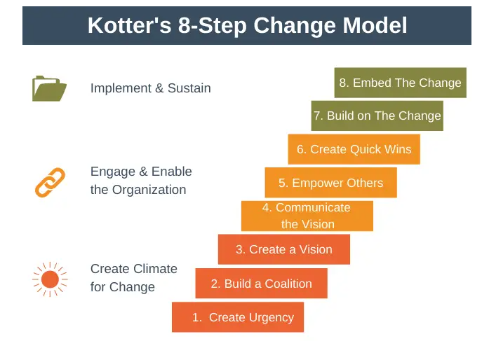(Expert Program Management, 2022)

Q8. Consider the importance and role that the people professionals in BPE and Emrosu could play during the changes. (AC 3.2)
I would think that Emrosu running a typical hierarchical structured business would have a Human Resource Team as part of their head office. A HR professional will play a crucial role in the planning stages of a business acquisition making sure that all employees are communicated with in the correct way, in the right time frame and keep a log of all information discussed. The transition should be planned to be made as smooth as possible between BPE and Emrosu. Some employees may have concerns and will need to be reassured gaining the confidence of their new employer Emrosu. It will be important to the employees of BPE to have a main HR contact such as a Change Champion that they can use for support during the new process.
The HR professionals will work on workforce planning looking at the workplace structure of the roles and possibly consider new roles within Emrosu for transferred employees by redeployment, redundancies and making new retention strategies. They will need to consider the effect of the changes to the employees and that everyone will need to be managed to avoid any issues that could impact on the business.

Q9. Discuss how the changes could impact people working at BPE and Emrosu. (AC 3.3)
Everybody reacts differently to change, some will refuse to accept change and others will look at the positives. As part of the planning stages of the business acquisition between BPE and Emrosu it would be advisable for management to prepare for all reactions of the employees in order to support them in the best way. BPE has been in business for thirty years and some of the employees may have served a long length of service and not be as accepting of the change from five branches to a larger business with one hundred stores. It can be quite emotional for some to make changes especially if they have become accustomed to working at BPE which is run by Shiva in a personal way. Along with shock and upset there may also be depression and employees with mental health issues that will need extra support in the changes allowing for trust to be built in a smooth transition. It may be a good idea to meet personally with the new employers or head of departments of Emrosu as they have been used to the family run culture of BPE.
If there are to be any job role changes, Emrosu needs to consider the least damaging way to relay this information again maybe meeting with the employees personally to discuss this rather than sending a letter or email which could be very impersonal. The employees will need time to get used to the changes and adapt as some may increase their job tasks, change their work location or require new skill sets. They may also look at the positives of the change. Moving into a larger business there may be quicker ways of working using updated technology, increased company benefits and the option to be more flexible with home working and adapted hours as Emrosu offers an internet service. Some may find that there are wider career prospect opportunities at Emrosu as the company has a head office with departments such as Sales & Marketing that they could be more specialised in.
How both BPE and Emrosu manage the acquisition is critical to the changeover, they cannot control the reactions of the employees, but they can prepare for them. Using a model such as the Kubler-Ross Change Curve can help plan the change journey such as the example below:

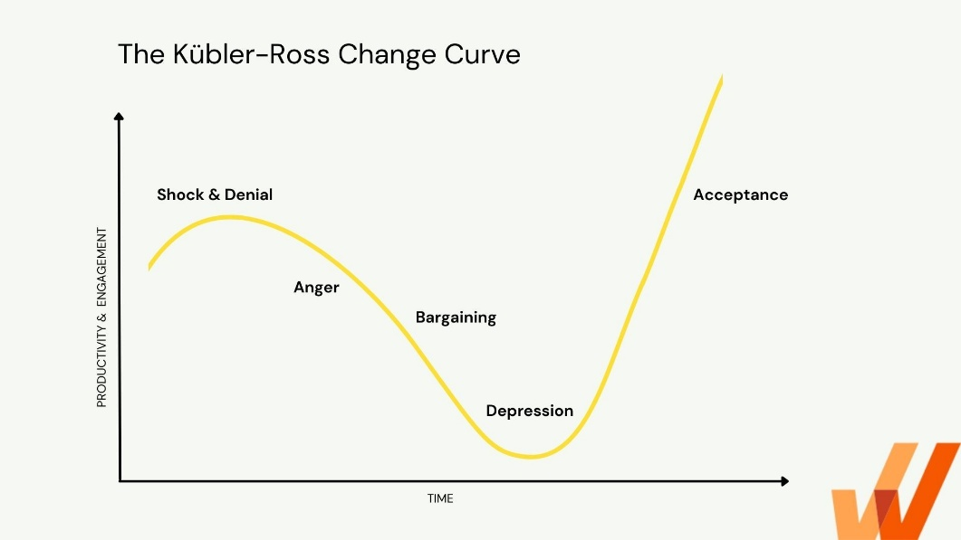
(Malik, 2022)

