MANAGING HOTEL ADMINISTRATION
Student Name: Bianca Alexandra Burcea
Student Id: 2122114
Table of Contents
Introduction 3
Reflection 3
Gibbs Reflective Cycle 3
Conclusion 7
References 8

Introduction
In the administration of hotel operations, I was responsible and obliged to manage the front office. In terms of overseeing this department, I was responsible for overseeing guest registration, room assignment, reservation management, guest services, billing and payment processing. Moreover, effective front office management has been crucial to enhancing the guest experience, improving operational efficiency, ensuring compliance with hotel policies and procedures.
The learning objectives from the placement reflect:
- To handle guest registrations, check-in, and check-out processes
- To understand room assignment and key management procedures
- To develop skills in handling guest complaints and resolving issues

Reflection
In terms of reflecting on experience, personal development, organisational issues and action plans Gibbs's reflective cycle has been encouraged. The phase of Gibbs's reflective cycle is important to examine and analyse the experience and the development of an effective action plan to seek further improvement (Galli and New, 2022).
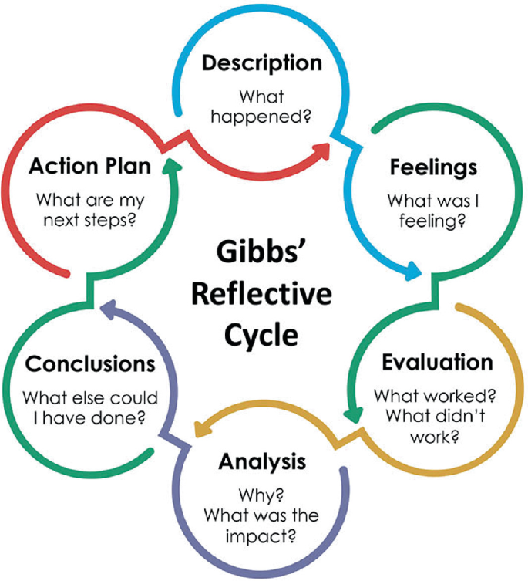
Figure 1: Gibbs Reflective Cycle
(Source: Miner and Nicodemus, 2021)

Gibbs Reflective Cycle
Description
Section 1: Reflection on Experience and Personal Development
In terms of acquiring a position in the front office department has have gained valuable insights into the responsibilities of the hospitality domain. In order to acquire holistic growth and development, the formulation of experience and personal development is important to adjust to the new environment. This also elaborates on the efficacy of individuals in facilitating better journeys (Anjum, 2020). Moreover, this has reinforced my experience in determining the significance of effective communication, teamwork and task management in ensuring seamless operation and responsibilities. Besides, the application of theoretical knowledge gained from academic studies and practical scenarios has been feasible to enhance my understanding of gusset service, conflict resolution and staff management. Besides, previous industry experience and academic studies complemented this placement, allowing me to appreciate the supervisor's role in driving guest satisfaction, employee engagement, and operational efficiency.
Section 2: Work-Based Skills and Technical Knowledge
Effective work-based skills, such as problem-solving and decision-making, and technical knowledge, including hotel management systems, are crucial in managing hotel administration (Fergusson, 2022). During my placement experience, I encountered specific skills and knowledge, including room inventory management and guest complaint resolution.
Section 3: Reflection on Organisational Issues
Effective work-based skills and technical knowledge are vital in managing hotel administration, ensuring seamless operations and exceptional guest experiences. Work-based skills such as problem-solving, communication, leadership, time management, and adaptability enable administrators to efficiently manage teams, resolve conflicts, and drive productivity. Technical knowledge of hotel management systems, room inventory management, revenue management, guest service standards, and financial management principles is also essential. Combining these skills and knowledge enables administrators to enhance guest satisfaction, improve operational efficiency, increase revenue, ensure compliance with hospitality standards, and develop effective teams (Kleefstra et al., 2020). The consequences of organisational issues can reflect inefficacy pertaining to poor organisational structure, ineffective leadership, poor communication, lack of employee engagement and others (Hughes et al., 2020). In terms of formulating my role in the front office department, the organisational issue encountered was due to inefficient communication between departments that have a hundred guest service and operations. The experience that I acquired in this aspect has forced me to witness certain challenges in terms of pursuing my role within the front office department.
Feelings
Section 1: Reflection on Experience and Personal Development
Reflecting on my experience and personal development, I felt excited and motivated as I applied theoretical knowledge in practical scenarios, observing effective leadership and developing new skills. However, I also felt challenged and intimidated by the complexities of hospitality management.
Section 2: Work-Based Skills and Technical Knowledge
Pertaining to my work-based skills and technical knowledge I felt appreciative of the nuances of hotel administration and recognised the importance of continuous learning. However, I have witnessed frustration during the process of balancing technical and interpersonal skills.
Section 3: Reflection on Organisational Issues
Besides, in terms of organisational issues, I felt emphatic towards the concerns of guests and staff as a result of communication breakdown. In this aspect, I have felt that hope and optimisation have been significant to focus on positive change, with the sense of driving organisational growth.
The role of feelings and emotions in terms of harnessing new experience and knowledge is essential to develop emphatic behaviours towards others. Moreover, this also elaborates on the cognitive ability of individuals to understand the concerns of other people by offering them viable solutions (Cliffe and Solvason, 2020) In general, the feelings, that I have gained in this aspect have been vital in the enhancement of my emotional journey, thereby determining the areas of growth and development.
Evaluation
Section 1: Reflection on Experience and Personal Development
In terms of experience and personal development, I can evaluate that I have gained a shadowing opportunity that has been highly valuable in gaining insights into the operational process of hospitality management. Being obliged towards responsibilities of the front desk office I have gained experience to enhance my skills pertaining to communication, teamwork and problem solving. Moreover, I have also evaluated room for improvement to address the concerns of unpredictable situations.
Section 2: Work-Based Skills and Technical Knowledge
In this aspect, I have evaluated that I have maintained a precise understanding of hotel management operations and front office management in a satisfactory manner. Nevertheless, I have also identified areas for improvement pertaining to my leadership skills and staying updated with industry trends and patterns.
Section 3: Reflection on Organisational Issues
In the aspect of organisational issues, I have evaluated that the communication gap has been a significant concern, which has impacted the parameters of guest satisfaction. In order to overcome such events, I have recognised that there is a need for improved guidelines and staff training. However, I have also determined the resilience of the department and its adaptability in overcoming concerns.
The process of evaluating experience is important to identify strengths and weaknesses in the area of quantifying progress, learning, improving and gaining support (Karahanoğlu, 2021). In this context, I have also evaluated the strengths and weaknesses, that require potential actions in terms of fostering adaptability skills, knowledge, training, driving positive change and others.
Analysis
Section 1: Reflection on Experience and Personal Development
In this context, I have analysed the haziness in terms of opportunities has developed a gap in gaining theoretical knowledge and practical application of my skills. Based on the experience, I have also recognised the importance of necessary skills such as emotional intelligence, adaptability and leadership management concerning the hospitality domain.
Section 2: Work-Based Skills and Technical Knowledge
In this aspect, I have analysed the key factors that will help me to effectively contribute to the administration of the front office role includes strategic decision-making, revenue management and technology expertise. I have also determined that interconnectedness between departments will help to promote operational efficiency.
Section 3: Reflection on Organisational Issues
I have analysed that the root cause of the communication gap has mainly been attributed as a result of inadequate training, lack of standardisation and departmental inefficacy.
Conclusion
Concluding my reflective journey the roles and responsibilities of the front office department have helped me to yield valuable insights concerning to hospitality domain. The role has been significant in the management of the experiential learning process and analysis of strengths and weaknesses.
Action plan

Areas of improvement | Action | Time-period
Experience and personal development | Engage in industry workshops and conferences | 6 months
Work and technical skills | Attend training sessions and emerging trends | 6 months
Organisational efficiency | Implement communication protocols | 6 months
Table 1: Action plan
(Source: Self-created)

Conclusion
The analysis of reflection has been feasible in transforming personal perspectives from both professional and personal contexts. Hence, the reflection has been favourable to stimulate effective decision-making, problem-solving and communication skills highlighting the importance of work-based skills and technical knowledge.

References
Anjum, S. 2020. Impact of internship programs on professional and personal development of business students: a case study from Pakistan. Future Business Journal, [online] 6(1), pp.1–13. Available at: https://fbj.springeropen.com/articles/10.1186/s43093-019-0007-3.
Cliffe, J. and Solvason, C. 2020. The role of emotions in building new knowledge and developing young children’s understanding. Power and Education, 12(2), pp.189–203. doi:https://doi.org/10.1177/1757743820930724.
Fergusson, L. 2022. Learning by… Knowledge and skills acquisition through work-based learning and research. Journal of Work-Applied Management, ahead-of-print(ahead-of-print). doi:https://doi.org/10.1108/jwam-12-2021-0065.
Galli, F. and New, C.J. 2022. Gibbs’ Cycle review. Emotions as a Part of the Cycle. e-Motion: Revista de Educación, Motricidad e Investigación, [online] 19(19), pp.92–101. doi:https://doi.org/10.33776/remo.vi19.7224.
Hughes, H.P.N., Davis, M.C., Robinson, M.A. and McKay, A. 2020. The pursuit of organizational impact: hits, misses, and bouncing back. European Journal of Work and Organizational Psychology, pp.1–16. doi:https://doi.org/10.1080/1359432x.2020.1722219.
Karahanoğlu, A. 2021. Act like a user, work like a teacher: evaluation of experience design works through peer-testing. International Journal of Technology and Design Education. doi:https://doi.org/10.1007/s10798-021-09712-3.
Kleefstra, A., Altan, M. and Stoffers, J. 2020. Workplace learning and organisational performance in the hospitality industry. International Hospitality Review, 34(2), pp.173–186. doi:https://doi.org/10.1108/ihr-12-2019-0025.
Miner, A. and Nicodemus, B. 2021. Situated Simulated Interpreting. Situated Learning in Interpreter Education, pp.81–101. doi:https://doi.org/10.1007/978-3-030-68904-9_5.

