

Assessment 1 – Reading Task Template
PART 1: Upload your photo of your A3 in-class notes here:
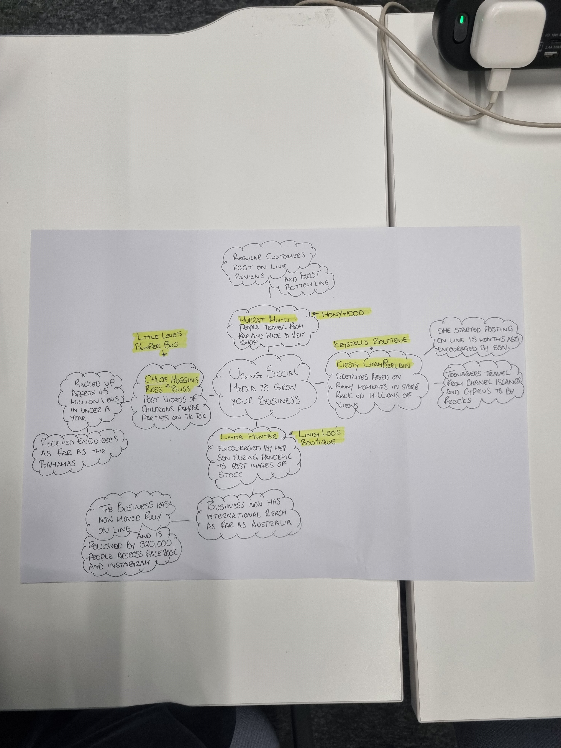
PART 2:
- Answer every question below in 1-3 full sentences.
- Use your own words. Do not use generative AI to answer these questions.
- Include a specific detail from the text when asked.
REMINDER
- The main idea is the overall message of the whole text.
- A key point helps to explain the main idea.
- A specific detail or example from the text shows that the key point is true.

- What is the main idea of the whole text?
This text talks about the benefits of advertising your business online, using various social media platforms, such as TikTok, Instagram and Facebook.

- What is one key point that supports the main idea, and which specific example from the text shows this?
Lindy Loos ’Boutique is a good example of how advertising your business online can boost sales and popularity. Linda currently has a social media following of 320,000 across Facebook and Instagram.

- What is a different key point that supports the main idea, and which specific example from the text shows this?
The Honywood sandwich shop located in Essex, post’s promotional videos on TikTok to increase sales and popularity, but they say it’s the “content posted from the customers” on social media that has “boosted its bottom line “. Some customers even travel for up to three hours to visit the Honywood sandwich shop.

- Which part of the text do you think is most important, and why?
The example from Krystalls Boutique stands out the most in my mind, as some of her customers travel from as far as the Channel Islands and Cyprus to buy a prom dress.

Reflection:
- What did you find difficult in this task (including in-class components), and why was it difficult?
I found question four the most difficult because I had to focus on a particular part of the text to get the information I needed, as opposed to the text overall.
In terms of the classroom component, creating the mind map was most challenging because I hadn’t done anything like that in a while.

- What helped you with this difficulty, and how did it help you?
I reviewed the text again, which helped me to decide what example to use to answer the question.

