

The effects of frame flex on the dynamics of a sport Motorcycle
  - A study to vailidation exercise
Connor Williams | Motorcycle B.Eng. | 10/11/2019

Abstract
This project was created to satisfy my thirst for information on the effects of frame rigidity of a modern motorcycle. You hear many things about how a bike feels and handles under varying dynamic situations, my interest is to study the particular effects of the frame in isolation from the various suspension components. Hopefully in less than a year I will become educated enough to progress towards further study in my final year at UWTSD.
I’ve been successful in persuading other students to study in this field alongside me, although both have focused on their own element of the topic. This is exciting as we can learn much more of the subject by our individual studies, than if we all shared the responsibilities of a narrow topic. Initially going our own way in our specific areas, then regrouping at various stages throughout the year and teaching each other about what we have learned. Another benefit of doing it this way is that it’s very difficult to estimate the learning curve of a particular subject, such as myself designing a frame in solid work, how long does that take? Do I know solid works well enough? Will it be accurate? Or does Yahye know about the production of carbon composite parts? Or Wes the rigidity of an engine and how it effects the frame stiffness? This way we can constantly change our project outcome to keep it challenging, or if the topic is far too in-depth and taking too much time, we can reign it back.
Each member has a responsibility to complete their topic and report back, without responsibility I don’t believe anything would get done. I will consider our project a success when I have learned the effects of frame stiffness along the axis of freedom a motorbike has.
I will think myself successful when I have received data from a 3D CAD model that corresponds to real data from measured motorcycle frame in torsional, Lateral and longitudinal stiffness. Comparing this data with a team members data, and analyzing the effects of the same frame but built from composite material.

The Team

Yahye | Interested in carbon composites and the benefits it has in reducing weight whilst maintaining the same flex characteristics of the existing frame material. Obviously, this is a massive topic with many challenges, the first of which is to learn as much as possible in the shortest time to hopefully get to a level where data can be gathered to help myself in my topic and Wes in his.
Wes | A similar project to mine but focused around a different configuration of chassis, an aluminum box type rather than the steel trellis of my part. This is interesting as its not possible to accurately make in solidworks and has to be 3d scanned first, made into a cloud point and then scaled accordingly. Wes should be very good at solidworks by the end of the year and we can help each other along the way.
Me | I will be looking at a standard road motorcycle and discovering its flex properties for the degrees of freedom it has in three ways; Firstly, with a 3d model in solid works, secondly with a static frame on a surface plate by measuring strain and deflection, and thirdly by attaching strain gauges to a motorcycle in a dynamic situation. I’m in my second year of university and appreciate that the researchers who do this professionally have been looking into the subject longer than I have been alive, I don’t expect to reinvent the wheel with the project, just validate the success of others in the subject of motorcycle dynamics, and concentrate my data for a given motorbike.

I scored 21 in the (Rosenman, 1950) “Type A behavior and your heart” test. Interestingly I agree with the result going from the typical Type A and Type B people, I do have both points of the spectrum. So hopefully I won’t have a heart attack caused by stress, but still have a sense of urgency!
Connor  Williams | Implementer | Coordinator | Shaper | Plant | Resource  Investigator | Monitor  Evaluator | Team  Worker | Complete  Finisher
Score | 14 | 8 | 14 | 4 | 7 | 10 | 7 | 6
The results of my (Belbin, 1969) evaluation are all average as well, the only worrying part is my low scoring team working ability. I find that interesting as I’ve worked as part of a team in quite a few situations; As a manager for a photography company, in previous university group projects and currently in my job as a Yamaha and Suzuki mechanic, just to name a few. I find that the effort put in is very closely related to what you will get out and find my input depends on the rest of the group and also the consequences of not performing. For instance, in my university projects very little effort was put in by other members of my group because they knew they would not get anything out of the assignment and the score would not affect anything in regards to their total grade when finishing, which makes sense, however I appreciated that although the task may have been a little silly, the underlying principles used were very relevant to the course, So I ended up doing a majority of the work. However, at work, my peers and I are more than happy to help each other out, the consequence of not being able deliver accurately and on time is obviously much higher.
That is why I am quite adamant that we all focus on something we are interested in, as soon as the project feels like a choir the sense of importance will go down…along with productivity and team work.
My ‘job’ within the team is not ‘team leader’, I much prefer ‘motivator’, I find giving people responsibility is much more effective than giving orders.
I will be looking at a standard road motorcycle and discovering its flex properties for the degrees of freedom it has in three ways; Firstly, with a 3d model in solid works, secondly with a static frame on a surface plate by measuring strain and deflection, and thirdly by attaching strain gauges to a motorcycle in a dynamic situation. I’m in my second year of university and appreciate that the researchers who do this professionally have been looking into the subject longer than I have been alive, I don’t expect to reinvent the wheel with the project, just validate the success of others in the subject of motorcycle dynamics, and concentrate my data for a given motorbike.

Tasks
My forecasted schedule.
Part | Description | Timescale
3D Model on Solidworks | This is the starting point for the project and allows me to get used to the solidworks platform and the process of FEA, useful for other modules in the course. | First semester/ before Christmas. Will also hopefully be done for the First Viva.
Static chassis validation | Proving my FEA is accurate, also nice to have a physical measurement rather than purely calculated data. | Second semester, may run into third.
Dynamic Validation | This is the most complex part. Complex and expensive. | Third semester once comfortable with static tests
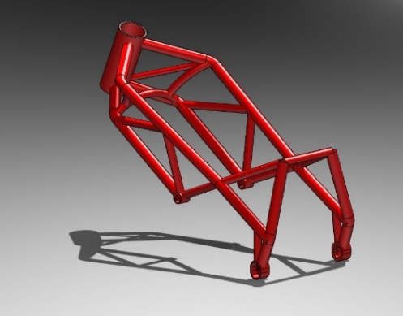
The 3d model is coming along really well so far with two different versions;
The first one is using the swept boss tool so the chassis is essentially one giant piece of material, this is much easier for the software to mesh together for FEA and with appropriate chamfers welds can also be replicated.

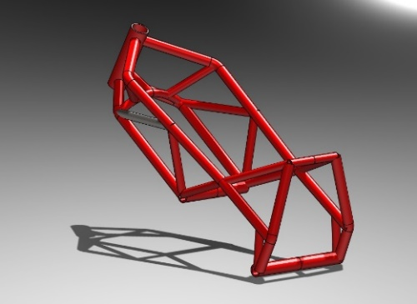
The second is via the Weldments section, this is exactly how you would image where the software treats each tube as a ‘beam’ that’s welded together. Its more realistic this way in terms of how the frame is manufactured but more complex to make the model behave in the correct way when loads are applied.
Frustratingly these models look identical, their construction is very different however.
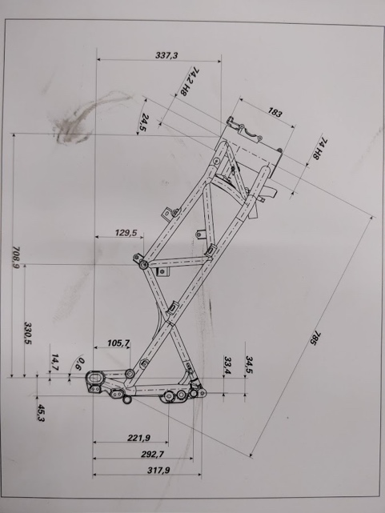
Both frames are based on a Ducati 999R constructed from a steel tube trellis frame, it’s the easiest frame to test as each tube will withstand a certain amount of torsional, lateral and longitudinal deflection. Rather than an aluminum beam frame which is harder to model accurately.
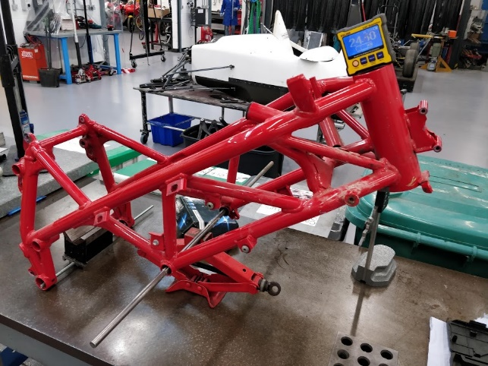
With very limited resources I’ve managed to source a frame from a Ducati 749, its identical in its construction with only minor none structural changes. However, its also from a bike that’s been in a very alarming crash and not quite straight anymore, however I have a copy of the dimensions from the workshop manual. Between the two I’ve managed to get a fairly accurate 3d model, that’s easily changed to suit any corrections it may need in the future.

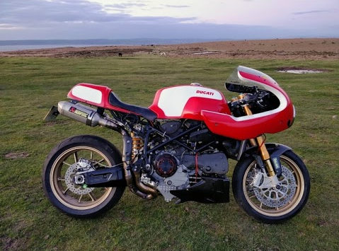
Thankfully I own a 999 so the final dynamic validation shouldn’t have any restrictions in terms of time or money…..or uni politics. Although I need to go through the static tests first to understand how the strain gauge measurements work. This can be done simply by removing the swingarm and bolting the bike by the swingarm mounts to a surface plate, more about this later.

How I can achieve this with my weekly schedule.
 | Monday | Tue | Wed | Thu | Fri | Sat | Sun
9am | Free | Free | Work | Management | Thermo | Work | Rest Day
11am | Free | Motorcycle  Dynamics | Work | Powertrain | Work | Work | Rest  Day
1pm | CAE & Stress | Free | Work | Free | Work | Work | Rest  Day
3pm (to 5pm) | Free | Free | Work | Group Project | Work | Work | Rest  Day
From this I can workout how much free time I have, I have tried to treat university as a job and spend dedicated time on subjects rather than sitting in front of a computer all night getting nowhere. As the group was formed on the 21st October and to be the project has to be handed in by 23rd of March, we have 154 days (22 weeks) to complete the project. Assuming 200 hours to complete the module that would mean working 9 hours a week. I have 16 free hours a week to complete both this and another Powertrain module, so I cannot deliver 200 hours to both modules. Currently I have been staying behind on Monday till around 7pm, Those extra 44 hours bring me up to a total time of 396 hours. So, I’m in the ball park for 200 hours per module and have other nights I can spend If I need too (hopefully my dog won’t pee on the floor while I’m away).
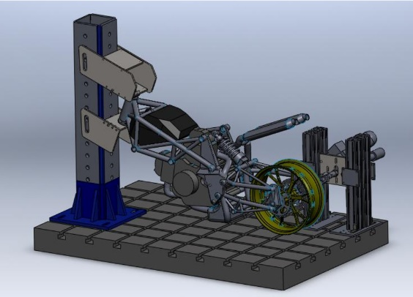
Costs and Equipment are fairly basic, the most demanding part will be getting the material to hold the chassis to the surface plate for the static tests. The workshop has various bits of steel purposely for student projects, a brief chat with Paul the workshop manager has assured me that an appropriate setup can be made easily without incurring addition costs and ordering new material, which I would like to avoid. This will be loosely based on a setup by the University of Padova known as “MotoStiff Meter” (University of Padova, 2015), a Jig designed to measure the vibration modes of various motorcycle structural components. Their setup allows the use of varying oscillations rather than simple linear displacement which is unfeasible for my project, I don’t think I would be able to get that in time for the project knowing the universities lead times upon request for funding and new equipment.
Figure 1 MotoStiff meter - University of Padova
However, a much more basic setup is possible measuring only deflection, force applied and frame strain in various points. However, I will likely hold the bike by the swingarm mount and apply force by the front tire contact patch, more detail will be shown later but this method allows measurement in two axes rather than one. Solidworks, a CAD software will be used in the project, the university has a student license for it so its free for the team to use for 3d modelling and FEA of the frames. For the purpose of this exercise and assignment I have been given an estimated cost of steel to make a small frame to hold the bike for the static tests, from (Express Metals, 2019) a local metal stockiest. From £50 - £150 would be the cost of material, thankfully with no lead time as they have a large stock. From my own experience as a fabricator in a previous life, it would take around 8 hours to make the setup.

Milestones & Gateway Objectives

The initial milestone was small sample tests which have already been completed.
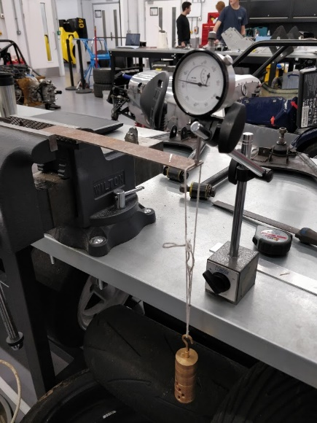
This was a test to ensure accuracy and more importantly the teams understanding of the physics of strain and deflection.
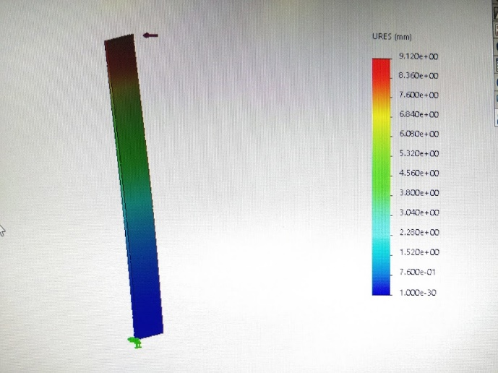

Two materials were tested, a 2mm strip of Aluminum and Steel. Yayhe has since made a similar strip from carbon which he would like to test also. Firstly, the deflection was calculated in excel, then modelled using FEA in solid words and finally measured in real life. This worked better than expected, all three were within 0.01 of a millimeter.
I then made a basic trellis frame in solid works to gain some experience before making a start on the larger model.
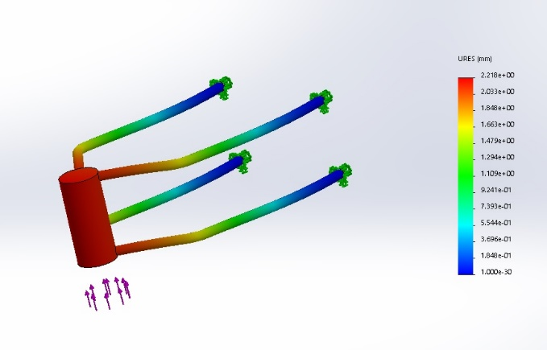
This did exactly what I wanted it too, I gained some valuable insight.
I also met with Kelvin Lake to discuss the options for making a full-scale model. He suggested that rather than making a model and testing it I should focus more on learning and understanding the FEA and 3d Modelling process, then start making the model.
The next step after researching FEA is to complete my full models and begin the FEA.
Once that is completed the project will really open up and I can do the real validation, so it really hangs on getting this done in the most efficient time frame, and accurate.
The major gateway will be will be when the CAD model is complete and I can begin getting data from it, As stated earlier this is being aimed for the first Viva. It’s definitely the most complex part of the project, I am assuming this to take the most time. I’m making the model in a way that’s easy to be altered at a later date as I don’t have all the measurements I need, Primarily the wall thickness of the frame tubes in various locations. I discussed this with Owen Williams who introduced me to an ultrasound-based tool that can measure thickness non-destructively, although it’s taking time to have access. So far, I have estimated the thickness for the sake of continuing progress, but as I said, its very easy to change this when I get the data.
Thirdly will be getting the real measurements from the frame. An exciting part of the project as from this point it becomes ‘hands on’. How I approach this will depend on the amount of support I can get from the workshop of the university.
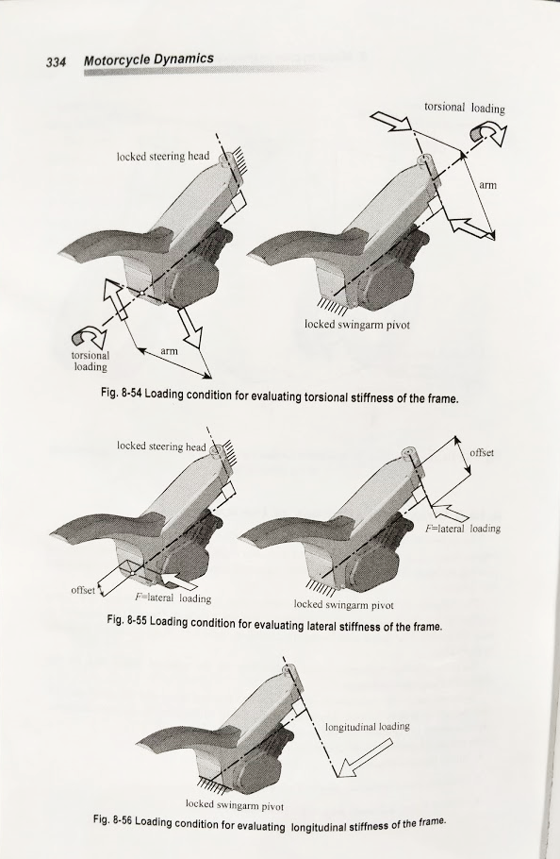
The way the frame will be held is obviously vitally important to the measurements. My holding jig will be based up (Cossalter, 2006) with one major difference. I will be measuring with the front fork and wheel assembly of the vehicle in place, essentially measuring the flex from the swingarm mounting point to front tire contact patch. I am able to isolate the frame from the front frame assembly (forks and wheel), by assuming the front static characteristics of deflection and spring rate based on (Taraborrelli, 2016) of a 1000cc sport motorcycle. This will allow me to see directly what is happening to the frame in the two degrees of freedom, Lateral and longitudinal. Even more important it will allow me to test this by only removing the swingarm of the bike and mounting it to a surface plate, rather than a complete disassembly.
Figure 2 Page 334, Motorcycle Dynamics

Risk management

A Gantt chart was created to ensure we stayed on target, or more importantly if we didn’t how we could correct it to catch up.
If all goes well it should be a simple project to predict – and thankfully – fairly low risk too. I have purposely planned it this way. I hope to continue and expand on this project in my final year, so I have more reason than usual to complete it on time. However, two flaws could be found in my plan.
Firstly, my lack of FEA knowledge could be grossly under looked, extending the first part of my plan (Ducati CAD Model) and pushing the rest of my section of the project back, even worse is that the data gathered by my FEA could be used by Yahye and failure by my part could push the entire project back. I have two redundancies in place for this, Wes is also using FEA to find similar results to me and (Cossalter, 2006) already has a baseline for a range of motorcycle frame deflection in his book. It may be outdated, but It is still relevant.
Secondly, I need a surface plate to measure the bike. Limited space in the workshops could leave me very stuck, especially at that time of year where everyone is very busy with projects. I have already spoke to Paul about my project and he has assured me that I shouldn’t have that problem, but if I do. It may mean that any dynamic testing of the bike may be out of the window with the large delays.

References
Belbin, D. M., 1969. A study of group behaviour , Henley-on-Thames: Henley Business School.
Cossalter, V., 2006. Motorcycle Dynamics. Padova: Lightening Source UK, LTD.
Express Metals, 2019. https://www.expressmetals.co.uk/plate-durbar-mild-steel/. [Online]
Available at: https://www.expressmetals.co.uk
[Accessed 10th November 2019].
Taraborrelli, L., 2016. Identification and improvement of the dynamic properties of the components of two-wheeled vehicle, Padova: University of Padova.
University of Padova, 2015. Moto Stiff Meter. Padova: University of Padova.

