

University of Wales Trinity Saint David
Wales Institute of Science & Art

ACEA6005 – Structural & Fluid Analysis

Fluid Flow: The Pelton Wheel
Student Name: Antony Gwilym Pugh
Student Number: 2221728
Programme: BEng (Hons) Mechanical Engineering
Lecturer: Kelvin Lake
Internal Verifier: Tim Tudor
Submission Date: 10th August 2026
Word Count: 3081
Contents
Abstract 1
1. Introduction 2
2. Development, Materials, Manufacture and Quality 3
2.1 Historical development 3
2.2 Current technology and applications 3
2.3 Future developments 4
2.4 Materials 4
2.5 Manufacturing processes 5
2.6 Quality control and inspection 6
3. Experimental Determination of Turbine Characteristics 7
3.1 Aim and apparatus 7
3.2 Experimental procedure 8
3.3 Theory and data reduction 9
3.4 Results: speed versus power and efficiency 10
3.5 Critical appraisal of results 13
4. Fluid Flow Around the Pelton Wheel 15
4.1 Jet formation and bucket impingement 15
4.2 Boundary layer and surface friction 15
4.3 Flow separation, windage and interference losses 16
4.4 Critical appraisal 17
5. Codes of Practice and Industry Standards 18
6. Conclusions and Recommendations 20
6.1 Conclusions 20
6.2 Recommendations 20
7. References 21
8. Appendices 24
Appendix A — Full experimental data 24
Appendix B — Sample calculations 25
Appendix C — Additional figures 29

Table of Figures
Figure 1: Experimental Pelton wheel apparatus. 8
Figure 2: Shaft power and efficiency against rotational speed at constant head. 13
Figure 3: Fluid flow and loss mechanisms around the Pelton bucket (Xiao et al., 2013). 17
Figure 4: Speed v Torque (constant head) 29
Figure 5: Speed v Power (constant head) 29

Table of Tables
Table 1: Comparison of Pelton runner materials. 5
Table 2: Principal manufacturing routes for Pelton runners. 6
Table 3: Test parameters and derived quantities. 7
Table 4: Experimental results — shaft power and efficiency against rotational speed. 12
Table 5: List of Codes of Practice and Industry Standards 18
Table 6: Full experiment data 24
Table 7: Raw data for calculations 25
Table 8: Final calculated example 26
Table 9: Given Pelton wheel values 27
Table 10: Final calculated for speed difference 28

Abstract
This report investigates the operating characteristics and fluid behaviour of a laboratory Pelton wheel. It relates the experimental observations to modern industrial hydropower practice. The study examines the historical development of the Pelton turbine together with its materials, manufacturing processes and quality control requirements. It also evaluates the experimental speed-power and efficiency characteristics under constant hydraulic conditions. The report also analyses the internal fluid flow, including jet impingement, boundary layer development and flow separation. It goes on to discuss the importance of international engineering standards in turbine design, testing and maintenance. Experimental testing identified a maximum shaft power of approximately 12.57 W and a peak efficiency of 65% at approximately 600-640 rev min⁻¹. Overall, the investigation demonstrated good agreement with Pelton turbine theory while highlighting the influence of real hydraulic losses on practical performance.

1. Introduction
The Pelton wheel is a high-head, low-flow impulse turbine widely used in hydroelectric power generation where large hydraulic heads are available. Unlike reaction turbines, the Pelton turbine converts the pressure energy of water into a high velocity free jet before it reaches the runner. Mechanical shaft power is then produced through the change in momentum as the jet is deflected by the split buckets. This makes the turbine one of the most efficient machines for mountainous hydropower installations.

The aim of this investigation was to determine the shaft power and efficiency characteristics of the laboratory Pelton turbine operating at constant hydraulic head and flow rate. Experimental measurements were used to calculate torque, shaft power and efficiency over a range of operating speeds before comparing the results with established Pelton turbine theory.

The report first reviews the historical development, materials, manufacturing processes and quality control methods used for modern Pelton turbines before presenting the experimental investigation. The internal fluid mechanics are then analysed with particular emphasis on jet formation, boundary layer development and flow separation. Finally, the relevant international standards governing design, acceptance testing, inspection and long-term operation are discussed.

2. Development, Materials, Manufacture and Quality

2.1 Historical development
The Pelton wheel was developed by Lester Allan Pelton during the California gold-rush era, where efficient water-powered machinery was needed for mining operations (Crawford, 2012). He observed that conventional water wheels lost significant energy because the water jet struck the buckets directly. Consequently, Pelton developed a split-bucket design incorporating a central splitter. This innovation divided the jet into two equal streams and reversed the direction of the water while minimising its exit velocity. This enabled a much greater proportion of the water’s kinetic energy to be converted into mechanical work (ASME, 2024). The initial prototypes were developed during the mid-1870s, followed by the first Pelton turbine installed in California in 1878 (ASME, 2024), although other historical accounts record the first operational installation at the Mayflower Mine in Nevada City, California, in the same year (Crawford, 2012). This discrepancy reflects differences in historical sources regarding whether the first installation refers to an early prototype or the first successful commercial application. Pelton patented the design in 1880 (US Patent 233,692; Pelton, 1880) before establishing the Pelton Water Wheel Company in San Francisco in 1888. By 1900, more than 11,000 Pelton wheels had reportedly been installed worldwide, demonstrating the rapid adoption of the technology for high-head hydropower applications (Doble, 1938; ASME, 2024). This success laid the foundation for later impulse turbines, particularly the Turgo turbine, while the split-bucket principle remains fundamental to the high hydraulic efficiency of modern Pelton turbines (Benzon, Aggidis and Anagnostopoulos, 2016; Quaranta and Trivedi, 2021).

2.2 Current technology and applications
Modern Pelton turbines are primarily used in high-head, low-flow hydroelectric schemes. They typically operate between approximately 60 m and 1,800 m of hydraulic head while achieving peak hydraulic efficiencies of approximately 90–92% (Quaranta and Trivedi, 2021). Their impulse operating principle allows them to maintain high efficiency over a wide operating range, making them suitable for variable flow conditions, peak-load generation and pumped-storage schemes that support electrical grid stability (Quaranta and Trivedi, 2021). Pelton turbines are manufactured in sizes ranging from micro-hydropower systems serving remote communities to utility-scale installations producing several hundred megawatts, demonstrating their versatility across a wide power range (Garg, 2023). One of the most significant examples is the Bieudron Power Station in Switzerland, which uses three vertical-axis, five-jet Pelton turbines, each producing 423 MW under a gross head of approximately 1,883 m, making it one of the world's highest-head hydroelectric installations (Grande Dixence, 2024). Around 16% of installed hydroelectric turbines in Europe are Pelton machines, highlighting their continued importance in mountainous regions where hydraulic head is available (Quaranta and Trivedi, 2021).

2.3 Future developments
Future developments focus on improving efficiency, durability and sustainability. Transient three-dimensional computational fluid dynamics (CFD) is now widely used to model the complex jet-bucket interaction. This allows designers to optimise bucket geometry while predicting splash losses and pressure distribution that cannot be captured by analytical methods (Chitrakar et al., 2020). Hybrid manufacturing methods, such as Cold Metal Transfer (CMT) welded build up and wire laser additive manufacturing, are also reducing material waste and improving the mechanical properties of critical components (Tomar and Shiva, 2023). Research continues into erosion resistant coatings, fluid-structure interaction and improving downstream water quality (Quaranta and Trivedi, 2021).

2.4 Materials
Industrial Pelton runners are typically manufactured from CA6NM (13Cr-4Ni) martensitic stainless steel because it provides high strength, excellent toughness and resistance to corrosion, cavitation and fatigue (Quaranta and Trivedi, 2021; IEC 62364, 2019). The bucket root experiences the greatest cyclic stresses and therefore requires high fatigue resistance to prevent catastrophic failure. Smaller laboratory and research turbines commonly use aluminium alloys or polymer composites because they are inexpensive and easy to manufacture. As shown in Table 1, CA6NM offers the most suitable balance between mechanical performance and durability.

Table 1: Comparison of Pelton runner materials.
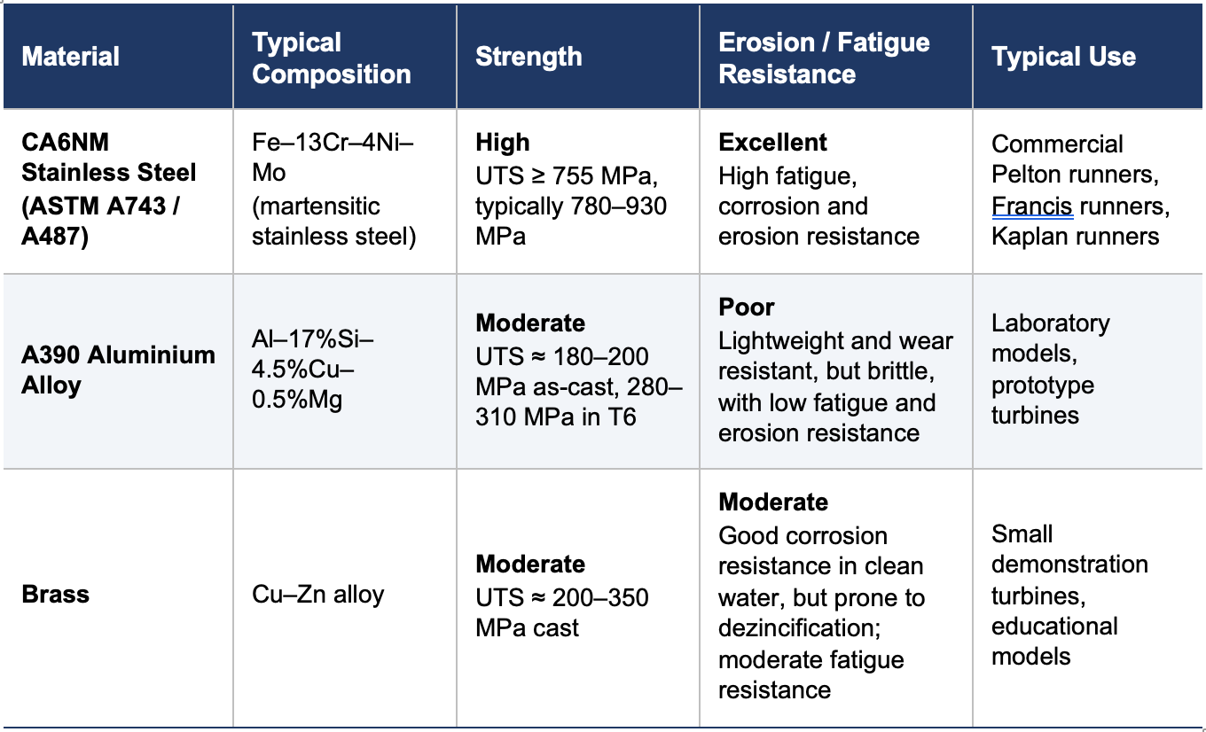
Source: compiled by the author from ASTM International (2020; 2021), Copper Development Association (no date), Ishola et al. (2019), Kaufman and Rooy (2004), ASM International (1990)and Padhy and Saini (2011; 2012).

2.5 Manufacturing processes
Pelton runners are manufactured by integral casting, machining from a forged CA6NM disc or welded bucket build-up onto a forged hub. Forged runners provide superior structural integrity but require extensive CNC machining, removing up to 70% of the original material. The Andritz MicroGuss process uses automated welding to build bucket profiles onto a forged hub. This reduces manufacturing time while improving fatigue performance. In both the machined-from-forging and welded build-up manufacturing routes, the highly loaded bucket root is forged rather than cast. This provides improved fatigue strength and corrosion-fatigue resistance. Table 2 compares the advantages and limitations of each manufacturing route (ANDRITZ AG, 2018).

Table 2: Principal manufacturing routes for Pelton runners.
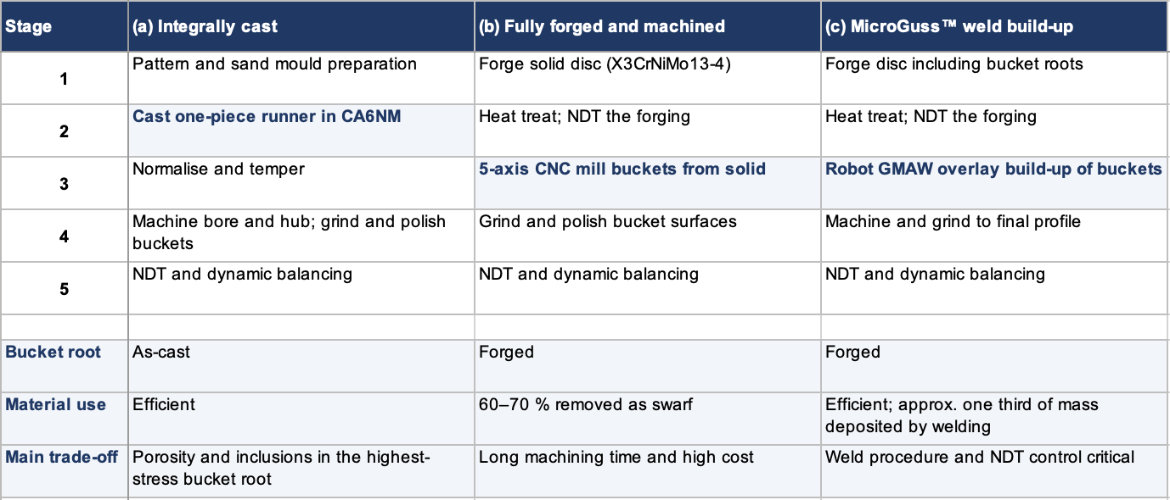
Source: drawn by the author from ANDRITZ AG (2018) and Appleyard (2012).

2.6 Quality control and inspection
Quality control combines non-destructive testing with dimensional inspection to ensure both structural integrity and hydraulic performance. Ultrasonic testing (UT), dye penetrant testing (PT), magnetic particle testing (MT) and radiographic testing (RT) are routinely used to detect surface and internal defects in turbine runners before commissioning (Appleyard, 2012). In addition, coordinate measuring machines (CMMs) are used to verify bucket geometry and runner concentricity (Appleyard, 2012). During service, inspection programmes focus on detecting fatigue cracks at the bucket root together with cavitation and hydro abrasive erosion damage. This is because these defects have the greatest influence on structural integrity and turbine efficiency (Rai et al., 2020). Acceptance criteria are supported by IEC 60609-2 for cavitation pitting evaluation of Pelton runners and IEC 62364 for hydro abrasive erosion assessment, providing standardised methods for inspection, evaluation and maintenance planning.

3. Experimental Determination of Turbine Characteristics

3.1 Aim and apparatus
The aim of this experiment was to determine the speed-power and efficiency characteristics of a laboratory Pelton turbine operating under a constant hydraulic supply. The investigation was carried out using a GUNT HM 150.19 Pelton turbine demonstrator (Figure 1). The set-up consisted of a single nozzle with an adjustable spear valve, and a Pelton runner enclosed with a transparent casing. The runner has an outer diameter of 132 mm with 14 buckets and is supplied by a 10 mm diameter nozzle (GUNT, 2026). In addition, there was a band brake fitted with two spring force meters, a digital tachometer for measuring rotational speed, and a pressure gauge monitoring the inlet pressure. The fixed experimental parameters used throughout the investigation are summarised in Table 3.

Table 3: Test parameters and derived quantities.
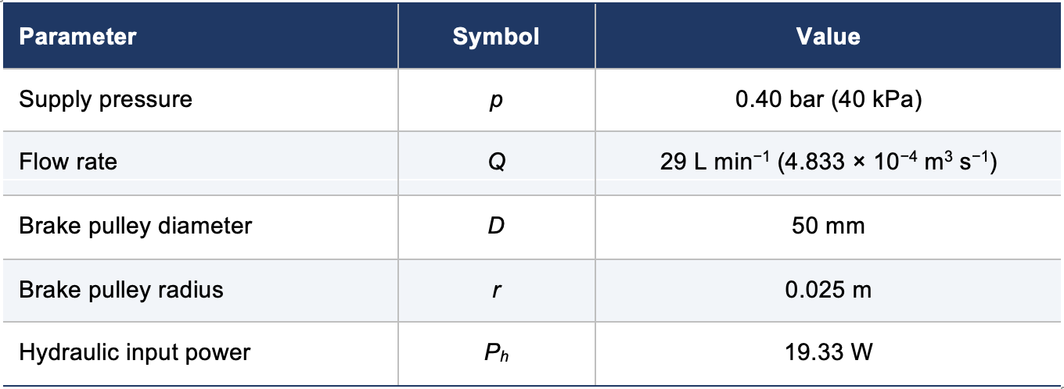
Source: rig settings and measurements recorded by the author. r and P_{h} are derived values, not direct readings.
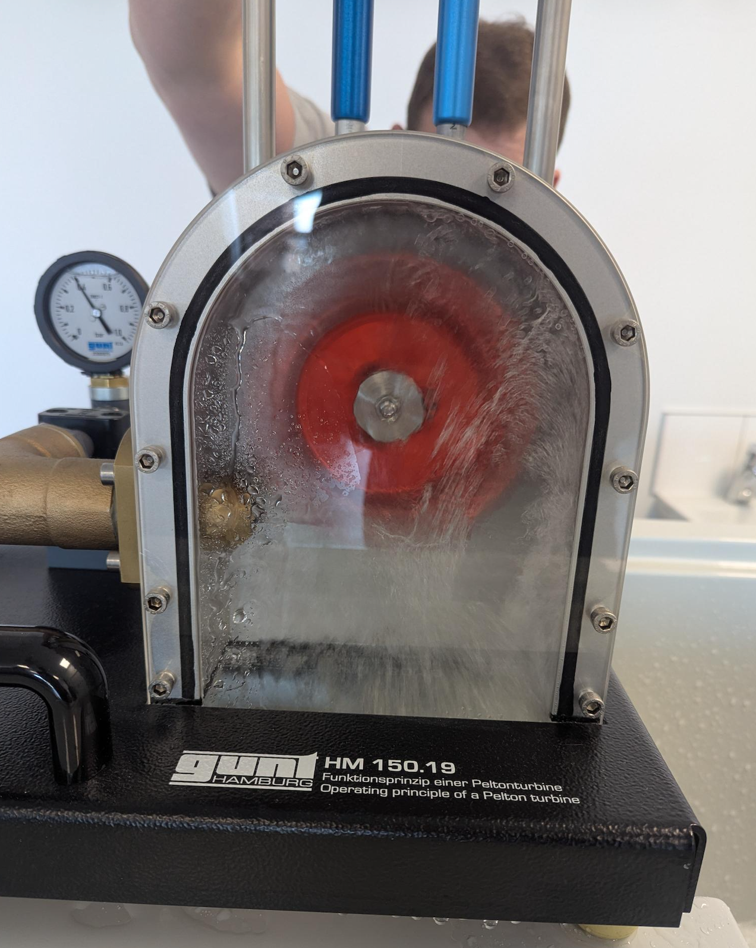

Figure 1: Experimental Pelton wheel apparatus.

3.2 Experimental procedure
The hydraulic supply was started and adjusted until the inlet pressure stabilised at 0.40 bar. The flow rate was maintained at 29 L min⁻¹ throughout the experiment to ensure constant hydraulic power.

Testing began with the brake unloaded, allowing the runner to rotate at its maximum (runaway) speed. The braking force was then increased incrementally by tightening the band brake. After each adjustment, sufficient time was allowed for the turbine speed to stabilise before measurements were recorded.

At each operating point, the readings from both force meters and the shaft rotational speed were recorded. This procedure was repeated until the braking force was sufficient to bring the turbine to a complete stop (stall condition). The recorded measurements were subsequently reduced to determine torque, shaft power and efficiency.

3.3 Theory and data reduction
The net braking force acting on the brake pulley was calculated from the difference between the two spring balance readings:
$F=F_{1}-F_{2}$ (1)
The shaft torque was determined from
$T=Fr$ (2)
where r is the brake pulley radius (0.025 m).
Angular velocity was calculated from the measured rotational speed:
$ω=\frac{2πN}{60}$ (3)
where N is the rotational speed in rev min⁻¹.
The shaft output power was then obtained from
$P=Tω$ (4)
Hydraulic input power remained constant throughout the experiment:
$P_{h}=pQ$ (5)
Using the measured pressure (40 kPa) and flow rate (4.833 × 10⁻⁴ m³ s⁻¹),
$P_{h}=(40 000)(4.833×{10}^{-4})=19.33 W$ (6)
Finally, turbine efficiency was determined from
$η=\frac{P}{P_{h}} × 100$ (7)

Worked example (600 rev min⁻¹):
- Force meter 1 = 13 N
- Force meter 2 = 5 N
- Net braking force:
$$F=13-5=8 N$$
Torque:
$$T=8×0.025=0.20 N m$$
Angular velocity:
$$ω=\frac{2π(600)}{60}=62.83 rad s^{-1}$$
Output power:
$$P=0.20×62.83=12.57 W$$
Efficiency:
$$η=\frac{12.57}{19.33}=0.65 (65\%)$$

This agrees with the calculated values presented in Table 6 (Appendix A).

3.4 Results: speed versus power and efficiency
The experimental results presented in Table 4 demonstrate the characteristic behaviour of an impulse turbine operating under constant hydraulic input. At no load the turbine achieved a maximum speed of approximately 1185 rev min⁻¹, although the shaft power remained low because very little torque was produced. The full data set is given in Appendix A.

As the braking load increased, rotational speed decreased while torque increased. Consequently, shaft power rose steadily, reaching a maximum value of approximately 12.57 W between 600 and 640 rev min⁻¹. Beyond this operating point, further increases in braking force reduced rotational speed more rapidly than torque increased. This caused the shaft power to decrease until it reached zero when the turbine stalled.

Maximum efficiency was approximately 65%, occurring at the same operating speed as the maximum shaft power. Efficiency approached zero at both the runaway condition and the stall condition.

The results agree well with Pelton turbine theory, which predicts that maximum energy transfer occurs when the bucket speed is approximately one half of the jet velocity (Zhang, 2016). The measured peak occurring at approximately 600–640 rev min⁻¹, around half of the no-load speed, is therefore consistent with the expected operating characteristics of an impulse turbine.

Table 4: Experimental results — shaft power and efficiency against rotational speed.
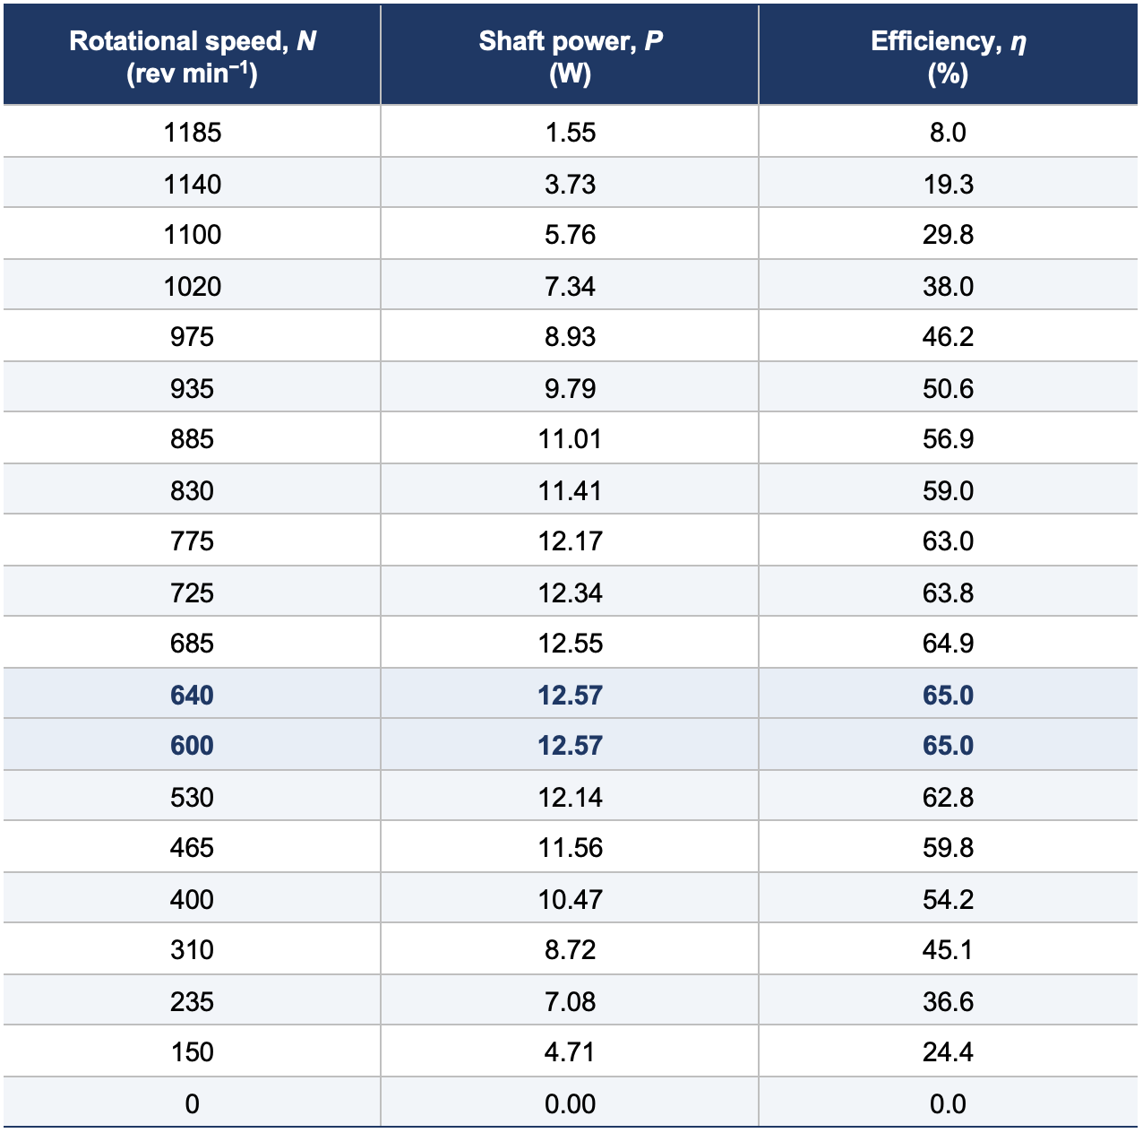
Source: measurements recorded by the author. Peak operating points are shown in bold.
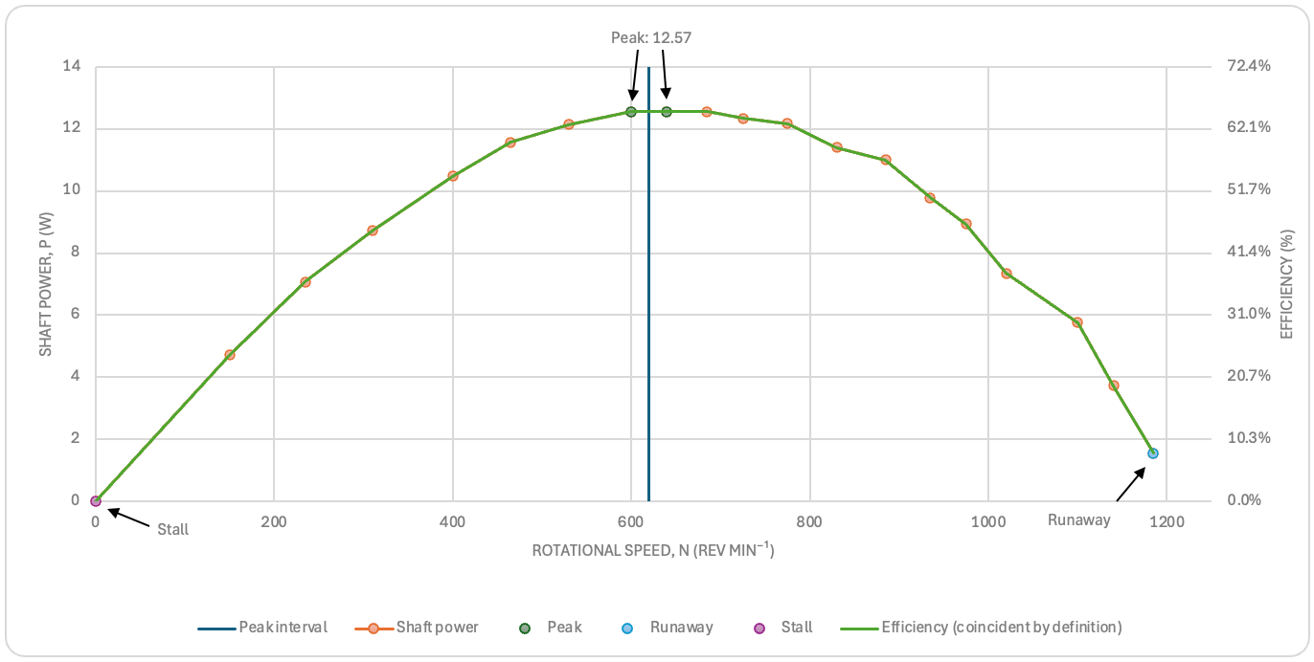
Figure 2: Shaft power and efficiency against rotational speed at constant head.
Source: plotted by the author from the data in Table 4. The efficiency curve is coincident with the power curve because P_{h} is constant at 19.33 W.

3.5 Critical appraisal of results
The measured performance closely followed the theoretical characteristics of a Pelton turbine, with both maximum power and efficiency occurring at an intermediate rotational speed. The peak efficiency of approximately 65% is lower than the 90% achievable by full scale hydroelectric turbines (Quaranta and Trivedi, 2021). This reflects the additional losses present in laboratory equipment. These include nozzle losses, bucket surface friction, residual exit kinetic energy, bearing friction, brake friction and air resistance. Using the measured supply pressure of 0.4 bar and the 132 mm runner outer diameter, taken here as an approximation to the pitch circle diameter, the calculated speed ratio at the peak power condition (640 rev min⁻¹) is U/V ≈ 0.495, which agrees closely with the theoretical optimum of approximately 0.5 for maximum energy transfer. The measured runaway speed of 1185 rev min⁻¹ was also lower than the theoretical value of approximately 1290 rev min⁻¹, consistent with the hydraulic and mechanical losses identified above (see Appendix B). Experimental uncertainty also influenced the calculated values. Small errors in tachometer readings directly affect angular velocity and shaft power, while inaccuracies in the force meters alter the calculated braking force and torque. Variations in pressure, flow rate or insufficient settling time between readings may also contribute to scatter in the results. The reliability of the experiment could be improved by calibrating the instruments and repeating measurements to obtain average results.

4. Fluid Flow Around the Pelton Wheel

4.1 Jet formation and bucket impingement
The Pelton turbine is an impulse turbine in which pressure energy in the penstock is converted into kinetic energy within the nozzle before reaching the runner. The spear valve regulates the jet diameter while the nozzle accelerates the flow to approximately 8.9 m s⁻¹ under the test conditions. Assuming negligible losses, the jet velocity can be approximated by $V=C_{v}\sqrt{2gH}$, where $C_{v}$ is the nozzle velocity coefficient, $g$ is gravitational acceleration and $H$ is the available head. Unlike Francis or Kaplan turbines, the runner operates in air at atmospheric pressure. This means power is produced by the change in water momentum rather than a pressure drop across the runner (Sandmaier, Meusburger and Benigni, 2023).

The high-speed jet strikes the splitter ridge and divides into two streams that flow around the twin buckets before leaving at approximately 165–170° (Quaranta and Trivedi, 2021). This large change in momentum generates the force that rotates the runner. Before reaching the runner, however, CFD studies indicate that boundary layer development on the injector needle produces a non-uniform jet, reducing the jet-core velocity by approximately 12% compared with the ideal profile (Marcelo Aldana, Abad and Merino, 2026). The flow is also neither steady nor ideal. It consists of a turbulent free-surface mixture of water and air with continuously changing pressure and velocity distributions. CFD studies show that these transient flow conditions reduce the efficiency predicted by simple momentum theory. This is because some kinetic energy is lost through turbulence and splashing before it can be converted into mechanical work (Zhao et al., 2023).

4.2 Boundary layer and surface friction
As the water flows across the bucket surface, a boundary layer develops because the fluid in contact with the metal satisfies the no slip condition. Within this region, viscous shear slows the flow, reducing the relative exit velocity and therefore the momentum transferred to the runner (Zhang, 2016).

The boundary layer thickens as the water travels around the bucket, increasing friction losses. A smooth polished bucket and a splitter edge of less than 1 mm reduce flow disturbance, minimise wall shear and help maintain attached flow. Consequently, manufacturing quality, surface finish and bucket geometry are closely linked to hydraulic efficiency because they influence boundary layer development, friction losses and the degree of flow separation across the bucket surface (Zhang, 2016).

4.3 Flow separation, windage and interference losses
Flow separation occurs when an adverse pressure gradient causes the boundary layer to detach from the bucket surface. This creates recirculating vortices that increase turbulence and dissipate kinetic energy, reducing the amount of useful work extracted from the jet (Fan, Sun and Guo, 2024). Similar separation can occur around the spear valve, producing a less uniform jet before impact.

Additional losses arise from interference between successive buckets. If the timing is imperfect, part of the incoming jet strikes the rear of the previous bucket instead of the splitter, reducing momentum transfer. Water leaving the buckets also forms spray and droplets that interact with rotating buckets and the surrounding air, creating windage and ventilation losses. These complex free surface interactions are difficult to model accurately, even using modern CFD (Sandmaier, Meusburger and Benigni, 2023), as illustrated in Figure 3. Collectively, friction, flow separation and interference losses explain why the experimental efficiency measured in Section 3.5 peaked at approximately 65%, rather than approaching the theoretical value predicted by ideal momentum analysis.
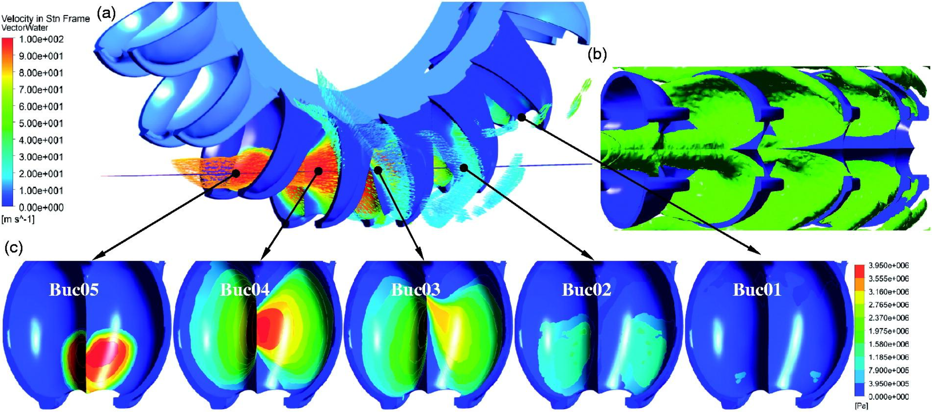
Figure 3: Fluid flow and loss mechanisms around the Pelton bucket (Xiao et al., 2013).

4.4 Critical appraisal
One-dimensional momentum theory provides a useful estimate of Pelton turbine performance but assumes steady, frictionless flow and therefore cannot represent the real hydraulic behaviour. In practice, the jet undergoes boundary layer development, turbulence, air entrainment and flow separation, all of which reduce energy transfer. CFD provides valuable insight into pressure distribution, velocity fields and transient jet bucket interaction, leading to improved bucket design. However, accurately modelling splash, droplet formation and ventilation remains challenging because of the complex two-phase free-surface flow. The difference between the theoretical efficiency and the measured value of approximately 65% demonstrates that these real flow losses are significant and must be considered alongside simplified analytical calculations when evaluating turbine performance.

5. Codes of Practice and Industry Standards
Table 5: List of Codes of Practice and Industry Standards
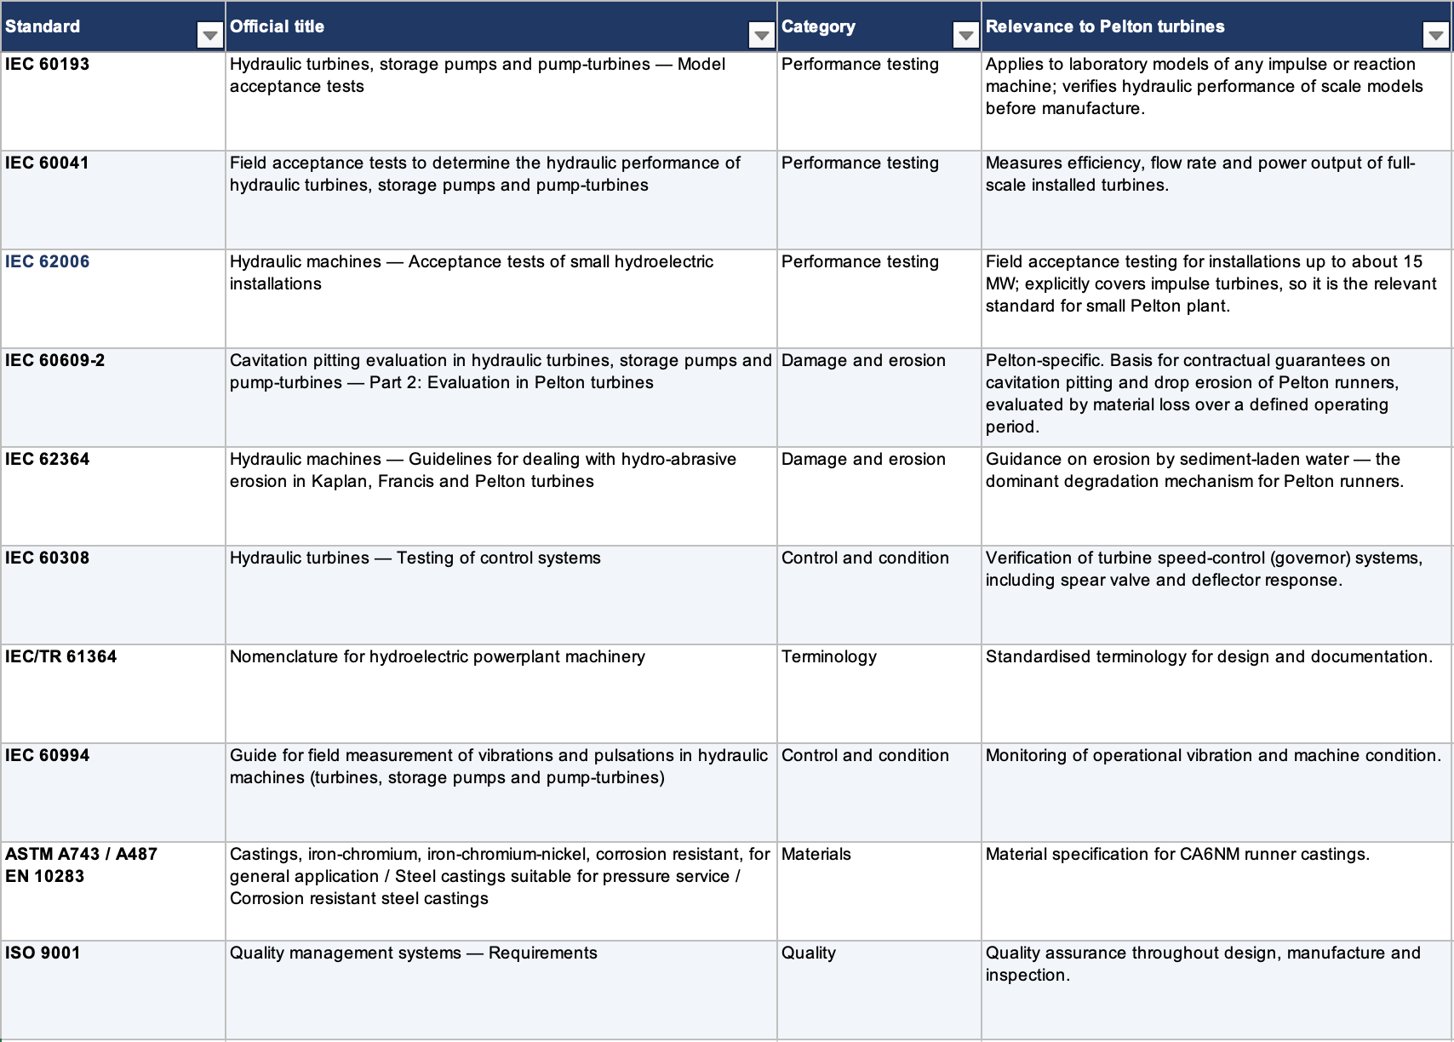

The principal standards relevant to this application are summarised in Table 5. International standards provide a consistent framework for the design, manufacture, testing and long-term operation of Pelton turbines. During the design stage, IEC 60193 specifies laboratory model acceptance tests that allow scale models to be evaluated before full-size manufacture. These tests verify predicted hydraulic efficiency, power output and flow characteristics, reducing technical risk and improving confidence in the final design (IEC 60193, 2019).

Once installed, hydraulic performance is verified using IEC 60041, which defines procedures for field acceptance testing of full-scale turbines. Measurements of flow rate, rotational speed, hydraulic head, shaft power and efficiency confirm that the installed unit meets contractual performance guarantees (IEC 60041, 1991). For smaller hydroelectric schemes, IEC 62006 provides equivalent guidance tailored to small hydropower applications (IEC 62006, 2010).

Long term reliability is addressed through standards relating to wear mechanisms. IEC 60609-2 establishes procedures for assessing cavitation pitting on Pelton buckets. It provides an objective basis for cavitation guarantees and maintenance planning (IEC 60609-2, 1997). Similarly, IEC 62364 offers guidance on hydro abrasive erosion caused by sediment laden water. It identifies material performance factors for 13Cr-4Ni martensitic steels such as CA6NM, supporting the material selection discussed in Section 2 (IEC 62364, 2019).

Material quality and manufacturing consistency are governed by ASTM A743/A487 or the European equivalent EN 10283. They specify the chemical composition and mechanical properties of CA6NM castings. Throughout manufacture, non-destructive testing methods including ultrasonic, magnetic particle, dye penetrant and radiographic inspection verify casting integrity. In addition, ISO 9001 quality management systems ensure traceability and process control (ISO 9001, 2015). Supporting standards such as IEC 60308, IEC/TR 61364 and IEC 60994 further ensure reliable governor performance, consistent technical terminology and effective vibration monitoring during service (IEC 60308, 2005; IEC/TR 61364, 1999; IEC 60994, 1991).

6. Conclusions and Recommendations

6.1 Conclusions
This investigation successfully determined the operating characteristics of a laboratory Pelton turbine under constant hydraulic conditions. The experimental results showed a maximum shaft power of approximately 12.57 W and a peak efficiency of 65% at a rotational speed of approximately 600–640 rev min⁻¹, which agrees well with the theoretical operating characteristics of an impulse turbine. The study demonstrated that real hydraulic losses, including boundary layer friction, flow separation, turbulence, windage and interference between successive buckets, reduce the amount of kinetic energy converted into useful mechanical work.

6.2 Recommendations
The accuracy of future experimental work could be improved through calibration of all measuring instruments and by repeating tests to obtain average values and reduce random error. Direct measurement of jet velocity would provide a more complete assessment of hydraulic performance, while testing over a range of operating heads would allow the influence of head on turbine characteristics to be evaluated. For industrial Pelton turbines, improvements in bucket surface finish, erosion resistant coatings and CFD optimised bucket geometry could further reduce hydraulic losses and improve overall efficiency.

7. References
ANDRITZ AG (2018). Cutting edge – manufacturing for a demanding market. [online] Andritz.com. Available at: https://www.andritz.com/hydro-en/hydronews/hn-europe/manufacturing [Accessed 6 Aug. 2026].
Appleyard, D. (2012). Welding Pelton runners. [online] Factor ThisTM. Available at: https://www.hydroreview.com/business-finance/welding-pelton-runners [Accessed 6 Aug. 2026].
ASM International (1990). ASM handbook. 10th edn. Materials Park, OH: ASM International.
ASME (2024). Pelton waterwheel collection. [online] Asme.org. Available at: https://www.asme.org/about-asme/engineering-history/landmarks/157-pelton-waterwheel-collection [Accessed 28 June 2026].
ASTM International (2020). ASTM A487/A487M-20: Standard specification for steel castings suitable for pressure service. West Conshohocken, PA: ASTM International.
ASTM International (2021). ASTM A743/A743M-21: Standard specification for castings, iron-chromium, iron-chromium-nickel, corrosion resistant, for general application. West Conshohocken, PA: ASTM International.
Benzon, D.S., Aggidis, G.A. and Anagnostopoulos, J.S. (2016). Development of the Turgo impulse turbine: past and present. Applied Energy, 166, pp.1–18. doi:10.1016/j.apenergy.2015.12.091.
Chitrakar, S., Solemslie, B.W., Neopane, H.P. and Dahlhaug, O.G. (2020). Review on numerical techniques applied in impulse hydro turbines. Renewable Energy, 159, pp.843–859. doi:10.1016/j.renene.2020.06.058.
Copper Development Association (n.d.). Copper and copper alloy microstructures: brasses. [online] Copper.org. Available at: https://www.copper.org/resources/properties/microstructure/brasses.php [Accessed 6 Aug. 2026].
Crawford, M. (2012). Lester Allan Pelton. [online] Asme.org. Available at: https://www.asme.org/topics-resources/content/lester-allan-pelton [Accessed 28 June 2026].
Doble, W.H. (1938). The Pelton water wheel. Transactions of the American Society of Mechanical Engineers, 60, pp.361–372.
Fan, W., Sun, L. and Guo, P. (2024). Investigation on unstable flow characteristics and energy dissipation in Pelton turbine. Engineering Applications of Computational Fluid Mechanics, 18(1). doi:10.1080/19942060.2024.2304643.
Garg, K. (2023). Pelton turbine: working principle, design and simulation. [online] SimScale. Available at: https://www.simscale.com/blog/pelton-turbine [Accessed 3 Aug. 2026].
Grande Dixence (2024). Grande Dixence: technical documentation. [online] Available at: https://www.grande-dixence.ch/files/Grande-Dixence-Technical-documentation-2.pdf [Accessed 3 Aug. 2026].
GUNT (2026). HM 150.19 operating principle of a Pelton turbine. [online] Gunt.de. Available at: https://www.gunt.de/en/products/fluid-machinery/turbomachines/hydraulic-turbines/operating-principle-of-a-pelton-turbine/070.15019/hm150-19/glct-1:pa-148:ca-756:pr-566 [Accessed 1 Aug. 2026].
IEC 60041 (1991). Field acceptance tests to determine the hydraulic performance of hydraulic turbines, storage pumps and pump-turbines. Geneva: International Electrotechnical Commission.
IEC 60193 (2019). Hydraulic turbines, storage pumps and pump-turbines – model acceptance tests. Geneva: International Electrotechnical Commission.
IEC 60308 (2005). Hydraulic turbines – testing of control systems. Geneva: International Electrotechnical Commission.
IEC 60609-2 (1997). Cavitation pitting evaluation in hydraulic turbines, storage pumps and pump-turbines – Part 2: evaluation in Pelton turbines. Geneva: International Electrotechnical Commission.
IEC 60994 (1991). Guide for field measurement of vibrations and pulsations in hydraulic machines (turbines, storage pumps and pump-turbines). Geneva: International Electrotechnical Commission.
IEC 62006 (2010). Hydraulic machines – acceptance tests of small hydroelectric installations. Geneva: International Electrotechnical Commission.
IEC 62364 (2019). Hydraulic machines – guidelines for dealing with hydro-abrasive erosion in Kaplan, Francis and Pelton turbines. Geneva: International Electrotechnical Commission.
IEC/TR 61364 (1999). Nomenclature for hydroelectric powerplant machinery. Geneva: International Electrotechnical Commission.
Ishola, F.A., Azeta, J., Oyawale, F., Agbo, C.O.A. and Olatunji, O. (2019). Simulation for material selection for a Pico Pelton turbine's wheel and buckets. Procedia Manufacturing, 35, pp.1172–1177. doi:10.1016/j.promfg.2019.06.073.
ISO 9001 (2015). Quality management systems – requirements. Geneva: International Organization for Standardization.
Kaufman, J.G. and Rooy, E.L. (2004). Aluminum alloy castings: properties, processes and applications. Materials Park, OH: ASM International.
Marcelo Aldana, D., Abad, A. and Merino, M. (2026). Computational fluid dynamics analysis of integrated needle-nozzle dynamics in Pelton turbines: insights from Cañón del Pato hydroelectric plant, Peru. Clean Energy, 10(2), pp.160–169. doi:10.1093/ce/zkag002.
Padhy, M.K. and Saini, R.P. (2011). Study of silt erosion on performance of a Pelton turbine. Energy, 36(1), pp.141–147. doi:10.1016/j.energy.2010.10.060.
Padhy, M.K. and Saini, R.P. (2012). Study of silt erosion mechanism in Pelton turbine buckets. Energy, 39(1), pp.286–293. doi:10.1016/j.energy.2012.01.015.
Pelton, L.A. (1880). Water-wheel. US Patent 233,692. [online] Available at: https://patents.google.com/patent/US233692A/en [Accessed 3 Aug. 2026].
Quaranta, E. and Trivedi, C. (2021). The state-of-art of design and research for Pelton turbine casing, weight estimation, counterpressure operation and scientific challenges. Heliyon, 7(12), p.e08527. doi:10.1016/j.heliyon.2021.e08527.
Rai, A.K., Kumar, A., Staubli, T. and Yexiang, X. (2020). Interpretation and application of the hydro-abrasive erosion model from IEC 62364 (2013) for Pelton turbines. Renewable Energy, 160, pp.396–408. doi:10.1016/j.renene.2020.06.117.
Sandmaier, L., Meusburger, P. and Benigni, H. (2023). Transient 3D CFD simulation of a Pelton turbine – a state-of-the-art approach for Pelton development and optimisation. International Journal of Turbomachinery, Propulsion and Power, 8(1), p.10. doi:10.3390/ijtpp8010010.
Tomar, B. and Shiva, S. (2023). Cold metal transfer-based wire arc additive manufacturing. Journal of the Brazilian Society of Mechanical Sciences and Engineering, 45(3). doi:10.1007/s40430-023-04084-2.
Xiao, Y., Wang, Z., Zhang, J., Zeng, C.J. and Zhou, Y. (2013). Numerical and experimental analysis of the hydraulic performance of a prototype Pelton turbine. Proceedings of the Institution of Mechanical Engineers, Part A: Journal of Power and Energy, 228(1), pp.46–55. doi:10.1177/0957650913506711.
Zhang, Z. (2016). Pelton turbines. Cham: Springer.
Zhao, H., Zhu, B., Xu, B., Tang, P., Guo, N. and Zhang, W. (2023). Investigation on the influence of bucket's flow patterns on energy conversion characteristics of Pelton turbine. Engineering Applications of Computational Fluid Mechanics, 17(1). doi:10.1080/19942060.2023.2234435.

8. Appendices

Appendix A — Full experimental data
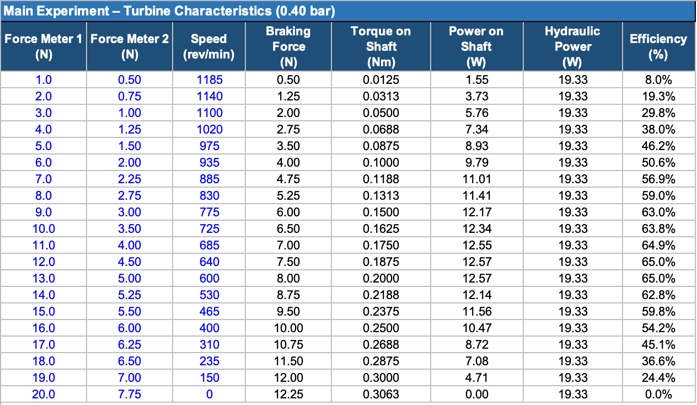
Table 6: Full experiment data

Appendix B — Sample calculations
Given
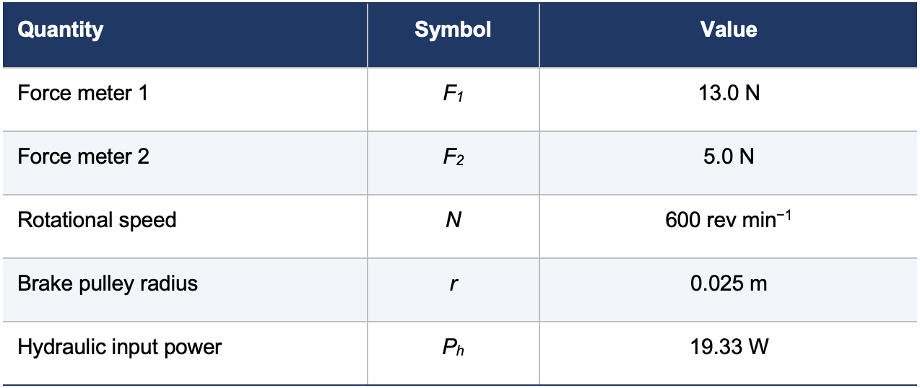
Table 7: Raw data for calculations

Step 1 — Braking force
$$F=F_{1}-F_{2}$$
$$F=13.0-5.0$$
$$F=8.0 N$$
Step 2 — Shaft torque
$$T=Fr$$
$$T=8.0×0.025$$
$$T=0.200 N m$$
Step 3 — Angular velocity
$$ω=\frac{2πN}{60}$$
$$ω=\frac{2π×600}{60}$$
$$ω=62.83 rad s^{-1}$$
Step 4 — Shaft power
$$P=Tω$$
$$P=0.200×62.83$$
$$P=12.57 W$$
Step 5 — Turbine efficiency
$$η=\frac{P}{P_{h}}×100$$
$$η=\frac{12.57}{19.33}×100$$
$$η=65.0 \%$$

Final calculated values
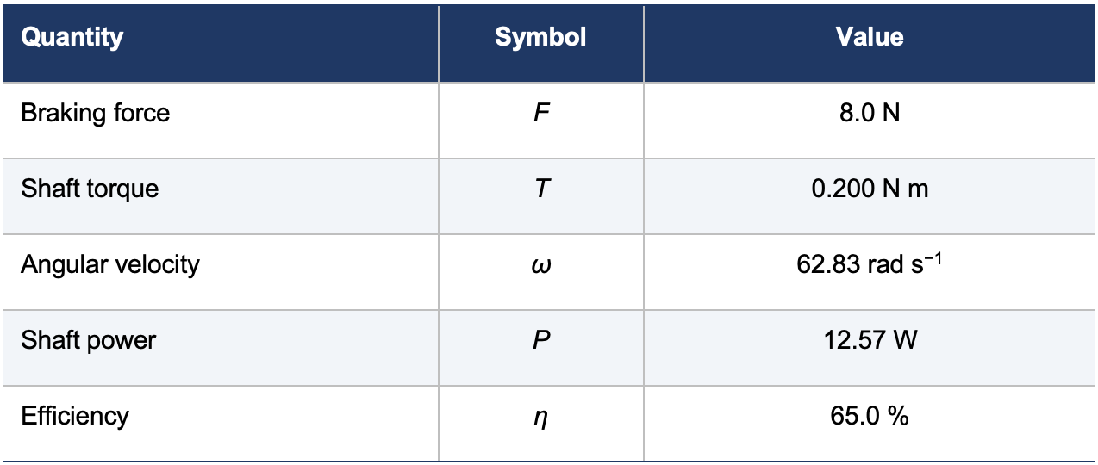
Table 8: Final calculated example
All values are quoted to three significant figures, consistent with the resolution of the spring force meters and the tachometer.

Appendix B — Sample calculations (continued): speed ratio and runaway speed
Given
Quantity | Symbol | Value
Supply pressure | ΔP | 0.4 bar = 40 000 Pa
Water density | ρ | 1000 kg m⁻³
Runner pitch circle diameter | D | 132 mm = 0.132 m
Speed at maximum power | N | 640 rev min⁻¹
Measured runaway speed | N_{measured} | 1185 rev min⁻¹

Table 9: Given Pelton wheel values
Step 6 — Theoretical jet velocity
$$V = \sqrt{\frac{2ΔP}{ρ}}$$
$$V = \sqrt{\frac{2 × 40 000}{1000}}$$
$$V = 8.94 m s^{-1}$$
Step 7 — Bucket peripheral speed at maximum power
$$U = \frac{πDN}{60}$$
$$U = \frac{π × 0.132 × 640}{60}$$
$$U = 4.42 m s^{-1}$$
Step 8 — Speed ratio
$$Speed ratio = \frac{U}{V}$$
$$Speed ratio = \frac{4.42}{8.94}$$
$$Speed ratio = 0.495$$
This is close to the theoretical optimum of 0.5, at which maximum energy transfer occurs.
Step 9 — Ideal runaway speed
At the no-load condition the bucket speed ideally equals the jet velocity, so U = V.
$$N = \frac{60U}{πD}$$
$$N_{ideal} = \frac{60 × 8.94}{π × 0.132}$$
$$N_{ideal} = 1294 rev \min^{-1}$$
Step 10 — Comparison with the measured runaway speed
$$Difference = \frac{N_{ideal} - N_{measured}}{N_{ideal}} × 100$$
$$Difference = \frac{1294 - 1185}{1294} × 100$$
$$Difference = 8.4 \%$$
The measured runaway speed is lower than the ideal value because bearing friction, windage and residual water losses still oppose rotation at no load.
Final calculated values
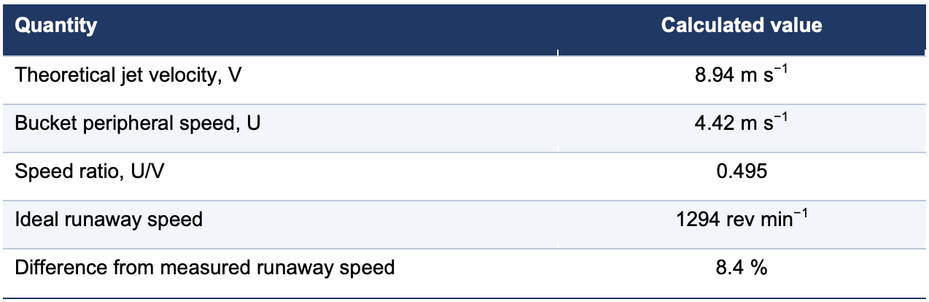
Table 10: Final calculated for speed difference
All values are quoted to three significant figures, consistent with the resolution of the pressure gauge and tachometer.

Appendix C — Additional figures
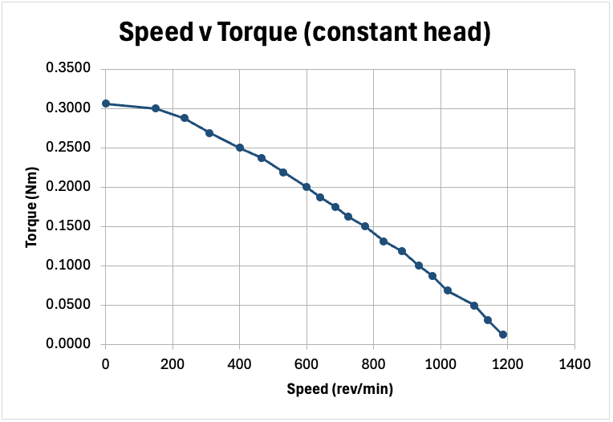
Figure 4: Speed v Torque (constant head)
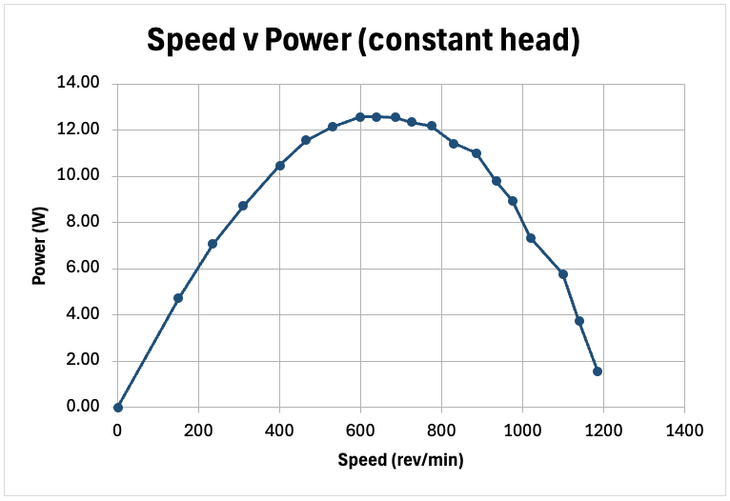
Figure 5: Speed v Power (constant head)

