

‘The Effects of Carbohydrate Mouth Rinse on Fasted High-Intensity Interval Training in Recreationally Trained Individuals’

by

Geraint Forster

A dissertation submitted to the Academic Discipline
of Sport and Healthy Living
at
University of Wales Trinity Saint David
in partial fulfilment of the requirements for
the degree of Master of Science

July 2024

Table of Contents
Declaration 3
Abstract 4
Chapter 1: Introduction 5
Chapter 2: Review Of Literature 8
HIIT and its Role in Health and Wellbeing 8
Intermittent Fasting and Its Effects on Health and Weight Management 10
Nutritional Considerations in Fasted Exercise 11
Carbohydrate Mouth Rinse: Mechanisms and Previous Research 13
Sex Considerations in Exercise Science and Nutrition 16
Methodological Approaches in Previous Studies 17
Conclusion of the Literature Review 18
Chapter 3: Method 20
Study Design 20
Rationale 20
Subjects 22
Rationale 22
Protocols 22
Rationale 23
Mouth Rinse 23
Rationale 24
Data Analysis 24
Chapter 4: Results 25
Power 25
Heart Rate 26
Distance 27
Subjective measures 27
Chapter 5: Discussion 29
Power 29
Practical applications 32
Limitations and future research 32
Chapter 6: Conclusion 34
References 34
Appendix A - Information Sheet 41
Appendix B - Informed Consent form 45

Declaration

DECLARATION FORM

Master’s Degrees by Examination and Dissertation Declaration Form

- This work has not previously been accepted in substance for any degree and is not being concurrently submitted in candidature for any degree.

Signed: 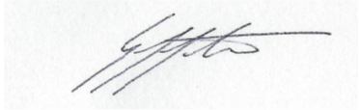 Date: 08/07/24

- This dissertation is being submitted in partial fulfilment of the requirements for the degree of MSc Sport and Exercise Nutrition.

Signed: Date: 08/07/24

- This dissertation is the result of my own independent work / investigation, except where otherwise stated.

Other sources are acknowledged by explicit references. A bibliography is appended.

Signed: Date: 08/07/24

- I hereby give consent for my dissertation, if accepted, to be available for photocopying, inter-library loan, and for deposit in the University’s digital repository.

Signed: Date: 08/07/24

Supervisor’s Declaration.

I am satisfied that this work is the result of the student’s own efforts.

Signed: ………………………………………

Dated: ………………………………………….

Abstract

Introduction: High Intensity Interval Training (HIIT) and Intermittent Fasting (IF) are popular trends in health and fitness, but research has not yet determined if IF complements or interferes with HIIT. Carbohydrate mouth rinse (CHO) has the potential to improve the performance of those participating in HIIT whilst fasting by reducing central fatigue. This study investigated the effects of CHO on fasted HIIT performance in recreationally trained individuals. Method: Using a double-blind, placebo-controlled, randomised crossover design, the study involved 15 recreationally trained subjects who completed cycling HIIT sessions under three conditions: CHO, placebo (PLA), and water (WAT). Primary outcomes of peak and mean power were measured, along with secondary outcomes of heart rate, distance and subjective measures. Results: No significant differences were found in peak or mean power between the three conditions. Both CHO and PLA conditions significantly (p<0.05) increased mean and peak heart rate, with medium-large effect sizes, compared to WAT, with no difference in perceptual responses. Conclusions: CHO and PLA mouth rinse may enhance HIIT performance in a fasted state by allowing the accumulation of greater metabolic stress, and thus physiological adaptations, for no increased perceptual cost. The greater metabolic stress may be the result of more work being completed in the first interval, however the sample size was insufficient to fully determine this. Since there appear to be no negative side-effects, rinsing the mouth with a CHO solution seems to be an accessible and cost-effective adjunct to HIIT training in the fasted state.

Chapter 1: Introduction

This chapter introduces the context and rationale behind investigating the effects of carbohydrate mouth rinse on fasted high-intensity interval training (HIIT) in recreationally trained individuals. Firstly, it will contextualise the study within contemporary societal issues and provide a brief overview of the benefits and challenges associated with HIIT and intermittent fasting (IF), highlighting the potential performance issues when combining these interventions. It will then introduce the theoretical basis for using carbohydrate mouth rinse as a strategy to mitigate these issues, before finally establishing the aims, objectives and research question for the study.

Globally, almost a third of the population does not meet recommended physical activity guidelines (Strain et al., 2024) and 38% of the population are currently overweight or obese (Koliaki, Dalamaga and Liatis, 2023), with these proportions being considerably higher in more developed countries. As a result, numerous trends and interventions within nutrition and exercise have emerged which claim to be effective in increasing physical activity levels, improving health and wellbeing and in managing body composition. The symbiotic relationship between the two pillars of nutrition and exercise is evident in the multifaceted impact they have on overall health, encompassing physiological, psychological, and metabolic dimensions. Whilst many trends and fads within fitness and nutrition have come and gone, some seem to endure both within the fitness industry and within published research (Thompson, 2022). Two of the popular trends in recent years are HIIT and IF.

The widespread popularity of these trends is highlighted by the American College of Sports Medicine's Worldwide Survey of Fitness Trends for 2022, where HIIT retained its position as one of the top fitness trends, emphasizing its enduring popularity (Thompson, 2022). The report also highlighted the increasing prominence of intermittent fasting as a nutritional strategy for weight management and metabolic health.

Over the last two decades, fitness enthusiasts have been increasingly gravitating towards HIIT, a workout methodology characterized by short bursts of intense exercise alternated with periods of rest or lower-intensity activity. HIIT has garnered popularity due to its efficiency in delivering robust cardiovascular benefits and promoting fat loss. A seminal study by Gibala et al. (2006) highlighted the time-efficient nature of HIIT, demonstrating comparable physiological adaptations to traditional endurance training in significantly shorter time frames. Within a busy modern society where ‘lack of time’ is often cited as one of the main barriers to exercise, HIIT is touted as a time-efficient solution to the decreasing levels of physical activity and general health within the population (Coates et al., 2023).

Simultaneously, the adoption of IF has emerged as a popular nutritional trend for individuals seeking effective weight management and enhanced overall health. IF involves alternating periods of eating and periods of fasting, either across the hours of a day, or across the days of a week. A review by Patterson and Sears (2017) underscored the potential metabolic benefits of intermittent fasting, showcasing improvements in insulin sensitivity, lipid profiles, and markers of oxidative stress. This nutritional paradigm has become particularly attractive for its purported ability to facilitate weight loss while offering diverse health benefits beyond caloric restriction alone. Considering the aforementioned global levels of overweight and obesity, any intervention that has the potential to aid in weight management has an important role to play in global health

As the popularity of HIIT and intermittent fasting continues to increase, the need for comprehensive research exploring their synergistic effects becomes key. While existing literature has extensively examined the benefits of each independently, there is a noticeable dearth of studies elucidating their combined impact on health and performance. Alongside the weight management benefits, proponents of IF claim that there are a number of metabolic and cardiovascular benefits including reductions in LDL and triglyceride concentrations, insulin resistance and blood pressure (Patikorn et al., 2021). Many of these benefits are similar to those made of HIIT raising the prospect that they may complement each other and result in a cumulative benefit greater than their sum parts.

Exercising in a fasted state has become popular with both elite athletes (Burke and Hawley, 2018) and with those exercising for health and wellbeing reasons (Wallis and Gonzalez, 2019), yet these studies tend to focus on performing sub-maximal steady state exercise, rather than HIIT. Periods of fasting can increase feelings of fatigue (Franchini, Brito and Artioli, 2012), and thus might impact the ability to achieve the high intensities required for HIIT to be effective. Alongside investigating the synergistic effects of these two interventions, any strategies to mitigate the interference of one on the other would also be beneficial.

Rinsing the mouth with a Carbohydrate (CHO) mouth rinse has been shown to be an effective ergogenic aid for long duration (>1 hour) steady state endurance exercise (Jeukendrup et al., 1999), without having to consume any calories (and thus break a fast). More recently, some studies have suggested that CHO mouth rinse may also have beneficial effects on shorter-duration high intensity exercise (Beaven et al., 2013; Phillips et al., 2014) yet findings are equivocal with a number of other studies showing contrasting findings.

Therefore, the specific context of fasted HIIT provides an opportunity to explore the efficacy of CHO mouth rinse in a contemporarily relevant context. Since HIIT relies heavily on both anaerobic and aerobic energy systems and involves maximal or near-maximal efforts, maintaining performance during fasted sessions is crucial for achieving the desired metabolic training adaptations. If CHO mouth rinse can be shown to mitigate the performance decrements that may occur during fasted exercise, then it may be an effective nutritional ergogenic strategy to be used alongside fasted HIIT interventions.

Historically there has been a distinct lack of female subjects within exercise science research, and it is well established that there can be variations in exercise responses, performance and nutritional requirements between males and females (Lundsgaard and Kiens, 2014). Recent opinion papers have stressed the importance of inclusive study designs that encompass both males and females, and where possible determine if there is a difference in response between the sexes (Elliott-Sale et al., 2021). It is essential therefore that this study attempts to determine if there are any differences in response between males and females, in order to attempt to redress this historic oversight.

The aim of this study, therefore, is to investigate whether there is an ergogenic effect of carbohydrate mouth rinse on fasted high-intensity interval training performance in recreationally trained individuals.

The primary objective of the study is:
- to test if carbohydrate solution (CHO) results in increased peak power and mean power in comparison to placebo solution (PLA) or water (WAT) during fasted HIIT.
The secondary objectives of the study are:
- to test if CHO results in different peak and mean heart rates in comparison to PLA and WAT during fasted HIIT;
- to test if CHO results in different ratings of perceived exertion (RPE) in comparison to PLA and WAT during fasted HIIT;
- to test if CHO results in different sensations of pleasure-displeasure in comparison to PLA and WAT during fasted HIIT;
- to test if CHO results in different levels of arousal in comparison to PLA and WAT during fasted HIIT; and
- to test if there is a difference in response between males and females across all variables.

The research question is ‘Does the use of a carbohydrate mouth rinse improve performance during fasted HIIT in recreationally trained individuals?’

Chapter 2: Review Of Literature

This chapter will review the relevant literature around the topic in order to inform the discussion of the findings. Initially research exploring the role of both HIIT and intermittent fasting will be separately explored to determine their benefits for health, wellbeing and weight management, and to establish the various strategies and protocols that can be adhered to. Following this, research into the interaction between the two will be reviewed, including the potential negative influence of fasting on exercise, along with any potential synergistic effects, and the role that CHO mouth rinse might play in supporting these effects. After an exploration into the potential mechanisms of action of CHO mouth rinse, a summary of the findings from previous studies on the topic will be presented. Finally, a discussion around methodological approaches and issues in previous research, including consideration of sex-based differences, will be conducted in order to conclude the chapter with a clear rationale for the design of the current study.

HIIT and its Role in Health and Wellbeing

High Intensity Interval Training (HIIT) can be defined as a mode of training whereby repeated short bouts of high intensity exercise are interspersed with recovery periods of lower intensity exercise or rest (Buchheit and Laursen, 2013). Interval training in its many different forms has been utilised in training for sports performance for at least a century, and research into the benefits of HIIT for general health and wellbeing has been ongoing for decades (Coates et al., 2023). In the annual report of worldwide fitness trends by the ACSM, HIIT has been consistently in the top 5 from 2014-2021 demonstrating that it is very popular both from a practical and research perspective (Thompson, 2022).

A comprehensive evidence base, including numerous randomised controlled trials, systematic reviews and meta-analyses show that HIIT programmes ranging from 5 days to 12 months are effective at improving VO2max, endurance capacity, resting metabolic rate, substrate metabolism, body composition, insulin sensitivity, cognitive function, mood and decreased feelings of depression and anxiety (Atakan et al., 2021). Reductions in the risk of a range of health conditions have also been demonstrated, including cardiovascular disease, breast cancer, metabolic syndrome, osteoarthritis and rheumatoid arthritis (Atakan et al., 2021).

One of the main practical benefits of HIIT is the reduced amount of time required to achieve desirable outcomes, with numerous systematic reviews and meta-analyses showing that HIIT can elicit comparable increases in cardiorespiratory fitness to moderate intensity continuous training (MICT) even though total training volume is considerably lower (Gist et al., 2014). Likewise, when total work is matched, HIIT has been consistently shown to result in greater improvements in cardiorespiratory fitness than MICT in a wide range of population groups of both healthy individuals and those with chronic health conditions (Leal, Galliano and Del Vecchio, 2020). As little as a 15-minute session (including warm up and cool down) performed 3 times per week for 6 weeks has been demonstrated to increase cardiorespiratory fitness by 1 MET which equates to an 11% reduction in relative risk for all-cause mortality, independent of age and sex (Coates et al., 2023). Considering that ‘lack of time’ is often cited as one of the main barriers to exercise (Atakan et al., 2021), it is no surprise that HIIT has been one of the predominant exercise trends for a number of years.

Within the HIIT research, there is variability in the duration and intensity of exercise. Many of the original HIIT protocols, such as the classic 4 x 4 protocol developed by Helgerud et al. (2007), although being time-efficient compared to moderate intensity training, still required a considerable time commitment. These ‘long-interval’ protocols involved exercising at 90-95% of VO2max for 3-5 minutes, with 2-3 minute rest periods, and completing 4-6 sets, thus total session time, including warm-up and cool-down still totalled at least 30 minutes and often more than 45 minutes. More recently, low-volume, short-duration sessions involving ‘all-out’ sprint efforts of under 30s have become popular and show similar benefits to both longer-interval HIIT and to MICT (Sun et al., 2019).

Studies such as that by Gillen et al. (2016) found that a Sprint Interval Training (SIT) protocol that involved 1 minute of intense exercise within a total of 10 minutes time commitment per session, resulted in similar improvements in peak oxygen uptake, insulin sensitivity index and skeletal muscle mitochondrial content to MICT. In this study, the MICT group performed 3 x 45 minutes sessions of cycling per week at 70% HR_{max} totalling 150 minutes per week (including warm-up and cool-down), whilst the SIT group also performed 3 sessions a week, totalling 3 minutes of intense exercise and 30 minutes of total time commitment. In both groups, the previously sedentary participants improved VO₂max by 19% over the 12 weeks; insulin sensitivity improved in both groups in comparison to the control group by 53% in SIT and 34% in MICT; and a number of markers of mitochondrial content improved in both groups compared to controls, yet the MICT protocol required 5 times the total time commitment.

A systematic review and meta-analysis by Sultana et al. (2019) into the effects of low-volume HIIT on body composition and cardiorespiratory fitness, found that across 47 studies, totalling 1422 individuals who were predominantly middle-aged and overweight, low-volume HIIT was similar or superior to MICT for developing cardiorespiratory fitness. Interestingly, they also found no evidence that low-volume HIIT or MICT were beneficial for improvements in body composition measures when compared to non-exercising controls. Considering the low-volume nature of these HIIT protocols (<500 MET-min/week) this is not surprising since they would not contribute much to total weekly energy expenditure, and thus not help to create the negative energy balance required to lose body fat. The authors do note however that research has suggested that HIIT may have favourable effects on factors such as appetite suppression, and hormonal responses in comparison to MICT, thus potentially benefit fat oxidation.

Thus although SIT on its own may not result in significant weight loss, it has the potential to be an effective adjunct to nutritional weight loss strategies. Sun et al. (2019) point out that overweight and obese individuals who are undergoing caloric restriction to attempt to lose body fat are unlikely to maintain continuous vigorous intensity aerobic exercise for a prolonged time due to low energy availability. Very short and intense sessions such as the SIT protocol described by Gillen et al. (2016) may benefit those attempting to lose weight through caloric restriction and/or fasting. The very short nature of the intense exercise (3 x 20s all-out sprints) might be more achievable for someone exercising in a fasted state than longer vigorous intensity sessions that require maintaining effort and motivation over 30 minutes or more. Whilst HIIT also has the potential to support the fasting by suppressing appetite following the session, along with also providing the associated health benefits listed above such as improved insulin sensitivity and cardiorespiratory fitness. Thus this SIT protocol has been chosen as the selected protocol for this study.

Intermittent Fasting and Its Effects on Health and Weight Management

Intermittent fasting (IF) can be defined as periods of eating alternated with periods of not eating and has emerged as one of the most popular diets for weight loss in recent years (Patikorn et al., 2021). It is suggested that the simplicity of the diet is one or the prime reasons for its popularity – there is no need to make drastic changes to eating habits, restrict certain macronutrients, monitor calories consumed each meal, develop new cooking skills, or stick to eating only certain food groups. The basic premise is to restrict eating to certain days of the week or hours of the day, which Patikorn et al. (2021) state can be broadly categorised into three different strategies: alternate-day fasting (ADF); the 5:2 diet; and time-restricted eating (TRE). As suggested by the name, ADF involves a feast day whereby food is consumed ad libitum, followed by a fasting day where either no food is consumed, or 25% of the normal diet is consumed. The 5:2 diet is similar but involves 5 feast days per week and 2 fast days (on consecutive or non-consecutive days), and TRE involves restricting the amount of time in which eating takes place each day (usually between 4-10 hours per day).

A number of studies have assessed the efficacy and benefits of the various IF strategies and are summarised in an umbrella-review of meta-analyses of randomised clinical trials performed by Patikorn et al. (2021). They found that all three strategies resulted in mild to moderate weight loss (1-8% in 6-12 weeks) as a result of consistent reductions in energy intake of 10-30%. There were also some beneficial changes to risk factors for metabolic disease, with all three IF diets resulting in a reduction in blood pressure, and ADF and 5:2 tending to lower LDL and triglyceride concentrations, although with a high degree of variability in results. All three IF diets, although not altering fasting glucose levels, did show promise in lowering fasting insulin, insulin resistance and HbA1c (glycated haemoglobin) in both individuals with obesity and individuals with prediabetes. Thus it is clear that there are metabolic health benefits to participating in IF.

Another reason individuals can choose to participate in IF is for longevity purposes, with a growing body of research suggesting that fasting periods trigger a cellular repair process termed autophagy where the body eliminates damaged cells and cellular components. The suggested mechanism of action involves cellular nutrient sensors including mechanistic target of rapamycin (mTOR) and AMP-activated protein kinase (AMPK). It is suggested that during periods of fasting, cellular energy levels decrease, which downregulates mTOR and upregulates AMPK (Bagherniya et al., 2018). mTOR generally stimulates anabolic growth and reproductive processes whilst AMPK stimulates catabolic processes. The upregulation of AMPK triggers the autophagic cellular recycling process whereby cells dispose of damaged or dysfunctional components such as organelles and proteins, as a survival mechanism. The cells thus favour maintenance and repair over growth and reproduction, enhancing stress resistance, recycling damaged molecules, stimulating mitochondrial biogenesis and promoting cell survival (De Cabo and Mattson, 2019). The regular triggering of autophagy through fasting, and the concomitant self-cleaning process within the cells, is suggested to improve the quality of cells and hence not only increase longevity, but also reduce the likelihood of developing numerous health conditions such as cancer, hypertension, diabetes and other age-related diseases (De Cabo and Mattson, 2019).

It must be noted that the majority of studies that have demonstrated the longevity benefits have been in animal models such as rodents and rhesus monkeys (Colman et al., 2009). A meta-analysis of all studies conducted in rats showed that lifetime caloric restriction resulted in an increase in median lifespan ranging from 14% to 45% (Swindell, 2012). These types of lifetime caloric restriction studies are clearly not possible in human subjects for ethical reasons, therefore the only means of assessing the longevity benefits are through measuring acute changes in markers of health and chronic disease in order to extrapolate the predicted effects on longevity. A study by Harvie et al. (2011) that directly compared IF to caloric restriction seems to suggest that there is an additional benefit incurred via fasting. In this study, subjects either reduced caloric intake by 25% or participated in a 5:2 IF protocol. Over a 6-month period the weight loss was similar between both groups, however the IF group had significantly improved insulin sensitivity and reduced waist circumference, thus suggesting that the periods of fasting added some benefits that simple overall reduction in calories did not.

The umbrella review by Patikorn et al. (2021) concludes that although more clinical trials are needed, particularly with long-term follow ups, IF is associated with successful weight loss and treatment for several medical conditions show promise, particularly metabolic diseases such as diabetes and fatty liver disease. They also conclude that the benefits extend beyond the benefits of weight loss, and that autophagy is likely to be an important mechanism.

Periods of energy deficit and fasting can increase fatigue and perception of effort, thus making any exercise performed feel harder, and potentially reducing the performance of individuals participating in high intensity exercise (Franchini, Brito and Artioli, 2012). Since SIT involves all-out maximal efforts, it is possible that the power outputs reached when fasted may well be lower than those reached in a fed state, potentially reducing the beneficial effects of the training. Thus any strategy or ergogenic aid that could increase performance or decrease perception of effort, without involving the consuming of any food/calories, would have potential benefits to those attempting to perform SIT whilst in a fasted state.

Nutritional Considerations in Fasted Exercise

A growing body of research is suggesting that both exercise and fasting can have a synergistic effect, and that exercising in a fasted state can enhance the benefits of both independent exercise and fasting. Burke and Hawley (2018) describe how elite athletes often use ‘nutritional periodisation’ to enhance performance, including practising ‘train high, sleep low, train low’ methodologies. This involves depleting muscle glycogen stores with an evening high intensity training session, then consuming a low-carbohydrate meal to ensure that glycogen stores are not replenished overnight. In the morning, a low-intensity training session is performed in the fasted (and thus low-glycogen) state. This is suggested to stimulate a number of metabolic adaptations, including enhancing the ability of the athlete to oxidize fat as an energy substrate, and thus potentially improve endurance exercise performance through sparing muscle glycogen.

Alongside the enhanced fat oxidation rates, Wallis and Gonzalez (2019) summarise that exercising in the fasted vs fed-state can have beneficial effects on plasma lipid profiles, daily energy balance, molecular signalling molecules related to fuel metabolism and on glycaemic control. All of these adaptations have potential beneficial effects on health, however there are some potential down sides to exercising in a fasted state, particularly when the exercise is of high intensity. As a result, the vast majority of studies into the beneficial effects of fasted exercise have involved low-moderate intensity steady state exercise.

Low to moderate intensity exercise requires a relatively low turnover rate of ATP, which can be provided through the aerobic oxidation of triglycerides and free fatty acids (Burke and Hawley, 2018). However, as exercise intensity increases, the rate of ATP required rises to the extent that the body preferentially oxidizes carbohydrates due to the greater net production of ATP per molecule of oxygen used (McArdle, Katch and Katch, 2015). At very high intensities of exercise, the aerobic system is unable to regenerate ATP at a sufficiently high rate, thus the predominant source of ATP is the ATP-PC system and anaerobic glycolysis. Glycolysis, as the name suggests, relies solely on glycogen/glucose as it’s fuel source (McArdle, Katch and Katch, 2015). Thus, low glycogen availability as a result of fasting can reduce the glycolytic capacity of exercising muscle, consequently reducing performance in high intensity exercise. It has also been suggested that perceptions of effort are higher during the fasted state, and that this may lead to a reduction in central neural drive, and accordingly maximal exercise performance (Aziz et al., 2017).

Aird, Davies and Carson (2018) conducted a systematic review and meta-analysis into the effects of fasted vs fed-state exercise on performance, which included four studies involving anaerobic exercise. One study demonstrated that pre-exercise carbohydrate improved time to exhaustion during continuous anaerobic exercise in comparison to being fasted (Galloway, Lott and Toulouse, 2014), but for the three HIIT studies they included, there was no effect on performance. This would suggest that being fasted does not negatively affect HIIT performance, however on closer analysis, two of the studies involved distinctly different exercise protocols to the current study. A study by Gillen et al. (2013) on overweight/obese females used a treadmill protocol involving 60s work, 60s rest, completed for 20 minutes, whilst the study by Little et al. (2010) involved 16 male athletes performing a 2 x 45 minute intermittent treadmill protocol designed to simulate a football match. Neither of these studies involve the all-out nature of the current study and are therefore not comparable. The final study cited, however, involved 3 x 10s all out sprints on a cycle ergometer, repeated six times (Pritchett et al., 2008). Although the total volume of sprints (18 vs 3) is much greater than in the current study, this appears to be the only study that has attempted to measure the effects of fasting vs fed-state on all-out cycle sprints. Their conclusion was that the feeding state did not have an effect on performance, however they note that there was a trend for total work done and mean power output to be lower in the fasted group. A group receiving CHO 60 minutes prior to the HIIT session completed 10% more work in total than the fasted group, a seemingly meaningful amount. It must be noted also that the study involved only 10 participants, thus it is possible that with a higher powered study, these trends might have resulted in significant findings.

A study by Terada et al. (2019) compared performing sprint interval training (30s all out sprints, 4-7 times) three times per week for four weeks in a fasted group verses a CHO fed group. They found no change in maximal aerobic capacity between the groups, however the fasted group significantly improved their time to exhaustion at 85% VO2_{peak} in comparison to the CHO group. They suggest this may be due to the potential upregulation of AMPK and then PGC 1 alpha, which is known to stimulate mitochondrial biogenesis. Similarly to the study above by Pritchett et al. (2008), they also found a reduction in work done and peak power output in the fasted group, but this time with a statistically significant difference. It is interesting to note that although the fasted group performed less total work, they had similar if not superior adaptations.

Although not specifically involving fasting, several studies have attempted to determine the effect of low glycogen availability on HIIT performance. These show a similar trend in findings regarding an increase in activation of metabolic signalling pathways linked to mitochondrial biogenesis, but a reduction in power output and work done during the actual training sessions (Forbes et al., 2020).

Thus although there is a growing body of knowledge suggesting that low-moderate intensity exercise performed in the fasted state has beneficial effects on a range of health markers, there is a lack of clear evidence regarding whether fasting alongside HIIT training would have a beneficial or detrimental effect. If, as suggested above, some of the detrimental effects are linked to perception of effort and central fatigue, any interventions that may act on these areas in a beneficial way, may be an effective adjunct to fasted HIIT.

Carbohydrate Mouth Rinse: Mechanisms and Previous Research

It has long been known that ingesting CHO during long duration (> 1 hour) endurance exercise improves performance by sparing muscle and liver glycogen content and thus delaying fatigue (Jeukendrup et al., 1999). However, studies also showed that performance was improved in endurance exercises lasting less than 1 hour, even though low muscle glycogen or hypoglycaemia are not considered causes of fatigue or limiting factors for exercise of that duration (Carter et al., 2004).

Fatigue can be defined as a reversible decline in the force generating capacity of a muscle and can be attributed to either central factors that limit the neural drive for muscle contraction, or peripheral factors within the muscle that often involve metabolic and ionic perturbations that reduce the muscle’s ability to respond to neural stimulation (Black et al., 2017). Clearly in the studies longer than 1 hour, the ingested carbohydrate was sparing muscle glycogen, thus delaying the point at which low glycogen availability would result in peripheral fatigue, however the improvements in performance in exercise of under 1 hour duration led researchers to suggest that the carbohydrate may be acting to reduce central fatigue in some way (Jeukendrup and Chambers, 2010).

Chambers, Bridge and Jones (2009) demonstrated using magnetic resonance imaging (fMRI) that activation in reward-system-related brain areas was greater when participants rinsed their mouth with solutions containing glucose or maltodextrin. They then went on to find that participants completed a cycling time trial of approximately 1 hour duration significantly faster when rinsing the mouth with the carbohydrate mouth rinse in comparison to a placebo mouth rinse containing saccharin. A number of follow up studies, including a systematic review and meta-analysis (Brietzke et al., 2019) have confirmed the potential of CHO mouth rinse to improve power output during cycling time-trials, thus there is a reasonably strong evidence-base suggesting that in endurance-based exercise, rinsing the mouth with a CHO solution without ingesting it can increase performance (Jeukendrup and Chambers, 2010).

The exact mechanism of action is still not fully understood. The fact that the CHO is expectorated rather than swallowed indicates that the taste buds must play a role in detecting the CHO and stimulating the reward centres of the brain. Taste receptor cells (TRC) are chemoreceptor proteins specialised in nutrient detection in the oral cavity (Pomportes and Brisswalter, 2020). Although it is widely accepted that humans have five primary tastes: salt, bitter, sour, umami and sweet, and that two G-protein-coupled receptors (T1R2 and T1R3) are responsible for detecting sweet tastes (Pomportes and Brisswalter, 2020), these do not appear to be responsible for detecting the CHO since these are also activated by non-caloric artificial sweeteners. Chambers, Bridge and Jones (2009) also found in their fMRI study that non-sweet maltodextrin solution stimulated the same brain regions as sweet glucose, yet even sweeter saccharin did not, thus suggesting a class of as yet unidentified chemoreceptors which respond to the energy density of CHO irrespective of sweetness. The action potential produced by these chemoreceptors is relayed to the brainstem via the cranial nerves, which then results in the activation of several different brain regions which are involved in reward, pleasure and motor control (Pomportes and Brisswalter, 2020). Central fatigue is considered to be an inhibition of motor output as a result of the integration of afferent information from a range of mechanical, metabolic, nociceptive and thermal receptors (Black et al., 2017). It is theorised that the activation of dopamine pathways in the basal ganglia by CHO detection in the mouth may counteract this inhibition (Chambers, Bridge and Jones, 2009), resulting in either an increase in motor output, or a reduction in perception of effort for the same motor output.

Although the evidence for CHO mouth rinse in steady state exercise is compelling, in high intensity, non-steady state exercise, the findings are equivocal. A study by Phillips et al. (2014) found that rinsing with CHO improved 30s cycle sprint performance in comparison to a placebo (PLA), however by contrast, a similar study found no difference in 30s cycling sprint performance after rinsing with maltodextrin, glucose or water in comparison to no mouth rinse (Chong, Guelfi and Fournier, 2011). Beaven et al. (2013) compared CHO to PLA mouth rinse for 5 x 6s maximal sprints interspersed with 24s recovery and found that CHO resulted in an increase in peak and mean power output for the first sprint (22W and 39W increase respectively), however a significantly decreased mean and peak power by the 5th sprint (37W and 39W decrease respectively). Similarly for repeat sprint performances, Simpson et al. (2018) found a small improvement for CHO in comparison to PLA mouth rinse towards the latter stages of multiple repeat sprints, yet Dorling and Earnest (2013) found no improvement in performance, RPE or perceived pleasure-displeasure.

The situation is similar for another predominantly anaerobic, intermittent mode of training, resistance training, with studies showing mixed findings - a systematic review and meta-analysis by Rodrigues Oliveira-Silva et al. (2022) summarised that CHO mouth rinse did not improve maximal strength but that some studies did suggest an improvement in muscular endurance. As discussed in the methodological considerations section below, numerous methodological differences and issues may account for the significant variation in findings in these research studies (Painelli et al., 2022), thus further research is needed in the area of high intensity intermittent exercise and carbohydrate mouth rinsing.

A study by Clarke et al. (2017) assessed the effects of carbohydrate or placebo mouth rinse on high intensity exercise in fasted individuals first thing in the morning. Using a randomised, placebo-controlled crossover study design, they found that CHO significantly improved performance in countermovement jump, 10m sprint, bench press and squat repetitions to failure at 60% 1RM, and mean ‘Felt Arousal’. No difference was found in isometric mid-thigh pull. Interestingly they also found small to moderate improvements in the placebo group in comparison to a non-rinse control group, suggesting that there is a potential placebo effect to mouth rinsing, independent of the effect of CHO on reward centres. They conclude that all studies should also include a control group who receive neither CHO nor PLA.

Krings et al. (2017) utilised five 15s maximal cycle ergometer sprints, interspersed with 4-minute rest periods, to compare the effects of CHO ingestion, CHO mouth rinse, PLA ingestion and PLA mouth rinse on a range of performance measures. Their main finding was that ingestion of CHO resulted in increased mean power output, total work and peak heart rate, and decreased fatigue index, in comparison to CHO mouth rinse. However, it is important to note in this study, that peak power and mean power were higher in both of the PLA conditions (ingested or mouth rinse) than in their comparable CHO condition, and since there was not a ‘no-mouth rinse’ condition, it is impossible to ascertain whether all four groups had an improvement in comparison to receiving no solution.

These mixed findings contrast with an early mechanistic study by Gant, Stinear and Byblow (2010) that used transcranial magnetic stimulation to show that carbohydrate ingestion immediately increases the excitability of the corticomotor pathway resulting in increased voluntary force production. They found that maximum voluntary force (MVF) production increased immediately after consuming a CHO drink but decreased slightly when consuming a PLA drink, and that these changes occurred prior to any detection of CHO appearing in the blood, which also then resulted in a further increase in MVF. This study, along with the Chambers, Bridge and Jones (2009) study showing increased activation of reward centres in the brain, therefore suggest that detecting CHO in the mouth would result in an increase in maximal force production, and a concomitant increase in high intensity exercise performance. As will be discussed below, a range of methodological issues may account for the equivocal findings to date, and support the notion that further research is required in this area.

Sex Considerations in Exercise Science and Nutrition

In investigating the human responses to exercise and nutrition, it is essential to delve into sex considerations, and the potential difference in responses to exercise and nutritional interventions. This section will discuss sex-specific differences, emphasising the need for inclusivity in research studies, and pinpointing existing gaps in literature concerning sex-specific effects of CHO mouth rinse during fasted HIIT in recreationally trained individuals.

Sex-specific responses to exercise and nutritional interventions are an increasingly important aspect of healthcare, performance optimisation and research studies. Research has consistently demonstrated variations in physiological responses, exercise performance, and nutritional requirements between men and women. Studies such as that by Lundsgaard and Kiens (2014) have extensively reviewed the influence of sex on exercise metabolism, emphasising the impact of hormonal fluctuations, body composition, and muscle fibre distribution on performance outcomes. Understanding these differences is paramount, not only for the sake of scientific accuracy but also for informing personalised exercise and nutritional prescriptions.

A key consideration in advancing our understanding of sex-specific responses is the necessity for inclusivity in research studies. Historically, much of exercise science research has been skewed toward male participants, resulting in a sex bias that hinders the generalisability of findings. Recognising this, recent opinion papers such as that published by Elliott-Sale et al. (2021) underscore the importance of inclusive study designs that encompass both males and females. This shift toward balanced representation not only ensures the applicability of research outcomes to diverse populations but also contributes to a more comprehensive understanding of how sex influences the outcomes of interventions.

The relevance of sex considerations is particularly salient in the investigation of carbohydrate mouth rinse effects during fasted HIIT in recreationally trained individuals. Ansdell et al. (2020) suggest that female skeletal muscle is more resistant to fatigue elicited by equivalent dosages of high-intensity exercise than male. While existing literature explores the impact of carbohydrate mouth rinse on exercise performance, limited research addresses potential sex-specific effects in the context of HIIT and fasting. A notable gap exists in understanding whether responses to carbohydrate mouth rinse during fasted exercise differ between men and women, potentially influencing factors such as substrate utilisation, perceived exertion, and overall performance outcomes.

Efforts to address this gap and explore sex-specific effects are key for advancing the field and optimising nutritional strategies for diverse populations. Editorials such as that by Devries and Jakobi (2021), emphasize the need for sex-specific research in nutritional science, highlighting the potential divergences in metabolic responses and the importance of tailoring recommendations accordingly. Incorporating sex-specific analyses in the current study allows the potential for novel insights into the interactions between carbohydrate mouth rinse, HIIT, and fasting, ultimately contributing to more effective and individualised nutritional guidance. The paradigm shift toward inclusive study designs that encompass both sexes is crucial for rectifying historical biases and enhancing the applicability of research findings to diverse populations. In the specific context of the current study, addressing existing gaps in literature concerning sex-specific effects of carbohydrate mouth rinse during fasted HIIT is a step toward rectifying historical omissions, whilst also developing new knowledge that could influence future practice.

Methodological Approaches in Previous Studies

As stated above, the equivocal results and significant variation in findings in studies on this topic may well be as a result of different methodological approaches taken in each study. There are so many different variables that need to be controlled for, that it can be very difficult to compare findings of different studies. This section will review the various methodological approaches taken in previous studies, evaluating their strengths and limitations, in an attempt to inform the decisions made in the design of the current study. Specific detail regarding protocols and methods will be discussed within the relevant section of the method chapter below, however the overall methodological approach will be discussed here.

Studies exploring the impact of carbohydrate mouth rinse on exercise performance have employed diverse methodologies. A notable body of research, such as the study conducted by Beaven et al. (2013), employed a repeated-measures, counterbalanced design to assess the effects of mouth rinsing with a carbohydrate solution on cycling performance. This design allowed for within-subject comparisons, minimizing individual variability and enhancing the reliability of observed effects. Similarly, other investigations, like those by Chambers, Bridge and Jones (2009) and Rollo, Williams and Nevill (2011), embraced a crossover design to compare conditions within the same participants, effectively controlling for individual differences.

In the realm of HIIT, research methodologies have varied to capture the nuanced effects of this training modality. A study by Trapp et al. (2008) implemented a randomised controlled trial (RCT) design to investigate the metabolic and cardiovascular responses to HIIT. This design facilitated the establishment of causal relationships between the intervention and outcomes. Additionally, some studies, such as that conducted by Gillen et al. (2016), incorporated a within-subject repeated-measures design to examine the physiological adaptations to HIIT.

Intermittent fasting research has similarly seen a spectrum of methodological approaches. The systematic review by Harris et al. (2018) synthesized evidence from various study designs, including RCTs and observational studies, to elucidate the effects of intermittent fasting on metabolic health. Such diversity in methodological approaches allows for a comprehensive understanding of the multifaceted impacts of intermittent fasting.

Each methodology employed in previous studies brings with it distinct strengths and limitations. Repeated measures and crossover designs offer advantages in controlling for inter-individual variability, allowing researchers to discern true treatment effects with greater precision (Thomas et al., 2022). These designs are particularly advantageous when investigating interventions like carbohydrate mouth rinse, where individual responses can vary, and effect sizes can be small. On the other hand, RCTs, commonly used in HIIT research, excel in establishing causal relationships by randomly assigning participants to intervention and control groups. This enhances internal validity, ensuring that observed effects can be attributed to the intervention rather than confounding variables (Thomas et al., 2022).

Despite these strengths, potential limitations persist. Repeated-measures designs may be susceptible to order effects, where the sequence of treatments influences outcomes. Crossover designs, while powerful, assume that there are no lasting effects from the first treatment when moving to the second, which may not always hold true. In RCTs, practical constraints may limit randomization, potentially introducing bias. Additionally, RCTs may struggle with external validity, as strict inclusion criteria may not fully represent real-world populations (Morrow Jr et al., 2015).

The decision to employ a double-blinded, randomised crossover design in the current study results from a synthesis of the strengths and limitations identified in previous research. This design not only allows for within-subject comparisons, minimising the impact of individual variability, but also incorporates the power of randomisation to ensure balanced assignment of treatments. The double-blinding aspect mitigates the risk of bias, as neither the participants nor the researchers are aware of the treatment conditions during data collection, enhancing the study's internal validity.

In summary, the methodological approaches adopted in previous studies lay the foundation for the current investigation. By critically evaluating these methodologies, identifying their strengths and limitations, and aligning them with the specific objectives of the research question, the chosen double-blinded, randomised crossover design is deemed the most appropriate choice for evaluating the effects of carbohydrate mouth rinse during HIIT in the context of intermittent fasting.

Conclusion of the Literature Review

The literature review has highlighted the multifaceted impacts of carbohydrate mouth rinse on exercise performance, with a particular focus on high-intensity interval training and the potential interactions with fasting. Despite the robust evidence supporting the efficacy of CHO mouth rinse in enhancing performance during endurance exercises, findings in the context of high-intensity, non-steady state exercise remain equivocal. This variation in outcomes can largely be attributed to methodological differences across studies, such as the design and implementation of protocols, the types of CHO mouth rinse used, and the specific outcome measures evaluated.

Notably, the potential for CHO mouth rinse to mitigate central fatigue by activating brain reward centres has been a key finding. However, the inconsistencies observed in high-intensity exercise studies necessitate further investigation, particularly to elucidate the underlying mechanisms and optimise application protocols. Moreover, the emerging evidence of sex-based differences in physiological responses underscores the importance of inclusive research designs that account for sex-specific effects. Addressing these gaps will not only rectify historical biases but also enhance the precision and applicability of nutritional interventions for diverse populations.

The current study aims to address these research gaps by examining the effects of CHO mouth rinse during fasted HIIT in recreationally trained individuals, with a focus on both male and female participants. By employing rigorous methodological approaches and incorporating sex-specific analyses, this study seeks to contribute novel insights into the optimisation of nutritional strategies for high-intensity training.

Having established the theoretical foundation and identified key research gaps, the subsequent chapter will detail the methodological framework employed in this study. This will include a comprehensive overview of the study design, subject selection criteria, experimental protocols, and the specific measures utilised to evaluate performance outcomes. By adhering to stringent methodological standards, this study aims to provide robust and generalisable findings that will advance the understanding of CHO mouth rinse efficacy during fasted HIIT.

Chapter 3: Method

This chapter details the method employed within this study. The chapter is broken into appropriate sub-sections of study design, subjects, protocols, mouth rinse, and statistical analysis. For each section, an initial succinct summary of the method employed is provided, followed by a rationale whereby appropriate literature is used to support and justify the decisions made.

Study Design

This study involved a double-blind, placebo controlled, randomised cross-over design to determine the effects of mouth rinse on high intensity interval training performance on a cycle ergometer. Subjects completed a total of 5 sessions – two familiarisation sessions and then three experimental sessions using a different mouth rinse each time. During the first familiarisation session, a physical activity readiness questionnaire (PAR-Q) was completed to ensure subjects had no health conditions that would preclude their involvement, informed consent was gained, and measurements of stature and body mass were taken. Following this, subjects completed a familiarisation session of the HIIT protocol (full details provided in ‘protocols’ section below), and then returned on a different day to complete the second familiarisation HIIT session.

During the experimental trials, subjects attended the laboratory in the morning (9am – 10.30am) after an overnight fast and having only consumed water that morning. Subjects were instructed to refrain from caffeine, alcohol and exercise for the 24 hours prior to the testing session. Following a repeated measures design, subjects received three doses one of the mouth rinse solutions (CHO, PLA, or WAT) to swill in their mouth prior to each of the three 20s sprints involved in the HIIT session. Subjects were instructed to swill the mouth rinse for 10s prior to spitting back into the cup. The three experimental trials were conducted in a randomised and counterbalanced order, with each trial being separated by at least 3 days.

Rationale

Since the aim of the study was to determine if a carbohydrate mouth rinse had a physiological effect on the body that resulted in improved performance, outside of any conscious awareness of the subject, then it took place within the realm of biological natural science. Thomas et al. (2022) state that the natural sciences adhere to the idea that the laws of nature are absolute and discoverable by objective, systematic observations and investigations that are not influenced by humans. It was therefore necessary to align the study within an objective, empirical research paradigm, rather than an inductive, subjective approach such as a qualitative study. In fact, in order to ensure objectivity and validity of results, a number of measures were taken to minimise any subjective factors.

In a ‘within-subjects’ design such as this study, the subjects acted as their own controls, performing each of the experimental conditions. To maintain internal validity, it was important to ensure that the order in which subjects performed the trials was counterbalanced and randomised (Thomas et al., 2022). That is, an equal number of subjects received the treatments in each of the six possible orders of CHO, PLA and WAT. Randomisation was achieved using an online randomisation software (Dallal, 2022).

The use of a placebo was necessary to discount the possibility that any effect was psychological, that is the result of an improved performance due to knowing that they were receiving a treatment of some kind. Having a control condition whereby subjects received a mouth rinse that was indistinguishable from the carbohydrate mouth rinse, but contained no carbohydrate, minimised this threat to internal validity.

When performing a placebo-controlled trial, it is also important to ensure that one considers the potential of the ‘placebo effect’ influencing the results. The placebo effect is a psychobiological response to a purported beneficial treatment, that is, subjects improve performance purely because they believe they are receiving some form of beneficial treatment (Hurst et al., 2017). A systematic review into placebo and nocebo effects on sports performance by Hurst et al. (2020) found that nutritional placebos had a small to moderate effect on performance. Thus, it was important to ensure that this was accounted for in the study, since it was possible that an improvement in the CHO condition might be masked by a similar improvement in the PLA condition, if subjects thought they were receiving the treatment in both conditions. To mitigate for this, the third condition of WAT (water mouth-rinse) was included. During this condition, subjects would know that they were not receiving any carbohydrate, thus would not be likely to have an ergogenic placebo effect. A water mouth rinse was included rather than a ‘no mouth-rinse’ condition in case the act of swilling the mouth for 10s prior to each sprint might influence performance in itself.

In order for a placebo-controlled trial to be effective, it is essential that the subjects are blinded to the treatment they are receiving (Thomas et al., 2022) – that is they do not know whether they are receiving the CHO or the PLA mouth rinse. To further enhance interval validity, a double-blind set up was utilised whereby the investigator was also unaware of the treatment being administered. This was accomplished by having an independent person mix the CHO and PLA mouth rinses prior to each trial, and label them A and B. Only after all data collection was completed was the investigator informed which was CHO and which PLA.

A review of current concerns and future perspectives of the effects of carbohydrate mouth rinse effects on exercise performance by Painelli et al. (2022) stated that studies of high intensity exercise must involve some familiarisation session to reduce learning-derived systematic errors, prior to assessing performance outcomes in experimental trials. They stress that since the beneficial effects of mouth rinse on performance might be small in magnitude, minimising the variability in performance outcomes by ensuring subjects are familiarised with the exercise session is imperative. To minimise this variability, all subjects performed two familiarisation sessions prior to the three experimental trials.

Due to the requirement to have fasted overnight, and also to minimise any effects of circadian rhythms on the performance outcomes, subjects completed all trials between the hours of 9am – 10.30am. In order to mitigate for any effects of confounding variables, subjects were given strict instructions to abstain from any caffeine, alcohol and exercise for 24 hours prior to the testing sessions. In previous studies, caffeine has been demonstrated to have an ergogenic effect on high intensity exercise performance (Southward, Rutherfurd-Markwick and Ali, 2018) whilst both fatigue and alcohol can potentially reduce high intensity performance. In order to minimise any residual fatigue from previous trials, subjects conducted the trials at least 3 days apart.

Subjects

Fifteen recreationally active adults (8 female, 7 male) volunteered to participate in the study (mean ± SD age: 42.1 ±12.1yrs; Stature: 170.3 ±9.9cm; Body Mass: 80.9 ±15.5kg). To participate in the study, subjects had to meet the following inclusion criteria: (1) good general health (as assessed by PAR-Q 2020+), (2) recreationally active 2-3 times per week, (3) no musculo-skeletal injuries that would limit ability to perform high intensity exercise, (4) not taking any performance enhancing drugs or ergogenic aids. Subjects were provided with a written information sheet (Appendix A) which was then explained to them during the first session, prior to signing an informed consent form (Appendix B). The information sheet explained all of the requirements of participation along with the rights of the subjects such as the right to withdraw, confidentiality, anonymity and all other rights outlined in both the BASES code of practice (BASES, 2024) and the UWTSD Research Ethics and Integrity Code of Practice. Ethical approval was gained in accordance with UWTSD policies.

Rationale

Historically, the majority of sport and exercise research has been conducted on male subjects only, which reduces the application of the findings to female subjects due to the known physiological differences between males and females (Elliott-Sale et al., 2021). In order to attempt to redress some of this imbalance, a sample of approximately 50% male and female was recruited, and alongside making whole group comparisons, male and female data was analysed separately to determine if there were any sex-based differences in responses.

ACSM guidance on preparticipation screening for exercise advises that for individuals who currently exercise and have no signs or symptoms of metabolic, cardiovascular or renal disease, no medical clearance is necessary (ACSM, 2020). Thus, a Physical Activity Readiness Questionnaire (2020 PAR-Q+) was used and only subjects who answered no to all questions were invited to participate in the study.

Due to the high intensity nature of the exercise, and the suggestion in the review by Painelli et al. (2022) that lack of familiarisation with this type of training can result in significant variability in performance, only those who currently train at least 2-3 times per week were included in order to attempt to reduce the variability that would be likely in novice exercisers. This along with the requirement to have no musculo-skeletal injuries, also reduced the likelihood of injury to subjects as a result of the high intensity exercise.

Protocols

On the first familiarisation session, stature was measured using a Seca 213 Stadiometer (Seca, Hamburg, Germany), with the subjects stood barefoot with their heels, buttocks, upper back and head touching the stadiometer and the head in the Frankfort plane. Body mass was measured in minimal clothing using Seca 875 digital weighing scales (Seca, Hamburg, Germany).

For each HIIT session, upon arrival subjects were fitted with a Polar H10 heart rate monitor Polar Electro, Warwick, UK), which was then paired to the Wattbike PM2 monitor (Wattbike, Nottingham, UK). All sessions took place on the same Wattbike Pro cycle ergometer (Wattbike, Nottingham, UK), with the same seat height settings being used for every session. Following completion of a 2.5 minute warm up on resistance setting 1, subjects performed 3 x 20s all-out sprints with a 2-minute recovery between each sprint, and remained seated throughout. As a result of pilot testing, male subjects performed the sprints on resistance setting 7, females on resistance setting 4. During the recovery the resistance setting was reduced to 1 and subjects were encouraged to gently cycle. Immediately after each sprint, subjects were asked for their rating of perceived exertion (RPE) (Borg, 1982), and the following data was extracted from the PM2 monitor: Mean Power Output (MPO), Peak Power Output (PPO), Distance (D), Mean Heart Rate (MHR) and Peak Heart Rate (PHR). On completion of the final sprint, alongside the above data, subjects were asked to rate their feeling using the ‘Feeling Scale’ (Hardy and Rejeski, 1989) and their arousal using the ‘Felt Arousal Scale’ (Svebak and Murgatroyd, 1985). Subjects were then encouraged to warm down for 2-3 minutes on resistance setting 1.

Rationale

In order to maximise reliability of findings, the same cycle ergometer was used every time for each subject, with the seat set at exactly the same height. Wattbike Pro ergometers are factory calibrated and do not require further calibration (Wattbike, 2023), however test re-test reliability is improved by using the same equipment each time (Morrow Jr et al., 2015).

The HIIT protocol used was based on that of Gillen et al. (2016) who found that this protocol performed three times per week for a total of 3 minutes of high intensity exercise demonstrated similar cardiometabolic health benefits to 150 minutes of weekly moderate intensity exercise. This protocol was chosen in part due to its strong evidence base and popularity within exercise enthusiasts, but also because of its ‘all-out’ nature, meaning that a physiological benefit of mouth rinse could be measured via an increase in peak and mean power output in the sprints. As the result, the primary outcomes of the study were peak and mean power output in the three 20s sprints. The other outcomes that were recorded were secondary outcomes that would help to indicate why any differences might be found between experimental trials – heart rate measures would give an indication of physiological work, RPE would indicate perception of effort, and the felt arousal scale and feeling scale would give a measure of affect.

Mouth Rinse

In order to ensure that subjects could not distinguish between the CHO and PLA mouth rinses, a pilot study was conducted with a different group of subjects to ‘blind taste test’ the proposed mouth rinse solutions. The PLA mouth rinse consisted of 25ml of a sugar free electrolyte sports drink (High 5 ‘Zero’ – Berry Flavour). The CHO solution consisted of the same sports drink but with 6% maltodextrin powder added (‘Pure Maltodextrin’ – Body Building Warehouse). Twenty subjects tasted each mouth-rinse in a randomised, counterbalanced order and were asked to identify which they thought contained carbohydrate. The results were evenly split between each solution, confirming that it was not possible to identify the solution that contained carbohydrate through taste.

Prior to the testing sessions, the PLA and CHO mouth rinse solutions were mixed by an independent individual and labelled A and B. Neither the subjects nor the researcher had any knowledge of which was which, to ensure double blinding. After the completion of all data collection sessions, the researcher was informed which solution was PLA and which was CHO. During the three testing HIIT sessions, subjects were provided with three cups, each with 25ml of their designated mouth-rinse for that trial. Thirty seconds prior to each 20s sprint, subjects were instructed to swill the solution around their mouth for 10 seconds, prior to spitting back into the cup.

Rationale

A number of studies have compared different durations and frequencies of mouth rinse on performance, such as Sinclair et al. (2014) who found that 10s mouth rinsing had a greater effect than 5s. The review by Painelli et al. (2022) describes numerous studies comparing a range of different concentrations of carbohydrate in mouth rinses, from 3.5% to 25% but concluded that no dose-response relationship appears to exist within the current research, although they do point out a number of methodological issues. Thus for this study, a 6% solution (similar to most commercial sports drinks) was rinsed for 10 seconds.

Data Analysis

Sample size was calculated using G*Power software (version 3.1.9.6, Universitat Kiel, Dusseldorf, Germany) for repeated measures ANOVA with α as 0.05 and a 1-β error probability of 0.8 revealed that for detecting a large effect size a sample size of at least 12 participants was required, for a medium effect size 27 participants and for small effect size 161 participants would be required.

All statistical analyses were performed using SPSS version 29.0. All data are reported as mean ±SD and a significance level of p<0.05 was considered statistically significant. The Shapiro-Wilk test was used to confirm normal distribution. Data were confirmed to be normally distributed and parametric. All dependent variables were analysed using a repeated measures analysis of variance (ANOVA) (Treatment x Sprint). Sphericity was confirmed using Mauchly’s test of sphericity followed by the Greenhouse-Geisser epsilon correction where required. When significant differences were found, a pairwise analysis with Bonferroni correction were used to show where they lay, effect sizes using Cohen’s d were calculated, which were defined as trivial (0-0.19), small (0.20-0.49), moderate (0.50-0.79) or large (≥0.80) (Cohen, 1992).

As suggested by (Devries and Jakobi, 2021), alongside analysis of the group as a whole, the responses of males and females were also independently analysed to determine any sex-based difference in response.

Chapter 4: Results

No difference in response was found in any variables when comparing the results of males and females separately, therefore the results section will only consider whole group mean data from this point onwards. Comparisons between the conditions are described below for each of the main variables measured. Since the G*Power analysis indicated that the study is only sufficiently powered to detect a large effect size, any differences that were approaching significance have also been highlighted in order to inform the discussion. All results are presented as mean ± standard deviation with Cohen’s d effect size where relevant. Subject characteristics are presented in table 1.

Table 1 – subject characteristics (mean ± SD)

 | n | Age (yr) | Stature (cm) | Body Mass (kg)
Female | 8 | 38.9 (±11.7) | 162.0 (±2.4) | 59.5 (±10.5)
Male | 7 | 45.7 (±13.1) | 179.9 (±4.7) | 84.0 (±7.8)
Whole group | 15 | 42.1 (±9.9) | 170.3 (±9.9) | 70.9 (±15.5)

Power

No significant differences were found between the three conditions for either mean power or peak power. Mean power for interval 1 for CHO (548±192W) was approaching significantly higher than for PLA (541±190W, p=0.067) with a medium effect size (d=0.512) and WAT (535±184W, p=0.074) with a small effect size (d=0.498). Peak power for interval 3 for CHO (648±240W) was approaching significantly lower than for WAT (667±258W, p=0.065) with a medium effect size (d=-0.517). Results for power are shown below in figures 1 & 2.

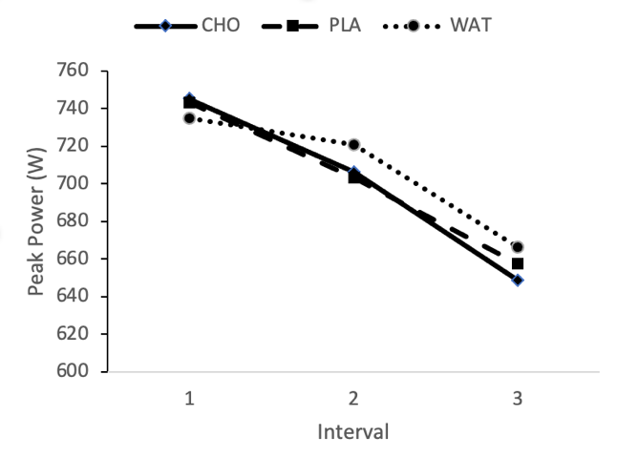
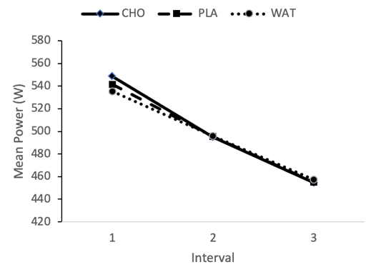
Figure 2: Peak power for each condition across three intervals.
Figure 1: Mean power for each condition across three intervals.

Heart Rate

As illustrated in figure 3, mean heart rate for interval 3 was significantly lower for WAT (133±15bpm) than for both CHO (141±14bpm, p=0.03) with medium effect size (d=-0.684) and PLA (140±11bpm, p=0.008) with large effect size (d=-0.877). For interval 2 mean heart rate was approaching significantly lower for WAT (126±15bpm) than for CHO (133±16bpm, p=0.095) with medium effect size (-0.502) and PLA (133±17bpm, p=0.075) with medium effect size (d=-0.541). Peak heart rate for interval 3 was significantly lower for WAT (144±17bpm) than for CHO (152±15bpm, p=0.041) with a medium effect size (d=-0.633) and PLA (151±12bpm, p=0.013) with a large effect size (d=-0.806), as illustrated in figure 4.

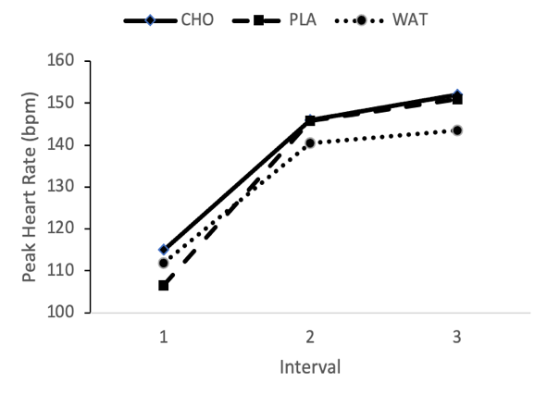
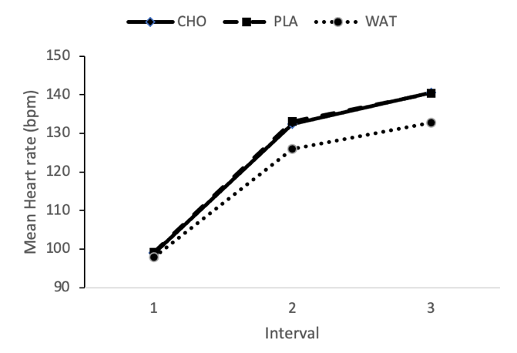
Figure 3: Mean heart rate for each condition across three intervals.
Figure 4: Peak heart rate for each condition across three intervals.

When the mean heart rate across all three intervals was calculated, WAT (119±15bpm) was significantly lower than PLA (124±14bpm, p=0.43) and approaching significantly lower than CHO (124±14bpm, p=0.148), with a medium (d=-0.628) and small (d=-0.428) effect size respectively.

Distance

No significant differences were found in the distance covered during each interval across all three conditions, however distance covered in interval 1 for CHO (293±37m) was approaching significantly higher than PLA (290±36m, p=0.84) and WAT (290±37m, p=0.111) both with small effect size (d=0.480 and d=0.439 respectively)

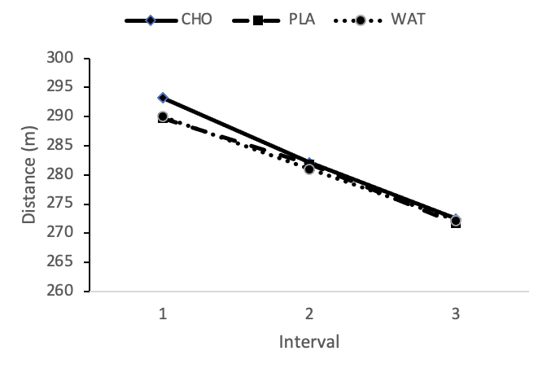
Figure 5: Distance covered in each interval across three conditions.

Subjective measures

Although CHO had the lowest mean RPE across all three intervals, no significant differences were found, with all conditions increasing from a mean RPE for interval 1 of 14.8±0.23, to 16.2±0.47 for interval 2 and finally 17.8±0.32 for interval 3, as shown in figure 6.

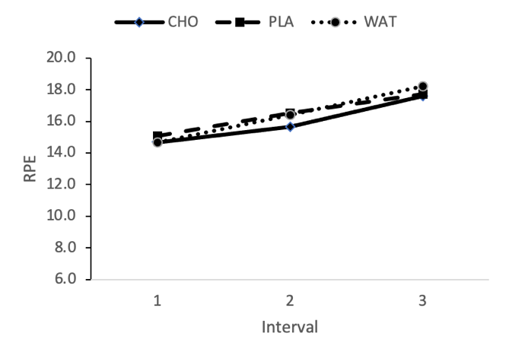

Figure 6: Mean RPE values for each condition across three intervals.

For the Felt Arousal Scale, CHO received the highest mean rating (3.8±1.1) and was approaching significantly higher than both PLA (3.3±1.2, p=0.135) and WAT (3.3±1, p=0.131) both with small effect size (d=0.410 and d=0.415 respectively) as illustrated in figure 7.

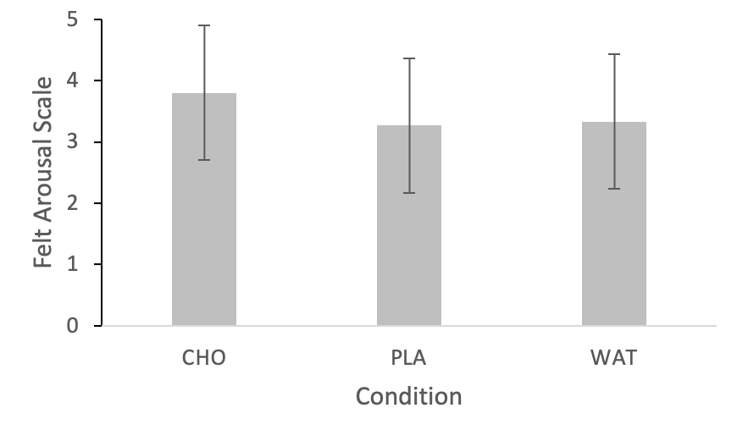
Figure 7: Felt Arousal ratings for each condition

For the feeling scale, no significant differences were found between CHO (0.6±2.4), PLA (0.73±2.4) and WAT (0.47±2.0), as illustrated in figure 8.

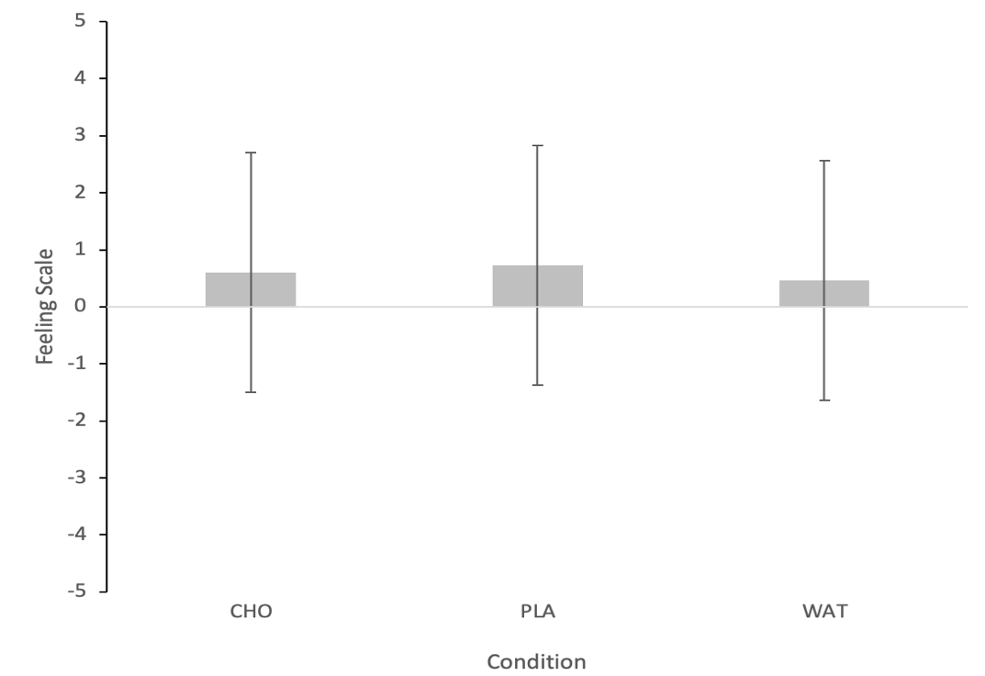
Figure 8: Feeling scale ratings for each condition

Chapter 5: Discussion

The main aim of this study was to determine if a CHO mouth rinse increased peak and mean power output during a sprint interval training session. No significant differences were found between any of the three conditions for either peak or mean power, during any of the three sprint intervals, therefore the primary finding of this study is that CHO mouth rinse does not improve sprint interval training performance in comparison to either a placebo mouth rinse or water. A significant difference was found between some of the conditions for some of the secondary variables such as heart rate, and as mentioned above, the study was under-powered to detect anything other than a large effect size, with results showing only small-medium effect sizes. Therefore, the results for each variable will be discussed in turn, with consideration given to any differences that were approaching significance. Since no differences were found in any of the variables between the responses of males and females, only the group mean results will be considered within this discussion.

Power

Although there were no significant differences in any power values, mean power for interval 1 was approaching significantly higher for CHO than for both PLA (p=0.067) and for WAT (p=0.074), whilst peak power for interval 3 for CHO was approaching significantly lower than for WAT (p=0.065). As shown in figures 1 and 2, the general trend was for mean power to have greater variability between the three conditions in interval 1, but be similar in intervals 2 and 3, whilst peak power appeared higher in CHO and PLA for interval 1, but higher for WAT in intervals 2 and 3, with a bigger decrease evident in CHO than PLA.

To date, no studies appear to have compared CHO, PLA and WAT mouth rinse on repeated cycle sprint intervals of 20s in a fasted state, however some studies have had similar methodologies. Beaven et al. (2013) had subjects perform 5 x 6 second all-out sprints on a cycle ergometer with 24s recovery, with either CHO or PLA mouth rinse. They found that CHO resulted in significantly higher mean power output for sprint 1 (p=0.0205) and significantly lower peak power output (p=0.048) for sprint 5. This is a similar trend to the current study and might suggest that the increased power output in the first interval might result in greater fatigue in later intervals due to having used greater amounts of ATP and phosphocreatine, and potentially resulted in greater accumulation of metabolites in the muscle such as phosphate and lactate ions. As discussed in chapter 2, the mechanism of action of CHO mouth rinse is thought to act upon central fatigue mechanisms by stimulating reward regions of the brain via dopaminergic pathways to either increase motor output or decrease perception of effort (Chambers, Bridge and Jones, 2009). The detection of CHO in the mouth is thought to be an afferent signal that feeds in to a ‘central governor’ which modules motor output (Jeukendrup and Chambers, 2010), however peripheral afferent signals regarding muscle pH and metabolite levels can also feed into this governor. It is possible that in the early sprints, there is an increase in central motor output because of the positive stimulus from the CHO detection, but the greater amount of work done in those early sprints results in greater depletion of phosphates and greater accumulation of metabolites in later sprints. The peripheral fatigue in later sprints may then provide a stronger afferent signal to reduce motor output, masking the signal from the CHO mouth rinse. The lower mean and peak heart rates in the WAT condition for intervals 2 and 3 (figures 3 and 4) would support the notion that the subjects recovered to a greater extent during the recovery periods as a result of having performed less work in the work intervals.

It is important to note, however, that subjects in Beaven et al. (2013) study were only fasted for 2 hours prior to the study, rather than overnight as in the current study. There was also no control group other than the PLA group, therefore it is possible that differences might have been even greater in comparison to a water or no-mouth rinse group.

Phillips et al. (2014) compared CHO and PLA mouth rinse for a 30s all-out cycle sprint in a group of 12 recreationally active male participants. They found that peak power output was 2.3% higher for the CHO group (p<0.05) and that although there was no significant difference in mean power output, when the 30s was broken down into 5s segments, the CHO group tended to be higher in the first 5s and then decrease to a greater extent as the sprint went on. This again supports the notion that the CHO stimulated a greater power output early on, but then also resulted in greater fatigue in the latter stages. In contrast, Chong, Guelfi and Fournier (2011) also used a 30s all out sprint and found no differences between maltodextrin, glucose, water or no-mouth rinse conditions, although they did only measure power for 10s intervals rather than 5s which may have missed the initial surge as a result of CHO.

Although not involving cycle sprints, Clarke et al. (2017) used a number of maximal intensity, anaerobic tests to determine the effects of CHO mouth rinse on fasted exercise, in comparison to both PLA and a no mouth rinse control (CON). They found CHO resulted in significantly higher values for 10m sprint, countermovement jump, Bench Press and Squat repetitions to failure, again supporting the notion of increased neural drive. Although generally CHO values were significantly higher than PLA, in most variables the PLA values were also significantly higher than CON, suggesting that there may be a placebo effect even when the mouth rinse does not contain carbohydrate. This is an important point to note, since a number of studies that found no difference between CHO and PLA mouth rinse did not have a third control arm that either received no mouth rinse or had water (which is not possible to be blinded to due to being easily distinguishable from a flavoured mouth-rinse). Dorling and Earnest (2013) found no difference in repeat sprint ability and Loughborough intermittent test between CHO and PLA, whilst Simpson et al. (2018) attempted to replicate a cyclocross race by having a 48-minute cycle interspersed with 18 x 10s sprints. They found mean power to be higher for the CHO group than PLA in all sprints, but only significantly in the final set – had they included a control group who received water or no mouth rinse they may have found even greater differences. Krings et al. (2017) had four conditions – CHO mouth rinse and CHO ingestion, and PLA mouth rinse and PLA ingestion, but again no control. Their subjects performed 5 x 15s all out cycle sprints with 4 min recovery, yet although they conclude that CHO ingestion was more effective than CHO mouth rinse, analysis of their results shows that in many of the variables, PLA values (for mouth rinse and ingestion) were at least the same if not higher than for the CHO group. Again it is possible that all four groups saw improvement in comparison to a taking no fluid at all. Figures 1-4 in this study support this suggestion, since the values for CHO and PLA seem to trend much more similarly than those of WAT.

Karayiğit et al. (2017) had 15 male football players perform 12 x 4s cycle ergometer sprints with 90s recovery with either CHO, PLA or no-mouth rinse conditions. They found that peak and mean power output were significantly higher for both CHO and PLA in comparison to the no mouth-rinse control, and that the difference persisted across all 12 intervals. The very short duration of the sprints, and the comparatively long recovery periods resulted in much less accumulation of fatigue, which is confirmed by the fact that there was no significant difference in power output between the first and last sprint. This supports the suggestion above that the lack of effect of mouthrinse in the second and third interval in the current study is as a result of strong afferent signals caused by peripheral fatigue masking the stimulating effect of the mouthrinse. The lack of difference between the CHO and PLA mouthrinse conditions in Karayiğit et al. (2017) study also points towards the potential placebo effect of performing a mouth rinse, particularly since the participants in the current study were not deceived as to the purpose of the study, and therefore were aware that there was a potential ergogenic effect to mouthrinse. This is more evident in their study since the control group had no mouthrinse, rather than WAT.

Subjective measures did not show any significant differences, however arousal, as measured by the Felt Arousal Scale (Svebak and Murgatroyd, 1985) was non-significantly higher (p=0.135) for CHO than both PLA and WAT with an effect size approaching medium. This again would support the notion that the tasting of CHO in the mouth stimulated the subjects in some way, resulting in greater power output. The RPE measures again are not significantly different, yet the CHO condition resulted in the lowest mean RPE in all three intervals, even though mean heart rate is significantly lower for WAT in interval 3, approaching significance for interval 2. If, as suggested above, the fatigue levels are greater in intervals 2 and 3 for CHO as a result of the higher mean power output in interval 1, it would generally be expected that these intervals would be perceived as requiring greater effort, yet that does not seem to be the case, again suggesting that the mouth rinse might be influencing the perception of effort.

In parallel with the higher mean power output in interval 1 for CHO, the distance covered during the interval was also approaching significantly greater than for PLA (p=0.84, d=0.48) and WAT (p=0.111, d=0.439). Although the effect sizes are approaching medium, what might be more relevant in the real world is how meaningful that effect might be. The difference in distance equated to 3m (293m v 290m), or just over 1%. In the context of performing sprint intervals regularly in order to stimulate metabolic adaptations for health, this small difference is unlikely to be particularly meaningful. However, in the context of competitive sport, 1% can have a much more meaningful difference. To illustrate this point, the running event that lasts approximately 20s is the 200m sprint. If the winner of the 2020 Tokyo Olympics men’s 200m, Andre De Grasse had finished 1% slower than his 19.62s, his time of 19.82 would have placed him in bronze medal position rather than gold (Olympics.com. 2024). Thus in the context of elite level sport, it is possible that this difference is meaningful, however it is difficult to imagine a situation whereby an elite athlete would be required to compete in an anaerobic event in a fasted state, thus the practical application of this meaningful difference is very limited.

Practical applications

Although the overall findings of this study are that CHO mouth rinse did not result in increased power output during the sprint interval training sessions, since there is no obvious negative side effect to conducting the mouth rinse, there is still sufficient reason to suggest that it might be an effective strategy to consider using whilst exercising in the fasted state.

The overall aim of a SIT session is to stimulate a variety of metabolic adaptations via cell signalling pathways such as AMPK as described in chapter 2. The signals to stimulate these adaptations are varied but generally involve metabolic stress and perturbations to homeostasis, with greater stress resulting in more powerful signalling (de Freitas et al., 2017). By the third interval in this study, both mean and peak heart rate were significantly higher in the CHO and PLA conditions than in the WAT condition and were approaching significance in interval 2. This would suggest that the metabolic stress was greater, which would potentially result in stronger cell signalling, yet the RPE and Feeling Scale values suggested that the increased stress was not perceived to be greater than in the WAT condition. It can be postulated that over several weeks, slightly greater metabolic signalling for no greater perceptual cost might cumulatively result in greater long-term adaptations that are beneficial to health. Since both the CHO and PLA conditions saw similar responses, then it is suggested that a placebo effect occurs, implying that even a mouth rinse containing artificial sweetener might be effective in comparison to no mouth rinse at all. The study by Beaven et al. (2013) found that a CHO and caffeine mouth rinse had an additional benefit to CHO alone, thus from a practical standpoint, rinsing with a soft drink such as cola might be an accessible and low-cost strategy to implement.

Limitations and future research

The first and most obvious limitation of the study is the sample size which was only sufficient to detect a large effect size. Since most of the differences were found to be small-medium effect sizes, then a greater sample size is required in order to be able to more comprehensively answer the research question. A greater sample size would have the additional benefit of being more likely to show any differences between male and female subjects, since in the current study, the total of 7 males and 8 females was unlikely to show significant differences.

As mentioned in chapter 2, there is uncertainty regarding the taste receptors that are responsible for detecting the carbohydrate in the mouth and stimulating the brain regions, and whether they are detecting sweetness or some other characteristic. Therefore, it is possible that the artificial sweetener contained in both the PLA and CHO mouth rinse may have interfered with this signalling. Future studies might consider adding the non-sweet maltodextrin to a beverage that does not contain artificial sweetener, in order to eliminate this potential confounder.

Since the study protocols required the subjects to adhere to a number of guidelines in the lead up to the testing, it is possible that these may have had an effect on performance. For example, abstaining from caffeine and breakfast in the morning might have had a greater effect on their perception of effort and work output than any of the mouth rinse conditions, thus masking the effects. Although this was mitigated for to a certain extent by ensuring the protocols were standardised for all conditions and that the order was randomised, if it had been possible to find subjects who were already accustomed to performing HIIT training in a fasted state without caffeine, this would have improved the validity of the study.

The all-out nature of the chosen HIIT session may have had an impact on findings. As suggested in the discussion, the high levels of metabolic stress and the associated peripheral fatigue may have masked any effects of the mouth rinse in all but the first interval. Future research should investigate the effects of CHO mouth rinse on ‘long interval HIIT’ (Buchheit and Laursen, 2013b) which involves longer durations (3-6 minutes) at intensities of 90-95% of VO2max, which would not result in the same levels of peripheral fatigue.

Chapter 6: Conclusion

The findings of this study contribute to the growing body of research on the effects of carbohydrate mouth rinse on fasted high intensity interval training performance. The results indicate that there is no clear benefit from the point of view of statistically significant power output improvements, however there is reason to consider the use of CHO mouth rinse in a practical context. The significantly higher heart rate response combined with the trend in lower ratings of perceived exertion suggest that using CHO mouth rinse may result in greater metabolic stress without any associated increased perception of effort, which over time may improve the efficacy of the HIIT training, and thus result in greater adaptation. Considering the low cost, ease of availability and lack of any obvious negative side-effects, it would seem pertinent to consider using this strategy as an adjunct to performing HIIT in a fasted state.

Future studies should focus on investigating the effects of different formulations of mouth rinse as well as their effects on longer-duration HIIT protocols, whilst ensuring that sample sizes are sufficient to appropriately power the study. Studies would also benefit from recruiting subjects who are already participating in IF and HIIT in order to increase ecological validity. Although not the focus of this study, the findings indicated that there may be a meaningful performance benefit during single bouts of anaerobic all-out exercise, which might merit future study.

Word Count – 13,897

References
ACSM (2020) ACSM's guidelines for exercise testing and prescription. Philadelphia: Lippincott Williams & Wilkins.
Aird, T.P., Davies, R.W. and Carson, B.P. (2018) 'Effects of fasted vs fed‐state exercise on performance and post‐exercise metabolism: A systematic review and meta‐analysis', Scandinavian Journal of Medicine & Science in Sports, 28(5), pp. 1476-1493.
Ansdell, P., Thomas, K., Hicks, K.M., Hunter, S.K., Howatson, G. and Goodall, S. (2020) 'Physiological sex differences affect the integrative response to exercise: acute and chronic implications', Experimental physiology, 105(12), pp. 2007-2021.
Atakan, M.M., Li, Y., Koşar, ŞN., Turnagöl, H.H. and Yan, X. (2021) 'Evidence-based effects of high-intensity interval training on exercise capacity and health: A review with historical perspective', International journal of environmental research and public health, 18(13), pp. 7201.
Aziz, A.R., Che Muhamad, A.M., Roslan, S.R., Ghulam Mohamed, N., Singh, R. and Chia, M.Y.H. (2017) 'Poorer intermittent sprints performance in Ramadan-fasted Muslim footballers despite controlling for pre-exercise dietary intake, sleep and training load', Sports, 5(1), pp. 4.
Bagherniya, M., Butler, A.E., Barreto, G.E. and Sahebkar, A. (2018) 'The effect of fasting or calorie restriction on autophagy induction: A review of the literature', Ageing research reviews, 47, pp. 183-197.
BASES (2024) Code of Conduct. Available at https://bases.org.uk/imgs/code-of-conduct202.pdf (Accessed: 12 January 2024)
Beaven, C.M., Maulder, P., Pooley, A., Kilduff, L. and Cook, C. (2013) 'Effects of caffeine and carbohydrate mouth rinses on repeated sprint performance', Applied Physiology, Nutrition, and Metabolism, 38(6), pp. 633-637.
Black, M.I., Jones, A.M., Blackwell, J.R., Bailey, S.J., Wylie, L.J., McDonagh, S.T., Thompson, C., Kelly, J., Sumners, P. and Mileva, K.N. (2017) 'Muscle metabolic and neuromuscular determinants of fatigue during cycling in different exercise intensity domains', Journal of applied physiology, 122(3), pp. 446-459.
Bodybuilding Warehouse (2023) Available at: https://www.bodybuildingwarehouse.co.uk/ (Accessed: Dec 22, 2023).
Borg, G.A. (1982) 'Psychophysical bases of perceived exertion.', Medicine & science in sports & exercise, 14(5), pp 377-381 .
Brietzke, C., Franco-Alvarenga, P.E., Coelho-Junior, H.J., Silveira, R., Asano, R.Y. and Pires, F.O. (2019) 'Effects of carbohydrate mouth rinse on cycling time trial performance: a systematic review and meta-analysis', Sports Medicine, 49, pp. 57-66.
Buchheit, M. and Laursen, P.B. (2013) 'High-intensity interval training, solutions to the programming puzzle: Part I: cardiopulmonary emphasis', Sports medicine, 43(5), pp. 313-338.
Burke, L.M. and Hawley, J.A. (2018) 'Swifter, higher, stronger: What’s on the menu?', Science, 362(6416), pp. 781-787.
Carter, J.M., Jeukendrup, A.E., Mann, C.H. and Jones, D.A. (2004) 'The effect of glucose infusion on glucose kinetics during a 1-h time trial.', Medicine and science in sports and exercise, 36(9), pp. 1543-1550.
Chambers, E.S., Bridge, M.W. and Jones, D. (2009) 'Carbohydrate sensing in the human mouth: effects on exercise performance and brain activity', The Journal of physiology, 587(8), pp. 1779-1794.
Chong, E., Guelfi, K.J. and Fournier, P.A. (2011) 'Effect of a carbohydrate mouth rinse on maximal sprint performance in competitive male cyclists', Journal of Science and Medicine in Sport, 14(2), pp. 162-167.
Clarke, N.D., Hammond, S., Kornilios, E. and Mundy, P.D. (2017) 'Carbohydrate mouth rinse improves morning high-intensity exercise performance', European journal of sport science, 17(8), pp. 955-963.
Coates, A.M., Joyner, M.J., Little, J.P., Jones, A.M. and Gibala, M.J. (2023) 'A perspective on high-intensity interval training for performance and health', Sports Medicine, 53(Suppl 1), pp. 85-96.
Colman, R.J., Anderson, R.M., Johnson, S.C., Kastman, E.K., Kosmatka, K.J., Beasley, T.M., Allison, D.B., Cruzen, C., Simmons, H.A. and Kemnitz, J.W. (2009) 'Caloric restriction delays disease onset and mortality in rhesus monkeys', Science, 325(5937), pp. 201-204.
Dallal, G. (2022) Randomization.com. Available at: http://www.randomization.com (Accessed: 21/12/2023).
De Cabo, R. and Mattson, M.P. (2019) 'Effects of intermittent fasting on health, aging, and disease', New England Journal of Medicine, 381(26), pp. 2541-2551.
de Freitas, M.C., Gerosa-Neto, J., Zanchi, N.E., Lira, F.S. and Rossi, F.E. (2017) 'Role of metabolic stress for enhancing muscle adaptations: Practical applications', World journal of methodology, 7(2), pp. 46.
Devries, M.C. and Jakobi, J.M. (2021) 'Importance of considering sex and gender in exercise and nutrition research', Applied Physiology, Nutrition, and Metabolism, 46(6), pp. iii-vii.
Dorling, J.L. and Earnest, C.P. (2013) 'Effect of carbohydrate mouth rinsing on multiple sprint performance', Journal of the international society of sports nutrition, 10(1), pp. 41.
Elliott-Sale, K.J., Minahan, C.L., de Jonge, X.A.J., Ackerman, K.E., Sipilä, S., Constantini, N.W., Lebrun, C.M. and Hackney, A.C. (2021) 'Methodological considerations for studies in sport and exercise science with women as participants: a working guide for standards of practice for research on women', Sports Medicine, 51(5), pp. 843-861.
Forbes, S.C., Candow, D.G., Smith-Ryan, A.E., Hirsch, K.R., Roberts, M.D., VanDusseldorp, T.A., Stratton, M.T., Kaviani, M. and Little, J.P. (2020) 'Supplements and nutritional interventions to augment high-intensity interval training physiological and performance adaptations—a narrative review', Nutrients, 12(2), pp. 390.
Franchini, E., Brito, C.J. and Artioli, G.G. (2012) 'Weight loss in combat sports: physiological, psychological and performance effects', Journal of the international society of sports nutrition, 9(1), pp. 52.
Galloway, S.D., Lott, M.J. and Toulouse, L.C. (2014) 'Preexercise carbohydrate feeding and high-intensity exercise capacity: Effects of timing of intake and carbohydrate concentration', International Journal of Sport Nutrition and Exercise Metabolism, 24(3), pp. 258-266.
Gant, N., Stinear, C.M. and Byblow, W.D. (2010) 'Carbohydrate in the mouth immediately facilitates motor output', Brain research, 1350, pp. 151-158.
Gibala, M.J., Little, J.P., Van Essen, M., Wilkin, G.P., Burgomaster, K.A., Safdar, A., Raha, S. and Tarnopolsky, M.A. (2006) 'Short‐term sprint interval versus traditional endurance training: similar initial adaptations in human skeletal muscle and exercise performance', The Journal of physiology, 575(3), pp. 901-911.
Gillen, J.B., Martin, B.J., MacInnis, M.J., Skelly, L.E., Tarnopolsky, M.A. and Gibala, M.J. (2016) 'Twelve weeks of sprint interval training improves indices of cardiometabolic health similar to traditional endurance training despite a five-fold lower exercise volume and time commitment', PloS one, 11(4), pp. e0154075.
Gillen, J.B., Percival, M.E., Ludzki, A., Tarnopolsky, M.A. and Gibala, M.J. (2013) 'Interval training in the fed or fasted state improves body composition and muscle oxidative capacity in overweight women', Obesity, 21(11), pp. 2249-2255.
Gist, N.H., Fedewa, M.V., Dishman, R.K. and Cureton, K.J. (2014) 'Sprint interval training effects on aerobic capacity: a systematic review and meta-analysis', Sports medicine, 44, pp. 269-279.
Hardy, C.J. and Rejeski, W.J. (1989) 'Not what, but how one feels: The measurement of affect during exercise', Journal of sport and exercise psychology, 11(3), pp. 304-317.
Harris, L., Hamilton, S., Azevedo, L.B., Olajide, J., De Brún, C., Waller, G., Whittaker, V., Sharp, T., Lean, M. and Hankey, C. (2018) 'Intermittent fasting interventions for treatment of overweight and obesity in adults: a systematic review and meta-analysis', JBI Evidence Synthesis, 16(2), pp. 507-547.
Harvie, M.N., Pegington, M., Mattson, M.P., Frystyk, J., Dillon, B., Evans, G., Cuzick, J., Jebb, S.A., Martin, B. and Cutler, R.G. (2011) 'The effects of intermittent or continuous energy restriction on weight loss and metabolic disease risk markers: a randomized trial in young overweight women', International journal of obesity, 35(5), pp. 714-727.
Helgerud, J., Høydal, K., Wang, E., Karlsen, T., Berg, P., Bjerkaas, M., Simonsen, T., Helgesen, C., Hjorth, N. and Bach, R. (2007) 'Aerobic high-intensity intervals improve V˙ O2max more than moderate training', Medicine & science in sports & exercise, 39(4), pp. 665-671.
HIGH5 (2023) Available at: https://highfive.co.uk/ (Accessed: Dec 22, 2023).
Hurst, P., Foad, A., Coleman, D. and Beedie, C. (2017) 'Athletes intending to use sports supplements are more likely to respond to a placebo', Medicine & Science in Sports & Exercise (MSSE), .
Hurst, P., Schipof-Godart, L., Szabo, A., Raglin, J., Hettinga, F., Roelands, B., Lane, A., Foad, A., Coleman, D. and Beedie, C. (2020) 'The placebo and nocebo effect on sports performance: a systematic review', European journal of sport science, 20(3), pp. 279-292.
Jeukendrup, A.E. and Chambers, E.S. (2010) 'Oral carbohydrate sensing and exercise performance', Current Opinion in Clinical Nutrition & Metabolic Care, 13(4), pp. 447-451.
Jeukendrup, A.E., Raben, A., Gijsen, A., Stegen, J.H., Brouns, F., Saris, W.H. and Wagenmakers, A.J. (1999) 'Glucose kinetics during prolonged exercise in highly trained human subjects: effect of glucose ingestion', The Journal of physiology, 515(Pt 2), pp. 579.
Karayiğit, R., Karabıyık, H., Yaslı, B.C., Koz, M. and Ersoz, G. (2017) 'The effect of carbohydrate mouth rinse on intermittent sprint performance in soccer players', Ortadoğu Tıp Dergisi, 9(4), pp. 183-190.
Koliaki, C., Dalamaga, M. and Liatis, S. (2023) 'Update on the obesity epidemic: after the sudden rise, is the upward trajectory beginning to flatten?', Current Obesity Reports, 12(4), pp. 514-527.
Krings, B.M., Peterson, T.J., Shepherd, B.D., McAllister, M.J. and Smith, J.W. (2017) 'Effects of carbohydrate ingestion and carbohydrate mouth rinse on repeat sprint performance', International Journal of Sport Nutrition and Exercise Metabolism, 27(3), pp. 204-212.
Leal, J.M., Galliano, L.M. and Del Vecchio, F.B. (2020) 'Effectiveness of high-intensity interval training versus moderate-intensity continuous training in hypertensive patients: a systematic review and meta-analysis', Current hypertension reports, 22, pp. 1-13.
Little, J.P., Chilibeck, P.D., Ciona, D., Forbes, S., Rees, H., Vandenberg, A. and Zello, G.A. (2010) 'Effect of low-and high-glycemic-index meals on metabolism and performance during high-intensity, intermittent exercise', International Journal of Sport Nutrition and Exercise Metabolism, 20(6), pp. 447-456.
Lundsgaard, A. and Kiens, B. (2014) 'Gender differences in skeletal muscle substrate metabolism–molecular mechanisms and insulin sensitivity', Frontiers in endocrinology, 5, pp. 195.
McArdle, W.D., Katch, F.I. and Katch, V.L. (2015) Exercise physiology. 8. ed., Philadelphia: Wolters Kluwer.
Morrow Jr, J.R., Mood, D., Disch, J. and Kang, M. (2015) Measurement and evaluation in human performance, 5E Human kinetics.
Olympics.com. (2024) Available at: https://olympics.com/en/olympic-games/tokyo-2020/results/athletics/men-s-200m (Accessed: 21/06/2024).
Painelli, V.d.S., Brietzke, C., Franco-Alvarenga, P.E., Canestri, R., Vinícius, Í and Pires, F.O. (2022) 'A Narrative Review of Current Concerns and Future Perspectives of the Carbohydrate Mouth Rinse Effects on Exercise Performance', SAGE Open Medicine, 10, pp. 20503121221098120.
Patikorn, C., Roubal, K., Veettil, S.K., Chandran, V., Pham, T., Lee, Y.Y., Giovannucci, E.L., Varady, K.A. and Chaiyakunapruk, N. (2021) 'Intermittent fasting and obesity-related health outcomes: an umbrella review of meta-analyses of randomized clinical trials', JAMA network open, 4(12), pp. e2139558.
Patterson, R.E. and Sears, D.D. (2017) 'Metabolic effects of intermittent fasting', Annual Review of Nutrition, 37, pp. 371-393.
Phillips, S.M., Findlay, S., Kavaliauskas, M. and Grant, M.C. (2014) 'The influence of serial carbohydrate mouth rinsing on power output during a cycle sprint', Journal of sports science & medicine, 13(2), pp. 252.
Pomportes, L. and Brisswalter, J. (2020) 'Carbohydrate mouth rinse effects on physical and cognitive performance: Benefits and limitations in sports', Science & Sports, 35(4), pp. 200-206.
Pritchett, K., Bishop, P., Pritchett, R., Kovacs, M., Davis, J.K., Casaru, C. and Green, M. (2008) 'Effects of timing of pre-exercise nutrient intake on glucose responses and intermittent cycling performance', South African Journal of Sports Medicine, 20(3), pp. 86-90.
Rodrigues Oliveira-Silva, I.G., dos Santos, M.P.P., Learsi da Silva Santos Alves, Sara Kely, Lima-Silva, A.E., Araujo, G.G.d. and Ataide-Silva, T. (2022) 'Effect of carbohydrate mouth rinse on muscle strength and muscular endurance: A systematic review with meta-analysis', Critical reviews in food science and nutrition, , pp. 1-12.
Rollo, I., Williams, C. and Nevill, M. (2011) 'Influence of ingesting versus mouth rinsing a carbohydrate solution during a 1-h run', Med Sci Sports Exerc, 43(3), pp. 468-475.
Simpson, G.W., Pritchett, R., O’NEAL, E., Hoskins, G. and Pritchett, K. (2018) 'Carbohydrate mouth rinse improves relative mean power during multiple sprint performance', International journal of exercise science, 11(6), pp. 754.
Sinclair, J., Bottoms, L., Flynn, C., Bradley, E., Alexander, G., McCullagh, S., Finn, T. and Hurst, H.T. (2014) 'The effect of different durations of carbohydrate mouth rinse on cycling performance', European journal of sport science, 14(3), pp. 259-264.
Southward, K., Rutherfurd-Markwick, K.J. and Ali, A. (2018) 'The effect of acute caffeine ingestion on endurance performance: a systematic review and meta–analysis', Sports Medicine, 48, pp. 1913-1928.
Strain, T., Flaxman, S., Guthold, R., Semenova, E., Cowan, M., Riley, L.M., Bull, F.C. and Stevens, G.A. (2024) 'National, regional, and global trends in insufficient physical activity among adults from 2000 to 2022: a pooled analysis of 507 population-based surveys with 5· 7 million participants', The Lancet Global Health, .
Sultana, R.N., Sabag, A., Keating, S.E. and Johnson, N.A. (2019) 'The effect of low-volume high-intensity interval training on body composition and cardiorespiratory fitness: a systematic review and meta-analysis', Sports Medicine, 49, pp. 1687-1721.
Sun, S., Zhang, H., Kong, Z., Shi, Q., Tong, T.K. and Nie, J. (2019) 'Twelve weeks of low volume sprint interval training improves cardio-metabolic health outcomes in overweight females', Journal of sports sciences, 37(11), pp. 1257-1264.
Svebak, S. and Murgatroyd, S. (1985) 'Metamotivational dominance: a multimethod validation of reversal theory constructs.', Journal of personality and social psychology, 48(1), pp. 107.
Swindell, W.R. (2012) 'Dietary restriction in rats and mice: a meta-analysis and review of the evidence for genotype-dependent effects on lifespan', Ageing research reviews, 11(2), pp. 254-270.
Terada, T., Toghi Eshghi, S.R., Liubaoerjijin, Y., Kennedy, M., Myette-Côté, E., Fletcher, K. and Boulé, N.G. (2019) 'Overnight fasting compromises exercise intensity and volume during sprint interval training but improves high-intensity aerobic endurance', J.Sports Med.Phys.Fit, 59(3), pp. 8281.
Thomas, J.R., Martin, P., Etnier, J. and Silverman, S.J. (2022) Research methods in physical activity Human kinetics.
Thompson, W.R. (2022) 'Worldwide survey of fitness trends for 2022', ACSM's Health & Fitness Journal, 26(1), pp. 11-20.
Trapp, E.G., Chisholm, D.J., Freund, J. and Boutcher, S.H. (2008) 'The effects of high-intensity intermittent exercise training on fat loss and fasting insulin levels of young women', International journal of obesity, 32(4), pp. 684-691.
Wallis, G.A. and Gonzalez, J.T. (2019) 'Is exercise best served on an empty stomach?', Proceedings of the Nutrition Society, 78(1), pp. 110-117.
Wattbike. (2023) Available at: https://support.wattbike.com/hc/en-gb (Accessed: Dec 22, 2023).

Appendix A - Information Sheet



Geraint Forster
g.forster@uwtsd.ac.uk

Participant Information Sheet

The effect of carbohydrate mouth rinse on High Intensity Interval Training (HIIT) performance in a fasted state.

Dear Participant,
Thank you for showing an interest in my study. Here is some further information regarding the nature of the study, along with the answers to some questions you may be wishing to ask. It is important that if you consent to participate in this study that you do so in a fully informed way, therefore I will go over this information sheet with you and give you an opportunity to ask any questions you have before you sign the informed consent form.

Location of the study:
The study will take place in the Physiology Laboratory and the Human Movement Studio on the Carmarthen campus of UWTSD.

Investigator:
The lead investigator is Geraint Forster.

Who is funding the research?
The research is not being funded, this is being conducted as part of an MSc Sport and Exercise Nutrition course at UWTSD Carmarthen.

Can I take part in the study?
I am looking for individuals who fulfil the following criteria:
- good general health (as assessed by PAR-Q 2020+);
- no Musculo-skeletal injuries that would limit ability to perform high intensity exercise on a cycle ergometer;
- recreationally active – participate in some form of recreational physical activity at least 2-3 times per week;
- not currently taking any performance enhancing drugs or ergogenic aids;
- willing to strictly comply with all study procedures and restrictions;
- willing to voluntarily participate, as indicated by signing the informed consent form.

What is the study about?
There is an increase in the popularity of several fasting strategies such as Intermittent Fasting (IF) and also in High Intensity Interval Training (HIIT). Some research has suggested that swilling the mouth with a drink containing carbohydrates (CHO) can reduce perception of effort and increase exercise performance, even when the drink is then spat out, rather than being swallowed. If this finding can be confirmed it could prove to be very beneficial to individuals who want to complete HIIT sessions in a fasted state.

The aim of this research, therefore, is to determine if there is an ergogenic effect of carbohydrate mouth rinse on HIIT performance in recreationally trained participants.

How will I be involved?
Participation in this study will involve visiting the Physiology Laboratory and the Human Movement Studio at UWTSD Carmarthen on five occasions.

Visit 1 – familiarisation.
This visit does not need to take place in the morning or in a fasted state and will start in the physiology laboratory with me discussing the contents of this information sheet with you and answering any questions or concerns that you may have. If you are then happy to participate, a consent form will be signed, and you will be required to complete a Physical Activity Readiness Questionnaire (PAR-Q) to ensure that you are safe to participate in the study.

Your height and weight will be measured and recorded, and we will then proceed to determine the appropriate seat height for you on the wattbike indoor cycle trainer. You will be fitted with a Polar heart rate chest strap.

You will then complete your first HIIT session on the Wattbike. The session involves three 20s all-out sprints, interspersed with some easy pedalling as shown in the image below:

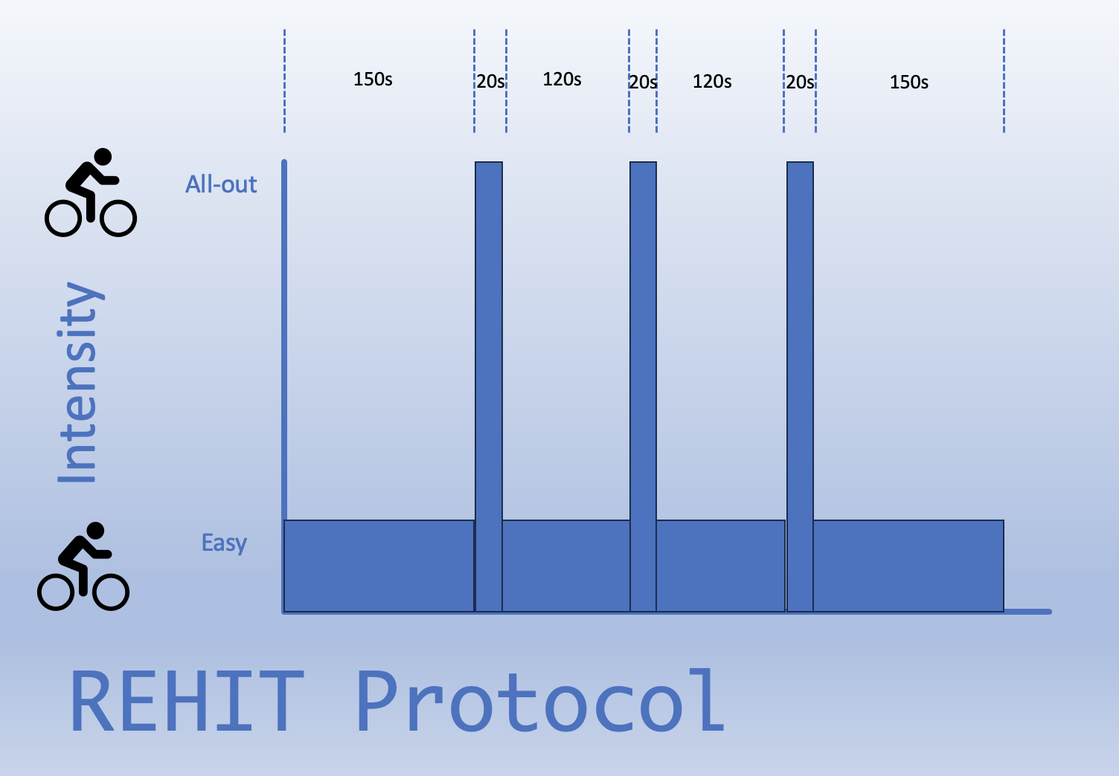
It is important that the three sprints all ‘all-out’ – that is a maximal effort for every second of the 20. Other than the three 20s sprints, the rest of the 10 minutes involves easy pedalling against a very light resistance.

Visit 2

This session again does not need to be in a fasted state and is just another chance for you to become familiarised with the HIIT workout by completing it again – this whole visit should only last 20 mins.

Visits 3-5
You will then attend the Lab on three different days, at least 3 days apart. The sessions will take place in the morning (between 9-11) and it is important that you adhere to the following restrictions/guidelines prior to the three testing days:
- Avoid any strenuous exercise for 24 hours prior to the test.
- Avoid any alcohol for 24 hours prior to the test.
- Have not eaten that morning, and only had water to drink,
- If possible, eat a similar meal the night before testing and try to ensure your sleep routine is similar.

Once again you will be fitted with the HR chest strap and will complete the HIIT session, but on these occasions, 30s prior to each sprint, you will be given 25ml of a drink to swill in your mouth for 10s then spit back into the cup. On one of the occasions the drink will be water, on another it will be a zero-calorie sports drink, and on the other it will be the same sport drink but with 6% carbohydrate added to it. Neither you nor I will know which drink you are receiving (other than the water obviously).

You will then be asked to complete a couple of short written questionnaires – you can refuse to answer any questions you are not comfortable answering.

Are there any risks involved in participation?

There are always some risks involved in participating in exercise, particularly at high intensity.

Muscle soreness is possible after the HIIT sessions due to the high intensity nature of the protocol however this should dissipate after about 72 hours.

Musculo-skeletal injuries are also a possibility; however we have tried to mitigate these by using cycling which is a low-risk exercise. It is important that you stop exercising at any point if you feel pain (as opposed to the discomfort of fatigue).

Can I change my mind?

Yes, you can withdraw from the study at any point without giving any reason. This will not in any way affect your studies or your standing within the University. You may also withdraw your data up to one week after the completion of testing.

What happens to my information?

Research data stored in paper form, such as your age, weight, height and medical information will be stored in a locked filing cabinet in the principal researcher’s office. All electronic data will be encrypted and kept in password protected cloud storage on the University Office 365 system which will not be shared. You will be given a unique identifier to ensure confidentiality and this list will be kept securely in the password protected folder. The data will be stored until the completion of the project and then deleted. In accordance with the DPA2018, you will have the right to ask to see what data is held relating to you, and this data will be deleted immediately if you request this, in which case the data will not be used in the project. The result of the study may be published in a scientific journal, but your name will never be published. All data will remain completely confidential at all times.

What if I have some questions?

You will have an opportunity to discuss any questions with me on the first visit, or if you would rather discuss these in private prior to this, you can contact me at g.forster@uwtsd.ac.uk

What if something goes wrong or I have complaints?

Please feel free to contact me if you have any concerns or issues, or feel free to contact the Programme Manager of the MSc Sport and Exercise Nutrition, Chris Cashin c.cashin@uwtsd.ac.uk

What do I do next?

If you are happy to participate having read this information sheet, please attend the familiarisation session and sign the informed consent form.

Appendix B - Informed Consent form

Research Study Informed Consent

Study Title: The effect of carbohydrate mouth rinse on High Intensity Interval Training (HIIT) performance in a fasted state.

This information is being collected as part of a research project conducted by Geraint Forster at the University of Wales Trinity Saint David. The information which you supply and that which may be collected as part of the research project will be entered into a filing system or database and will only be accessed by authorised personnel involved in the project. The information will be retained by the University of Wales Trinity Saint David and will only be used for the purpose of research, and statistical and audit purposes. By supplying this information you are consenting to the University storing your information for the purposes stated above. The information will be processed by the University in accordance with the provisions of the Data Protection Act 1998. No identifiable personal data will be published.
Statements of understanding/consent:
- I confirm that I have read and understand the participant information leaflet for this study. I have had the opportunity to ask questions if necessary and have had these answered satisfactorily.
- I understand that my participation is voluntary and that I am free to withdraw at any time without giving any reason. If I withdraw my data will be removed from the study and will be destroyed.
- I understand that my personal data will be processed for the purposes detailed above, in accordance with the Data Protection Act 1998.
- Based upon the above, I agree to take part in this study.

Name of participant........................... Date..................... Signature..........................

Name of researcher........................... Date..................... Signature...........................

