
Name: - Dev Kishorkumar Manseta
Student Id:-2212021
Subject: -Digital Marketing
Subject Code: - LCMB7010
Chosen Company: - APPLE
Lecturer’s Name: - Mr Amitave Banik

`

Table of Contents
Part 1 3
Introduction 3
Background of Organisation 3
Concept of digital marketing 5
Analysis of Digital Marketing tools used by organisation 6
Digital assets the organisation owns 6
Balance between internal and external communication 9
Information architecture 13
Marketing Mix 15
Part 2 21
Application of ML in digital marketing to maximise ROI 21

Conclusion 25
Reference list 27
Appendix 1: CRM of Apple Mac 33
Appendix 2: Mind Map of Apple Marketing Mix 34

Part 1

Introduction
Digital marketing is the process of marketing the services and products using digital technology mainly on the internet incorporating display advertisement, mobile phones and any other digital medium (Saura et al. 2019). Marketing mainly consists of organisational and individual activities which can facilitate and expedite the exchange of relationships in a dynamic environment through promotion, pricing, distribution of services and ideas (Vieira et al. 2019). The task is divided in two parts, the first part describes the analysis of digital marketing tools used by a specific organisation in terms of digital assets, information architecture, internal external communication and digital marketing strategies. The second part focuses on the utilisation of machine learning which an essential component of artificial intelligence is for knowing individual customers from market segmentation and marketing intelligence for forecasting decisions. This section focuses on how application of machine learning can be utilised in digital marketing to maximise the ROI of business.

Background of Organisation
Apple is a renowned American consumer and computer electronics organisation that is famous for creating the iPad, iPhone and Mackintosh computers. Organisation is one of the largest companies with a market capital of two trillion dollars. Services of the business are renowned for the devices of their design by tide integration between Software and hardware that provide the system a performance over the competitor system with similar specifications. The organisation has focused on the digital marketing strategy that helps to create an experience for enhancing customer interaction by using unique value propositions and online marketing tools. Apple mainly focuses on values and captivating visuals to understand the target market aspect based on strategic marketing (Apple.com, 2023).. Rather than that, there are Apple stores worldwide where the customer can visit physically to purchase the product (Apple.com, 2023). Therefore, it can be stated that Apple can utilise both the online and offline marketing for their product and services to attract the target audience.
The market for consumer electronics size is expanding globally which was estimated to be over USD 1.10 trillion in 2021 and estimated to grow about USD 1.70 trillion by 2028 (Howard, 2023). It has been found by the Zion industry research that the global market is anticipated to expand at a compound annual growth rate which is 7.6% from the current year to 2028 (Howard, 2023).
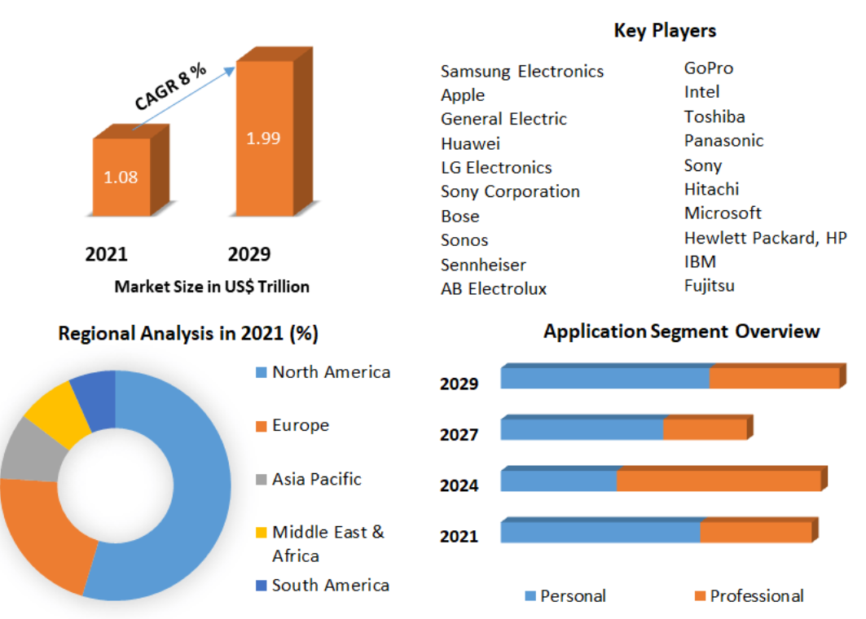
Figure 1: Global Market of Consumer Electronics Products
(Source: Howard, 2023)
The organisation Apple operates in different countries including the United States, United Kingdom, China, and Australia. The organisation has expanded the number of retail locations with 525 stores across 26 countries (Howard, 2023).
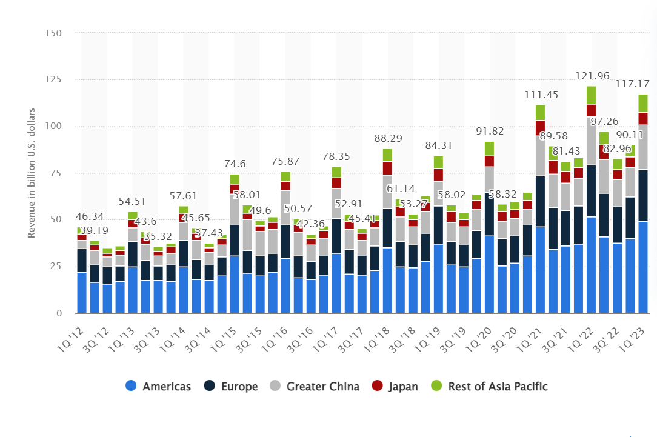
Figure 2: Revenues of Apple based on Country
(Source: Laricchia, 2023)
From the above diagram it has been found that the Americans are the biggest regional market of Apple which brought the net sale of 49.28 billion US dollars in the first quarter of the current fiscal year. Greater China and Europe are the two other major markets of Apple.

Concept of digital marketing
Digital marketing is the promotion of services and products with the help of digital devices and the internet. As stated by Darma and Noviana (2020), the digital marketing strategy involved applying the technology from online channels to markets such as SEZ, SEM,
The concept of digital marketing is to support the marketing activities with a multi-channel buying process and customer life cycle. There are different approaches to digital marketing that can be helpful to migrate the customer for online service through traditional and e-communication channels. In the opinion of Christina et al. (2019), it is helpful to deliver and improve customer knowledge based on online services and targeted communication. There are mainly five different ways of digital marketing which include search engine marketing, social media marketing, search engine optimization, content marketing and email marketing. As opined by Saura et al. (2021), search engine marketing is the process of gaining website traffic from different searches by utilising the platform such as Google AdWords, search ads, bing ads. Social media marketing primarily refers to the process to get the visitors and traffic from social media channels by utilising Instagram, Facebook, and Twitter.
Most of the large business organisations have used social media marketing for influencing the target audience and managing the business decision. In the opinion of Al-Weshah et al. (2021), search engine optimization is the process to get traffic from the different search engines such as off page SEO and on page SEO. Much literature focuses on the concept of content marketing which is the strategic marketing tool to focus on distribution and creating relevant and valuable content for attracting the visitors and converting it to the potential customers. As argued by Olson et al. (2021), it is helpful for the business to increase sales, cost effectiveness and enhance customer loyalty. There are several benefits of utilising digital marketing in the organisation to enhance customer acquisition, development of ROI, instant access of the information, increase customer loyalty and retention, communication building and reputation. As per the opinion of Peter and Dalla Vecchia (2021), in the contradiction, some of the major disadvantages of digital marketing have also been utilised such as weaker trust due to large number of scams, information getting sold faster and bigger competition in the competitive landscape. As opined by Qurtubi et al. (2022), sometimes digital marketing is not suitable for different products and services and they are prone to glitches such as non-working URLs that can bring the whole campaign down. Therefore, it has been identified that digital marketing has more benefits rather than disadvantages which compelled the large organisation to strategically implement digital marketing tools in the business platform.

Analysis of Digital Marketing tools used by organisation

Digital assets the organisation owns
A digital asset is primarily the content store digital and uniquely identified by the organisation for realising the value. Examples of digital assets include audio, video, slide presentation, websites and spreadsheets (López García et al. 2019). Apple utilised digital asset Management to store the information regarding the design of individual products such as iPhone, iPad, audio, video files in a content centric field that can be accessed by individual employees of the business. Apple has utilised the digital asset for customer engagement and process optimisation that can help to provide quality assurance and innovation in the business (David, 2022). There are more than 15,400 employees in the organisation who need to access the assets such as audio, video and important files of the organisation easily and quickly without leaving their useful workflow. The digital assets are listed below:
Websites
The website of Apple is a digital asset which contains the digital contents regarding the new product launchers and supporting activities. The website also provided information about the values of Apple in accessibility, education, privacy, supplier responsibility and environment (Apple.com, 2023). The website contains the trademark and trade name which are the valuable asset of the organisation to create corporate brand identity.
Operating system
The primary operating systems of Apple include OS/iOS, iPadOS, watchOS, macOS, tvOS. iOS mobile operating system that has been developed by the organisation exclusively for the hardware that powers many of the mobile devices including iPhone. MacOS is a computer operating system that has been initiated by Apple for managing the laptops and desktops which is a graphical operating system that empowers every Mac (Apple.com, 2023). Interact with the computer hardware by allocating the resources for completing the task such as running applications.
Personal Digital Assistance
Another digital asset of Apple is a personal digital assistant provided within the integration of Siri that can be helpful for playing music on iPhone and listening to music with apple music voice on the iPhone. Helpful to control the home using Siri on the iPhone. It is helpful to keep the information secure and private that is associated with the Apple id (Apple.com, 2023). Power of the Apple neural engine ensures the audio of requests that never leave the iPhone.
Flow and Metamask
In February 2020, the organisation hired Jeff Bronikowski who is the former head of technology innovation working with a number of blockchain efforts for creating the digital assets for Apple using a public blockchain called Flow. In 2022, Apple has focused on digital asset Management by using the crypto wallet MetaMask that can be helpful to surpass 30 million monthly active users for supporting the organisation and customs to buy lip to directly from the wallets. The tool can be helpful for the organisation to maintain effective communication and collaboration based on the experience on digital acids and employee integration of important information (David, 2022). It is also helpful to keep track of where the digital asset belongs to and the centralised place where users can locate the digital asset for tracking the all valuable content of Apple. The recreation of digital assets will be helpful to cost time and money and beneficial for Apple to closely integrate with crypto features and functionality like ethereum or crypto payments in the blockchain technology.
Other supporting digital assets
The organisation is spending billions of money in their product design and new features development that can be stored as digital assets by following their hardware and software ecosystem (David, 2022). The key employees of the organisation are working together for product release and keynote events that can focus on strong signs of blockchain and crypto for gaining prominence through the mobile phones. With the integration of iPhone and the key Technology the organisation is focusing on to on-board people into crypto that help to understand the possibility of transaction on d centralised permission less and transparent digital network (van der Merwe, 2021). Individual employees and customers in the organisation will focus on crypto technology. The CEO of Apple focuses on believing in the privacy of digital assets by making fundamental human rights and having control of all the information in the organisation. The digital asset of the business is helpful to control over all the information and transparency by promising trust to the Employees and customers (Arya et al. 2019).
Nearly two billion people still have access to the financial services of Apple and different products and services (Apple.com, 2023).

Balance between internal and external communication
Internal communication refers to the exchange of ideas and information within the organisation while external communication focuses on exchange of information both within the organisation and outside the business (Fu, 2022). Focusing on the websites and the balance between internal and external communication Apple enhances their business performance to enhance business strategy and managing the digital marketing objectives. Apple has utilised SAP software for their application store, online store, iTune and other services by using different application systems for their human resource and finance department. The software helps the organisation to enhance the communication flow with the internal and external stakeholders and develop the relationship with them. The SAP helps to connect the provider of Apple for external communication with support sending using telecommunication services, internet mail and fax.
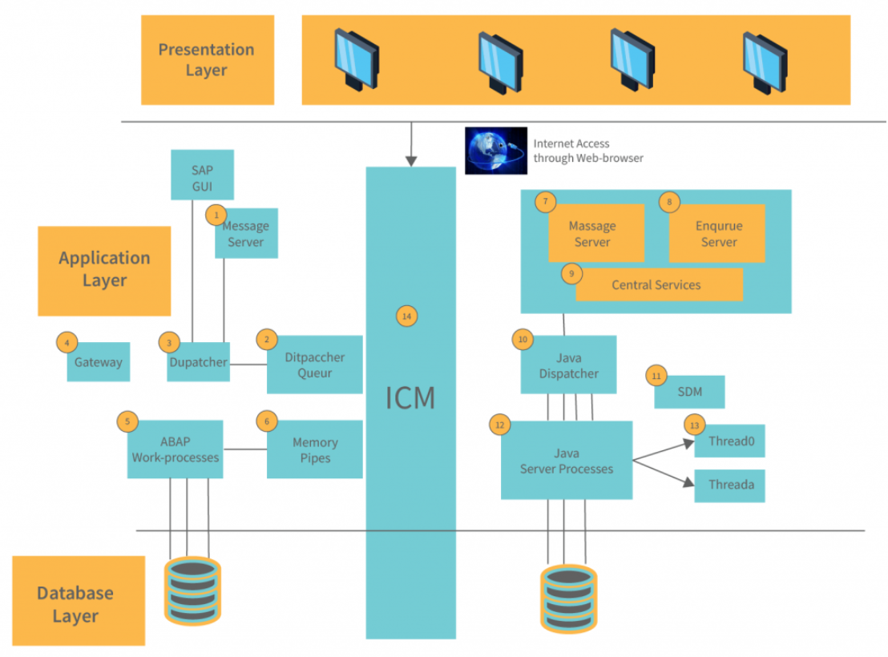
Figure 3: ERP System Architecture of Apple for Communication flow
(Source: apple.com, 2023)

Internal Communication
The organisation is known for its secrecy based on the development of new products and services where the Apple employees are able to gain internal access with effective communication. The technical giant organisation is developing an application named UniBox which helps the employees to communicate with each other and deal with customers as well as test the individual devices (inc.com, 2023). Another application utilised by the organisation is AppleConnect which is a secure employee only service that helps the employee for signing in the application and services by making use of the Android styles swipe pattern system for providing effective shapes and services.
It is focused on the ecosystem of Apple by adapting the knowledge management and the application through the official platform. The closed ecosystem of the organisation has embraced the internal communication effectively by keeping track of different departments. The organisation has an employee communication missed that can be utilised for sharing of documents and information easier. There are several applications which have been built by the organisation such as to maintain closed ecosystem such as Tank, Inferno, and Genius, for Apple to demonstrate the capabilities of different products and services and enhance the internal communication between employees to employees (inc.com, 2023).
External Communication
Apple is a smart company which focuses on the communication strategy by delivering messages to customers. External communication is helpful for the organisation to implement innovation sustain in the competitive business environment. For external communication with the customer the organisation has maintained a relationship management framework that can be helpful for using information technology for creating a cross functional enterprise system that automates and integrates the customer service process in marketing and sales of the product (Dewnarain et al. 2019).
The external communication strategy applied by the organisation can be characterised as inclusive and professional because it is helpful to answer all the enquiry of the customer. The customer relationship management ensures high level communication and focuses on customer satisfaction in terms of communication with the business representative at an exclusively high level. The integration of the CRM framework, all the complications between customer experience and Organisation can be solved with productive communication with the clients (Khashab et al. 2020). Another important component of the external communication strategy of Apple is to manage the interaction between employees and manager by ensuring business reputation and customer satisfaction (Ayyagari, 2021). The code of communication utilised by the organisation focuses on dealing with transparent issues and honesty with the customers by preventing negative repercussions of unethical behaviour as well as incorrect comments from the representative of the Apple.
With the implication of digital marketing strategy, can promote the services and product in digital media tools which can help to improve the customer company communication by developing better relationships with the clients. The communication process in the organisation of Apple can be achieved with the creation of a friendly atmosphere and with the association with client organisation by integrating in digital media and channels such as through websites and social media platforms (crm_org, 2023). The CRM system in Apple has integrated its own application. In 2018, Salesforce and Apple announced partnership by including CRM functionality inside the iOS devices that can be helpful to provide customer service and integration. With the integration of basic Apple applications individuals can get a lot of CRM functions which include Apple mail, Safari, Contacts and calendar for recognising the contact information and sharing with the customer by saving time in communication with making effective schedule appointments with individual customers (crm_org, 2023).
From the above analysis it can be stated that internal communication and external communication in Apple help to enhance the digital marketing strategy by attracting target audience base and mitigating the complaints immediately. The integration of CRM allows Apple to identify the target customer so that they can be retained as lifelong by providing more profitable services in the business. CRM of Apple provides possible real time customization of product and services based on customer buying habits and needs [Referred to Appendix 1]. It is helpful to track the customer contact and also enable the organisation for providing a consistent customer experience and superior services for supporting across the customer
Swot Analysis
Strength  - Company-customer interaction  - All-inclusive presence on the social media  - Clear and concise messages | Weakness  - Authoritarian view of communication  - Slow reaction time
Opportunities  - More presence on social media  - Better response time  - Customer service satisfaction surveys (apple.com, 2023)  - Customer benefits | Threats  - Unwillingness of the customers for following the trends.  - Inability for engaging the customers (apple.com, 2023)  - New interaction method for developing the rivals.

Information architecture
Information architecture focuses on structuring, labelling and organising content in a sustainable and effective way for helping the user to find complete tasks and information. The retail store Apple highlights the role of information architecture for building the bridge experience by crossing various contexts and experiences with the objective of defining a human information interaction model that can enhance the digital marketing strategy with the information of task and flow (Jia et al. 2020). The organisation bridges experience with the crossing of internet application. The website and the Apple store share common information despite their necessary interface differences with the integration of information architecture. Based on the information architecture diagram it has been found that the navigation bar shows the different tabs such as iPod, iPhone, iTune, Home that can be utilised by the employees and customer to share information quickly and easily for influencing the digital marketing capability.
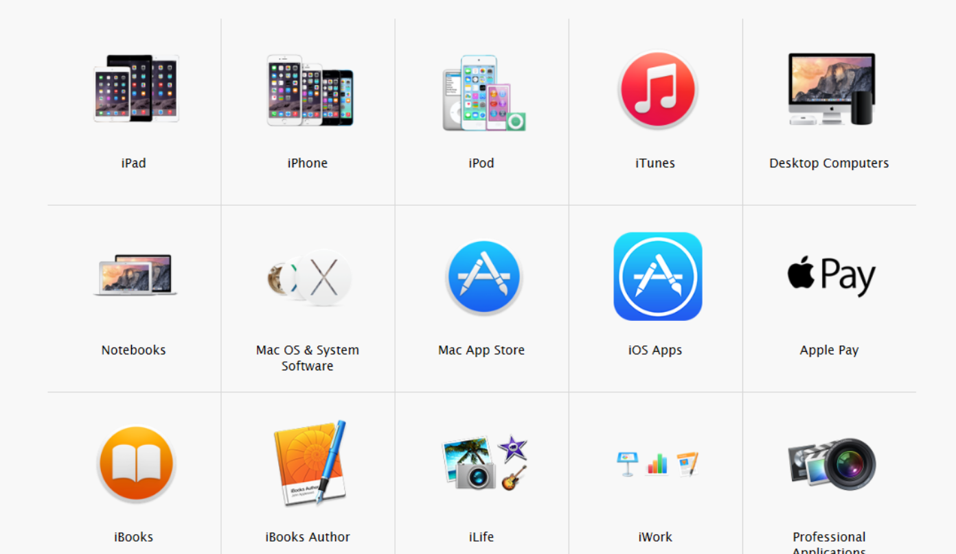
Figure 4: Information System of Apple
(Source: apple.com, 2023)
Retail stores
Inside the retail store of Apple there is an LCD video screen that has provided the particular areas for demonstrating the product on sales by specifying their features and accessories. Inside the main there are computers which are displayed based on the features and specification of the devices that are helpful to bring attention for compatibility and similarity within different devices (Li et al. 2021). in different products and services of Apple such as iPod and iPhone.
The information architecture of Apple is based on the viewing experience of the product on video screen and different correlated products that can be suggested with the purchase related association such as people who looked for the product and people who bought the product. This kind of suggestion is a strategy for the organisation for circular flow of Information and also enhances the information seeking process that helps to lead the customer for evaluating the needs (Mazzia et al. 2020). Specific services and products can be suggested for contextual content on the videos to aim and encourage customers for enhancing the information search. In this way Apple can utilise the same information that can be retrieved by various information searches through the incorporation of a multi-dimensional approach. The customer can identify different parts for following the specific information needed based on the video screen interface and web screen interface in the physical retail space (Bahador, 2019). The information seeking process in Apple can be considered as transversal research which can focus on the final set of confusing information about the product and services that can be helpful to market the product in front of the target audience.
Websites
The employees can improve the design process for making effective suggestions in terms of customer demands and function by recognising the information and interacting with the information. From Apple website to the retail store the digital interface to the physical one can be helpful to play a proactive role in the overall design by making bridge experience for crisscrossing and creating in everyday life (Putri et al. 2020). Sweet Spot is a rifle reloading tool that analyses chronograph speeds, group sizes and charge weight. It calculates the average velocity, extreme spread, standard deviation and shows velocity charts to visually see speed nodes on your rifle.

Marketing Mix
The digital marketing strategies of Apple can be showcased with the integration of 8P’s marketing mix theory that represent product, price, place, promotion, People, Positioning, Process, Performance practice of the organisation to capture the target audience in the consumer electronics, information technology, online service and digital content distribution. The primary focus of the digital marketing strategies is to enhance business profit and also gain the attention of the customer base by innovative products and services [Referred to Appendix 2].
Product | The primary product of the organisation for Digital marketing including the goods and services that are classified as information technology. The main products include iPhone, iPad, AppleCare, cloud services, wearable accessories, payment services and digital content. The advertising service of the organisation mainly focuses within the application store. Organisation focuses on two types of pricing strategy such as premium and freemium. The premium pricing strategy involved the organisation to offer different Apple products at a premium price for the elite customer. For example, iPhones are expensive compared to other competitive smartphones in the business market then result in the maximisation of profit margin.
Price | However in the digital marketing place, high price can be considered as a weakness as there are competitive organisations that provide low price products. It is a marketing strategy for the organisation for example Apple offers free 5 GB of iCloud storage however to access the storage capacity the customer needs to pay a recurring fee. Therefore, the premium pricing policy of the organisation supports associated product design and premium branding with development offering.
Place | Organisation has more than 500 retail stores in 15 different countries that strategically enhance their business growth by providing high traffic locations like urban shopping districts and quality of shopping malls. Online stories are official websites where customers can access and purchase the product.
Promotion | Apple has utilised digital marketing strategy using the digital advertisement network and online website promotion tools. The promotion media of Apple include personal selling, advertisement, public relations and sales promotion. The organisation promotes the product by advertising in Vogue magazine. Organisation also has agreements with prominent websites for promoting and advertising Apple products. The business has utilised personal selling by providing specific information which involved sales promotion. The organisation has utilised public relations for optimising the corporate image as a leading technology and online service business. For example, the company has utilised social media marketing strategies for maximising the profit positively. Apple has used a public-relation initiative that incorporates ConnectED that aims for improving education outcomes while promoting services and products. Apple has used a communication strategy for satisfying business needs to mitigate customer needs.  Television promotion  Apple focuses on television promotion in different countries to introduce its new product and services. For example the marketing campaign of Apple "Get a Mac" was a series of television commercials that was created by the organisation for marketing the Mackintosh computers. In this campaign there were 66 individual commercials that can successfully promote the computers of Apple (Imore.com, 2022).  Social media promotion  During the pandemic of Covid-19 the organisation has launched the "creativity goes on campaign" which focuses on the social media commercials compiled of families and individuals at home during the lockdown using the Apple devices for shooting videos and taking pictures in other creative pursuit (Esloganmagazine.com, 2020). The aim of the campaign is to provide a Ray of sunlight breaking to the cloud of pandemic by promoting positive Apple TV shows for providing entertainment to the users.  Advertisement strategy  Recently Apple has shown the ability for suiting the product in the latest campaign such as "The Greatest" which is the advertisement that shows features available on iPhone, watches, Apple macbooks and iPads (Marketingmag.com.au, 2022). Advertisement promotion focuses on people with different ability levels from people in wheelchairs to different deaf persons by highlighting how the products can assist the different ability levels.
People | The marketing team of Apple is responsible for selling of products by improving reputational growth.
Positioning | Apple's brand positioning is based on three key elements: innovation, design, and customer experience. These three factors allow Apple to stay ahead of competitors while maintaining a strong sense of identity (apple.com, 2023)
Process | Online marketing campaign and advertisement.
Performance | High return on profits and reputational gain.

Push and Pull Strategy
Apple is currently focusing on push marketing strategy by improving product lines such as Mac but also the organisation has also facilitated pull marketing strategy to improve branding.

Part 2

Application of ML in digital marketing to maximise ROI
Machine learning is a crucial component of artificial intelligence which can be applicable in digital marketing for maximising the ROI of business. AI marketing is a method to leverage technology for improving the customer journey. It can be also utilised for boosting the return on investment of the marketing campaign (Peyravi et al. 2020The application of machine learning in digital marketing for maximising the ROI are listed below:
SOASTEC Analysis/Digital Marketing Plan
Situation | Based on customer analysis it can be stated that Apple needs to more focus on digital marketing planning for to provide more information on products and its features.
Objectives | With the integration of machine learning and Big Data analytics it is helpful to get insight of the target audience.
Strategy | Machine learning can be helpful to use the information for delivery product recommendation based on customer interest and also buy the same item in the digital portal that can enhance the buying experience of the audience. This can be helpful to increase the ROI of business by understanding customer demand and provide the particular products for enhancing business profit (Dastane, 2020).
Tactics | Chatbots can be programmed for providing the replies for frequently asked questions and a dedicated conversion mode for humans to enhance their buying experience. This helps to reduce the time for customer service agents and also the workload by providing free time to deal with conversations that need personal response.
Action | The integration with machine learning and AI can be helpful to suggest the alternative and recommendation that has been influenced by the past browsing history at the shopping behaviour of the target audience (Ovuakporaye, 2022).
Control | After implication of machine learning Apple can successfully integrate digital marketing plan for enhancing ROI.

Improved personalization and recommendation
The machine learning application helps to enable the marketers to personalise their communication with the customer that relies on past purchasing history. The technology can work to predict the customer behaviour based on Intelligence learned from the previous interaction with the brand. For example, Amazon has a record of individual purchases made by the customer based on the product browsing history, the address of the customer, product rating and product reviews (Nair and Gupta, 2021).
Dynamic Pricing
Another application of machine learning is dynamic pricing by providing a discount for increasing the sales that customers will buy with a small discount. Machine learning can be utilised to set the price of a product depending on the availability, demand, customer profile and other factors for maximising both the profit and sale (Dumitriu and Popescu, 2020). For example, the product price of Amazon can be displayed in camel.com that can track the price of every product and also each product has a graph showing how much the price fluctuates depending on the popularity and season (Dastane, 2020). Henceforth, it can be stated that dynamic pricing can be helpful to maximise the profit of business by predicting the right price of the product that can help the customer for more buying.
Customer Service Chatbots
Another application of machine learning as well as AI is customer service chat boards that can provide a convenient way for customers to contact the seller for enhancing business profit. For example, Facebook WhatsApp and messengers applications have been popular that have been utilised by the organisation to ensure that the accounts are constantly stuffed with customer service agents (Saura et al. 2021). For reducing the workload and providing the fast response to the customer some organisations utilise chatbots for dealing with common customer queries and providing instant replies all the time (Lies, 2021). It is helpful to enhance the ROI of business by providing customer satisfaction and managing the business growth. For example, the retail giant of the UK such as Amazon, Tesco has utilised virtual assistants like Alexa, Cortana, Google assistant, Siri chatbots to enhance customer experience.
Search Engine Optimization
Search algorithms are improving in every aspect with the application of machine learning from small database product searches to the eCommerce site and every search engine like Google which are used by millions of people. Google is becoming sophisticated for working out the searches of different products in the digital marketing environment that can enhance the buying experience of the customer. For example, if someone searches for Apple it will be showing information like about the technology company or the fruit. The search engine optimization can be beneficial to enhance the profit of the business by providing the exact product wanted by the customers for enhancing revenues and growth.
PPC Ad Optimization
A/B testing is the traditional approach for optimising the marketing message by displaying the advertisement. It is a painstaking process that can be helpful with an infinite number of variables for focusing a lot of time and resources. The application of AI algorithm can automatically and continuously optimise advertisement depending on the interaction and conversation with the customers for improving the purchasing perception and enhancing the digital marketing experience (Devang et al. 2019). The advertisement optimization can be helpful for the target audience for knowing which products are on the top of demand. Based on selling the demanded product the organisation can achieve a high amount of return on investment on that particular product.
Content Creation and Curation at Scale
The application of machine learning can be helpful to optimise and speed up content marketing in different ways. Automated content software is now able to generate new reports and stories of different scenarios that can be taken by a human writer hours or days for creation. The machines can be helpful to generate social media posts that can attract the target audience to buy the product and maximise the profit of the business. Application of AI in content production can be faster and efficient for scaling up the content marketing in the digital age (Eriksson et al. 2020). For example, the Washington Post utilises their in house reporting Technology which is called heliograf for writing the basic Social Media news stories and post. Hence, it can be stated that the creation of content can be helpful to attract the audience for specific products and services that can enhance the sale of business.
Behavior Analysis and Predictive Analytics
Nowadays, the internet is like a giant behavioural science which has so many data sets that humans cannot alone possibly hope for analysing. Utilisation of data and machine learning can be helpful to provide the business with a deep insight about the target audience perception and preference. It can be helpful for the business not only to hyper-personalise the interaction but also predict the future customer behaviour based on the collected data. Most of the current business organisations invested huge amounts of money for the development of machine learning and AI which is an efficient way to apply the technology in digital marketing based on customer shopping perception prediction. Most of the business organisations are hiring professionals like programmers, scientist for their marketing departments to enhance the marketing campaign that can be helpful to improve business growth and profit (Basri, 2020). Hence, it can be stated that the application of machine learning and AI can maximise the profit of business based on customer purchasing behaviour and also predict the future trend in the market.

Conclusion
From the above discussion it can be summarised that digital marketing is the emerging trend in the business environment which can positively impact the business growth and overall profitability. The study focuses on the selection of the organisation Apple and portrays the concept of digital marketing for product innovation, quality creation of product that can be helpful in personal selling and public relations. The detailed concept of digital marketing has been discussed which can be helpful for the social media marketers to enhance business growth by utilising the platform such as search engine optimisation, search engine marketing, email marketing and content marketing. It is helpful for the organisation to enhance the sales and profit of the business. The main finding from the study is based on the analysis of digital marketing tools used by Apple such as digital assets, the balance between the external and internal communication that can be helpful for the organisation to improve their sales and services. The information architecture of Apple can also be useful to share information and maintain the productivity of the business based on personalised suggestions. The digital marketing strategies of the organisation clearly focuses on the promotion and pricing strategy in the digital marketing media which can attract the customer. The second part focuses on the application of machine learning in digital marketing for developing the ROI of the business. There are several applications of machine learning which include improvement of recommendation and personalization, search engine optimization, behaviour and predictive analytics, content creation and curation.

Reference list
Al-Weshah, G.A., Kakeesh, D.F. and Al-Ma'aitah, N.A., 2021. Digital marketing strategies and international patients’ satisfaction: an empirical study in Jordanian health service industry. Studies of Applied Economics, 39(7).
Apple.com, 2023. Company Overview, Available at: https://www.apple.com/uk/ [Accessed on 16 April, 2023]
Arya, V., Sethi, D. and Paul, J., 2019. Does digital footprint act as a digital asset?–Enhancing brand experience through remarketing. International Journal of Information Management, 49, pp.142-156.
Ayyagari, M.R., 2021. A framework for analytical CRM assessments challenges and recommendations. International Journal of Information, Business and Management, 13(2), pp.108-121.
Bahador, M.H.H., 2019. The effect of marketing mix on organizations performance. In 1st Strategic Management Conference (Vol. 1, p. 10).
Basri, W., 2020. Examining the impact of artificial intelligence (AI)-assisted social media marketing on the performance of small and medium enterprises: toward effective business management in the Saudi Arabian context. International Journal of Computational Intelligence Systems, 13(1), p.142.
Christina, I.D., Fenni, F. and Roselina, D., 2019. Digital marketing strategy in promoting product. Management And Entrepreneurship: Trends Of Development, 4(10), pp.58-66.
crm_org (2023) Best CRM for mac OS 2023: Top 16 apple CRM software (free & paid), CRM.org. Available at: https://crm.org/crmland/best-crm-for-mac#:~:text=Partnerships%20aside%2C%20you%20can%20get,with%20customers%20or%20schedule%20appointments (Accessed: April 16, 2023).
Darma, G.S. and Noviana, I.P.T., 2020. Exploring Digital Marketing Strategies during the New Normal Era in Enhancing the Use of Digital Payment. Jurnal Mantik, 4(3), pp.2257-2262.
Dastane, D.O., 2020. Impact of digital marketing on online purchase intention: Mediation effect of customer relationship management. Journal of Asian Business Strategy, DOI, 10, pp.142-158.
David, D. (2022) Apple and crypto-here's what you should know, Forbes. Forbes Magazine. Available at: https://www.forbes.com/sites/derickdavid/2022/04/11/apple-and-crypto-heres-what-you-should-know/?sh=5a7c0ad5257d (Accessed: April 16, 2023).
Devang, V., Chintan, S., Gunjan, T. and Krupa, R., 2019. Applications of artificial intelligence in marketing. Annals of Dunarea de Jos University of Galati. Fascicle I. Economics and Applied Informatics, 25(1), pp.28-36.
Dewnarain, S., Ramkissoon, H. and Mavondo, F., 2019. Social customer relationship management: An integrated conceptual framework. Journal of Hospitality Marketing & Management, 28(2), pp.172-188.
Dumitriu, D. and Popescu, M.A.M., 2020. Artificial intelligence solutions for digital marketing. Procedia Manufacturing, 46, pp.630-636.
Eriksson, T., Bigi, A. and Bonera, M., 2020. Think with me, or think for me? On the future role of artificial intelligence in marketing strategy formulation. The TQM Journal, 32(4), pp.795-814.
Esloganmagazine.com, 2020. Apple-covid19-commercial-creativity-goes-on, Available at: https://en.esloganmagazine.com/apple-covid19-commercial-creativity-goes-on/ [Accessed on: 17 April 2023]
Fu, J.S., 2022. Understanding the internal and external communicative drivers of organizational innovativeness. Communication Research, 49(5), pp.675-702.
Gkikas, D.C. and Theodoridis, P.K., 2019. Artificial intelligence (AI) impact on digital marketing research. In Strategic Innovative Marketing and Tourism: 7th ICSIMAT, Athenian Riviera, Greece, 2018 (pp. 1251-1259). Springer International Publishing.
Harshbarger, C., Burrus, O., Rangarajan, S., Bollenbacher, J., Zulkiewicz, B., Verma, R., Galindo, C.A. and Lewis, M.A., 2021. Challenges of and solutions for developing tailored video interventions that integrate multiple digital assets to promote engagement and improve health outcomes: tutorial. JMIR mHealth and uHealth, 9(3), p.e21128.
Howard, M. 2023. Global Consumer Electronics Market Size, share, trends, segments & growth, CAP, value, industry outlook, 2030, LinkedIn. Available at: https://www.linkedin.com/pulse/global-consumer-electronics-market-size-share-trends-segments-howard/ (Accessed: April 25, 2023).
Imore.com, 2022, get-mac-campaign-was-instrumental-shaping-apples-reputation-consumers, Available at: https://www.imore.com/get-mac-campaign-was-instrumental-shaping-apples-reputation-consumers [Accessed on: 17 April 2023]
inc.com, 2023. The secret apps that only Apple employees get to use | inc.com (no date). Available at: https://www.inc.com/business-insider/the-secret-apps-only-apple-employees-use.html (Accessed: April 16, 2023).
Jia, W., Zhang, Y., Lian, J., Zheng, Y., Zhao, D. and Li, C., 2020. Apple harvesting robot under information technology: A review. International Journal of Advanced Robotic Systems, 17(3), p.1729881420925310.
Khashab, B., Gulliver, S.R. and Ayoubi, R.M., 2020. A framework for customer relationship management strategy orientation support in higher education institutions. Journal of Strategic Marketing, 28(3), pp.246-265.
Khatri, M., 2021. How digital marketing along with artificial intelligence is transforming consumer behaviour?. International Journal for Research in Applied Science and Engineering Technology, 9(VII), pp.523-527.
Laricchia, F. 2023. Apple sales revenue by country/region 2023, Statista. Available at: https://www.statista.com/statistics/382175/quarterly-revenue-of-apple-by-geograhical-region/#:~:text=U.S.%3A%20Apple's%20biggest%20market&text=Although%20international%20sales%20have%20a,percent%20of%20Apple's%20net%20sales (Accessed: April 25, 2023).
Li, Y., Feng, X., Liu, Y. and Han, X., 2021. Apple quality identification and classification by image processing based on convolutional neural networks. Scientific Reports, 11(1), p.16618.
Lies, J., 2021. Digital marketing: Incompatibilities between performance marketing and marketing creativity. Journal of Digital & Social Media Marketing, 8(4), pp.376-386.
López García, J.J., Lizcano, D., Ramos, C.M. and Matos, N., 2019. Digital marketing actions that achieve a better attraction and loyalty of users: An analytical study. Future Internet, 11(6), p.130.
Marketingmag.com.au, 2022. Is-apples-latest-campaign-the-greatest-a-positive-step-or-just-another-corporate-marketing-plo, Available at: https://www.marketingmag.com.au/featured/is-apples-latest-campaign-the-greatest-a-positive-step-or-just-another-corporate-marketing-ploy/#:~:text=Apple%20has%20shown%20off%20the,has%20gone%20above%20and%20beyond [Accessed on: 17 April 2023]
Mazzia, V., Khaliq, A., Salvetti, F. and Chiaberge, M., 2020. Real-time apple detection system using embedded systems with hardware accelerators: An edge AI application. IEEE Access, 8, pp.9102-9114.
Miric, M., Boudreau, K.J. and Jeppesen, L.B., 2019. Protecting their digital assets: The use of formal & informal appropriability strategies by App developers. Research Policy, 48(8), p.103738.
Nair, K. and Gupta, R., 2021. Application of AI technology in modern digital marketing environment. World Journal of Entrepreneurship, Management and Sustainable Development, 17(3), pp.318-328.
Olson, E.M., Olson, K.M., Czaplewski, A.J. and Key, T.M., 2021. Business strategy and the management of digital marketing. Business horizons, 64(2), pp.285-293.
Ovuakporaye, K., 2022. The Impact, Comparison and Usefulness of Digital Marketing Communications Tools on Organizational Profit Maximization Using Facebook. Asian Journal of Research in Computer Science, 13(4), pp.46-64.
Peter, M.K. and Dalla Vecchia, M., 2021. The digital marketing toolkit: a literature review for the identification of digital marketing channels and platforms. New trends in business information systems and technology: Digital innovation and digital business transformation, pp.251-265.
Peyravi, B., Nekrošienė, J. and Lobanova, L., 2020. Revolutionised technologies for marketing: Theoretical review with focus on artificial intelligence. Business: Theory and Practice, 21(2), pp.827-834.
Putri, S.A.M., Hayati, S.R. and Firmansyah, E.J.R., 2020. An investigation of the antecedents to marketing mix strategy implementation. Ihtifaz: Journal of Islamic Economics, Finance, and Banking, 3(2), pp.125-142.
Qurtubi, M.A.F., Sugarindra, M., Hidayat, A. and Suyanto, M., 2022. The Impact of Digital Marketing: A Systematic. iJIM, 16(13), p.15.
Saura, J.R., Palos-Sanchez, P.R. and Correia, M.B., 2019. Digital marketing strategies based on the e-business model: Literature review and future directions. Organizational transformation and managing innovation in the fourth industrial revolution, pp.86-103.
Saura, J.R., Ribeiro-Soriano, D. and Palacios-Marqués, D., 2021. Setting B2B digital marketing in artificial intelligence-based CRMs: A review and directions for future research. Industrial Marketing Management, 98, pp.161-178.
Saura, J.R., Ribeiro-Soriano, D. and Palacios-Marqués, D., 2021. Setting B2B digital marketing in artificial intelligence-based CRMs: A review and directions for future research. Industrial Marketing Management, 98, pp.161-178.
van der Merwe, A., 2021. Cryptocurrencies and Other Digital Asset Investments. The Palgrave Handbook of FinTech and Blockchain, pp.445-471.
Vieira, V.A., de Almeida, M.I.S., Agnihotri, R., da Silva, N.S.D.A.C. and Arunachalam, S., 2019. In pursuit of an effective B2B digital marketing strategy in an emerging market. Journal of the Academy of Marketing Science, 47, pp.1085-1108.

Appendix 1: CRM of Apple Mac
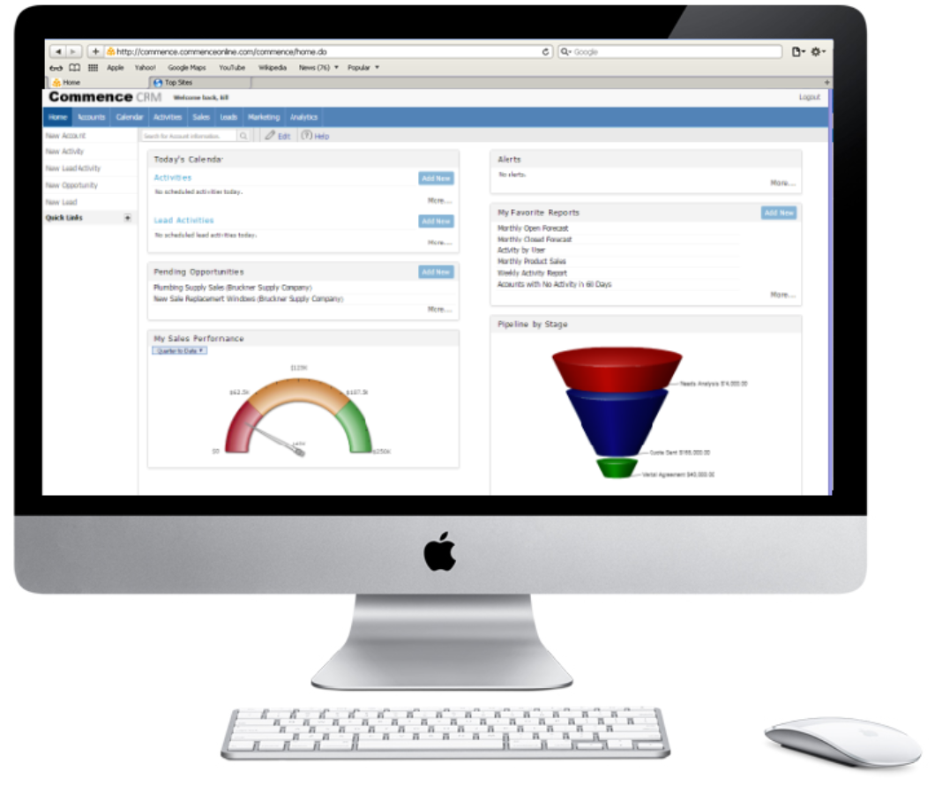
(Source: Apple.com, 2023)

Appendix 2: Mind Map of Apple Marketing Mix
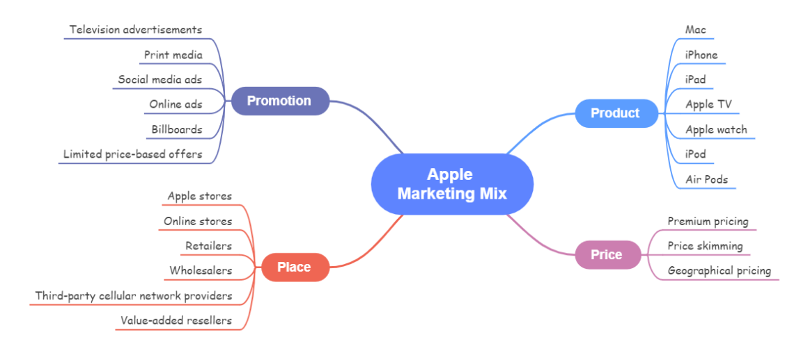
(Source: Apple.com, 2023)

