Introduction
Why is it worth developing? –
By working on myself I can discover that I can better deal with my emotions. Know effective ways of resolving conflicts. See that everyone has different needs, which you need to ask directly.

Personal development enhances the sense of value.
Looking at my self-starting to recognize my successes. This gives greater self-confidence and a matter that I'll be more happy and open to new challenges. It will make me less touched by defeat and rejection. Become stronger. This will allow me to accept all myself – together with imperfections.

Development will help me become an expert.
When I start working on myself, I discover my resources: work experience, knowledge, strengths. I start to focus on them and improve them. It's a natural process! It becomes a better seller, lawyer, teacher, entrepreneur or parent etc.

Development makes new opportunities emerge.
So, it was with me too. Of course, these possibilities existed before, but I was not able to notice them with that knowledge and experience. With the development of my life, new people came together, with whom I started to implement extraordinary projects!

When working on myself, it makes decisions more easily.
Personal development is the challenge, conscious choices, self-acceptance and others. Development gives me self-awareness: I know my needs, rules, values. This makes me a signpost and it's easier to take decisions.

According to of the leading managerial websites (research-methodology.net and learning-theories )one of the most effective methods of determining the best development strategies is SWOT. With SWOT we can get to know ourselves. We can be inferred to develop our talents, which can be difficult and challenging for us. At the end, after examining the opportunities that the environment creates, we can create an appropriate career development plan based on our thoughts.

Strengths  - I know what I want to achieve. I have a clearly defined goal  - I’m liked and appreciated by all friends and co -workers  - I care about myself and my well-being  - Ambitious, determined, hardworking. Always ready to develop and improve my qualifications.  - Assertive, I do not allow others to decide about my life or choices with I take  - I know how to work in a group of people  - I do have a good sense of humour.  - I’m always on time and well organised  - knowledge of foreign languages: English, Russian, German  - I can work under stress | Weaknesses  - I’m often struggle with the realization of tasks at the intended time  - I'm erratic. Often, I make some decisions than I am changing them to make my life easier  - I stress to much in situations that are not at all such important  - I'm too worried about what others think about me  - I'm impulsive.  - I have too few practical skills, my knowledge is more theoretical  - I have too few practical skills, my knowledge is more theoretical
Opportunities  -My enthusiasm is contagious, I can involve many people in my actions.  -I am open to new experiences  -I have a chance to take a career in business after completing a three-year course  -I met many interesting people with whom I can exchange opinions and work together on future tasks and presentations  - | Threats  - technical progress and uncertainty if I follow it  - My impulsiveness can lead to quarrels with colleagues  - My skills may not be enough.  - Big competition from other graduates.  - English is my second language and I’m not 100% certain that I be fine in new situations  - By selfishness and belief that I would do everything myself, I would not be able to work with deadlines from the pressure of work.

Constantly changing economic, social and technological conditions lead to the necessity of introducing changes to adapt to new conditions.
Go mad ( refer to moodle and linkedin)

This is a new resource on coaching based on the Go MAD principles developed by the authors Andy Gilbert and Ian Chakravarty 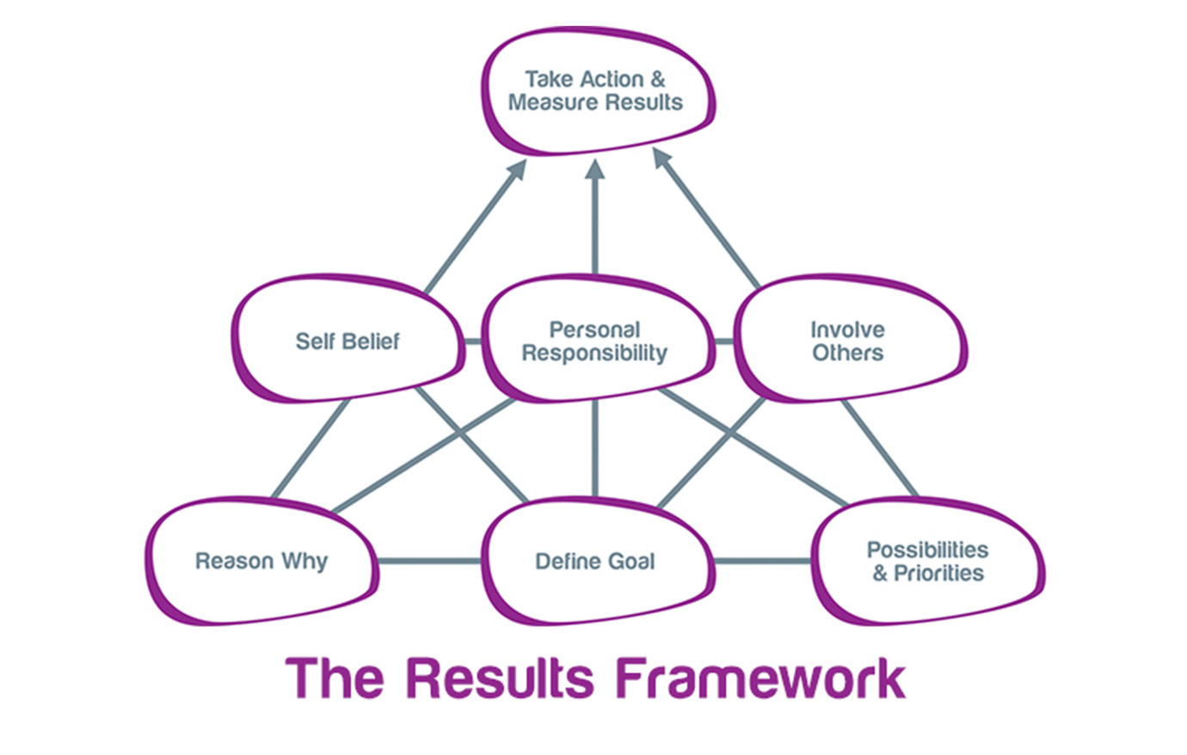
This is a new resource on coaching based on the Go MAD principles developed by the authors Andy Gilbert and Ian Chakravarty

Self-belief:
-I’m confident, never devastated by criticism
-I’m responsible
-I know my values
-I accept myself unconditionally

Reason why:
-expanding knowledge
-personal development and adaptation to the requirements of the environment
-better opportunities’ after finishing the course
-strengthening the sense of personal value

Define goals:
SMART
As brought on the website projectsmart by Dunclan Haughey smart goal is :

S-SPECIFIC
M-MEASURABLE
A-ACHIEVABLE
R-REALISTIC
T-TIME BASED

My personal SMART goal: accomplish my classes in leadership and management in 3 years by successful completing Certificate of Higher Education for work place to progress to a job in management.
Specific-

Personal responsibilities:
-Work hard, systematically
-Attend for all lectures
-Actively participate in group exercises
-Write assignments before deadlines

Taking actions:
-immediately start!
-Systematic hard work without putting any academic work away for tomorrow or later
-In spare time read a lot of useful materials

Involve others:
-Lecturers -when I need help with understanding a task, struggle with assignments or homework
-Friends-if I need help to look after my soon. Also, they can comfort me in times or weakness or crisis
-Children -if I need help with electronic devices

Plans and priorities:
-Attend for lectures
-Write assignments without delay
-Read a lot
-Research
-Complete all homework and assessed work. Use feedback to improve future work

V A R K
VISUAL AUDITORY READ /WRITE KINAESTHETIC

It is very important in the professional development to recognize the right method of learning, acquiring knowledge. After filling out the VARK questionnaire expanded by Fleming and Mills I explored that the most appropriate method for me is learning by read/write.

My VARK results:

Total number of V’s=2
Total number of A’s=4
Total number of R’s=7
Total number of K’s=1

According to this method (point out by Peter Morgan), I should look for manuals and other written sources for the subject. Plan, make notes and summaries, copy information with my own words, describe charts and drawings.

Other VARK categories are:

V-learning by visual study strategies- learning by drawing pictures and graphs, visualizing processes and objects, focusing on photos and movies. Use coloured pens and other tools whenever possible to make text interesting to the eye.

A-learning by aural study strategies- learning by repeat data aloud, attend lectures and presentations. Discuss issues with other people, using recorder to record own comments and speeches. Focus primarily on listening.

K-learning by kinaesthetic study strategies - Learning by memorizing as something smells, tastes or behaves in the performance of certain tasks

Honey and Mumford’s learning styles (refer to talentlens.co.uk)
Activist - prefers learning by doing more than reading instructions.

Reflector - prefers to remain in the shadows and observation. His strength lies in meticulous data collection and analysis to bring the conclusion.

Theorist - prefers the adaptation and integration of all observations in the form of theories or frameworks of action.

Pragmatist - always looks for new ideas that he could put into practice.

After filling the questionnaire and count the points I discovered that my style of learning is reflector. I acquire knowledge through observing, thinking and analysing about what happened. Personally, I prefer stay a on the side and investigate matters from many different perspectives, collecting data and for long time draw conclusions.
As a reflector I learn best by: discussions in pairs, questionnaires, analyses, observations, opinions of other persons, interviews, coaching.

The Johari windows
The Johari (as presented on www.selfawareness.org) window is a tool for visualizing and raising the degree of self-awareness and mutual understanding between individuals or groups. This technique was proposed by two American researchers, Joe Loft and Harry Ingram as one of the effects of a study on the dynamics of a group conducted in the 1950s at the University of California. Nowadays, this tool is widely used in coaching. It is also used as a technique to for the communication process in a group and thus becomes a useful method to support the process of conflict management.

The Johari window technique recognises a human self-awareness in a model. The premise of this concept is that every person knows the qualities of his own personality, but also possesses traits he does not realize. The people around us also have some knowledge of others, but some information is unknown to them. The result of these considerations is the distribution of awareness of its characteristics into four areas (panes):

"Open"-features known to us and known to others,
"Hidden"-features known to us, but unknown to others,
"Blind"-features that others perceive in us, but they do not realise them,
"Unknown"-features not known to anyone, neither us nor others.

My open, secret, blind and unknown areas:
OPEN  -name, nationality, age  -Some of my feelings (from my body language, facial expressions, tone of the voice)  -fun loving  -helpful  - marital status  -hobbies and interest | Secret:  -my dreams, feelings and thoughts  -my weight and high -no one knows my BMI  -illegal actives  -private things  - my ability to stand in front of the class and do the presentation  -assignments results
Blind  -afraid to be different  -don’t feel comfortable under competition  -behaviour patterns  -things I do, not in purpose but they might annoying others | Unknow  -How long will I live?  -My hidden talents  -Meaning of my dreams

To change one on my secret to open areas I need to practise more with presentations -in order to be more confident in the future.

The Kolb learning cycle (based on www.businessballs.com)
Each of us learns in a unique way, which often is a mixture of different styles of learning. Many times, it’s a mixture of different styles and we are trying to adapt them to our needs.
Kolb distinguishes four basic steps of the learning process Learning can be conceived as a sequence of repetitive stages, of which an experience is crucial. Importantly, today it may seem obvious, but the flasks stated that when we learn something new, we modify our previous experiences. On the other hand, our new experiences will also have an impact on the next ones we face in the future. Test – This is the stage of testing new behaviour based on lessons learned from experience. New competencies in practice. We constantly go through similar sequences every day. We acquire consciously new competencies or develop existing ones.

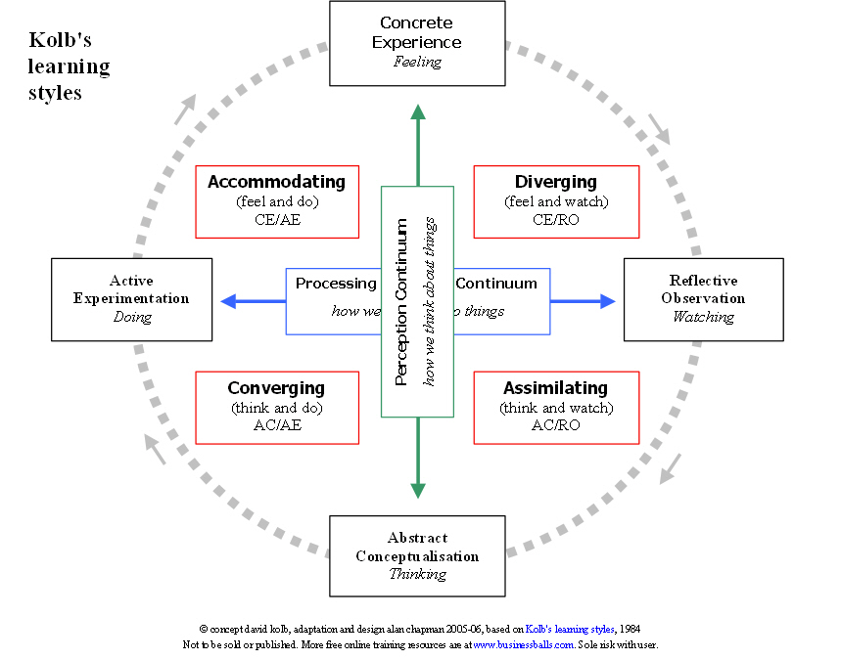

Personal development plan:

Develop objectives | Specific  actions | Barriers and how to remove them | Support | How I know when I achieve the object
1.Time management | Focus on what's the most important. | A lot of sport activities. Love them all but due to lack of time I need to select the important. | Family, personal trainer | When I won’t be in a continuous hurry or late. Will have more time for my studies.
2.Improving academic knowledge | Read, write and research more. | No time. I must spend a certain amount of time per day focused on my learning. | Family-to help with housework and looking after my child.  Lectures -if I have a problem with understanding tasks, homework or writing assignments. | When I will receive a better feedback than I had on the beginning and when it will take me less time to complete the tasks with I was struggle before.
3 Self-awareness of what I want and ability to say “NO” | Disagreeing with others if I have a different plan for my day or how to spend my free time. | Afraid to hurt someone’s feelings. I need to be honest and explain to someone who may it concern why I can’t do it. | Friends and family | If I won’t be a part of something I don’t like. When I will strong enough to refuse to be part of something I don’t really enjoy.

Big 5 personality tests

The test by Paula Cost and Robert McCrea (refer to the website bing.com) includes 5 personality factors i.e. neuroticism, extroversion, openness to experience, agreeableness, conscientiousness. Neuroticism (vs. Emotional stability)
Neuroticism decides how we are cope with difficult situations and the susceptibility to experience negative emotions such as fear, anger, sadness, guilt. The high degree of neuroticism makes it difficult to cope with stress, increases the susceptibility to experience anxiety, depression. In turn, the low level of neuroticism promotes emotional stability. These people better cope with stress and their self-assessment is more stable.

Extroversion
Extroversion refers to the amount of social interaction, level of activity and energy, demand for action and activity in search of impressions. Interactions with others in the case of extraversion increase their energy levels, and in the case of introversion deprive them thereof.

Openness to experience
Illustrates the willingness to experience new experiences, new things, curiosity. People with low openness prefer to stick to proven things, ways, rules, etc.

Agreeableness (vs antagonism)
Determines the attitude to other people. High agreeableness is linked to trust in others, modesty, tendency to make concessions.

Conscientiousness (vs. nontargeting)
Determines the degree of organization, perseverance and motivation. It allows you to forecast your professional and school activity. People with low conscientiousness tend to laziness. High conscientiousness is expressed in responsibility, perseverance in striving for purpose, order and prudence in planning and making new tasks. These people are better off in terms of opportunities to succeed in school or work.

The above factors are:
- real
-immutable
- universal (i.e. independent of race, sex or culture)
- biologically conditioned

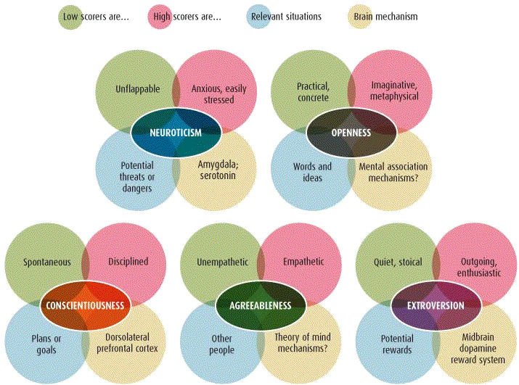

The creators of this concept believe that these personality factors are transmitted genetically. The most powerful openness on experience (57%), extroversion (54%), conscientiousness (49%), neurotise (48%), agreeableness (42%)

Conclusion:
Personal development is important regardless of age or circumstances. It greatly increases my understanding of myself, my business, or people I work with. Continuous development, communication skills, resistance to stress, time management, creativity, assertiveness – these abilities should be practiced throughout life if I want to achieve satisfactory cooperation and be received as a professional. In order to do this, I must identify the biggest problem and start working on it directly.

References /bibliography:
https://www.bing.com (accessed on 28/03/18)
http://blog.lib.umn.edu/meyer769/myblog/five.gif (accessed on :26/03/18)
https://www.businessballs.com (accessed on 25/03/2018)
https://www.businessballs.com/self-awareness/kolbs-learning-styles-64/ (accessed on 22/03/2018)
Gilbert, A. (2001) Go MAD! The art of Making a Difference, Leicestershire: Bath Press

Gilbert, A. (2002) Go MAD About Coaching: Helping People to Think in a Solution Focused Way, Leicestershire: Go mad books
learning-theories.com (2017) Swot analysis tool [online ] Available : https://www.learning-theories.com/swot-analysis.html. Accessed :23/3/2018
linkedin andygomad [online]. Avaliable: https://uk.linkedin.com/in/andygomad Accessed:21/03/2018
Maund , A. (2017). Certificate in Higher Education: Skills for the Workplace Student Yearbook. London: Sage Publications.
Morgan, P. (2016). The Business Student’s Guide to Study and Employability. London: Sage
projectsmart.co.uk(2018) Smart goals[online] Available : https://www.projectsmart.co.uk/smart-goals.php .Accessed: 25/03/2018
research-methodology.net (2017) Necessary knowledge to conduct a business research[ online] Available: https://research-methodology.net/theory/strategy/swot-analysis/ .Accessed: 20/03/ 2018
talentlens.co.uk Learning style questionnaire [online] Available: www.talentlens.co.uk/product/learning-style-questionnaire( accessed on 24/03/2018)
Warwick (2017) Self-awareness [online] Available : https://warwick.ac.uk/services/counselling/informationpages/selfawareness/ Accessed on :20 /03/2018)

The aim of this report is to understand the manager recruitment process. To choose well, at the beginning important is precisely determine who the company is looking for. In preparing the perfect profile, important is to remember about personality aspect, professional culture and above all knowledge, experience and leadership skills.
In the recruitment process first of all are requirements, divided to "must" and "nice to have" keeped throughout the process. Key to this position are: good communication skills, strategic ability to think, creativity, innovation, coaching ability, diplomacy, emotional Intelligence, negotiating skills.
These competencies should be evaluated during an interview and should be dealt with by questions asked. The manager's work is characterized mainly by frequent contacts with people. Through good communication is understood not only the ability to communicate with others, but also openness, willingness to understand the other person and empathy. Manager is a strategic position, it is the same as it should look like the recruitment process: planned, structured, with a certain timeframe, with great respect for the candidates.

1 Advert

Live in Cardiff or the surrounding area? Good news for you! New Polish delicatessens and restaurant in Barry-opening 01/05/2018. For this reason, our company based in Wales is looking for a person for a manager position.
For a suitable business provides: contract for work, bonuses with good results, valuable experience and the possibility of development in different projects, professional training in the field of tasks, new knowledge and great atmosphere in a harmonious team.

Our expectations:
-at least 2 years of experience in a similar position (including fresh product management)
- customer focus
- team management skills and employee motivation
- very good working skills, initiatives and independence
- energy and positive attitude
- availability
-driving licence
-fluent in both languages: Polish and English
- realization of sales according to formed plan
- attention for attractive store image and high customer service

Daily tasks (as mentioned by Barker, S. (2012))
-Identifying risks
- Sales management, image, care and efficient store operation.
- Supervision of orders and costs control
- Providing professional customer service, responding to complaints
- Realization of designated commercial purpose
- Team management and organisation of its work
- Recruitment, motivation and training of employees. Caring for their development
- deal and respond to complaints
Join our family today !!!People interested in cooperation have to send c. v or fill the application form.

Interview questions - many different questions may be asked during a job interview.
Those listed below are based on the research of: Williams, L. (2015); Yate, M.J. (2005); Brand, A.W. (2014); Yeung, R. (2015) Catt, H. (2014) and my own conclusions due to this.
-Why do you want this job?
- What are your strengths /week sides?
- What’s yours most professional achievement?
-What are you like with deadlines?
- How much you want to earn/ what are your financial expectations?
- What sets you apart from other candidates?
- Where else you apply? How many recruitments processes you participate in?
- What you will do in a situation when you have too little staff- This situation requires the skills of fast and effective troubleshooting problems. To be in charge of staff often appear difficult situations on which you must have a ready solution. What probes do you take to ensure the proper personal facilities as soon as possible?
-- Have you had any conflicts with your supervisor? - Answer on this question will show us whether any candidate for the post is loyal to the employer. He cannot complain about the previous boss, criticize him.
-What animal/ vegetable would you like to be? - This is a strange question, but thanks to him we know the person's character and the speed of reaction to the custom situations. The employee appreciates activities, diligence, creativity, communicative skills. If applies to the manager's post, answer that "cat" or "snail" is not the best
- How many times have you been in a job interview?
- What are your career goals? - Recruiters like candidates who have a specific plan for the direction of their development and try to achieve it
- What do you want to do for the next 5 years?
- What was the cooperation with the previous superiors? - Moments are harder in every job. The value of employees can cooperate even if their sentence differs from their superiors.
- Why you are the right candidate for this position?
- What motivates you to work? – we would like to talk to people we want to invest in. The employment of a new employee needs to be profitable for the company, so it is important to emphasize professional development. What is the perfect answer? The perfect candidate should show that he can perform tasks with satisfaction and enthusiasm. Motivated by ambitious tasks. It can motivate him to succeed and acknowledge his projects.
- Why do you want to change the job? Why do you want to work with us? - Does anyone want to change the job just to have the money necessary for keeping up and living on a decent level? Is it always going to work only because it does not get along with your superiors? We are looking for a person who likes his work and wants to grow in this direction. It is known that the engaged worker will do his job much better than the one for whom the only motivation is money.
- What do you know about our company- Why some candidates can fall on this question There are still candidates who do not bother to check the basic information about the company and the chosen. The answer to this recruitment question often might be for the candidates a problem. Perfect candidate should take a moment before the meeting to see what the company is doing and what he /she can do with it.
- Who do you like to work with? Do you work effectively in a team? The ideal candidate knows what must do with the company and is aware of what will be able to offer. Must have experiences and skills in the context of the job. On the interview, he need to prove how much he can offer if he will be employed. Show how it can help our business.
The ideal manager ought to have the following qualities: ( Based on the website business-achievers.com)
-discipline
-confidence
-motivation
-reliability
- knowledgeable with tasks
-well-organised
-listening skills
-has legal knowledge
-able to handle the money well

To the next stage of the recruitment process will pass the successful candidate who will be able to demonstrate:
- Employee awards
- improvements, which they managed to introduce
- Completed projects
- Received promotions
- Carried out by companies or obtained customers

Interview is not the only tool used in the recruitment process, which is designed to investigate whether the candidate we consider in the context of employment can cope with work. Therefore, during the recruitment will meet with different kinds of tests in the opinion of Huston, K. (2016) and Leeds, J. (2013-2014).
Candidates will be tasked with checking the level of specific skills and the potential of the candidate and his knowledge. In other words, they examine in a standardised manner whether the candidate knows what he or she must know in each position and can handle tasks at work. Those tests are so effective allow allow compare the level of knowledge of the candidates among each other – everyone gets the same questions tasks. There is no risk that someone will get harder and someone easier question, or that the person leading the recruitment forget to ask about something.
Tests are carried out by someone on managerial functions in the organization in which the recruiting department is conducted.

SKILL TESTS

- Single or multiple-choice questions – which leads to the examination of the candidate's knowledge in a specific area. They do not leave room for interpretation. They will be developed in such a way that the question will be clear.
-Open questions – Where the candidate describes the answer alone – they are able to examine the knowledge, but they can also diagnose how to work with the problem (e.g. when the test is to indicate the sequence of actions undertaken in a task's work process).
- Language tests are used in positions where foreign language skills are required. They are tasked with examining a resource of vocabulary (general or specialist), communication skills in writing, knowledge of grammar rules, the ability to understand written or heard text. They may have-like tests of closed, open or task tests (e.g., command to write an offer in Polish)
- Psychological tests

They are designed to measure:

-Personality traits (e.g. extraversion level, flexibility, assertiveness)
-Personality competencies (ability to compromise, management styles)
-Group roles (preferred behaviour in the collaborators group).
-Intelligence (intellectual, emotional)

Conclusion:
This report shows that each recruitment of a new employee is a multi-stage process. It also shows how the employee's recruitment process can look. A list of possible questions and tests, which may occur at interview. This method is very effective, but very time consuming. Its effectiveness is due to the fact that the candidate cannot prepare for this conversation in any way. It is an element of recruitment that allows to determine the true nature, skills and intelligence of the candidate.

References /bibliography:
Brand, A.W. (2014) Answering tough interview questions for dummies, (second edition) Chichester: John Willey & sons
Houston ,K.(2016) How to succeed at assessment centres ,London :Palgrave
Inness, J .(2012) The interview book ,Harlow :Person Education Limited
Lees ,J. (2013-2014) How to get a job you’ll love ,Berkshire :Mc Graw-Hill Professional
Maud ,A.(2017) Certificate of higher education Skills for the workplace student yearbook, London : Sage
Mills ,K.(2017) second edition How to plan your career and land your perfect job ,Bath: Truman publishing
Soudamore ,P.(2014)The interview coach ,London: Hodder &Stoughton
Williams, L. (2015) Ultimate interview, London: Kogan Page Limited
Yate, M.J.(2005 )sights edition Great answers to tough interview questions 6th edition ,London :Kogan page limited
Yeung, R. (2015) Smart answers to tricky interview questions, (fifth edition) London: Robinson Constable & Robinson Ltd.

