

LCMB7006 -INTERNATIONAL MARKETING
Student Name : RIYA BHATT
Student Id : 2223984
Lecturer’s Name : Tushara Balendran

EXECUTIVE SUMMARY
The in-depth research and tactical suggestions for Cadbury Dairy Milk's international marketing strategy in the UK and France are summarized in this executive summary. The paper offers a comprehensive view on how to position Cadbury Dairy Milk in these various areas by utilizing a multidimensional framework that includes the Marketing Mix (7Ps), Hofstede's cultural dimensions, Porter's Five Forces, Ansoff Matrix, and TOWS Matrix. The Marketing Mix study shows how well Cadbury can adjust its product, price, distribution, marketing, people, process, and physical evidence tactics to take into account the unique cultural characteristics of each country. Cadbury uses its strong points its long history as a brand and its widespread recognition to connect emotionally with customers. By leveraging individuality and cultural preferences, Cadbury positions Dairy Milk as a harmonious pleasure, as shown by the Hofstede dimensions. The Porter's Five Forces research dives into market competitiveness, and while both nations experience fierce competition, Cadbury has an advantage because to its brand loyalty and flexibility. The Ansoff Matrix highlights Cadbury's commitment to product innovation by producing unique Dairy Milk varieties that combine novelty and tradition to satisfy changing consumer preferences. The TOWS Matrix aligns strengths and weaknesses to better improve strategic suggestions. Given its brand awareness and customer tolerance to novel flavors, the United Kingdom provides a more favorable environment for Cadbury's product development strategy, according to the report's comprehensive study. The already oversaturated premium chocolate market in France, on the other hand, poses particular difficulties that call for careful adaptation and teamwork in order to establish Dairy Milk's premium status.

Table of Contents
Introduction 4
Background 4
Macro environment analysis 5
PESTLE 5
Hofstede model of cultural dimensions 8
Industry attractiveness between UK and France 10
Porter five force 10
SWOT analysis 13
Similarity and differences between two nations based on SWOT 15
Market mix 7p 15
Market segregation strategies 17
Directional development strategies 19
Ansoff matrix 19
Market penetrations 20
Product development 21
Recommendation 22
TOWS matrix 22
Conclusion 23
References 25

Introduction
The success of a product or brand on the constantly changing international market depends on its capacity to adapt and successfully meet the various demands and preferences of various customer segments. This study explores the global marketing tactics used by Cadbury to promote its main product, Dairy Milk, in two different markets, the UK and France. The tactics, resemblances, and contrasts in the setting of high involvement consumer products will be clarified by this examination. With its creamy and delicious chocolate bars, the well-known confectionery brand Cadbury Dairy Milk has established a solid presence in the French and UK markets. This report aims to analyses and assess the segmentation, targeting, and positioning (STP) strategies used by Cadbury as well as the critical components of the marketing mix, known as the 7Ps (product, price, place, promotion, people, process, and physical evidence), along with directional development. This report will offer insights into the adaptability and flexibility of international marketing strategies, illuminating how a globally renowned brand like Cadbury Dairy Milk customizes its strategies to resonate with the sensibilities of the British and French consumers.

Background
Due to its delightful selection of chocolates, Cadbury, a venerable and iconic confectionery company, has been titillating taste buds all over the world for more than a century. Cadbury Dairy Milk distinguishes out among its outstanding selection of products as a genuine symbol of chocolate enjoyment. Since its introduction in 1905, this silky-smooth delight has been a mainstay in homes all around the world. The astounding sales numbers demonstrate its lasting appeal; in 2020 alone, Cadbury Dairy Milk generated global sales of almost £2.69 billion, demonstrating its popularity (Statista, 2021). Customers have developed an emotional bond with this product since it represents happy and festive occasions. Each Dairy Milk chocolate is handcrafted from the finest cocoa beans, demonstrating Cadbury's dedication to quality and providing a dependable and unmatched flavor (Ir.mondelezinternational.com, 2023). Customers have responded well to this commitment, which has helped the product achieve extraordinary success. Furthermore, a significant factor in the rise of Dairy Milk has been Cadbury's deliberate push into overseas markets. It has gained a sizable market share as a consequence of its expansion into various locations. For instance, Dairy Milk continues to dominate the chocolate industry in the UK with a market share of over 17.6% (Statista, 2021). Similar to this, Cadbury has been able to establish a strong footing in France, a country with a very competitive chocolate industry, and carve out a niche among affluent customers. This general overview and backdrop capture Cadbury's Dairy Milk's long history, widespread appeal, and commercial successes, laying the groundwork for an in-depth examination of its international marketing tactics in various areas (Ir.mondelezinternational.com, 2023). This backdrop and gentle overview capture Cadbury's Dairy Milk's long history, widespread appeal, and commercial successes, laying the groundwork for an in-depth examination of its international marketing tactics in various nations. As we go deeper into the marketing tactics, it becomes clear that Cadbury's careful consideration of regional tastes and cultural quirks was essential to its success on the international stage.

Macro environment analysis

PESTLE
Factors | UK | France
Political | - Stable political environment  - Favorable trade agreements (Brexit impact) | - Presidential democracy  - Strong government influence on business
Economic | - Strong GDP growth  - Developed financial services sector (Tien, Phu, and Chi, 2019) | - Mixed economy  - High unemployment rates (Paul, 2020)
Social | - Diverse and multicultural society  - Aging population | - Strong cultural emphasis on gastronomy  - Work-life balance focus
Technological | - Advanced technology adoption  - E-commerce growth (Katsikeas, Leonidou, and Zeriti, 2020) | - Innovation in luxury fashion  - High-speed rail network (Williamson, 2021)
Environmental | - Climate change regulations  - Increasing focus on sustainability (Tien, Anh and Ngoc, 2020) | - Emphasis on renewable energy  - Stringent environmental regulations
Legal | - Well-established legal system  - Consumer protection laws | - Strict labor laws and regulations (Antamoshkina, and Zinina, 2019)  - Intellectual property protection
Table 1: PESTLE analysis
(Source: Self developed)
Political
The UK's political climate continues to be very stable, which benefits Cadbury's operations. The country's well-established political system and degree of political predictability provide a strong base for corporate continuity. However, Cadbury must negotiate a level of uncertainty brought on by the impact of Brexit on trade relationships (Nambisan, Zahra, and Luo, 2019). Despite this, the general political environment's stability gives Cadbury a good amount of confidence with which to plan and carry out its marketing activities.
Economic
The UK has strong GDP growth and a thriving financial services industry, which help to create a stable economic environment for Cadbury. These characteristics give a favorable consumer market the means to make purchases. On the other hand, Cadbury faces a more complicated economic environment because of France's mixed economy and increased unemployment rates. However, Cadbury's strategic strategy and brand awareness enable it to tap into both economies, utilizing its advantages and managing its disadvantages.
Social
Cadbury benefits from a varied and multicultural environment in the UK, which makes it possible for its Dairy Milk product to appeal to a broad spectrum of customers. However, ageing populations may have an effect on consumption trends (Itskhoki, and Moll, 2019). The significant cultural focus in France on cuisine and finding a work-life balance complements Cadbury's upscale brand and decadent products. Although the societal dynamics in each area are different, Cadbury is able to adjust its marketing tactics to account for these specifics, maintaining brand relevance and consumer loyalty.
Technological
In both the UK and France, technological developments constitute a consistent advantage for Cadbury. Cadbury is able to communicate with customers through multiple digital channels, supporting personalized marketing campaigns and real-time engagement thanks to the UK's significant technology adoption and growing e-commerce ecosystem (Desfiandi et al., 2019). In France, where there is a focus on innovation in high-end fashion and a high-speed train system, Cadbury has the chance to match its marketing plans with these technical developments, increasing brand recognition and accessibility. Because of its skillful use of technology, Cadbury is able to adapt quickly to changing market conditions and consumer preferences.
Environmental
Cadbury may take advantage of steady environmental circumstances in the UK and France. Cadbury's initiatives to encourage moral and environmentally beneficial behavior are complemented by the UK's emphasis on climate change policies and sustainability. Similar to this, Cadbury's dedication to ethical sourcing and production is in line with France's strict environmental rules. Due to these consistent environmental issues, Cadbury may appeal to environmentally aware customers in both areas by positioning itself as a socially responsible brand.
Legal
Both the UK and France provide solid legal frameworks for Cadbury's businesses. Both nations established legal systems offer a strong framework for conducting business. But there are variations in the form of labor laws and rules. France's stringent labor rules may limit Cadbury's ability to operate with operational flexibility, while the UK's more permissive approach has certain benefits. Despite these variations, Cadbury's compliance with regulatory requirements guarantees compliance and sustainability in both markets (Shams et al., 2021). Due to its stability, Cadbury is able to successfully navigate regulatory environments, building credibility with stakeholders and customers alike.

Hofstede model of cultural dimensions
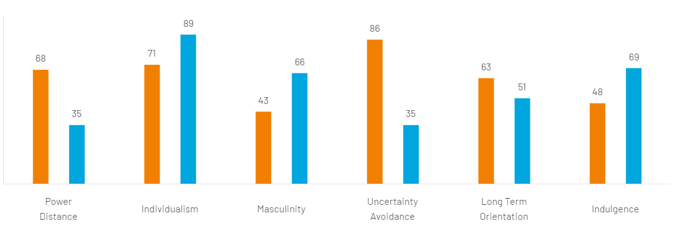
Figure 1: Hofstede cultural dimension between UK and France
(Source: Hofstede-insights.com, 2023)
Advantage
For Cadbury Dairy Milk in the UK and France, Hofstede's Cultural Dimensions framework offers a useful benefit for examining customer behaviour and customising marketing plans. The approach helps marketers learn how to successfully engage with customers in each nation by thoroughly researching cultural subtleties. Low power distance and moderate masculinity scores in the UK indicate a balanced attitude to emancipation and emotional fulfilment. By creating advertising that emphasises Dairy Milk as a source of both pleasure and comfort, Cadbury can take advantage of this. The UK's high uncertainty avoidance score highlights Cadbury's solid reputation, and the business is encouraged by the moderate long-term orientation to position Dairy Milk as a fusion of tradition and innovation, appealing to customers' enthusiasm for tried-and-true favourites with contemporary twists.
The framework reveals a culture in France that places a greater value on independence and hedonism. Because of this, Cadbury may position Dairy Milk as a special treat that satisfies French consumers' need for extraordinary experiences and hedonistic pleasures. Additionally, Dairy Milk's lower uncertainty avoidance score offers a marketing opportunity to position Dairy Milk as an exciting diversion from the norm. Assuring a successful market launch for Cadbury Dairy Milk, Cadbury can successfully manage the different consumer preferences of UK and French customers by aligning marketing strategies with these cultural factors.
Disadvantage
Although Hofstede's framework for cultural dimensions provides useful insights, it also poses difficulties for Cadbury Dairy Milk's UK and French marketing strategies. The UK's relatively high uncertainty avoidance score (86) may make it more difficult for Cadbury to experiment with novel flavours because customers there want consistency. Moreover, efforts to bring significant modifications to the product's conventional appeal may be hampered by the modest long-term orientation (score of 63). The high individualism score (89) in France may make it challenging to develop a cohesive marketing message that appeals to a variety of self-expressive needs. The higher indulgence score (69) may also need for careful balancing in order to depict Dairy Milk as a luxury delicacy without going overboard. Cultural differences, such as the UK's moderate indulgence (score of 48) and France's lesser degree of uncertainty avoidance (score of 35), might make it more difficult for Cadbury to properly match its product positioning and messaging with divergent customer preferences. Despite these difficulties, it is nevertheless essential for Cadbury to comprehend these cultural aspects in order to traverse complex customer behaviour and adjust its strategy to effectively enter and flourish in both countries.
Similarity
In the context of Cadbury Dairy Milk's marketing approach, the Hofstede scores show startling parallels between the UK and France. Low power distance ratings between the two countries show a shared regard for equality and decentralised power arrangements. Due to these similarities, Cadbury may emphasise inclusive messages in both markets, empowering customers and encouraging emotional connections. Additionally, both nations' relatively high individuality ratings (France: 89; UK: 71) indicate a common value in self-expression and individual freedom. By focusing its marketing efforts on positioning Dairy Milk as a treat for oneself, Cadbury may take advantage of this connection and appeal to the cultural yearning for special experiences and self-reward. Both nations exhibit a balanced view of masculinity (UK: 43; France: 51), showing a harmonic mix of assertiveness and nurturing. In both areas, Cadbury may use this resemblance to portray Dairy Milk as a source of pleasure that meets cravings and offers consolation and a sense of accomplishment. Additionally, both nations' modest long-term orientation ratings (UK: 63, France: 51) highlight a respect for tradition and an openness to embracing current developments. Due to their closeness, Cadbury may position Dairy Milk as a link between traditional and modern tastes, appealing to customers' desire of both classic tastes and novel experiences.
Differences
According to Hofstede's ratings, there are significant cultural variations between the UK and France for Cadbury Dairy Milk. The UK (score: 68) favours rigid but flexible hierarchies in terms of power distance, allowing Cadbury to prioritise inclusive messages and emotional connections. While France (score: 35) favours more democratic decision-making, Cadbury has chosen to concentrate on collaboration and co-creation. The UK (score: 71) prioritises personal freedom and incentives, which is consistent with Dairy Milk's personalised pleasure approach. The high level of individuality in France (score: 89) places an emphasis on self-expression and demands unique experiences, forcing Cadbury to create messaging for distinctive self-indulgence. The UK (score: 43) strikes a balance between pleasure and comfort in masculinity, allowing Cadbury to market Dairy Milk as a gratifying but soothing pleasure. Dairy Milk should be promoted as a mark of achievement and excellence in light of France's 89 out of 100 for forceful masculinity. The UK scored well on uncertainty avoidance (86), allowing Cadbury to capitalise on its reputation for dependability, whereas France scored lower (35), encouraging Cadbury to promote Dairy Milk as a fun break from routine. The UK's long-term attitude (score: 63) emphasises both history and modernity, which helps Cadbury provide legacy products with current twists. Due to France's similar score (51) and French admiration for both heritage and innovation, Dairy Milk has potential to connect the past and present. To successfully adjust Cadbury Dairy Milk's marketing messaging for successful market entrance and brand resonance, these distinctions call for sophisticated techniques.

Industry attractiveness between UK and France

Porter five force
Porter's Five Forces | UK | France
Threat of New Entrants | Moderate due to established brand loyalty (Rakhmanberdiev et al., 2022) | High due to well-established local brands
Bargaining Power of Suppliers | Low due to multiple sourcing options | Low due to strong supplier relationships (Shooshtarian et al., 2020)
Bargaining Power of Buyers | Moderate due to consumer choice and switching costs | Moderate due to diverse consumer preferences
Threat of Substitute Products | High due to wide variety of confectionery options (Ratten, 2020) | High due to rich culinary culture and desserts
Competitive Rivalry | High due to intense competition among confectionery brands | High due to competitive chocolate market
Table 2: Porte five force analysis
(Source: Self developed)
Threat from new competitors
The threat posed by new competitors is moderate in both the UK and France. Due to its high brand loyalty and the established market position of Cadbury Dairy Milk, the UK does, however, have a tiny edge. Generations of consumers have formed strong emotional bonds with the brand, erecting a formidable barrier for future competitors (Tien, and Ngoc, 2019). It is difficult for new competitors to get momentum in this industry because of the trust and reputation that Cadbury has developed over the years.
Purchasing Influence of Suppliers
France and the UK both have weak supplier bargaining leverage. Due to the numerous sourcing alternatives for its raw materials provided by Cadbury's extensive worldwide supply network, the business has a significant edge in negotiations (Paul, and Mas, 2020). However, the UK may have a modest advantage due to its well-developed logistical infrastructure and long-standing supplier connections, which enable effective supply chain management and cost control.
Buyers' Bargaining Power
Buyers' negotiating power is moderate in both the UK and France due to certain market-specific characteristics. Customers in the UK have access to a variety of confectionary selections, which helps to temper their negotiating power. However, Cadbury is able to maintain a strong position while minimising possible buyer impact thanks to its high brand equity and wide product line (Chi, Trigeorgis, and Tsekrekos, 2019). The focus on sweets and treats in French cuisine gives customers a wide range of options, which affects their negotiating power.
Threat of Replacement Products
Because there are such a wide range of candy substitutes accessible, there is a noticeable high danger of replacement goods in both the UK and France. For Cadbury Dairy Milk, the competitive confectionary market in the UK poses a serious challenge. However as said by Sharma et al., (2020), the brand's established presence and strong emotional connection offer a clear competitive edge. Similar to this, the desire of sumptuous delicacies is fostered by France's culinary tradition, raising the threat of alternatives.
Competitive opposition
In the candy sector, there is fierce competition between the UK and France. Other well-known companies are fierce competitors for consumers' attention and allegiance in the UK, and Cadbury is no exception. But Cadbury stands out from the competitors because to its long history and strong marketing tactics. Similar demands for ongoing innovation and distinction are made by France's fiercely competitive chocolate sector.
Similarity
According to Porter's Five Forces research, the Cadbury Dairy Milk industry has remarkably comparable competitive environments in both the UK and France. Due to the UK's high level of brand loyalty and France's established local brands, both markets show a mild threat from new entrants. Due to the abundance of sourcing possibilities in the UK and the strength of supplier connections in France, suppliers have little negotiating leverage in both countries. Due to customer choice and a variety of tastes, buyers' negotiating strength is moderate in both marketplaces. Due to the abundance of confectionary alternatives in the UK and the robust culinary culture in France, it is also clear that both nations face substantial risks from replacement goods. Last but not least, both markets continue to experience tremendous competitiveness, which is reflected in France's competitive chocolate market and the UK's fierce struggle among confectionery businesses. These commonalities highlight the demand for a strategic strategy designed to meet the same-market difficulties and seize the possibilities.
Differences
While there are prospects for Cadbury Dairy Milk in both the UK and France, there are noticeable variances in the market dynamics of each country. Brand loyalty makes the danger of new entrants in the UK modest, but established local brands make it high in France cultures (Chowdhury, Dhar, and Stasi, 2022). Due to the availability of sourcing choices, suppliers' bargaining power is low in the UK, whereas it is low but due to strong supplier ties in France. In contrast to France's wide range of preferences, the UK's option gives buyers a moderate amount of negotiating power. High risks of substitutions come from many confectioneries in the UK and a strong culinary tradition in France. Both markets have significant levels of competitive rivalry, which is fueled by fierce brand competition in the UK and a competitive chocolate market in France.

SWOT analysis
Strengths  - Strong brand heritage  - Global recognition  - Wide distribution  - Emotional connection (Verhoef, and Bijmolt, 2019) | Weaknesses  - Health-conscious trends impacting sales  - Dependence on chocolate segment  - Limited product diversification
Opportunities  - Emerging markets  - Innovation potential  - Customization options  - Growing premium segment | Threats  - Intense competition  - Health and wellness trends  - Fluctuating raw material prices (Goncharova, Solosichenko, and Merzlyakova, 2019)  - Evolving consumer preferences
Table 3: SWOT analysis
(Source: Self developed)
Strengths
Cadbury Dairy Milk enjoys a strong brand legacy in the UK that dates back more than a century. Generations of British customers have developed a deep emotional bond with the brand, cementing its status as a household favorite. Additionally, Cadbury's reputation as a mark of excellence and indulgence throughout the world helps to boost its brand equity in the UK market. Its huge product line and broad distribution network add to its power, assuring Dairy Milk's accessibility and appeal across a range of customer demographics (Mio, Panfilo, and Blundo 2020). Similar to this, Cadbury Dairy Milk uses its global awareness in France to gain a foothold in a cutthroat confectionary market. The brand connects with the French customer successfully because it can adjust to regional tastes and preferences and appeals to their emotions. The premium positioning and nostalgic appeal of Dairy Milk fit with the expanding premium category in the French market, adding to its success.
Weaknesses
Due to its low product variety, Cadbury Dairy Milk has difficulties in both the UK and France. The brand's preponderance in the chocolate industry creates a vulnerability, especially in a sector where customer preferences are being influenced by health-conscious tendencies. Its potential for expansion and ability to appeal to a wider audience may be constrained by the perception that there aren't enough healthy options (Stallkamp, and Schotter, 2021). Furthermore, Cadbury's historical reliance on dairy milk may make it more difficult for company to rapidly adjust to changing customer demands for novel and ground-breaking items.
Opportunities
In the UK, Cadbury Dairy Milk has a chance to capitalize on developing markets, especially those in Asia and Latin America, where there is a rising demand for high-end candy. The brand's established history and reputation serve as a strong base for growth into new regions. The ability of Cadbury to innovate in terms of product choices, flavors, and formats also creates opportunities to draw in health-conscious customers and satisfy evolving taste preferences.
Cadbury Dairy Milk may benefit from the growing premium market in France, where customers are looking for opulent, high-quality products. Dairy Milk may become more distinctive and appealing if there are customization choices that take into account regional culinary tastes. The company's capacity for innovation and adaptation may help it further increase its appeal to the varied French market.
Threats
Threats in the form of fierce rivalry come from both the UK and France. Numerous well-known brands competing for customer attention characterize the confectionery marketplaces in these nations. The availability of substitute confectionary choices in the UK presents a threat to Dairy Milk's market share. As said by Sampe et al., (2020) the popularity of wellness and health movements, as well as the wide variety of regional specialties, represent a threat to Cadbury's conventional decadent offers in France. A hazard that both markets share, fluctuating raw material costs, can have an effect on Cadbury's cost structure and profitability. The market performance of Dairy Milk may also be impacted by economic uncertainty and shifting consumer purchasing habits, particularly as customers choose healthier alternatives more and more.

Similarity and differences between two nations based on SWOT
The SWOT assessments for Cadbury Dairy Milk in the UK and France reveal characteristics that are both similar to and different from these two countries. The brand's deep emotional connection and widespread awareness serve both markets, ensuring Dairy Milk's continuing appeal. Additionally, both nations face the difficulties posed by a lack of product variety and a susceptibility to health-conscious tendencies, which call for smart answers. However, there are distinctions in the possibilities and risks that are present (Mykhailichenko et al., 2021). While there are chances for innovation and growth in both industries, the UK's concentration on developing countries and France's emphasis on the expanding premium segment highlight different growth paths. A typical worry is the danger of fierce rivalry, although because to regional tastes for sweets, competitive dynamics vary. Despite being a common problem, fluctuating raw material costs can have different effects depending on each country's economic situation and consumer purchasing habits. In conclusion, even though Cadbury Dairy Milk encounters comparable fundamental dynamics in both the UK and France, subtle differences in possibilities and challenges highlight the significance of customized strategies for long-term success in each country.

Market mix 7p
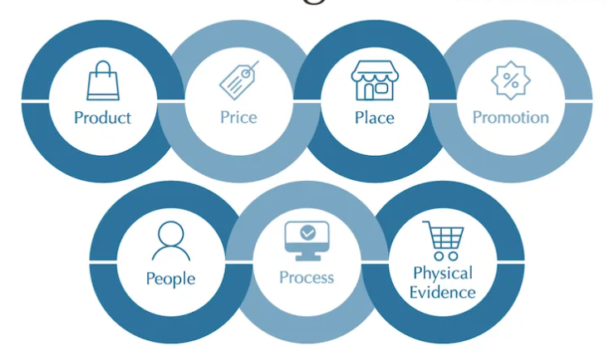
Figure 2: Marketing mix 7Ps
(Source: Gatto, 2020)
Product
In both the UK and France, Cadbury Dairy Milk is seen as a symbol of excellence and decadence. The product makes the most of its historic tradition in the UK by offering a broad variety of varieties, sizes, and packaging that appeal to various consumer tastes. Customers in Britain have a strong emotional connection to the traditional purple packaging because it is entwined with nostalgia and history. The Dairy Milk product maintains its premium standing in France by highlighting its rich flavor and silky texture, which are in line with the French preference for gastronomic experiences.
Price
Cadbury Dairy Milk's pricing policies take into account regional economic realities and customer trends. In the UK, a dynamic pricing strategy is used, offering several sizes and flavors at various price points to cater to clients who are both price-conscious and premium-seeking (Wang, Hong and Gao, 2020). In France, the pricing strategy is designed to present Dairy Milk as a decadent delicacy inside the luxury chocolate market, in keeping with the reputation of the nation's cuisine. In both markets, unique promotions and seasonal deals are put into place to keep prices competitive and boost sales.
Place
In order to ensure the accessibility and availability of Dairy Milk, distribution is crucial. The product has a wide distribution network in the UK that includes supermarkets, convenience stores, vending machines, and internet marketplaces. Wide market penetration is ensured by the strong presence throughout these many channels. A similar multi-channel strategy is used in France, where Dairy Milk is positioned strategically in upscale supermarkets, specialty chocolate shops and online marketplaces to appeal to the affluent French consumer seeking luxury confections.
Promotion
Cadbury The marketing tactics employed by Dairy Milk are specific to the cultural quirks of each area. The company leverages its illustrious past in the UK with sentimental marketing campaigns that promote tradition and close-knit family ties. The enduring "Glass and a Half Full Productions" advertisements have become emotionally resonant and synonymous with Dairy Milk. By highlighting the luxury status of Dairy Milk through innovative advertising that emphasizes the chocolate's creamy texture and excellent flavor in France, Cadbury celebrates the nation's passion of cuisine.
People
Cadbury's employees' interactions with customers are crucial to boosting the brand experience. Cadbury lays a big focus on training and giving its employees the tools they need to interact with clients effectively in both the UK and France. Local customs are incorporated into in-store experiences to provide personalized encounters that reflect the distinct customer preferences in each region.
Process
The product must be delivered with efficiency and consistency. In the UK, simplified procedures guarantee that Dairy Milk is easily accessible in a variety of formats at diverse retail locations. Similar attention to operational effectiveness in France guarantees that shoppers can readily locate Dairy Milk in upscale locations, improving the whole shopping experience. The product must be delivered with efficiency and consistency. According to Perevozova et al., (2020), in the UK, simplified procedures guarantee that Dairy Milk is easily accessible in a variety of formats at diverse retail locations. A smooth product flow from production to shop shelves is ensured by the brand's well-organized supply chain and responsive inventory management, effectively fulfilling consumer demand. Similar attention to operational effectiveness in France guarantees that shoppers can readily locate Dairy Milk in upscale locations, improving the whole shopping experience. The dedication of Cadbury to upholding excellent standards in production and delivery increases customer confidence and solidifies its status as a dependable and affordable treat.
Physical evidence
The product's physical characteristics and packaging have a big impact on how people perceive the Dairy Milk brand. In the UK, the distinctive purple box bearing the Cadbury emblem serves as an easily recognizable visual clue. The package keeps its upscale appearance in France, appealing to the nation's love of style and refinement. The product's unified visual identity promotes brand loyalty and influences purchasing behavior in both regions.

Market segregation strategies
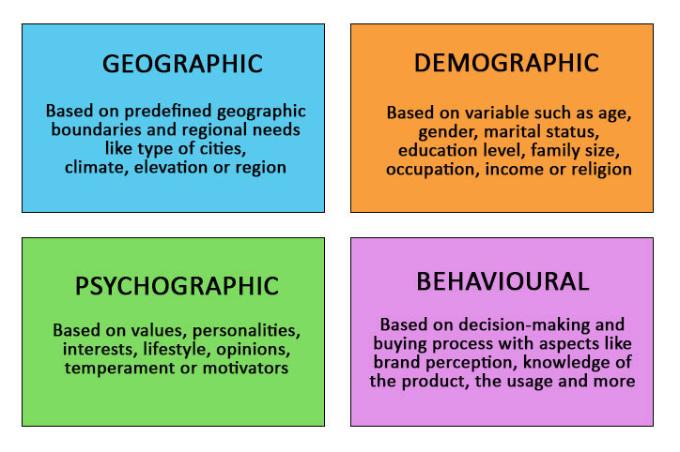
Figure 3: Market segregation strategies
(Source: Kotabe, and Helsen, 2022)
Geographical Division
Cadbury makes use of regional segmentation in the UK to reach both urban and suburban regions. Due to the brand's extensive distribution network, Dairy Milk is always available nationwide in convenience shops, supermarkets, and online marketplaces (Bahoo, Alon, and Paltrinieri, 2020). Geographic segmentation in France concentrates on major cities like Paris, Lyon, and Marseille to take advantage of the dense population and high-end shopping options.
Segmenting by demographics
Cadbury Dairy Milk targets a wide variety of age groups in both markets, according to demographics. Utilizing its vast customer base and nostalgic appeal, the product appeals to families, young adults, and kids in the UK. The premium positioning of Dairy Milk in France draws sophisticated adults who value quality pleasure and are prepared to spend more for upscale dining experiences.
Targeting and Positioning
The positioning approach supports the primary theme of Cadbury Dairy Milk, which is to please customers. In the UK, the brand emphasizes family get-togethers and shared experiences as a way to present itself as a companion to ordinary events. According to Kumar et al., (2020), D\due of the French people's appreciation of fine foods, the positioning in France emphasizes dairy milk as a sign of refined enjoyment.
Comparative and Disparate Analysis
Despite maintaining a consistent brand throughout both nations, Cadbury Dairy Milk's message and cultural quirks vary. The French strategy is in line with their gastronomic culture, whereas the UK marketing appeals to history and nostalgia. Although the quality of the brand is valued in both markets, the UK emphasizes familiarity while France emphasizes exclusivity.
Chosen entry technique
In order to grow inside an existing market in the UK, Cadbury uses a market penetration strategy, capitalizing on its well-known brand presence. The company pursues a market expansion strategy in France, capitalizing on its widespread recognition to reach a new customer base with Dairy Milk.
Benefits and Drawbacks of Different Entry Methods
- Market Entry in the UK
Benefits include maximizing distribution and marketing efforts for Cadbury while minimizing risk and leveraging current brand affinity.
Limitations on future market segment expansion and fierce rivalry from regional brands are drawbacks.
- French market development
Benefits: Expands the company's consumer base, benefits from the reputation of Cadbury across the world, and creates chances for revenue development.
Disadvantages: May be difficult to enter a crowded market; requires cultural adaptability and knowledge.

Directional development strategies

Ansoff matrix
Market Penetration  - Increase Dairy Milk sales  - Encourage repeat purchases | Market Development  - Introduce Dairy Milk to new markets  - Expand into emerging markets
Product Development  - Introduce new Dairy Milk variants  - Innovate with different flavors | Diversification  - Expand into new product categories  - Develop related confectionery products
Table 4: Ansoff analysis
(Source: Self developed)
It is clear that both the UK and France provide distinct benefits when analyzing the product development plan for Cadbury Dairy Milk within the framework of the Ansoff Matrix, although the UK emerges as a more hospitable environment for this approach.
United Kingdom: The UK offers a very open environment for Cadbury's product development strategy. The UK offers several chances to launch new Dairy Milk varieties and flavors due to its wide and established customer base. The popularity of limited-edition products like "Dairy Milk Oreo" and "Dairy Milk Daim" demonstrates how enthusiastic UK customers are about trying new flavors. Furthermore, the British market's familiarity with Cadbury's history and inclination to accept both conventional and cutting-edge goods foster a climate that is favorable for experimenting with product variants (Labanauskaitė, Fiore, and Stašys, 2020). Additionally, the launch of health-conscious products like "Dairy Milk 30% Less Sugar" coincides with changing consumer tastes, enabling Cadbury to appeal to a wider market while upholding the integrity of its brand. The UK's existing brand loyalty, customer readiness to accept change, and well-developed distribution channels all contribute to the success of the product development approach in this market.
France: While the complexity of French cuisine and its love of fine dining experiences are in line with Cadbury's product development strategy, the market does present some difficulties. There are several well-known local brands in the French candy market with strong ties to regional flavors and workmanship. The market currently offers a broad variety of luxury chocolate alternatives that are strongly established in the cultural fabric, so introducing new Dairy Milk versions inspired by French delights may encounter opposition. According to Jafari-Sadeghi et al., (2021), establishing partnerships with regional patisseries or chocolatiers could provide logistical and cultural difficulties. The process of making Cadbury a premium and culturally relevant option for discriminating French customers may need significant efforts and resources, notwithstanding the possibility of success.
Due to its established consumer base, openness to innovation, and harmony with the brand's past, the United Kingdom emerges as the most advantageous market for Cadbury's product development plan for Dairy Milk. Even if the French market has potential, the competitive environment and cultural considerations provide certain challenges that may call for further strategic adaption and efforts to successfully implement Cadbury Dairy Milk's product development plan.

Market penetrations
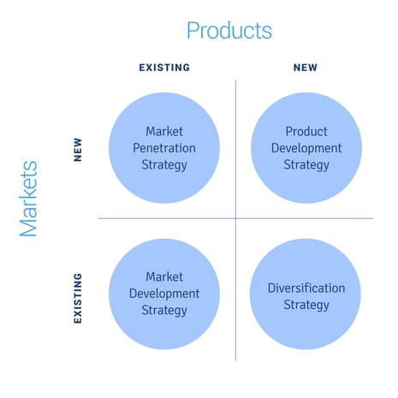
Figure 4: Market Penetration
(Source: Kotabe, and Helsen, 2022)
The well-known chocolate company in the UK, Cadbury Dairy Milk, uses a strong market penetration approach to establish dominance and broaden its reach in this established sector. Taking advantage of its deeply ingrained brand loyalty and rich legacy, Cadbury ramps up its marketing initiatives to promote repeat purchases and seize a bigger portion of the current customer base. By providing different container sizes, bundle discounts, and time-limited promotions, the brand encourages customers to treat themselves more regularly, further solidifying Dairy Milk as a staple in their daily routines. This strategy takes use of the emotional bonds that customers have with the brand and cleverly promotes Dairy Milk as a reassuring and reliable option for all situations. It is simple to get Cadbury products because to their regular availability in supermarkets, convenience shops, and online platforms. Engaging marketing efforts also help to preserve and reinforce the brand's relationship with happy occasions and social gatherings (Kotabe, and Helsen, 2022). By employing this market penetration approach, Cadbury Dairy Milk efficiently increases the size of its market share in the UK confectionary sector while reaffirming its status as a household favorite.
Cadbury Dairy Milk uses a market penetration strategy in France to further establish its position in this affluent and culturally diverse market. Cadbury ramps up its attempts to satisfy the affluent preferences of French consumers in recognition of the nation's love for high-end pleasure. Dairy Milk increases its exposure among target consumers looking for high-end delights by strengthening its existing distribution channels and proactively collaborating with upscale supermarkets and specialized shops. By highlighting the smooth texture and rich flavor of its product while capitalizing on its timeless appeal, Cadbury aims to appeal to the French palate's love of fine dining (Czinkota, Ronkainen, and Cui, 2022). The brand's marketing efforts emphasize Dairy Milk's decadent qualities, promoting it as a mark of refined pleasure and a priceless complement to moments of indulgence. By enhancing its presence in the confectionery section and linking Dairy Milk with sophisticated delight, Cadbury's market penetration strategy seeks to meet the growing demand from French customers for high-quality products. By making these efforts, Cadbury Dairy Milk hopes to strengthen its position in the French market and foster enduring brand loyalty among customers who value quality over quantity.

Product development
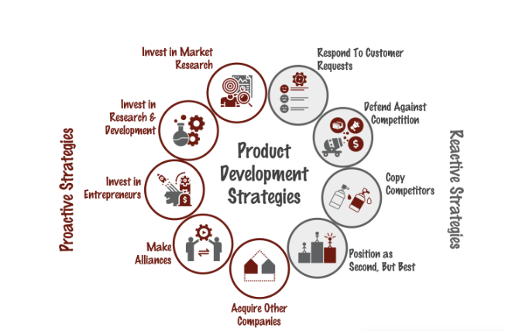
Figure 5: Product development
(Source: Gatto, 2020)
Cadbury uses a product development strategy in the UK market to consistently capture people and maintain a lead in their preferences. Cadbury announces new Dairy Milk varieties that mix tradition and innovation while building on its rich legacy. For example, the launch of limited-edition flavors like "Dairy Milk Oreo" or "Dairy Milk Daim" exemplifies the brand's capacity to combine its recognizable chocolate with well-liked auxiliary components. Cadbury also makes adjustments to their product line to reflect shifting trends in health consciousness. With the introduction of "Dairy Milk 30% Less Sugar," the brand responds to consumers looking for enjoyment with less sugar. The reach and relevance of the product are increased by these developments, which not only appeal to devoted Dairy Milk fans but also to new sectors of health-conscious customers.
Cadbury Dairy Milk adapts a product development strategy for the French market in line with the nation's sophisticated cuisine and love of fine dining. Cadbury introduces premium Dairy Milk varieties designed for French preferences by drawing on its international reputation for excellence. For example, Cadbury may launch a "Dairy Milk Artisan Collection" with flavors modelled after French specialties like "Crème Brûlée" or "Lavender Infusion." This tactic promotes Dairy Milk as an upscale delicacy in addition to making use of the sophisticated flavors preferences of French customers. In order to produce limited-edition Dairy Milk products that combine the brand's expertise with French culinary creativity, Cadbury may also investigate partnerships with neighborhoods patisseries or chocolatiers. By curating a portfolio of sophisticated and culturally resonant offerings, Cadbury Dairy Milk elevates its status in the French confectionery market and establishes itself as a premium choice for discerning consumers.

Recommendation

TOWS matrix
TOWS | Weakness | Strength
Threats | Strengthen product diversification efforts to counter competition and mitigate overreliance on chocolate segment | Introduce limited-edition Dairy Milk flavors that combine tradition with innovation, leveraging brand heritage and consumer openness to new flavors
Opportunities | Launch innovative Dairy Milk products tailored to local tastes in emerging markets, capitalizing on global recognition | Develop new Dairy Milk variants that cater to health-conscious consumers, leveraging brand recognition and wide distribution
Table 5: TOWS Matrix
(Source: Self developed)
The research emphasizes Cadbury's robust brand heritage and widespread familiarity as important assets in the UK. Utilizing these advantages, the suggested SO strategy is on the creation of fresh Dairy Milk varieties aimed at consumers who are health-conscious. The brand may successfully adapt to changing customer tastes while preserving its extensive distribution network by producing goods that blend Cadbury's dependable reputation with health-conscious trends. The ST approach recommends developing limited-edition flavors that continue Cadbury's tradition of innovation and appeal to customers' curiosity about new flavors combinations. This strategy benefits from customer acceptance of new flavors and brand awareness. The report, however, highlights the marketplaces' inadequate product variety as a problem. The WO approach suggests introducing creative Dairy Milk products catered to regional tastes in growing regions to solve this. This strategy not only addresses the problem of product diversity but also makes use of Cadbury's widespread awareness to establish a presence in other regions. The TW plan also suggests stepping up diversification efforts to combat fierce competition and reduce dependency on the chocolate market. The challenges created by competitive pressures are addressed while also playing to Cadbury's current strengths. The risk that consumer preferences will be impacted by trends in health and wellness exists in both markets. The TO approach recommends spending money on research and development to produce dairy milk substitutes that are healthier while also taking into account customers' shifting tastes. The report also emphasizes the difficulty presented by changing raw material costs in both markets. The TW method advises negotiating long-term supplier contracts and streamlining supply chain procedures to reduce price volatility, guarantee stability, and maximize cost effectiveness.

Conclusion
In conclusion, the thorough examination of Cadbury Dairy Milk's strategic course in both France and the United Kingdom highlights the brand's capacity to negotiate various market environments while capitalizing on its key competencies. The use of the 7Ps of the marketing mix that are unique to each nation demonstrates Cadbury's skill in catering to regional tastes and cultural quirks, successfully positioning Dairy Milk as a beloved pleasure. This comprehension is strengthened by taking into account the Hofstede cultural elements, enabling Cadbury to connect with customers on a deeper level. Additionally, the competitive dynamics particular to each market are illuminated by the strategic insights derived from the Porter's Five Forces study, which direct Cadbury's strategic focus on market penetration and differentiation. The brand's dedication to innovation is further shown by the Ansoff Matrix thanks to product development tactics that blend tradition and originality. By balancing familiarity and originality, Cadbury manages to retain its iconic reputation while continuing to appeal to the changing tastes of its customer base. It is possible for Cadbury to take advantage of opportunities, fix weaknesses, and secure its position against challenges in the confectionery business thanks to the TOWS Matrix, which synthesizes these insights into practical solutions. This strategy synthesis shows how flexible and receptive.

References
Antamoshkina, O.I. and Zinina, O.V., 2019, May. A methodology for assessing the prospects of modifying business strategy of an enterprise in the external environment. In IOP Conference Series: Materials Science and Engineering (Vol. 537, No. 4, p. 042023). IOP Publishing.
Bahoo, S., Alon, I. and Paltrinieri, A., 2020. Corruption in international business: A review and research agenda. International Business Review, 29(4), p.101660.
Chi, T., Li, J., Trigeorgis, L.G. and Tsekrekos, A.E., 2019. Real options theory in international business. Journal of International Business Studies, 50, pp.525-553.
Chowdhury, E.K., Dhar, B.K. and Stasi, A., 2022. Volatility of the US stock market and business strategy during COVID‐19. Business Strategy & Development, 5(4), pp.350-360.
Czinkota, M.R., Ronkainen, I.A. and Cui, A., 2022. International marketing. Cengage Learning.
Desfiandi, A., Yusendra, M.A.E., Paramitasari, N. and Ali, H., 2019. Supply chain strategy development for business and technological institution in developing start-up based on creative economy. Int. J. Supply Chain Manag, 8(6), pp.646-654.
Gatto, A., 2020. A pluralistic approach to economic and business sustainability: A critical meta‐synthesis of foundations, metrics, and evidence of human and local development. Corporate Social Responsibility and Environmental Management, 27(4), pp.1525-1539.
Goncharova, N.A., Solosichenko, T.Z. and Merzlyakova, N.V., 2019. Brand platform as an element of a company marketing strategy. International Journal of Supply Chain Management, 8(4), p.815.
Hofstede-insights.com, 2023. COUNTRY COMPARISON TOOL. Available at: https://www.hofstede-insights.com/country-comparison-tool?countries=france%2Cunited+kingdom [Accessed on 10.08.2023]
Ir.mondelezinternational.com, 2023. INVESTOR RELATIONS RELEASE DETAILS. Available at: https://ir.mondelezinternational.com/news-releases/news-release-details/mondelez-international-reports-q4-and-fy-2022-results [Accessed on 10.08.2023]
Itskhoki, O. and Moll, B., 2019. Optimal development policies with financial frictions. Econometrica, 87(1), pp.139-173.
Jafari-Sadeghi, V., Garcia-Perez, A., Candelo, E. and Couturier, J., 2021. Exploring the impact of digital transformation on technology entrepreneurship and technological market expansion: The role of technology readiness, exploration and exploitation. Journal of Business Research, 124, pp.100-111.
Katsikeas, C., Leonidou, L. and Zeriti, A., 2020. Revisiting international marketing strategy in a digital era: Opportunities, challenges, and research directions. International Marketing Review, 37(3), pp.405-424.
Kotabe, M.M. and Helsen, K., 2022. Global marketing management. John Wiley & Sons.
Kumar, V., Singh, D., Purkayastha, A., Popli, M. and Gaur, A., 2020. Springboard internationalization by emerging market firms: Speed of first cross-border acquisition. Journal of International Business Studies, 51, pp.172-193.
Labanauskaitė, D., Fiore, M. and Stašys, R., 2020. Use of E-marketing tools as communication management in the tourism industry. Tourism Management Perspectives, 34, p.100652.
Mio, C., Panfilo, S. and Blundo, B., 2020. Sustainable development goals and the strategic role of business: A systematic literature review. Business Strategy and the Environment, 29(8), pp.3220-3245.
Mykhailichenko, M., Lozhachevska, O., Smagin, V., Krasnoshtan, O., Zos-Kior, M. and Hnatenko, I., 2021. Competitive strategies of personnel management in business processes of agricultural enterprises focused on digitalization. Management Theory and Studies for Rural Business and Infrastructure Development, 43(3), pp.403-414.
Nambisan, S., Zahra, S.A. and Luo, Y., 2019. Global platforms and ecosystems: Implications for international business theories. Journal of International Business Studies, 50, pp.1464-1486.
Paul, J. and Mas, E., 2020. Toward a 7-P framework for international marketing. Journal of Strategic Marketing, 28(8), pp.681-701.
Paul, J., 2020. Marketing in emerging markets: a review, theoretical synthesis and extension. International Journal of Emerging Markets, 15(3), pp.446-468.
Perevozova, I., Horal, L., Mokhnenko, A., Hrechanyk, N., Ustenko, A., Malynka, O. and Mykhailyshyn, L., 2020. Integration of the supply chain management and development of the marketing system.
Rakhmanberdiev, R., Gulamov, A., Masharipov, M. and Umarova, D., 2022, June. The digitalization of business processes of railway transport of the Republic of Uzbekistan. In AIP Conference Proceedings (Vol. 2432, No. 1). AIP Publishing.
Ratten, V., 2020. Coronavirus and international business: An entrepreneurial ecosystem perspective. Thunderbird International Business Review, 62(5), pp.629-634.
Sampe, F., Yusuf, M., Pakiding, D.L., Haryono, A. and Sutrisno, S., 2022. Application Of Digital Marketing In Maintaining Msmes During The Covid-19 PandemiC. Jurnal Darma Agung, 30(2), pp.663-676.
Shams, R., Vrontis, D., Belyaeva, Z., Ferraris, A. and Czinkota, M.R., 2021. Strategic agility in international business: A conceptual framework for “agile” multinationals. Journal of International Management, 27(1), p.100737.
Sharma, P., Leung, T.Y., Kingshott, R.P., Davcik, N.S. and Cardinali, S., 2020. Managing uncertainty during a global pandemic: An international business perspective. Journal of business research, 116, pp.188-192.
Shooshtarian, S., Maqsood, T., Wong, P.S., Khalfan, M. and Yang, R.J., 2020. Market development for construction and demolition waste stream in Australia. J. Constr. Eng. Manag. Innov, 3, pp.220-231.
Stallkamp, M. and Schotter, A.P., 2021. Platforms without borders? The international strategies of digital platform firms. Global Strategy Journal, 11(1), pp.58-80.
Statista.com, 2023. Cadbury products ranked by number of consumers in Great Britain from 2018 to 2021 (in 1,000). Available at: https://www.statista.com/statistics/312031/cadbury-leading-products-in-the-uk/ [Accessed on 10.08.2023]
Tien, N.H. and Ngoc, N.M., 2019. Related and Non-related Diversification Strategy of Domestic Business Groups in Vietnam. International journal of advanced research in engineering and management, 5(7), pp.12-17.
Tien, N.H., Anh, D.B.H. and Ngoc, N.M., 2020. Corporate financial performance due to sustainable development in Vietnam. Corporate social responsibility and environmental management, 27(2), pp.694-705.
Tien, N.H., Phu, P.P. and Chi, D.T.P., 2019. The role of international marketing in international business strategy. International journal of research in marketing management and sales, 1(2), pp.134-138.
Verhoef, P.C. and Bijmolt, T.H., 2019. Marketing perspectives on digital business models: A framework and overview of the special issue. International Journal of Research in Marketing, 36(3), pp.341-349.
Wang, Y., Hong, A., Li, X. and Gao, J., 2020. Marketing innovations during a global crisis: A study of China firms’ response to COVID-19. Journal of business research, 116, pp.214-220.
Williamson, B., 2021. Making markets through digital platforms: Pearson, edu-business, and the (e) valuation of higher education. Critical Studies in Education, 62(1), pp.50-66.

