Introduction to Web and Database Concepts

Student Name: Ethan Shellem-Prince
Student Number: 2109509
Module Code: ACCA4023
Course: Computing (Software Engineering)
Date of Submission: 05/05/2022



Table of Contents
Context Diagram ………………………………………………………………………………………………………… 3
Level 0 DFD ………………………………………..………………………………………………………………………. 4
Entity Relationship Diagram ……………………………………………..………………………………………… 5
Report Outputs …………………………………………………………………………………………………………… 7
Form Screenshots ………………………………..………………………………………………………………..…… 8
Query Examples …………………………………………………………………………………………………………. 11
User Guide ………………………….……………………………………………………………………………………… 12

Context Diagram
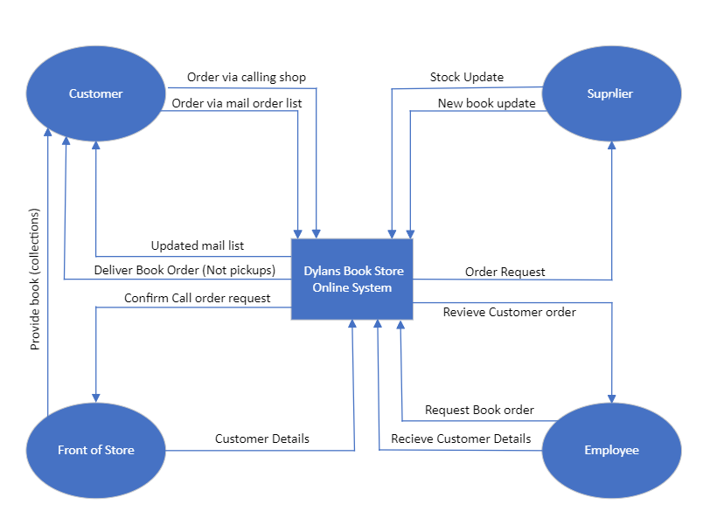

Level 0 DFD
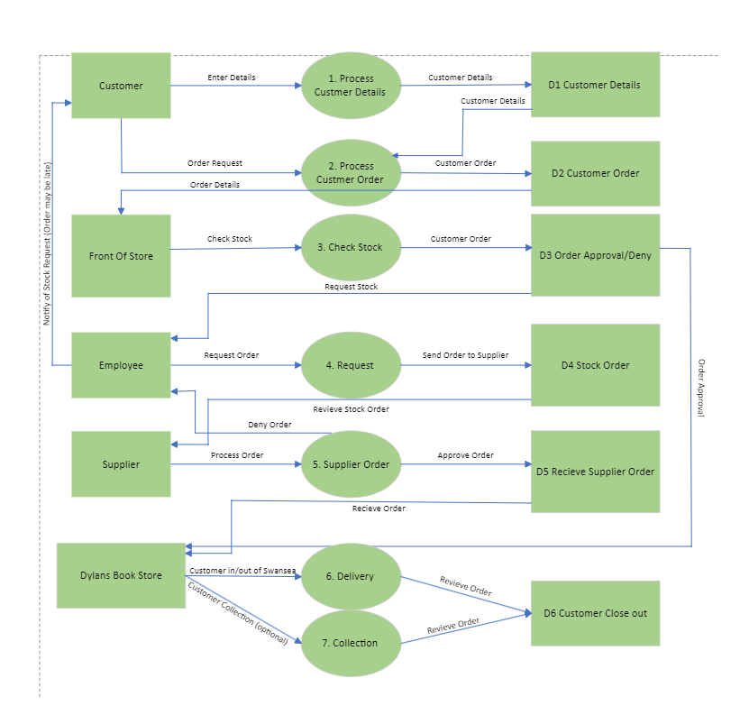

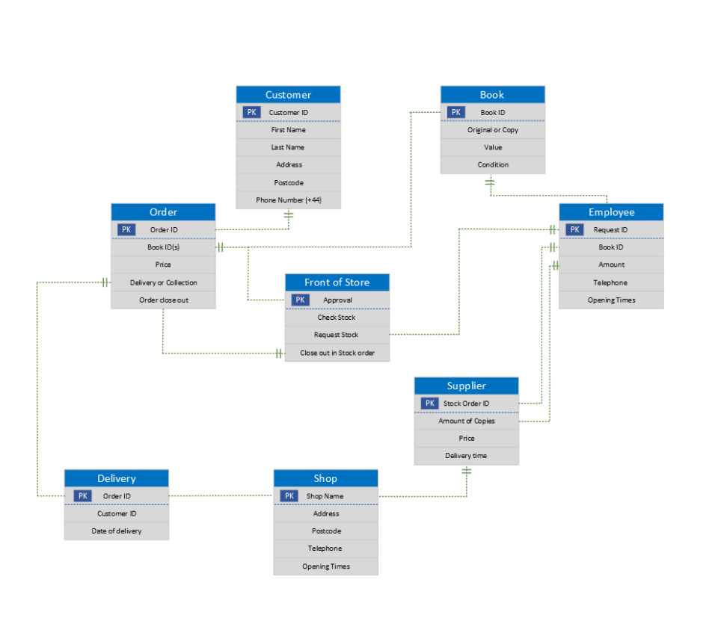
Entity Relationship Before Database Creation

Entity Relationship After Database Creation
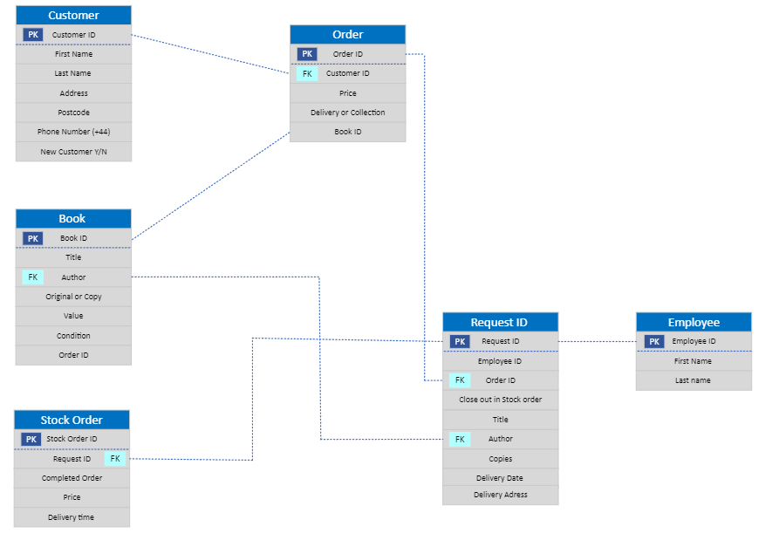

Report Outputs (Microsoft Access)

Book Information
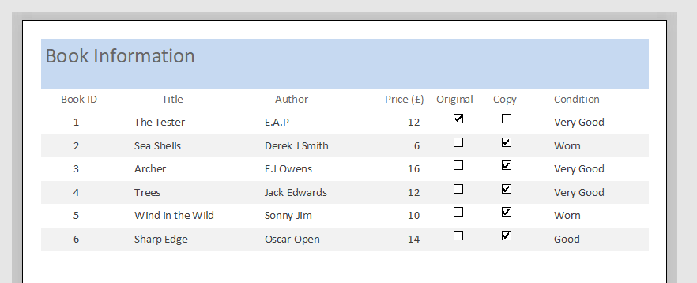

Customer Information
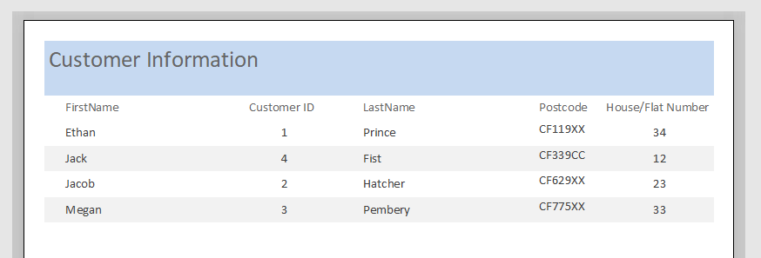

Customer Order Information
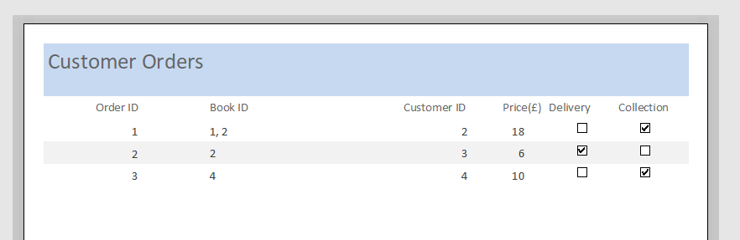

Stock Order Information
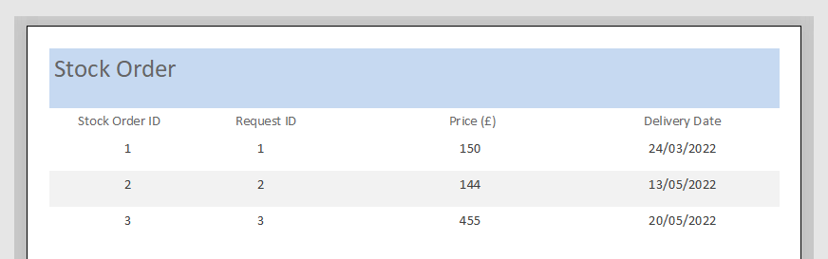

Forms (Microsoft Access)

Book ID (Details about the Book)
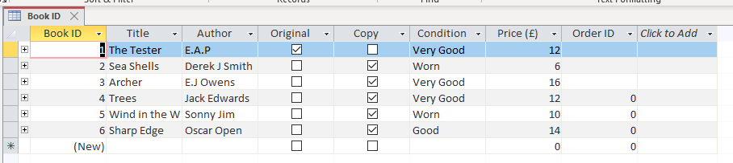

Customer Information (Details about the Customer)
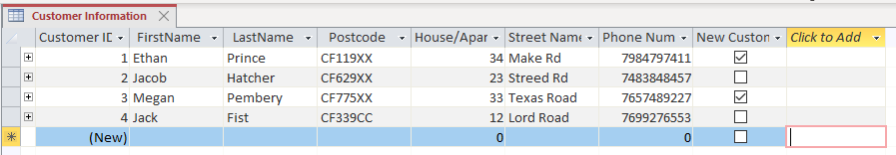

Employee Details (Details about the Employee)
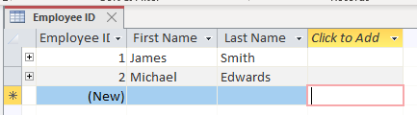

Order ID (Details about Customer Orders)
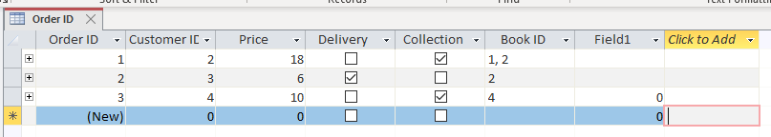

Request ID (Details about requested stock)
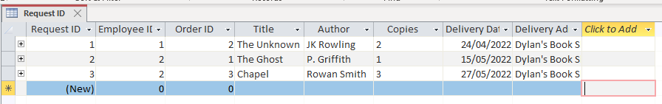

Stock Order ID (Details about supplier Stock Order)
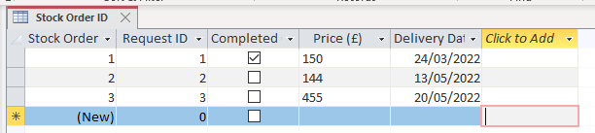

Query Examples (Microsoft Access)

Customer ID, Name and Order ID
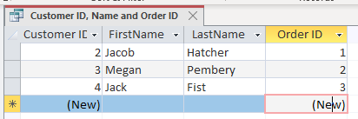

Book Condition
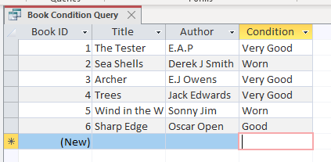

User Guide
Overall this Database can be used to store data such as,
- Book Information
- Customer Details
- Current Order Details
- Employee Details
- Book Request Details
- Stock Orders to Supplier Information
To use this Database you will need to have Microsoft Access 2016 installed. You are free to amend the Tables however you please. The Tables are key objects within the database. They contain data that is permanently stored within the database. You are able to add different headers and rows with as much information you need. The Tables all have automatic ID numbers, this will allow you to identify many different items based on the ID. For example each customer, book and order will have its own unique ID.
As the tables continue to expand the data will become harder to read. You may query the database to see filtered data. This will allow you to easily see the data you want without having to manually look for it in the tables. There are two queries already set up. For example, Book Condition and Customer ID, Name and Order ID. These queries will allow you to narrow down certain data so its easily viewable.
Forms are data that can be edited to add, edit or display data. There are many different forms available to use. The forms will automatically input the data added into the tables. This will result in all of the reports and queries to be updated automatically. The forms are also amendable. The design tab allows you to amend the inputs with access to add/remove any parts you wish.
I have also set up 4 key reports. These reports will allow you to view the outcome of the database. The reports can be used to track and hold data such as customer information. The reports updates automatically once the database has been updated. You are able to print these reports and display them in an A4 document.

