University of Wales Trinity Saint David
School of Engineering
Quality Tools and Root Cause Analysis
Michael Corish
2115171
Advanced Manufacturing Operations
31/03/2022
L4 – Quality and Business Improvements ACMA4004



Table of Contents

1 Problem Statement 1
2 Data Collection 2
3 Data Analysis 3
3.1 Coiler Identification 3
3.2 Defect Identification 4
4 Root Cause Analysis 6
4.1 Ishikawa Diagram 6
4.2 5 Whys Diagram 6
5 Action Plan 8
6 References 10

Table of Figures
Figure 1 - Check sheet of Coil Diversions by quality defect between 13/03/22 - 19/03/2022. 2
Figure 2 - Number of Diversions produced from Coiler 4 and Coiler 5. 3
Figure 3 - Statistical Process Control Chart showing comparison of Coil Diversions by defect against total average. 4
Figure 4 - Pareto chart of C4 Coil Diversions 4
Figure 5 - Ishikawa diagram of Bad Walling/Staggered defect. 6
Figure 6 - The outcome of 5 Why's Root Cause Analysis 7
Figure 7 - Action plan table outlining the Short Term and Long Term actions to be taken. 8

Problem Statement

The Hot Mill within Tata Steel is a manufacturing process line that reduces steel slab into steel strip through multiple individual processes. The main aim of the process is to manufacture a coil that meets the customers’ requirements. These requirements include coil presentation, gauge, profile, width and temperature. The Coiler department is the final process of the mill, which produces the finished product ready for direct dispatch to the customer. Lately, the Coiler department has had an increase in coil diversions due to presentation defects. This means that when the coil is quality checked and believed to be outside customer specifications, the coil is diverted to specific re-work processes or can be coded as scrap. These unwanted diversions have a detrimental effect on Tata Steel and its customers. Having to re-work coils has a financial effect on the company because the coils need to be diverted into stock and scheduled for the Coil Temper Mill, resulting in higher energy costs and more manning required. Also, the high number of diversions is causing stock levels to rise close to the maximum holding capacity. Once there is no space left to hold stock, the Hot Mill must either slow or halt production so that re-worked material can be exported to reduce stock levels, this has a large financial impact on the company. Other than financial and time consuming effects, this issue also decreases customer satisfaction. The customer is having to wait longer for their product and when products are outside specifications it’s causing breakdowns on their manufacturing processes. With these issues arising, customers either want to pay less for their product or are willing to look elsewhere for better quality. The aim of this project is to collect and analyse data on quality defects from both coilers (C4 and C5), to identify if there is a specific coiler that needs to be improved. Once the data has been analysed, root cause analysis techniques will be used to identify the specific area that needs to be addressed. By identifying the root cause, an action plan will then be put in place to improve the coiling process and ultimately, reduce the number of coil presentation defects.

Data Collection

 | C4 | C5 | A Rota | B Rota | C Rota | D Rota | Total
Shouldering | 16 | 8 | 6 | 5 | 10 | 3 | 24
Bad Walling/Staggered | 25 | 7 | 8 | 7 | 12 | 5 | 32
Oval/Domed | 2 | 3 | 1 | 0 | 2 | 2 | 5
Damaged Tail Ends | 0 | 2 | 1 | 1 | 0 | 0 | 2
Loose Laps | 4 | 4 | 3 | 2 | 1 | 2 | 8
Tail End Run Off | 8 | 4 | 3 | 5 | 3 | 1 | 12
Telescoping | 5 | 6 | 4 | 4 | 2 | 1 | 11
Missing Band | 4 | 5 | 2 | 2 | 4 | 1 | 9
Total | 64 | 39 | 28 | 26 | 34 | 15 | 103
The first step of the improvement plan is to retrieve data from the process, which can be used throughout the improvement project for data analysis. Check sheets are one of the 7 basic quality tools, used to make information visually easier to identify the main issues within a process. A check sheet is a data-recording device, essentially a list of categories (Summers, 2010). The quality tool is used to collect the frequency that each specific defect occurs over a pre-selected timeline. These were used to record the frequency of coil diversions from quality defects over a week (Fig.1).

Figure 1 - Check sheet of Coil Diversions by quality defect between 13/03/22 - 19/03/2022.

The main aim of data collected was to be able to categorise each defect by specified coiler and working shift. By understanding which coiler is producing most defects, it narrows down the location of where the problem is arising. The decision was made to collect information against each shift instead of days of the week, so analysis can be made to identify if there are any differences in operating procedures and standards. Each defect has been individually categorised to understand and identify which is being diverted to re-work processes most frequently. All information is captured through the Pencilman’s role. The role is to examine each coil off the coiler process for quality defects and compare these against customer specifications. When coils are deemed to be outside of the specification they are coded and diverted for re-work. All diversions are entered into the company computer system and are added up at the end of each shift. Now the required data has been collected, it can be analysed using other quality tools.

Data Analysis

Now data has been collected and recorded, tools are in place to assist with analysing the information. By using the quality tools, it provides a better view of the process as a whole and identifying which problem to investigate. Selecting the correct tools to use for the data collected is key for visual aid.

Coiler Identification

To be able to identify the main cause for coil diversions, the decision was made to firstly recognise which coiler was producing most defective coils. A simple bar chart was used to show the differences in overall coil diversion totals between C4 and C5 over the weekly period (Fig.2).

Figure 2 - Number of Diversions produced from Coiler 4 and Coiler 5.

The bar chart gives visual representation that C4 is producing a much larger number of coil diversions compared to C5. This information helps to narrow down the location of the problem but before more in depth analysis of a specific coiler, a control chart was created to understand the trends of each coiler by individual defect frequencies (Fig.3).

Figure 3 - Statistical Process Control Chart showing comparison of Coil Diversions by defect against total average.
After analysing the data, the chart above clearly shows that C4 is producing above average bad walling/staggered and shouldered coils. The trend for both coilers is quite consistent with the average control line except for these two defects. The ultimate aim is to produce coils with zero defects resulting in no diversions, but stock levels and workload can be managed by keeping diversions close to this average line. This clearly shows that C4 needs further analysis by inserting data into a Pareto chart so the most significant defects can be identified (Fig.4).

Defect Identification

Figure 4 - Pareto chart of C4 Coil Diversions
The Pareto chart is a graphical tool used for ranking problems from most significant to least significant (Summers, 2010). The principle is to use the 80-20 rule to identify the ‘vital few’, this means that 80% of problems is caused by only 20% or otherwise known as the ‘vital few’. The use of Pareto charts allows the vital problems to be separated from the trivial many (Summers, 2010). The Pareto chart above (Fig.4) shows that the main problems causing high diversions are bad walling/staggered coils, shouldering and tail end run off. After analysing the data, the main concern is what is causing these identified defects and setting up an action plan to resolve. The decision was made to investigate the bad walling/staggered defect because it is classed as the most significant defect at this moment in time. By reducing the defect frequency, will have a positive impact on financial and inventory issues the company has been facing.

Root Cause Analysis

The aim of this step is to investigate and understand the root cause of the defect, so an action plan can be introduced with preventable actions to ensure it does not repeat itself. The focus is to treat the root cause and not just the symptoms produced from the problem.

Ishikawa Diagram

The Ishikawa diagram otherwise known as the Cause-and-Effect diagram, allows the improvement team to state the effect and then split brainstorming ideas into manageable sections. The diagram provides a uniformed view of the potential causes. By organising the causes into different sub-categories means that each section can be analysed individually to locate the root cause. The diagram below (Fig.5) shows the outcome of a completed brainstorming session displayed using the Ishikawa diagram.
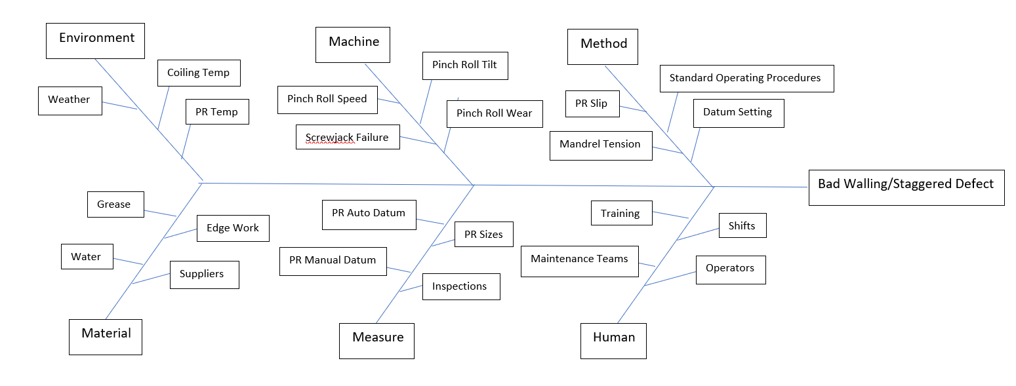
Figure 5 - Ishikawa diagram of Bad Walling/Staggered defect.

5 Whys Diagram

If a problem is going to be fixed then the real root cause needs to be understood (Brook, 2017). The 5 Whys technique is a straightforward but effective way of identifying the root cause. By starting with a generic ‘why?’ question about the problem and then following up with further why’s to the answers found, helps to delve deeper into the issue. This allows the real root cause being treated rather than the symptoms this problem has created. The technique was used during the root cause analysis of the Bad Walling/Staggered defect (Fig.6)
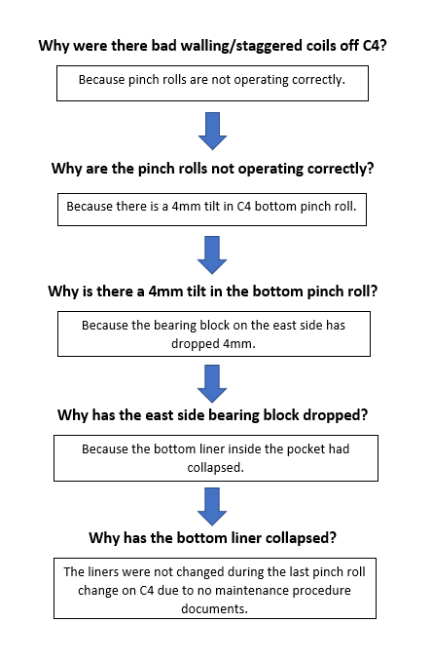

Figure 6 - The outcome of 5 Why's Root Cause Analysis

The information provided has resulted in the root cause of the defect being identified. The tilt in C4 bottom pinch roll has occurred due to a collapsed liner. By asking why this has occurred, has resulted in the discovery of no liner change documentation being provided to the maintenance team with the bottom pinch roll documents on the last change. Now the real root cause has been identified, it allows an action plan to be put in place with preventative and corrective actions. These solutions will hopefully reduce the number of defects and ultimately, the number of diversions highlighted at the beginning of the project.

Action Plan

Short Term Actions | Long Term Actions
Jack east side bearing block and insert 4mm packers to level bottom pinch roll. | Ensure that liner inspection/change is added to the bottom pinch roll change Job Method Statement.
Manually datum C4 pinch roll with feeler gauge to accurately measure gap and tilt on a daily basis. | Manually datum each downshift (6-8 weeks) to keep track of tilt.
Routine inspections each shift of temporary packers in place. | Re-instate pinch roll tilt clutch system. Allows operator to change tilt offset from pulpit.
Continue to collect and analyse data of coil diversions by defect. To ensure that the root cause has been found. | Review diversion data and compare with previous recorded data.

Figure 7 - Action plan table outlining the Short Term and Long Term actions to be taken.

The action plan table above (Fig.7) splits solutions into two categories. The short term actions are to be put in place up until the next planned maintenance stop, this will give the company time to plan and implement the long term actions. The actions to be taken before the stop are mainly corrective measures, which means that it will temporarily solve the issue but will not prevent it from re-occurring. For that reason, the area engineering team will need to make regular inspections to contain the problem until there is enough available time to take preventive actions. By adding the liner inspection or change to the bottom pinch roll change Job Method Statement, provides less paperwork for the maintenance team, and allows all steps to be completed. The pinch roll has two screws that drive hydraulic cylinders which adjust the gap between the top and bottom pinch rolls. By re-instating the screw jack clutch system, will allow the operator to have full control of pinch roll tilt from the pulpit. The clutch between the two screws disengages so the operator can drive each screw individually and then engages after the tilt has been set. This system removes the need for temporary packers if the failure was to repeat itself. After all actions have been implemented it is vital that data should be continually analysed over a set period. For example, by tracking coil diversions using a Statistical Process Control Run chart, will allow the team to compare previous data with recent data. This will be analysed, to define the scale of improvement after implementing the selected actions and that coil diversion frequencies are being kept under control.

References

Brook, Q., 2017. Lean Six Sigma & Minitab - The complete toolbox guide for business improvement. 5th ed. s.l.:OPEX Resources.
Summers, D. C. S., 2010. Lean Six Sigma Process Improvement Tools and Techniques. s.l.:Pearson.

