Nazia sadiq 2330095
Module code: LCHS4003
Lecturer: Aishat Bakre

Origins of the national health service NHS
The National Health Service (NHS) is one of the most significant social reforms in British history. It was established on 5 July 1948 with the aim of providing free healthcare for all citizens, regardless of their income or social status (NHS England, 2023). Before the NHS was created, healthcare in the United Kingdom was fragmented and largely based on a person’s ability to pay. Many working-class families could not afford medical treatment, relying instead on voluntary hospitals, charitable organizations, or local government services (Webster, 2002). This inequality in access to healthcare became more visible during the interwar years and especially during World War II, when the need for a coordinated and fair healthcare system became urgent.
The origins of the NHS can be traced back to the 1942 Beveridge Report, which outlined a vision for a welfare state that would address the “five giant evils” of want, disease, ignorance, squalor, and idleness (Beveridge, 1942). The report argued that healthcare should be available to everyone as a right, not as a privilege. Aneurin Bevan, the then Minister of Health, was responsible for implementing this vision under the Labour government led by Clement Attlee. Bevan’s guiding principle was that the NHS should be “universal, comprehensive, and free at the point of delivery” (Bevan, 1952). This meant that every person in the UK could receive healthcare funded through taxation, rather than personal payment. The NHS was built on three core principles: to meet the needs of everyone, to be free at the point of use, and to be based on clinical need rather than the ability to pay (NHS, 2024).
The establishment of the NHS represented a major shift towards social equality and collective responsibility. However, it was not without challenges. Many doctors initially opposed the reform, fearing loss of independence and income this resistance, the NHS quickly became an essential part of British life, improving health outcomes and life expectancy across the population. Over the decades, the NHS has evolved to meet changing demographic, technological, and financial demands.
The current structure of the NHS is complex. It is made up of four separate systems in England, Scotland, Wales, and Northern Ireland, each responsible for its own policies and budgets (The King’s Fund, 2024). In England, NHS England oversees the delivery of healthcare, supported by Integrated Care Systems (ICSs), which bring together NHS organizations, local authorities, and voluntary partners to plan services locally (NHS England, 2024). Primary care, including general practitioners (GPs), serves as the first point of contact for most patients, while secondary and tertiary care provide specialized services in hospitals and clinics. Public health is largely managed by local authorities and supported by national agencies such as the UK Health Security Agency.
Despite its achievements, the NHS faces major challenges today. These include long waiting lists, workforce shortages, underfunding, and increasing demand due to an ageing population and chronic illnesses (British Medical Association, 2024). The COVID-19 pandemic further exposed weaknesses in capacity and resource management. Critics argue that the NHS model, while ethically sound, is struggling to remain sustainable under financial pressures. The government’s focus on efficiency, privatization, and digital transformation has also generated debate about the NHS’s future identity as a publicly funded service. Nevertheless, its founding principles—universality, equity, and accessibility—remain central to its mission.
In conclusion, the NHS emerged from a period of social and economic hardship, embodying the values of fairness and solidarity. While its structure has adapted over time, the fundamental goal of providing healthcare for all continues to guide its operation. However, sustaining these ideals in the face of modern challenges requires ongoing investment, workforce development, and strong leadership. The NHS remains a cornerstone of British society, reflecting the enduring belief that good health is a right, not a privilege.

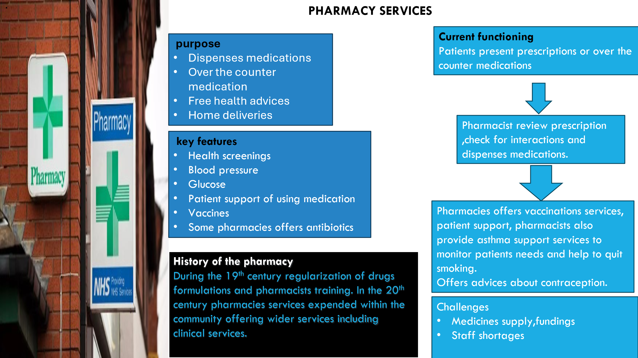
References
Beveridge, W. (1942) Social Insurance and Allied Services. London: HMSO.
British Medical Association (2024) NHS Pressures and Workforce Crisis. Available at: https://www.bma.org.uk. NHS (2024) Principles and Values of the NHS in England. Available at: https://www.nhs.uk.
NHS England (2023) History of the NHS. Available at: https://www.england.nhs.uk
The King’s Fund (2024) How is the NHS Structured? Available at: https://www.kingsfund.org.uk
Webster, C. (2002) The National Health Service: A Political History. Oxford: Oxford University Press.
Pharmaceutical Journal (2023) special report: The stressors burning out pharmacists. Available at: https://pharmaceutical-jounal.com/article/feature/special-report-the stressors-burning-out-pharmacists.

