Feasibility plan for an international meeting
Student id:2227451
Name: Florin Dragomir
Lecturer Name: Kathryn Flynn
Module BMIH6007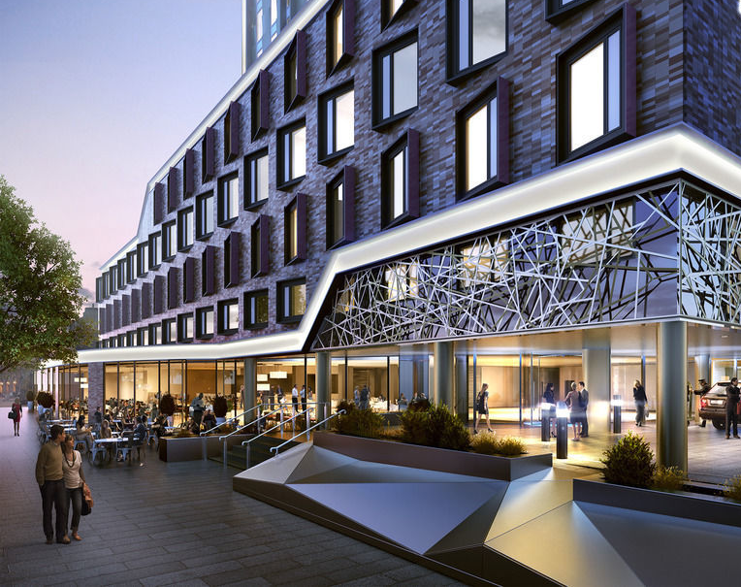

Event management is the process of planning but also organizing and coordinating events. It also represents an event that is focused on equality, diversity and inclusion being entitled Flavours without Borders. This would take place in the Park Plaza, Westminster Bridge and would aim to celebrate the increasingly rich cultural diversity through global cuisines in terms of hotel dining. From tasting sessions to cooking stations, it would greatly encourage hotels to implement a range of culturally diverse environmental options, thereby enhancing inclusive hospitality.

The event will be called "Flavours Without Borders: A Celebration of Cultural Diversity in Hotel Dining" and the event is a cultural event as well as a food festival that focuses on highlighting the vitality and inclusion in hotel dining services. Also, aiming to strengthen the role of cultural cuisine in improving guest services, the event promotes the inclusion of satisfaction and thus dietary preferences as well as variety. People should have great respect for the living culture but also their rituals, norms, food and more. This event focuses on integrating culinary traditions from around the world to improve the reputation of the hotel along with increasing customer satisfaction. Integrating traditional global cuisines greatly helps hotels to attract a much wider audience base from around the world (Wondirad et al. 2021). This is thus a food festival but also a cultural event that is designed to attract guests but also hospitality companies as well as chefs and employees and the nature of this event is of special interest that combines tasting sessions, culinary demonstrations but also worship with chefs from more diverse backgrounds who make traditional dishes and share various stories but also tasting sessions with everyone.
The workshops can thus train chefs to include cultural diversity in their menus but also to provide more inclusive dining services to everyone. This aims not only to promote equality but also to encourage inclusion but also diversity and embrace a welcoming atmosphere for all guests.

The target market of this event is hotel professionals such as food and beverage managers, as well as hospitality executives and chefs who are looking to improve the dining experience for their money. The secondary audience is global travelers, culinary enthusiasts, and cultural ambassadors looking for authentic and diverse culinary experiences. Even international and local businesses are also its target markets, who are interested in promoting cultural inclusion in their hotel businesses. When it comes to demand, the culinary tourism market is estimated to grow by USD 208.6 billion in 2024-2028, representing a 22% CAGR. There is a growing demand for culturally diverse dining services in the hospitality sector, which cater to travelers from all over the world and cater to dietary preferences such as vegan, gluten-free, or halal items. It is also reported that over 72% of travelers prioritize cultural dining experiences during their stay, thus driving demand for inclusive menu items.
Lastly, the delivery is analyzed and hotels like Park Plaza Westminster Bridge have diverse dining options and have strong cultural infrastructure to host large-scale facilitated culinary events. The hotel has over 32 meeting rooms with extensive ballroom space, making it extremely suitable for hosting large events. The hospitality industry is emphasizing diversity, equality and inclusion which aligns with global trends to offer diverse food and accommodate diverse cultural preferences. The event would also support the sector’s ongoing commitment to enhance guest satisfaction through culinary diversity.

There are many other food events in London, such as Taste Of London or London Food Festival, which attract a similar customer segment seeking diverse and also culinary experiences. Popular events such as the National Geographic Traveler Food Festival have attracted over 7,000 foodies in just two days, offering a diverse range of visitors the chance to witness a world-class array of expert food writers and international chefs, but due to its consistent brand recognition, it may threaten the popularity of this event. Other local cultural events or pop-up dining experiences can thus strengthen the kitchens and entertain potential attendees at their events. Rival hotels can thus host food festivals and themed dining options, thus reducing attendance at our event. Virtual cooking classes worldwide are set to grow at an 11.3% CAGR by 2032 and their growing popularity, along with food blogs, could pose a strong threat to this event and provide alternative experiences.
Additionally, Flavours without Borders events would combine live workshops, demonstrations and other inclusive dining sessions that would differentiate themselves from their competitors and increase their appeal to a diverse audience.
Additionally, Flavours without Borders events would combine live workshops, demonstrations and other inclusive dining sessions that would differentiate themselves from their competitors and increase their appeal to a diverse audience.

Launching engaging campaigns would be a great idea so that participants can share their favorite cultural dishes using the hashtags #FlavorsWithoutBorders. Hashtags help them reach huge traffic and increase their views, shares and likes and Hosting live cooking demos online on YouTube and Instagram by their chefs would help them create a huge social media presence. . Partnering with pietlee but also local cafes helps them set up temporary tasting booths but also provide them with samples of their festival food along with distributing flyers for the events. It is also possible to collaborate with food bloggers and create huge interest for their event among diverse audiences. Also, discounts promote psychological incentives to buy and encourage them immediately. Also, discounted tickets can be offered for absolutely all early registrations to stimulate engagement but also interest among customers. Engaging storytelling is another strategy that would help chefs share their cultural traveler stories through newsletters and blogs and help them create stronger connections with their target audience.

The event will be held at Park Plaza Westminster Bridge, known for its first-class hotel lines and extensive dining facilities. It also features flexible open spaces including conference rooms and outdoor areas where various activities such as cooking shows, tasting sessions or workshops can be held monthly. This is best suited for the availability of audiovisual equipment and professional kitchens, being the best for interactive live workshops and demonstrations. This hotel is located in the heart of London, with the City of Westminster on its doorstep, with excellent transport facilities such as cars, buses and rail. The hotel is renowned for its luxury destination, which suits the purpose of our event to embrace cultural diversity.

There are a number of essential skills required such as event planning and organization skills would be the foundational skills required for this event. The second set of skills are strong event planning skills help manage deadlines, ensuring smooth completion. Communication skills must be strong to effectively consult vendors but also attendees, sponsors and chefs. In organizing events for the hospitality industry, adequate knowledge of cultural cuisine and diverse traditions is essential to promote authenticity. Proficiency in promotion but also in marketing is very important as it involves clients with event campaigns and thus attracts diverse customers. Strong negotiation skills are also required to secure potential partnerships, terms and conditions with suppliers and sponsors, as well as critical thinking skills to address challenges during events. Budget management skills, team management, leadership skills, and deeper research into event technologies are also required.

The main objective of resource allocation in event management is to combine the best resources to meet the requirements by recognizing the demand of the event. The event would need qualified chefs from diverse cultural backgrounds. Additional staff such as marketing professionals, volunteers, event coordinators, and wait staff would also be required to assist with logistics and guest management. Premium quality catering resources such as equipment or food supplies would be required to prepare and serve a diverse audience with a variety of dishes, including ensuring food inclusivity. Good lighting helps to direct the public’s attention to the program and here professional lighting would be needed to give the dining areas, live cooking areas and workshops a vibrant and primitive atmosphere. Adequate parking, with proper signage, comfortable seating and audiovisual equipment is another equipment that would help to make the event more engaging and interactive. Thoughtful event decorations elevate the holistic aesthetics and leave a lasting impact on the attendees. This event would have a culturally themed decor that would help to enhance its appeal.

The event is estimated to cost a total of £32,500 with very high overheads including venue hire of £10,000, catering of £8,000, staff of £5,000 and marketing of £3,000. Additional costs include technical set-up, decorations and miscellaneous expenses. The total estimated income is £58,000 which is generated from ticket sales of £50,000, partnerships and sponsorships of £5,000 and supplier fees of £3.00. Sponsorships from local businesses as well as cultural organisations and food brands will help offset this, while vendor fees will continue to contribute. This structure thus provides a profit of £25,000, and thus financial sustainability.

Flavours Without Borders is designed to celebrate cultural diversity by showcasing diverse cuisines, promoting inclusion and showcasing diverse culinary traditions. The event will thus help hotel brands integrate these diverse offerings into their operations, thereby increasing their cultural awareness. Effective planning, budget management and marketing are key to ensuring the event runs smoothly. Revenue comes from vendor fees, sponsorships and ticket sales. With careful financial management, the event is expected to be highly profitable and sustainable, while also enhancing the reputation of participating hotels as culturally conscious and inclusive destinations globally.

Allen, J., Harris, R. and Jago, L., 2022. Festival & special event management. John Wiley & Sons.
Bowdin, G.A., Allen, J., Harris, R., Jago, L., O'Toole, W. and McDonnell, I., 2023. Events management. Routledge.
BRI, 2025. Online Cooking Class Market Size, Share, Growth, 2032. Available at: https://www.businessresearchinsights.com/market-reports/online-cooking-class-market-102782 (Accessed on: 24 January 2025).
Carswell, J., Jamal, T., Lee, S., Sullins, D.L. and Wellman, K., 2023. Post-pandemic lessons for destination resilience and sustainable event management: the complex learning destination. Tourism and Hospitality, 4(1), pp.91-140.
Chakrabarti, P., Malvi, E., Bansal, S. and Kumar, N., 2023. Hashtag recommendation for enhancing the popularity of social media posts. Social Network Analysis and Mining, 13(1), p.21.
Daheri, M., Warsah, I., Morganna, R., Putri, O.A. and Adelia, P., 2023. Strengthening Religious Moderation: Learning from the Harmony of Multireligious People in Indonesia. Journal of Population & Social Studies, 31.
Dolores, L., Macchiaroli, M. and De Mare, G., 2021. Sponsorship’s financial sustainability for cultural conservation and enhancement strategies: an innovative model for sponsees and sponsors. Sustainability, 13(16), p.9070.
Dowson, R., Albert, B. and Lomax, D., 2022. Event planning and management: Principles, planning and practice. Kogan Page Publishers.
F&B Insights, 2025. National Geographic Traveller (UK) Food Festival: Embark on a Culinary Adventure. Available at: https://www.foodbeverage-outlook.com/food-beverage-insights/national-geographic-traveller-uk-food-festival-embark-on-a-culinary-adventure#:~:text=National%20Geographic%20Traveller%20(UK)%20Food%20Festival%20welcomed%20over%207%2C000%20foodies,chefs%20and%20expert%20food%20writers. (Accessed on: 24 January 2025).
Gordon, J. and Furlong, G., 2023. Strategic Negotiation: Building Organizational Excellence: A Roadmap to Harnessing the Power of Alignment. Routledge.
Hilton, 2025. Culture and Experiences Will Drive Leisure Travel Decisions. Available at: https://stories.hilton.com/2024trends-culture-experiences (Accessed on: 24 January 2025).
Koppel, J., Van Dyke, T. and Kavanaugh, R.R. eds., 2023. Hospitality With a Heart: Concepts and Models for Service Learning in Lodging, Foodservice, and Tourism. Taylor & Francis.
LinkedIn, 2023. The importance of diversity in the hospitality industry. Available at: https://www.linkedin.com/pulse/importance-diversity-hospitality-industry-felipe-serrano-cirnc?utm_source=share&utm_medium=member_android&utm_campaign=share_via (Accessed on: 24 January 2025).
Livingston, J., 2021. Designing with light: The art, science, and practice of architectural lighting design. John Wiley & Sons.
Mahendra, D., 2024. The Impact of Tourism on the Preservation and Transformation of Cultural Identity in Bali, Indonesia. Studies in Social Science & Humanities, 3(6), pp.34-41.
Park Plaza, 2025. Park Plaza London Westminster Bridge | Home. Available at: https://www.parkplazawestminsterbridge.com/ (Accessed on: 24 January 2025).
Technavio, 2025. Culinary Tourism Market Size 2024-2028. Available at: https://www.technavio.com/report/culinary-tourism-market-industry-analysis (Accessed on: 24 January 2025).
Westminster Bridge, 2025. Meetings & Events | Park Plaza Westminster Bridge London. Available at: https://www.parkplazawestminsterbridge.com/meetings-events/ (Accessed on: 24 January 2025).
Wondirad, A., Kebete, Y. and Li, Y., 2021. Culinary tourism as a driver of regional economic development and socio-cultural revitalization: Evidence from Amhara National Regional State, Ethiopia. Journal of Destination Marketing & Management, 19, p.100482.
Zhang, K., Cai, F. and Shi, Z., 2021. Do promotions make consumers more generous? The impact of price promotions on consumers’ donation behaviour. Journal of Marketing, 85(3), pp.240-255.

