WonderWorld: Final Project
By Aimee Williams
2205102

Contact
Process document 1
Appendix 1 – Monday management software 6
Appendix 2 – Working Journal 7
Appendix 3 – Workshop plans 11
Bibliography 14

For my final project this academic year, I created WonderWorld, a wellbeing workshop at University of Wales Trinity Saint David's Carmarthen campus for students. I considered various ideas but ultimately decided against them due to personal vulnerabilities and challenges, especially working with participants on a dementia journey, as well as limited resources for gathering participants in the early stages of the project. This lead me to designing a series of fantasy workshops in an immersive setting to encourage and empower participants. The overview for this project was that the wellbeing workshops would be based in fairy tale, I facilitate for the University of Walse Trintiy Saint David students at Carmarthen campus, offering a distinctive and inventive method to encourage overall well-being among students. These workshops will create a space for students to come together in a creative and engaging setting. Developing a sense of community by providing a break from their regular routines, encouraging personal development, and introspection. By delving into the captivating realm of fairy tales, these workshops enhance the holistic well-being of students and support their comprehensive growth. Throughout this project, I refined my goals to offer engaging fairy tale workshops for students at the University of Wales Trinity Saint David. Specific outcomes included fostering creativity, teaching emotional regulation techniques, and enhancing problem-solving abilities. Participants formed connections through shared experiences and storytelling, engaging in enjoyable activities to promote relaxation and develop empathy, communication skills, teamwork, and trust. I utilised roleplay, Mantle of the Expert activities, and the Neelands framework to cultivate various skills, while using the project management tool Monday (Appendix 1) to establish an efficient working schedule.

I presented the initial workshop in the WonderWorld series as a sample session one week before the Easter break. The purpose of this was to determine the level of interest among potential participants and to gain a sense of the environment in the room. Utilising Neelands' (2010) temple from Beginning Drama 11-14 as a framework for planning the sample session, I was inspired to further develop my own facilitation style during the Easter holidays, as I felt that the sample session was lacking a personal touch. So planning the rest the project I need to decide which approach I would take, needed to develop a strategy and establish tactics. The difference between them is that a strategy provides a broad framework and direction, while tactics are the specific actions taken to execute that strategy. Strategy focuses on the big picture and long-term goals, while tactics are more concrete and short-term. Both are necessary for success which James Thompson (2009, p.122) supports by saying in the applied theatre reader, “because applied theatre operates in situations that are governed by both tactical and strategic actions, operating solely at the level of the tactical and private means that our private acts can be subsumed into the public strategies of other”.
During the development of the WonderWorld series, a concept came to mind. I envisioned organising a sequence of workshops set in a fictional world where participants could choose their destinations, activities, and methods to develop their ownership of the workshops. Inspired by Dorothy Heathcote's (2020, p178) approach in Mantle of the Expert, where in aiming to empower participants by entrusting them with the responsibility of problem-solving, task execution, and altering workshop outcomes. However, the structure I had in mind bore resemblance to the popular game, Dungeons and Dragons, which increases self-esteem of the player. I wondered if empowerment and belonging had connection and found the study by Jungmin Seo (2023), researching the psychological empowerment of employees which enhances their sense of belonging at work. This also aligns with observations made by Wilkinson and Kitzinger in the applied theatre reader, emphasising the importance of representing Others, engaging in theoretical conversations, challenging power dynamics, acknowledging complexities, promoting inclusivity, and recognising the significance of silence. They also highlighted the role of social power dynamics and the importance of empowering the disempowered. An example of this empowerment happened during the third official session as my participants took charge of outcome of our workshop. They encountered thieves in a jungle and I tasked them with solving the problem through role play. I divided the room into adventurers and thieves, with the adventurers ‘finding a solution’. Surprisingly, the participants playing thieves recruited the adventurers into their faction. This unexpected turn of events was exactly what I had hoped for. The improvised scene included romantic narratives and even penguins in the jungle, showcasing the ownership participants had taken within this fictional world we created. This transformative experience had a profound impact, as subsequent participants identified themselves as thieves and asserted their freedom to act.

To achieve this I had to plan which role-playing aspect I should use in my workshop. To do this I consulted the Baim, Brookes, and Moutford (2002) Geese Theatre Handbook which explores various role-playing techniques. I found that incorporating ‘Whole Group role play’ could be beneficial for examining social interactions, while ‘Forum role play’ could help participants explore different viewpoints and enhance problem-solving skills. Lastly, ‘Role Play for Empathy, Feedback, and Self-talk’ highlights compassion, understanding, and self-reflection in the workshop sessions. I also referred to Davies (2014) Larping rule book for guidance on roleplaying, which emphasises the importance of not going overboard, treating players as allies, and utilising history. Throughout the workshop, I observed instances where the choices made by participants influenced and inspired them, the history of the workshops kept them engaged. One significant illustration of this occurred when, in the first session after the easter break, participants chose to 'lock a child in a cave'. This particular decision resonated throughout the workshops, as it was frequently revisited, culminating in a final encounter with 'the child in the cave'. I faced a challenge in refraining from going too far, as the workshops offered a wealth of potential that I wished to incorporate but could not due to the sheer volume. This realisation reminded me to trust the participants and the process which I could not do without being intentional with my facilitation.

Sadeghi-Yekta and Prendergast (2022, p115) emphasise the importance of actively listening to personal narratives and using artistic elements such as scenes, movement, metaphor, and music to convey the essence of these stories with empathy. They also highlight the value of discomfort in challenging oppression and promoting ethical praxis (2022, p116)(2022, p126), demonstrating how critical generosity can improve learning and result in positive outcomes (2022, p127-128). This reminded me of the facilitation tool call OARS (2002), which stands for Open Questions, Affirmation, Reflective Listening, and Summary Reflection. During the WonderWorld workshop I used this tool to actively engage with every participant in ascendance of these workshops, which I received positive feedback and create a sense of belonging. One instance of this occurred when a new attendee joined the group. Although I was not acquainted with this individual, I had heard their name before and made a mental effort to remember it. When we checked in and I mentioned their name, their expression brightened and they expressed surprise that I had recalled their name so quickly. This simple gesture instantly made them feel included in the group, acknowledged, and accepted for who they were, aligning with my intentions for this project.

One of the difficulties I encountered during the workshops was managing time effectively. Often, I found myself running over the scheduled hour or having participants who wanted to extend the workshop beyond the allotted time. In reflecting on this challenge, I found solace in the words of Augusto Boal during his interview on DemocracyNow in 2007 (2022, 9:07 – 9:12), where he stated on, "when we are free in space, we are arrested in time...". This concept was echoed by Bell Hooks (2009, p.85) in the applied theatre reader, stating, “Spaces can be real and imagined. Spaces can tell stories and unfold histories. Spaces can be interpretated, appropriated, and transformed through artistic and literary practise.” . These quotes helped me reconcile with the concept of time management in facilitation, as it emphasised the importance of balancing freedom in the workshop space with the limitations of time. Another aspect of this project that was demanding of me was the ethics of vulnerability which Sadeghi-Yekta and Prendergast(2022, p.154)(2022, p.161-162). explain that exploring vulnerability from various perspectives is a key aspect in creating diverse dramatical projects. Vulnerability in facilitation, like with any practitioner, is a valuable tool in the creative process and fostering freedom in the space. This was challenging but we're warding as participants commented that they were “ able to release their inner child.” The vulnerability and sense of liberation among my participants were evident when I incorporated bubbles into my workshop. This seemingly simple childhood toy sparked a surge of creativity among my participants and quickly became a cherished moment within the project. As previously mentioned, I utilised the OARS facilitation tool to empower my participants. This process had been described as a negotiation of power by my lecture who had been observing one of the workshops within this project. However, I had briefly taken to an assertive facilitation style as I neared the end of the project which the introduction of bubbles it shifted priorities within my participants and consequently my facilitation. Consequently, I had to let go of the authority and power I believed I held in the room and resort back to the state of service through negotiations instead the imposing facilitation style I had fallen into. This experience was both humbling and inspiring, as relinquishing my ‘power’ allowed my participants to thrive and fully embrace their ownership of this project.

As the facilitator, I acknowledge that there were areas where I could have improved during the evaluation of this project. Specifically, I failed to adequately plan the evaluation format for the initial two workshops. The taster session merely asked participants whether they enjoyed it, while the first session after the Easter holidays lacked both de-rolling and feedback mechanisms due to my oversight. The participants and my lecture pointed out this issue, prompting me to actively seek out evaluation methods in order to address this concern. Halfway through this project I was introduced to the concept of Planning Process Drama advocated by Bowell and Heap (2013), I embarked on a thorough study and research of this innovative approach to see if I could utilise. As I delved deeper into its intricacies, I reached a realisation that if I were to design a new project, I would undoubtedly incorporate this format. However, a challenge arose as I had encountered this practice midway through my ongoing project, leaving me perplexed about how to seamlessly integrate it into my existing planning. I also contemplated utilising this practice as a means of reflection yet struggled to adapt my existing process to accommodate this approach. Instead I created a notice board to gather feedback from my participants. This was inspired from my process through developing this project as we often used post-it notes to get all the essential information and we could easily revisit. IN my personal experience facilitators have used this as a tool to gather information about the process analysis which simplifies and enhances understanding, project planning for agile and complex endeavours and brainstorming to stimulates creativity through idea generation.

During my workshop, my main focus was on the concept of well-being. In order to properly assess the well-being of my participants, I decided to employ the notice board format as a means of gathering their feedback. To engage them further, I introduced a daily question that revolved around relevant well-being and project-related inquiries. To keep them updated on their progress throughout the project, I utilised a coin count system that correlated with the various 'adventures' they engaged in during the workshops. Furthermore, I encouraged those who had attended previous workshops to provide a review, allowing participants to rate and comment on their last 'adventure'. One particularly encouraging aspect of my evaluation notice board was the implementation of a 1-10 scale to measure participants' experiences before and after each 'adventure'. Upon analysing the results obtained from each session, I discovered that, on average, participants' ratings on this scale increased by two points. This positive outcome served as a source of motivation for me to continue with this project. Which proved fruitful as during my final session I took 15 minutes out of the workshop to solely focus on evaluation and some of the responses I got from my participants were incredibly positive discussed our favourite moments , any last comments, we discussed a sense of belonging, support and any skills built within this project, and participants described the change in their lives since attending the WonderWorld Series

In conclusion, this final project, the WonderWorld Series has proven to be highly valuable for the students at the University of Wales Trinity Saint David’s Carmarthen campus. It has not only tested my ability to facilitate and apply praxis in my work but also introduced sense of community, belonging and new perspectives on our fellow academic associates. Thereby bringing about a remarkable transformation in both my life and the lives of the participants involved.

Word Count: 2186

Appendix 1 – Monday management software
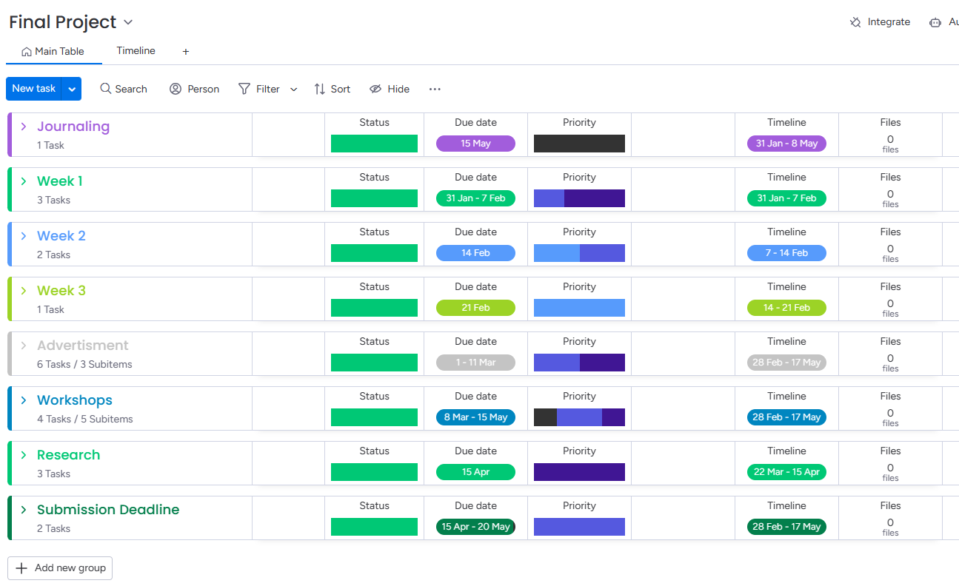
Managing tasks on Monday

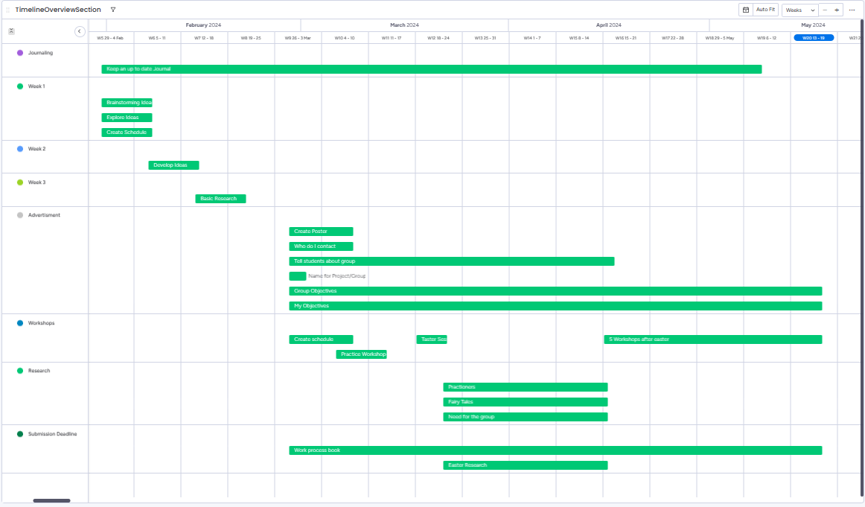
Overview of timeline on Monday

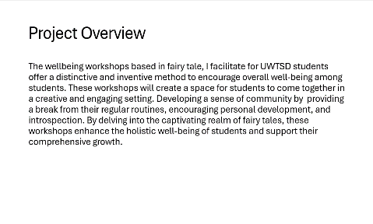
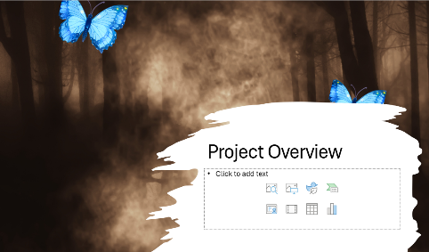
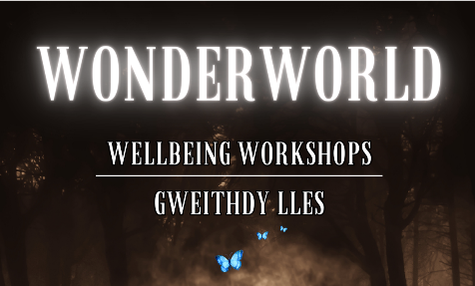
Appendix 2 – Working Journal
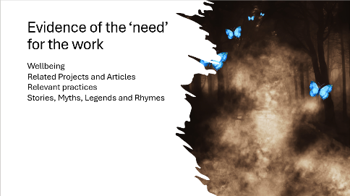
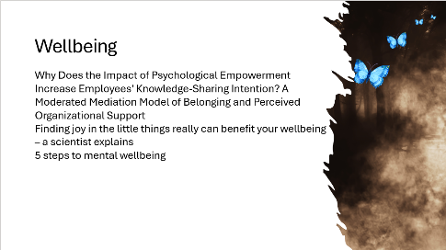
Slide1 Slide2 Slide3
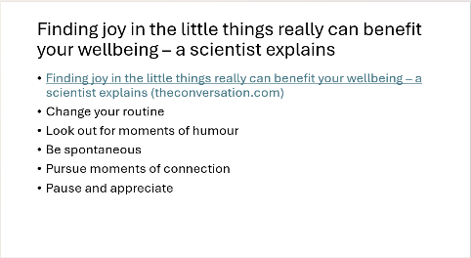
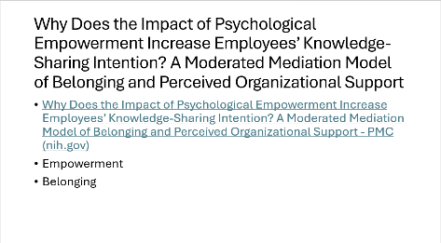
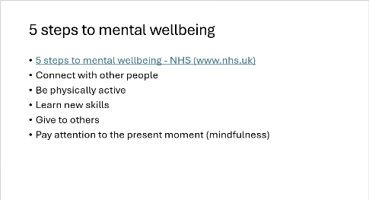
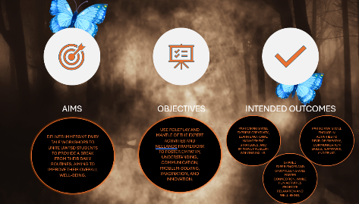
Slide4 Slide5 Slide6
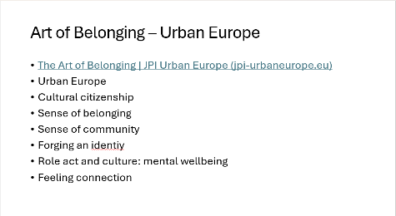
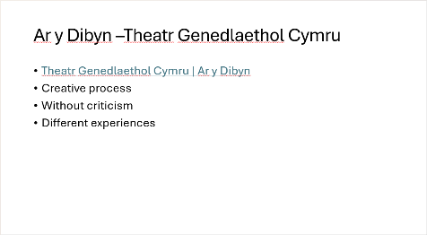
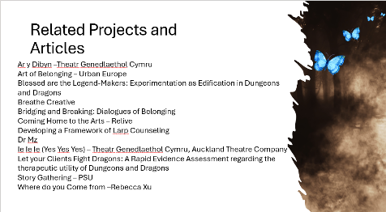
Slide7 Slide8 Slide9
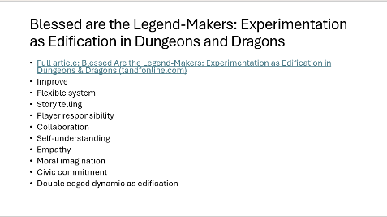
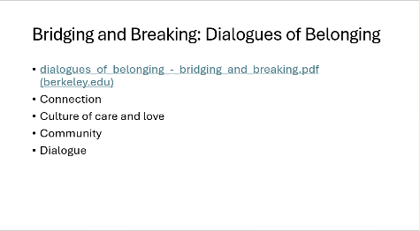
Slide10 Slide11 Slide12
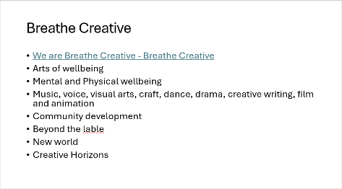
Slide13 Slide14 Slide15
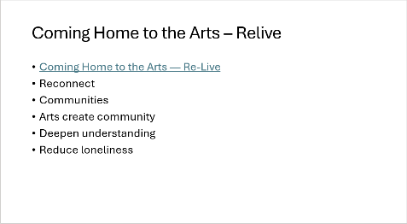
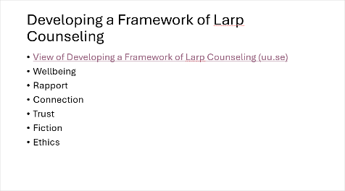
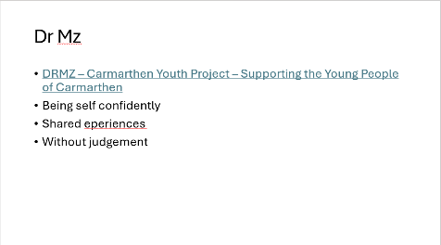

Slide16 Slide17 Slide18
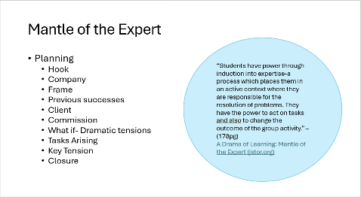
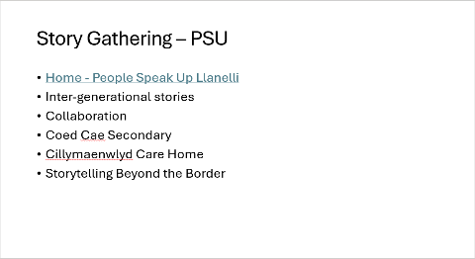
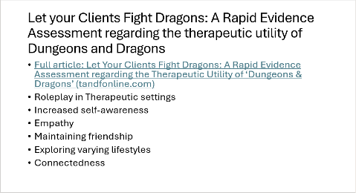
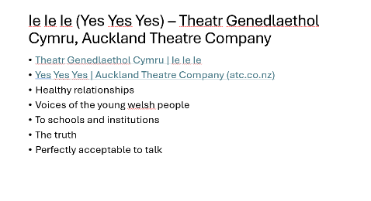
Slide19 Slide20 Slide21
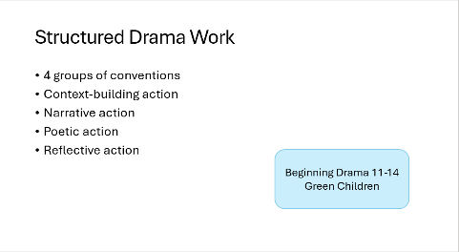
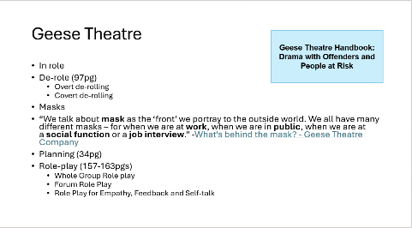
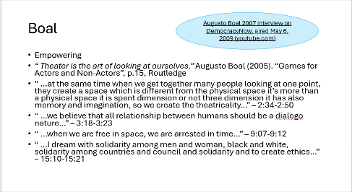
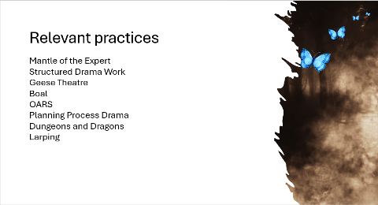
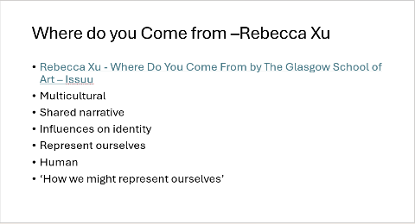
Slide22 Slide23 Slide24
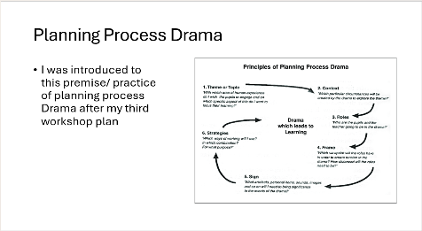
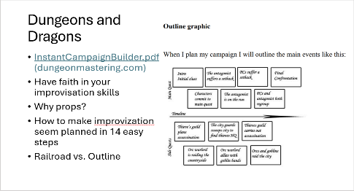
Slide25 Slide26 Slide27
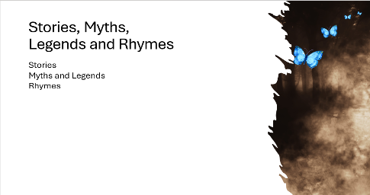
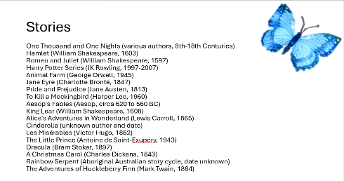
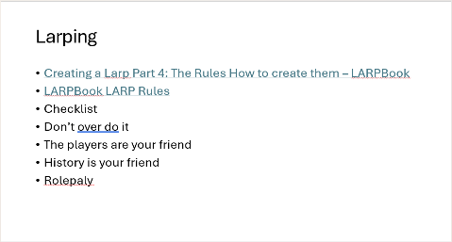
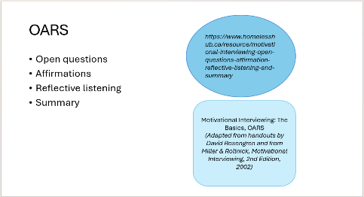
Slide28 Slide29 Slide30
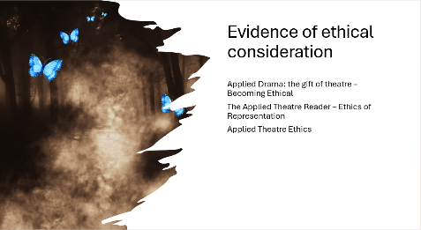
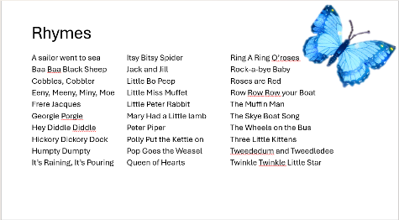
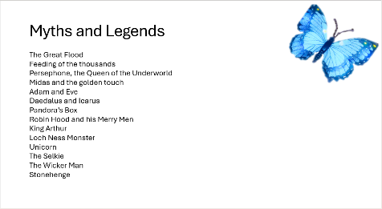
Slide31 Slide32 Slide33
Slide34 Slide35 Slide36

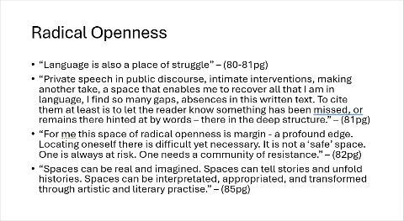
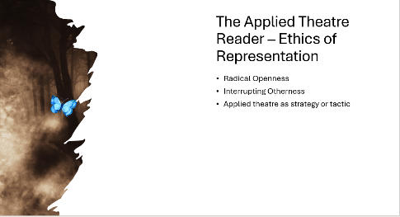
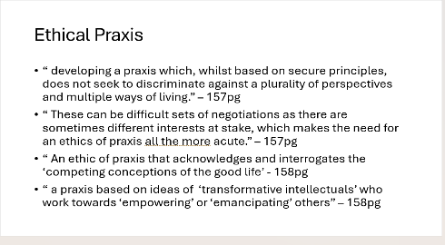
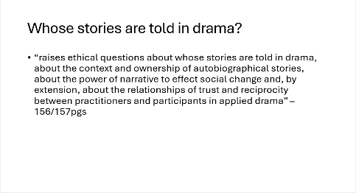
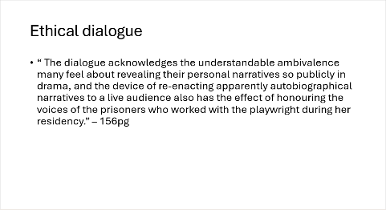
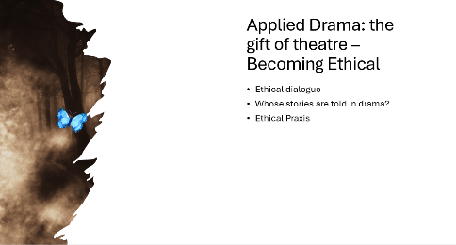
Slide37 Slide38 Slide39
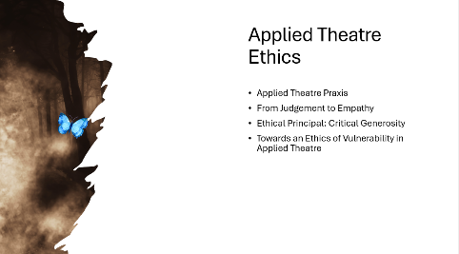
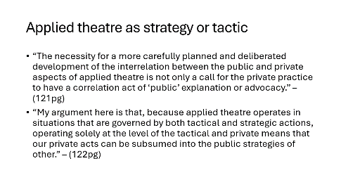
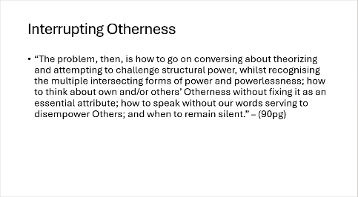
Slide40 Slide41 Slide42
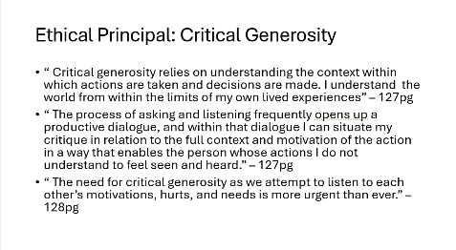
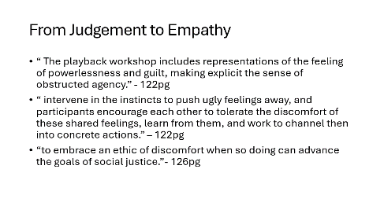
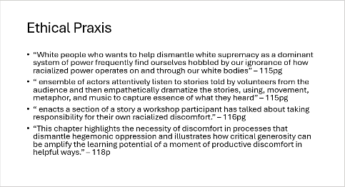
Slide43 Slide44 Slide45
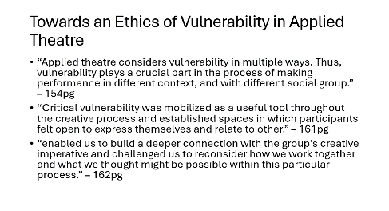
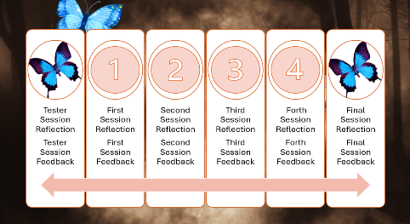
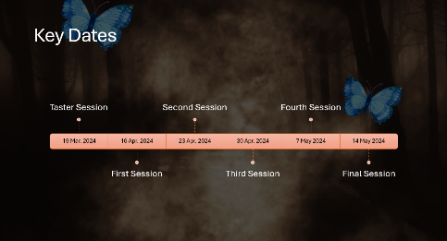
Slide46 Slide47 Slide48
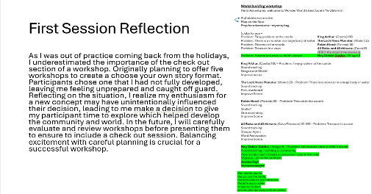
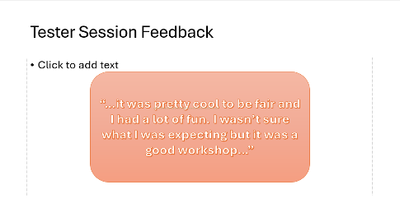
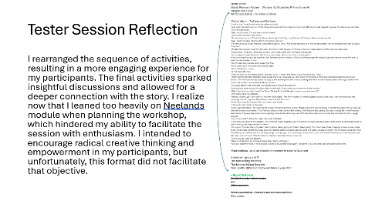
Slide49 Slide50 Slide51
Slide52 Slide53 Slide54

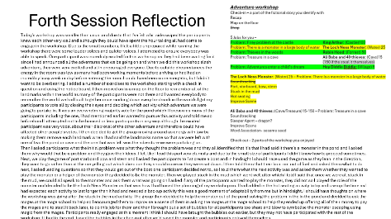
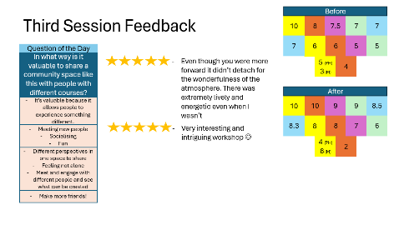
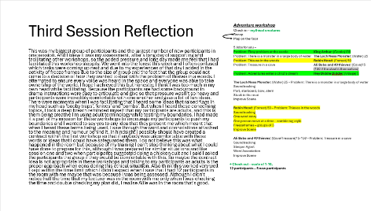
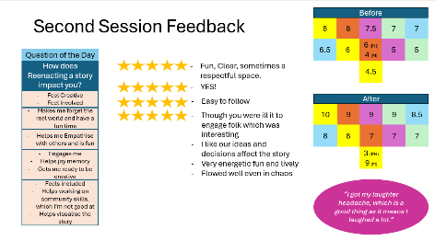
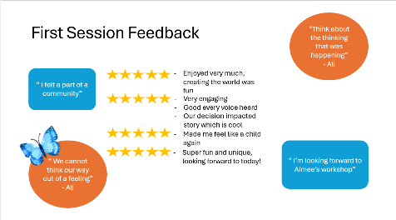
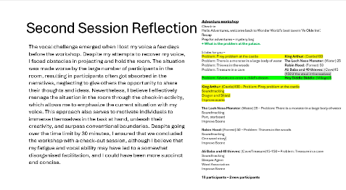
Slide55 Slide56 Slide57
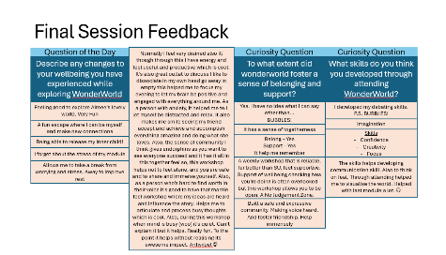
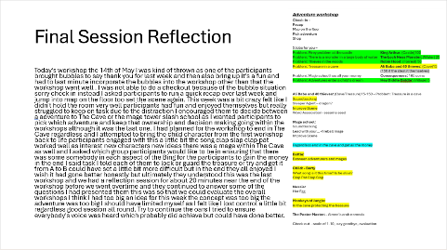
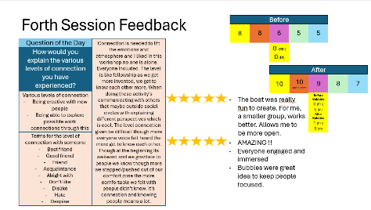
Slide58 Slide59 Slide60
Slide61 Slide62 Slide63
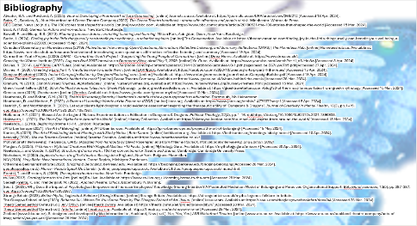
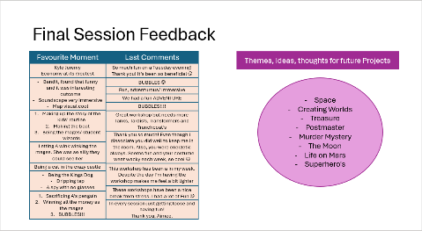

Slide64 Slide65

Working Journal Link –
FP Journal Powerpoint.pptx
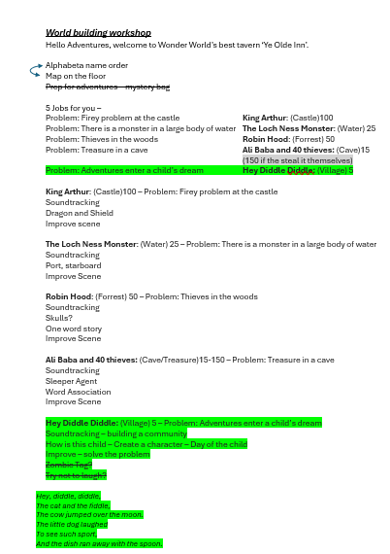
Appendix 3 – Workshop plans
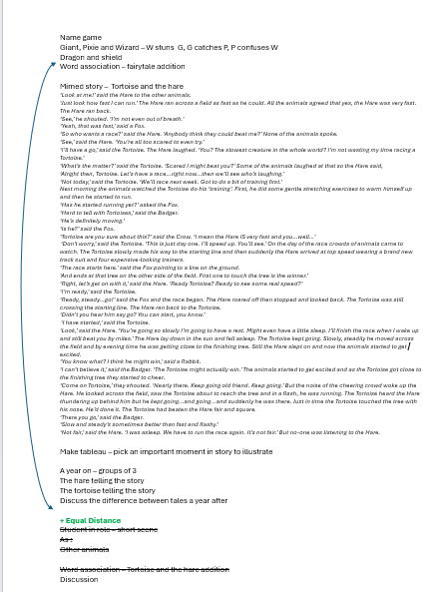
(Taster Session) (First Session)
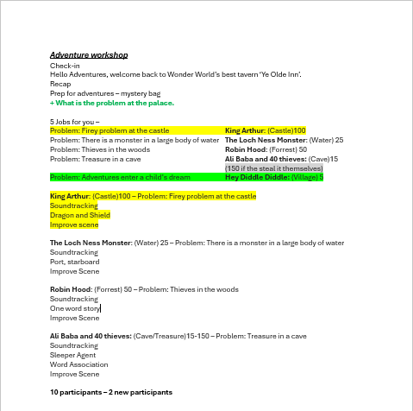

(Second Session)
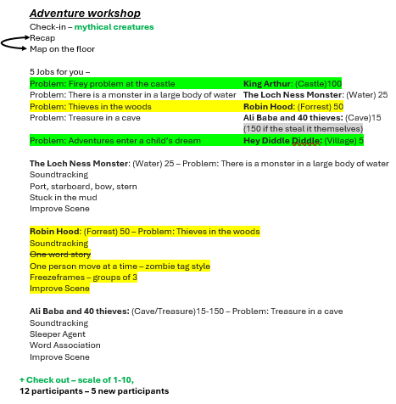

(Third Session)
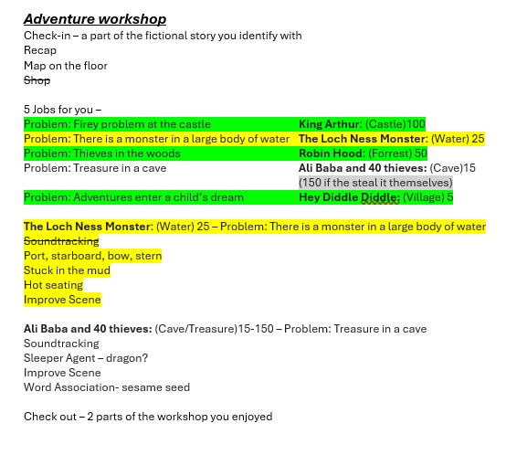

(Forth Session)
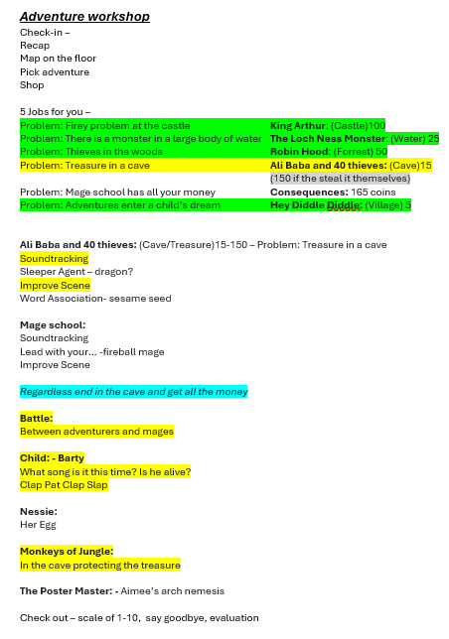

(Final Session)

Bibliography
Atwater, B.A. and Rowland, A. (2024). View of Developing a Framework of Larp Counseling. [online] Journals.uu.se. Available at: https://journals.uu.se/IJRP/article/view/268/212 [Accessed 18 Apr. 2024].
Baim, C., Brookes, S., Alun Mountford and Geese Theatre Company (2002). The Geese Theatre handbook : drama with offenders and people at risk. Winchester: Waterside Press.
BBC Global News Ltd (n.d.). The 100 stories that shaped the world. [online] www.bbc.com. Available at: https://www.bbc.com/culture/article/20180521-the-100-stories-that-shaped-the-world [Accessed 15 Mar. 2024].
Boal, A. (1992). Games for Actors and non-actors. New York: Routledge.
Bowell, P. and Heap, B.S. (2013). Planning process drama : enriching teaching and learning. Milton Park, Abingdon, Oxon ; New York: Routledge.
Burke, J. (2024). Finding joy in the little things really can benefit your wellbeing – a scientist explains. [online] The Conversation. Available at: https://theconversation.com/finding-joy-in-the-little-things-really-can-benefit-your-wellbeing-a-scientist-explains-222020 [Accessed 15 Apr. 2024].
Canadian Observatory on Homelessness (2019). Motivational Interviewing: Open Questions, Affirmation, Reflective Listening, and Summary Reflections (OARS) | The Homeless Hub. [online] Homelesshub.ca. Available at: https://www.homelesshub.ca/resource/motivational-interviewing-open-questions-affirmation-reflective-listening-and-summary [Accessed 19 Apr. 2024].
Carmarthen Youth Project (2020). DRMZ – Carmarthen Youth Project – Supporting the Young People of Carmarthen. [online] Drmz-Home. Available at: https://www.drmz.co.uk/.
Crossing the Waters Institute (2022). Augusto Boal 2007 interview on DemocracyNow, aired May 6, 2009. [online] YouTube. Available at: https://www.youtube.com/watch?v=Hl_n8-Mrx8w [Accessed 8 Apr. 2024].
Davies, R. (2014). LARPBook LARP Rules. [online] Available at: https://larpbook.com/wp-content/uploads/2014/12/larpbook-larprules-v0-1.pdf.pagespeed.ce.B67uywJTo5.pdf [Accessed 27 Apr. 2024].
Davies, R. (2020). Creating a Larp Part 4: The Rules How to create them. [online] LARPBook. Available at: https://larpbook.com/2020/10/creating-a-larp-part-4-the-rules/ [Accessed 15 Apr. 2024].
DungeonMastering (2007). Instant Campaign Builder by DungeonMastering.com. [online] Available at: https://www.dungeonmastering.com/InstantCampaignBuilder.pdf [Accessed 18 Apr. 2024].
Geese Theatre Company (n.d.). What’s behind the mask? [online] Geese Theatre Company. Available at: https://www.geese.co.uk/whats-behind-the-mask/ [Accessed 28 Mar. 2024].
Granum, M. (2019). List of Nursery Rhymes, Alphabetically. [online] Nurseryrhymes.org. Available at: https://www.nurseryrhymes.org/nursery-rhymes.html [Accessed 15 Mar. 2024].
Greek Travel Tellers (2019). 30 of the Most Famous Tales from Greek Mythology. [online] greektraveltellers.com. Available at: https://greektraveltellers.com/blog/30-of-the-most-famous-tales-from-greek-mythology [Accessed 15 Mar. 2024].
Greeka.com (2018). Greeka.com. [online] Greeka. Available at: https://www.greeka.com/greece-myths/ [Accessed 15 Mar. 2024].
Heathcote, D. and Bolton, G.M. (2010). Drama for learning Dorothy Heathcote’s mantle of the expert approach to education. Portmouth, Nh Heinemann.
Heathcote, D. and Herbert, P. (2022). A Drama of Learning: Mantle of the Expert on JSTOR. [online] Jstor.org. Available at: https://www.jstor.org/stable/1477037?seq=1 [Accessed 8 Apr. 2024].
Henrich, S. and Worthington, R. (2021). Let your clients fight dragons: a rapid evidence assessment regarding the therapeutic utility of ‘Dungeons & Dragons’. Journal of Creativity in Mental Health, 18(3), pp.1–19. doi:https://doi.org/10.1080/15401383.2021.1987367.
Hollander, A.T. (2021). Blessed Are the Legend-Makers: Experimentation as Edification in Dungeons & Dragons. Political Theology, 22(4), pp.1–16. doi:https://doi.org/10.1080/1462317x.2021.1890933.
Holzwarth, L. (2021). The Most Epic Myths from Around the World. [online] History Collection. Available at: https://historycollection.com/the-most-epic-myths-from-around-the-world/ [Accessed 15 Mar. 2024].
Neelands, J. (2010). Beginning drama 11-14. London: Routledge.
JPI Urban Europe (2021). The Art of Belonging. [online] JPI Urban Europe. Available at: https://jpi-urbaneurope.eu/project/the-art-of-belonging/ [Accessed 18 May 2024].
Kanter, B. (2015). The Art of Facilitating Virtual Meetings with Sticky Notes | Beth Kanter. [online] bethkanter.org. Available at: https://bethkanter.org/meetings-sticky-notes/ [Accessed 10 Apr. 2024].
katekelly (2020). We are Breathe Creative. [online] Breathe Creative. Available at: https://www.breathecreative.co.uk/.
Motivational Interviewing: The Basics, OARS.
(Adapted from handouts by David Rosengren and from Miller & Rollnick, Motivational Interviewing, 2nd Edition, 2002)
Morgan, A. (2024). ▷ Unicorn. Mythical Creatures With Magical Abilities +15 Facts. [online] Mythology Guru. Available at: https://mythology.guru/unicorn/ [Accessed 30 Apr. 2024].
Neelands, J. and Goode, T. (2015). Structuring drama work : 100 key conventions for theatre and drama. Cambridge: Cambridge University Press.
Nicholson, H. (2005). Applied drama : the gift of theatre. Basingstoke England ; New York: Palgrave Macmillan.
NIV (2018). Holy Bible: New International Version. Grand Rapids, Michigan: Zondervan.
Othering & Belonging Institute (2020). Bridging & Belonging. berkeley.edu. Available at: https://belonging.berkeley.edu/bridging-belonging [Accessed 28 Mar. 2024].
peoplespeakup (n.d.). Home - People Speak Up Llanelli. [online] peoplespeakup.co.uk. Available at: https://peoplespeakup.co.uk/index.html.
Prentki, T. and Preston, S. (2009). The applied theatre reader. New York: Routledge.
re-live (2012). Coming Home to the Arts. [online] Re-Live. Available at: https://www.re-live.org.uk/coming-home-to-the-arts [Accessed 28 Mar. 2024].
Sadeghi-Yekta, K. and Prendergast, M. (2022). Applied Theatre: Ethics. Bloomsbury Publishing.
Seo, J. (2023). Why Does the Impact of Psychological Empowerment Increase Employees’ Knowledge-Sharing Intention? A Moderated Mediation Model of Belonging and Perceived Organizational Support. Behavioral sciences, 13(5), pp.387–387. doi:https://doi.org/10.3390/bs13050387.
Strange Britain (2023). British Myths, Legends & Folklore | Strange Britain. [online] Strange Britain. Available at: https://strangebritain.co.uk/myths-legends-folklore-in-britain.
The Glasgow School of Art (2023). Rebecca Xu - Where Do You Come From by The Glasgow School of Art - Issuu. [online] issuu.com. Available at: https://issuu.com/theglasgowschoolofart/docs/a4 [Accessed 28 Mar. 2024].
Theatr Genedlaethol Cymru (n.d.). Ar y Dibyn. [online] theatr.cymru. Available at: https://theatr.cymru/en/projects/ar-y-dibyn/ [Accessed 28 Mar. 2024].
Theatr Genedlaethol Cymru (n.d.). Ie Ie Ie. [online] theatr.cymru. Available at: https://theatr.cymru/en/shows/ie-ie-ie/ [Accessed 28 Mar. 2024].
Zealand (www.bka.co.nz), S. designed and developed by bka interactive ltd, Auckland, New (n.d.). Yes, Yes, Yes | ASB Waterfront Theatre. [online] www.atc.co.nz. Available at: https://www.atc.co.nz/auckland-theatre-company/acts-of-imagination/yes-yes-yes/ [Accessed 28 Mar. 2024].

