Name: FATHI SHARIF
Student Number: 1701105
Module Title: COMPUTER SYSTEMS
Lecturer Name: Prof John Rees

COMPUTER SYSTEMS SEMESTER 1

Repot

I am creating virtual PCs in VirtualBox and I’m naming the PCs with two different names. I am giving each PCs a specific purpose, for example, I will be connecting the sever to to a client which going to handle the requests.

I will be installing Windows 7/8, so I can install Windows 7 on my client and Windows 8 on my server. By doing this I’m using a feature of VirtualBox which allows me to point each virtual PCs.

I will be arranging IP addresses manually for each PC by doing this, I will be going to the network and Sharing Center. Then I’m going to run a ping test.
In order to find my mac address, IP address I will be going to the start menu and I will type cmd in box. I’m going right click on cmd click run as administrator. At the cmd will be typing ipconfig.Then press enter in order to find my IP address. In order to find more information about my network connection, I will be typing ipconfig /all at cmd.

I’m basically setting up my server as a primary domain controller and DNS and then I'm using my client virtual PC to join the domain. I’m also creating a DHCP server on the DNS because I want my client virtual PC to get the IP address automatically from the server.

I’m opening the VirtualBox, as you can see.
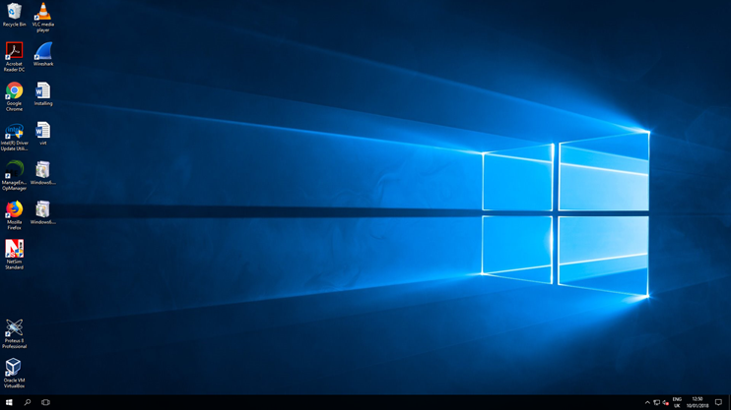

When I opened VirtualBox from the windows desktop, I clicked on new so I can create a Virtual PC.
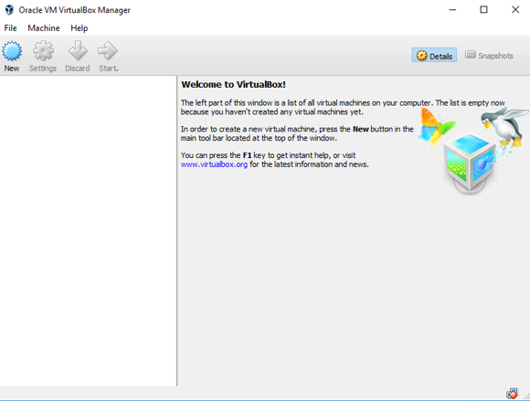

I am creating my new virtual machine and I‘m giving my virtual machine a name (Server_1). I’m selecting the OS and the version that I installed.
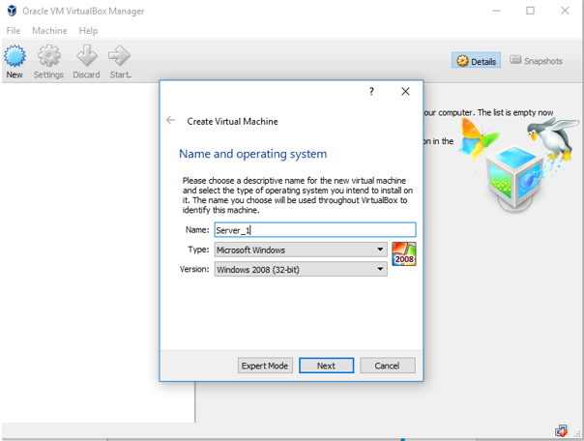

I’m selecting the amount of memory RAM that I want to allocate for my virtual machine. I’m going to allocate 4GB of RAM for my virtual machine. My virtual PCs need to have memory because is one of the most important components that determine the performance of the system. The memory (RAM) will give my applications a place to store and access data on a short-term basis. (Jain, 2015)

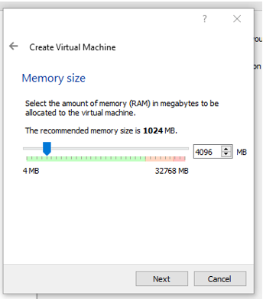

In the virtual hard disk, I’m selecting create new hard disk.
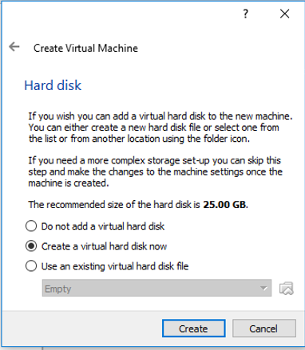

I’m selecting VDI as the file type to create the virtual disk.

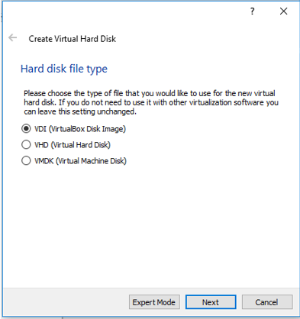

On the following step, I click on fixed size and then I click next.
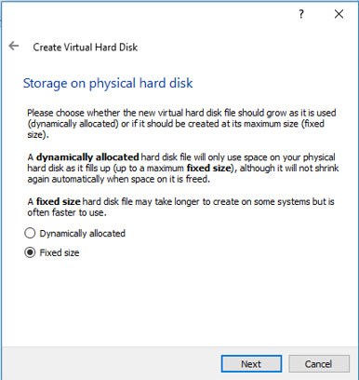

I’m making the size of the hard driver 20 GB.
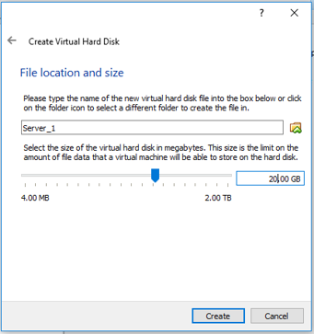

I have just created my virtual PC. As you can see I click on settings and then I click on the network because I'm going to select the internal network from the drop-down menu. I named the internal network ‘Public Net’.

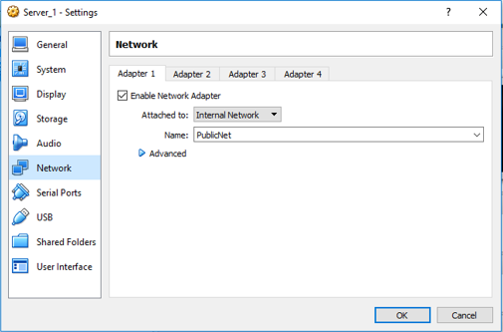
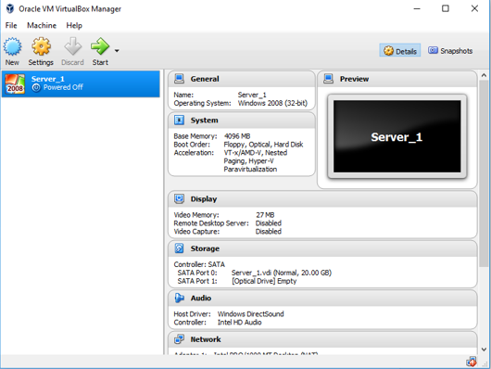

I click on the internal network from the drop menu and then I named my network ‘PrivateNet1’.
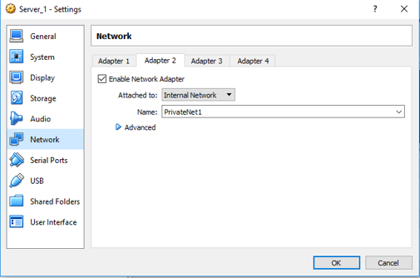

Now I’m gone click on system, motherboard. Now I’m choosing system, motherboard. I’m setting up the correct combination of processor features, and I need to make sure that because the installation can go wrong if this option isn’t set up the right way.
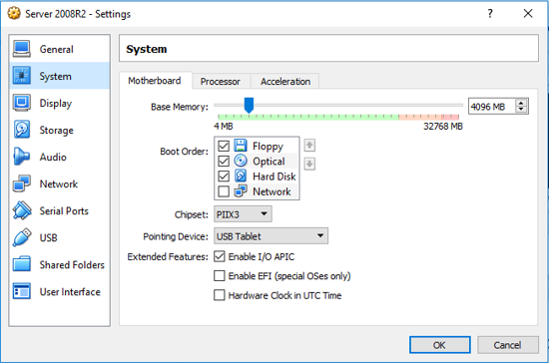

I have clicked on the processer and then I check the Enable PAE/NX box.
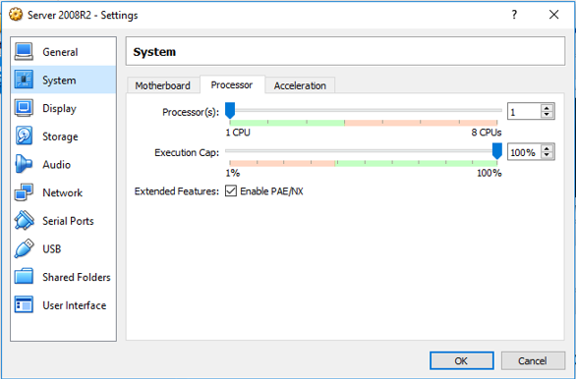

I have chosen to select acceleration tap and checked the Enable VT =x/AMD-V, I left disabled Enable Nested Paging.
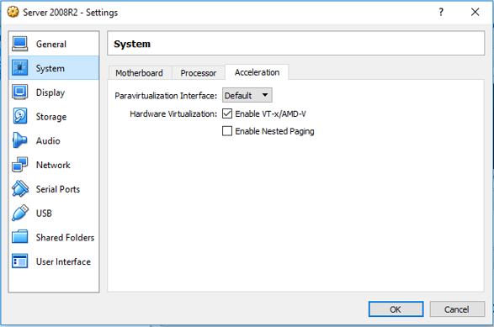

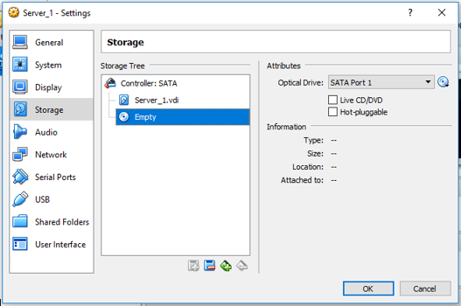
Now I’m opening the storage and then I’m selecting the Empty below the server _1.vdi. Now, I’m choosing SATA port 1 and I’m clicking icon next to the optical drive.

As you see, I’m selecting windows 2008 from the file menu. I have already downloaded.
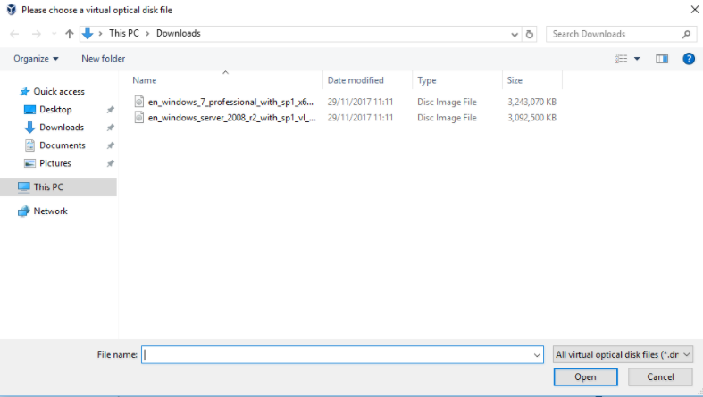

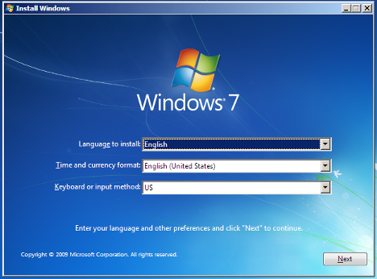
I’m doing all normal steps for installing the operating system. I must make a note of my username and password of my administrator user account that I create in the virtual machine because I will need to log into the virtual machine.
I click start and then I open the control panel. Then I click on network and sharing centre.
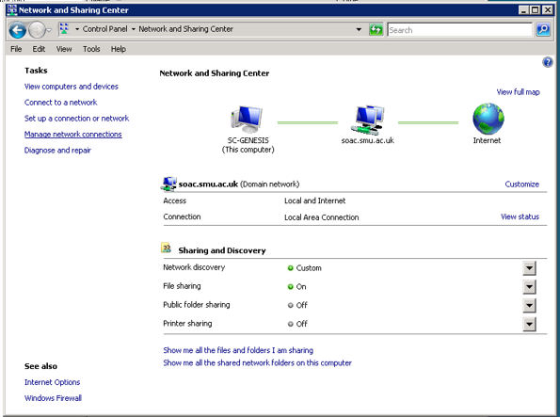

I click on manage network connections and then I click on the local area connection, I’m calling this connection publicnetwork.

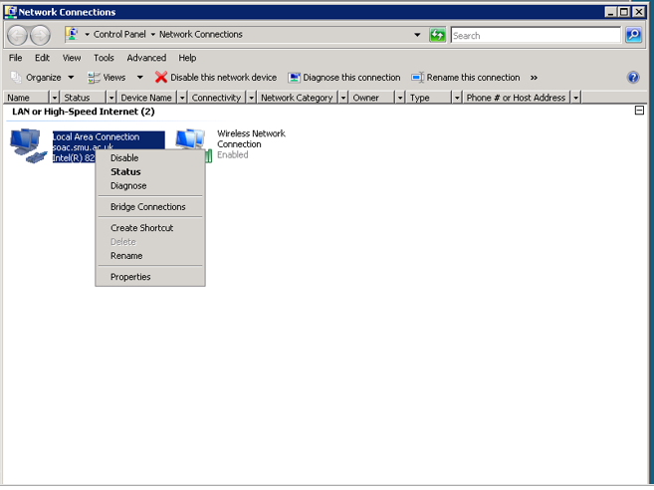

Now I’m clicking on TCP/IP version 4 and then I’m going to set up the IP address manually.

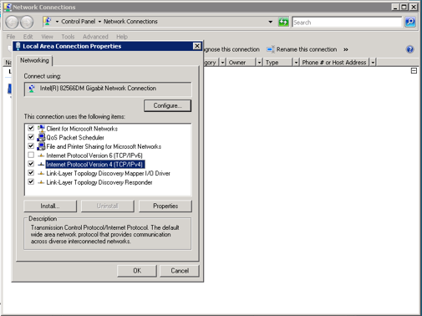

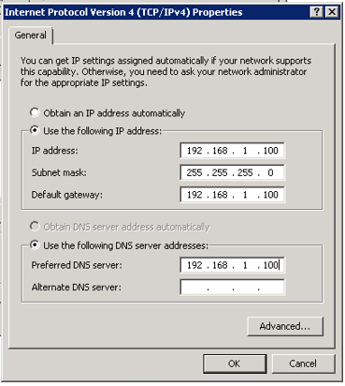

As you can see, I open the setting and then I click on network. I have click on adapter 2 and now I’m calling it privatenetswitch1, then I click on OK.
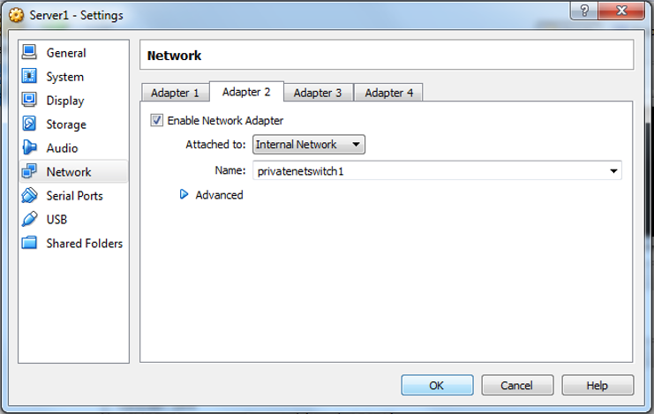

Here, I’m turning off the firewall because the firewall sometimes restricts certain programs from accessing the internet. To do that, I open the control panel from the start menu and in the control panel I have change the view to large icons because I can be able to easily see the windows firewall icon at the lower bottom of the window. I click on it in order to open it and now I click on the turn windows firewall on or off option.
As you can see, I click on the radio button available for the turn off option in order to disable the firewall for home and work networks and I also turn off the public networks, I then click on the ok button.
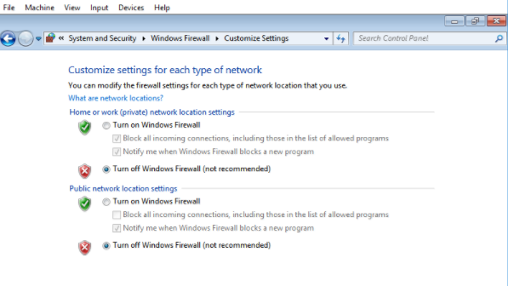

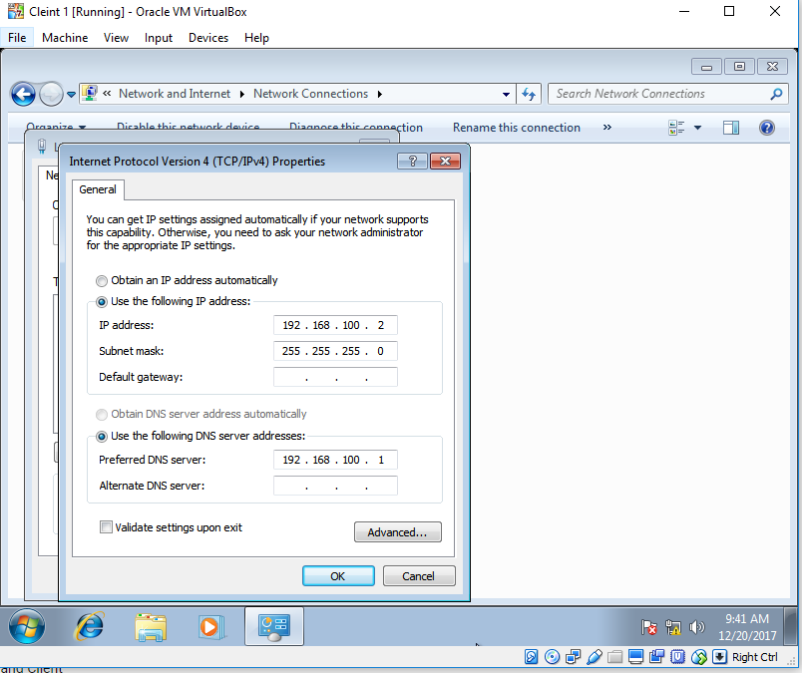

I click on start and I open the control panel. Form the control panel I open network and sharing center and then I open the view network status and tasks page. Then I click on change adapter settings and on here have my local area connection and I right click on local are connection, then I click on properties. I’m going to highlight internet protocol version 4 and when I open internet protocol version 4, I have check that the IP address because they had to be class c.
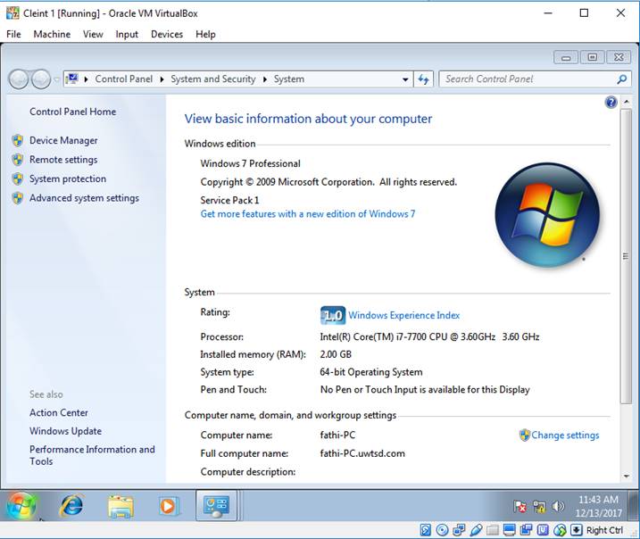

I click on start button and in to the control panel and in that page, I’m choosing system and security and I click on system. I click on change settings.

Now, I’m moving the bullet from workgroup up in to domain and I’m going to name my domain ‘uwstd.com’, I click on ok.
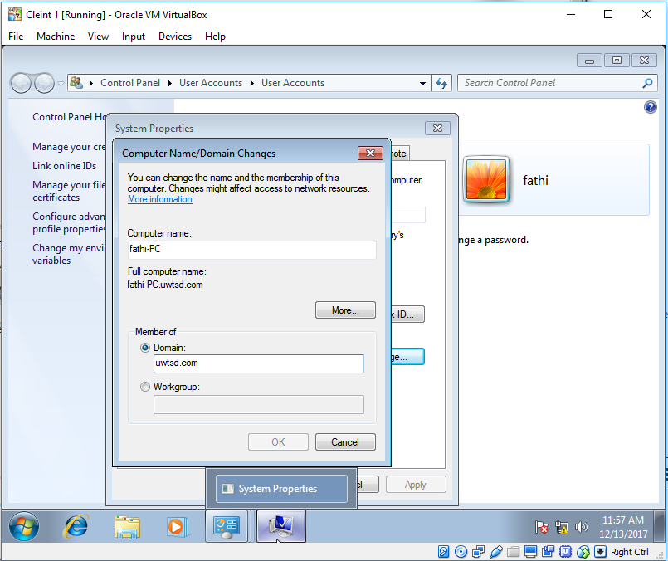

Now, I’m providing domain credentials that have the appropriate permission to add a computer account into my active directory domain. My virtual PC have just located an active directory domain controller and I click on ok
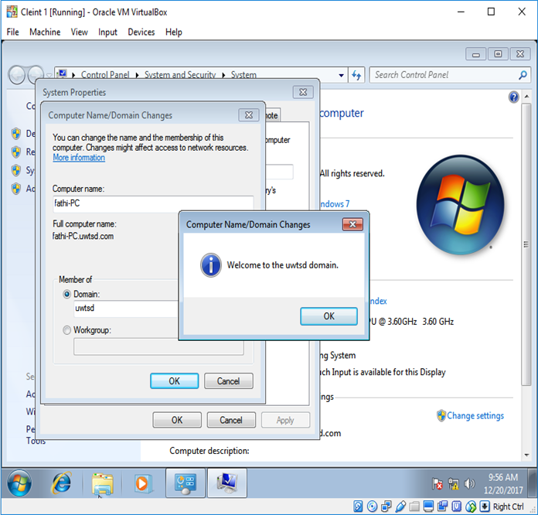

I’m opening the server manager and I click on add roles.

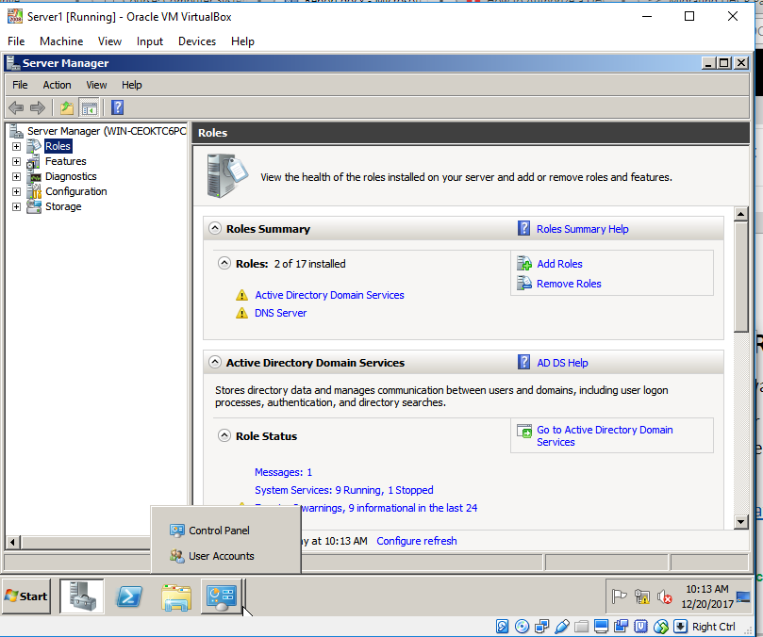

I click on next.
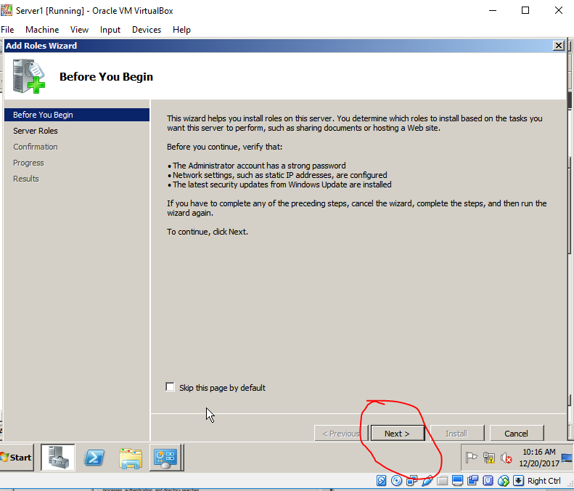

Here, I’m going to put I tick next to DHCP server and then I’m going click on next.
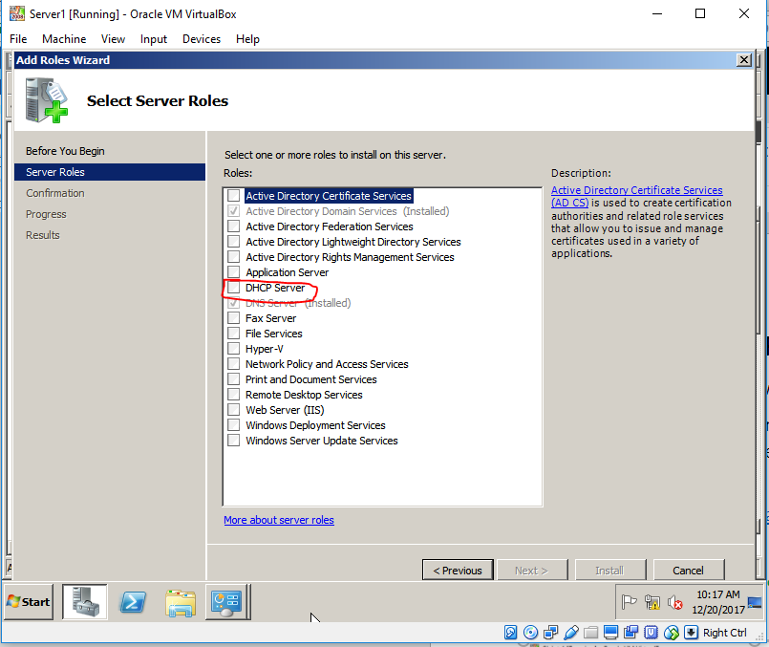

Now this screen is basically giving me information about DHCP, so I click next.
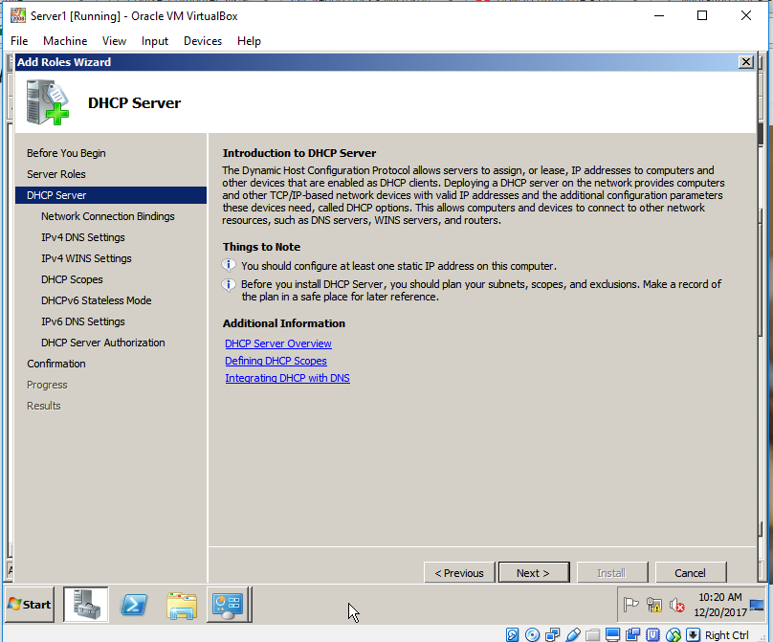

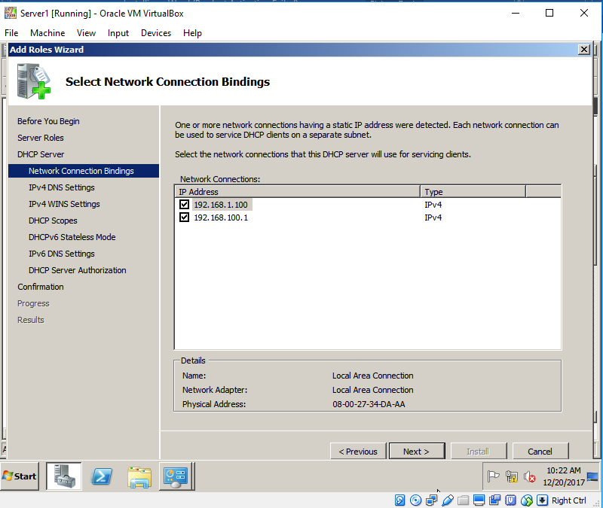
Here as you can see have two adopters now and I’m going to click next.

On this window, I’m going to change to my DNS IP and then I’m going to click next.

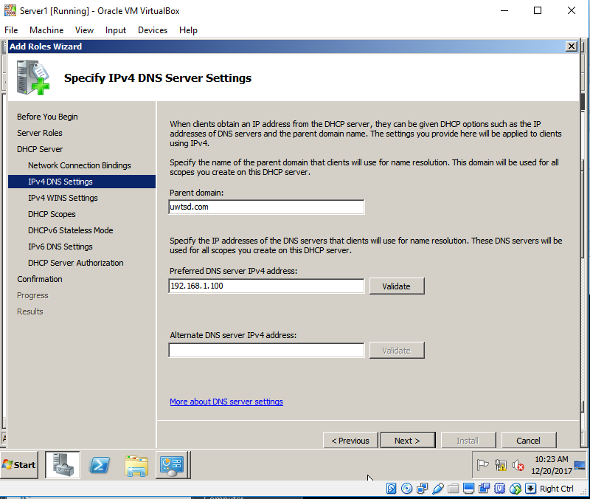

Here, I’m going to choose disable DHCPv6 stateless mode and then I click on next.
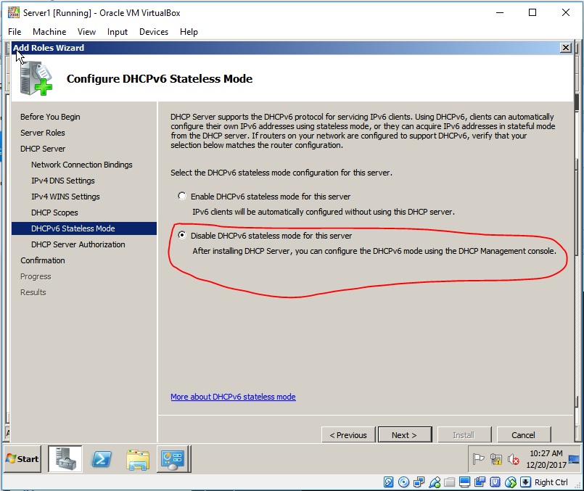

here, I’m going to click next.
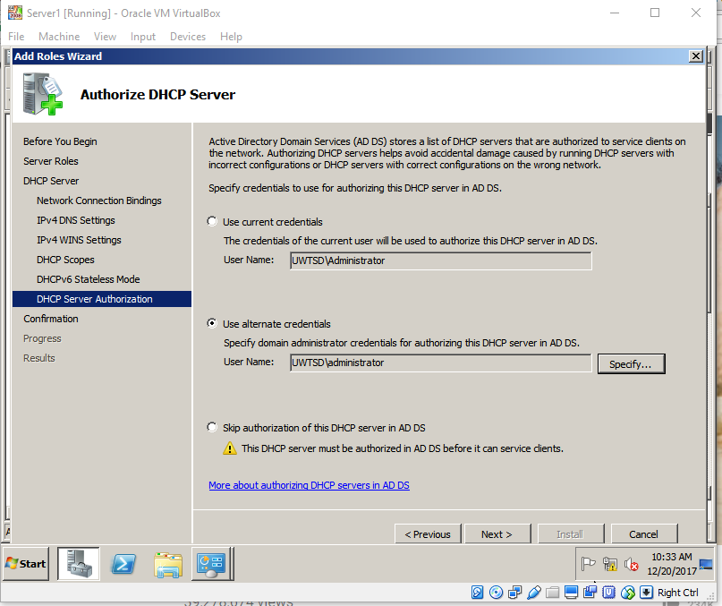

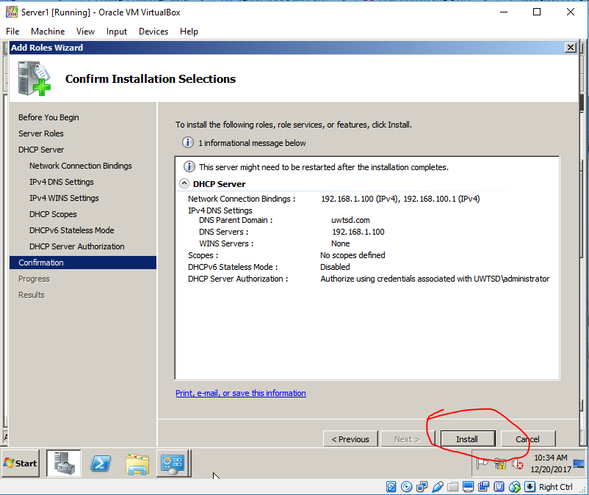
Here, I got summary DHCP server configuration which I can print or save and then I’m going to click install.

As you can see, the DHCP is now successfully installed. Now I’m going to close the wizard and restart my server.
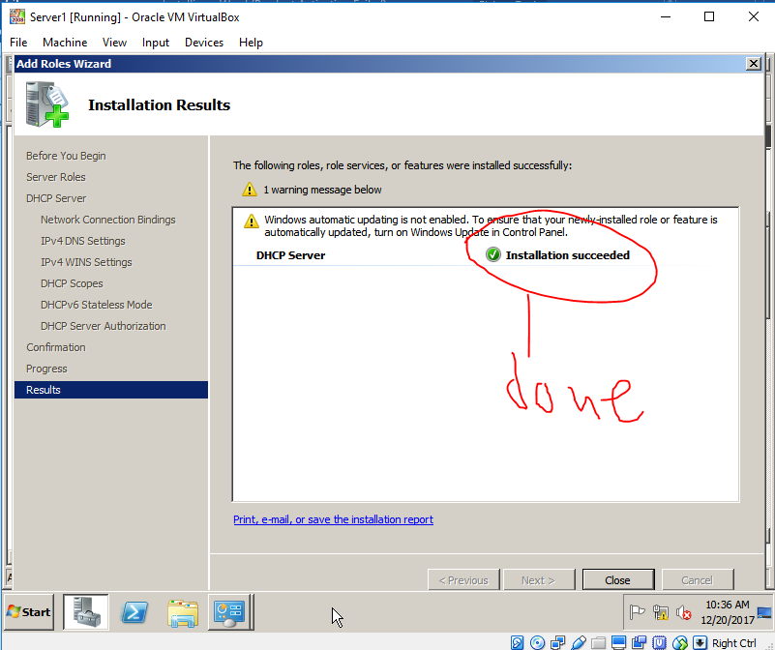

I click on the start button to open the administrative tools and then I click on DHCP. When I open the DHCP, I click on (‘win-ceokt6pcr’). I click on IP4 and I’m going to new scope, I click on next.
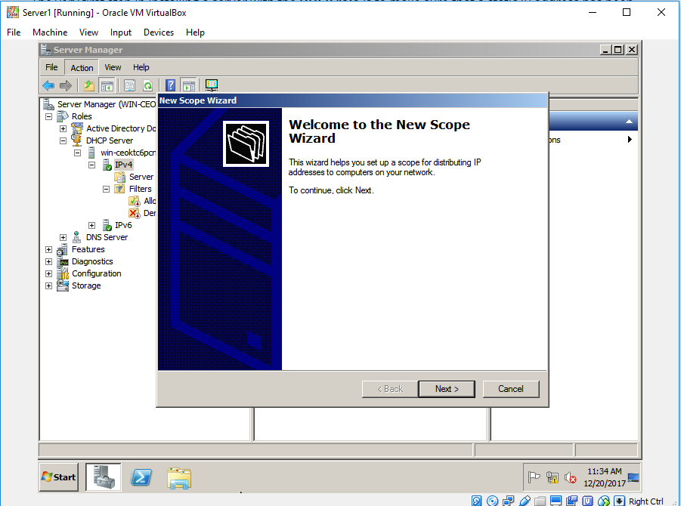

Here, as you can see I’m giving a name (SalesClient), I don’t need a description so I’m going to click next.
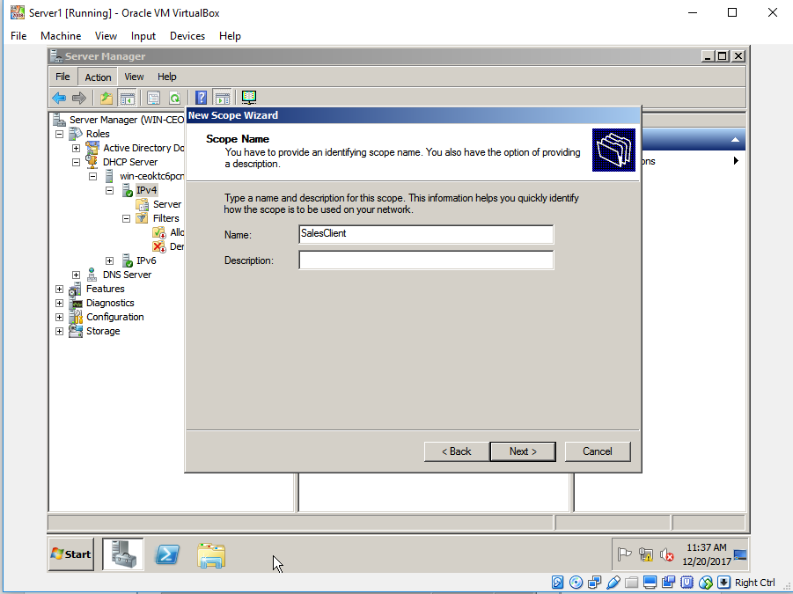

I’m activating the scope later because I have a DHCP server on my network and I’m going to click on next. Now I have my scope one and scope two, I also have my new address pool that my client will have access to.
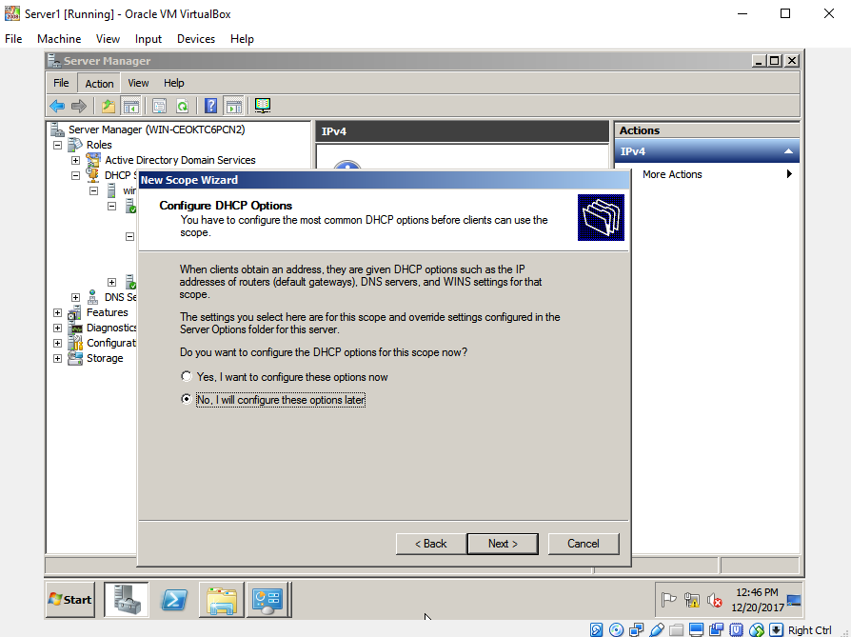

I open the start button left hand corner in windows and click on cmd.
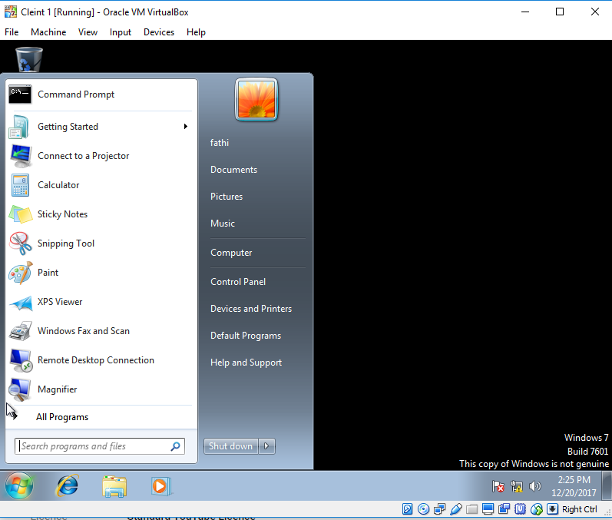

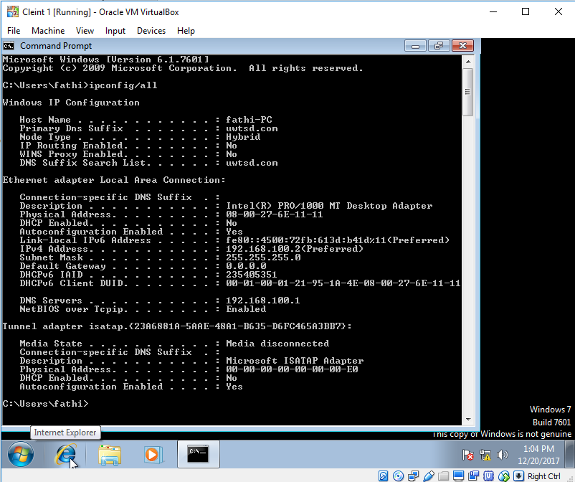
Now, I’m going to type (‘ipconfig/all’) in the command prompt and press enter. As you can see my IP address is listed to the right-hand side.

I click on the start button and now I’m opening the DHCP console, I click on IP4 range.

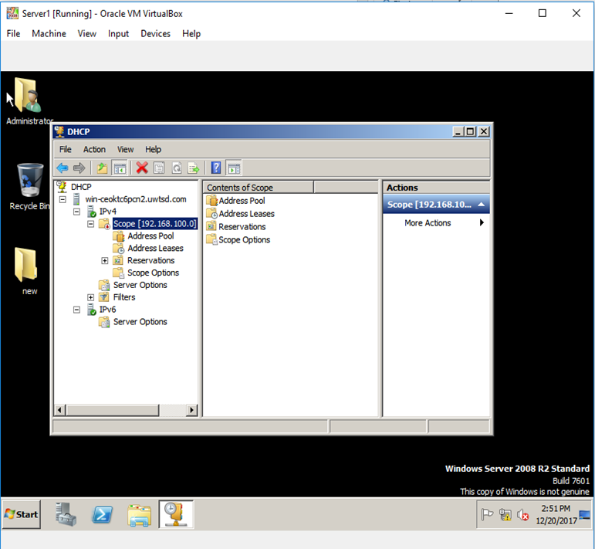

I am right clicking scope option, I click on configure options and now putting a tick next the 03 router. I put an IP address, I click add and then ok.
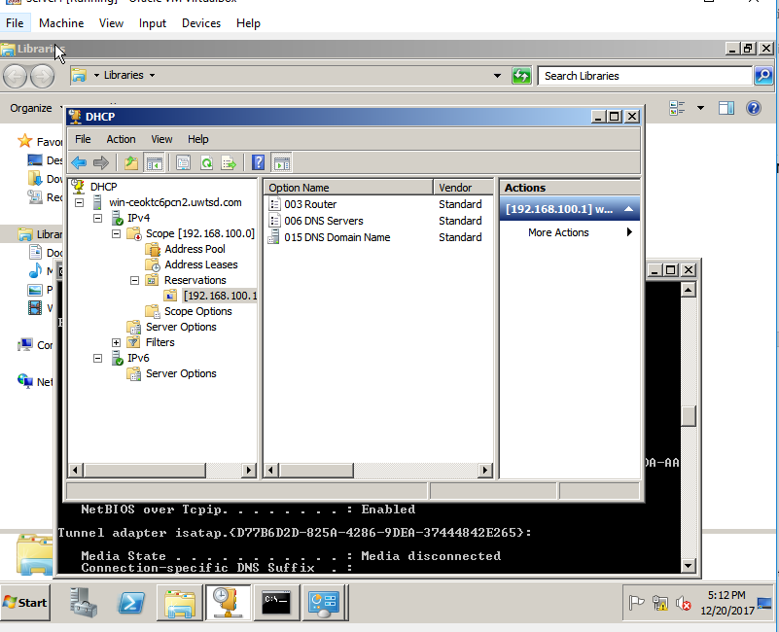

I’m going to type ipconfig/all and this tells me about my network connection such as my IP address, my subnet mask and my default gateway.it also tells a lot about my virtual machine such as the name, domain, mac address and so many other staff.


