Data Handling & Business Intelligence Assessment 2

NAME: Alexandru Sebastian Melinte
STUDENT ID: 1907706
MODULE TITLE: Data Handling & Business Intelligence (LCBB5000)
ASSIGNMENT TITLE: Data Handling & Business Intelligence (LCBB5000) – A2
MODULE LECTURER’S NAME: Dr Joy Botu

Contents
Introduction 2
Part 1 3
PART 2 9
References 16

Introduction
This document report demonstrates the analysis on the provided data set. The analysis of data is done in excel by using some function given in the brief.
Data analysis is the procedure of deep cleaning, reshaping, and analysing raw data in order to attain useful, pertinent information to enable businesses make informed choices. The technique helps in dealing with decision-making by providing valuable insights from data, which are typically presented in visualisations, pictures, tables, and bar charts.
Data analytics includes not only data analysis, but also data collection, organisation, and repository, as well as the methods used to dig deep into data, and also those used to report the results, like tools of visualization. Data analysis, on the other side, is related to the process of reshaping raw data into usable statistical data, information, and interpretations.
Data visualisation is a multiple disciplines area that deals with the schematic representation of data. When the data is too enormous, like in a time series, it is a very systematic method of expressing.
The mapping specifies how the properties of these elements respond differently to the data. In this sense, a bar chart is a visualisation of the intensity of a parameter to the duration of a bar. It is a fundamental constituent of data visualisation because the visual content of the mapping can have a detrimental effect on the readability of a chart.
The recursive Data Analysis Process is composed of different phases:
• Data Requirement Specification, Gathering, Processing, Cleaning, Analysis, and Communication
Data analysis is an important technique which can assist us in making better decisions. Microsoft Excel is among the most widely used data analysis programmes, with pivot tables being most prevalent analytic tool.
Microsoft Excel is an excellent tool for pre - processing and dealing structured data set. Excel has functions and processes that make it a lot easier to purify structured data set. Its functions are used to pre- process the data. These functions help to simplify the data pre - processing process. There are many functions used in Microsoft excel. Mostly used functions are if, sum, text, look up, pivot table, average, concatenate etc.
Basically it lets to analyse and perceive data from a wide number of ways. The data could have come from different type of sources. The data can be exported in a various formats and converters.
This report analysis is distributed in two parts. First part of analysis is performed on the crime rate data set provided to evaluate the crime rate and appraise the use of Excel for data pre-processing, analysis, and visualisation. Second part of analysis is performed on the ice cream data set provided.
The part 1 analysis is shown below:

Part 1
The part 1 analysis the data by using the data set provided to determine the crime rate and is evaluated with the use of excel for analysis and visualize the data. This is done practically with the use of two Excel functions – If and Pivot Table. These functions performed are also shown on the pivot charts appropriately based on the findings.
- IF FUNCTION: The IF function is one of the most commonly used in Excel, allowing us to make logical correlations between a value and what we expect.
SYNTAX = IF (logical_test, [value_if_true], [value_if_false])

The syntax of if function states that firstly condition will evaluate, if that condition will true only then that value will return otherwise, second outcome will returned.

As a result, an IF statement can outcome in one of two outcomes. If the comparison is true, the first result is returned, and if it is False, the second outcome is returned.
For example: if function is applied on the crime data set to know the rate of crime. The conditions is like if crime rate is greater than 60 then it will display the “High” crime rate. Otherwise it will show “Low”. This function is shown below in the following expression.

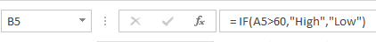
Figure: 1 (if function)
This expression will return high if condition becomes true. On the other hand, it will return Low if condition becomes false. This is shown in the pivot table below. The pivot table shows high where the crime rate is greater than 60 and low where the crime rate is lesser than 60.
Pivot Table can be used to summarise, analyse, prospect, and manifest summary data. Pivot Charts supplement PivotTables by appending visualisations to the summarized data in a Pivot Table, letting people perceive correlations, preferences, and insights. Pivot Tables and Pivot Charts both allow us to make rational decisions about sensitive data in the organisation.
PIVOT TABLE: A Pivot Table is a visual tool for quickly summarising large amounts of data. A Pivot Table can be used to analyse numeric information in great detail and to address unexpected concerns about the data. A Pivot Table is ideal for the following applications:
- Massive quantities of data can be queried in a variety of user-friendly aspects.
- Numerical data subtotal and aggregate, data summarization by classifications and sub classifications, and specially designed analyses and notations.
- Broadening and imploding data levels to concentrate the outcomes, as well as trenching down to details from data collected for points of research to us.
- To see distinct descriptions of the original dataset, move rows to columns or columns to rows.
- Statistics that are clear and precise, appealing, and validated can be presented online or in print.
The below pivot table shows about how high and low the crime rate actual is. It is analysed by using if function. For example, the condition is applied above that if crime rate is greater than 60 then it crime rate is high, otherwise low. We can check this by the below pivot table shows that if crime rate is 45.5 then it is displaying low.
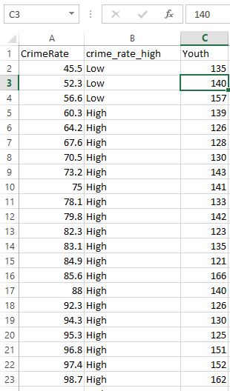
Figure: 2 (pivot table showing high or low crime rate)
The following analysis of crime rate is done on the basis of youth in the pivot table. This analysis is also shown graphically with the use of pivot chart.
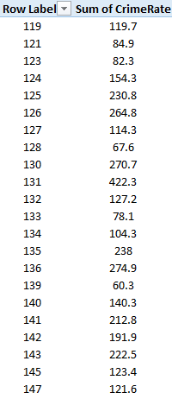
Figure: 3 (pivot table of crime rate among youth)
It can be difficult to see how the big picture when the actual data hasn't been summarised. The first reflex may be to develop a Pivot Table, not many can instantly interpret numeric values in a table. Pivot Charts are a simple and great way to add data visualisations to the data.
Pivot Chart in Excel is an in-built curriculum tool in Excel that allows us to summarise picked rows and columns of data in a worksheet. It is a pictorial depiction of a pivot table or any tabular data that aids in the summarization and analysis of datasets, patterns, and correlations. In simple terms, a pivot chart in Excel is a collaborative Excel chart that summarises massive quantities of data.
The Pivot Chart for the above Pivot Table analysis is shown below. This Pivot Chart is displaying at which rate crime is increasing and decreasing as per youth.
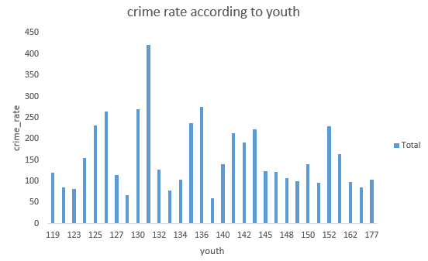
Figure: 4 (crime rate according to youth)
Next analysis is shown among high youth unemployment, youth employment and mature unemployment. Similarly in this analysis, firstly pivot table is shown then pivot chart is shown for that pivot table.
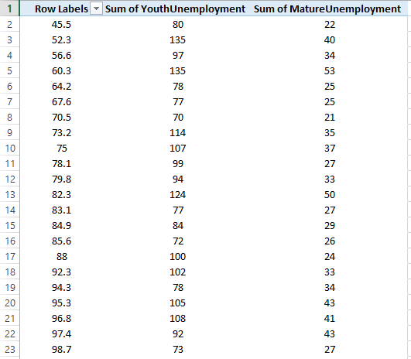
Figure: 5 (pivot table showing sum of youth and mature unemployment among crime rates)
In this pivot chart, sum of all youth unemployment, and mature unemployment are shown by the specific blue, and orange colour respectively. The youth unemployment range lies between 40 to 140 and mature unemployment range lies in between 0 to 60.
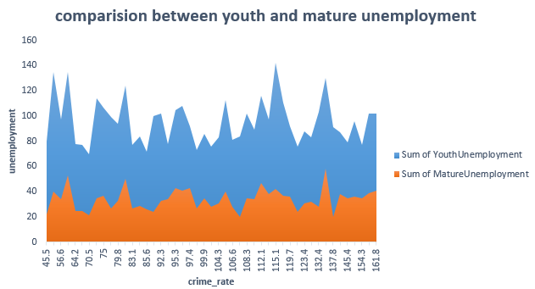
Figure: 6 (comparison among youth and mature unemployment)
Next analysis is performed among wage and below wage irrespective of crime rate. The pivot table is shown then pivot chart for that analysis is shown pictorially.
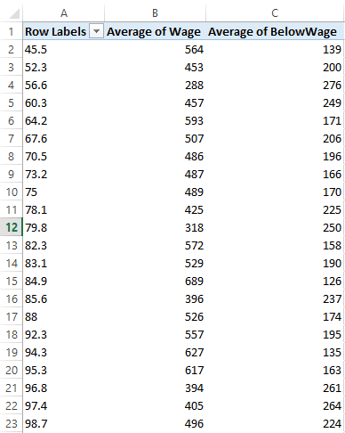
Figure: 7 (pivot table of wage and below wage among crime rate)
The pivot chart shows that the range of average wage lies between 300 to 700 and average of below wage lies in between 150 to 300.
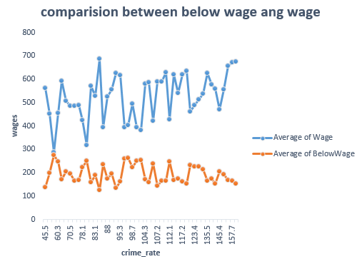
Figure: 8 (crime rate comparison among wage and below wage)
Next analysis is performed on the basis of expenditure. The pivot table shows the grand total of expenditure which is 47. Out of which 44 is consider as high expenditure and 3 is low expenditure.
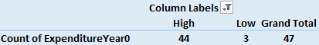
Figure: 9 (pivot table showing crime rate according to expenditure)
The below pivot chart depicts that crime rate is high when expenditure is high i.e. 44. On the other hand crime rate is low when expenditure is low i.e. 3.
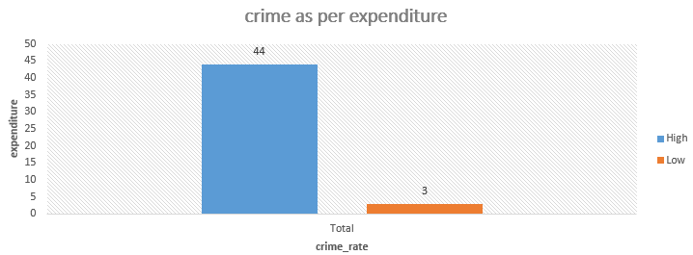
Figure: 10 (crime rate as per expenditure)

PART 2
Findings of the following questions on graphs:
- How many students like vanilla flavour?
In this figure, there are total 95 students who only like vanilla flavour. This clearly visible in the following figure.
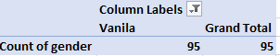
Figure 11: Number of students who like vanilla flavour

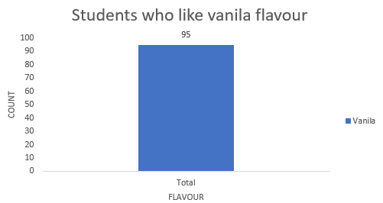
Figure 12: pivot table of students who like vanilla flavour
- How many students are Male and Female?
The following figure shows the analysis that how many students are males and how many students are females. It is clearly visible from the data labels that 109 students are females and 91 students are male.
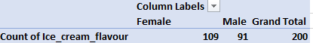
Figure 13: Number of students who like vanilla flavour

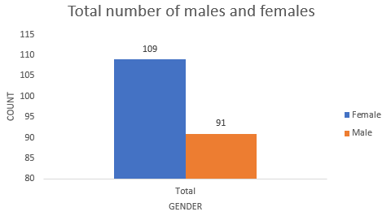
Figure 13: pivot table of students on the basis of gender

- What are the Mean and Median of participants who likes chocolate and strawberry flavour?
The following figure depicts the mean, median of participants who only likes chocolates and strawberry.
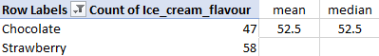
Figure: 14 (mean, median of participants who likes chocolates and strawberry)
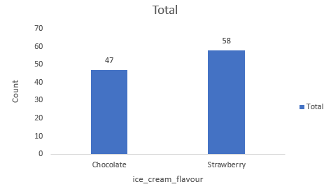
Figure: 15 (mean, median pivot chart of participants who likes chocolates and strawberry)

a) SPSS
It is abbreviated as Statistical Package for the Social Sciences is a flexible and versatile programme which can perform a variety of statistical tasks. This software is utilized in a wide range of fields and is accessible from all computing areas. SPSS provides four applications to help academics with complicated data analysis.
- Statistics Program
- Text Analytics for Surveys Program
- Visualization Designer
- Modeller Program
Clustering: It is the process of splitting a populace or set of data points into clusters so that data points in the similar group are more similar to data points in other clusters than data points in other clusters. In a nutshell, the objective is to distinct clusters that share similar characteristics and allocate them to clusters.
K-means: This clustering is an unsupervised learning that we can use when we have unlabelled data. This algorithm's objective is to achieve clusters in the data, with the variable K constituting the clusters found. Based on the relevant characteristics, the algorithm repeatedly allocates every data point to one of K - clusters. Data points are grouped together based on their classification resemblance.
Steps in k-means clustering:
1: Select a k value, such as k=2.
2: Arbitrarily initialise centroids
3: Measure Euclidean distance from centroids to every data point and form clusters near centroids
4: Calculate the centroid of each cluster and upgrade centroids
5: Repetition of step 3
Centroids are updated every time a cluster is formed, and the upgraded centroid is the centre of all points in the cluster. This procedure is iterated until the centroid stops changing, indicating that the response has converged.
To analyse a survey, there are total 200 number of high school students given with their scores on numerous tests, containing a video game and a puzzle in the dataset. This analysis is done with open source SPSS data mining software using the ice cream dataset provided.
Using the dataset Ice cream with SPSS and specific example of clustering (ex. K-means). Working with the screenshots are clearly explained below:
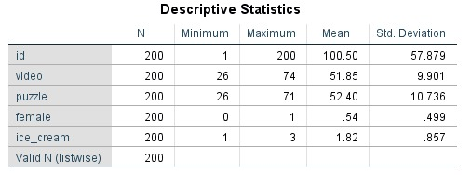
Figure 14
This figure shows the descriptive statistics with mean, median, mode and std. deviation. It is obtained with 200 total number of students. All results of id, video, puzzle, female, ice cream are shown in the figure. Specifically the minimum, maximum, mean and standard deviation of video - 26, 74, 51.85 and 9.901 respectively obtained.
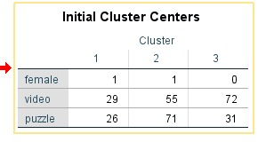
Figure 15
This figure shows the initial cluster centers of female, video and puzzle. This is shown in the form of clusters 1, 2 and 3.

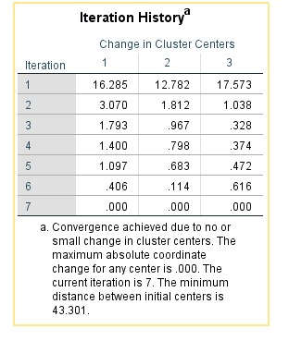
Figure 16
The iteration history is depicted in the figure above. Convergence was achieved as a result of no or small modifications in cluster centres. For any centre, the maximum absolute coordinate change is 000. The current iteration is number 7. The shortest distance between the initial centres is 43.301.

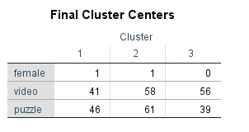
Figure 17
The above figure depicts that final cluster centers of female, video and puzzle into 3 clusters.
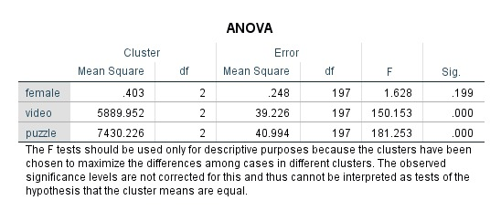
Figure 18
The F test is only used for descriptive purposes in this figure. It is used in this case as the clusters were chosen to maximise the differences between cases in various clusters.
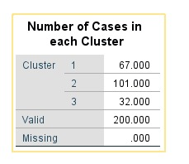
Figure 19
This figure depicts that how many number of cases are there in each cluster. In cluster 1, there are 67.000 cases, in cluster 2, there are 101.000 cases present, and in cluster 3, 32.000 cases exist. But from all the clusters, 200.00 cases are only valid and .000 are missing cases.
b) Data Mining: It is the method used by businesses of getting valuable information and knowledge from massive amounts of data (or big data). Utilizing different data mining methods, the disparity between data and intake has been narrowed. It is also known as knowledge discovery from data (KDD). It can be carried out on a wide range of databases and information directories, including relational databases, transactional databases, data streams, and various others.
Different methods of data mining
- Association: It is also known as relation analysis because it is used to show a correlation between two or more things by recognizing an underlying patterns in the data set. In data mining methods, this method is used to forecast behavior of customers.
Assume a store's business manager wants to know which products are typically bought together.
EXAMPLE
Purchases (y, "strawberry") -> purchases(y, "chocolate"). [1% endorse, 50% confidence]
- In this case, y represents a customer who purchases both strawberry and chocolate.
- Confidence demonstrates assurance that if a customer purchases a strawberry, there is a chance of 50% that he or she will also purchase chocolates.
- Support indicates that strawberry and chocolates were purchased together in 1% of all transactions examined.
There are numerous analogous examples, such as chips and cold drink or computer and software.
- Classification: This method of data mining is used to categorize items in data sets into clusters or categories. It supports in incisively, simulation and modelling of companies within a group. It is a two-step procedure: Learning and Classification step.
EXAMPLE
A company of banking may use to recognize credit contenders with low, medium, or high credit risks. Likewise, a health researcher examines cancer information to forecast which medication to give to a patient.
- Clustering Analysis: It is related to classification, however in this case, clusters are formed based on data item commonalities. Various groups have objects that are dissimilar or unrelated. Because it divides large data sets into groups based on similarities, it is also known as data segmentation.
EXAMPLE
A same example of credit contenders can be viewed here as well. The figure below illustrates some distinctions.
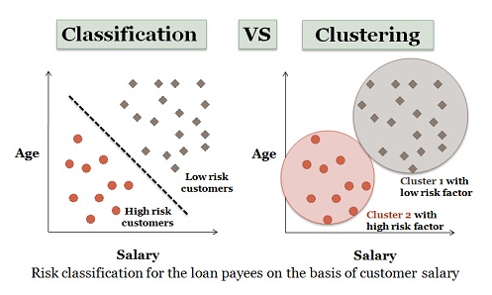

- Prediction: This method forecasts the prospect based on previous and present patterns or data sets. It is typically used in conjunction with other methods of mining.
Example
Suppose the sales supervisor wants to predict the revenue that each item will produce based on previous sales data. It represents a continuous-valued function that identifies lacking data values of numeric.
- Sequential Patterns: This method is used to detect patterns in order often over a specified time period.
E.g.: a dress firm's marketing manager may notice which sweater sales show increased just before the cold season, or pastry shop sales appear to increase around Xmas time or New Year's Eve.

Text Mining: It also referred to as text data mining, is the method of converging unorganized text into an organized manner in order to recognize valuable trends and new deep insights. Businesses can explore new hidden patterns and relationships within their unorganized data by using various statistical methods.
Different text mining methods
- Term based method: A concept has been defined as a word in a document that has a well-explained interpretation. The term-based method inspects the document on the premise of terms and benefits from constructive high performance computing while catching the hypotheses for term weightage.
- Phrase based method: Phrases are vaguer and have more different kinds of semantic information. Documents are envisioned on the grounds of phrases in this method because they are less suspicious and more convenient than individual terms.
- Concept based method: Text mining techniques based on the analytical analysis of words and phrases are used in this method to reach the conclusion terms (words) at the sentence and document levels. Analytical analysis is used in this case to recognise the word relevance in the absence of any documentation.
- Pattern taxonomy based method: v The Pattern-based model performs better rather than any other pure data mining-based method. Documents are analysed using this method on the basis of structures, which are constructed in a taxonomy using a connection. Data mining techniques such as association rule mining, common item set mining, sequential pattern mining, and closed pattern mining can be used to identify patterns.

References
Support.microsoft.com. 2022. Analyze Data in Excel. [online] Available at: <https://support.microsoft.com/en-us/office/analyze-data-in-excel-3223aab8-f543-4fda-85ed-76bb0295ffc4> [Accessed 6 April 2022].
Builtvisible. 2022. How to Make a Pivot Table in Excel versions: 365, 2019, 2016 and 2013 [Includes Pivot Chart]. [online] Available at: <https://builtvisible.com/how-to-make-a-pivot-table-and-chart-in-excel/> [Accessed 6 April 2022].
Support.microsoft.com. 2022. IF function. [online] Available at: <https://support.microsoft.com/en-us/office/if-function-69aed7c9-4e8a-4755-a9bc-aa8bbff73be2> [Accessed 6 April 2022].
Work?, W., 2022. What is SPSS and How Does It Work? | A Complete Guide to SPSS. [online] EDUCBA. Available at: <https://www.educba.com/what-is-spss-and-how-does-it-work/> [Accessed 6 April 2022].
Analytics Vidhya. 2022. K Means Clustering with Simple Explanation for Beginners. [online] Available at: <https://www.analyticsvidhya.com/blog/2021/02/simple-explanation-to-understand-k-means-clustering/> [Accessed 6 April 2022].
Education, I., 2022. What is Text Mining?. [online] Ibm.com. Available at: <https://www.ibm.com/cloud/learn/text-mining> [Accessed 6 April 2022].

