

Module Name : Human Capital Management
Module code : LCMB7023
Assessment component 1: Individual report –
HR strategy
Lecturer name: Dr.Eno Maycock
Student Name: Manpreet singh Mehra
Student Id :2522997

Table of Contents
Part 1 — HR Strategy Report 3
1. Introduction to Aether Innovations 3
2. Diagnosing Current Problems in Tech Company Culture 3
2.1 Typical Culture Problems in Tech Firms 3
2.2 Structural Work Problems 4
3. Creating a Culture of Innovation 4
3.1 Innovation-Driven Cultural Framework 4
3.2 Cultural Initiatives (Practical Implementation) 5
3.3 How Culture Improves Performance 6
4. Future of Work Model (Hybrid Strategy) 6
4.1 Proposed Work Model 6
4.2 Supporting HR Policies 7
4.3 Impact on Creativity & Motivation 7
5. Integrated HR Impact Model 7
Part 2: Reflective Report 9
6. Personal Learning Reflection (Gibbs Cycle) 9
7. Working with AI Without Being Replaced 11
8. References 13

Part 1 — HR Strategy Report

1. Introduction to Aether Innovations
Aether Innovations is an intermediate-sized technology firm with around 300 employees and a competitive digital environment where the speed of innovation and customer experience are the deciding factors in success. In the recent past, the organisation has been having flat business growth, increased employee turnover and poor customer satisfaction (Bareja and Ghai, 2025). High turnover has been evidenced to lower productivity and organisational performance and rise in training expenses and knowledge loss. Meanwhile, employee engagement has a powerful impact on customer experience, as engaged teams are able to increase customer satisfaction and sales performance (Cattermole, 2023). These problems indicate that the problems faced by the company are not technological but rather human-capital issues. The new position as the Human Capital Consultant is to reconnect people practices to business strategy to regain organisational effectiveness.
Thus, this report suggests a combined culture and future-work HR plan aimed at restoring the innovation potential, enhancing the engagement, and eventually, the performance and customer outcomes on the organisational level.

2. Diagnosing Current Problems in Tech Company Culture

2.1 Typical Culture Problems in Tech Firms
There are numerous technology companies that do not succeed due to the inability of the employees, and this is the case with the organisational expectations that do not align with the experience of a person. In the psychological contract of Rousseau, employees anticipate growth, fairness and meaningful work, failure to which the performance and commitment becomes poor. Psychological contract breach is empirically found to lower job performance and provoke employee silence and withdrawal (Yu et al., 2022). This breach is frequently the result of aggressive deadlines and continuous change in fast-growing tech companies, and people are disengaged.
This is related to the theory of burnout postulated by Maslach. Burnout - exhaustion, cynicism and lessened efficacy have a detrimental impact on performance and mediate the association between contract breach and productivity. Similar results were reported in the study by, which listed burnout as a significant factor in workforce turnover (Trinkenreich et al., 2023). The employees become detached psychologically when they feel overworked and not valued.
Kahn engagement theory started by stating that only when work is perceived to be safe and meaningful do employees invest physical, emotional and cognitive effort (Huang, Huang and Chang, 2022). Companies that are more engaged have a reduced turnover and high financial results. This culture of toxic productivity - urgency, observable productivity and pressure to perform above the average - is hence de-engaging, contributes to turnover and eventually kills innovation since employees are afraid to take any risks (Saban, 2024).
Experimentation is part of innovation and workers in stressful work places focus more on reducing errors than on seeking new ideas. As a result, the turnover increases, the discretionary effort decreases, and creative performance worsens.

2.2 Structural Work Problems
Structural design failures are also seen in modern tech workplaces. Siloed teams limit sharing of knowledge and hinder learning together. Agile techniques may exacerbate the situation where long sprint cycles of delivery concentrate on delivery but not reflection (Locke, 2025). Simultaneously, meeting overload shortens productive time research by Locke (2025), indicated that excessive meetings decrease burnout probability and creativity decrease creativity.
Hybrid work only adds pressure. Remote employees tend to have unclear work-life boundaries and an increased risk of burnout, and virtual meeting overload leads to digital fatigue and reduced job satisfaction (Dong et al., 2025). With employees claiming that they are being efficient, managers might see productivity loss, which causes mistrust and lack of independence.

3. Creating a Culture of Innovation

3.1 Innovation-Driven Cultural Framework
Aether will be forced to make a conscious change towards a culture of learning as opposed to a culture of performance-pressure. The model of organisational culture by Schein states that behaviour is motivated by underlying assumptions, thus constant delivery pressure makes employees understand that it is safer to make no mistakes than to make attempts. This suppresses innovation (Williams, 2022).
Senge approach to learning organisations indicates that firms can only be competitive when their employees are constantly updating their knowledge. Such flexibility is needed in today's work environments as employee welfare is on the decrease worldwide and lack of engagement is costing organisations billions of dollars in productivity (Gallup, 2025).
Psychological safety lies at the heart of this shift (Edmondson). The effectiveness of teams in which people are comfortable to take risks is much greater - the project Aristotle at Google discovered that psychological safety was the most effective predictor of team performance. Creativity, satisfaction and learning behaviour is also enhanced by psychological safety (Cote, 2024).
Hence, Aether needs to substitute the fear-driven accountability (do not make mistakes) with the learning accountability (test and refine) and change employees into the knowledge giver (instead of being task executors).

3.2 Cultural Initiatives (Practical Implementation)
Innovation Sprints
Aether needs to implement structured every two weeks innovation sprints in addition to delivery sprints. Teams are assessed not by output measures, but by learning acquired and hypotheses tested. This is in line with findings that safe experimentation results in enhanced team learning and performance.
Failure-tolerant metrics promote the creation of ideas since innovation involves risk-taking behaviour but not efficiency maximisation.
Intrapreneurship Programme
Internal pitching events take place quarterly and employees can pitch their ideas. Funding and recognition bonuses are given to selected projects.
Workers appreciate meaningful work and autonomy over compensation - 28% of employees consider work-life balance and purpose as their primary motivational factor (Gutierrez, 2025).
Internal entrepreneurship improves retention since employees get a sense of ownership as opposed to employment.
Cross-Functional Squads
- Create product-customer-engineering squads similar to platform team models. Psychological safety and norm clarity significantly predict software team performance (Lenberg and Feldt, 2019).
- Cross-functional collaboration removes knowledge silos and accelerates problem solving.
Psychological Safety Practices
Implement:
- No-blame retrospectives
- Leader vulnerability behaviour
- Open idea platforms
- Psychological safety allows employees to take interpersonal risks and improves innovation capability (Bonterre, 2025).

3.3 How Culture Improves Performance
Learning culture enhances engagement, retention and innovation in one way. Hybrid flexibility by itself lowers employee turnover rates by a third, yet lacking supportive culture, the creativity continues to decrease (Bloom, Han and Liang, 2024).
Effective high psychological safety teams are 26 times more efficient. Discretionary effort is higher when employees are safe and enabled, which enhances customer outcomes (Mckinsey, 2021).
This is indicative of a High-Performance Work System (HPWS) - combined HR practices generate motivated behaviour that generates organisational performance.
Thus, innovation culture is a business approach and not a people initiative.

4. Future of Work Model (Hybrid Strategy)

4.1 Proposed Work Model
Aether should implement a structured hybrid model based on task type:
Work Type | Location
Deep work | Remote
Collaboration | Office
Innovation | Co-located
Routine tasks | Flexible
Full remote work enhances isolation and emotional burnout, whereas full office work decreases flexibility and retention (Dong et al., 2025). The study by Dale, Wilson and Tucker (2024), indicated that the majority of workers prefer hybrid environments and find it most engaging in such environments.
In a socio-technical systems approach, performance hinges on the optimisation of human and technical interaction. The work design theory equally indicates that jobs that demand innovativeness should be done through interaction and jobs that demand analysis should be done through concentration.
Hence hybrid design matches work setting and cognitive requirements.

4.2 Supporting HR Policies
To operationalise hybrid work Aether should implement:
- Asynchronous communication rules to reduce interruption
- Meeting-free days (reduce overload and burnout)
- Digital collaboration platforms
- Outcome-based performance evaluation
- Flexible schedules
Burnout levels have reached 66% globally and poor work-life balance reduces productivity and engagement (Robinson, 2025). Remote flexibility also decreases stress for 48% of employees.
These policies shift focus from time monitoring to value creation.

4.3 Impact on Creativity & Motivation
- Hybrid autonomy supports Self-Determination Theory — autonomy increases motivation.
- Under the Job Demands-Resources model, flexibility reduces demands while increasing resources, improving engagement and performance.
- Hybrid working improves retention and satisfaction without reducing productivity (Crawford, 2024).

5. Integrated HR Impact Model
Aether’s HR strategy must operate as a system rather than isolated initiatives.
Causal chain: Culture → Motivation → Behaviour → Innovation → Customer Value → Business Growth
Using the AMO framework:
- Ability: cross-functional learning and intrapreneurship develop skills
- Motivation: psychological safety and autonomy increase engagement
- Opportunity: hybrid work and innovation sprints enable participation
Together these produce innovative behaviour which drives customer satisfaction and performance.
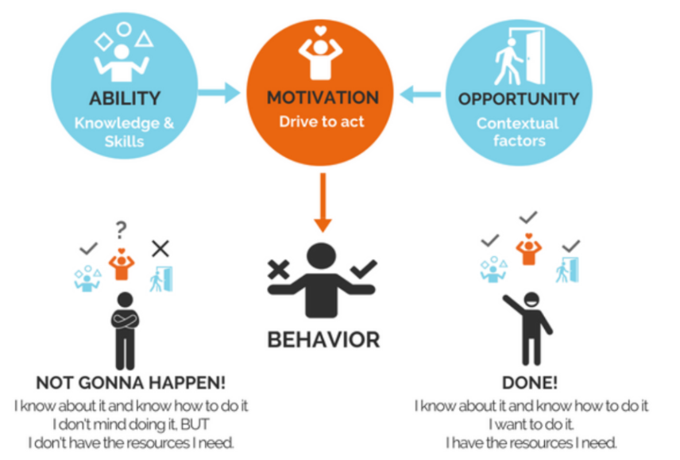
Figure 1 AMO framework
(Source: Bloom, Han and Liang 2024)
Strategic HRM study by Bloom, Han and Liang (2024), indicated that performance is enhanced when HR practice is mutually reinforcing, as opposed to being independent. Hybrid flexibility enhances retention and psychological safety enhances team effectiveness - they together generate long-term performance benefit.
Conceptual Model Explanation
Aether moves from control-based HR → capability-based HR.
The organisation does not control attendance and output, but rather controls learning, collaboration and experiments. This unified system converts human capital into innovation capital - connecting employee experience with customer experience and long-term growth.

Part 2: Reflective Report

6. Personal Learning Reflection (Gibbs Cycle)
The reflective cycle by Gibbs offers a systematic process comprising of description, feelings, evaluation, analysis, conclusion and action planning, that assists professionals in transforming experience into learning and development (Adeani, Febriani and Syafryadin, 2020).
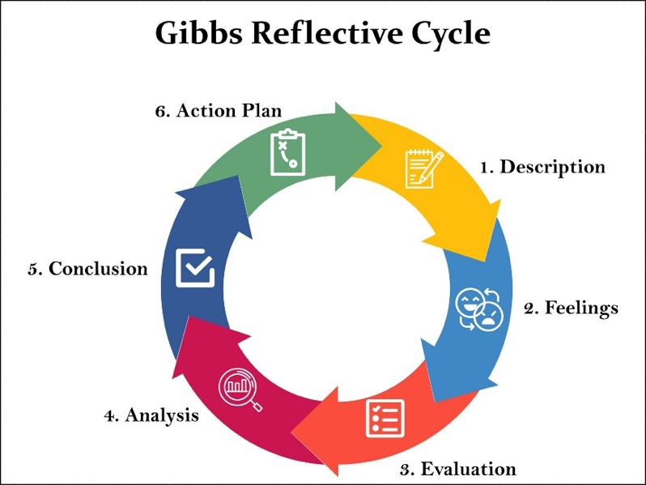
Figure 2 Gibbs’ reflective cycle
(Source: Adeani, Febriani and Syafryadin, 2020)
6.1 Description
In this module on Human Capital Management, I learnt the ways in which HR practices affect the organisational performance, not just the administrative processes. I investigated engagement, leadership, motivation, organisational culture and strategic HR alignment. I examined actual organisational examples that revealed a direct relationship between employee experience and customer experience and business performance. I learnt via lectures and research reading that in the modern organisations, people capability is the defining characteristic of competition, not merely technology or finance.
The module asked me to assess job issues based on HR theories and develop interventions that are practical. This assisted me in comprehending how HR systems engage with organisational behaviour, as well as performance and not as independent policies.
6.2 Feelings
Initially, I considered HR a support department whose primary functions were recruitment and payroll and compliance. I now understand that this perception was constrained. I was surprised to learn that employee engagement and leadership behaviour could have such a great impact on profitability and innovation.
My confidence grew as I advanced since I learnt to view managerial decisions through the prism of human behaviour. Considering my own experiences of working in a group, I realised the influence of psychological safety on the participation process: when individuals did not feel threatened, the discussion was much better.
This altered my thinking: HR is not the management of people as an administrative task but rather strategic management of organisational capability.
6.3 Evaluation
HR as a strategic partner was the most powerful idea to me. I had to understand that the success of an organisation lies in the ability to de-align people practices and business goals. The connection between people and performance slipped into focus - productivity, collaboration and performances are enhanced through employee engagement.
Coaching leadership was another big learning point. Coaching enhances engagement, confidence and performance as well as facilitating innovation (Karim and Rahlin, 2024). Research by Colgate (2025), also indicated that workplace coaching enhances organisational performance and wellbeing. I understood that developmental leadership builds capability and traditional command-and-control style of leadership decreases learning. Moreover, reflection in itself became useful. The reflective cycle helps leaders to turn experience into learning and improved decision-making.
On the whole, I have learned that successful HR systems are aimed at empowering employees instead of managing them.
6.4 Analysis
This module transformed my thinking considerably as a manager. In the past, I knew leadership to be about commanding staff and observing performance. I now realize that leadership is performance enabling.
In terms of leadership, coaching leadership enhances creative performance since employees are free to share ideas (Hwang, Kang and Choi, 2023). This implies that in the future my leadership approach would be based on questioning, offering feedback and building people, as opposed to telling.
In terms of motivation, I gained the understanding that employees are motivated when they feel competent, valued and trusted. Coaching programmes have the potential to enhance performance, by up to 25 percent, and raise collaboration. Consequently, the motivation is not developed under pressure but under support and independence.
My mindset about innovation also transformed (Rhee, 2023). Psychological safety and learning behaviour are needed in innovation rather than strict efficiency. Employees will cease experimenting in the event they are afraid of making errors. As such, the managers need to create conditions in which ideas are fostered.
I now appreciate that management is system design: culture is created through leadership behaviour, behaviour is created through culture, and performance is created through behaviour. This realization transformed the way I see issues at the workplace fundamentally, as now I am able to analyse the root causes instead of symptoms.
6.5 Conclusion
This module taught me that I have a tendency to emphasize task accomplishment more than people development. I realised that I was more directive than supportive in my leadership tendency. I also learned that I appreciate structured thinking and need to enhance empathy and listening.
Above all, I got to understand that organisational performance relies on the human behaviour systems. My work as a future manager does not involve controlling the employees but giving them the chances to perform.
6.6 Action Plan
Skill | Why I Need It | Development Method
Leadership | Improve team direction and trust | Leadership courses + feedback
Coaching | Develop employee capability | Practice coaching conversations weekly
Strategic thinking | Align people and business goals | Analyse case studies monthly
Communication | Improve collaboration | Active listening practice
Emotional intelligence | Build engagement | Reflection journal and peer feedback
Coaching improves leadership skills and engagement , therefore I will prioritise coaching ability as my main development focus.

7. Working with AI Without Being Replaced
7.1 AI Impact on HR Roles
Artificial intelligence is remaking the HR by automating routine and data-intensive activities including CV screening, arranging interviews and simple queries posed by employees. The study by showed that generative AI can machine-perform a large percentage of routine knowledge-work tasks and at the same time enhance productivity instead of eradicating whole professions. This proves augmenting, but not replacement.
HR functions thus become administrative to interpretative. Rather than processing information, HR professionals should have a comprehension of context, culture and behaviour. HR is becoming valued on the attributes of judgement, communication and ethical decision-making where AI cannot understand social problems.
7.2 How I Will Use AI
I will employ AI as a decision-support tool and not a decision-maker. For example, I am able to apply analytics to determine turnover trends, engagement trends and skills gaps. Research by indicated that AI enhances the quality of decisions when used together with human judgement and not in place of it.
AI can be applied to summarise feedback in employee surveys, to identify patterns of sentiment and aid workforce planning. Nonetheless, ultimate decisions -hiring, promotion, dispute resolution, etc. involve human knowledge of fairness and organisational circumstances. Thus AI is going to make me a better manager but will not dictate results. I will be tasked with responsible interpretation of data.
7.3 Future-Proof Skills
I need to acquire human-centric capabilities to keep up with current times. Ethical leadership and judgement are necessary since AI is not morally accountable. Empathy enables to empathize with the concerns of employees and develop trust. Organisational change leadership and complex problem solving involve balancing needs of the many stakeholders which cannot be done alone by algorithms.
With the growing technology, the technical execution is being automated and the human leadership is gaining weight. Managers capable of designing culture systems and meaning will be retained.
Designing of systems will substitute execution of tasks by managers.

8. References
Adeani, I.S., Febriani, R.B. and Syafryadin, S. (2020). Using Gibbs’ Reflective Cycle in Making Reflections of Literary Analysis. Indonesian EFL Journal, 6(2), pp.139–148. doi:https://doi.org/10.25134/ieflj.v6i2.3382.
Bareja, D. and Ghai, R. (2025). Understanding Cause and Effect of Employee Turnover in the IT Sector: A Comprehensive Literature Review ARTICLE INFO ABSTRACT. [online] Available at: https://jisem-journal.com/index.php/journal/article/download/7979/3644/13313?utm_source=chatgpt.com [Accessed 14 Feb. 2026].
Bloom, N., Han, R. and Liang, J. (2024). Hybrid Working from Home Improves Retention without Damaging Performance. Nature, [online] 630(1), pp.920–925. doi:https://doi.org/10.1038/s41586-024-07500-2.
Bonterre, M. (2025). Why Psychological Safety Is the Hidden Engine Behind Innovation - Harvard Business Impact. [online] Harvard Business Impact. Available at: https://www.harvardbusiness.org/insight/why-psychological-safety-is-the-hidden-engine-behind-innovation-and-transformation [Accessed 14 Feb. 2026].
Cattermole, G. (2023). Engaged Employees = Greater Customer Satisfaction - The Survey Initiative. [online] The Survey Initiative. Available at: https://surveyinitiative.co.uk/engaged-employees-greater-customer-satisfaction [Accessed 14 Feb. 2026].
Colgate, M. (2025). The Importance and Application of a Coaching Leadership Style in Businesses. Businesses, [online] 5(3), p.32. doi:https://doi.org/10.3390/businesses5030032.
Cote, C. (2024). How to Build a Psychologically Safe Workplace. [online] Business Insights Blog. Available at: https://online.hbs.edu/blog/post/psychological-safety-in-the-workplace [Accessed 14 Feb. 2026].
Crawford, K. (2024). Study finds hybrid work benefits companies and employees. [online] news.stanford.edu. Available at: https://news.stanford.edu/stories/2024/06/hybrid-work-is-a-win-win-win-for-companies-workers [Accessed 14 Feb. 2026].
Dale, G., Wilson, H. and Tucker, M. (2024). What is healthy hybrid work? Exploring employee perceptions on well-being and hybrid work arrangements. International Journal of Workplace Health Management, 17(4), pp.335–352.
Dong, J.-J., Tan, Z.-D., Zhang, Y.-L., Sun, Y.-J. and Huang, Y.-K. (2025). Work from home and employee well-being: a double-edged sword. PubMed, 13(1), pp.748–748. doi:https://doi.org/10.1186/s40359-025-02994-5.
Gallup (2025). State of the Global Workplace Report. [online] Gallup. Available at: https://www.gallup.com/workplace/349484/state-of-the-global-workplace.aspx [Accessed 14 Feb. 2026].
Gutierrez, S. (2025). Work-Life Balance Statistics 2025: Data Trends & Expert Advice. [online] SurveyMonkey. Available at: https://www.surveymonkey.com/curiosity/work-life-balance-statistics/ [Accessed 14 Feb. 2026].
Huang, S.Y.B., Huang, C.-H. and Chang, T.-W. (2022). A New Concept of Work Engagement Theory in Cognitive Engagement, Emotional Engagement, and Physical Engagement. Frontiers in Psychology, [online] 12(1). doi:https://doi.org/10.3389/fpsyg.2021.663440.
Hwang, C.Y., Kang, S.-W. and Choi, S.B. (2023). Coaching leadership and creative performance: A serial mediation model of psychological empowerment and constructive voice behavior. Frontiers in Psychology, [online] 14(14). doi:https://doi.org/10.3389/fpsyg.2023.1077594.
Karim, H.B.A. and Rahlin, N.A. (2024). Exploring the impact of coaching on employee performance and organization effectiveness: A conceptual study. Journal of BIMP-EAGA Regional Development, 10(1). doi:https://doi.org/10.51200/jberd.v10i1.5892.
Lenberg, P. and Feldt, R. (2019). Psychological Safety and Norm Clarity in Software Engineering Teams. arXiv (Cornell University). doi:https://doi.org/10.48550/arxiv.1802.01378.
Locke, B. (2025). How to reduce meeting overload in hybrid & remote teams. [online] WorkTime. Available at: https://www.worktime.com/blog/employee-monitoring/how-to-reduce-meeting-overload-in-hybrid-remote-teams [Accessed 14 Feb. 2026].
Mckinsey (2021). Just 26 percent of leaders create psychological safety for their teams. [online] McKinsey & Company. Available at: https://www.mckinsey.com/featured-insights/week-in-charts/just-26-percent-of-leaders-create-psychological-safety-for-their-teams [Accessed 14 Feb. 2026].
Rhee, S. (2023). Coaching in the Workplace - 10 Key Benefits | Animas Coaching. [online] Animas Centre for Coaching. Available at: https://www.animascoaching.com/blog/10-evidence-based-benefits-of-coaching-in-the-workplace [Accessed 14 Feb. 2026].
Robinson, B. (2025). Job Burnout At 66% In 2025, New Study Shows. [online] Forbes. Available at: https://www.forbes.com/sites/bryanrobinson/2025/02/08/job-burnout-at-66-in-2025-new-study-shows [Accessed 14 Feb. 2026].
Saban, J. (2024). Toxic management - how to discover, prevent and cure negative impacts to productivity of individuals, teams and organizations. [online] repositum.tuwien.at. Available at: https://repositum.tuwien.at/handle/20.500.12708/198358.
Trinkenreich, B., Klaas-Jan Stol, Steinmacher, I., Gerosa, M.A., Sarma, A., Lara, M., Feathers, M., Ross, N. and Bishop, K. (2023). A Model for Understanding and Reducing Developer Burnout. doi:https://doi.org/10.1109/icse-seip58684.2023.00010.
Williams, P. (2022). Organisational culture: definitions, distinctions and functions. [online] www.elgaronline.com. Available at: https://www.elgaronline.com/edcollchap/edcoll/9781788976251/9781788976251.00008.xml [Accessed 14 Feb. 2026].
Yu, D., Yang, K., Zhao, X., Liu, Y., Wang, S., D’Agostino, M.T. and Russo, G. (2022). Psychological contract breach and job performance of new generation of employees: Considering the mediating effect of job burnout and the moderating effect of past breach experience. Frontiers in Psychology, 13. doi:https://doi.org/10.3389/fpsyg.2022.985604.

