Hand rendered draft - false drop repeat tile
Draft: the first version of a design (not finished, but has the bones to become a finished outcome)

These pattern types can work well in a false block repeat system but are not limited to this method of repeat. Fauna, Floral, Foliage, Singular Motifs.

You can draft out a false drop repeat within the framework of a square or rectangle, something like this…

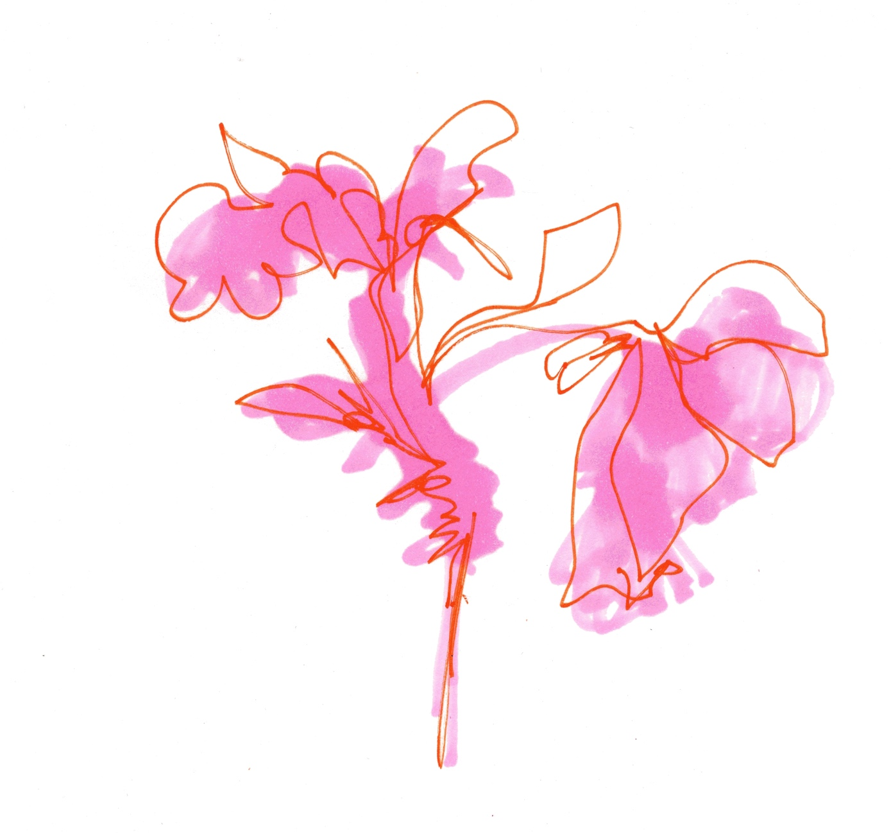Continuous line drawn motif over a colour block form a highlighter pen.

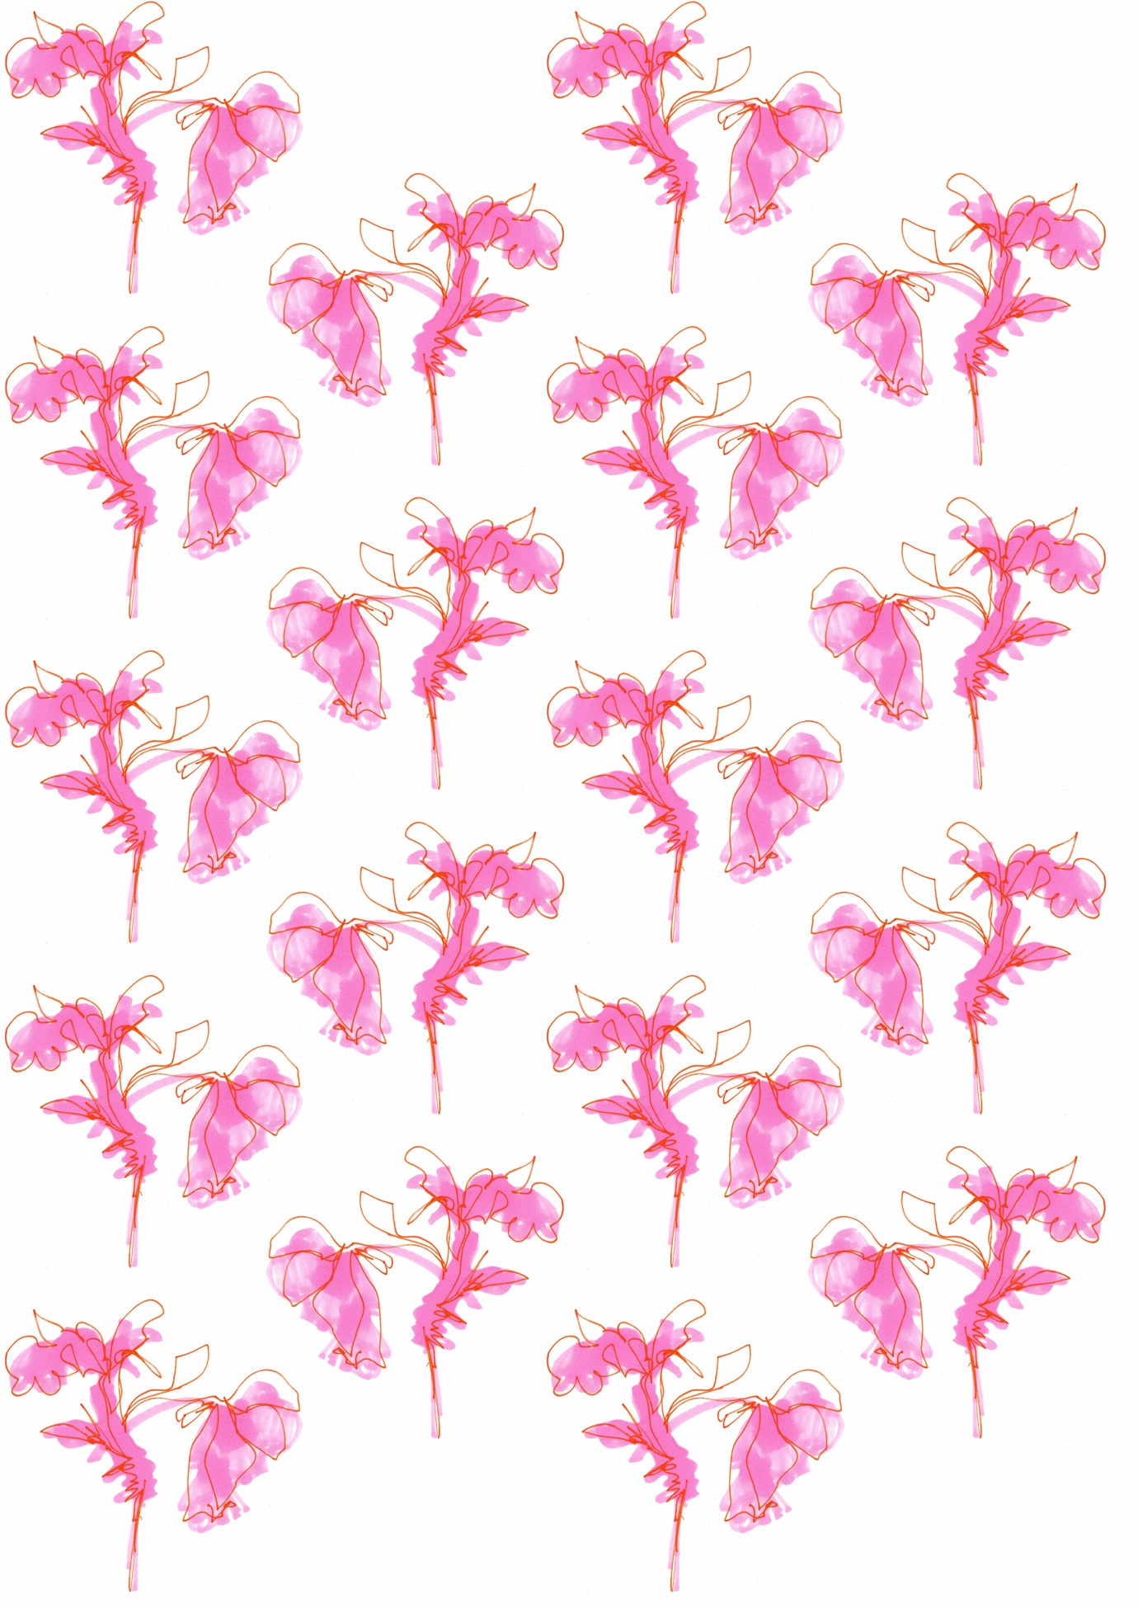
Motif has been flipped and dropped by half to create a false drop. Background colour has been applied digitally.
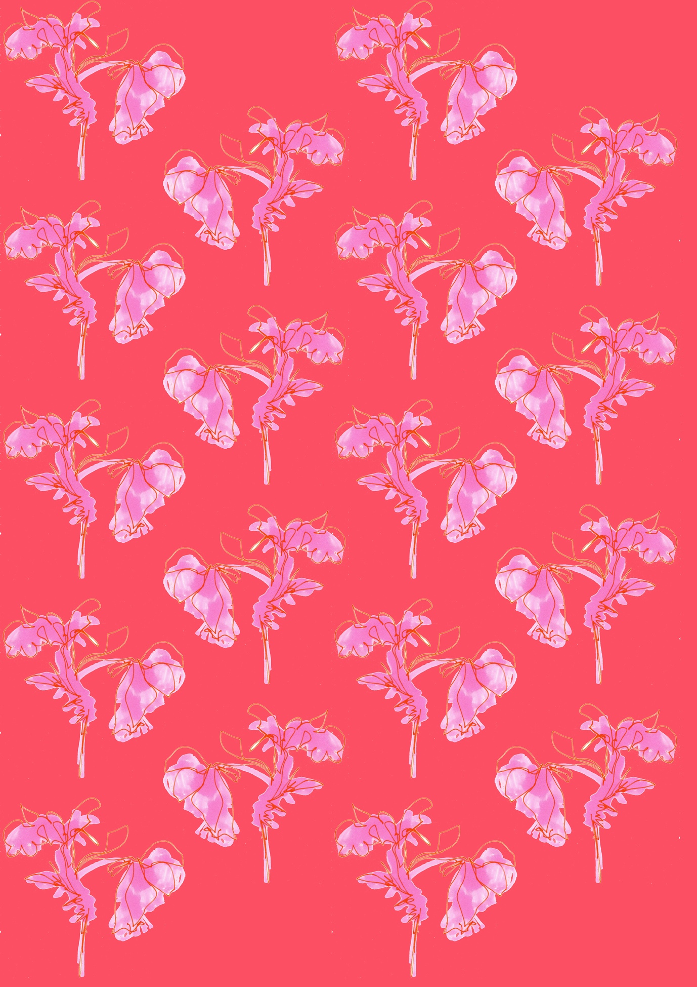

Motif has been flipped and dropped by half to create a false drop. Background colour has been applied digitally.

