STUDENT NAME: Ionut Tudureanu
STUDENT NUMBER: 1917144
PROGRAMME: BA Business Management
Module Title: Project Management
MODULE CODE: LCBB5005
ASSIGNMENT TITLE: Assessment 1
LECTURER’S NAME: Sadeque Shaikh

Salisbury House (SH)
Project
Assessment 1

Table of contents

- Introduction………………………………………………………………………..4
- Project Initiation Document (PID)……………………………………………….4
  - Project summary………………………………………………………….4
  - Project scop……………………………………………………………….5
  - Budget Assumptions……………………………………………………..6
  - Assumptions………………………………………………………………7
  - Constraints…………………………………………………………… …..8
  - Stakeholders analysis………………………………………………… ...8
    - Stakeholder Map……………………………………………………..9
  - Project organisation structure…………………………………...……..12
    - The programmatic structure………………………………………..12
  - Project control mechanisms …………………………………………..13
  - Reporting framework……………………………………………………15
  - Project planning with milestones………………………………………16
    - Gant Chart………………………………………………………..16
    - Milestones………………………………………………………..17
- References……………………………………………………………………….20
- Appendix: Risk assessment document………………………………………..21

- INTRODUCTION

Project management is the practise of guiding a team to achieve specific goals. Project management comprises planning, tracking, and communication to deliver work successfully within schedule, scope, and budget restrictions (B.Harned, 2022).
This paper focus is on the University of Wales Trinity Saint David initiative (UWTSD). UC Berkeley has bought Salisbury House, a new building in the Kennington industrial district, for research purposes. The project includes remodelling and equipping student classrooms and administrative offices, as well as installing necessary hardware and software. A lunch area with additional cooking facilities will be created, as well as a restroom. With more students and employees, the new building will include more classrooms and administrative offices.

- PROJECT INITIATION DOCUMENT (PID)
PID Sets the project's parameters, outlines its goals, and lays out how it will be achieved. Establishes a baseline from which to measure the project's success for the project manager and the board of directors. The PID is a continuing process that changes and evolves as the project progresses. Project Management Plan from the Project Management Body of Knowledge (B.Roseke, 2019).
  - PROJECT SUMMARY
Defining the objectives, goals, and scope of the project is a critical component of project management. We've established our objectives and taken the necessary steps to achieve them. This light plays a significant role in guiding a project manager's way B.Roseke, 2019).
Salisbury House requires numerous improvements to make it a better location to work and learn, including renovations in all classrooms and laboratories, furnishing, and installing all necessary materials. The project consists in 5 classrooms, 3 IT laboratories, 1 kitchenette. 1 lunch area, 1 toilet space with 8 toilets ( gents and ladies), 2 administration offices and I reception.

  - PROJECT SCOP
A scope statement is a required component of every project plan where is written future guidelines for project selections. The scope statement summarises the scope (the work required). UWTSD project has as main scop creating of a great learning area for students but for teachers as well .
- Planning Scope management
Project plan, project charter, and stakeholder participation are used to construct a scope management plan. At this stage are planned and find the renovation company, furniture suppliers, the design company to implement the furniture(tables, chairs),and an IT company bringing and installing the hardware and software to classrooms, laboratories, administration offices.
- Collecting requirements
A requirements management plan is created based on the scope management strategy and stakeholder feedback. Interviews, focus groups, and surveys will be used to gather needs everything being recorded.
- Defining scope
Using the project charter and scope management method, a project scope statement is developed. This definition will guide all following project efforts.
- Creating the Work Breakdown Structure
After examining the project scope and requirements, a WBS is constructed. The work breakdown structure (WBS) divides the project into jobs with explicit deliverables.
- Validating scope
Deliverables are examined and graded here. They are either approved as is or requested to be modified.
- Controlling scope
Maintaining scope during the project's execution is essential. The project plan may need to be revised if performance reports do not match project criteria.

  - BUDGET ASSUMPTIONS
Estimating project costs is an essential aspect of the planning process. An accurate cost projection is essential during the budgeting stage of a project. For contract creation and to keep the total project cost within the estimated budget, short- and long-term budget development is essential. Materials, equipment (new or leased, or depreciation on existing equipment linked to this project), and indirect costs such as space rental, utilities and other peripheral expenditures are often included in a project's cost (K. Boogaard,2021).
Product/ Service | Cost (£)
Building renovation | 63,000
Floor | 18,000
Carpets | 34,500
Toilet equipment | 7000
Blackboards 10 (units) | 4500
Projectors (8 units) | 32,600
Tables  (8 classrooms x 30 units + 3(admin office) x 35£/unit) | 8,400
Chairs  (244 units x 21£/unit) | 5,124
Kitchenette appliances | 3100
Eating tables with chairs (lunch area)  15 (tables)+ 40 (chairs) | 4850
Hardware  (30pc x 3 lab +accessories and wires) | 85,000
Software | 10,700
TOTAL COST | 276,774
Fig.1.: Budget assumptions

  - PROJECT ASSUMPTIONS
Assumption is a feature of a project that has no empirical data or verification. It is hard to plan a project without making assumptions. Assumptions are based on prior knowledge and facts. Assumptions are a normal element of the project life cycle, and they pose risk by not being correct or materialising. False project assumptions often become limits, causing major setbacks or project limitations.
A lot is made of budgets, schedules, and resource and talent restrictions. These aspects are expected to be true under future conditions, and project plans are built around them. An incorrect assumption can ruin a whole project strategy. Recognition and documentation of these assumptions is crucial for risk assessment. They can spark innovative ideas or risk-averse strategic decisions. For Salisbury House project there where found four assumption: resource assumptions, technology, timing and quality. If any of these assumption mentioned would raise, the project needs to extend its time framework which is not convenient in a university.
    - Resource assumptions
At the time of a need, all resources (people, materials, and money) must be available for allocation. When it comes to planning and managing projects, these assumptions are crucial. Insufficient or inadequate resources can have a negative impact on the project's timeline, operations, and even its scope and final goal. Aside from that, the amount of resources available is also important. Even if the project is adequately funded, it may be in jeopardy.
    - Technology assumptions
The technological architecture of the project is predicated on technological assumptions. Technology resources include software, IT assistance, and physical devices such as PCs and smartphones. Due to the fact that technology is normally internal but can be outsourced, it is vital to understand how accessibility, capabilities, and potential procedural difficulties affect the technology's reliability. Having a plan in place in the event that any of these concerns happen will enable you to maintain a smooth operation of your organisation.
    - Timing hypotheses
Scheduling assumptions are typically modified by essential resources such as technology, cash, and manpower. Again, incorporate contingencies to account for resource shortages that could significantly impact your project's timeline.
    - Quality/Specification Assumptions
If the job is not completed to a satisfactory standard, it must be redone, which adds time to the project's schedule. When the team is obliged to adhere to certain requirements, there is little room for error, and any deviation from the specified criteria jeopardises the project's success.
  - CONSTRAINTS
Project assumptions, restrictions, and dependencies can be confusing in any project. The project's team must function within a certain set of parameters, known as constraints, to complete the project. The biggest constraint in this project is the time. All the refurbishment needs to be done within one month and in holyday from 02 September to 02 October as on 04 October the space needs to be ready to welcome the students. The project needs to run smoothly, and every stage needs to be completed within time parameters.
  - STAKEHOLDERS ANALYSIS
Stakeholder analysis helps project managers identify project stakeholders, their concerns, and how the project will affect them. In addition to identifying key individuals with whom you must communicate regularly about the project's status and scope, stakeholder analysis helps you determine the topics you must speak about and the frequency with which you should do so. This article defines stakeholder analysis and explains its importance.
An first stakeholder study identifies the key players and difficulties they confront. Stakeholder requests and expectations may contradict with one another or the project's core objectives.
Interviews, design work, and brainstorming are the first steps in stakeholder analysis, according to Mattmann. Stakeholder comments may not match the project's core requirements. A stakeholder analysis will assist you evaluate what modifications need to be made to the project's scope or direction.

    - Stakeholder Map
A stakeholder map will assist is visualising the frequency with which I as the project manager of this project should communicate with each stakeholder, the degree to managing them, and the best way to keep them satisfied and/or informed. To create a stakeholder map, there needs to be specified a few important dimensions, then constructing quadrants for the parameters wanted to optimise and grouping stakeholders within those quadrants.
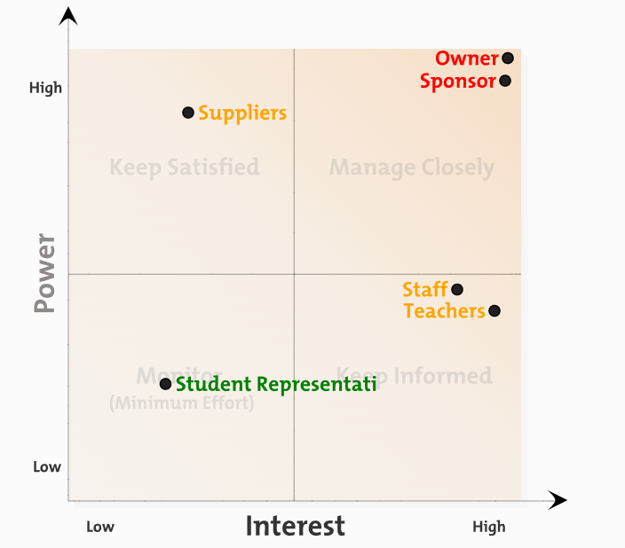
Fig.2: Stakeholder Map

  - PROJECT ORGANISATION STRUCTURE

Project Organizations are structures that aid in the coordination and execution of project operations (PO). Its primary objective is to improve teamwork by minimising disruptions, overlaps, and disagreements among the group's members. The organisational structure that will be used to handle the project is a significant decision. The success of a project is highly dependent on the organisation chart's design. An organisation chart allows for a clear view of each member of a project's hierarchy. Those at the top of a pyramid-shaped organisational structure have more authority and responsibility than those at the bottom. The lines connecting the boxes on the organisation chart represent the official supervision and communication routes between the individuals, which are determined by their relative positions on the chart.

    - The programmatic structure
The structure used for this project is programmatic organizational structure because is centred on a conventional one in which programme sector managers exercise formal authority over the lion's share of resources. It is restricted to projects that fall under a specific programme area. It is not, however, perfect for efforts that require a diverse group of professionals from several programme sectors. In a programming organisation, individuals from the same area work on the same project. The project team has access to all of the resources it requires through a single point of contact. For instance, the health unit may provide resources to a project if it is health related (PM4DEV, 2016).

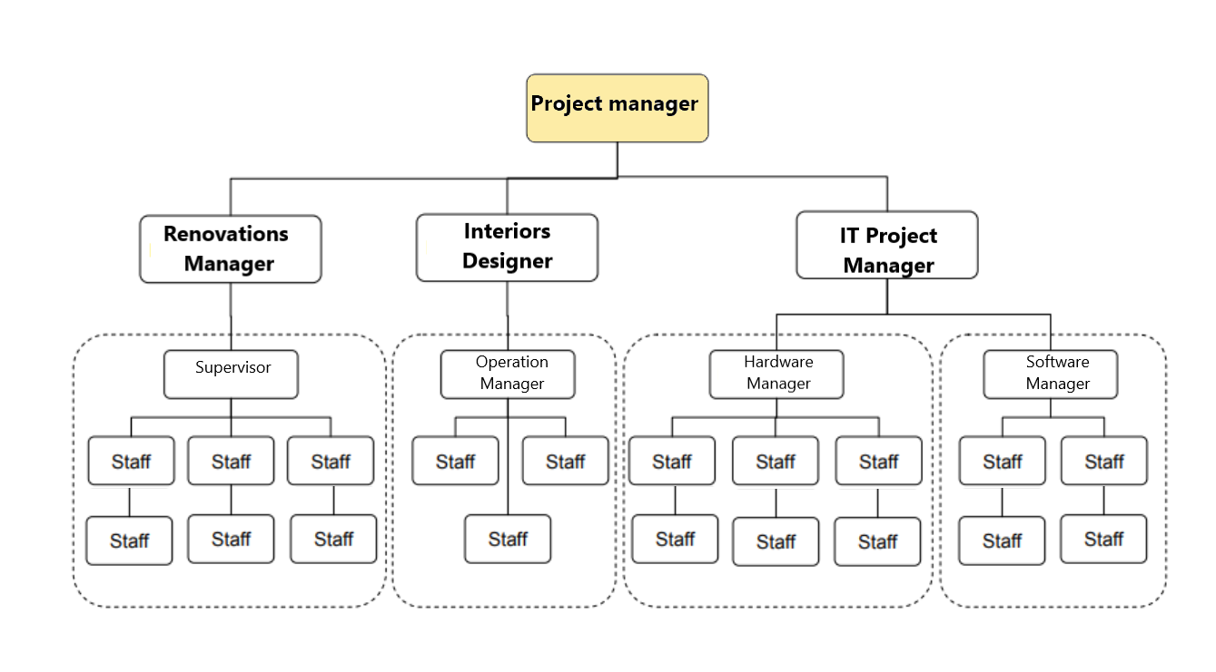
Fig.4. The project organisational structure

  - PROJECT CONTROL MECHANISMS
With the data obtained by project controls, risk-reduction decisions may be made more quickly and precisely. It is your obligation as a project manager to ensure that the project is completed on time and within budget. The success of the project may be jeopardised or hampered if critical questions are not addressed on time. This list includes various reasons why projects can deviate from their intended path in the absence of project controls, including the following:
People: Who is accessible to work on a project, who is accountable for specific responsibilities and tasks, and who should be accountable for specific actions during the project's development phase may all be pertinent questions.

Procedure: The project control process ensures that expectations are met, phases are finished, and everything works properly.
Cost: Unexpected costs may arise as a result of stakeholder changes or miscalculations during project planning if expenses are not tightly controlled.
Time: It is critical to maintain track of project time in order to avoid issues such as schedule delays, shifting priorities, and resource conflicts that can result in subpar project outputs.
- Preparation for a project (initiation)
During the project planning stage, there is the opportunity to incorporate project controls into the foundation of your project. There is less control management to be done afterwards if the plan is more comprehensive.
Planning the project budget and estimating future expenditures are both important considerations throughout the project planning stage. This stake will be assured with a quality check through meet assuring that all important details are not missing.
- Execution of the project
This phase needs quality control methods into action as soon as the project enters the development phase. The project controls will allow keeping tabs on the status of the project as it is being worked on by the team members. As the project progress through the project life cycle, there will be kept an eye out keeping a straightforward communication with all members of the project. These controls can provide with an up-to-the-minute overview of the current state of your project as it is being carried out.
- Project Closure
After all project stakeholders have received the final deliverables, have a post-mortem meeting using the information acquired from the project control methods. Having a post-mortem meeting is an excellent opportunity to reflect on the project's lessons learned and get suggestions for the future. My step gives me the opportunity to apply any lessons I've learned from this experience to future initiatives, whether or not I made costly blunders.

  - REPORTING FRAMEWORK
Project managers have a lot to do every day. The most critical task is to coordinate the actions of all parties engaged to achieve common goals. A good project manager can collect and provide data to their team.
Project managers spend a lot of time communicating to coordinate activities. Project teams must coordinate their efforts to collect and disseminate enormous amounts of data (S.Joubert,2020).
Without communication, multiple persons or teams working on the project may end up performing the same thing in the wrong sequence, expanding the project's scope beyond the initial design. As a result, projects may stall or even fail.
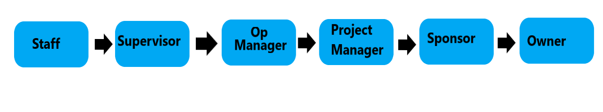
Fig.5: Reporting Organizational Framework
  - PROJECT PLANNING WITH MILESTONES
    - Gantt Chart
Gant Chart allows concurrent use of resources and assets while keeping fully aligned with project requirements. So the project will need more segmentation. These summary tasks assist effective project grouping:
- Planning
Every project starts with defining its goals and expected outcomes. The summary activities help plan the London site's capacity for new classrooms and computer labs.

- Requirement identification:
The main goal is to find out what the institute needs to improve teaching and learning. It helps project stakeholders understand the needs (Kerzner and Kerzner, 2017). This is done through meetings and surveys.
- Design
Part of this activity is creating a floor layout. A workstation for notebooks, pencils, and bags. Choosing right equipment and software can also create a pleasant learning environment.
- Implementation
Achieve desired room décor and functionality by installing resources in the institute and integrating software or other setups. Project success in a network infrastructure context depends on security and device configuration.
- Evaluation
The tool's multiple functions help evaluate the project's performance and quality. Starting with planning, we may analyse the findings.
- Project closure
An evaluation ensures the results and validations are accurate (Harrison and Lock, 2017). Change management is included if the project scope changes during evaluation.
    - Milestone
A project milestone can help the project reach quality and outcome goals. Milestones help tracking the progress and adjust the leadership style over time. The project has three major milestones that can be utilised to monitor progress and assure intended outcomes.
Planning Milestone: These were all covered in this milestone. Rational designs with iterative testing and verification are required now. The stage is well-managed in terms of assets.
Installing Milestone: Install and configure all technical and non-technical components required to create a great learning environment (Heagney, 2016). A functional model of requirements has evolved over time.
Closure Milestone: is the product completion. So long as the project is moving forward as anticipated with no major changes. The project is complete, and no duties remain. It uses to finish the project.

- REFERENCES

S.Joubert, (2020), “The Critical Role of Communication in Project Management”, Available at: https://www.northeastern.edu/graduate/blog/communication-in-project-management/ , Accessed:15.04.2022.
Asana, (2021), “5 project controls and where to implement them”, Available at: https://asana.com/resources/project-controls , Accessed: 12.14.2022.
PM4DEV, (2016), “Project Management Organizational Structures”.
L.Hoory, (2021), “What Is A Stakeholder Analysis? Everything You Need To Know”, Available at: https://www.forbes.com/advisor/business/what-is-stakeholder-analysis/ , Accessed: 12.04.2022.
K.Boogard, (2021), “What are Project Assumptions?”, Available at: https://www.wrike.com/blog/what-are-project-assumptions/ , Accessed:12.04.2022.
B.Roseke, (2019), “PRINCE2’s Project Initiation Document”, Available at: https://www.projectengineer.net/prince2s-project-initiation-document/ , Accessed: 13.04.2022.
B.Harned, (2022), “What Is Project Management? Definitions & Terms”, Available at: https://www.teamgantt.com/project-management-guide/what-is-project-management , Accessed: 12.04.2022.
J.Freeman, (2021), “What is a Milestone in a Gantt Chart? - Everything You Need to Know”, Available at: https://www.edrawsoft.com/project/what-is-milestone-in-gantt-chart.html, Accessed: 14.04.2022.

Appendix:
RISK ASSESSMENT DOCUMENT

A risk register enables an organisation to monitor and analyse all potential threats to its success, as well as develop cost-effective mitigation methods. Risk registers assist project managers in identifying and evaluating alternative methods for increasing productivity and quality. Additionally, it aids in resource optimization and outcome management (Pritchard and PMP, 2014). As a general rule, the more likely something is to occur, the more often it will be referred to as "unlikely," conversely the more improbable something is, the more likely it will be referred to as "very likely." Additionally, the impact's severity is quantifiable, ranging from mild to severe.


