

Student Name | Cristopher Alexander Gonzalez Hidalgo
University Name | University of Wales Trinity Saint David (London Campus)
Module Name | Cloud Computing Administration
Programme | BSc Cloud Computing
Module code: | ACCA5029_LON
Lecturer: | Renuga Jayakumar
Student ID | 2113442
Word Count | 6,000
Assessment | 1

Index
Background Introduction 4
a) Total Cost of Ownership Calculator (TCO) 5
1. Servers 5
1. Windows Server 5
2. Linux Server 5
3. Web Applications 5
2. Networking 13
3. Adjust Assumptions 14
b) Azure File Storage 15
1. Azure Blobs 15
2. Azure Files 15
3. Azure Elastic SAN 15
4. Redundancy 17
Single region: 17
c) Azure Database 20
1. Azure Database for MySQL. 20
Management 20
Performance. 20
Development experience. 20
Security and compliance. 20
2. Azure Database for PostgreSQL 20
Familiarity. 20
Flexible Server. 20
AI-Powered. 20
IP Advantage and Microsoft Defender for open-source relational databases. 20
3. Azure SQL for Database 21
d) Azure Backup 24
e) Analyse the suitable option for GLI using Azure Site Recovery 25
f) Conclusion 26
g) References 27

Background Introduction
The Global Learning Institute (GLI) is a medium-sized educational institution which offers online courses and certifications for approximately 20,000 students. Currently, they manage their IT infrastructure with local servers for hosting user profiles, course materials, and various administrative systems. This institution is considering migrating its entire IT infrastructure to the cloud offered by Azure because it offers greater scalability and lower cost. The main reasons for doing so are:
- On-premises servers are expensive to maintain and update.
- Servers at local facilities are vulnerable to hardware failures, power loss, and natural disasters.
- On-premises servers have limited storage and processing capacity, they cannot handle it effectively manually due to increased demand for your online courses and certifications.
This report will analyse why to migrate the entire IT infrastructure to the Azure cloud platform to do this I will do analyse some of the main key points, which are which will be analysed in detail in the following pages.
To do so, several key aspects will be analysed, such as:
- Total Cost of Ownership Calculator (TCO)
- Azure File Storage
- Azure Database
- Azure Backup
- How to minimize downtime in case of unexpected problems and disasters

Total Cost of Ownership Calculator (TCO)
The first key point to analyse is to estimate the cost savings that can be achieved if data is migrated from on-premises servers to the services used in the Azure cloud. Given that GLI is a medium-sized company, solutions can be made regarding the use of different servers to analyse which one offers the best features according to what the institution needs, likewise the same process can be carried out for the best choice in As far as databases, storage types and network types are concerned, it is necessary to use the Azure total cost of ownership (TCO) calculator which will help with this purpose.

Servers
The number of servers used by educational institutions can vary significantly based on their size, infrastructure, and technological requirements. As GLI is a medium-sized institution they will need different servers for different applications such as: servers for email, websites, virtual learning environments, and administrative systems. According to what was previously established, we can estimate that the number of servers can range from 500-1000, also considering that this will allow the institution's capacity of students to be expanded soon.
Microsoft Azure offers two types of servers, which are: Windows/Linux and Web App.
- Windows Server. Developed by Microsoft, it runs services created and maintained by Microsoft. It offers a rich collection of additional features.
- Linux Server. Based on open-source Linux distributions, it provides more flexibility and customization options. This contains thousands even millions of developers that provide their knowledge to keep updated and optimized this server.
- Web Applications. Deployed on web servers accessible via browsers.
For the type of applications that the institution will use, it is most advisable to use physical servers that allow tasks to be executed and services provided on local machines which will be used by staff, administrators, and students.
As mentioned above, Azure Cloud offers two types of physical servers, Windows Server, and Linux Server. The choice depends entirely on what you want to install and use within the server, since both platforms offer different performance, security, and stability for the applications, depending on the environment in which they run. Let's now look at each of the characteristics.
Windows servers are oriented to use ASP, ASP.NET, Access databases and MSSQL, for example. Although it is well known that they can also run applications made in a variety of other languages such as C, C++, Python, and other cross-platform languages such as PHP [1].
Linux servers are ideal for running technologies such as C, Perl, MySQL or PHP with Nginx or Apache web servers, which are optimized for this environment, since they were languages created specifically under these Linux-based platforms and Unix, where they run natively and from where you can get the maximum performance when executing them [1].
Keeping this in mind some characteristics of each one to be able to choose the most suitable one. A table detailing the characteristics of each will be shown below.

Features | Windows Servers | Linux Servers
Uses | Windows dedicated servers are in themselves much easier to manage than Linux, especially if we are beginners in the subject, thanks to their visual interfaces. Even so, an expert user of Linux dedicated servers will have no problems performing all kinds of complex tasks. | Dedicated Linux servers do not have a graphical interface, so they can be more difficult to manage than a Windows server.
Functionality | One can be much more useful than the other depending on the technologies that are going to be used, so for some things one will be more useful over the other and vice versa so it will totally depend on the technology that is going to be executed within.
Reliability | Microsoft is a world-renowned company that has been developing the Windows operating system for as long as we can remember, which is why it also has great support. | Both are extremely similar since they have existed for many years and are frequently updated. Linux is supported by hundreds of thousands (if not millions) of developers around the world, who contribute their knowledge to opensource projects, although there are also large corporations founded on opensource and Linux, such as RedHat Inc, creators of the system platforms. CentOS, RHEL and Fedora.
Prices | In Windows Server we need to acquire separate licenses for certain products that are quite essential in some cases, such as MSSQL Server for example. | Linux servers are cheaper, since they use a generally free operating system (you do not have to pay a license like Windows), and they also have a large open-source community where we can obtain many completely free applications.
Security | Both types of servers can be equally secure. It is possible to achieve a considerably high level of security in both cases, although there are many more cases of security holes and service exploits on Windows servers than on those running Linux. This is simply for two reasons, a software development architecture issue, and on the other hand the fact that Windows has been the most used operating system in history, and logically it tends to receive more attacks than those that are not so popular.
Control Panel | In the case of the Microsoft operating system, you can find a similar version adapted for Windows under the name Plesk, which is a similar control panel, but in many ways more complicated and difficult to carry out at the configuration and updates level. | The most popular in the case of Linux is cPanel, a control panel specially created for Web Hosting environments where you can find an easy, secure, and fast solution to work in the web hosting business.
Performance | At low load levels, both types of servers usually have similar performance, although here more factors influence, such as the number of resources available for each server (CPU, RAM and type of disks that are used more than anything). Although on high traffic platforms generally, Linux servers are much more powerful than those running Windows Server 2008, 2012 or 2016.
Given the specific characteristics of each type of server and given the usefulness of each one, it is most advisable to opt for Windows Server since it is a product endorsed by a world-leading company such as Microsoft, which enjoys a great reputation worldwide and It is known that it will provide great support to IT teams.
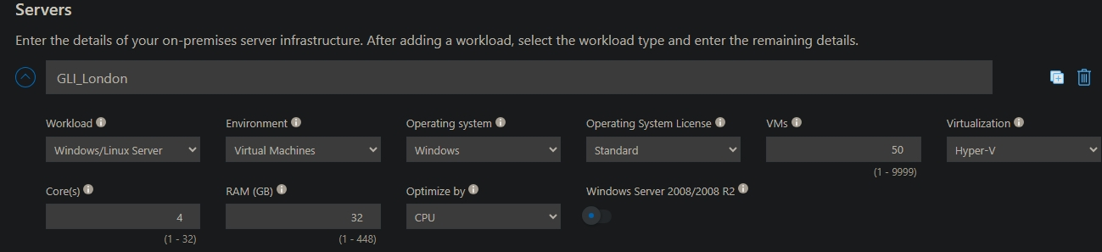
Although it is a bit expensive to opt for Microsoft servers, this can be offset when hiring personnel since there are more people trained in the management of these servers and the complexity when managing them is not as high. The Total Cost Calculator (TCO) has been used to analyse the cost of migrating the entire IT infrastructure, specifying the hardware and software characteristics that the company has in its facilities versus what it would cost to have them hosted in the Azure cloud and these are the results:
In this case, GLI has a main headquarters where it carries out its activity, which is in London. Here are the specifications of the servers assigned to this location. The servers shown here possess certain features that are standards for optimal resource execution and data management.
This following graphic represents the costs in the next 5 years if GLI continues keeping the infrastructure of IT on-premises site instead of to Azure Cloud Services. In the following images the activities that cost more money will be explained. As was mentioned before, the cost is estimated on the next five years doing their activity.

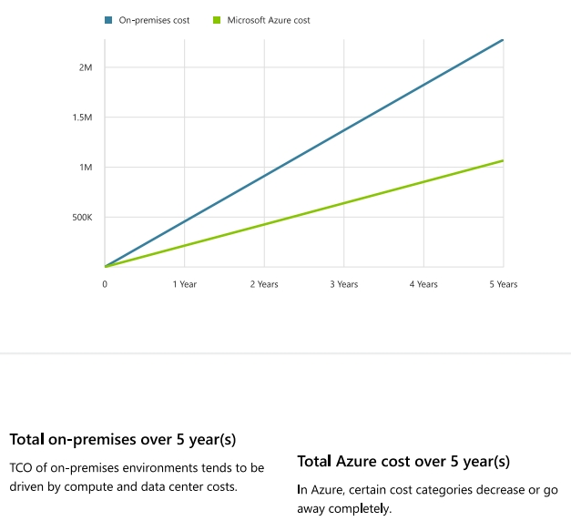

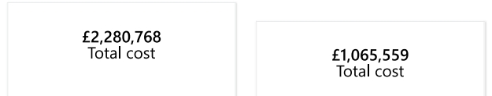

This cost is divided by:
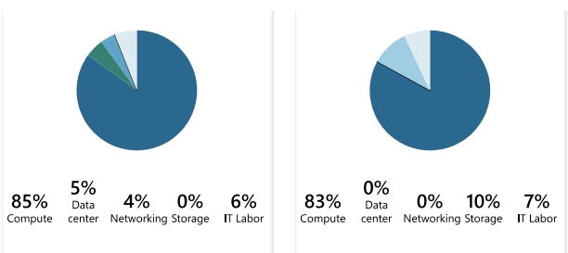
Those percentages represent the money invested in each department required to do their services activities.

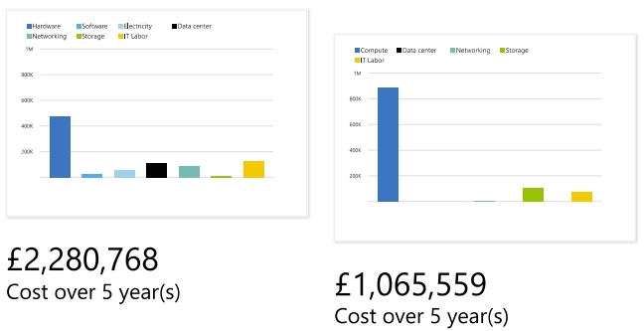

As is showed above, on-premises GLI must pay for every department such as: hardware, software, electricity, datacentre, networking, storage and IT Labor, but using Azure Services some payments (electricity, software) are not necessary because Azure Cloud covers all those features, and those departments represent a huge cost that GLI can save if the moving on Azure Cloud. On the next image the costs are detailed for an easy comprehension.
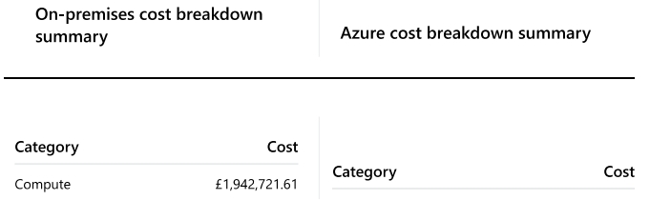

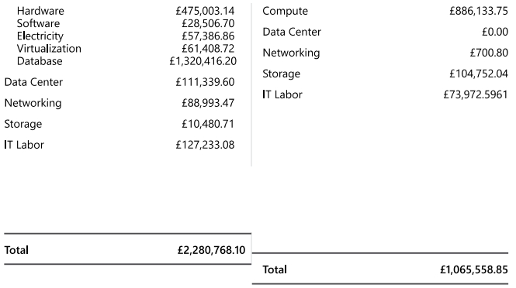

On-premises, Data Centre, GLI pays £111,339.60; on Azure the cost is 0£, a huge difference. Even on IT Labor on premises costs £127,233.08 on Azure is £73,972.60. Other reason to move to Azure Cloud. On-premises GLI must pay electricity bills that represent £57,386.86 on Azure is £0.
To observe more differences on details, check the image below.
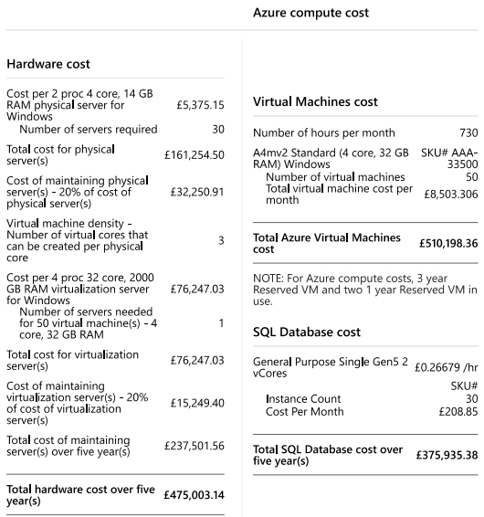

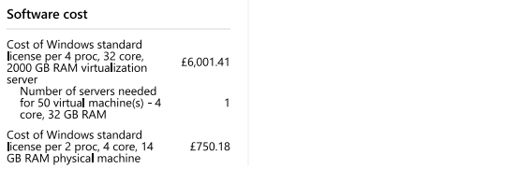
On-premises GLI must pay the hardware and the software that will runs on the hardware, each one is a separate cost.

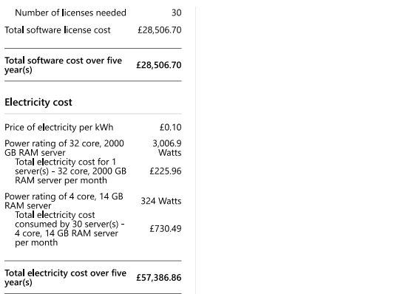

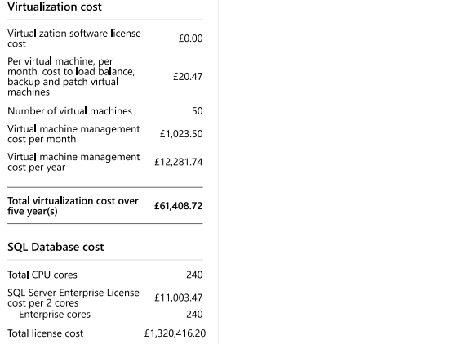
The software needs to be licensed so that is other cost to be paid and all the devices need electricity so, that represent other more costs.

Every feature that GLI needs such as virtualization, database, etc represents costs, on Azure the payment is only one and includes all the feature that GLI requires.
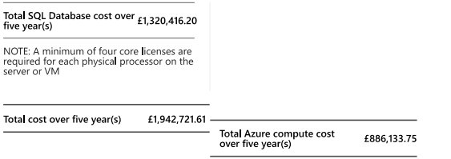

Sometimes, there are on Azure is a different cost but anyway those cost is less that on-premises cost.
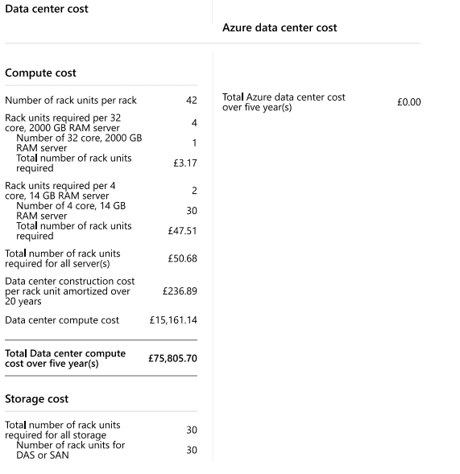

For compute is the same, on-premises for computing GLI must pay £75,805.70 on Azure is £0.

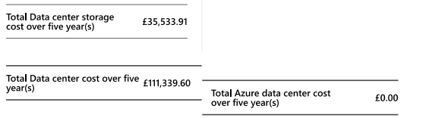

GLI faces the same issue with the storage and here is even worse because in case that requires more storage must buy physical devices and place on-premises, increasing with that the cost and the electricity, on Azure only is necessary to pay for the storage requires and in the case that you need more, simply add it. On-premises this cost represents £111,339.60 on Azure is £0.

Networking
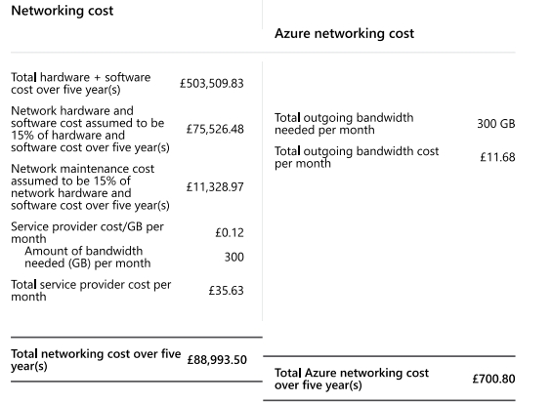
The cost of networking is referred to the bandwidth that GLI is using on-premises environment, GLI is using now 600 GB per month, this is an average. Using the same quantity of bandwidth on Azure Cloud services costs too much less than on-premises as the image below:

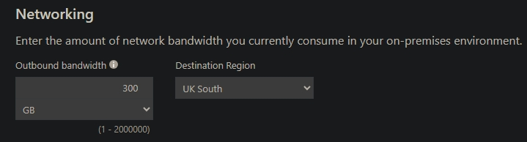
A huge difference because is on Azure is only £700.80; on-premises is £88,993.50.
The image below specifies the cost for IT Labor:
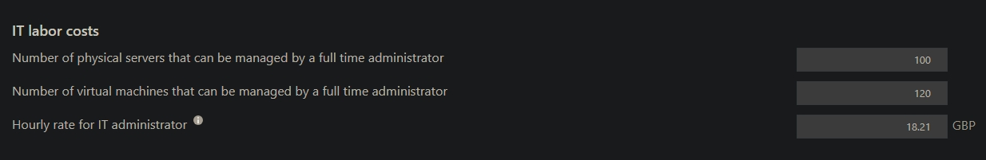
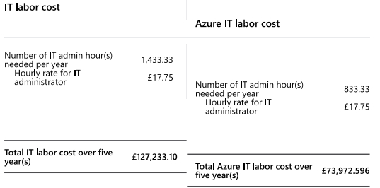

For example, in this case the costs on Azure are not £0 but is considerably less because on-promises are £127,233.10 while on Azure is £73,972.60. The difference is £53,260.50 all the costs that GLI can save is money that they don’t have to pay, that means that this money is savings.
There are other features that GLI can activate to keep the data safe if a natural disaster occurs such as the following:

Adjust Assumptions
These are adjustments that Azure offers with assumed situations that can be chosen for better performance of the contracted services. Some of the most notable are [2]:
- New Version Rights. Each license covered under the software insurance could be updated to the newest version.
- Spread Payments. License payments can be split into equal payments through annual payments.
- Microsoft Desktop Optimization Pack (MDOP) for Software Assurance. Subscription additions available.
- E-Learning. The number of users who can access courses is based on the number of licensed copies of qualifying products enrolled in Software Insurance.
- Cold Backups for Disaster Recovery. For each Server Permit secured with Program Affirmation, you're entitled to run 1 occasion of the computer program on a “cold” server for calamity recuperation purposes.
All of those are good ideas but increase the costs of the infrastructure and the main objective to migrate it is to save on cost so the most recommended for GLI is discard them and stay with the basic plan.

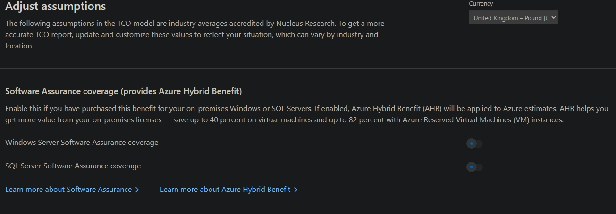
Also, other features such as Windows Server Software Assurance coverage is deactivated because increase to much the costs, the same happened with SQL Server Software Assurance coverage for the same reason.
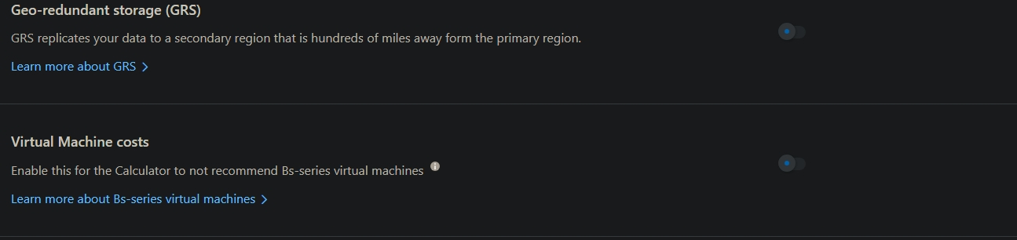
The Geo-redundant storage (GRS) is discarded as well, this feature allows to keep the data in different zones or regions to have all the time the data available in case of natural disasters or something else.

Azure File Storage
The Azure Storage platform is Microsoft's cloud storage solution for modern data storage scenarios. Azure Storage offers secure, durable, highly scalable, and highly available storage for a variety of data objects in the cloud, ideal for our case as it offers high performance at a low cost compared to on-premises storage. Another advantage that Azure Cloud offers is that stored objects can be accessed from anywhere in the world over HTTP or HTTPS through a REST API. Developers and IT professionals can use Azure PowerShell and Azure CLI to write scripts for configuration or data management tasks. The Azure portal and Azure Storage Explorer provide user interface tools to interact with Azure Storage and more easily and efficiently manage stored files and user permissions and privileges over them.
The Azure Storage platform includes the following data services:
- Azure Blobs: A enormously adaptable protest store for content and twofold information. Moreover, incorporates back for enormous information analytics through Information Lake Capacity Gen2.
- Azure Files: Provides fully managed cloud file sharing that you can access from anywhere via the industry standard Server Message Block (SMB) protocol, Network File System “NFS”; Azure Files REST API and Protocol.
- Azure Elastic SAN: Azure Elastic SAN is a fully integrated solution that simplifies deployment, scaling, management, and configuration of SANs, while providing integrated cloud features such as high availability. All these features are perfect for the expansion of courses and learning materials that GLI wants to roll out in the coming years.
There are other services such as:
- Azure Queues: A informing store for solid informing between application components.
- Azure Tables: A NoSQL store for schemeless capacity of organized information.
- Azure Managed Disks: Block-level capacity volumes for Sky blue VMs.
- Azure Container Storage: A volume administration, sending, and organization benefit built natively for holders.
For the proposed of GLI the most recommended services to used are:
Azure Blob Storage and Azure Files.
Azure Blob Storage. This is an unstructured data type in what you can storage several types of files, BLOB means Binary Large OBject (any file), those Blob files are storage in containers and on Azure can exits as many containers as there are needed, those containers allow to the user and the apps to work their files on the cloud.
Azure Blob Storage, uses three kind of storage tiers:
- Hot: frequently accessed data, for example in the case that a web application must deliver images to the customer this would be the tiers used because offers the best performance for the files, as offers the best performance is also the most expensive one.
- Cool: this is another solution that allows to the files being accessible data, this offers less performance, but a high durability and a significant discount for storage date. This is a perfect solution for storage all the versions for backups and applications.
- Archive: this one is the cheapest one because only lets to backup files than you to need to keep for 10 years.
The most recommended tier for GLI is cool, this allows to the users and applications to work on cloud provided high durability and less costs.
Each benefit is gotten to through a capacity account with a one-of-a-kind address.
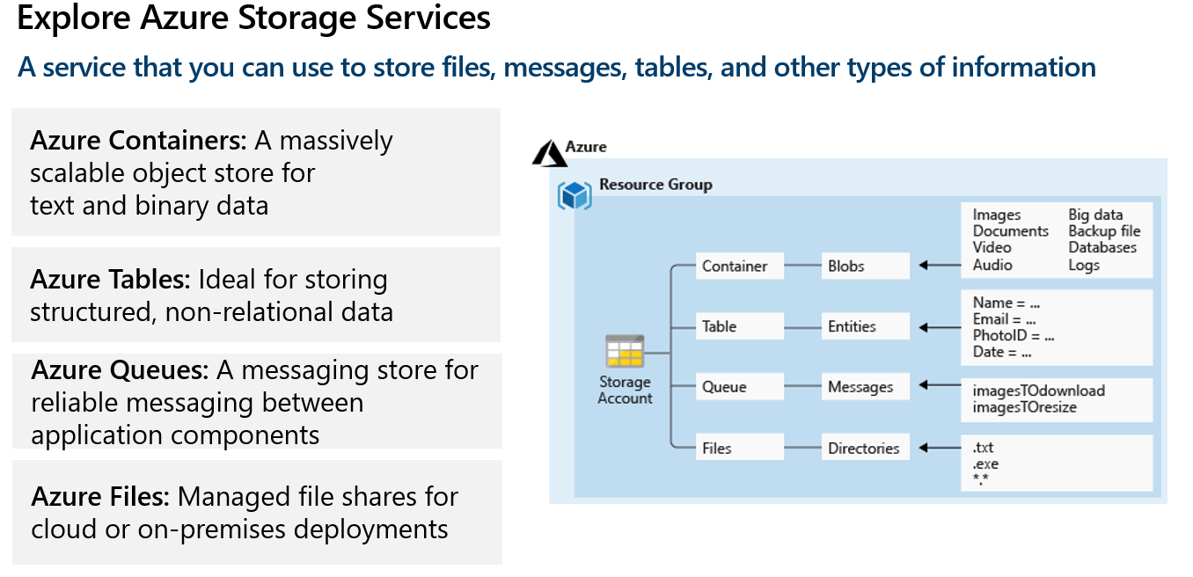
Azure Files has the following features:
- Identity: Enter ID; Storage account key.
- Performance: Standard (300 Mbps); Premium (5 Gbps).
- Direct mount: SMB, NFS, HTTP.
- Azure File Sync: Cloud tiering; Multi-site access; Cloud site backup.
- Redundancy: LRS/ZRS; GRS/GZRS; RA options.
- Storage tier (cost): Premium; Transaction optimized; Hot/cool/archive.

Redundancy
Geo-redundant storage. This is another important setting that can be an add-on feature such as an extra setting to allow backup copies to be made in a different region, thus allowing our data to be insured in case the main region suffers some type of incident. such as floods, fires, earthquakes, tornadoes, etc.
Those are the way to keep the date in secure backups in different locations this could be:

Single region:
- LRS: Three replicants in one locale; secures against disk, hub, and rack disappointments; type in is recognized when all replicants are committed. Prevalent to dual-parity Strike.
- ZRS: Three replicants in three zones in one locale, synchronous composes to all three zones; secures against disk, hub, rack, and zone disappointments.
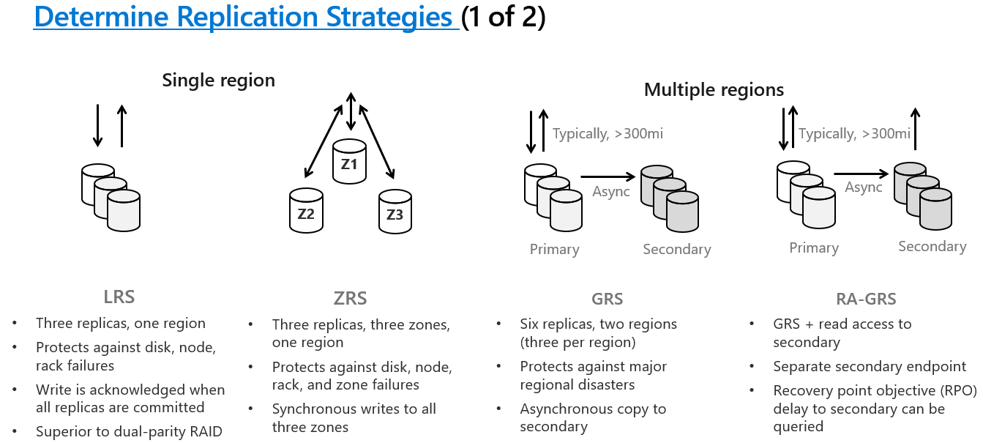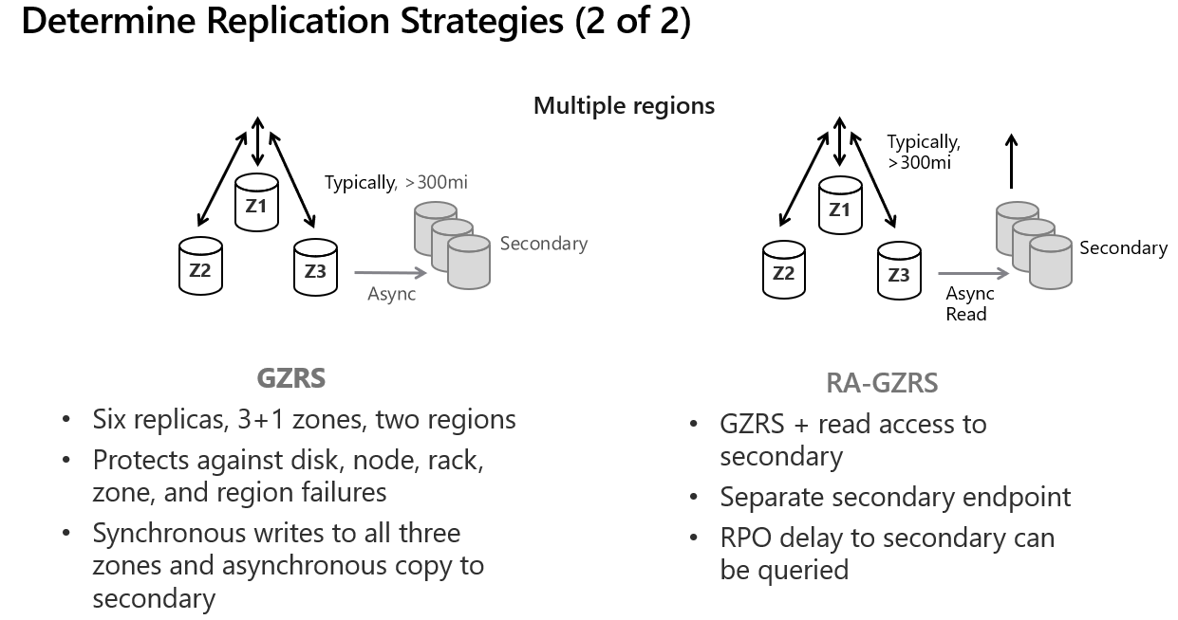

Below are two images about creating a storage account and how it is displayed in Azure Cloud.
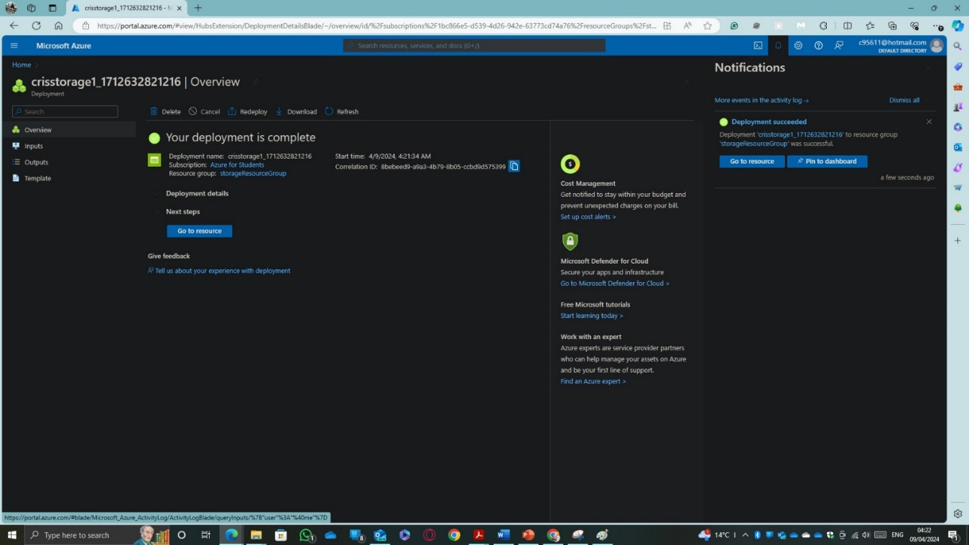

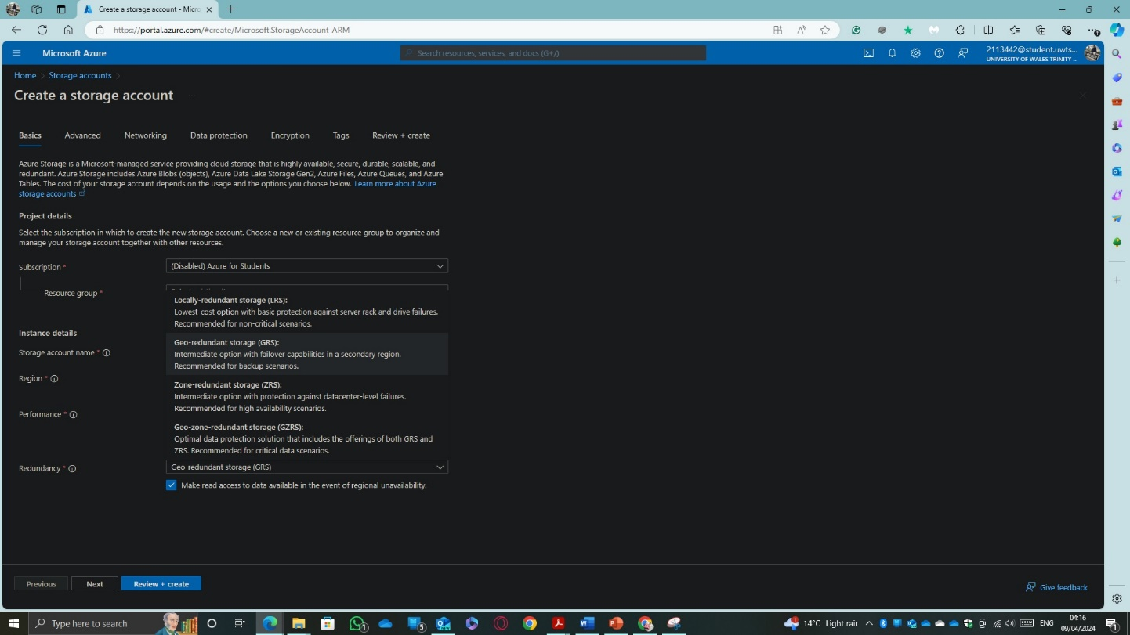

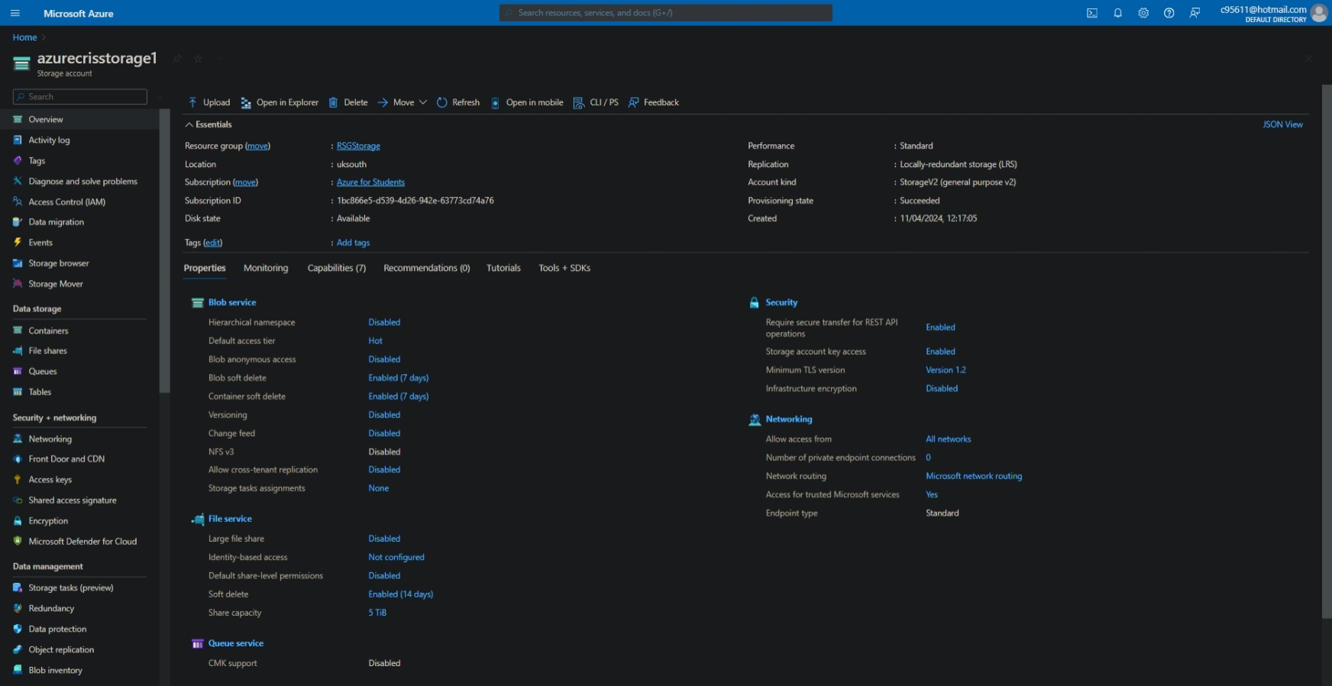
This is the result.

Azure Database
Evaluate different Azure database options (Azure Database for MySQL, Azure Database for PostgreSQL and, Azure SQL Database).

Azure Database for MySQL.
Center on application improvement with Purplish blue Database for MySQL, which is taken a toll viable and simple to set up, work, and scale. Appreciate progressed security, tall accessibility, and a service-level understanding (SLA) of up to 99.99 percent. Perused the diagram and learn how emigrate your on-premises MySQL database to Sky blue [3].
The main features are:

Management
Fully managed MySQL, this makes it compatible with the latest versions of community editions, it also provides maximum flexibility for all types of relational database operations.

Performance.
Smart performance recommendations provide personalized analysis and more effective suggestions for MySQL database optimization.

Development experience.
Thanks to a simplified development experience and a very close relationship with Azure Application Services and Azure Kubernets Service (AKS), Azure manages to offer very simple and easy database management skills.

Security and compliance.
It offers enterprise-grade security and compliance, as well as the enhanced security capabilities of Microsoft Defender for Identity.

Azure Database for PostgreSQL
With Azure Database for PostgreSQL focus on application innovation, not database management, with an intelligent, fully managed Azure Database for PostgreSQL. This also allows you to scale your workload quickly with ease and confidence. Features high availability with a service level agreement (SLA) of up to 99.99 percent uptime and a choice of high availability in the same zone or with zone redundancy, AI-based performance recommendations, and security integrated business [4].

Familiarity.
The main features are: Familiar functions like JSON because it is a derivative of the famous JSON language, it also offers geospatial support, rich indexing and dozens of extensions.

Flexible Server.
Flexible server, this allows us to offer high availability with zone redundancy and a simplified user experience, very valuable and necessary features but for another type of organization other than GLI.

AI-Powered.
It enables query storage and intelligent performance optimization by using artificial intelligence to build and scale your database thereby improving its performance.

IP Advantage and Microsoft Defender for open-source relational databases.
Azure IP Advantage allows you to effectively manage IP addresses and, together with Microsoft Defender, provides greater protection for data in relational databases, especially open-source ones.

Azure SQL for Database
Azure SQL Database always runs on the latest stable version of the SQL Server database engine and patched operating system with 99.99% availability. PaaS capabilities built into Azure SQL Database allow you to focus on domain-specific database management and optimization activities that are critical to your business. With Azure SQL Database, you can create a high-performance, highly available data storage layer for Azure applications and solutions. SQL Database can be the right choice for a variety of modern cloud applications because it allows you to process both relational data and non-relational structures, such as graphs, JSON, spatial, and XML. Making this an ideal option for the case study [5].
Given the characteristics seen above, the best option given the GLI requirements is Azure SQL for Database since the servers will also be configured by Azure, this improves and optimizes compatibility in the communication between the database and the other services., as well as the execution of applications. As for its hardware specifications, they are specified in the following image:

To create a Microsoft SQL Database is necessary to follow the next steps:
First, go to Azure portal and type SQL, click on create.
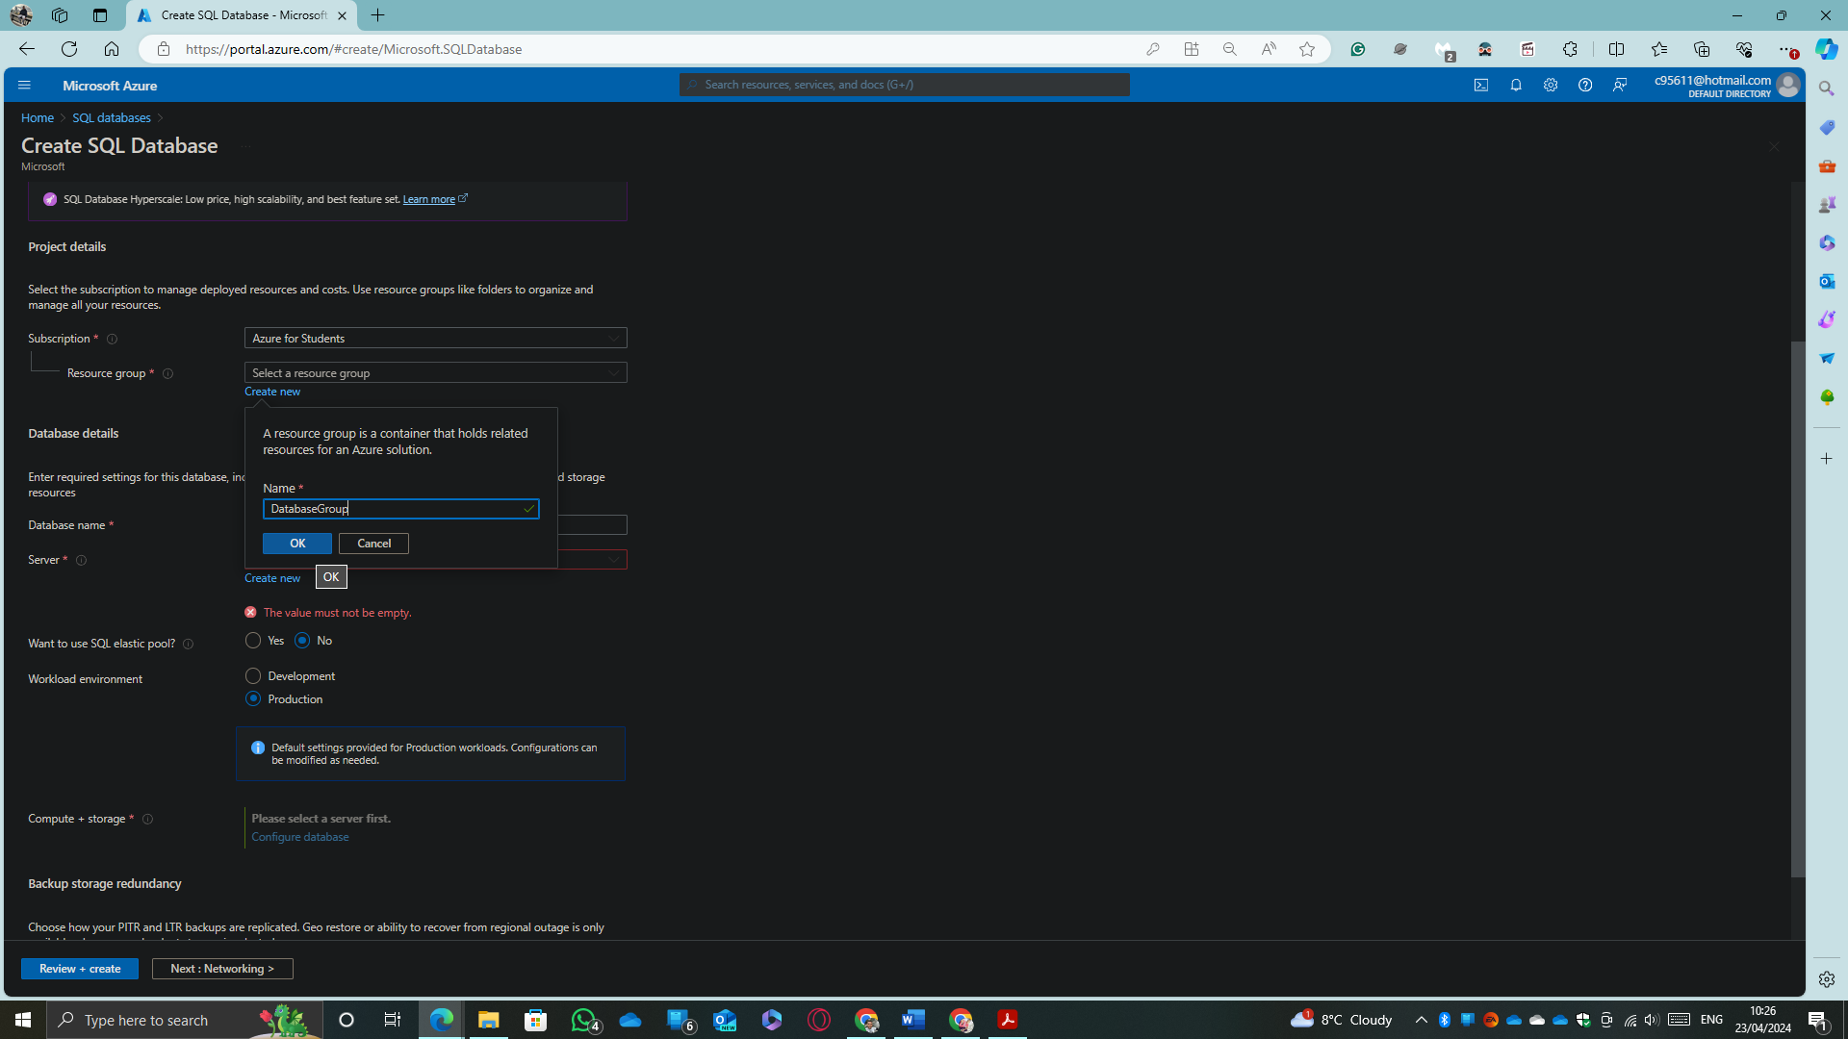
It is probably to fill the part of the server, that means that it is necessary to create a new one if none exists. To create a new one, click on create and fill the following fields:
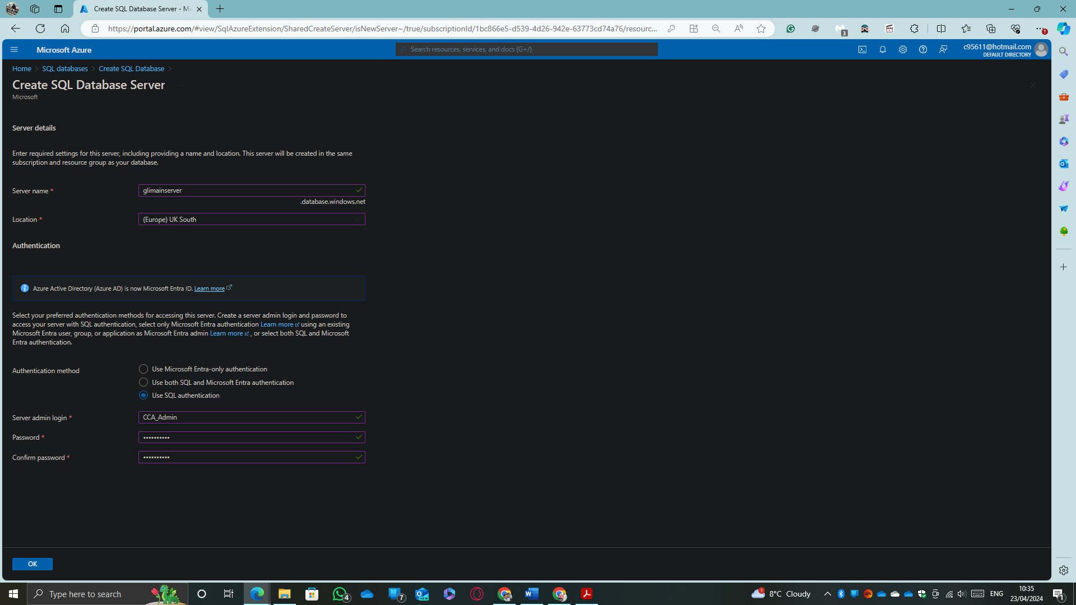
Choose the server’s name, the location and the method to authenticate for the database administrator. In this case the method used will be the SQL Authentication, after setting up the details of the administrator and click on Ok.
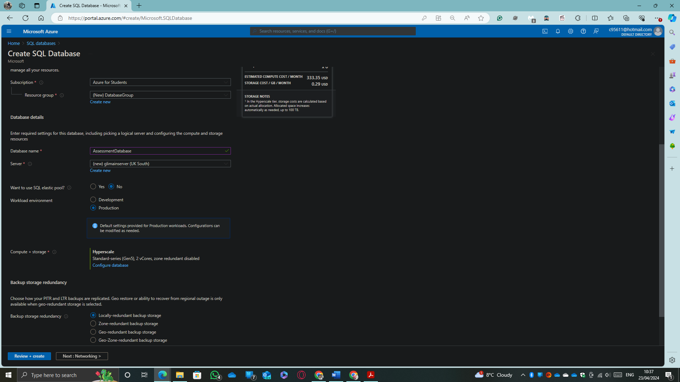
In geo-location the setting up will be configured as a Locally-redundant back up storage. This option will allow to GLI save on the database cost because the data will be storage in one site only, offering what the company requires.
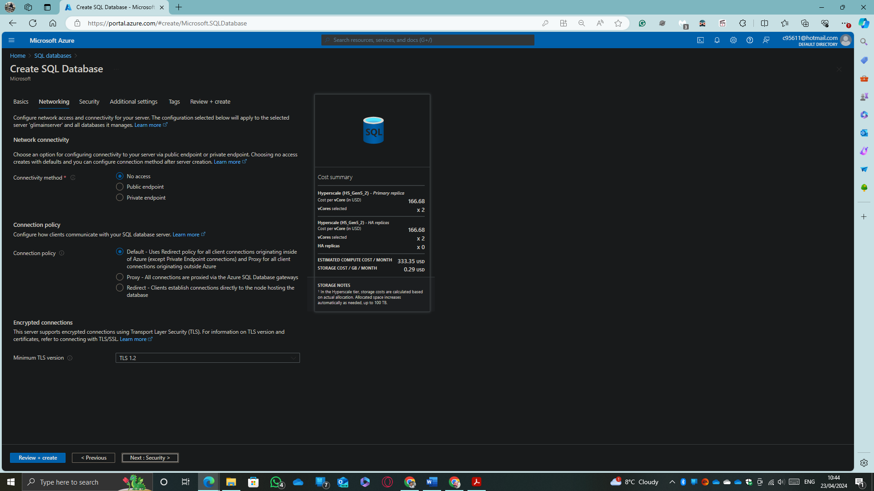
Here the connectivity method could be changed it is necessary. The rest of the configurations are setting up with the default selections. After the review finished only is remained to click on ok and start with the deployment.
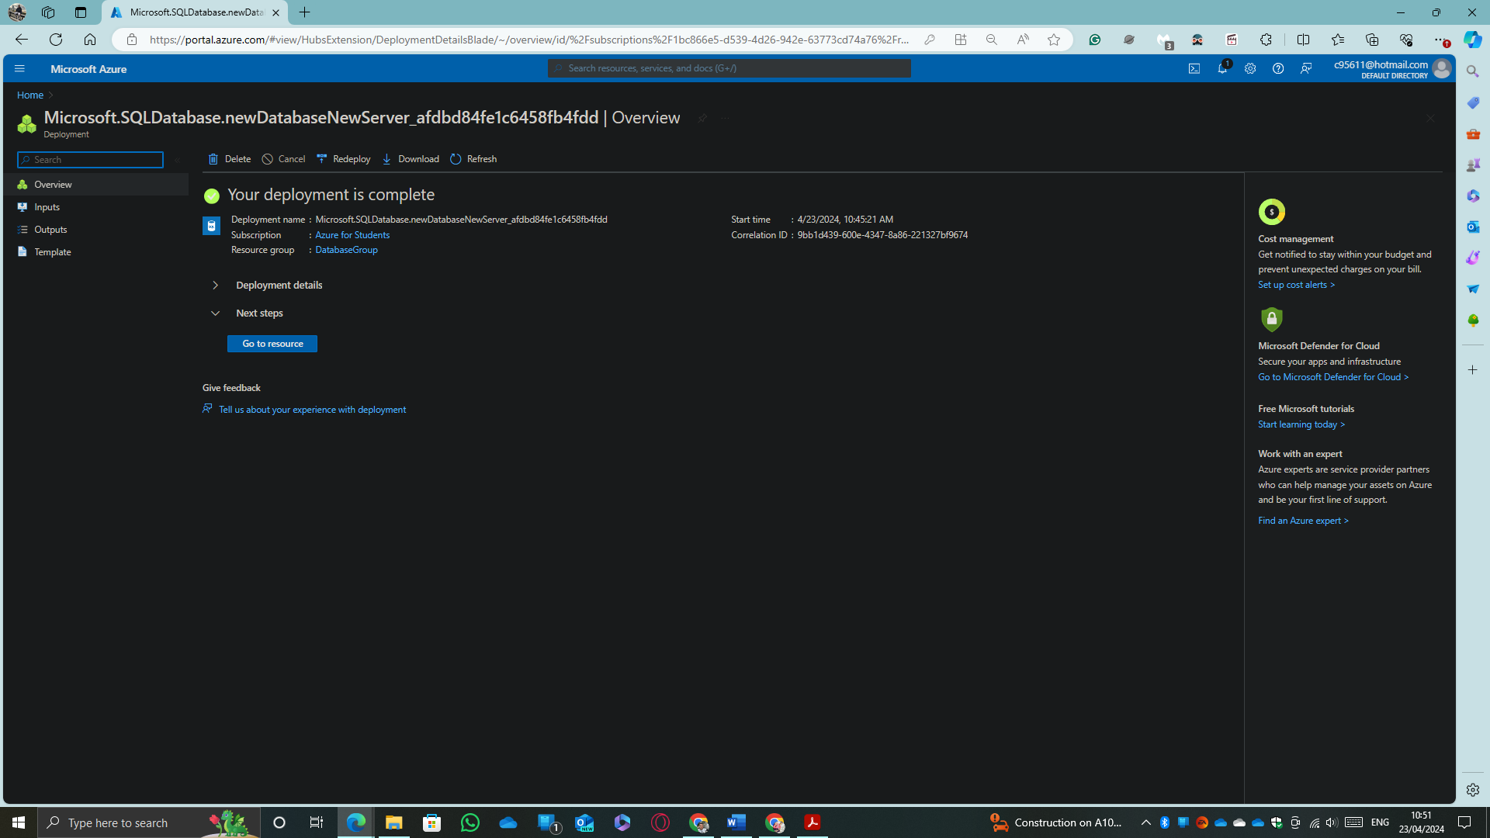
If everything was ok, this is the result.
Using the Microsoft Application to manage databases “Microsoft SQL Server Management Studio” An attempt was made to connect to the database to verify that everything is working correctly, but first it is necessary to enable remote connections to the database. In the following image we have the result of this test.
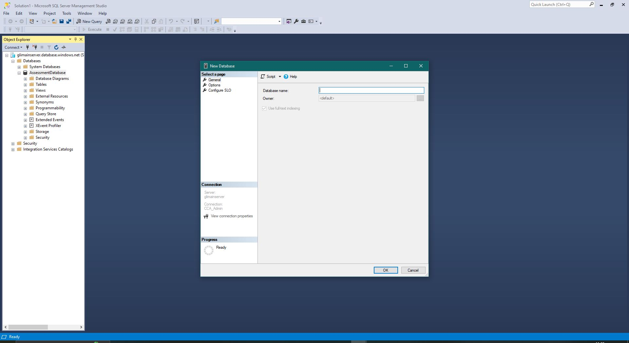
As you can see, the connection was a complete success since with the credentials previously closed for the database administrator it is possible to log in and manage the entire database by creating tables, making reports and a countless number of operations that are available in this program. Azure will manage the connection to the database through the portal but in this case, it was used only for the purpose of demonstrating that the database was created correctly and that a successful connection can be established and accessed remotely, if you have previously enabled this option in your connection settings.

Azure Backup

As a learning institution GLI must be able to effectively manage its students' data (name, last name, student ID, grades, modules) as well as the files and other available resources to which they have access and continue their learning... By hiring Azure services this can be done very easily and quickly. Below is the link to an explanatory video in which the creation of a file storage account is carried out, as well as the creation of a database. of data to manage the institution's data and the management of backup and recovery on site.
YouTube link video: https://youtu.be/DiomL_a6uCk

Analyse the suitable option for GLI using Azure Site Recovery

Azure Site Recovery offers ease of deployment, cost-effectiveness, and reliability. Implementing these replication, failover, and recovery processes through Site Recovery can help keep all your applications and services running during planned and unplanned outages.
While Site Recovery is a native disaster recovery service (DRaaS), and Microsoft has been recognized as a leader in DRaaS based on completeness of vision and ability to execute by Gartner in the 2019 Magic Quadrant for Disaster Recovery As a service, this makes Azure the best option on the market to execute cloud services with the best tolerance to failures and unplanned problems [6].
Simply to implement and manage
Setting up Azure Site Recovery is simply replicating an Azure virtual machine to a different Azure region directly from the Azure portal. Additionally, recovery issues are minimized by sequencing the order of multi-tier applications running on multiple virtual machines. Also, ensure compliance by testing your disaster recovery plan without impacting production workloads or your end users.
Reduce infrastructure costs.
Reduce the cost of deploying, monitoring, patching, and maintaining on-premises disaster recovery infrastructure by eliminating the need to build or maintain an expensive secondary data centre. Plus, you pay only for the compute resources you need to support your applications in Azure. All of this is a huge advantage over traditional on-premises data centres.

Conclusion

To conclude, I would like to raise several points: today, any company that needs an information technology infrastructure with some handling of large volumes of data, it is preferable to look for options to migrate or hire directly (in case you are starting) cloud platforms like Azure. In this case Global Learning Institute (GLI) is the type of business that would be better off migrating its entire infrastructure to the cloud due to everything mentioned throughout this report, but as a summary it stands out: the operational cost, assuming a much lower cost compared to what would be carried out if we continued with infrastructure in the facilities themselves, not only because of the cost of the infrastructure and equipment but also because of other additions such as electricity and network connections. Another very notable point is the scalability that Azure offers, with Azure you only pay for the resources you consume and when you need more it is very easy to scale and increase the number of users, the latter with a future perspective above all.

References

[1] S. Borges, “Servidor Linux vs Servidor Windows: Diferencias, Ventajas y Desventajas,” Infranetworking, Sep. 21, 2021. https://blog.infranetworking.com/linux-vs-windows-servidores/ (accessed Apr. 03, 2024).
[2] Microsoft, “Microsoft Software Assurance Benefits Overview,” Apr. 09, 2024. https://www.bing.com/ck/a?!&&p=23a4a4b6249a96c7JmltdHM9MTcxMjUzNDQwMCZpZ3VpZD0yMzg3Y2IzMy1iOWMxLTYzMTAtMGZmMy1kOGE4Yjg2OTYyOWQmaW5zaWQ9NTMwNQ&ptn=3&ver=2&hsh=3&fclid=2387cb33-b9c1-6310-0ff3-d8a8b869629d&psq=windows+server+software+assurance+coverange&u=a1aHR0cHM6Ly9kb3dubG9hZC5taWNyb3NvZnQuY29tL2RvY3VtZW50cy91ay9saWNlbnNpbmcvc2EvZG93bmxvYWRzL1NBX0JlbmVmaXRzQ2FyZF9PdmVydmlldy5wZGY&ntb=1 (accessed Apr. 09, 2024).
[3] Microsoft Azure, “Azure Databases - Types of Databases on Azure | Microsoft Azure,” azure.microsoft.com. https://azure.microsoft.com/en-us/products/category/databases/ (accessed Apr. 23, 2024).
[4] Microsoft Azure, “Azure Database for PostgreSQL | Microsoft Azure,” azure.microsoft.com. https://azure.microsoft.com/en-us/products/postgresql/ (accessed Apr. 23, 2024).
[5] MashaMSFT, “Azure SQL Database Documentation - Azure SQL,” learn.microsoft.com. https://learn.microsoft.com/en-us/azure/azure-sql/database/?view=azuresql (accessed Apr. 23, 2024).
[6] Microsoft Azure, “Azure Site Recovery | Microsoft Azure,” azure.microsoft.com. https://azure.microsoft.com/en-gb/products/site-recovery/?ef_id=_k_597927d390f11356fc0541fb2ec16898_k_&OCID=AIDcmm3bvqzxp1_SEM__k_597927d390f11356fc0541fb2ec16898_k_&msclkid=597927d390f11356fc0541fb2ec16898 (accessed Apr. 24, 2024).

