Module Name: Academic Skills in the Digital Era
Module Code: BMSW4013
Assessment 1: E-Portfolio
Student Name: William Hollins
Student Number: 2504216
Lecturer: Scott James
Deadline: Friday 21st November 23:59PM

I confirm that I have not presented any AI generated materials as my own work.
I confirm that I have copies of my drafts, notes, and other resources I used, which I may be asked to provide in evidence.

Component 1
Source Exploration

The book that I have chosen is “Digital distractions in education: a systematic review of research on causes, consequences and prevention strategies” and it is written by Florence Martin and published in 2025. The main point of this article is that digital tools are very useful in a school and workplace environment, but they can cause massive distractions. There are multiple tools which help students learn better but a lot of tools which can cause problem as most phones come with YouTube already installed but YouTube can be good as students can watch informational videos to help them understand a topic better. This source was chosen as it is written in a simple language, it is recent and written by trusted sources. The CRAAP test was used to check the source is current. relevant, and comes from a reliable source.

Key challenges for students
One challenge students face when using digitals tools is weather, they can use them or they cannot, as some things that students use will not be allowed to use as they may have AI which is not allowed to be used in a lot of courses. For example, some laptops have Grammarly installed already and some people may know or on Google there is a AI summary which some people might miss and use the information that is there. This challenge is important as it sets boundaries and helps people understand what is and what isn’t allowed. While digital tools offer significant benefits for teaching and learning, such as accessing multimedia content, communicating instantly, retrieving vast amounts of information, and improving productivity, they also pose challenges, particularly in the form of digital distraction (Martin, 2025) Another challenge they face is distractions, for example I have two monitors, and I often get distracted with what goes on the second screen as I like to have a movie, show or video playing, as while I am writing this, I have nativity on.

Key opportunities for students
An amazing opportunity that digital tools poses are the fact that you have a lot of access to most learning materials now. In the past you only used to have books and what was given out in class and past papers. While digital tools offer significant benefits for teaching and learning, such as accessing multimedia content, communicating instantly, retrieving vast amounts of information, and improving productivity (Martin, 2025). This article has given examples of digitals tools being useful in the workplace and school environment, I use YouTube and Quizlet to study topics and do research. This is good as many students have different ways of learning and understanding topics, some like practical methods, some like metals ways too.

Planning My Report

For Component 2, My focus will be on the challenges and opportunities, both of these topics are important in this digital era and it highlights while that digitals tools can help in the long term, they can also cause distractions, and mean people will prolong topics and doing work.
In the report I plan to showcase tools which can be used to help for example, YouTube, Quizlet, Google Docs which are tools that are used in everyday learning in higher education.
The report will follow a similar structure to
- Introduction -> Challenge (Distractions) -> Opportunities (Access to Tools) -> How students adapt -> Conclusion
This will help keep ideas clean and concise and easy to follow
Timeline to complete Component 2:
Task | Date/Deadline
Finish research | 26th October 2025
Draft first section | 7th November 2025
Complete first draft | 14th November 2025
Final editing | 20th November 2025

Component 2: Answering the Question

Introduction
Digital tools like computers, phones, tablets and laptops have all changed how students learn, these tools all have benefits but also cause problems. It’s very important for students to understand the good and bad side of digital tools in learning. This report will cover and explore two key challenges, two opportunities they provide, and 3 ways students can adapt to problems and adapt to succeed

Challenges Students face
Arguably the biggest challenge students face is distractions. When we are allowed to use digitals tools in learning is it very easy to get distracted by social media, videos and games. I often find myself getting distracted by social media and games a lot of this time, while writing this I have got distracted multiple times by playing games and going on my phone because my attention span is very short. This has made it very hard to complete this report. Digital distractions can lead to a range of negative outcomes. Among personal performance issues, shifting/losing attention, multi-tasking (Martin, 2025)
Another problem student face is digital fatigue. I often get headaches for being in front of screen for long times, I also get very tired while working in front of screens. I have found being in front of screens from a young age I have found my attention span has diminished over the years of always working in front of screens. I have in front of screen for about 11 years, not all of this has been for a good use, a lot of it is gaming spent but I have found using some digital tools can be used for good and can be used in a good way like helping students understand subjects better.

Opportunities digital tools provide
Digital tools provide a lot of opportunities in higher education, one of the biggest opportunities I see digital tools provide is being able to find videos on very niche topics and subjects, I also find Quizlet is very good for learning too.
Digital tools can also be used to help tailor learning to specific needs, in one of my classes I had to do a JISC learning badge just to see what I needed to improve on and I found this very helpful as it allowed me to focus on that main point and helped me adapt my work to improve that area. This also made it fun as this is something that I had not tried yet.

How students can adapt

For students to succeed in the digital era, there are multiple methods, tools and techniques for students to learn to use:

- Create a study schedule
Students can use a calendar or planner like I have in this report to stay on track with deadlines, they can also create day to day planners with, for example it can have 25 minutes learning, then a 5-minute break, then back to learning for 25 minutes. For example, I use alarms on my phone to take breaks and set up a schedule

- Be critical of using AI Tools
I am very weary on using AI Tools as sometimes they like to make up information and get confused, a lot of information after 2021 is wrong as well, but I personally dislike using AI as its bad for the environment and doesn’t have the emotion humans have when writing, if a student was to use AI it is recommended to verify what information you are given

- Familiarise yourself with tools
Many schools, universities and clubs have places to help you learn and understand what tools you have access to and help you understand how to use them; you will also find that by being in higher education you have access to a lot of Microsoft tools.
By following these suggestions hopefully students will find that using digital tools will help and improve their learning experience.

Conclusion
In summary, all students face challenges with using digital tools in higher education. For example, students face challenges like distractions, fatigue and struggles with understanding and using digital tools. However, there are multiple ways to help students, There are personalised learning plans for students, as well as multiple time management applications and use AI tools sparingly or be vary critical about it. These are multiple ways to help students succeed in the digital era. Understanding these points will help students understand how to succeed and make the most of their given digital tools.

Component 3: Reflective presentation
Slide 1 (overview)
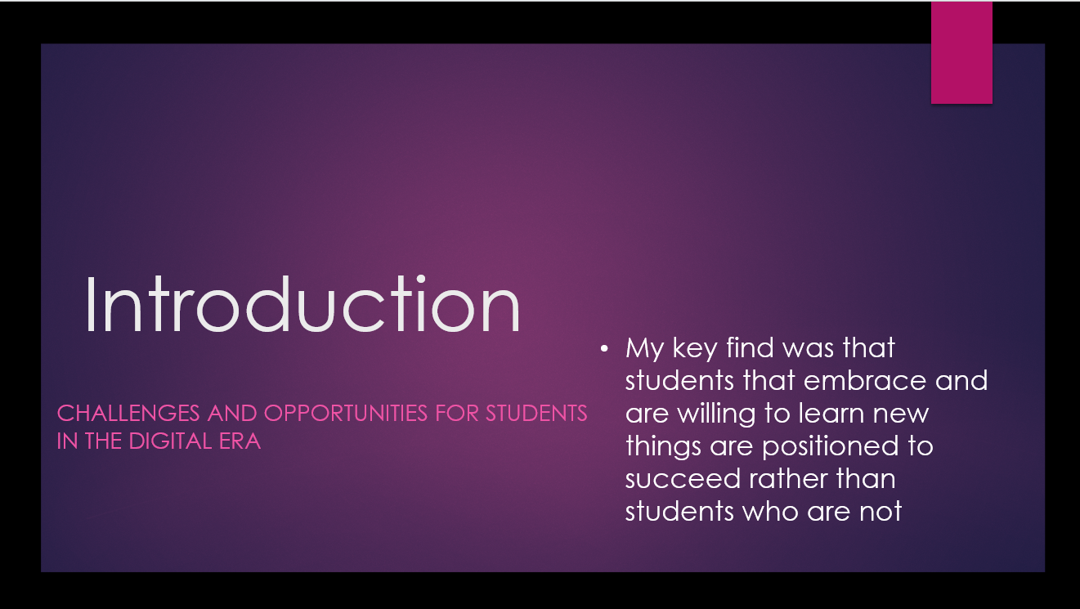

Slide 2 (Research)
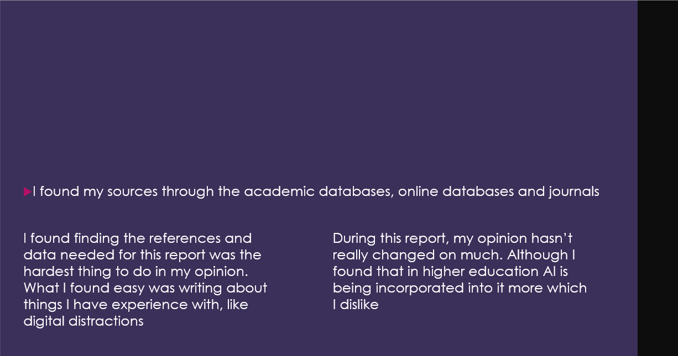

Slide 3 (Planning and writing)
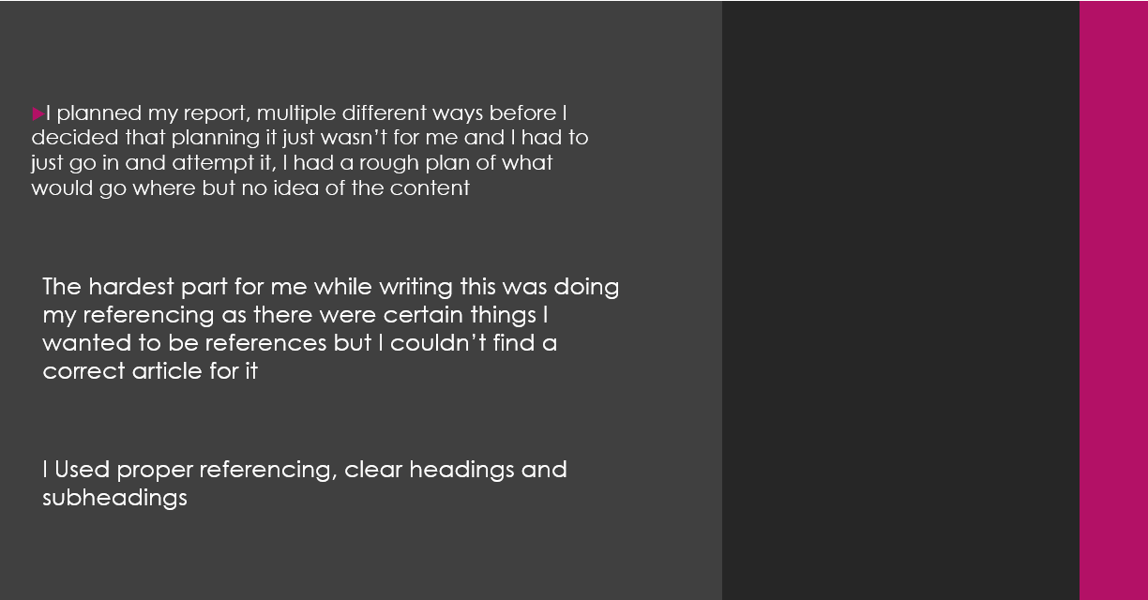
Slide 4 (Challenges)
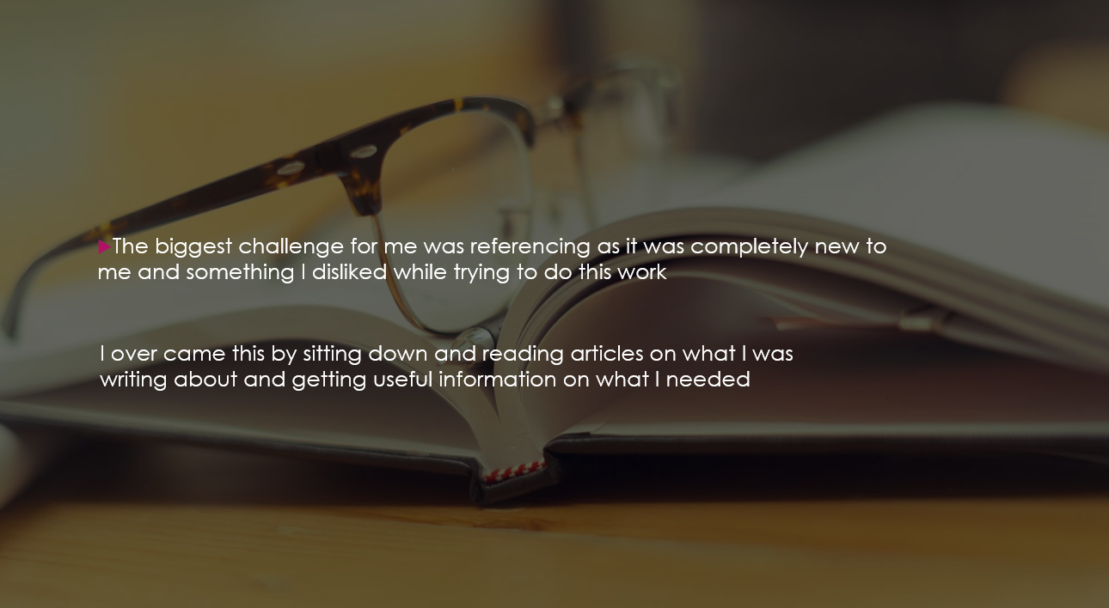

Slide 5 (Successes)
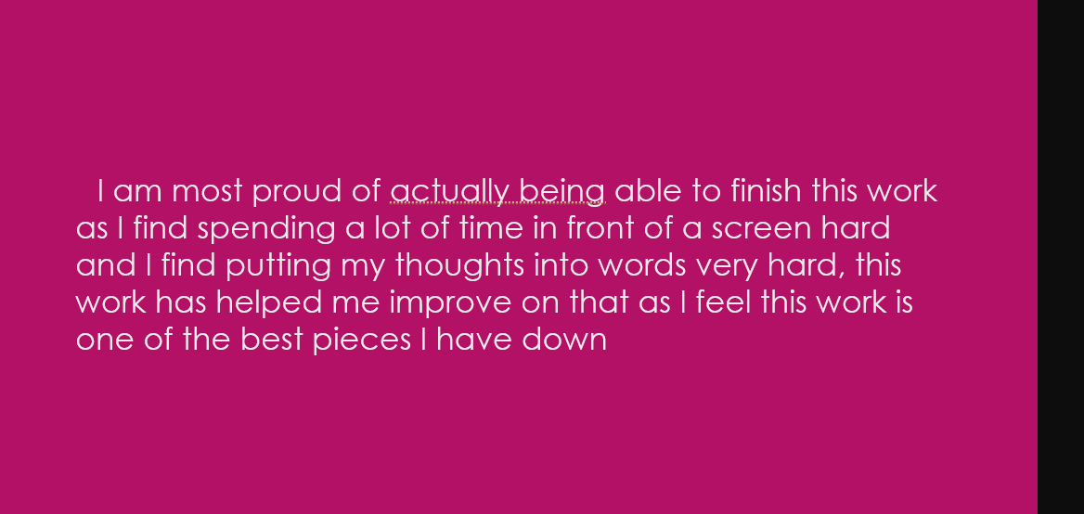

Slide 6 (Looking Forward)


