Surveying M4X01317
Basic Site Levelling at the SA1 Swansea Waterfront development
Kelly Marie Glover
Student number: 1706641
Submission date: 28/01/2019



Introduction
We were tasked to carry out a basic levelling on the planned site of a Gymnastics Centre on the SA1 Swansea Waterfront development. The Gymnastics Centre is to be positioned next to the newly built library building. The area in which the basic levelling will take place is currently being used as a carpark for UWTSD staff and students. The task was to find the difference in elevation at the proposed site and also calculate the reduced levels of various points within that area.
I will carry out a dumpy level survey that will calculate the horizontal levels on the ground and provide me with the difference in ground height at selected points. When surveying there are various terminology to understand.
The ‘backsight’ (BS) is the initial reading taken from the measuring staff at your first point. The ‘foresight’ (FS) is the last reading taken from the measuring staff at that location. The term ‘intermediate sight’ (IS) is used for all reading taken between the backsight and foresight. The ‘reduced level’ (RL) is the vertical measurement between the point and the datum. The ‘datum’ is the reference point where all measurements are taken from. The ‘temporary bench mark’ (TBM) is used if an OS bench mark is unknown. For this survey, I was provided with a bench mark of 648 metres.

Equipment
Personal protective equipment is important when surveying. A Hi-Viz jacket and hard hat must been worn during all surveying exercises, this ensures you are highly visible to everyone. It is also a good idea to wear steel toe capped boots as footwear. An umbrella may also be brought to site.
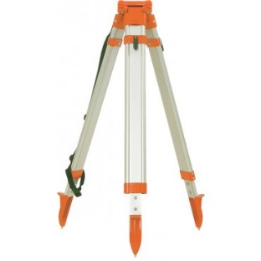
A surveying tripod is essential when carrying out a field project. Without the tripod there would be nowhere for the dumpy level to sit. It is important when setting up your tripod that the three legs are out far enough apart to ensure it is safe and stable. The legs of the tripod have a sharp metal point which can be pushed into the ground by placing your weight on the little ledge mounted to the legs.

(www.surveying.com)
You will need a field book and pencil to record your results from the survey.
A plumb bob is a metal, cone shaped weight. It is suspended from a string and is tied underneath the centre of the tripod. Due to gravity it will always hang vertically. It is used as a reference line to measure from the tripod to the measuring stations.
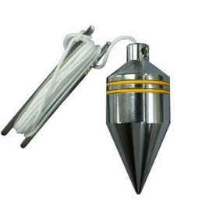

(www.indiamart.com)
A measuring tape or wheel is used to measure the distance between the plumb bob to the stations. A measuring wheel is useful if the distance is more than 100 metres. Measuring tapes can be ribbon nylon or steel.
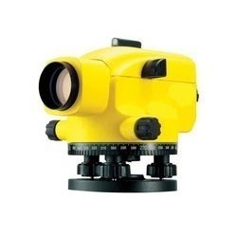
An electronic dumpy level is used to measure levels when surveying land. It is an instrument which sits on top of the tripod. The electronic level is simply a telescope which can be rotated freely around its base. It is used to measure the height of the land. Firstly, you have to ensure that the baseplate screw is tightened to secure the dumpy level to the tripod. Once mounted you will need to look at the bubble from above and adjust the three levelling screws to get the bubble to sit perfectly within the markings, this is just like a spirit level. When using the electronic level it rain, you must ensure it is fully protected using an umbrella or a rain hood.

(www.indiamart.com)
A staff is aluminium measuring instrument. It is placed at the points to be measured. It has a bubble attached to it to ensure the person who is holding it can keep it vertically level. The 5 metre telescopic staff can be reduced to 1 metres for easy use and can be stored in a bag. The reading are in metric units. Care must be taken when using the measuring staff near electric cables.
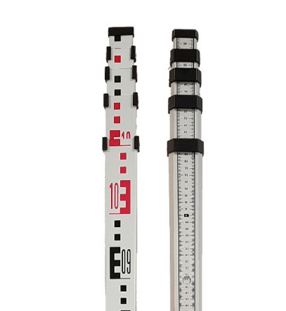

(www.imextools.co.uk)

Procedure
Firstly, we collected the necessary equipment from the university store room. We were all given a hi-viz jacket each which we wore straight away. The equipment which was needed included, 1x tripod, 1x electronic level (stored in a box), 1x plumb bomb and 1x measuring staff. Each member of the group had their own field book and pencil. It’s important to check all equipment for signs of damage before you start your levelling.
The reduced level (temporary bench mark ‘TBM’) which I was given was 648 metres and had been located on the ground with spray marker paint. From looking at the plan of the area given, we located location 1. This is where our base would be for the first four stations.
I assembled the tripod carefully, ensuring the pointed ends faced down at all times. I released the catches, extended the legs and secured the legs. I ensured that the tripod was at a good height for all team members to be able to look through the level once attached. The tripod must be positioned so that once the level is attached it can rotate in the direction of all four stations without being moved.
The level was opened from the box and placed on top of the tripod, ensuring the central screw lined up underneath. The screw was then tightened. The electronic level now had to be adjusted using the three screw adjusters underneath to get the bubble central. Once the bubble sat in the centre of the screen we knew it was level and our readings would be accurate.
After the level was fitted, the plumb bob was attached to the hook underneath the tripod and hung vertically. Where the metal cone stopped is where the exact point of location 1 would be. I marked this with spray paint.
My colleague then moved to point A which had a temporary bench mark (TBM) of 648 metres. He extended the measuring staff to its full length and held it vertically, on the TBM, facing the tripod towards location 1.
The first reading taken on the level is the back sight. This was done by rotating the level, ensuring the tripod is not moved, to the direction of station A. I then looked through the telescope, adjusted the instrument focus to take the reading from the measuring staff. The central lines and cross hairs must align perfectly to get an accurate reading. The result was recorded in our field books under Station 1: BS = 1.61 metres.
.My colleague moved to point B with the measuring staff, this reading is called the intermediate sight. The level was rotated towards point B and the reading was taken. The same method was used for point C which is also the intermediate sight, and the procedure was repeated.
Point D is named the foresight. The same procedure applied for this station. My colleague at point D had to remain at this position in till the location of the tripod was changed.
After measuring the reading for points A, B, C and D, we moved the tripod with the level and plumb bob to station 2. The tripod had to be made secure again and the electric level adjusted to guarantee it was level. After the plum bob was vertically still, I marked the ground again with spray paint to illustrate location 2.
We proceed to take reading from station E and F which are the intermediate sights for location 2.
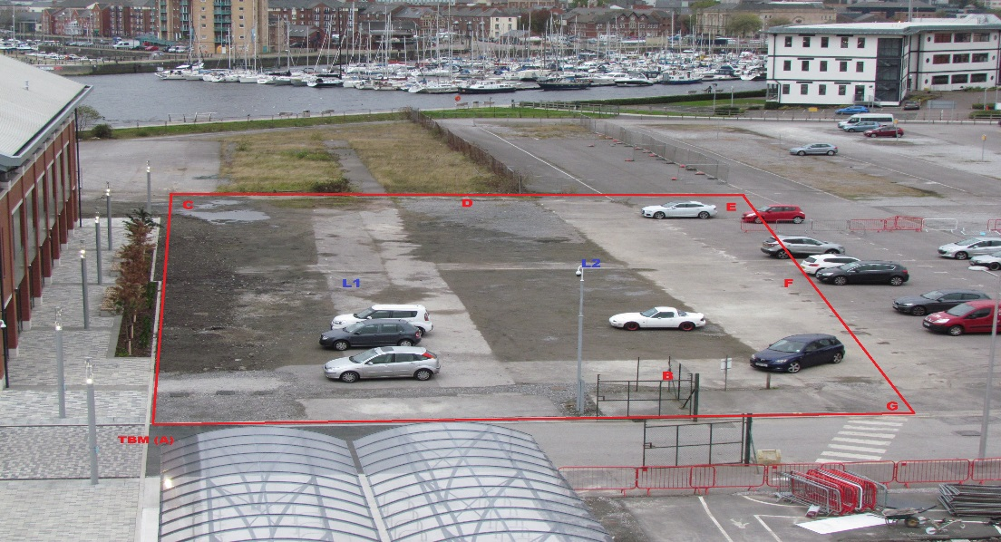
Point G was the final station, this is called the foresight reading for location 2. After we obtained the results from all seven station we all agreed the surveying site work was complete. The measuring staff was put back into its case, the electronic level was demounted and secured in the box and the tripod folded back and secured. All equipment was placed back in the store room.

Plan of basic levelling site including station and points (Young. N)

Results from field book – Reduced levels using the rise and fall method
BOOKING |  |  |  |  | REDUCTION
STATION | POINT | BS | IS | FS | RISE | FALL | RL
L1 | A (TBM) | 1.61 |  |  |  |  | +648
L1 | B |  | 1.67 |  |  | 0.06 | +647.94
L1 | C |  | 1.953 |  |  | 0.283 | +647.657
L1 | D |  |  | 1.69 | 0.263 |  | +647.92
L2 | D | 1.648 |  |  |  |  | +647.92
L2 | E |  | 1.835 |  |  | 0.187 | +647.733
L2 | F |  | 1.759 |  | 0.076 |  | +647.809
L2 | G |  |  | 1.753 | 0.006 |  | +647.815
SUM (Ʃ) |  | 3.258 |  | 3.443 | 0.345 | 0.53
All height in metres (m)

Calculation for reduced level
TBM = 648m
- Staff reading at point A is 1.61m and at point B, 1.67m. Therefore the difference in height: = A(BS) - B(IS) = 1.61 - 1.67 = -0.06m (this is a fall as it is negative)
TBM A (RL) - 0.06 = B(RL) = 648 - 0.06 = 647.94m
Therefore there is a fall in the level from point A to point B.
- The difference in height between station B and C:
=B(IS) – C(IS) = 1.67 - 1.953= -0.283m
B(RL) – 0.283 = C(RL) = 647.94 - 0.283= 647.657m
Therefore there is a fall in the level from point B to point C.
- The difference in height between station C and D:
=C(IS) – D(FS) = 1.953 – 1.69= 0.263m (this is a rise as it is positive)
C(RL) + 0.263 = D(RL) 647.657 + 0.263= 647.92m
Therefore there is a rise in the level from point C to point D.
Change to station 2
- Staff reading at point D(BS) is 1.648m and at point E, 1.835m. Therefore the difference in height: = D(BS) - E(IS) = 1.648 – 1.835 = -0.187m (this is a fall as it is negative)
D(RL) – 0.187 = E(RL) =647.92 – 0.187 = 647.733m
Therefore there is a fall in the level from point D to point E.
- The difference in height between station E and F:
=E(IS) – F(IS) = 1.835 -1.759 = 0.076m
E(RL) + 0.076 = F(RL) =647.733 + 0.076 = 647.809m
Therefore there is a rise in the level from point E to point F.
- The difference in height between station F and G:
=F(IS) – G(FS) = 1.759 – 1.753 = 0.006m
F(RL) + 0.006 = G(RL) 647.809 + 0.006 = 647.815m
Therefore there is a rise in the level from point F to point G.
Arithmetic check for the reduction level
Ʃ(BS) - Ʃ(FS) = 3.258 – 3.443 = -0.185m
Ʃ(RISE) – Ʃ(FALL) = 0.345 – 0.53 = = -0.185m
LAST(RL) – FIRST(RL) = 647.815 – 648 = -0.185m
As the answer it not 0 it is a misclosure.

Factors which could affect the accuracy of a levelling exercise
The weather can vary massively from hour to hour. When we undertook this survey it was dry but slightly windy. The wind could affect the positioning of the measuring staff. The measuring staff we used did not have a bubble staff attached which meant my colleague had to assume the measuring staff was vertical and try to keep it still.
The SA1 Swansea Waterfront area is still under development, there were construction, staff and student vehicles parked on the site which we had to survey which meant we had to be careful where the stations and points were located. Obstacles like these located on site could affect your reading.
Faulty equipment could cause faulty readings. A damaged tripod could cause the electronic level to not be positioned properly, or the plumb bob to not sit in the correct position. The electronic level must be carried in its casing at all times to prevent any damage.
Human error can influence results when carrying out a basic levelling survey that’s why it’s important to check readings several times working with colleagues is a good way to double check your work.
The terrain where the field work will take place can influence your surveying results. A survey may have to take place on rough terrain for example and this may cause differences in the results if the area is boggy or overgrown. The measuring staff will not sit exactly on ground level and therefor the reading from the level will not be genuine.
An electronic levelling device and theodolites will need calibrating regularly in order for them to be accurate. This often involves sending the devices to a professional who will undertake the job in laboratory conditions.

Fly levelling
Only back sights and foresights are used when fly levelling and the position on the level remains in the path of the survey line. It is a survey which is done to join the benchmark to the starting point. The photo below shows the proposed site for the new student and staff Gymnastics Centre where the fly levelling survey took place.
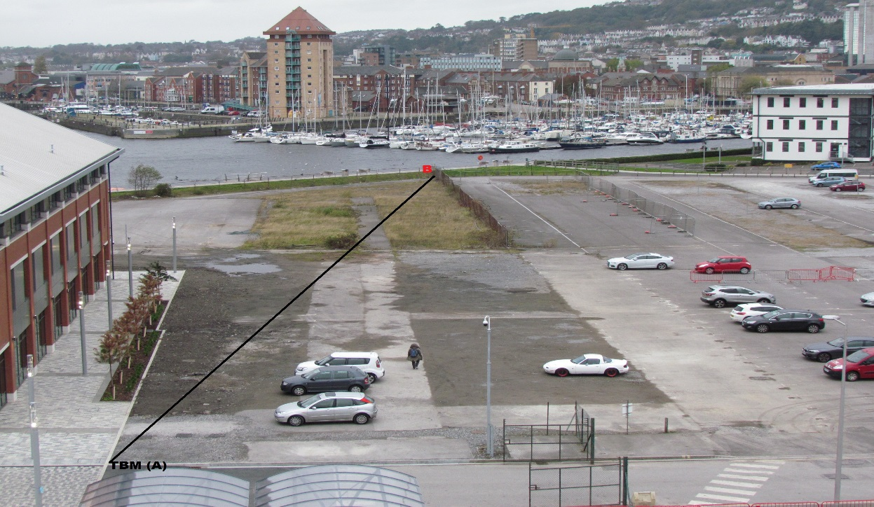

B

Station 2
X₁
Station 1

(Young.N)
Results from field book
BOOKING |  |  |  |  | REDUCTION
Station | Point | BS | IS | FS | HPC | RL
1 | A | 1.57 |  |  | 649.57 | 648
1 | X₁ |  |  | 1.7 | 649.57 | 647.87
2 | X₁ | 1.58 |  |  | 649.45 | 647.87
2 | B |  |  | 1.995 | 649.45 | 647.46
SUM (Ʃ) |  | 3.15 |  | 3.695
All height in metres (m)

Arithmetic check for the reduction level
Ʃ(BS) - Ʃ(FS) = 3.15 – 3.695 = -0.54m
LAST(RL) – FIRST(RL) = 647.46 – 648 = -0.54m

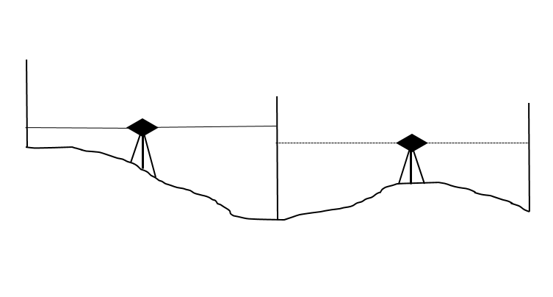
Figures used from fly levelling results.
2
1
X₁
B
A
1.995
1.58
1.7
1.57

Reference
www.britannica.com, Surveying
www.scribd.com, Introduction and Purpose of Fly Levelling
www.theconstructor.org, Dumpy Level Surveying

