
Skills for the Workplace
Module Assignment Submission
Student Name: | Selim Ahmed
Student Number: | 1705777
Module No: | BMSK4005
Module Title: | Professional Career Development

Table of Contents
Introduction: 3
Definition of Employment: 3
Definition of Professionalism: 3
Definition of Market Needs: 3
Career Lifeline: 4
Personal Values and Principals: 4
Values: 4
My Personal Values: 5
Self-Motivation Quiz: 6
The Johari Window Model: 9
Definition of Learning: 11
Leaning Styles: 11
Honey and Mumford Learning Style: 12
Kolb’s Learning Theory: 13
VAK Learning Styles Self-Assessment Questionnaire: 14
SWOT Analysis: 14
Use SWOT analysis to assess individual’s skills and abilities: 14
Analysis and Findings: 15
Part 2: Understanding and expectations of the world of employment 15
Employer Following to Recruit: 15
Activities of Recruiter: 16
Job Description: 16
Job Specification: 16
Own Potential in a Suitable Job Role: 17
CV of a Local Restaurant Manager: 17
Part: 3- Making Choice 18
Suitability: 18
Short Term and Long Term Goals: 18
Personal Development Plan: 19
Personal Development Plan Chart: 19
Conclusion: 20
References: 21

Introduction:
Employment is nothing but an act of employment someone or something. Employment is nothing but way that, people are involving themselves for earning money to live their life.

Definition of Employment:
- Employment is the emotional commitment the employee has to the organization and its goals. (Kevin Curse, Fobers Contributor and NY Time Best Selling Author)
- Employment is nothing but an emotional connection employee feels towards his or her behavior and level of effort in work related activities. (Business Dictionary)

Definition of Professionalism:
Professionalism is getting paid to do something. This is nothing but a commitment to do something by providing the best effort of someone. For performing professional activities people need some skills (Brian Rigsby, 2010).
The Merriam Webster dictionary defines professionalism as: “Professionalism is the conduct aims and qualities that characterize or mark a profession or professional person”

Definition of Market Needs:
Market needs means what market actually wants. And this things matters in case of career also. Because market has demand for jobs and that type eligible people.
Job market is a very essential market in which employers search employees according to their needs. Market need is nothing but what employers actually want or demand for fulfilling the purposes of their organization. And Job Market is the physical place of fulfilling this demand. Actually market demand depends on the demand and supply of labour (Investopedia)

Career Lifeline:
Lifeline exercise is very important for the career. It helps to develop and build up the career. A lifeline exercise helps to build up a better career. In one sentence, it helps to show the high and lows of someone’s experience and career. It can be created or drawn up across the point or data. It will be helpful and add values while creating data’s such as major issues of the employment. It is helpful and very formative about people, events and other activities in the career.

This is my career lifeline. And for reaching all these stages I have faced lots of ups and downs also. I am going to point out the ups and downs of reaching in my goals:
Came in UK for starting and developing my career. At first, I was starting doing job in a Garage of car. But soon as I have no previous experience in this sector, I switched the job and started doing job in a local restaurant as a customer assistant. After working there almost 6 months, I made a plan to develop my career in the restaurant business as well as in the marketing sector of a Multinational company. So I wanted to develop myself a little bit more for that kind job. I started my education in the leadership management course. As a manager, I need to gain knowledge about leadership skills. Besides that, I am continuing my job in the restaurant business too getting more experience beside my educations.

Personal Values and Principals:

Values:
Values are nothing but what a person actually thinks that are important and wants to be doing about his or her life. According to Wilson (2009), “Freely chosen, verbally constructed consequences of ongoing, dynamic, evolving patterns of activity, which establish predominant reinforces for that activity that are intrinsic in engagement in the valued behavioral pattern itself”
Ethical behavior and values are important for the wellbeing of others and the company. In other words, a man needs making decision on basis of his or her values and self-interests. I am going to explain some values in the below:
Individualization | Each person has the right to make his or her own individual image or personality. But sometimes individualization is not enough.
Acceptance | Acceptance is one of the best value of someone. We met lots of people every day with different personalities and morals. So we need to accept an individual as they are. This includes: Color, Skin, Religious, Belief, Income, Status and so on.
Self Determination | Each man has the right to choose their own ways to do a work. Also they will use their own ways.
Confidentiality Issues | People will start trusting on others when we keep their information confidential. People like confidentiality and always feel happy when someone else keep their information confidential.
Respect | Each person has the expectation to get respect for who they are and what they are wanted to be. It really means to be someone for them. So respect is must. There is a proverb goes: “Give Respect to Take Respect.” So everyone needs to be treated with respect.
Expression | Expression means presentation. Presentation is a matter and very important part. People need to create the expressions that suits them.
Safety | Safety is a big issue. People always expect for healthy and safe environment for himself. So creating safety is considered as another very important value and principal.

My Personal Values:
Everyone has their own personal values. My values created from my family members. I belong to a middle class family where hand working is the best solution to earn money and live a very comfortable life. So behind building up my own values I inspired by my family.

Self-Motivation Quiz:
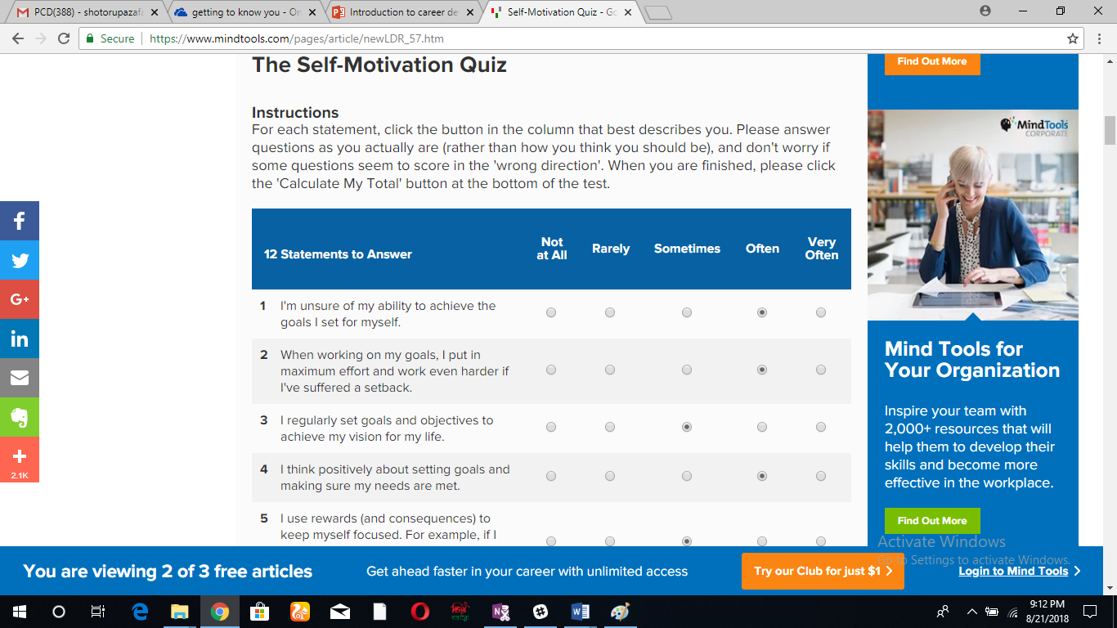
This is a very important quiz to know how much motivated a person can be through the total score from this motivational quiz.

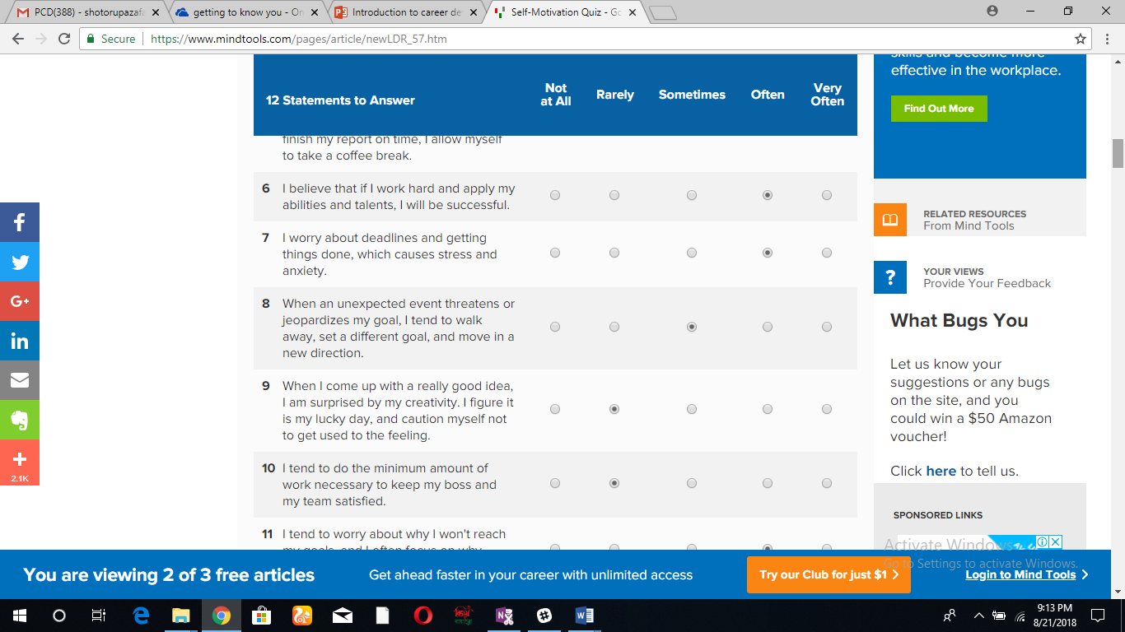
Picture: 2

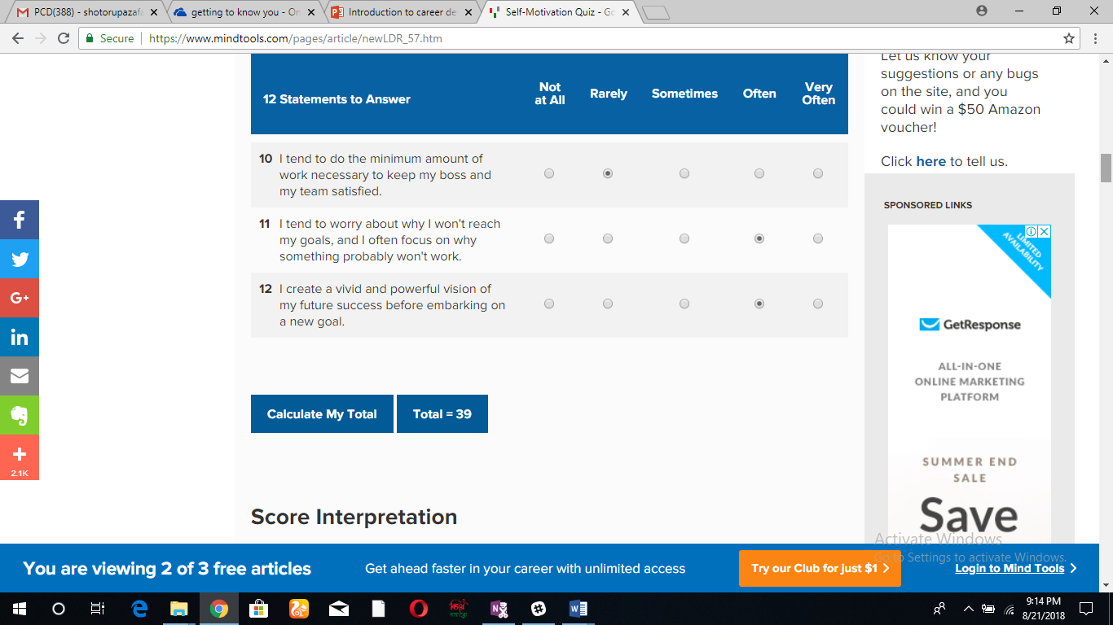
Picture: 3
In this self-motivation evaluation my score is in between the range of 28-43. In this view I am doing on in case of self-motivation. I am not certainly failing but however my score can some a little bit more. For doing this I need to give more focuses on the motivational factors of my life. There are four strongest level of Motivation:

Self Confidence and Self Efficacy:
Albert Bandura, a Professor of Stanford University said, “Self Efficacy and Self Confidence is a belief of own ability to succeed. And also it is the ability to achieve the goals that we set for ourselves. This belief is highly connected with achieving the goals of our success.”
- I always think about own achievements of owns life, That is one of the key value of my life
- I try to find out the strengths of mine so that I can use it for achieving different kind of purposes.
- Determine what people actually think that are my strengths and key capabilities
- Always very concerned to achieve the goals and after achieving it just enjoy the success of it.
Positive Thinking:
Positive thinking is highly connected and closely related with self-confidence as a factor of self-motivation. It is important to get and set up a very positive mind. Especially positive mind works very well when things are not going so well. Some values that is mandatory for creating positive thinking are given in the below:
- I am become aware of my positive ideas and plans.
- I always challenge my negative thoughts, find out them and replace it with the negative ones
- Create a tremendous big picture of what I wanted to achieve and after that develop plans to achieve the targets.
- Always practice the positive thinking.
Focus and Strong Goals:
Each goal is an individual promise. When we set a goal, we actually set some promises. Focus on goals and find out the ways that provide someone a clear direction to achieve that goals. A goal must be consisted of:
- Clarity: Effective goals are clear. They are also effective and easy to measure.
- Challenges: Goals must be difficult. But not difficult enough that cannot be achieved.
- Commitment: Goals must be liked attainable as well as achievable. So it is like to be committed to be achieved.
- Feedback: A feedback on achieving goals are must. Either the goal achieved or not, that is very important part of achieving goals. Because if goal did not achieve, we have to set some other goals or need to change the plans. That is a very important core value in case of achieving goal.
Motivating Environment:
The final thing is to surround in an environment that reminds us about the goals, objectives, mission and vision. This is the external factors that motivate our values and principles to achieve our goals.
- Observe the team opportunities. Working in a team will help to achieve the goal in a very easy way instead of work in achieving a goal individually.
- Trust is a very important factor for team members for achieving the goals. Need strong trust among team member to achieve goals.

The Johari Window Model:
The Johari Window model is nothing but a special psychological tool created by Joseph Luft and Harry Ingham in 1955. It consist with:
- Self-Awareness
- Personal Development
- Improving Communications
- Interpersonal Relationships
- Group Dynamics
- Team Development
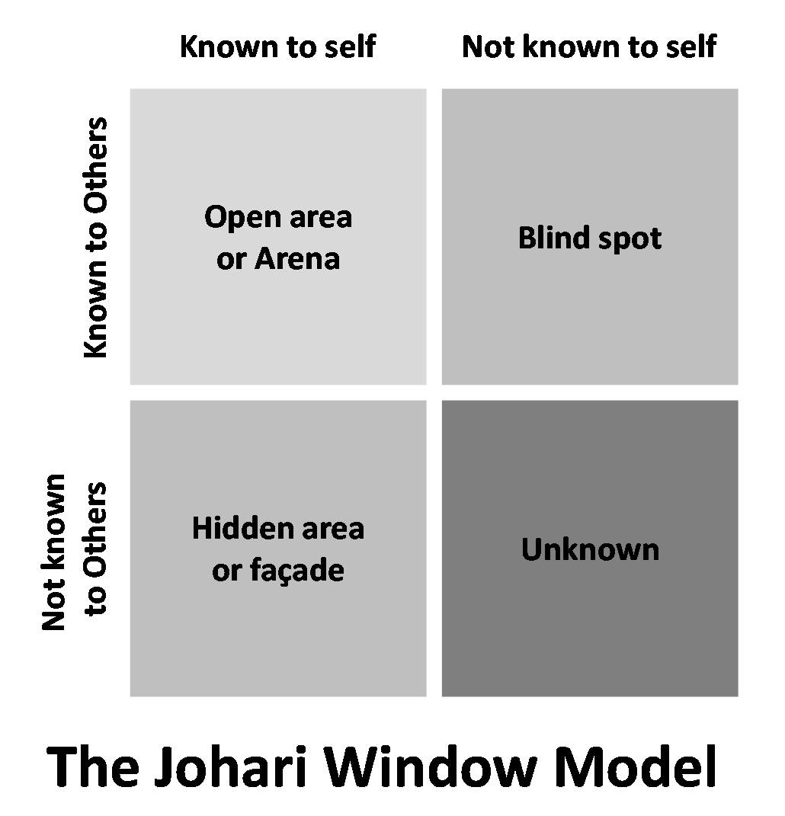
- Inter Group Relationships
Johari Windows Model is consisted with two important factors:
- What I know about myself
- What other people knew about me
Open Area:
Open area means anything that I knew about myself and want to share with others. Means everything is clear and open. This open area helps to build trust among one another and helps people to know each other. People usually share their information to others when they can build trust. So this area is known as open area where information of an individual is opened and very specific.
Blind Area:
Blind area means any part that an individual does not know about himself but others and other group members knew it very well is called Blind Area. By getting feedbacks from others about the positive and negative sides of own, one can easily develop himself more. So feedback from team about personal characteristics is also considered as important and necessary.
Unknown Area:
There are also aspects that an individual aware about himself but others do not know about it which is considered as the unknown area. Means this is an area that is unknown to someone else.
Hidden Area:
Hidden area means an individual do not tell one of his aspect to anyone, but now he wants to share it with others which was previously kept hidden. That is known as the hidden area.

Definition of Learning:
Leaning is nothing but considered as a function of the brain. It understood by many ways and definitions:
By Robert Gagne, “Learning is a change in human disposition and capability that persists over a period of time and is not simply scribble to processes of growth.”
From connectives- a learning theory for the Digital Age by George Siemens: “Learning is a process that occurs within nebulous environments of shifting core elements – not entirely under the control of the individual. Learning (defined as actionable knowledge) can reside outside of ourselves (within an organization or a database), is focused on connecting specialized information sets, and the connections that enable us to learn more are more important than our current state of knowing.”

Leaning Styles:
Learning styles is the unique collections of individual skills and preferences that strongly affect how a person perceives, gathers, process and analyses the information.

Honey and Mumford Learning Style:
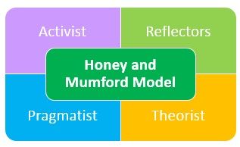

The four Learning Styles (Mobbs 2010),
Activists:
Activists are considered to those individuals who learns by doing. They take on the job training as they love learn about an activity by doing it. They have encourages and they wanted to know the things through learning. These is included:
- Brainstorming
- Problem Solving
- Group Discussions
- Puzzles
- Competitions
- Role-play
Theorists:
They want ideas, models and many other theories with a specific goal to participate in the specific learning styles. They also like statistic data’s and chart, graphs style learning and their learning procedure is long term.
Pragmatists:
These individuals have the capacity to use their learnings and use their learnings in the reality. They love experiments with their new thoughts and ideas.

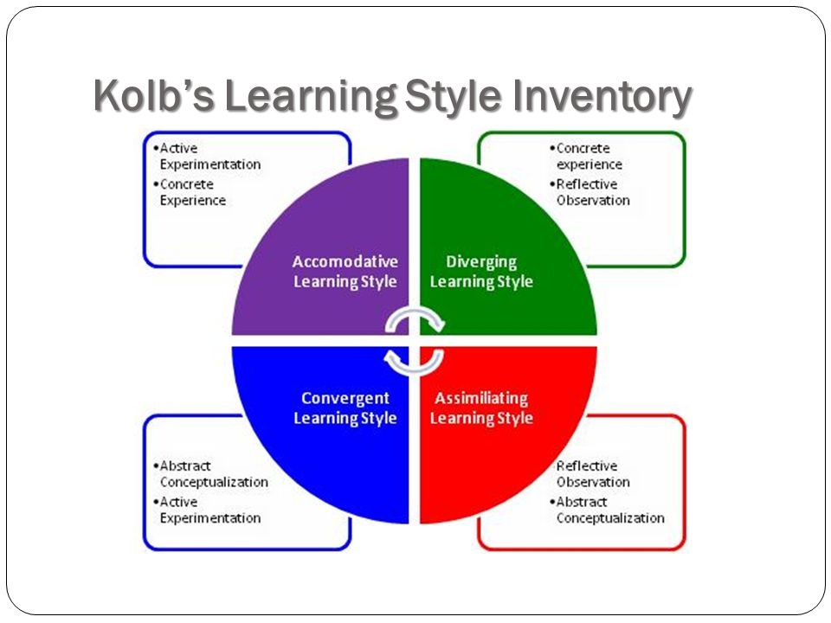
Kolb’s Learning Theory:

In this figure it is clearly mentioned that, Actully Kolb’s has 4 stages of learning styles. Kolb’s Learning Theory (1974) mentioned briefly that different people want and preferred different types of learning styles. Various factor’s are influences a person’s style of learning in a different way.
For Example:
- Social Environment
- Educational Experiences
- Basic Cognetive Structure of an individual
Diverging | This type of individuals are able to look at things from various different ways and perspectives. Their characteristics are very sensitive and they love to watch rather than do to. They can watch the things in several view points which can not be seen by a general man.
Assimilating | For this kind of Individual ideas and concepts are more important than people. They want logical informations instead of practical experiences.
Converging | People with converging learning styles can solve the problems that they have faced and they solve and find out solutions for the practical issues. People with this category are the best in use of their theories in the practical issues. They can solve problems by using question answer patterns.
Accomodating | The accomodating learning style is based on intitution instead of logics. These people are usually based on practical approach instead of experimental approach. They love to take challenges and make plans of fulfilling the challenges.
Source: Saul Macleod (2013)

VAK Learning Styles Self-Assessment Questionnaire:
I have done an online survey of VAK Learning Style to know under which sector I can identify of myself Visual Learner’s (The learners who preferred to learn through picture, handouts and visual kits), Auditory Learner’s (They preferred more learning by listening lectures and other audio materials), Kinesthetic Learner’s (They preferred learning things by doing practically).
After adding up of how many A’s, B’s and C’ selected:
A’s = 17 B’s = 4 C’s = 9
Here, If chose mostly A’s, I have a VISUAL learning style. If I chose mostly B’s I have an AUDITORY learning style. If I chose mostly C’s I have a KINAESTHETIC learning style.
Findings:
I am in the section Visual Learning Style. A person who belongs to visual learning style has a preference for seen or observe things for example: Picture, Diagrams, Demonstrates, Displays, Handouts, Films, Flip-Chart and so on. I am actually love to take instructions of doing something. As a visual learner:
- I love to read
- I take copious notes from slides
- I am a very good observer and presenter
- I like to notice everything in details in a big picture
- I like to manage and communicate with other people
My learning style absolutely perfect and suitable with the career. I want to Marketing executive in Multinational Company in our country. I love to read, take notes, I am a good observer of people and in the near future I will be a good observer of my clients. I am extrovert and I love quiet surroundings. So it clears that, I am following Visual Learning Style subconsciously from the very beginning.

SWOT Analysis:
SWOT analysis is nothing but a Strength, Weakness, Opportunity and Threat analysis and it is considered as a very common tool for professional world. A personal SWOT analysis is very important for the individuals for achieving their common goals.

Use SWOT analysis to assess individual’s skills and abilities:

Marlo Zakra (a certified professional coach) said, “A SWOT Analysis can help people become the best version of themselves.”

Analysis and Findings:

Strengths:
Good Sides: | I am very honest and hard worker. I have some other positive traits too like: Goal Oriented and Challenge Lover so on.
Skills: | I have IT or Computer based skills. As I worked in a local restaurant as a manager, I have managerial and leadership skills also.
Natural born skills | I am a very good listener as well as speaker. I keep promises as well as my commitments.
Weakness:
Negative work habits and traits | I am a very talkative person.
Do you need any improvement | Yes, I need improvement in my communication skills as per the requirement of my professional goal.
Noticeable weakness | My result in my Leadership management course is not that much up to mark. That will be a challenge for me to get job in MNC.

Opportunities:
Situation in the country you want to build my career | Very Uncertain
Technological Facilities: | It is a developed country. So technologies are developed as per demand and situation
Target Industry growing | Yes
Threats:
Competition of getting job | Yes
Biggest danger my goal | Huge competitions in case of skills and advancement.

Part 2: Understanding and expectations of the world of employment
In this part I will discuss the understanding and expectations of the world employment:

Employer Following to Recruit:
- Understand their own path proactively: Employer wants a story in such a way from the job seeker that he or she knew his goals and also knew that how to achieve this goal.
- Goal Oriented: Everyone has short term goals and long term goals. So interviewer look at how many goals the job seeker already set up and how many among them he can achieved.
- Team Player: To do a job, an employee must need the skills to contribute in the team. Maximum time employer are searching for a team player who can cope up with different sort of people.
- Have Interpersonal Skills: Communication skill is a must criteria maximum time interviewers are asking and searching in the job seeker.
- Have Encourage to Learn: Learning is a perpetual process. There is no age of learning. So having encourage of learning is a very strongest side that interviewer searching for.

Activities of Recruiter:
- Achieve Organizational Visions: Recruiter play an important role of achieving organizational future visions by hiring the right people in the right place.
- Identify Potential Candidate: Identify potential candidate is must. The aim of an recruiter will be to identify the candidate that is suitable for achieving organizational goals and objectives.
- Need Analysis: Understand the company needs. What kind of Candidates Company needs to fulfill the vacant position of the organization?
- Recruit the Targeted Candidates: A recruiter’s one of the most important traits is to attract the target candidates. It will save time as well as make smooth the overall recruitment process.
- Back up plans: Recruiter will always make back up recruitment plans. If one plan won’t come out perfect, go for the next one.

Job Description:
Job Description is a mandatory thought of today’s companies all over the world. A job description or JD is nothing but a very simple document that describe the tasks, duties, responsibilities of a specific position. It also included with the job position, salary, locations and so on
According to Torrington, “A JD is generally made for analysis a job which are included the tasks that are necessary to perform a job.” This analysis means the skills and knowledge an individual need to perform a specific task or job.

Job Specification:
Job Specification means the skills, abilities and others need to perform a specific task or job properly. Job Specifications attached with different aspects like: Education, Experience, Skills and Abilities needed to perform a specific task. In this competitive world, to build up a very successful career a candidate must need the skills on the basis of an organization want. So job seekers need to focus on Job Specification. As job Description and Job Specification are interrelated with one another.

Own Potential in a Suitable Job Role:
I have been working in this restaurant almost 5 years. Here, I developed my managerial skills a lot. I learned how to deal with different types of people. As everyday lots of new and old customers come to this Restaurant. I learned how to control the anger and replying in a very polite way. In these 5 years of my experience, I did a lot of Market Research on Customer’s Demand and Competitors. I got the Complain Management skills by managing the complains of the customers. Learned about government rules and regulations of different businesses.
As I have experience in restaurant business and market sides, I want to develop my career in a Multinational Company in UK as Marketing Executive. That’s why I want develop myself. I
Admitted in a Leadership Management Course to develop my leadership skills with the managerial skills, which is a mandatory requirement in the MNC’s of UK. With the help of these skills and degree, I will reach my goal to work in MNC very soon.

CV of a Local Restaurant Manager:
Name: Selim Ahmed
Address…………………………………………………
Phone No: …………………………………………
Email:
Career Objective: To work in a Restaurant as Manager and develop myself rapidly with increasing my responsibilities.
Key Skills and Competencies:
- Have Managerial Skills
- Strong interpersonal and people management skills
- Ability to work under pressures
- Target Oriented
- Handle every situation politely and perfectly.
Work Experience:
Local Restaurant in UK
Position: Manager
Year: 2015 to Continue
Duties and Responsibilities:
- Look after the overall restaurant activities of the restaurant
- Ensure good quality of Food with taste
- Train up the waiters of the restaurant to ensure the quality service
- Be very careful about the decoration and neatness of the restaurant
- Make long lasting relationship with the customers as well as supplier
- Do market research about customer’s demand and competitors
- Involve in different kind of promotional activities.
- Do lots of work in team.
Education:
- I am doing graduation in Leadership and Management Skills from University of Wales Trinity Saint David.
Year: 2017 to Continue
Language: English, Bengali, Hindi
Reference: Available on Request.

Part: 3- Making Choice

Suitability:
Suitable job is a very important factor now a days. When people do not get a suitable job, they switch it and look for a suitable one. For Example: I switched my very first job because I did not enjoy it and somehow I did not get it suitable for me. So suitability is an important factor.

Short Term and Long Term Goals:
Everyone has some short term as well as some long term goals in his life. I will discuss my goals through the SMART Objective Framework:
- Specific: Target a specific area. I have divided my goals as I want to grow up my career. My Short-term goal is to join in the marketing department of a multinational company in UK and long term goal, I want to be a leader in the marketing department in the MNC of UK.
- Measurable: The goal must be measurable, or minimum can count the progress. I want to achieve my short-term goal within year 2020 after completing my graduation and I want to achieve my long term goal within year 2025.
- Attainable: Specify the goal will be achieved. My goals are attainable. Because to fulfill my long term and short-term goals I am doing graduation on Leadership and Management Skills also I am doing job in a local restaurant.
- Realistic: The goal must be realistic. Do not fix any goals that are impossible to achieve. Goal to work in MNC can be achievable and real.
- Timely: Specify the time. I fix a time till year 2025, which I think perfect to achieve my goals.

Personal Development Plan:
Now a days companies are very much concerned about employee development plan. Development is considered as essential term in case of fulfilling the current demand of manpower. To achieve long term and short term goals, personal development is must. Because without development it is impossible to achieve the goals. Now I am going to discuss the personal development cycle on basis of my long term and short term goals:
Establish Purpose: As I mentioned my purpose is very clear. My short term goal is to work in the Marketing Department in a Multinational Company. And my long term goal is make myself a leader of MNC in UK.
Identify Development Needs: For these goals I need to develop my skills, abilities and knowledge. As I already worked in a restaurant as manager, I have communications and other skills too that are needed to work in the marketing department. I have mentioned about my skills and abilities earlier. Besides now I am doing my graduation in Leadership Management Skills as my target is to become a leader in the Marketing sector of MNC.
Learning Opportunities: As the market is expand, there are huge learning opportunity in this sector in the market. So I am trying my best to use my learning opportunities inside the organization as well as outside the organization.
Collect Necessary Resources: I have gathered all necessary resources that will help me to achieve my goals. I am doing lots of market research, make good long lasting relationship with customers as well as suppliers. Soon I will do some short training courses in the field of marketing to enhance my values.
Evaluate the Review: I am trying my best to evaluate my development for achieving my short-term and long-term goal with in the specific time schedule.
Source: Chartered Management Institute (2015)

Personal Development Plan Chart:
Section | Short Term Goal | Long Term Goal
Establish Purpose | To Get job in Marketing Dept. at MNC | To be a leader of MNC
Development Need | Get more experience as a Restaurant manager, Improve Communication Skills, Managing Skills, People Handle Skills, Build up relation with customers | Increase leadership skills, do market research, get educational knowledge about leadership skills
Learning Opportunities | Attend Training Sessions, Seminars, Talk with other people on the same positions, Read Newspapers, Do Market Research regularly. | Knowledge about the leaders or managers of MNC’s, Increase Communication level with them by using social medias.
Collect Resources | Collect all necessary documents and certificates that will be necessary and add the values in case of applying in a suitable job at MNC. | Tried to collect the contacts of the leaders of MNC’s as well as other papers that will be helpful for you in the future.
Evaluate the Review | From now I will evaluate my every tasks that is important for me to achieve my short term goal. | As well as I will evaluate my reviews too to become a leader of MNC within year 2025.
Completion | □  Date  □  Date  □ | □  Date  □  Date  □

Conclusion:
Now a day’s career is considered as one of the most important part of our life. In UK make or female does not really matter. For developing a good career setting long term and short term goals. Also to achieve that goals, everyone needs some professional as well as personal development plans. Undoubtedly, it’s a very long term process. Moreover, to develop the career, everyone faces some bindings and problems. But we have to solve it and overcome it. Because, success never comes out in one night. We need to hard work with patience and proper plans.

References:
- Justin Warner (2018), 7 Definitions of Employee Engagement retried from: https://www.decision-wise.com/7-definitions-of-employee-engagement/
- Brian Rigsby (2010), What is professionalism retried from: https://envoc.com/think/what-is-a-professional
- Investopedia (2017), Job Market, Retried from: /www.investopedia.com/terms/j/job-market.asp
- Ralph Barton Perry (2007), The definition of Values, retried from: https://brocku.ca/MeadProject/Perry/Perry_1914.html
- StudioQ (2013), “Work within a legal and ethical framework” retried from: https://etraining.communitydoor.org.au/mod/page/view.php?id=54
- The Self-Motivation Quiz, Retried from: https://www.mindtools.com/pages/article/newLDR_57.htm
- Connie Malamed (2016), 10 Definitions of Leaning, retried from: heelearningcoach.com/learning/10-definitions-learning/
- Saul Mcleod (2013), “Kolb Learning Style”, retried from: http://cei.ust.hk/files/public/simplypsychology_kolb_learning_styles.pdf
- Chartered Management Institute (2015), “Personal Development Planning” Retried from: https://www.managers.org.uk/knowledge-bank/personal-development-planning

