

University of Wales Trinity Saint David (UWTSD)
Module Name: Employability and Career Development
Module code: LCLM 4005
Assessment Title:
Mock Interview – Component 1 Assessment
CertHE Business Skills for the Workplace
Submitted by:
Iulia Teodora Vilsan
Student ID: 2524025
Lecturer: David Oyebisi

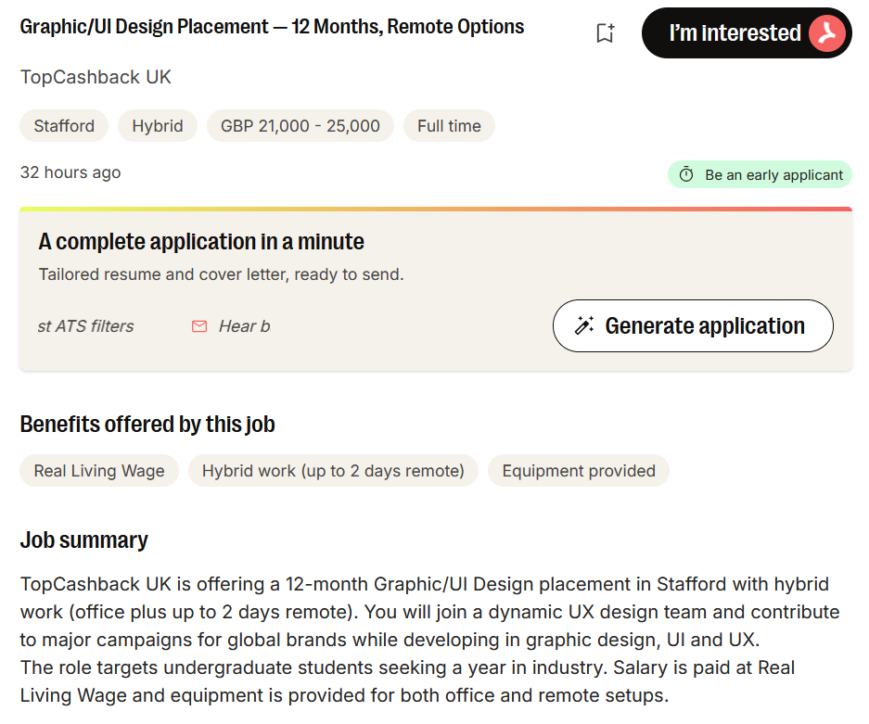
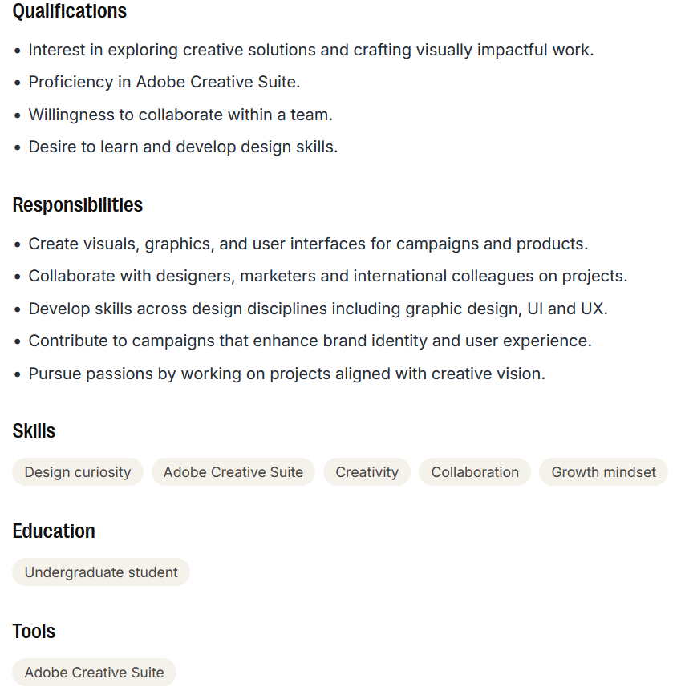

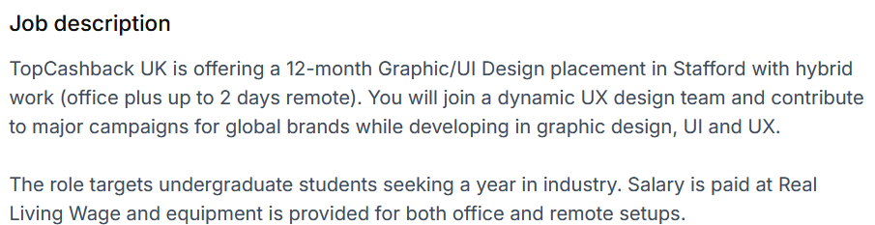

The Job Link:

https://www.jobleads.com/gb/job/graphic-ui-design-placement-12-months-remote-options--stafford--e2c75fa2aeb77c8996fc4b8ad688c3ad2?utm_campaign=google_jobs_apply&utm_source=google_jobs_apply&utm_medium=organic

Iulia Teodora Vilsan

Stafford / UK | Phone: 07508859544 email: viuliateodora@yahoo.com
LinkedIn: https://www.linkedin.com/in/iulia-vilsan-351837318
Personal Profile
Motivated and creative student with a strong interest in Graphic Design, UI and UX. Currently working in stock control and studying Business Management while developing design skills through courses and personal projects. Reliable, organised, and always ready to learn new tools and improve visual design abilities. Looking for a 12-month placement to grow as a designer and gain real industry experience.
Key Skills
- Adobe Creative Suite (Photoshop, Illustrator, basic XD)
- UI basics: wireframes, simple layouts, visual hierarchy
- UX basics: user flows, accessibility awareness
- Creativity and visual thinking
- Colour theory
- Figma (beginner level)
Work experience

Stock Control Associate – Pets at Home July 2024 – Present
- Managing stock levels and placement using the JDA system and SAP.
- Keeping stock accurate through regular inventory checks and investigations.
- Supporting deliveries and ensuring products reach stores in good condition.
- Monitoring inbound orders and helping close them quickly to improve availability.
- Improved weekly stock KPI accuracy by 98%
- Reduced discrepancy investigation time by 10 hours/week.

ICQA Problem Solver – Amazon UK December 2016 – February 2024
- Investigated inventory issues and corrected stock errors.
- Analysed data to find root causes of problems.
- Worked with multiple departments to improve processes.
- Gained strong organisation, teamwork and communication skills.
Education

University of Wales Trinity Saint David (UWTSD) - (2026)
Business Management in the Workplace – Year 1
Planning to start a Graphic Design course next academic year.
Web & Software Development Programme – Amazon - (2022 – 2023)
ITonlinelearning Ltd. & Codecademy
Google UX Design Certificate - In progress
Foundations of UX, wireframes, prototyping, user research.

Attributes
- Digital illustration on tablet (Procreate / similar apps).
  - Personal portfolio https://iuliavilsan.my.canva.site/
- Personal graphic design practice: website, logos, posters, simple UI screens.
- Created several pro bono logos for small projects to gain experience.
  - Logo created for small business https://preservia.co.uk/
- UX course work: wireframes, low-fidelity prototypes, user journeys.
- Continuous learning through online tutorials and design challenges.
- Strong interest in Graphic Design, UI/UX, branding and creative problem solving.

Iulia Teodora Vilsan
ST17 4JB
209 Silkmore Lane

Hiring Manager
TopCashback UK
Stafford, UK
15 October 2026

Dear Hiring Manager,
I am writing to apply for the Graphic/UI Design Placement at TopCashback UK. I am a motivated and creative student with a strong interest in Graphic Design, UI and UX, currently working in stock control while developing my design skills through courses and personal projects. I am looking for a 12-month placement where I can grow as a designer, learn from experienced professionals, and contribute to real campaigns.
Although my background is not yet in design, I bring valuable transferable skills from my roles at Pets at Home and Amazon, including organisation, accuracy, problem solving, and collaboration. In my current role as a Stock Control Associate, I work with systems such as JDA and SAP, investigate discrepancies, support deliveries, and help maintain reliable stock data. These tasks require attention to detail, structured thinking, and clear communication, qualities that support strong design work, especially in UI and UX.
Alongside my job, I am actively building my design foundation through the Google UX Design Certificate, digital illustration practice, and personal graphic design projects. I have created logos, posters, and simple UI screens, and I regularly challenge myself with wireframes, prototypes, and user journeys. I enjoy exploring creative solutions and improving visual design skills, and I am confident in my ability to learn quickly and adapt to new tools such as Adobe Creative Suite and XD.
What attracts me most to this placement is the opportunity to join a dynamic UX design team, contribute to campaigns for global brands, and develop across graphic design, UI and UX. I am enthusiastic, curious, and committed to improving every day, and I believe this role is the perfect step for me to transition into the design industry.
Thank you for considering my application. I would welcome the opportunity to discuss how my motivation, creativity, and willingness to learn can support your team at TopCashback.

Yours sincerely,
Iulia Teodora Vilsan

