Lessons from the Soddgarŵ
Lily Mŷrennyn

As Autumn arrives this year, I'm reminded of the atmosphere, colors, and feelings that inspire much of my work. Y Soddgarŵ (Ross & Mŷrennyn 2021), my first published book as an illustrator, is no exception to the influence of Autumn, so it is fitting that I saw the physical book in a shop for the first time this October.

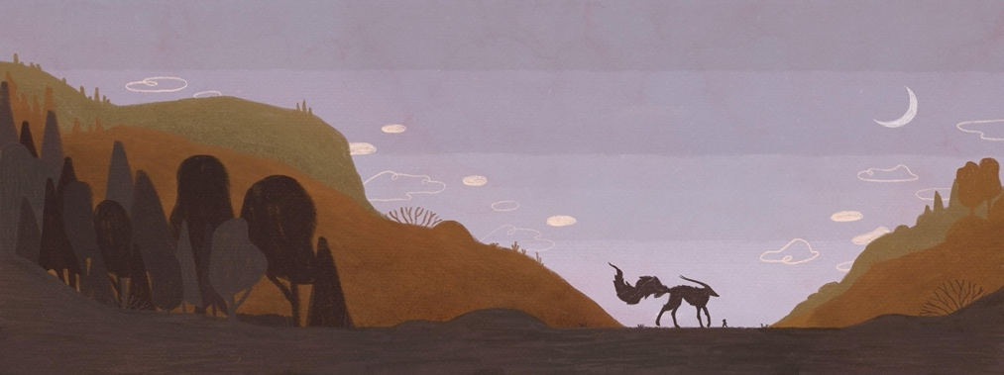

Mŷrennyn (2021) Y Soddgarŵ

The story, for children, written by Manon Steffan Ros and published by Atebol earlier this year, is for me a story about friendship. ‘At first glance, this concept may seem obvious and simple, but as I often do as an artist and as a person’ (Beynon 2021 p 333), I have come to find a deeper meaning and interpretation for the concepts that appear in the story.

There is a typical attitude of fear and hostility around the titular creature, the Soddgarŵ, when the story begins. The townspeople are scared and angry at this new arrival that has come into the area and make judgments based on presumption and a lack of understanding. These ideas become exaggerated and blown out of proportion, to the point where the creature gains a reputation as a terrible monster. (Roberts 2021 p 13)

By the end of the story, everything works out well, but not without the empathy and understanding shown by one child. This development is noteworthy, not only because the story is aimed at children, but also because it may ring true beyond the confines of the story. It brings up the notion that perhaps we should think more carefully about where our ideas and assumptions come from, but it also gives a beautiful example of what children (and everyone!) can achieve if given the chance to follow their intuition, empathy and kindness above all else. (Davies 2013)

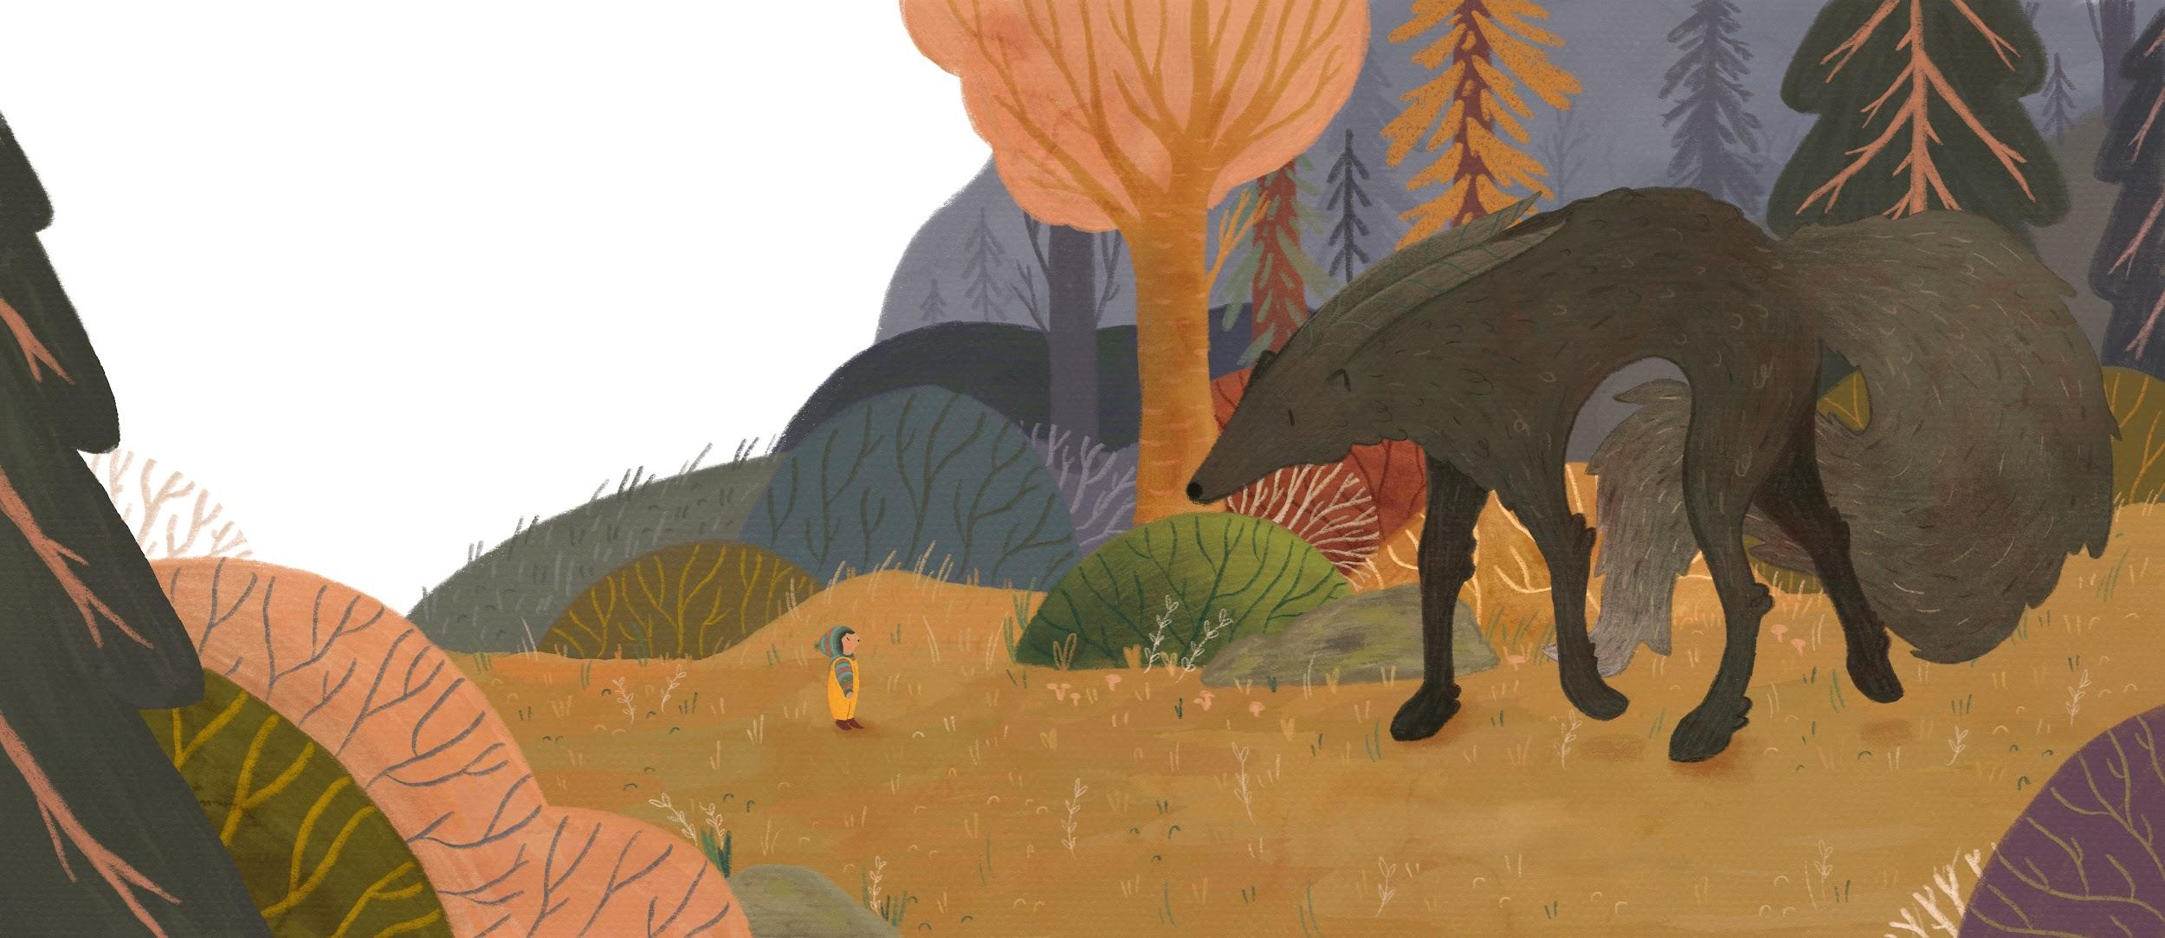
Lily Mŷrennyn (2021) Y Soddgarŵ

The opportunity to illustrate the book came through entering a competition with the Urdd Eisteddfod, in early 2020 before the lockdowns. The competition brief included creating pictures to accompany the text of the story. In particular, it was important to create a visual form for the creature, because images can play a major role in the way a concept or character is received. I decided to use a mixture of elements from different animals to create the Soddgarŵ, but the main inspiration was my three dogs. I hoped this choice would create a feeling of sympathy and familiarity towards the creature.

Something truly valuable that came from the opportunity was the experience of creating a book from beginning to end. Working hand-in-hand with the publishers provided many useful and transferable insights into the process and the publishing world. I am optimistic that the experience and skills I developed through the project will be invaluable to my career, and I hope to be able to create more narrative work in the future.

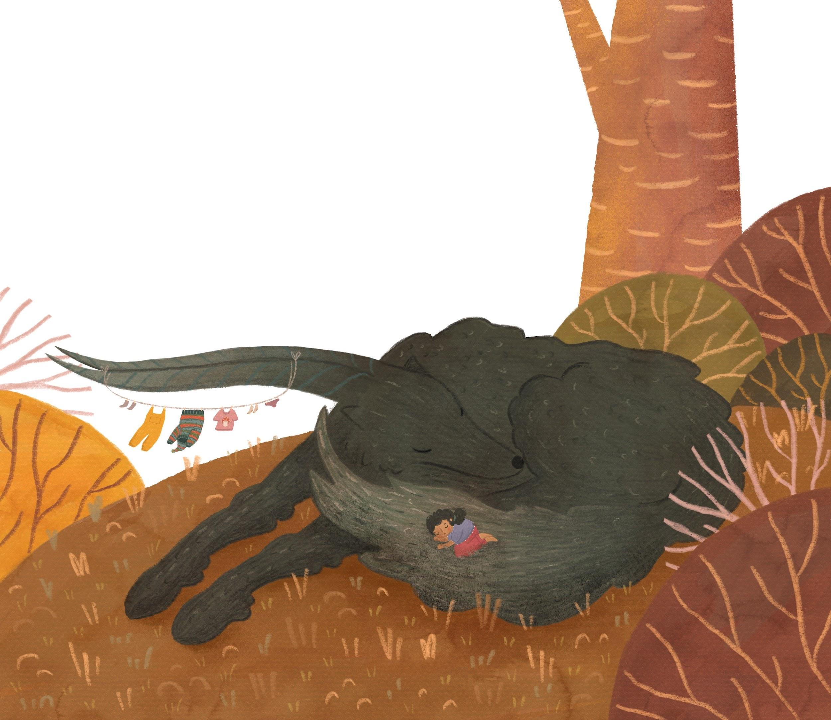
Mŷrennyn (2021) Y Soddgarŵ (2021)

The Soddgarŵ by Manon Steffan Ros and Lily Mŷrennyn (2021) is available through the website Atebol.com, as well as in bookshops and libraries across Wales.

Lily Mŷrennyn graduated with a BA(Hons.) in Illustration from Swansea College of Art in 2020. She works freelance as an illustrator and artist and has recently returned to Swansea College of Art to work as an artist in residence for the next academic year.

All images reproduced through Artist’s copyright.

Ros, M. S. (Author), Myrennyn; L. (Illustrator) (2021) Y Soddgarŵ, [Illustration] Aberystwyth: Atebol Cyfyngedig.

