
University of Wales Trinity Saint David

Table of contents
E-Portfolio Link: https://25381261.wixsite.com/my-site-2
Module Name: Learning In the Digital Era
Module Code: ACCA 4025
Date:24th July 2026
Student Name: Nufeesa Imran
Student ID:2538126
Group: 3

Lecturer’s Name: Anees Baqir

Introduction 3
Main Body 3
Task 1: Essential Academic and Employment Skills for the future career Path 3
Task 1a: Report on Essential Academic and Employment Skills 3
Task 1b: Evaluation of Task 1 (a) based on Similarity report 4
Task 2: Collaborative Mind Map and Individual Poster 5
Mind Map (Collaborative) 5
Planning and Organisation: 6
Inclusion and Diversity: 6
Collaboration: 6
Poster (Individual) 8
Task 3: Virtual Collaboration and RefWorks 9
Riding the Storm 9
Conclusion 10
RefWorks: 10
Step-by-step process of using RefWorks with visuals 10
Task 4: E-Portfolio Creation and Evaluation 14
Task 4 (a): E-Portfolio Creation 14
Task 4 (b): Illustrative Review of E-Portfolio tool Selection 23
Conclusion 23
References 23
Task 1 References: 23

Introduction
In this report we have discussed various academic skills that are needed in a workplace such as critical thinking, critical writing and report writing we have covered some key skills which are essential in any workplace, such at team building, team collaborations and how to resolve conflicts within a team. We have also learn the importance of referencing correctly.

Main Body
Task 1: Essential Academic and Employment Skills for the future career Path

Task 1a: Report on Essential Academic and Employment Skills
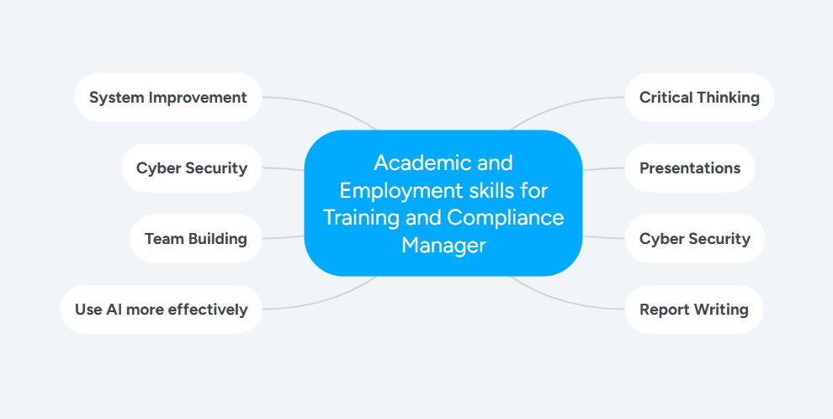
I currently work at Luton Airport with the Assisted Travel team supporting guests with any kind of disability physical or hidden travel through the airport based on the kind of assistance they require. As a contractor our client is LLA, we also work alongside other contractors, stakeholders and service providers to ensure they guests journey is seamless. My role within the company is Standards & Compliance manager, I am responsible for staff training, maintaining compliance, and monitoring operational standards.
As a trainer presentations are an essential medium used to deliver training the staff members. The presentations should be engaging, have concise visual content. To improve engagement presentations should use concise visual content, minimise text, and incorporate AI- generated images and videos where appropriate. [1][2]
In our Software Solutions for Business module I can further improve on my analytical skills needed to track training records and maintain audit records and reports.[3] These skills will support evidence-based decisions-making and improve operational efficiency.
The module Learning in the Digital Era will strengthen my critical thinking, collaborations and team building skills, as these are critical skills in any workforce especially as a manager [4].
Cyber Security is essential in any workforce especially in an airport. Through this course I will gain a better understanding of the risks and how to mitigate them within the team. It will also help me better evaluate our current systems in place and how I can improve them.[5]
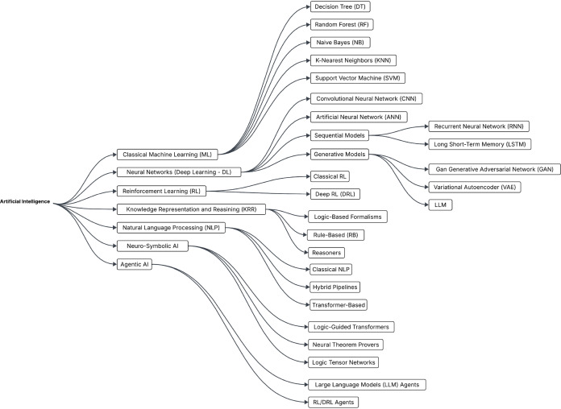[6]

Task 1b: Evaluation of Task 1 (a) based on Similarity report
In my draft similarity report is 0%. While writing this report I did use AI to research and assist me to write my report which I then rephrased into my own words. In the future I will give more time to research and try to rely on AI less and use my own creative writing.
According to GAC criteria I would score myself a 2.2 based on the fact that knowledge of the topic and process was well presented but more research could be done, also, I could give more time to the assignment and work on my critical thinking and writing.

Task 2: Collaborative Mind Map and Individual Poster

Mind Map (Collaborative)

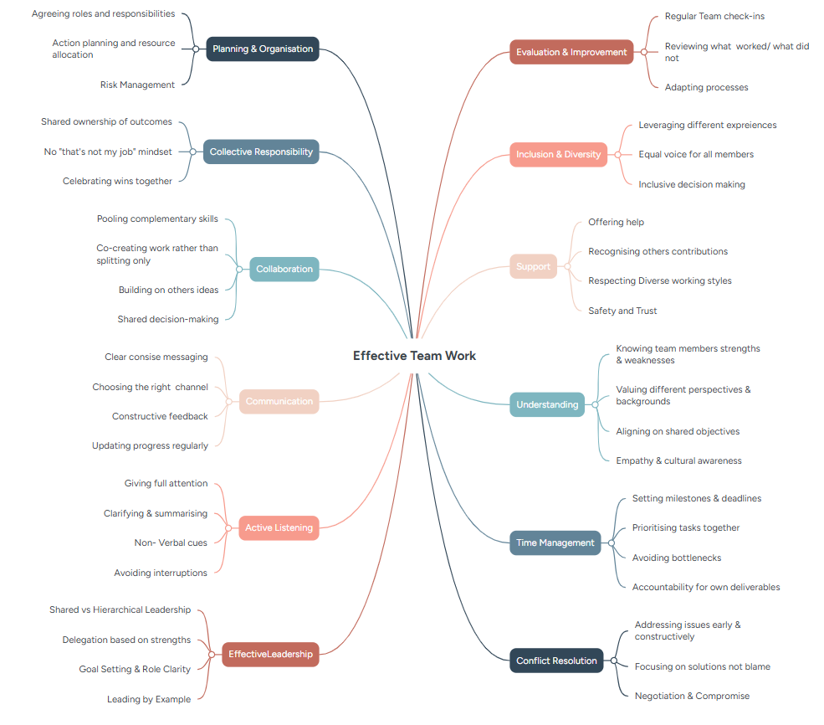

Team Member: Nufeesa Imran

Planning and Organisation:
For a team to work effectively roles or tasks should be assigned to each team member depending on their strengths and weaknesses, so all the load of work is equally distributed among the group. In the same way resources should be allocated appropriately. There should be a clear and concise plan in place outlining the how the project will be completed including a timeline, there should also be a contingency plan in place anything does not go according to plan.

Inclusion and Diversity:
An effective team is one in which each team member is valued for their differences and experiences. It is important to treat all team members equally and understand that they all have equal importance. Ensuring everyone has a voice in the team.

Collaboration:
One of the key qualities of a team is collaboration. Listening to each other's ideas and adding to them. Working together as one group rather than individually.

Comfort Musa:
Teamwork is the collaboration of individuals working together toward a shared goal, and it becomes effective when the team is clear about its objectives and united in achieving them. Three key factors that strengthen effective teamwork are time management, understanding team dynamics, and offering support​[7].

Time management is essential, it enables teams to prioritise tasks, set milestones, avoid bottlenecks, and remain accountable for their individual contributions[8]​.

Second, understanding team dynamics involves recognising each member’s strengths and weaknesses, valuing diverse perspectives, and aligning everyone around common goals. Third, support within a team through offering help, acknowledging contributions, and respecting different working styles, builds trust and psychological safety​[8]​.

In conclusion, for a team to function effectively and accomplish its objectives, it must manage time wisely, understand each member’s strengths and weaknesses, and cultivate a supportive environment. These factors work together to strengthen collaboration, enhance productivity, and nourish the team toward successful outcomes​[9]​.

Team Member: Hashmat Hydari:
Conflict is common in academic projects and organisations because people have different opinions, work styles, and priorities. However, with effective leadership and conflict management, disagreements can become opportunities for improvement rather than obstacles.
Effective leadership provides direction, motivates team members, and keeps everyone focused on shared goals. In university group projects, good leadership helps organise tasks, allocate responsibilities, and ensure work is completed on time. Constructive communication is equally important, as it allows team members to express concerns, share ideas, and clarify misunderstandings, reducing the risk of conflict. When disagreements arise, conflict resolution strategies such as discussion, negotiation, compromise, and collaboration help identify the cause of the issue and reach solutions that benefit the whole team. Building trust and psychological safety also strengthens teamwork by encouraging members to share ideas, ask questions, and learn from mistakes without fear of embarrassment. Credibility is essential in business management, as it promotes trust and cooperation. In my future career in business management, I will continue developing leadership and conflict-resolution skills to manage teams effectively and achieve organisational success.

Poster (Individual)
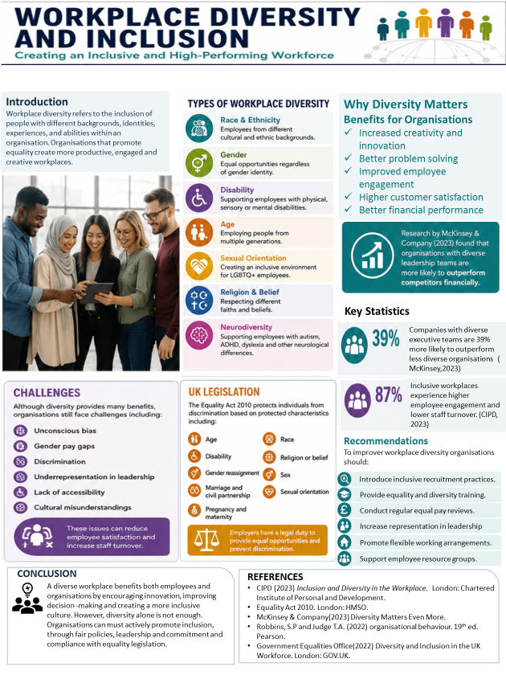

Task 3: Virtual Collaboration and RefWorks

Riding the Storm
This section examines the storming stage, which is the second phase of Tuckman's (1965) model of team development. During this stage, team members begin working together more closely, but differences in opinions, personalities, and working styles can lead to disagreements. Although conflict can make collaboration difficult, it is a normal part of team development and can help teams improve communication and decision-making if managed effectively (Tuckman, 1965).
Several characteristics are commonly associated with the storming stage. Team members may display competitive behavior as they try to influence decisions or establish their role within the group. Some individuals may become frustrated or irritated when their ideas are challenged, while others may attempt to dominate discussions. Communication can also become less effective, leading to misunderstandings and the formation of smaller groups or alliances. If these issues are not addressed, they may reduce trust and negatively affect the team's overall performance (Tuckman & Jensen, 1977).

Virtual teams often experience additional challenges during the storming stage because they rely heavily on digital communication rather than face-to-face interaction. The absence of body language and non-verbal cues increases the risk of misunderstandings and miscommunication. Team members may also struggle to stay motivated without regular personal interaction, which can result in feelings of isolation and reduced engagement. According to Duarte and Snyder (2006), successful virtual teams require clear communication, trust, and effective leadership to overcome these challenges.[10]

Managing conflict effectively is essential to ensure the team progresses to the next stage of development. One useful approach is to identify issues early and encourage open discussions before disagreements become more serious. Where possible, team members should arrange a phone or video call instead of relying solely on text messages, as verbal communication helps reduce misunderstandings. It is also important to give colleagues the benefit of the doubt, separate facts from assumptions, and work collaboratively to find a solution. Once an agreement has been reached, it should be documented to ensure everyone has a shared understanding of the outcome.

Clearly defined roles and responsibilities also contribute to successful virtual collaboration. A role can be described as the expected pattern of behavior associated with a particular position within an organization (Mullins, 2019). Recognizing each team member's strengths and allocating responsibilities accordingly improves accountability and productivity. Ensuring that every member has an opportunity to contribute also creates a more inclusive environment and encourages collaboration.

Conclusion
The storming stage is an essential part of team development, particularly within virtual teams where communication barriers can increase the likelihood of conflict. By understanding the characteristics of this stage, applying effective conflict management strategies, and assigning clear roles and responsibilities, teams can overcome challenges and develop stronger working relationships. These practices enable virtual teams to move towards higher levels of collaboration and performance.

RefWorks:

Step-by-step process of using RefWorks with visuals
Step-1: Open Google Scholar and search some key words related to your topic, once you have selected your article, click on Cite:
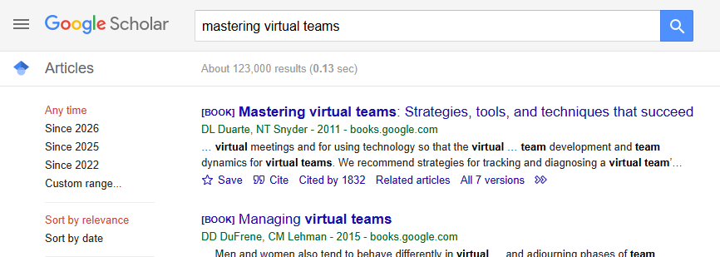

Step 2:
You will then see the following interface select Refworks.
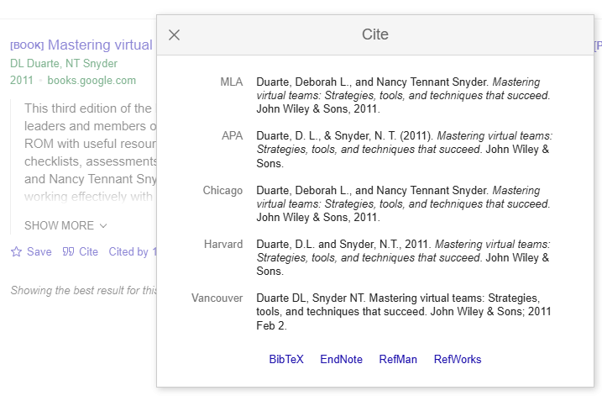
Step 3: RefWorks will open and you will see the following interface. Select the folder in which you would like to save the citation and select import
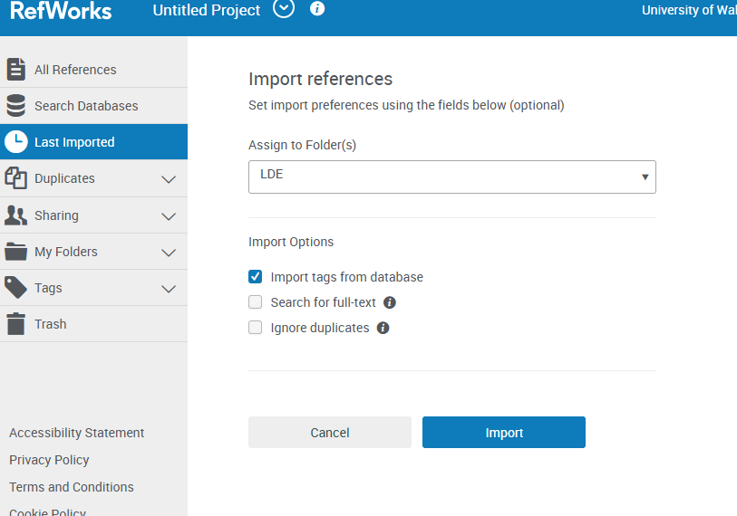

Step 4: Click on last imported to ensure citation as been imported.

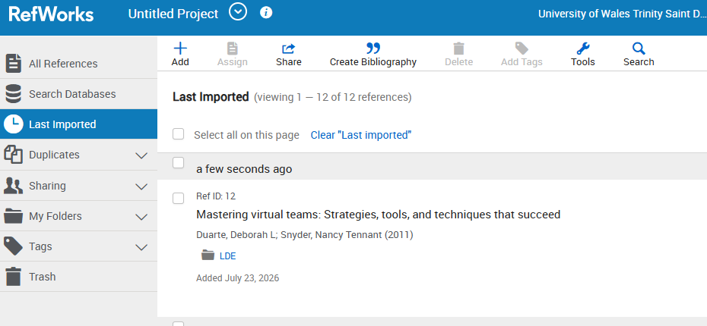
Step 4: Open the word document in which you would like to add the citation. Click on RCM and select RefWorks Citation Manager. Place the cursor where you would like to add the citation.

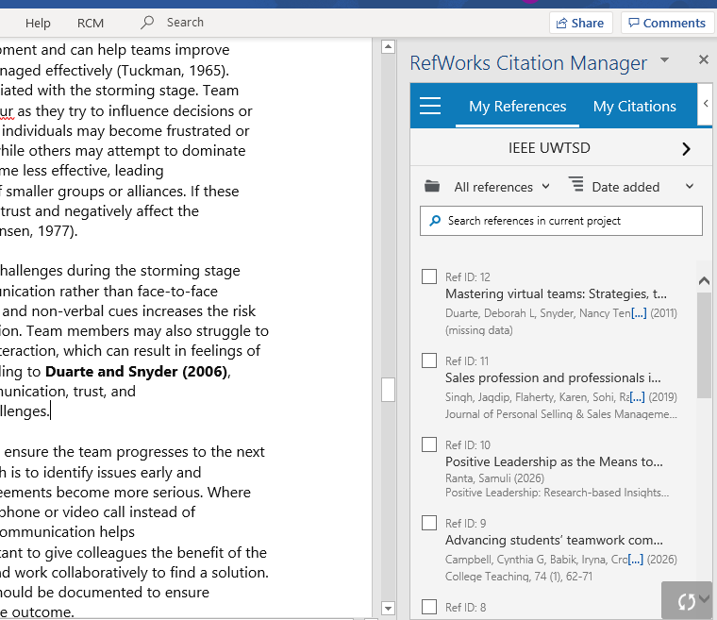

Step 5: Select the Citation you would like to add and click insert citation

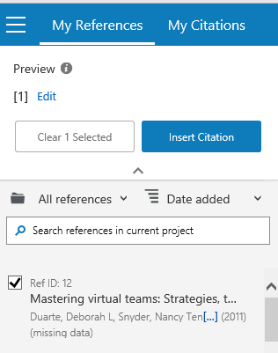

Step 6: Your citation will be inserted.
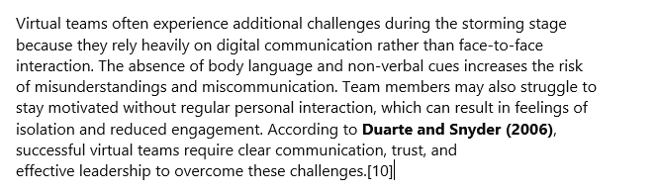

Step 7: Ensure you Bibliography is on and check references have been inserted at on the last page of document.

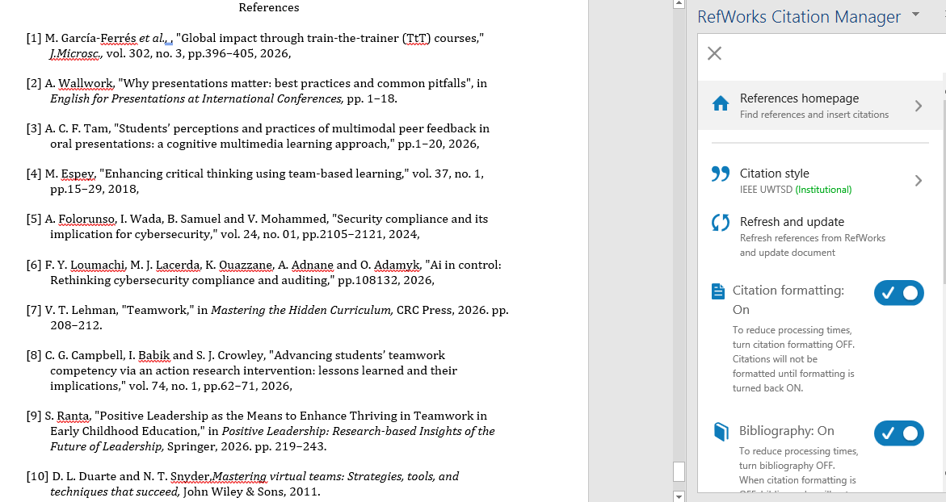

Task 4: E-Portfolio Creation and Evaluation

Task 4 (a): E-Portfolio Creation
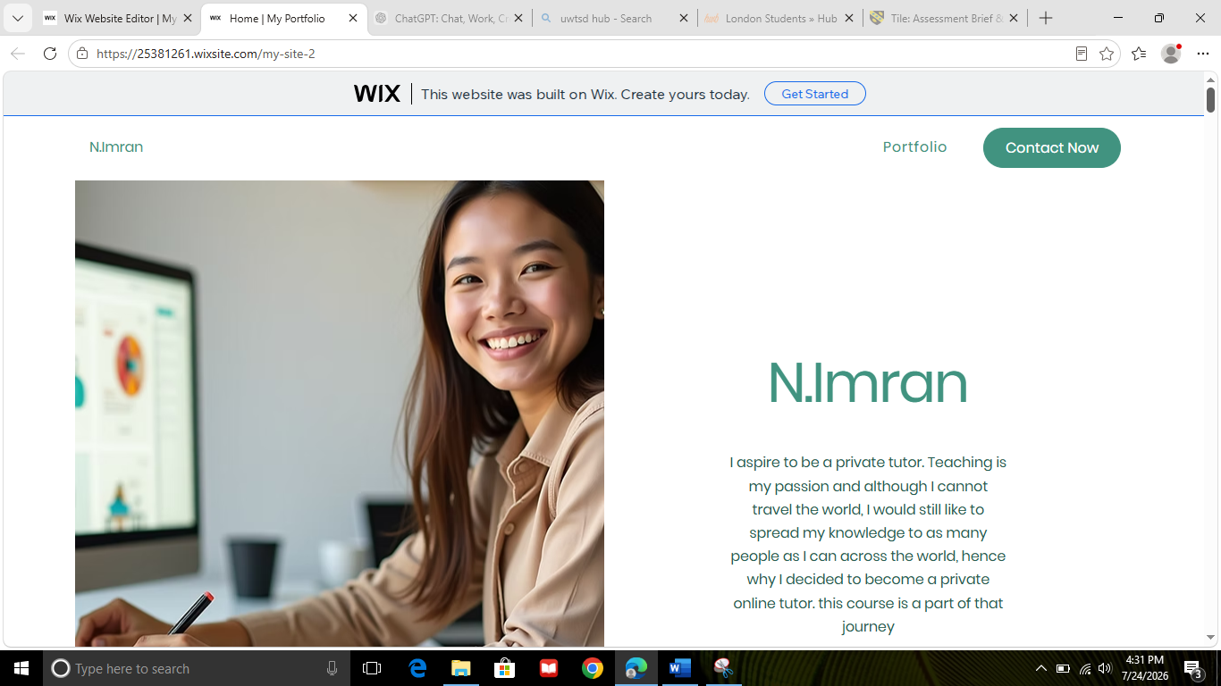
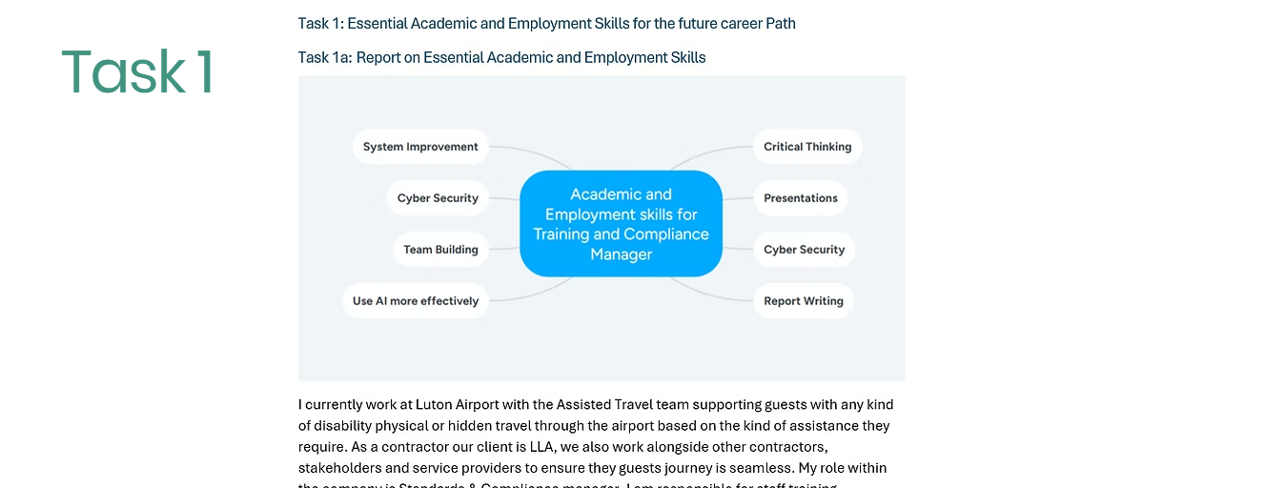

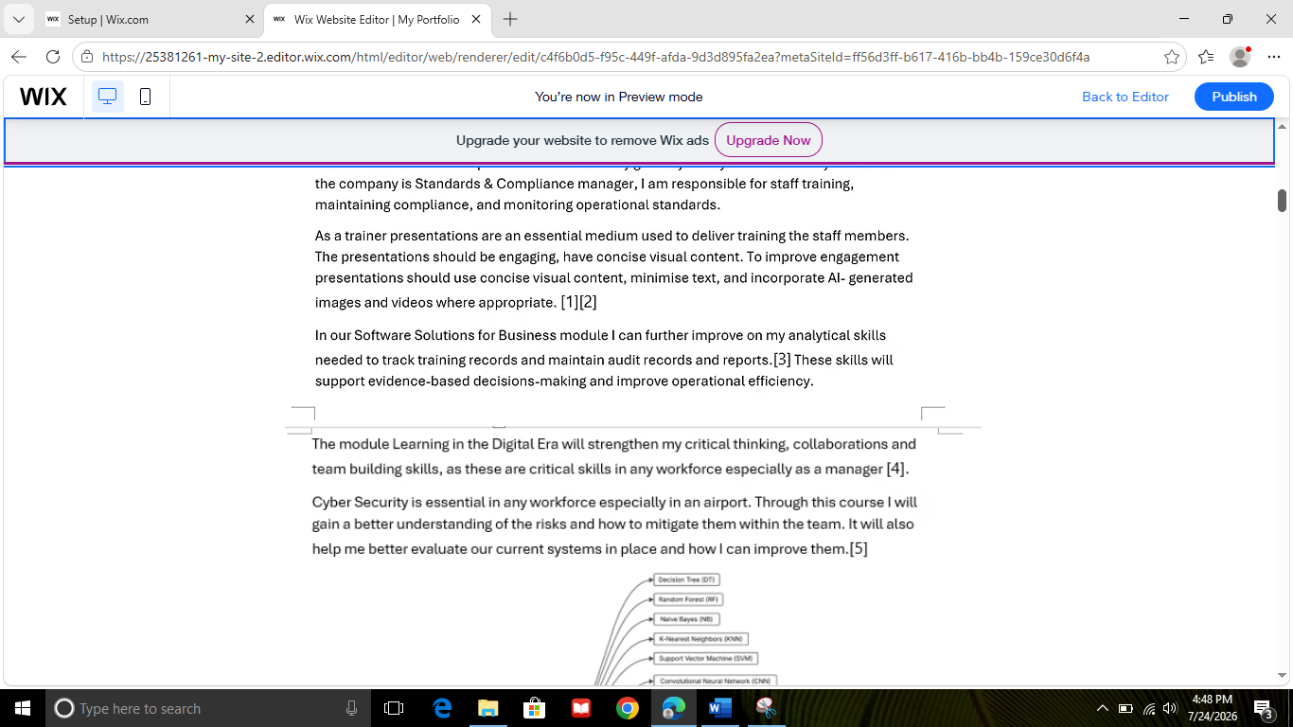

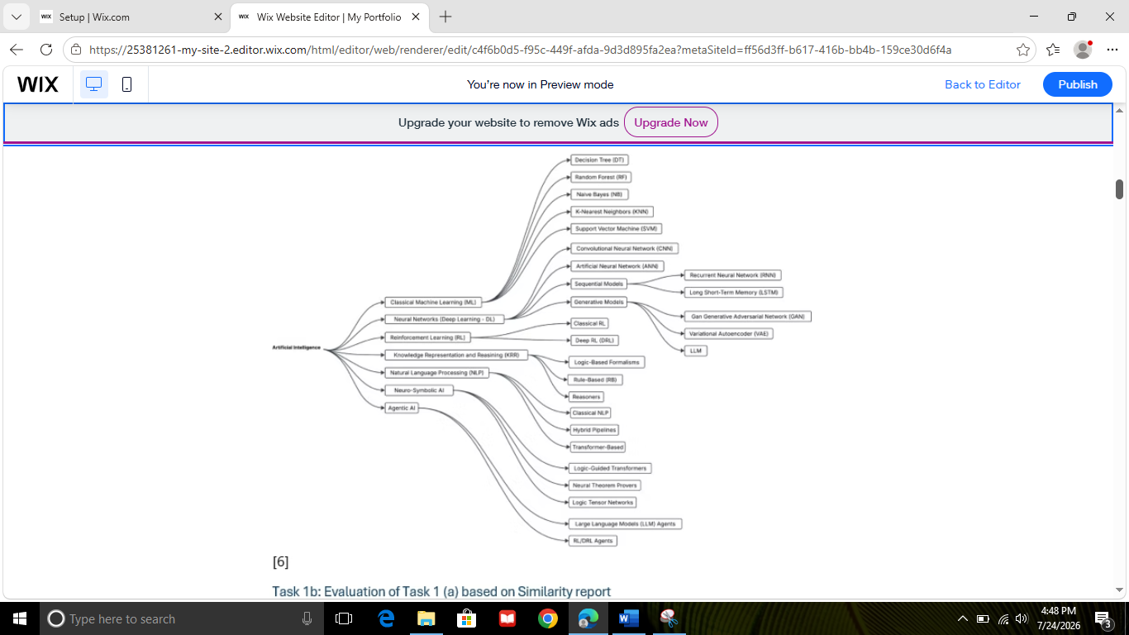

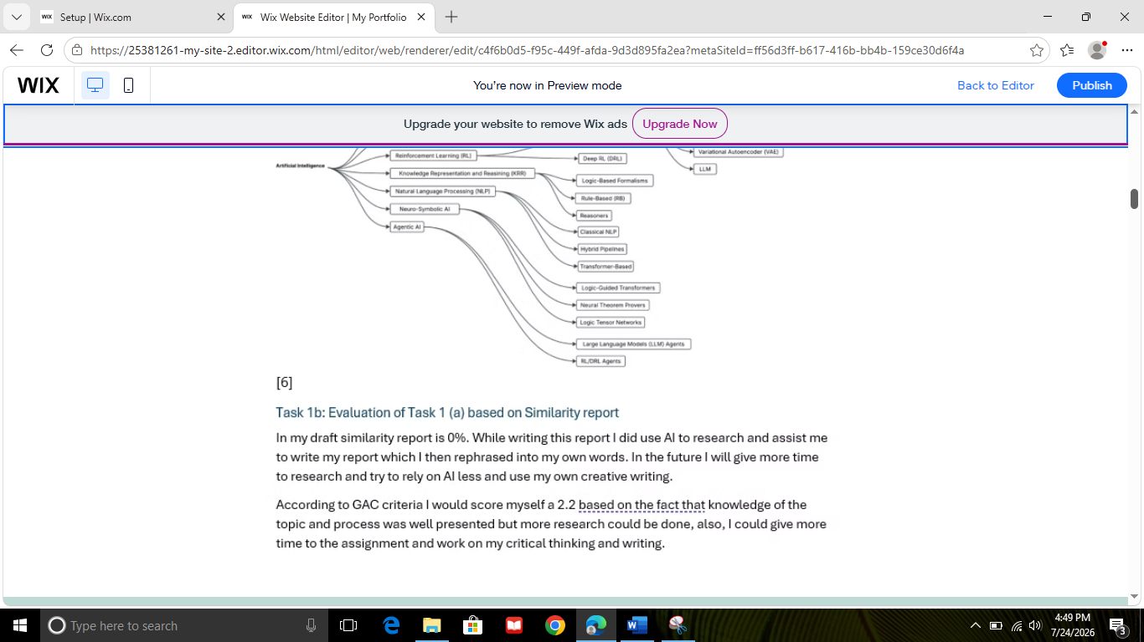

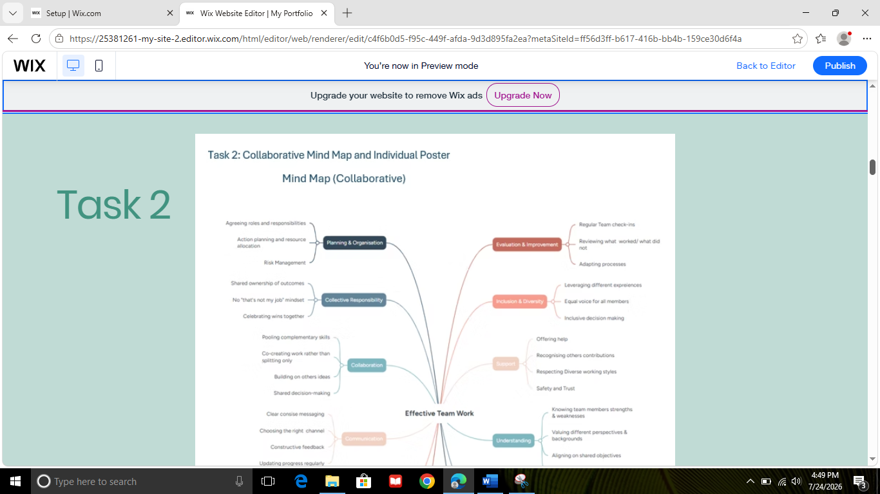

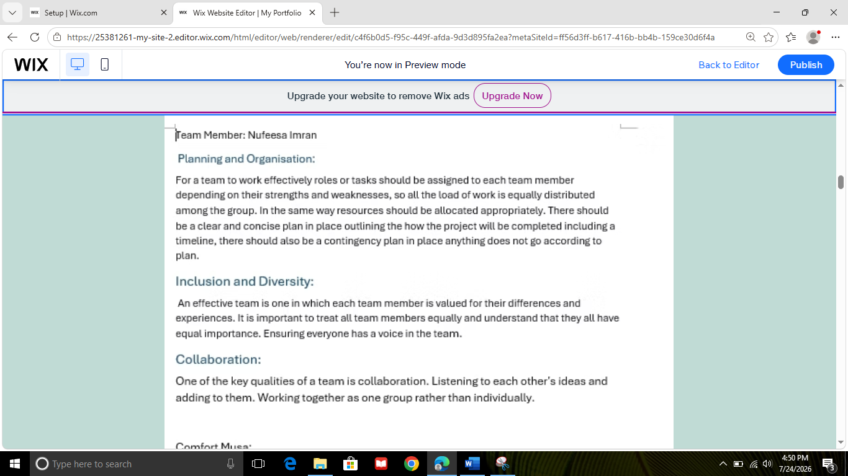

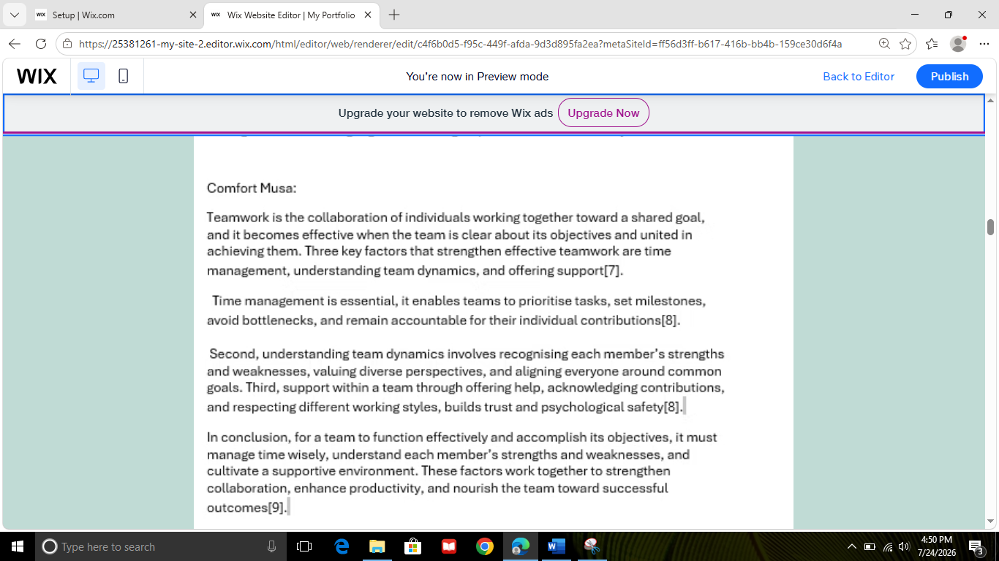

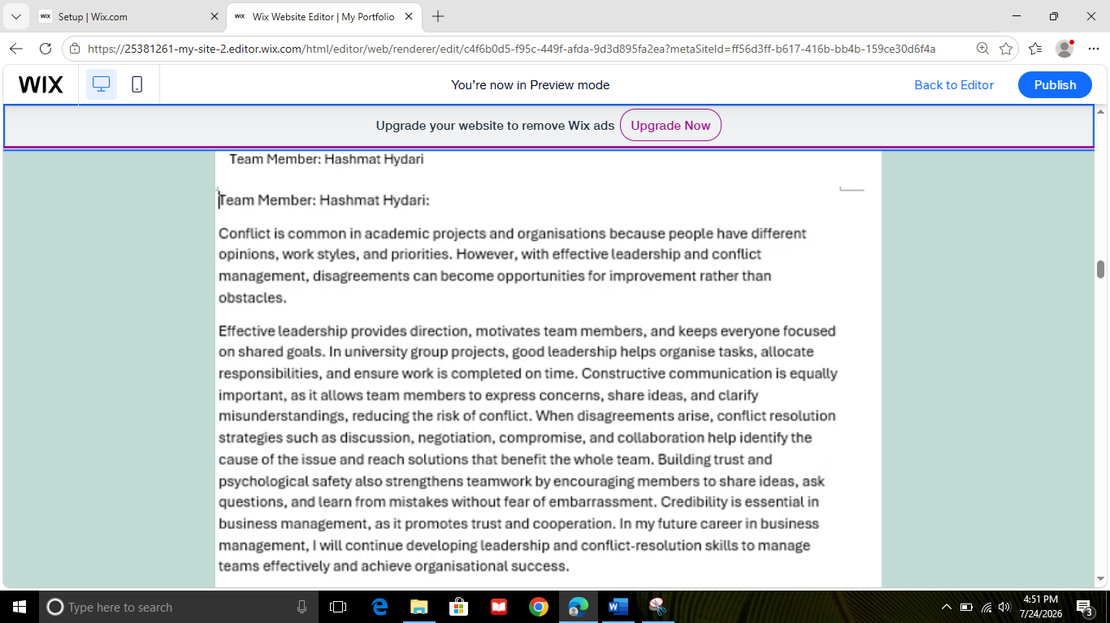

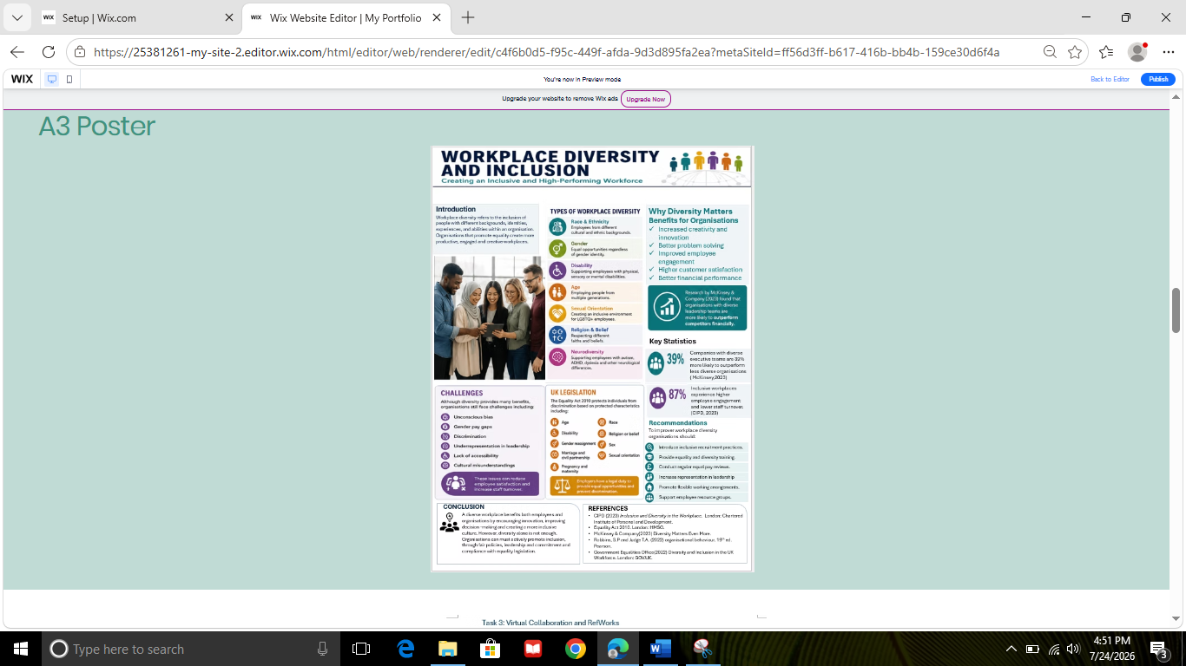

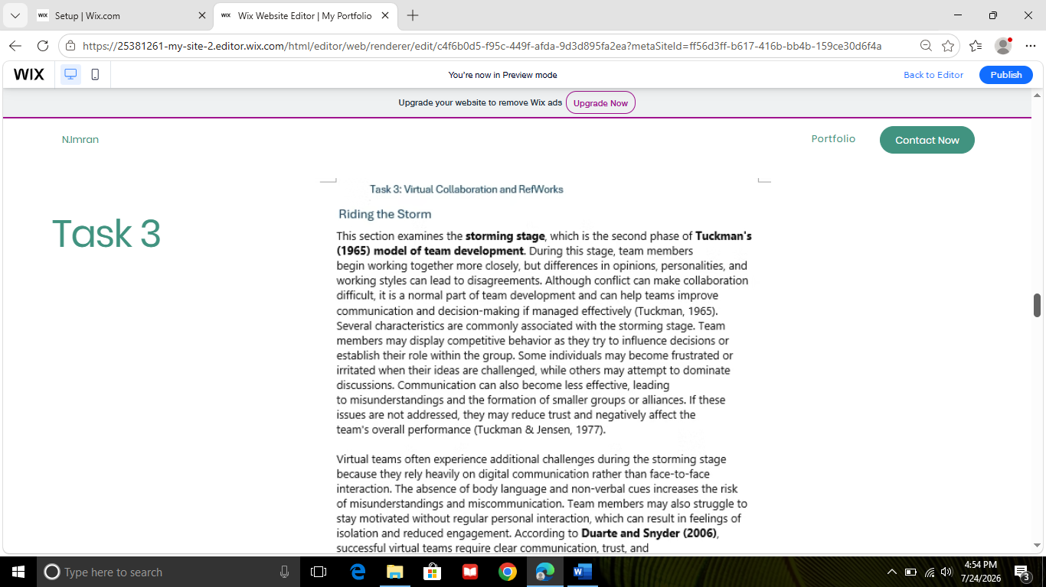

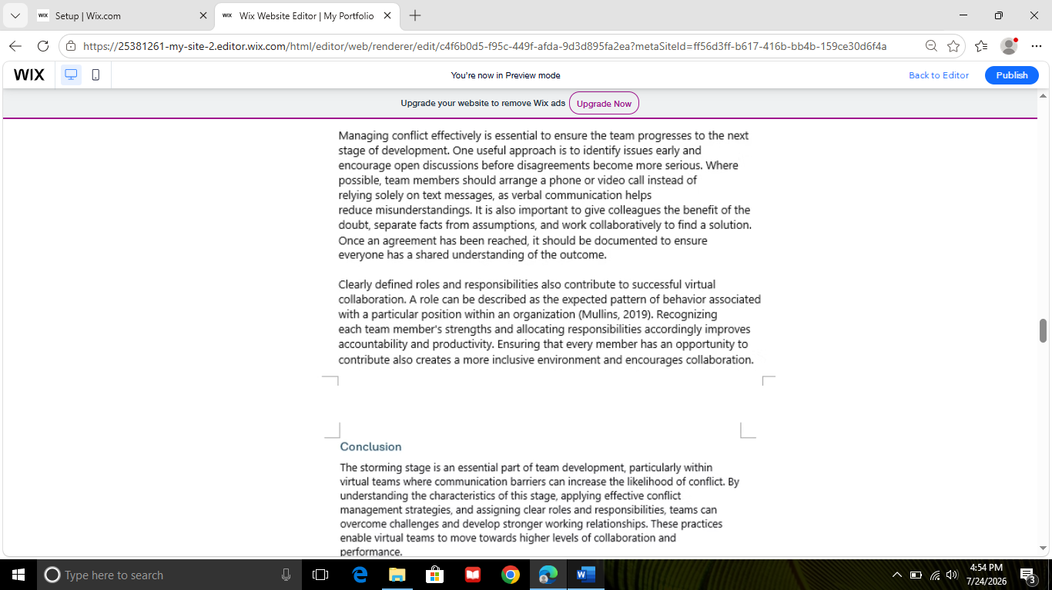

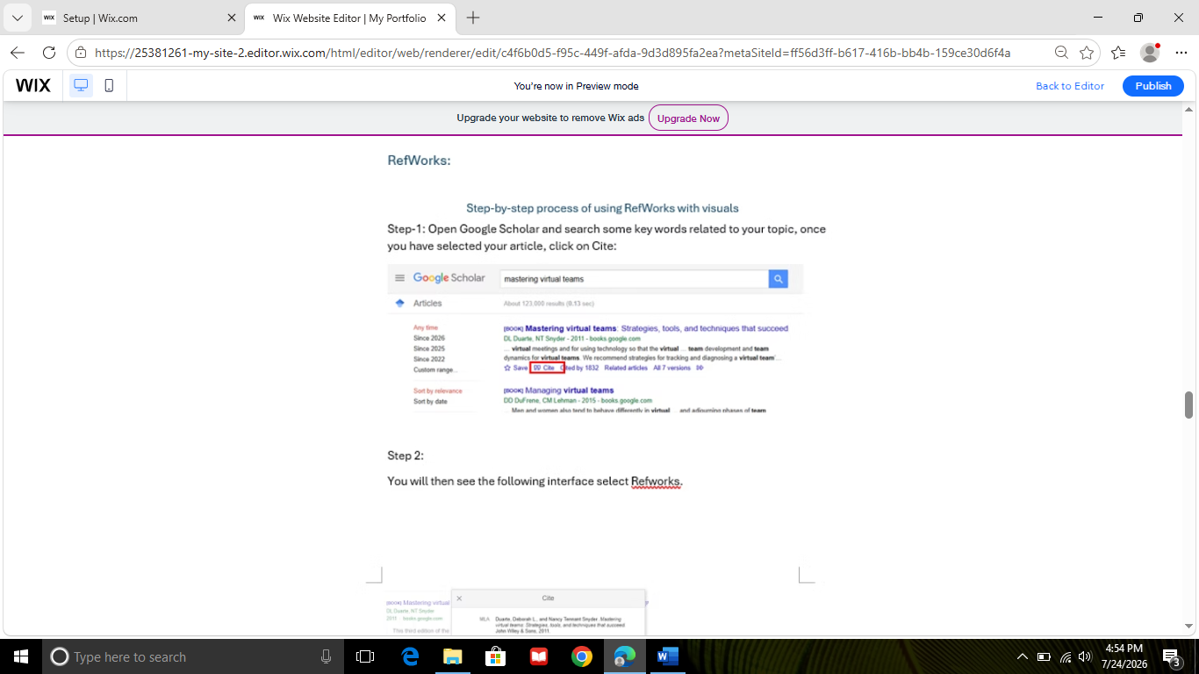

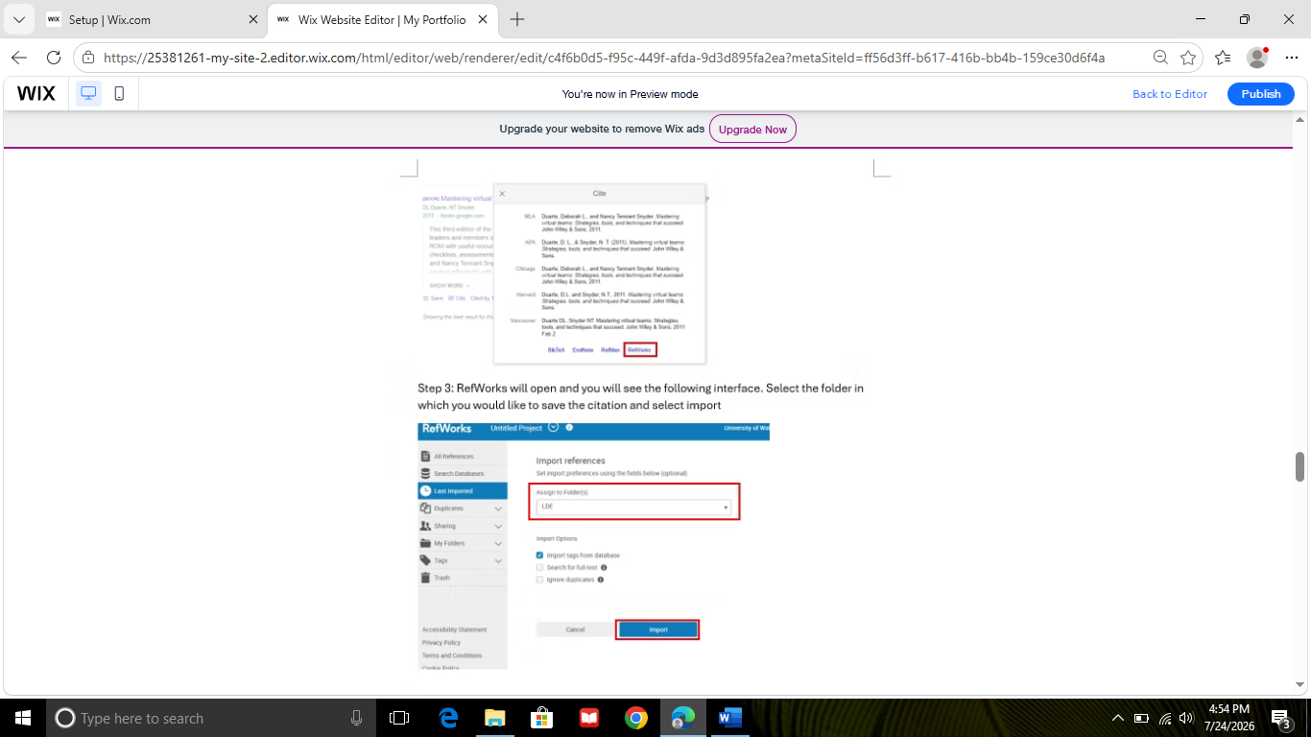

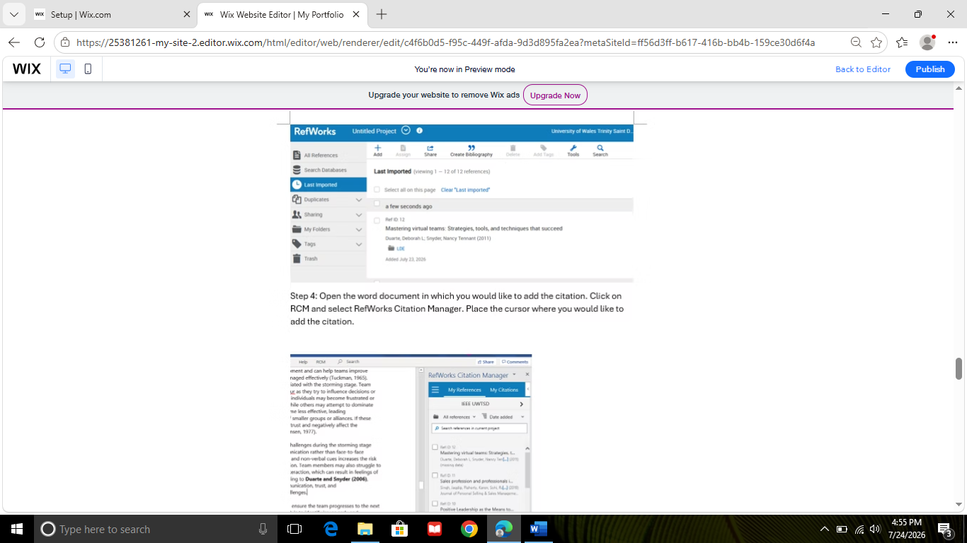

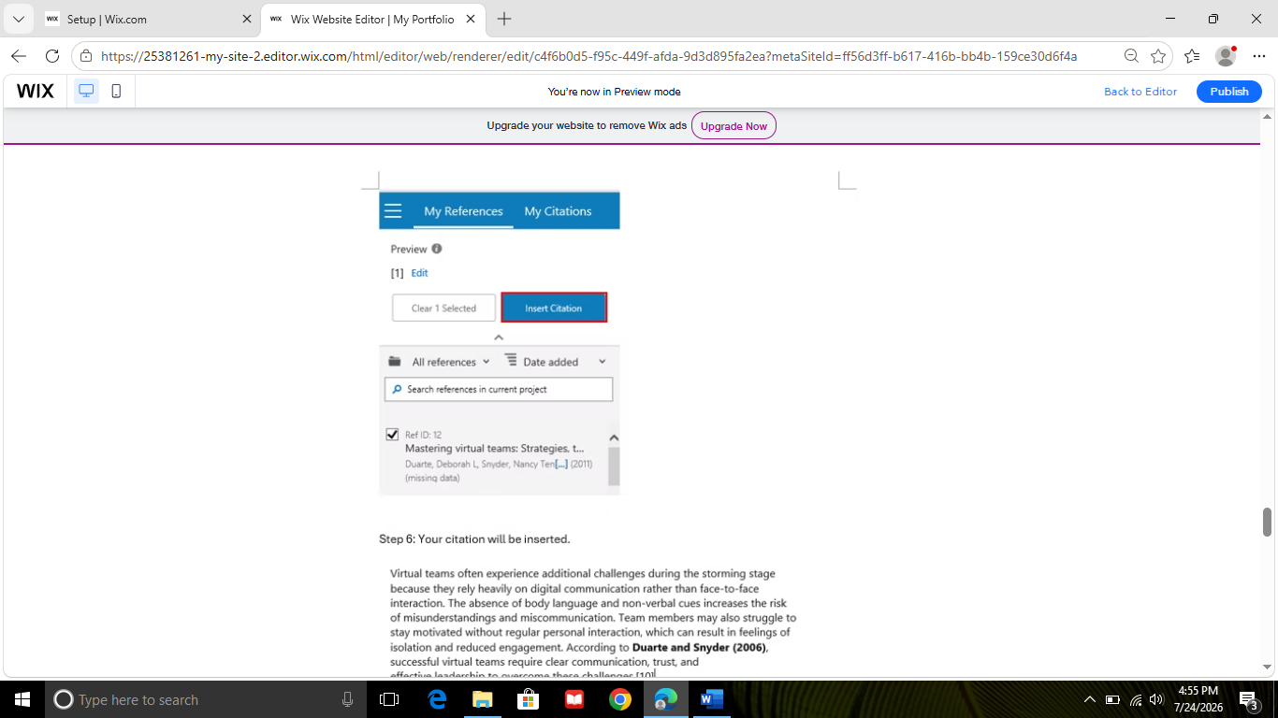

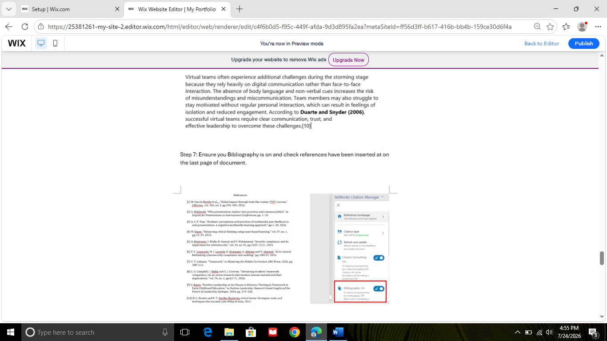

Task 4 (b): Illustrative Review of E-Portfolio tool Selection
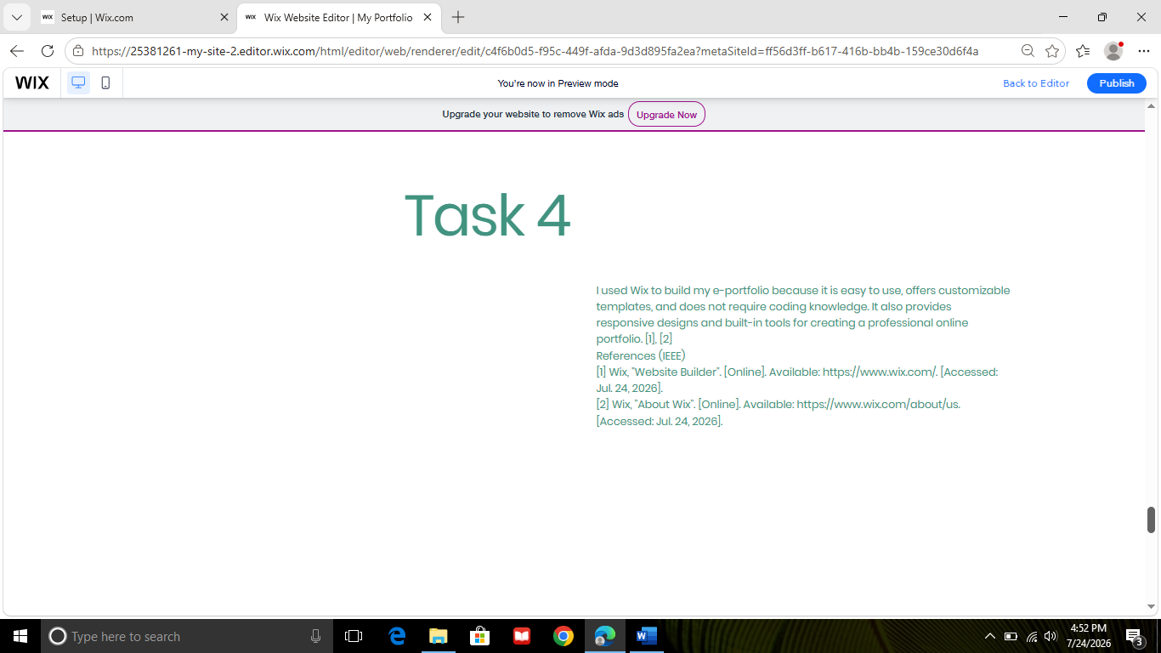

Conclusion
In this technological Era, it is essential to keep in touch with the technological advancements of this Era, we must open our mind to the diversities of the workplace, to grow in our careers.

References

Task 1 References:
References
[1] M. García‐Ferrés et al., , "Global impact through train‐the‐trainer (TtT) courses," J.Microsc., vol. 302, no. 3, pp.396–405, 2026,
[2] A. Wallwork, "Why presentations matter: best practices and common pitfalls", in English for Presentations at International Conferences, pp. 1–18.
[3] A. C. F. Tam, "Students’ perceptions and practices of multimodal peer feedback in oral presentations: a cognitive multimedia learning approach," pp.1–20, 2026,
[4] M. Espey, "Enhancing critical thinking using team-based learning," vol. 37, no. 1, pp.15–29, 2018,
[5] A. Folorunso, I. Wada, B. Samuel and V. Mohammed, "Security compliance and its implication for cybersecurity," vol. 24, no. 01, pp.2105–2121, 2024,
[6] F. Y. Loumachi, M. J. Lacerda, K. Ouazzane, A. Adnane and O. Adamyk, "Ai in control: Rethinking cybersecurity compliance and auditing," pp.108132, 2026,
[7] V. T. Lehman, "Teamwork," in Mastering the Hidden Curriculum, CRC Press, 2026. pp. 208–212.
[8] C. G. Campbell, I. Babik and S. J. Crowley, "Advancing students’ teamwork competency via an action research intervention: lessons learned and their implications," vol. 74, no. 1, pp.62–71, 2026,
[9] S. Ranta, "Positive Leadership as the Means to Enhance Thriving in Teamwork in Early Childhood Education," in Positive Leadership: Research-based Insights of the Future of Leadership, Springer, 2026. pp. 219–243.
[10] D. L. Duarte and N. T. Snyder,Mastering virtual teams: Strategies, tools, and techniques that succeed, John Wiley & Sons, 2011.

