Module name and code: Psychopathological Classifications and Provisions, BMHP6029
Student name and number: Teodora Evgenieva, 2324070
Assignment title: Component 1 (Poster)
Lecturer's name: Neale Haddon

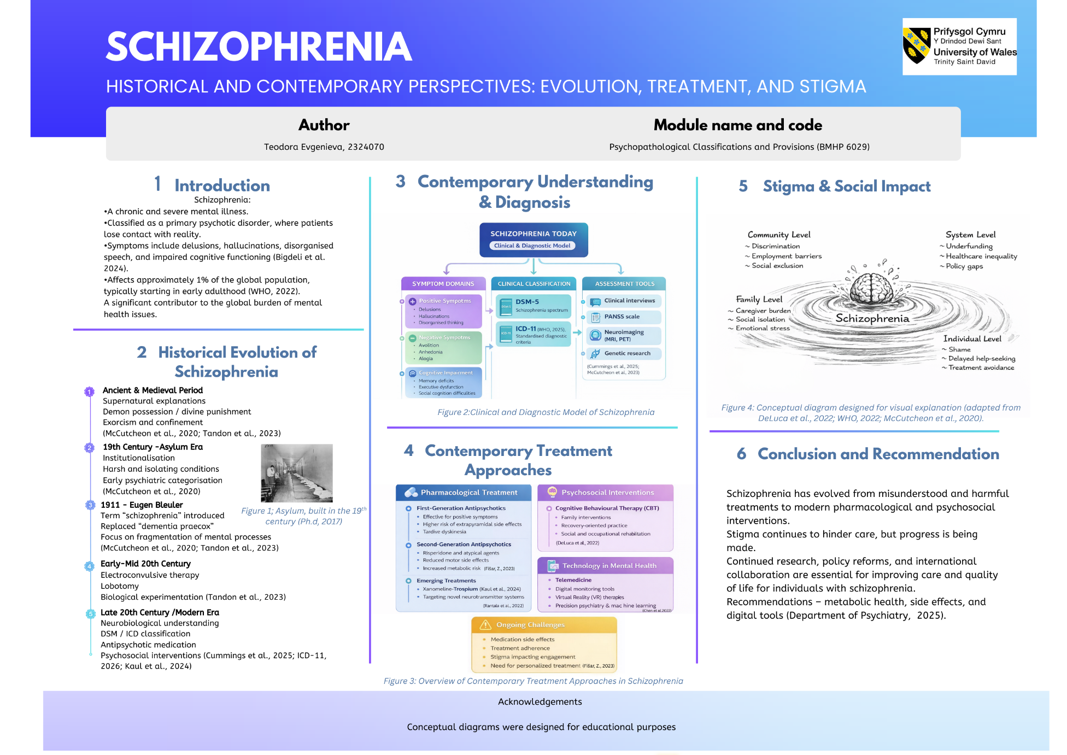
References

- Bigdeli, T.B., Chatzinakos, C., Bendl, J., Barr, P.B., Venkatesh, S., Gorman, B.R., Clarence, T., Genovese, G., Iyegbe, C.O., Peterson, R.E., Kolokotronis, S.-O., Burstein, D., Meyers, J.L., Li, Y., Rajeevan, N., Sayward, F., Cheung, K.-H., DeLisi, L.E., Kosten, T.R. and Zhao, H.( 2024) Biological Insights from Schizophrenia-associated Loci in Ancestral Populations. Available at: https://doi.org/10.1101/2024.08.27.24312631 (Accessed: 28 February 2026).
- Chen, Z.S., Kulkarni, P. (Param), Galatzer-Levy, I.R., Bigio, B., Nasca, C. and Zhang, Y.( 2022) Modern views of machine learning for precision psychiatry. Patterns, 3(11), p.100602. Available at: https://doi.org/10.1016/j.patter.2022.100602 (Accessed: 28 February 2026).
- Cummings, M.A., Arias, A.L.W. and Stahl, S.M.(2025) What is the neurobiology of schizophrenia? CNS spectrums, 30(1), p.e13. Available at:: https://pubmed.ncbi.nlm.nih.gov/39473188/ (Accessed: 28 February 2026).
- DeLuca, J.S., Pamela Rakhshan Rouhakhtar, Klaunig, M.J., Akouri-Shan, L., Jay, S.Y., Todd, T.L., Sarac, C., Andorko, N.D., Herrera, S.N., Dobbs, M.F., Zarina Bilgrami, Kline, E., Brodsky, A.E., Jespersen, R., Landa, Y., Corcoran, C. and Schiffman, J.(2022) Psychosis-like experiences and resilience: A systematic and critical review of the literature. Psychological Services, 19(Suppl 1), pp.120–138. Available at: https://doi.org/10.1037/ser0000585 . (Accessed: 28 February 2026).
- Department of Psychiatry (2025) New international guidelines for the treatment of schizophrenia. Available at: https://www.psych.ox.ac.uk/news/new-international-guidelines-for-the-treatment-of-schizophrenia (Accessed: 3 March 2026).
- Fišar, Z.( 2023) Biological hypotheses, risk factors, and biomarkers of schizophrenia. Progress in Neuro-Psychopharmacology and Biological Psychiatry, 120, p.110626.Available at: https://doi.org/10.1016/j.pnpbp.2022.110626 (Accessed: 28 February 2026).
- ICD 11 (2026) INTERNATIONAL CLASSIFICATION OF DISEASES -Mortality and Morbidity Statistics. Available at: https://faculty.ksu.edu.sa/sites/default/files/icd11_mms-en-06.pdf (Accessed: 28 February 2026).
- Kaul, I., Sawchak, S., Walling, D.P., Tamminga, C.A., Breier, A., Zhu, H., Miller, A.C., Paul, S.M. and Brannan, S.K.( 2024) Efficacy and Safety of Xanomeline-Trospium Chloride in Schizophrenia. JAMA Psychiatry, 81(8). Available at: https://doi.org/10.1001/jamapsychiatry.2024.0785 (Accessed: 28 February 2026).
- McCutcheon, R.A., Keefe, R.S.E. and McGuire, P.K.(2023) Cognitive impairment in schizophrenia: Aetiology, pathophysiology, and treatment. Molecular Psychiatry, 28(5), pp.1–17. Available at:: https://doi.org/10.1038/s41380-023-01949-9 (Accessed: 28 February 2026).
- McCutcheon, R.A., Reis Marques, T. and Howes, O.D.( 2020) Schizophrenia—An Overview. JAMA Psychiatry, 77(2). Available at: https://doi.org/10.1001/jamapsychiatry.2019.3360 (Accessed: 28 February 2026).
- Mosolov, S.N. and Yaltonskaya, P.A.(2022) Primary and secondary negative symptoms in schizophrenia. Frontiers in Psychiatry, 12(766692). Available at: https://doi.org/10.3389/fpsyt.2021.766692 (Accessed: 28 February 2026).
- Ph.d, D.N.G. (2017) The Digital Research Library of Illinois History Journal: Dunning, The Story of Chicago’s Insane Asylum. Available at: https://drloihjournal.blogspot.com/2017/10/the-story-of-dunning-asylum-chicago.html (Accessed 6 March 2026).
- Rantala, M.J., Luoto, S., Borráz-León, J.I., y Krams, I.( 2022) Schizophrenia: The new etiological synthesis. Neuroscience & Biobehavioral Reviews, 142(1), p.104894. Available at: https://doi.org/10.1016/j.neubiorev.2022.104894 (Accessed: 28 February 2026).
- .!! 9)!N!!DD!!?)N!?:!@!?.!!9!0C!:!:!:8D) !:.!>#:!C!N!EN!0
- :!6564!6567N#9##$!.6J7/6J71!'K6H!*GG!G'5!'5'JG;!!6564!''!5'L!
- Tandon, R., Nasrallah, H., Akbarian, S., Carpenter, W.T., DeLisi, L.E., Gaebel, W., Green, M.F., Gur, R.E., Heckers, S., Kane, J.M., Malaspina, D., Meyer-Lindenberg, A., Murray, R., Owen, M., Smoller, J.W., Yassine, W. and Keshavan, M. ( 2023) The schizophrenia syndrome, circa 2024: What we know and how that informs its nature. Schizophrenia Research, 264(264), pp.1–28. Available at:: https://doi.org/10.1016/j.schres.2023.11.015 (Accessed: 6 March 2026).
- World Health Organisation (2022) Schizophrenia. World Health Organisation. Available at: https://www.who.int/news-room/fact-sheets/detail/schizophrenia (Accessed: 28 February 2026).
- World Health Organisation (2025) ICD-11 for Mortality and Morbidity Statistics. Who.int. Available at: https://icd.who.int/browse/2025-01/mms/en (Accessed: 28 February 2026).

