

LOCATION: Swansea | LLEOLIAD: abertawe
LEVEL 5 | LEFEL 5
EXAMINATION PERIOD | CYFNOD ARHOLIADAU
July 2019 | Gorffennaf 2018

MODULE CODE: M5X02201
MECHANICAL PRINCIPLES
PHASE TEST 2
TIME: 2 HOURS
answer all questions

Equipment or materials required – None
Adnoddau neu ddefnyddiau sydd eu hangen – Dim

Calculators are permitted –show your working

A ‘formula sheet’ is provided for reference.

Assume ‘g’ = 9.81 m/s².

and 1 bar = 10⁵ N/m² (P_{a})

ANSWER ALL QUESTIONS

Show all your workings and state any assumptions or approximations you have made.

QUESTION ONE

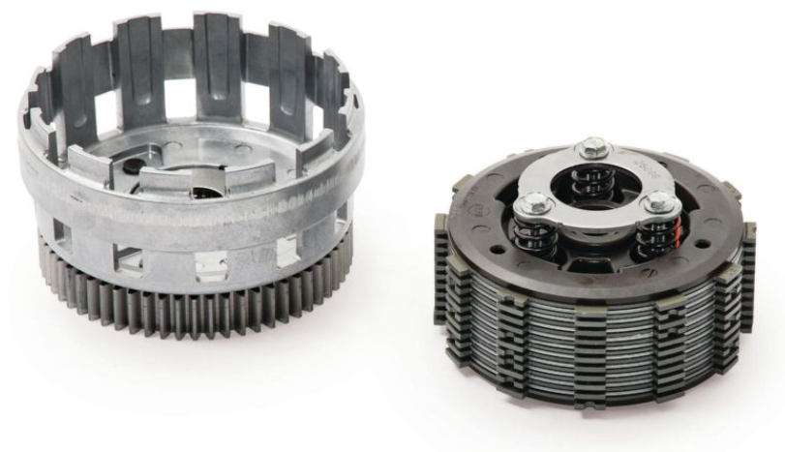

A multi-plate clutch must transmit 20 kW of power without slipping at 4000 rev/min. The coefficient of friction is 0.25. The inner and outer diameters are 80 and 160 mm respectively. The axial force applied to the plates is 600 N.

Determine the number of plates required using:

- The uniform pressure theory
(5 Marks)
- The uniform wear theory
(5 Marks)

QUESTION TWO

A belt drive must transmit 7.5 kW of power at 3800 rev/min. The pulley wheel is 110 mm diameter and the coefficient of friction is 0.3. The lap angle is 120º. Assuming the initial belt tension is 200 N and the belt mass may be taken to be negligible;

- Calculate the linear velocity of the belt
(2 Marks)
- Calculate the maximum and minimum belt tensions
(4 Marks)
- Calculate the maximum power transmitted per belt
(2 Marks)
- Calculate the number of belts required
(2 Marks)

QUESTION THREE

The diagram below shows masses on two rotors in planes B and C. Determine the masses and their positions, to be added on the rotors in planes A and D at radius 28 mm which will produce static and dynamic balance.
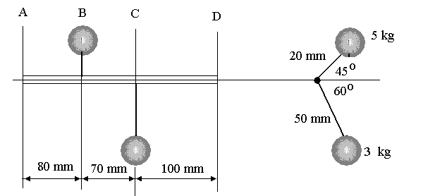
1.72kg
2.0kg

- Construct a table to calculate the magnitude of the forces and moments created by the rotating masses
(2 Marks)

- Construct a vector diagram using a suitable scale to represent the resultant moment (mrx polygon) and calculate mass D and it’s position
(4 Marks)

- Construct a vector diagram using a suitable scale to represent the resultant force (mr polygon) and calculate mass A and it’s position
(4 Marks)

QUESTION FOUR

The diagram shows a torque - angle diagram for a certain machine.
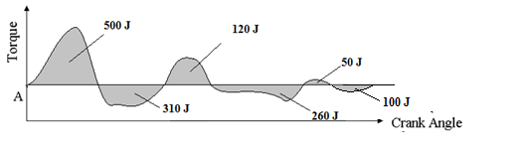
If the speed of the shaft must be maintained between 2500 and 2250 rev/min,calculate

- the coefficient of fluctuation of speed (2 Marks)
- the maximum fluctuation of energy (βW) (3 Marks)
- the moment of inertia of a suitable flywheel. (3 Marks)
- the radius of gyration of the flywheel if it has a mass of 13 kg. (2 Marks)

QUESTION FIVE

The diagram below shows a compound gear train. Gear A is the input gear and revolves at 1500 rev/min anticlockwise when viewed for the left end. If the input torque is 15 Nm and the gear train efficiency is 85% calculate the following;

- the ouput speed and direction
- the output power
- the holding torque required
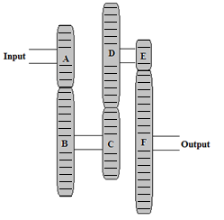

Gear A has 20 teeth
Gear B has 32 teeth
Gear C has 26 teeth
Gear D has 36 teeth
Gear E has 16 teeth
Gear F has 39 teeth



