A critical review of the support provided for neurodiverse employees in South Wales Police and its impact on mental health
Word count: 2857

Nadine Galtry (2312705)
2024
Table of Contents
1. Introduction 2
2. Literature Review 2
2.1 Skills of a neurodiverse workforce 2
2.2 Work place adjustments 3
2.3 Recruitment 3
2.4 Mental Health 4
3. Methodology 4
3.1 Aims and objectives 4
3.2 Research Philosophy and Methodology 5
3.3 Data analysis 6
3.4 Reliability, validity, and research limitations 6
4. Findings 7
4.1 Demographic 7
4.2 Recruitment 8
4.3 Reasonable Adjustments 9
4.4 Mental Health 10
5. Conclusion 10
6. References 11
7. Appendices 14

Introduction

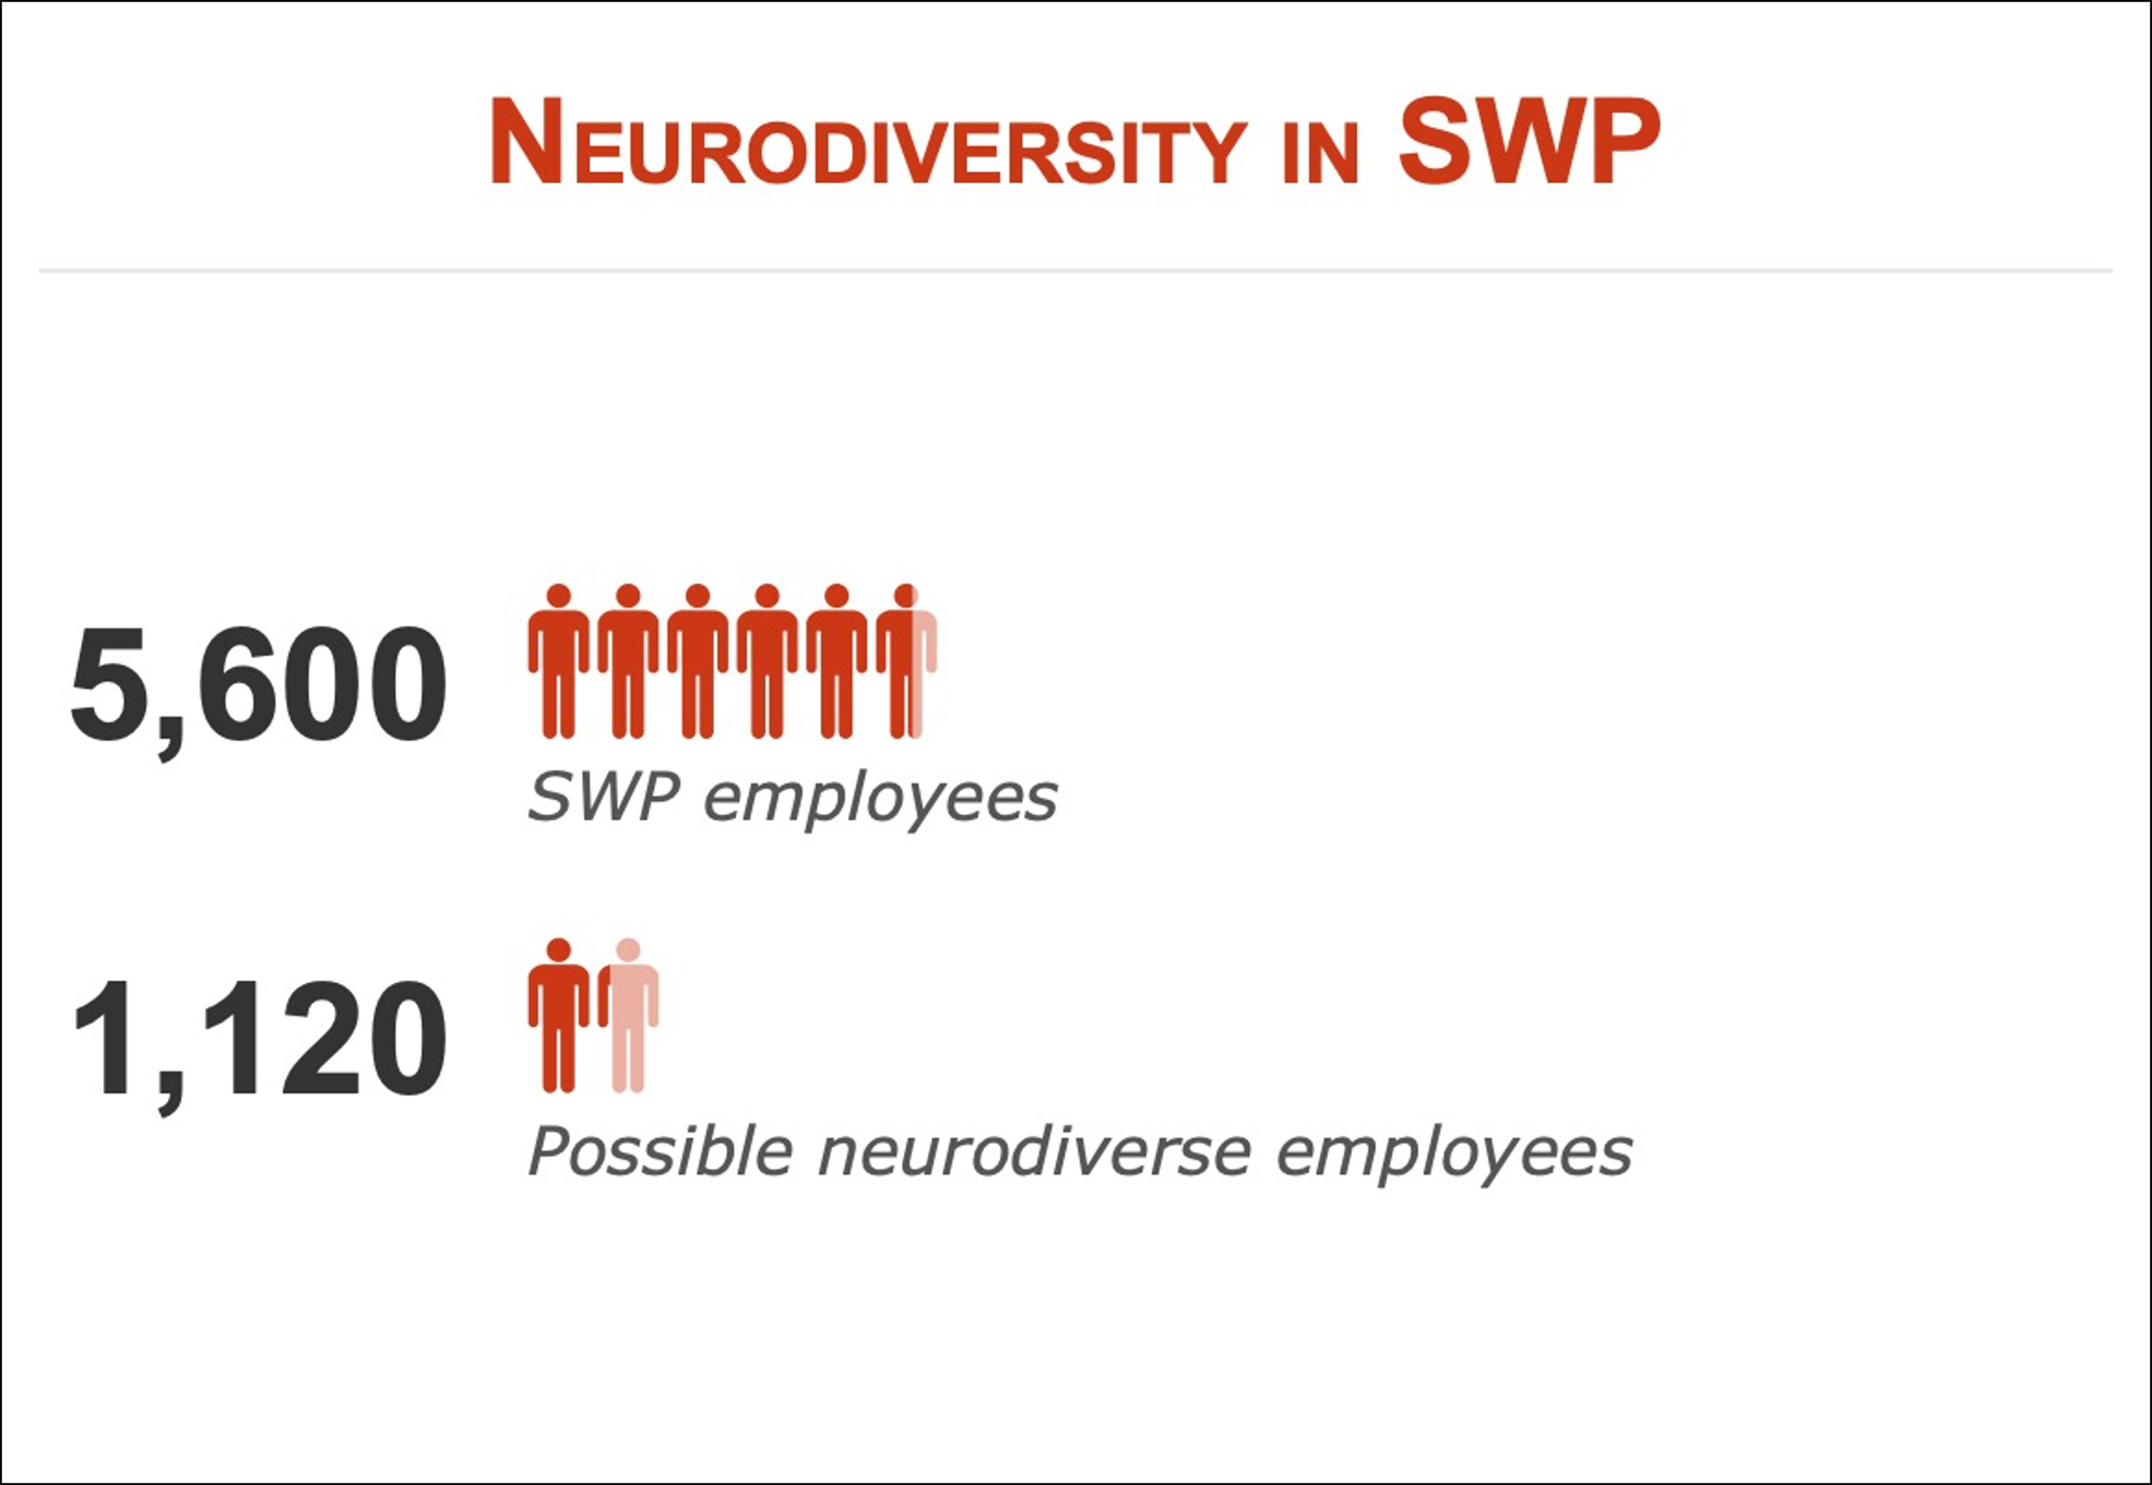
Neurodiversity is a term used to describe individuals who think differently and includes dyslexia, dyspraxia, dyscalculia, attention deficit hyperactivity disorder (ADHD), autism and Tourette’s (Brady, 2022). There has been an increase in diagnosis of autism and ADHD over recent years which could be due to a number of factors, increased awareness, improved diagnostic practices, and wider acceptance within society (Moses, 2023). South Wales Police (SWP) has approximately 5600 resources between Police Officers, Police staff and volunteers (South Wales Police, no date), and it is estimated that between 15-20% of people in the UK are neurodivergent (British Dyslexia Association, 2022) so it can be assumed that around 1120 employees in SWP are neurodiverse. While SWP already offers and implements a wide range of reasonable adjustments and support for various disabilities, the area of neurodiversity needs to be more fully understood by line managers for suitable support to be put in place. The aim of this study is to establish what further support SWP can implement for current neurodiverse employees, how to better attract and support neurodiverse candidates through recruitment processes, and the impact this could have on the organisation. Primary research was conducted through a questionnaire distributed to members of the SWP Neurodiversity network using a mixed method approach to gather both qualitative and quantitative data. Secondary research was collected from peer reviewed journal articles, relevant books, and reputable and relevant websites.
Figure 1 – Neurodiverse employees in SWP

Literature Review

2.1 Skills of a neurodiverse workforce
The World Economic Forum’s Future of Jobs report (2023) reveals the most sought-after skills by 2027 will be analytical and creative thinking, artificial intelligence and big data. It is important to consider the skillset neurodivergent individuals can bring to the workplace, hyperfocus, creativity, innovative thinking and detail processing are some of the highest reported abilities (Birkbeck University of London, 2023). With the speed of technological advancements and automation, spelling, reading quickly, rote memory and organisational skills are becoming less important (LeFevre-Levy et al., 2023). While the abilities of neurodiverse people are important, characterising neurodiverse people as having “superpowers” could unintentionally marginalise them or make them feel they must prove their unique talent will increase profit or productivity (Silver, Nittrouer and Hebl, 2023).

Work place adjustments
Only 17.3% of neurodivergent employees without adjustments reported being very unlikely to leave their employment, whereas, for those with tailored adjustments this figure rose to 49.6%, highlighting the importance of reasonable adjustments in retaining employees (McDowall, Doyle and Kiseleva (2023).
A report by McDowall, Doyle and Kiseleva (2023) found that neurodiverse individuals reported the most helpful adjustments were flexible schedules and hybrid working, closely followed by having a private work space and a duel-screen set up. This is further confirmed within a study by Davies, et al (2022) who found some of the most successful adjustments for autistic adults included changes to working hours and remote working. Unsuccessful adjustments included having a designated quiet space, changes to the sensory environment such as noise and lighting, and changes to social and cultural practices. Developing a neuro-inclusive culture in a large organisation like SWP can be difficult to facilitate, CIPD (2024) advise neurodiversity awareness training across an organisation can develop a general awareness, understanding and appreciation of the conditions.
A study by Weber, et al (2022) assessed hypersensitivity and hyposensitivity from environmental stimulation, many organisations focus on reducing hypersensitivity through noise cancelling headphones, quieter workspaces, and dimmed lighting but little is done to address hyposensitivity which can impact on performance. It is suggested that hyposensitivity could be adjusted for by use of white noise machines, non-stimulating colour schemes and textures, and use of air-purifiers to remove odours.

2.3 Recruitment
Only 3 in 10 working age autistic people are in employment, this is lower than the average for all disabled people (5 in 10), (Gov.uk, 2024). Research has evidenced how technology can be used to improve recruitment for autistic individuals through directly assessing performance ability rather than behavioural during interviews (Walkowiak, 2021). Lexxic (no date) advise that organisations should move away from standardised interview assessments and allow individuals to demonstrate their skills. CIPD (2024) state conventional recruitment processes can exclude neurodiverse talent, avoiding use of non-essential competencies and jargon in role profiles may encourage more neurodiverse talent to apply.
According to the Westminster AchieveAbility commission (2018) 88% of neurodiverse individuals have felt discouraged from applying for a job, 52% have felt discriminated against during selection processes. A survey by My Disability Jobs (2024) found that only 23.5% of candidates would disclose they have a neurodiverse condition on their application, and only 6.3% would disclose during an interview.
Many organisations including Microsoft, Google, and JP Morgan Chase have specific neurodiverse recruitment programmes which include providing questions in advance, extended interview time, conducting interviews in writing, and skills assessments (Microsoft, no date, Google Cloud, 2021, JP Morgan Chase, 2023). The results of this describe decreased error rates, improved morale, and a more inclusive culture among teams with a mix of neurotypical and neurodivergent colleagues (JP Morgan Chase, 2023). JP Morgan Chase also found those in the Autism at Work initiative were 90%-140% more productive than neurotypical employees (My Disability Jobs, 2024).

2.4 Mental Health
Neurodiverse conditions are not mental health conditions, but the additional challenges and barriers faced can lead to an increased risk of stress, anxiety and depression (NHS Dorset, no date). Autism has been linked to higher rates of anxiety, eating disorders, gender dysphoria, mood disorders, and substance misuse (Kirby, 2021). Around 1 in 4 adults with ADHD have a mood disorder and almost half also have anxiety (Charlie Health, 2024). Having to adapt to the ways of a neurotypical workplace can impact on the mental load of a neurodiverse employee, this can be combated by removing obstacles that affect comfort, engagement and performance, and supporting individuals to learn strategies to regulate symptoms of anxiety and depression (Personnel Today, 2024).

Methodology

3.1 Aims and objectives
In order to complete a critical review of the support provided for neurodiverse employees in SWP and its impact on mental health the following objectives were set.

- To research and analyse existing literature relating to neurodiversity in the workplace.
- To review existing secondary data from within SWP and benchmark against other organisations.
- To conduct quantitative and qualitative primary research through the use of a survey to establish the perception of members of the SWP Neurodiversity Network, with specific reference to the support received and reasonable adjustments.
- To make recommendations for improvement to the support currently provided to neurodiverse employees.

Research Philosophy and Methodology

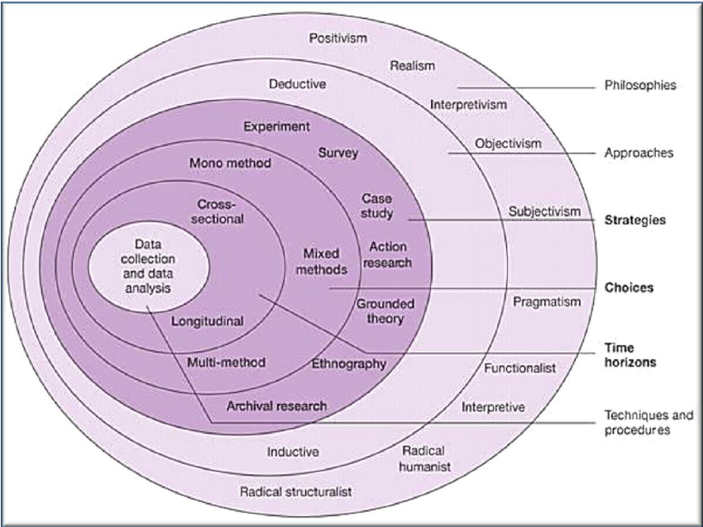
Figure 2 – Research Onion by Saunders (2007)

The Research Onion developed by Saunders, Lewis and Thornhill (2007) details the stages of the research process, using this model for the primary research demonstrates the progression of the methodology used. The research philosophy most appropriate is interpretivism, while having quantifiable data is useful it is recognised that the participants within this study would have different experiences and different needs, as such gaining their opinions and personalised feedback was important. The approach to theory development was deductive, there is substantial existing research on neurodiversity and workplace adjustments, and personal knowledge of SWP reasonable adjustments indicated there was not enough support or knowledge within the organisation.
A mixed method approach was chosen for the methodology. The benefits to using a mixed method design include allowing for more diverse views to be shared, allowing the qualitative findings to enhance the quantitative findings, and gives greater confidence in conclusions and recommendations (Saunders, Lewis and Thornhill, 2019).
A questionnaire (Appendix A) was chosen over interviews or focus groups following initial research detailing the barriers neurodivergent people face in interview situations due to social anxieties and sensory sensitivities (Milliner, 2023). Timescales used for the data collected followed a cross-sectional approach, this gives a picture of the current beliefs and feelings of the participants.
Collection of the data involved gaining buy-in from the chair of the SWP Neurodiversity Network, they circulated the questionnaire to the network members (Appendix B) and encouraged participation. None of the questions were mandatory as they may not all be applicable, this would also encourage as much feedback as possible from those specifically with a neurodiverse condition and allies.

3.3 Data analysis
As the questionnaire was created using Microsoft Forms, analysing the data could be easily done as it automatically transfers the data in to charts. However, to ensure accuracy of the data it was transferred to Microsoft Excel and cleaned to avoid any duplicate data or other errors. Once the data was cleaned it was assessed to look for themes and patterns throughout.

3.4 Reliability, validity, and research limitations
The reliability of the data cannot be guaranteed, as the data collected is predominantly based on individual experiences and opinion, should the study be repeated the results may vary (Chapman and McNeill, 2005).
Data validity was assured by checking for any missing or incomplete data, as not all of the questions were mandatory, they were not all completed by every participant leaving some fields blank. There is a possibility of bias affecting the results, as the survey was completed by people with a wide variety of neurodiverse conditions, the feedback will be based on their own experiences with their own conditions and therefore the results cannot be used as a blanket for all neurodiverse individuals.
With only 34 participants and a potential for 1120 neurodiverse employees as calculated in the introduction, the experiences and thoughts of only approximately 3% of neurodiverse employees has been captured. This does not give a full view of the needs of neurodiverse employees in SWP, to gain a more well-rounded assessment further investigation needs to be undertaken. While it was important to collect quantitative and qualitative data, the qualitative data takes more time to analyse and assess trends and themes throughout. In some cases the questions may not have been read and answered correctly, leading to anomalies.

Findings
The following details the findings from the survey sent out to the neurodiversity network looking at the key areas of general workplace adjustments, recruitment adjustments, and the impact felt on mental health.

4.1 Demographic
Of the 34 individual responses the most common conditions were ADHD (24), dyslexia (16), and autism (13) with 61.76% reporting more than one condition. 11 respondents reported they have no official diagnosis, of those with an official diagnosis the majority received their diagnosis between the ages of 20-49. This indicates that most did not receive a diagnosis during their education but rather during their employment years. 61.76% of respondents were female, 32.35% were male, and 5.88% were non-binary. ADHD was the most common condition among both male (54.55%) and female (80.95%) respondents. A good variety of ranks were included in the responses giving perspective from different areas of the force.
Figure 3– Reported neurodiversity conditions

4.2 Recruitment
When asked whether they would declare themselves disabled during a recruitment or promotion process 17 responded that they would not, not all neurodiverse individuals would consider themselves disabled, the question could have asked whether they would declare themselves as neurodivergent. This correlates to research by McDowall, Doyle and Kiseleva (2023), 64.7% responded their reason for not disclosing their neurodivergence was because they were concerned about stigma and discrimination from management, and 55% were concerned about discrimination from colleagues.
82.35% advised they do not feel there is enough information about adjustments available. Interestingly, 50% advised they thought SWP recruitment and promotion processes were accessible to neurodiverse candidates. 58.82% of respondents had not used reasonable adjustments during recruitment or promotion processes. Of those who had reasonable adjustments, extra time was the most common, one had the questions in advance and one received additional specialist software. Based on this feedback there could be a correlation between a lack of information about reasonable adjustments and individuals not requesting them.
Figure 4 – Recruitment reasonable adjustments
The majority of respondents had not been declined reasonable adjustments (79.41%), but of those who had been declined, the rejected adjustments included the ability to complete assessments on a laptop rather than by hand, extra time, and having the questions in advance. As the most common adjustment identified was extra time, and one individual advised they were provided questions in advance, this has highlighted an inconsistency in what adjustments are agreed, having a pre-approved list of adjustments force-wide may assist in providing more consistency.
When asked if they had ever withdrawn from a recruitment or promotion process 20.59% advised they had. One respondent withdrew an application after being declined reasonable adjustments, others sighted not applying due to struggling to write large amounts of text in applications, and pressure of interview situations and keeping concentration.
When asked how SWP could make recruitment and promotion processes more accessible some of the common themes included changing the interview approach to ensure candidates can perform their best, providing questions in advance, sending video/photographs of the building and interview room, and allowing bespoke reasonable adjustments rather than ‘text book’ options. Adjustments must be made in line with individual symptoms, a ‘one size fits all’ approach is unlikely to be effective (Blackburn, 2023). CIPD (2024) advise that considering alternative assessment methods such as work trials or practical assessments would focus on the candidate’s ability to do the role rather than their ability to perform in an interview.

4.3 Reasonable Adjustments
67.65% of respondents do not feel SWP provides enough support. When asked to provide more detail on why they feel that way the majority of answers indicated a lack of knowledge on neurodiversity across the organisation with some individuals referring to line manager knowledge, but also with mention of HR knowledge. One respondent stated there was “not enough awareness and understanding, lack of understanding around reasonable adjustments.” Many sighted that reasonable adjustments available were poor and felt like a ‘tick box exercise’. When asked what additional support or reasonable adjustments they wanted SWP to implement the most common themes included awareness training for line managers, and availability of neurodiversity ‘experts’ to support line managers and individuals. Other themes included the removal of ‘hot-desking’, removing open plan offices and providing ‘quiet spaces’ for people to work from or decompress. Having an allocated desk or office space was proven to be a successful adjustments, but designated quiet spaces appeared unsuccessful (Davies et al, 2022), highlighting that reasonable adjustments should be individual based.
Figure 5 – SWP support
When asked if they had sought support from their line managers only 55.88% responded that they had, when probed further about how well supported they felt by their line manager 11.76% stated it was exceptional, but 23.53% rated it as poor. Employers reported the biggest challenges in implementing adjustments was a lack of disclosure (69.3%) and a lack of understanding of neurodiversity by managers (65.4%) (McDowall, Doyle and Kiseleva (2023). According to ACAS (2024) neurodiversity can often amount to a disability under the Equality Act 2010, even if the individual themselves does not consider themselves disabled. The Equality Act 2010 describes a disability as a physical or mental impairment having “substantial and long-term” negative effects on the ability to do “normal day-to-day activities”. Where an employee declares a disability or the employer has reason to believe an employee is disabled, they have a responsibility under law to make reasonable adjustments, this also applies to individuals in recruitment processes.

4.4 Mental Health
When asked if their mental health had ever been impacted as a direct result of their neurodiverse condition 79.41% responded yes, correlating to evidence that 70% of adults with ADHD and 40% with autism have a further diagnosis of depression (Personnel Today, 2024). In providing more detail common themes include feelings of overwhelm and burn out, bullying relating to neurodiverse characteristics by both line management and colleagues, and imposter syndrome. When asked if their mental health has ever been impacted as a direct result of not having appropriate support and reasonable adjustments 58.82% responded with yes, this gives an insight that while support and reasonable adjustments do impact on mental health it is not the only factor that needs to be considered for wellbeing.
Figure 6 – Mental health impact

Conclusion

Based on the findings of this study there is a clear need for SWP to provide more support and bespoke reasonable adjustments to its neurodiverse employees. It is recognised that the more successful and desirable reasonable adjustments such as flexible working patterns and home working (McDowall, Doyle and Kiseleva, 2023) cannot always be facilitated to front line staff in an emergency service, however SWP needs to invest more into understanding what it can offer. Force wide neurodiversity training for all employees would be a good starting point to build up knowledge and understanding of neurodiverse conditions and give line managers a better ability to provide support (CIPD, 2024). Having trained workplace assessors would benefit the organisation by bringing expert knowledge on the barriers and solutions that can be implemented which are relevant to the force. Providing more information about the reasonable adjustments that are available through recruitment and promotion processes may also encourage more neurodiverse talent to apply. Overall, better workplace support can only improve the mental health and wellbeing of neurodiverse employees (Personnel Today, 2024).

References

ACAS (2024) What disability means by law. Available at: https://www.acas.org.uk/what-disability-means-by-law#:~:text=Attention%20deficit%20hyperactivity%20disorder%20(ADHD,consider%20themselves%20to%20be%20disabled (Accessed: 6 September 2024).
AchieveAbility (2018) Neurodiverse voices: opening doors to employment. Available at: https://www.achieveability.org.uk/files/1518955206/wac-report_2017_interactive-2.pdf (Accessed: 6 September 2024).
Birkbeck University of London (2023) 65% of neurodivergent employees fear discrimination despite UK businesses promoting neurodiverse workplaces. Available at: https://www.bbk.ac.uk/news/neurodivergent-employees-fear-discrimination-despite-uk-businesses-promoting-neurodiverse-workplaces (Accessed: 6 September 2024).
Blackburn, B. (2023) ‘Managing neurodiversity in workplaces’, Occupational Medicine, 73(2), pp. 57-58. Available at: https://academic.oup.com/occmed/article/73/2/57/7078309?login=true (Accessed: 6 September 2024).
Brady, H. (2022) ‘Neurodiversity in the workplace’, Occupational Medicine, 72(3), pp. 190. Available at: https://doi.org/10.1093/occmed/kqab123
British Dyslexia Association (2022) Neurodiversity in business. Available at: https://www.bdadyslexia.org.uk/news/neurodiversity-in-business-nib (Accessed: 6 September 2024).
Chapman, S. and McNeill, P. (2005) Research methods. 3rd edn. Routledge.
Charlie Health (2024) What it means to be neurodivergent & how it relates to mental health. Available at: https://www.charliehealth.com/post/what-it-means-to-be-neurodivergent-how-it-relates-to-mental-health (Accessed: 6 September 2024).
CIPD (2024) Neuroinclusion at work. Available at: https://www.cipd.org/uk/knowledge/guides/neuroinclusion-work/ (Accessed: 6 September 2024).
Davies, J., Heasman, B., Livesey, A., Walker, A., Pellicano, E., and Remington, A. (2022) ‘Autistic adults’ views and experiences of requesting and receiving workplace adjustments in the UK’, PLoS One, 17(8). Available at: https://www.proquest.com/docview/2699087168/fulltextPDF/83F9D5CA7DBE4BF2PQ/1?accountid=130472&sourcetype=Scholarly%20Journals (Accessed: 6 September 2024).
Equality Act 2010. Available at: https://www.legislation.gov.uk/ukpga/2010/15/contents (Accessed: 6 September 2024).
Google Cloud (2021) Strengthening our workplace with neurodiverse talent. Available at: https://cloud.google.com/blog/topics/inside-google-cloud/google-cloud-launches-a-career-program-for-people-with-autism (Accessed: 6 September 2024).
Gov.uk (2024) The Buckland review of autistic employment: report and recommendations. Available at: https://www.gov.uk/government/publications/the-buckland-review-of-autism-employment-report-and-recommendations/the-buckland-review-of-autism-employment-report-and-recommendations#:~:text=2%20Despite%20their%20wish%20to,10%20for%20non%2Ddisabled%20people (Accessed: 6 September 2024).
JP Morgan Chase (2023) Demystifying neurodiversity: it’s time to embrace the different ways we think. Available at: https://www.jpmorganchase.com/newsroom/stories/neurodiversity (Accessed: 6 September 2024).
Kirby, A. (2021) Is there a link between neurodiversity and mental health? Available at: https://www.psychologytoday.com/gb/blog/pathways-of-progress/202108/is-there-a-link-between-neurodiversity-and-mental-health (Accessed: 6 September 2024).
LeFevre-Levy, R., Melson-Silimon, A., Harmata, R., Hulett, A. L., and Carter, N. T. (2023) ‘Neurodiversity in the workplace: considering neurotypicality as a form of diversity’, Industrial and Organisational Psychology, 16(1), pp. 1-19. Available at: https://www.proquest.com/docview/2784771130?accountid=130472&parentSessionId=wXH%2FlsxljMoCqxzmxnafwotIfrQ6cGN%2B6pTGM1wpIHc%3D&pq-origsite=primo&sourcetype=Scholarly%20Journals (Accessed: 6 September 2024).
Lexxic (no date) Investing in neurodivergent talent: strategies for neuro-inclusive recruitment. Available at: https://lexxic.com/blog/investing-in-neurodivergent-talent-strategies-for-neuro-inclusive-recruitment (Accessed: 6 September 2024).
McDowall, A., Doyle, N., Kiseleva, M. (2023) Neurodiversity at work: demand, supply and a gap analysis. Available at: https://eprints.bbk.ac.uk/id/eprint/50834/ (Accessed: 6 September 2024).
Microsoft (no date) Global diversity and inclusion. Available at: https://www.microsoft.com/en-us/diversity/inside-microsoft/cross-disability/neurodiversityhiring (Accessed: 6 September 2024).
Milliner, S. (2023) Main barriers for people who are neurodiverse. Available at: https://www.linkedin.com/pulse/main-barriers-people-who-neurodiverse-stuart-milliner#:~:text=Using%20open%2Dended%20or%20ambiguous,expectations%20or%20frame%20responses%20effectively (Accessed: 6 September 2024).
Moses, A. (2023) Why has there been a rise in autism and adhd diagnoses? Available at: https://www.psychologytoday.com/gb/blog/thinking-about-becoming-a-psychologist/202307/why-has-there-been-a-rise-in-autism-and-adhd (Accessed: 6 September 2024).
My Disability Jobs (2024) Neurodiversity in the workplace. Available at: https://mydisabilityjobs.com/statistics/neurodiversity-in-the-workplace/ (Accessed: 6 September 2024).
NHS Dorset (no date) neurodiversity and mental health. Available at: https://nhsdorset.nhs.uk/neurodiversity/explore/mentalhealth/ (Accessed: 6 September 2024).
Personnel Today (2024) How to support the mental health of neurodivergent employees. Available at: https://www.personneltoday.com/hr/support-mental-health-neurodivergent-employees/ (Accessed: 6 September 2024).
Saunders, M. N. K., Lewis, P., and Thornhill, A. (2019) Research methods for business students. 8th edn. New York: Pearson.
Saunders, M. N. K., Lewis, P. and Thornhill, A. (2007) Research methods for business students. 4th edn. New York: Pearson.
South Wales Police (no date) Overview. Available at: https://www.south-wales.police.uk/police-forces/south-wales-police/areas/about-us/about-us/overview/ (Accessed: 6 September 2024).
Silver, E. R., Nittrouer, C. L., Hebl, M. R. (2023) ‘Beyond the business case: universally designing the workplace for neurodiversity and inclusion’, Industrial and Organisational Psychology, 16(1), PP. 45-49. Available at: https://www.proquest.com/docview/2784773952?accountid=130472&parentSessionId=jCu2NuFOS5Z0IkN9AAHXt%2Fx6S9t5ALuojgXJUlNWZks%3D&pq-origsite=primo&sourcetype=Scholarly%20Journals (Accessed: 6 September 2024).
Walkowiak, E. (2021) ‘Neurodiversity of the workforce and digital transformation: the case of inclusion of autistic workers at the workplace’, Technological Forecasting and Social Change, 168, pp. 120739. Available at: https://www-sciencedirect-com.ezproxy.uwtsd.ac.uk/science/article/pii/S0040162521001712?via%3Dihub#tbl0004 (Accessed: 6 September 2024).
Weber, C., Krieger, B., Häne, E., Yarker, J., and McDowall, A. (2022) ‘Physical workplace adjustments to support neurodivergent workers: a systematic review’, Applied Psychology, 73(3), pp. 910-962. Available at: https://iaap-journals-onlinelibrary-wiley-com.ezproxy.uwtsd.ac.uk/doi/full/10.1111/apps.12431 (Accessed: 6 September 2024).
World Economic Forum (2023) The future of jobs report 2023. Available at: https://www.weforum.org/publications/the-future-of-jobs-report-2023/ (Accessed: 6 September 2024).

Appendices
Appendix A – see additional attachment.
Appendix B:
From: NEURODIVERSITY <NEURODIVERSITY@south-wales.police.uk>
Sent: Friday, August 2, 2024 1:57 PM
Subject: FW: Neurodiversity Research Request

Good Afternoon,

We have had an asked to do this survey if anyone wouldn’t mind completing this to support Nadine that would be amazing,
I am a HR Advisor who is currently studying CIPD Level 7 Strategic People Management at Swansea University with the aim of enhancing my knowledge and skills at a strategic level within the organisation.

As part of my course I need to complete a research project on a topic of my choice, for this I have chosen to look at reasonable adjustments and support for those with a neurodiverse condition. The reason I have chosen this area to focus on is because I am currently working with other in the force to make improvements in this area, as such my hope is that I can use this research for both my University work and also to inform some of the work we are doing internally.

I would really appreciate your support with this project by completing the survey on Microsoft Forms, the link to this can be found below. I would also like to reassure you that the data you provide will be confidential and only used to analyse areas of improvement and the impact on the organisation. The closing date for responses will be 3pm on 30th August 2024.

If you have any concerns or queries in relation to the data or information requested, please don’t hesitate to contact me and I would be happy to discuss this with you.

https://forms.office.com/e/YjqHZmnBaf

Kind regards

Neurodiversity in the Workplace Poster Wording

Introduction
Neurodiversity describes individuals with conditions such as dyslexia, dyspraxia, dyscalculia, attention deficit hyperactivity disorder (ADHD), autism and Tourette’s (Brady, 2022). It is estimated that 15-20% of the UK population are neurodiverse (British Dyslexia Association, 2022). This study was designed to establish what further support SWP can implement, how to attract and support neurodiverse candidates, and how this would benefit the organisation. Primary research was conducted through a questionnaire distributed to the SWP Neurodiversity Network and secondary research was gathered from articles, books and websites.

Literature Review
Neurodiversity Skillset:
The skillset of neurodiverse individuals includes hyperfocus, creativity, innovative thinking and detail processing (Birkbeck University of London, 2023) which are skills that will be most desirable by 2027 (World Economic Forum, 2023).
Workplace Adjustments:
Some of the most useful workplace adjustments are flexible schedules and hybrid working (McDowall, Doyle and Kiseleva, 2023). Unsuccessful adjustments included quiet spaces, sensory environment changes, and changes to culture (Davies et al, 2022). CIPD 13.(2024) note that awareness training can develop awareness, understanding and appreciation for neurodiversity.
Recruitment:
Only 3 in 10 working age autistic people are employed (Gov.uk, 2024). Research shows that 88% of neurodiverse people felt discouraged from applying for jobs and 52% felt discriminated against in a recruitment process (AcheiveAbility, 2018). Lexxic (no date) advise that standardised interview assessment may not enable candidates to demonstrate their skills. Many organisations have neurodiversity recruitment schemes, with reasonable adjustments including providing questions in advance, extended interview time, interviews conducted in writing, and skills assessments (Microsoft, no date, Google Cloud, 2021, JP Morgan Chase, 2023). The results of having more neurodiverse employees show decreased error rates, improved morale, more inclusive culture, and neurodiverse employees were found to be up to 140% more productive (JP Morgan Chase, 2023, My Disability Jobs, 2024).
Mental Health:
Neurodiversity can impact on mental health through the additional challenges and barriers individuals may face (NHS Dorset, no date). Almost half of adults with ADHD also suffer with anxiety (Charlie Health, 2024). Workplace adjustments can assist in removing barriers that affect comfort, engagement and performance (Personnel Today, 2024).

Methodology
The aim of this research was to conduct a critical review of the support provided form neurodiverse employees in SWP and its impact on mental health.
The research onion developed by Saunders, Lewis and Thornhill (2007) was used to demonstrate the progression of the methodology. A mixed method approach was used to gain data through a questionnaire sent out to members of the SWP Neurodiversity Network. A questionnaire was chosen as it seemed more accessible for neurodiverse individuals then other methods (Milliner, 2023).
The questionnaire was created in Microsoft Forms, data was then assessed for themes and patterns.
As the data collected was based on individual opinion and experiences the validity cannot be guaranteed (Chapman and McNeill, 2005).
Limitations of this study include the sample size of only 34 respondents which is not a sufficient pool of people, the study could be repeated to gain more insight, giving individuals more time to respond and not conducting the research during the summer holidays when a lot of people take leave. There was a risk of bias as the feedback was based on their own personal experiences with their specific conditions.

Findings
Of the 34 respondents to the questionnaire, the most common reported conditions were ADHD, dyslexia, and autism, with 61.76% reporting more than one condition.
Most advised they would not declare themselves disabled during a recruitment or promotion process which aligns to research by McDowall, Doyle and Kiseleva (2023). Only 41.18% had used reasonable adjustments in a recruitment or promotion process, of those who had, extra time was the most common. One person reported having the questions in advance and another advised they had been declined this when requested which highlights inconsistency. When asked how SWP could more recruitment more accessible, feedback included allowing bespoke reasonable adjustments which mirrors Blackburn (2023), having questions in advance, sending photos/videos of the building, and changing the interview approach.
With 67.65% advising they felt that SWP does not provide enough support there was a theme of individuals feeling there was a lack of knowledge from line managers and training around neurodiversity was needed. Only 55.88% of individuals had sought support from line managers, 23.53% found that support to be poor.
79.41% of respondents felt their mental health had been impacted as a result of their neurodiversity, this aligns to evidence that 70% with ADHD, and 40% with autism also have depression (Personnel Today, 2024).

Conclusion
To ensure SWP supports neurodiverse employees and candidates to the best of its ability further consideration needs to be given to bespoke reasonable adjustments. In-house workplace place assessors would bring expert knowledge on barriers and solutions. Force wide neurodiversity training would build on knowledge and understanding as recommended by the CIPD (2024). Providing information about the reasonable adjustments available at point of recruitment and promotion may appeal to neurodiverse talent. To improve the wellbeing of neurodiverse employees, better workplace support needs to be provided (Personnel Today, 2024).

References

AchieveAbility (2018) Neurodiverse voices: opening doors to employment. Available at: https://www.achieveability.org.uk/files/1518955206/wac-report_2017_interactive-2.pdf (Accessed: 6 September 2024).
Birkbeck University of London (2023) 65% of neurodivergent employees fear discrimination despite UK businesses promoting neurodiverse workplaces. Available at: https://www.bbk.ac.uk/news/neurodivergent-employees-fear-discrimination-despite-uk-businesses-promoting-neurodiverse-workplaces (Accessed: 6 September 2024).
Blackburn, B. (2023) ‘Managing neurodiversity in workplaces’, Occupational Medicine, 73(2), pp. 57-58. Available at: https://academic.oup.com/occmed/article/73/2/57/7078309?login=true (Accessed: 6 September 2024).
Brady, H. (2022) ‘Neurodiversity in the workplace’, Occupational Medicine, 72(3), PP. 190. Available at: https://academic.oup.com/occmed/article/72/3/190/6570554?login=true (Accessed: 22 September 2024).
British Dyslexia Association (2022) Neurodiversity in business. Available at: https://www.bdadyslexia.org.uk/news/neurodiversity-in-business-nib (Accessed: 6 September 2024).
Chapman, S. and McNeill, P. (2005) Research methods. 3rd edn. Routledge.
McDowall, A., Doyle, N., Kiseleva, M. (2023) Neurodiversity at work: demand, supply and a gap analysis. Available at: https://eprints.bbk.ac.uk/id/eprint/50834/ (Accessed: 6 September 2024).
Charlie Health (2024) What it means to be neurodivergent & how it relates to mental health. Available at: https://www.charliehealth.com/post/what-it-means-to-be-neurodivergent-how-it-relates-to-mental-health (Accessed: 6 September 2024).
CIPD (2024) Neuroinclusion at work. Available at: https://www.cipd.org/uk/knowledge/guides/neuroinclusion-work/ (Accessed: 6 September 2024).
Davies, J., Heasman, B., Livesey, A., Walker, A., Pellicano, E., and Remington, A. (2022) ‘Autistic adults’ views and experiences of requesting and receiving workplace adjustments in the UK’, PLoS One, 17(8). Available at: https://www.proquest.com/docview/2699087168/fulltextPDF/83F9D5CA7DBE4BF2PQ/1?accountid=130472&sourcetype=Scholarly%20Journals (Accessed: 6 September 2024).
Google Cloud (2021) Strengthening our workplace with neurodiverse talent. Available at: https://cloud.google.com/blog/topics/inside-google-cloud/google-cloud-launches-a-career-program-for-people-with-autism (Accessed: 6 September 2024).
Gov.uk (2024) The Buckland review of autistic employment: report and recommendations. Available at: https://www.gov.uk/government/publications/the-buckland-review-of-autism-employment-report-and-recommendations/the-buckland-review-of-autism-employment-report-and-recommendations#:~:text=2%20Despite%20their%20wish%20to,10%20for%20non%2Ddisabled%20people (Accessed: 6 September 2024).
JP Morgan Chase (2023) Demystifying neurodiversity: it’s time to embrace the different ways we think. Available at: https://www.jpmorganchase.com/newsroom/stories/neurodiversity (Accessed: 6 September 2024).
Lexxic (no date) Investing in neurodivergent talent: strategies for neuro-inclusive recruitment. Available at: https://lexxic.com/blog/investing-in-neurodivergent-talent-strategies-for-neuro-inclusive-recruitment (Accessed: 6 September 2024).
Microsoft (no date) Global diversity and inclusion. Available at: https://www.microsoft.com/en-us/diversity/inside-microsoft/cross-disability/neurodiversityhiring (Accessed: 6 September 2024).
Milliner, S. (2023) Main barriers for people who are neurodiverse. Available at: https://www.linkedin.com/pulse/main-barriers-people-who-neurodiverse-stuart-milliner#:~:text=Using%20open%2Dended%20or%20ambiguous,expectations%20or%20frame%20responses%20effectively (Accessed: 6 September 2024).
My Disability Jobs (2024) Neurodiversity in the workplace. Available at: https://mydisabilityjobs.com/statistics/neurodiversity-in-the-workplace/ (Accessed: 6 September 2024).
NHS Dorset (no date) neurodiversity and mental health. Available at: https://nhsdorset.nhs.uk/neurodiversity/explore/mentalhealth/ (Accessed: 6 September 2024).
Personnel Today (2024) How to support the mental health of neurodivergent employees. Available at: https://www.personneltoday.com/hr/support-mental-health-neurodivergent-employees/ (Accessed: 6 September 2024).
Saunders, M. N. K., Lewis, P. and Thornhill, A. (2007) Research methods for business students. 4th edn. New York: Pearson.
World Economic Forum (2023) The future of jobs report 2023. Available at: https://www.weforum.org/publications/the-future-of-jobs-report-2023/ (Accessed: 6 September 2024).

